TakeTopDSH Team
User Guide

## Table of Contents
- [1. Overview
- [2. Platform Login
- [3. Management Page
- [4. DSH Workbench
- [5. Member Work
- [6. DSH Operation

1. Overview
This guide is intended for users, and clearly explains: Login - Open the Workbench - File Management / My Tasks - Admin Task Assignment, Instance Management, Language Switching - Member DSH Usage!

2. Platform Login
Open the TakeTopDSH Team directory and you will see the two files below. Run the file that matches your operating system to open the login page!
> - Windows: Double-click **`start.bat`**
> - macOS / Linux: Run **`./start.sh`**
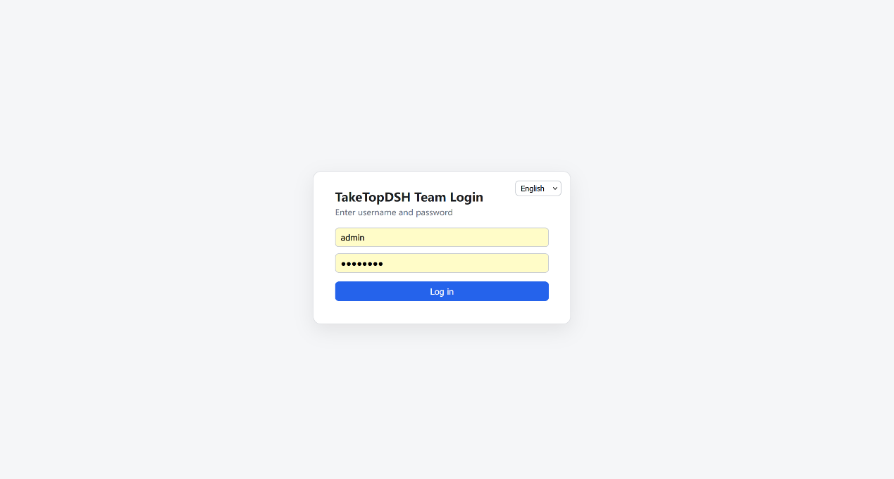
Enter the username: admin, password: 12345678 to log in to the platform. After the first login, the TakeTopDSH Team backend service, TakeTopDSHLauncher, runs in the background. As long as you have not restarted the computer, you can open the browser and enter this address http://127.0.0.1:46001 to continue opening the login page. If the launcher has been closed (for example after restarting the computer), you need to run the start program mentioned above again!

3. Management Page
After the admin user logs in to the platform, you will see the page style below. This is the management page for the admin user.
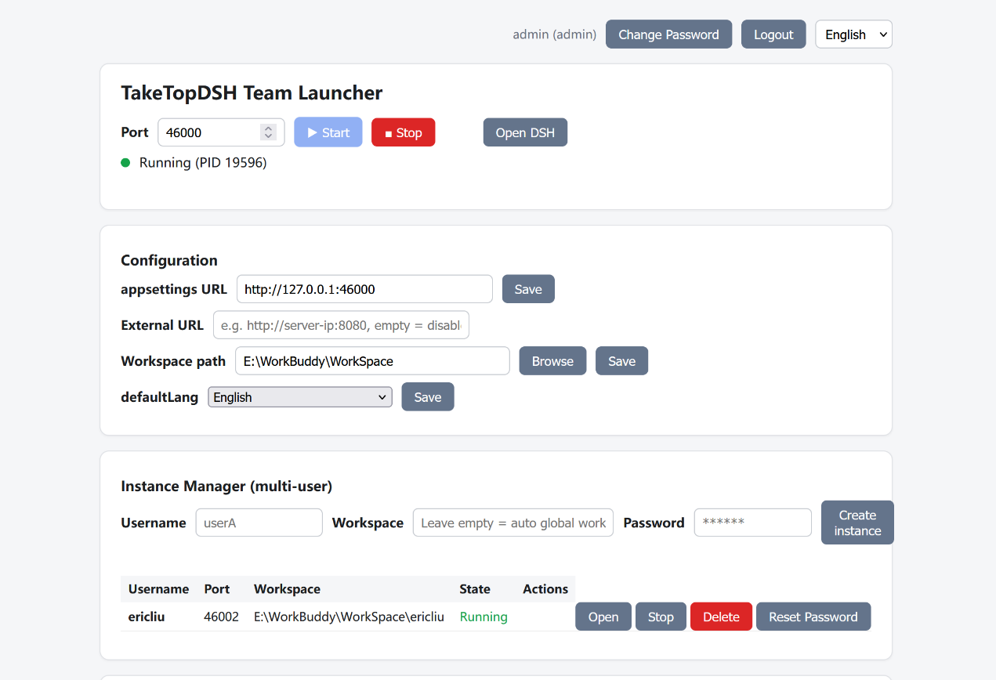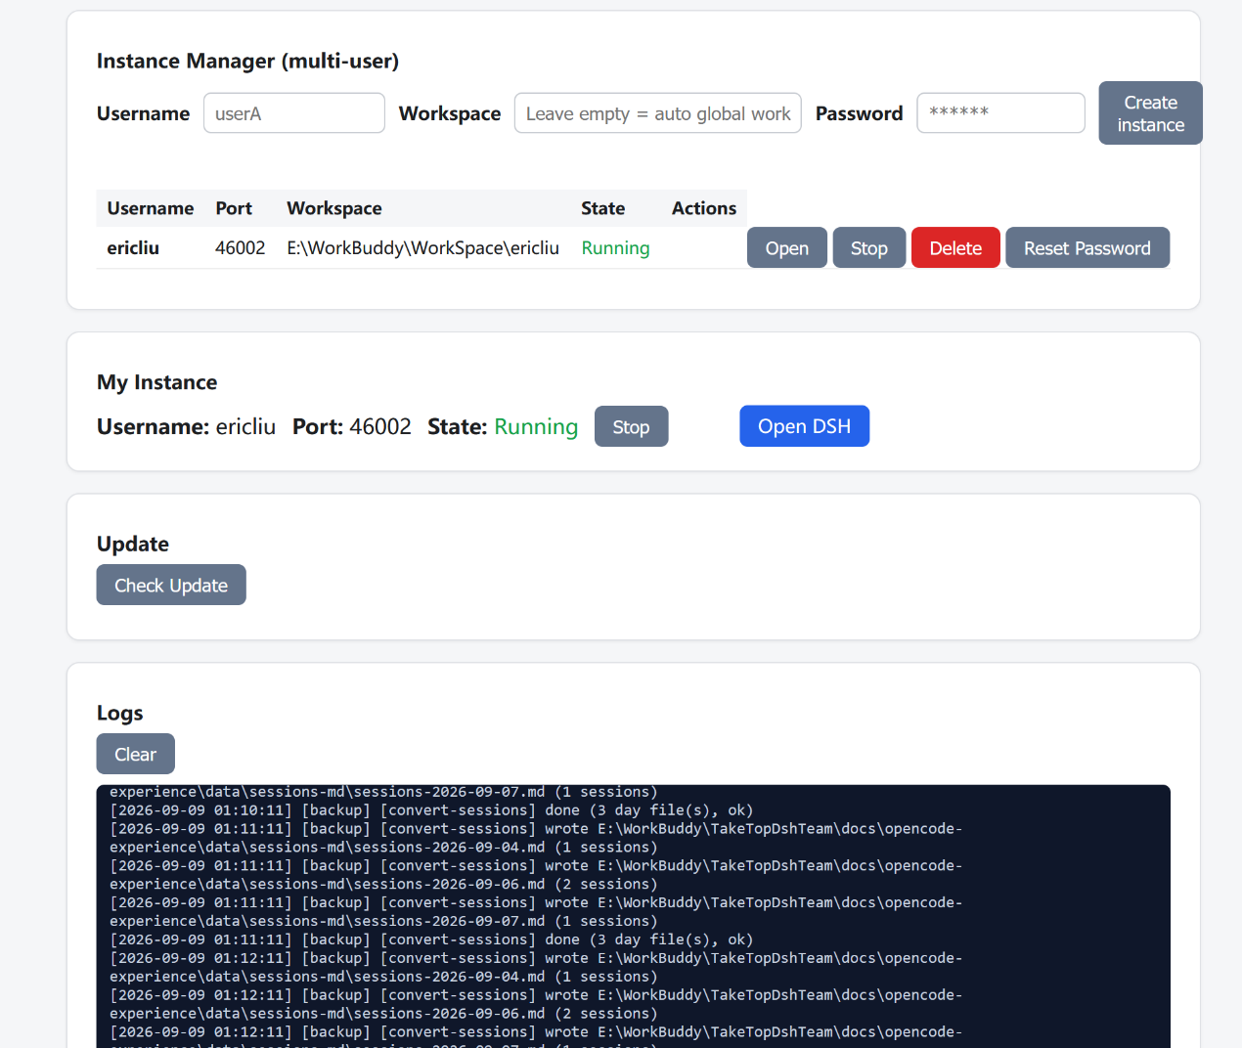
You can use this platform to: Start/Stop, Open DSH, Configure, Manage Instances, and Change Password. The following parts are explained in detail; the others are self-explanatory and will not be covered!
  - Configuration
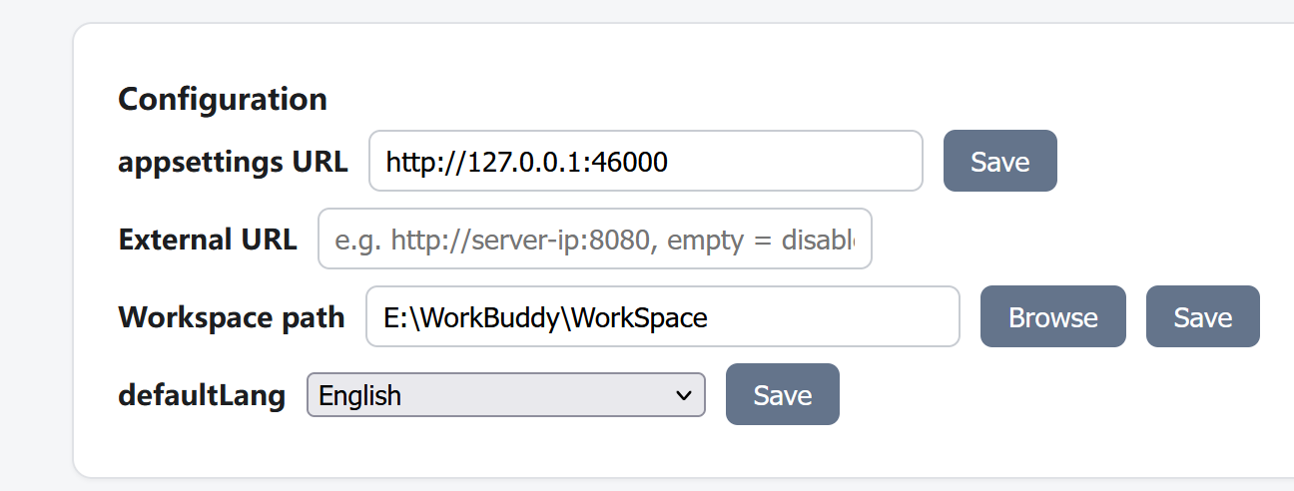
3-1-1. Set Workspace Path
Setting the Workspace path means setting the work area directory of the platform. Note that this directory can be located on any drive of your computer, but plan it well to make sure it has enough capacity, because all the data you enter and all the files you upload in TakeTopDSH Team are stored in this directory!

3-1-2. Set External URL
External URL means: if the platform also needs to be used from the external network, you can assign a public IP to the server and enter it here. For example, if the public IP is 188.88.88.88, you can set it as: http://188.88.88.88:46000. If you are not sure, you should consult your network administrator to make sure the setting is correct!

  - Add Member User
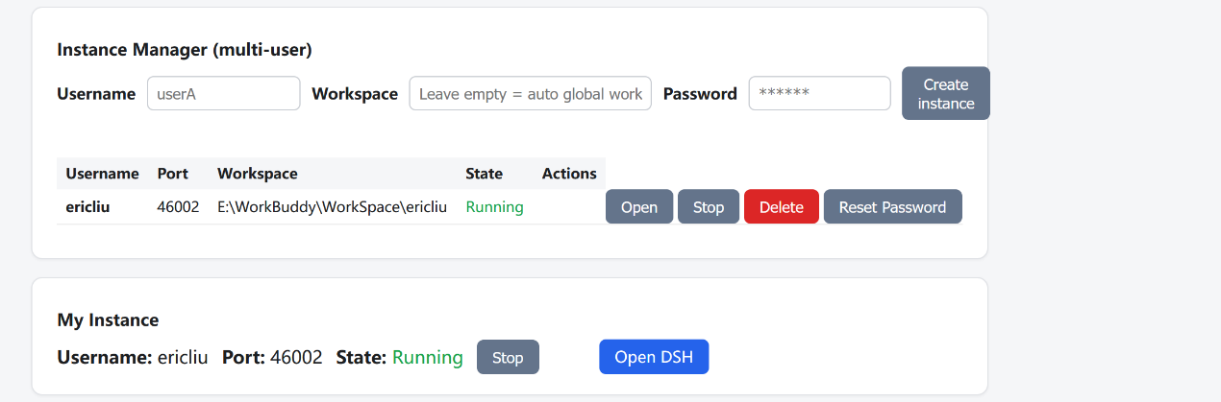
You can add member users here. Note that the username must use English letters, not Chinese. Remember the password you set for the user, for example set it to: 12345678. After the member user logs in to the platform, they can change it by themselves. The member's work area directory does not need to be set; it is generated automatically. Specifically: main work area directory + username, and this directory is generated automatically!

  - Platform Upgrade
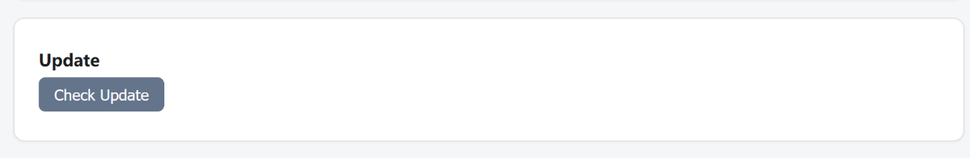
Because TakeTopDSH Team is an AI collaboration platform extended based on DeepSeek Harness, after DeepSeek Harness releases a new version you can also click this button to upgrade, ensuring that you can use the latest features of DeepSeek Harness!

4. DSH Workbench
After completing the settings on the management page above, click the Open DSH button in the TakeTopDSH Team Launcher section to open the workbench page!
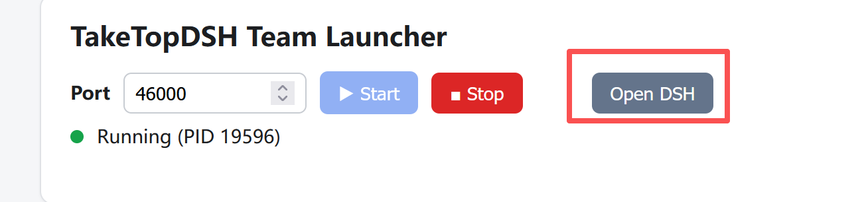

The workbench page is shown below, with left/right columns. The left side is File Management / My Tasks, and the right side is the DSH conversation interface.
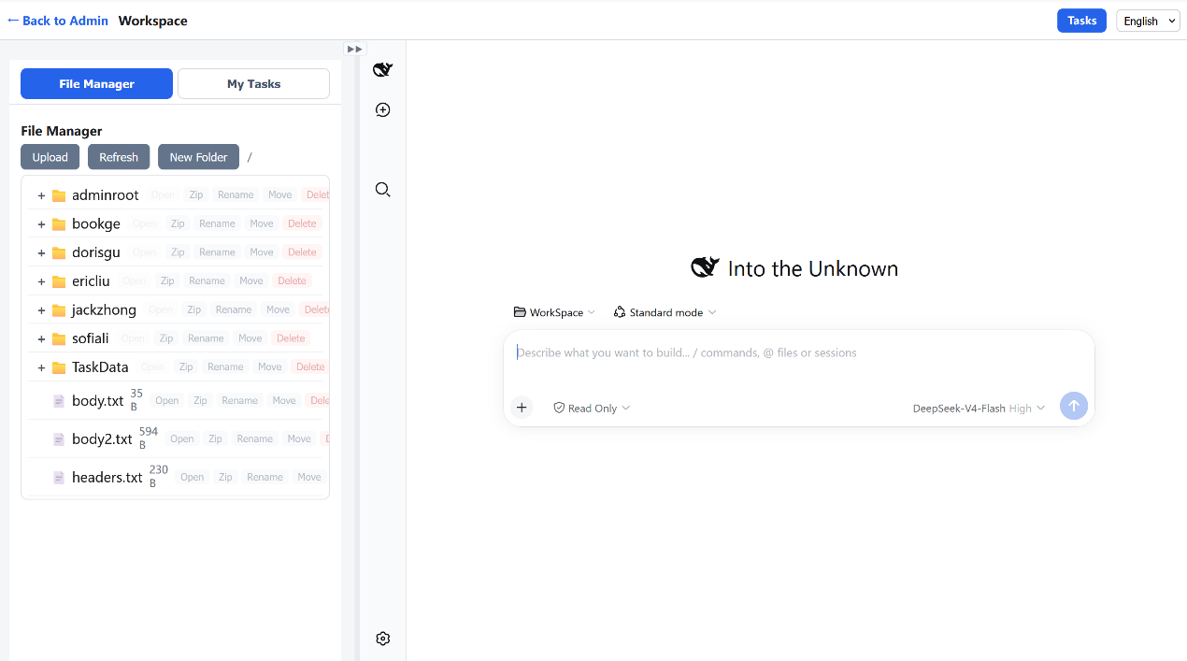
4-1. Configure the API Key of the AI Model
Although TakeTopDSH Team is extended based on DeepSeek Harness, it can also connect to other large models, such as OpenAI, Kimi, etc., and it can also connect to local large models!
First, click the settings icon at the top-left of the right sidebar to open the settings page, as shown below.
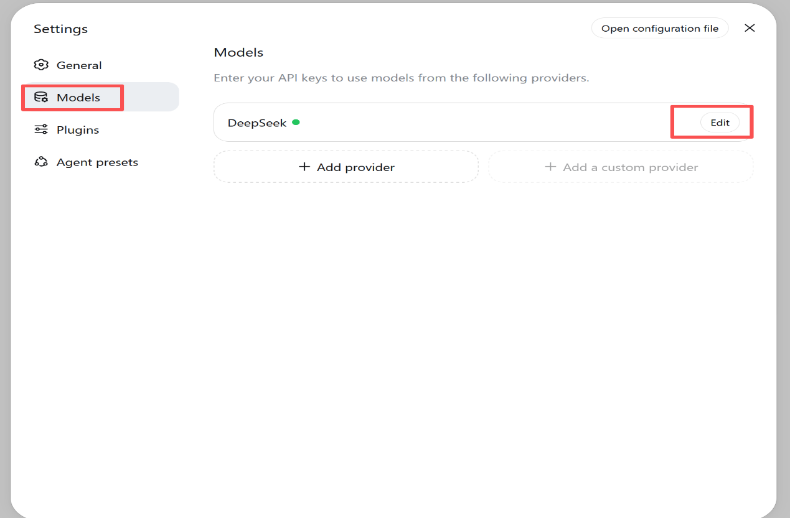
Click the Edit button. As shown below, you can select a model from the listed ones, or click Add model to add a model. After selecting, enter the key you obtained in the API Key field. You can learn how to configure it on the website of the large model you plan to connect to!
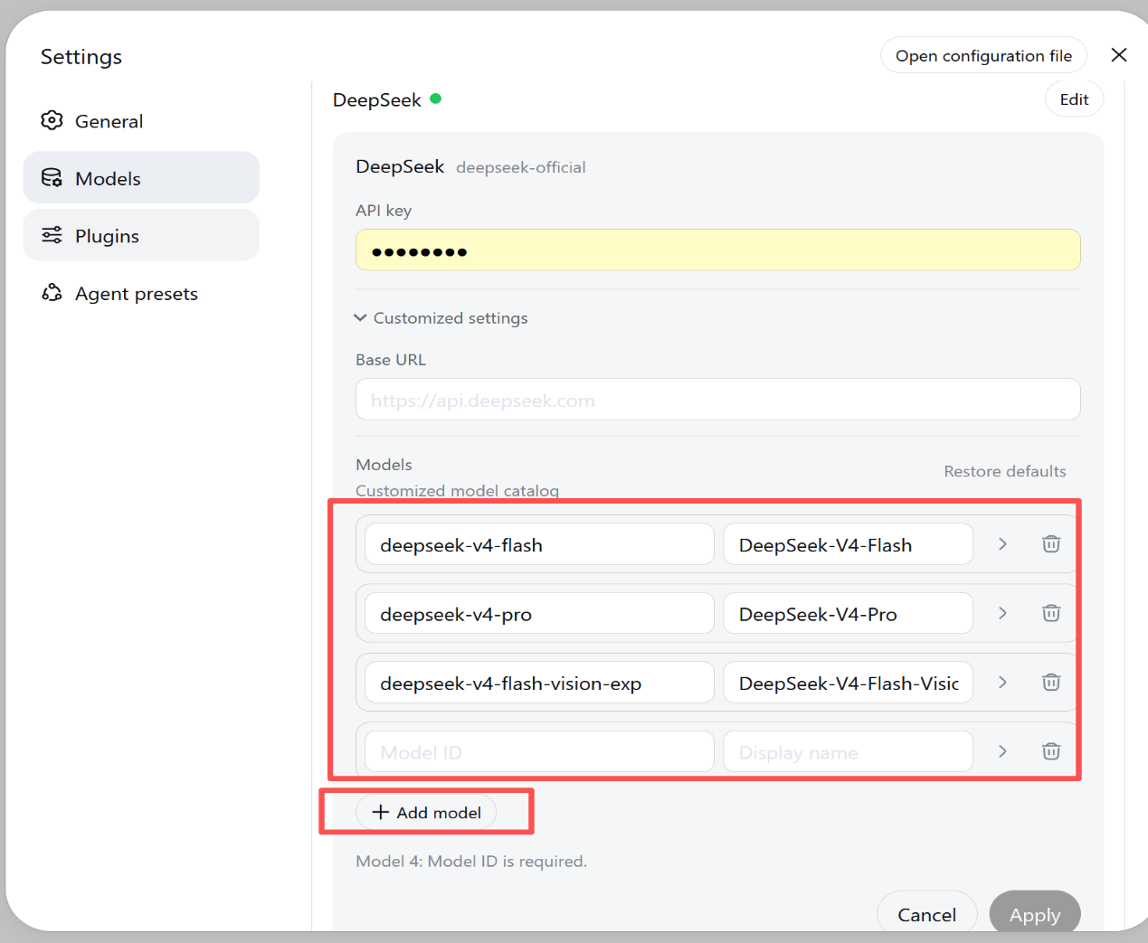
After configuring the API Key for the large model, you can use DSH to have AI conversations, as shown below:
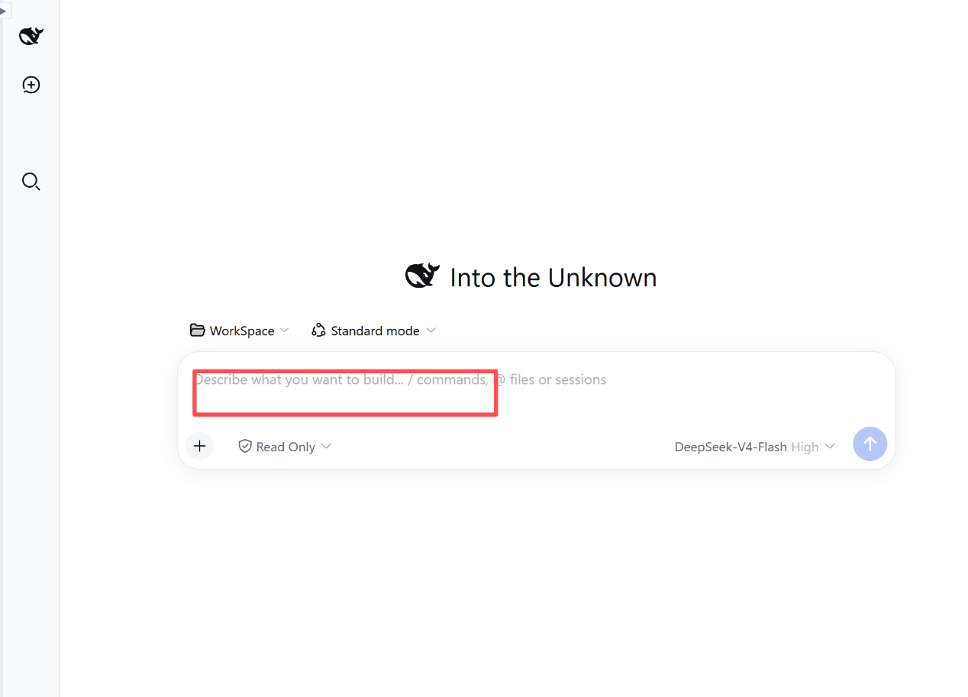
4-2. File Manager
The first tab in the left sidebar of the workbench is your File Manager, as shown below. It displays the files in your work area directory. You can only operate on the files in this work area directory. You can upload the files you want to work on to this directory (multiple file upload is supported), and you can also perform operations such as open, download, move, rename, and delete.
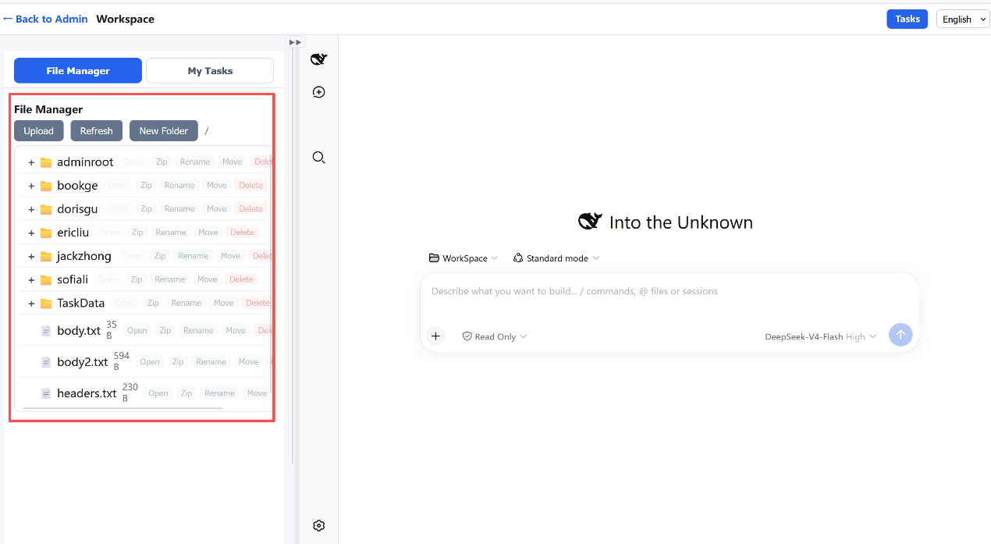
4-3. Task Management. Click the Task Management tab. As shown below, this displays the task list assigned to you by other members. You can click the task name to preview the detailed content of the task, and you can also click the feedback button to provide feedback on the details of how you handled the task!
```
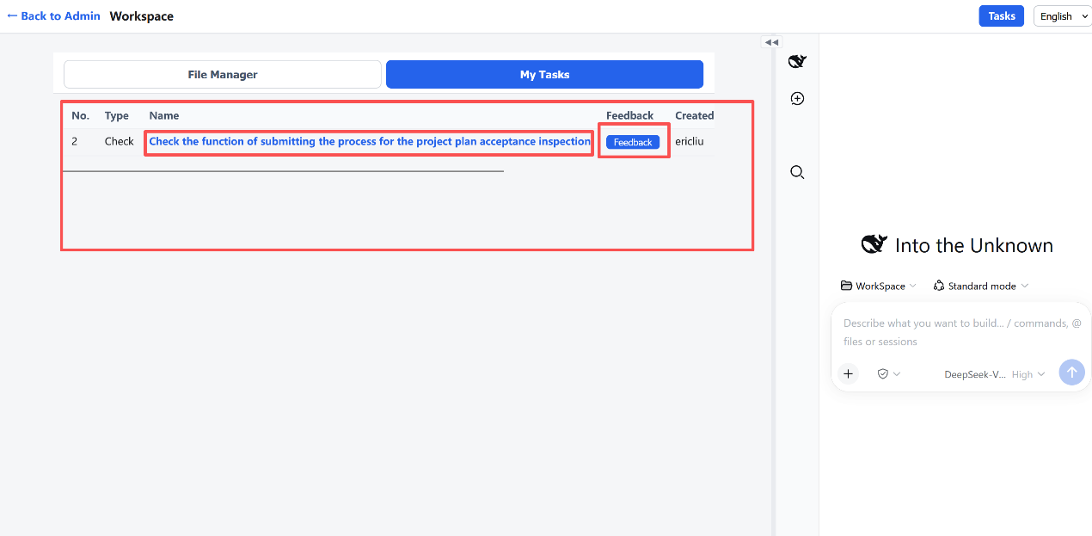
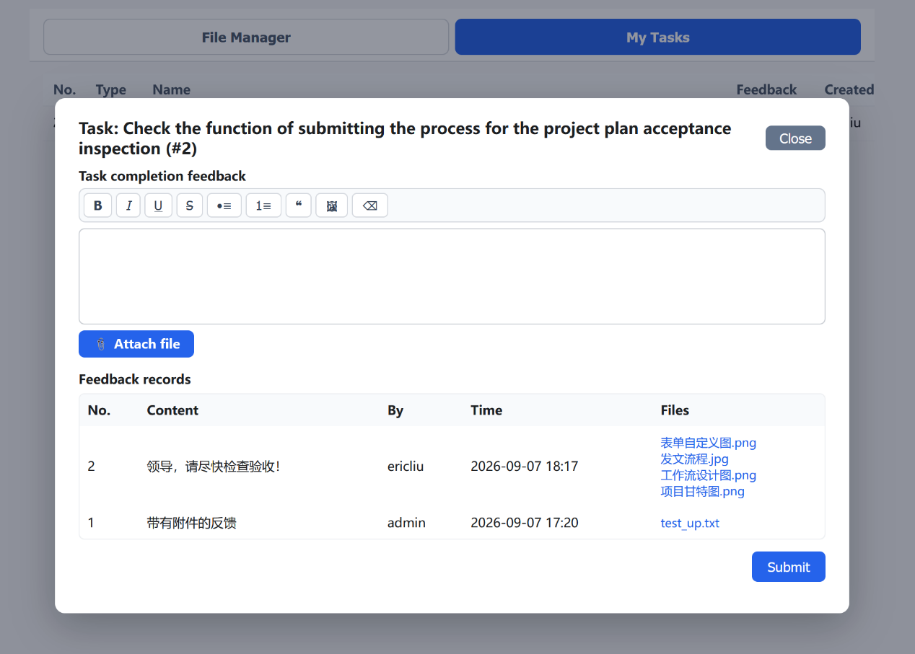
The input box above can be used to enter text or paste images. Click the Attach file button below to upload attachments!
4-4. Task Assignment
Click the "Task Assignment" button at the top-right of the page to open the task assignment page, as shown below.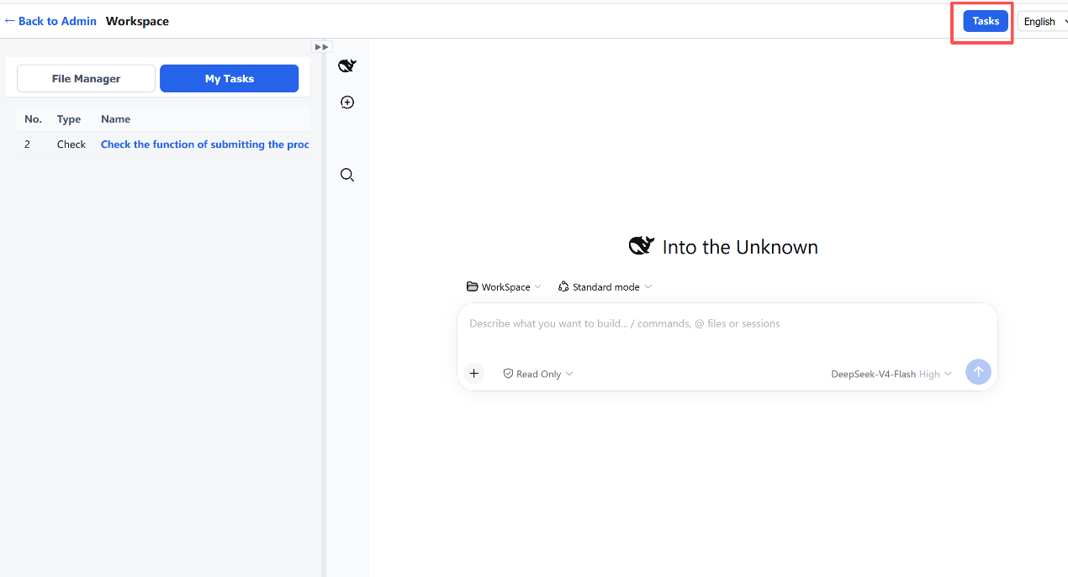
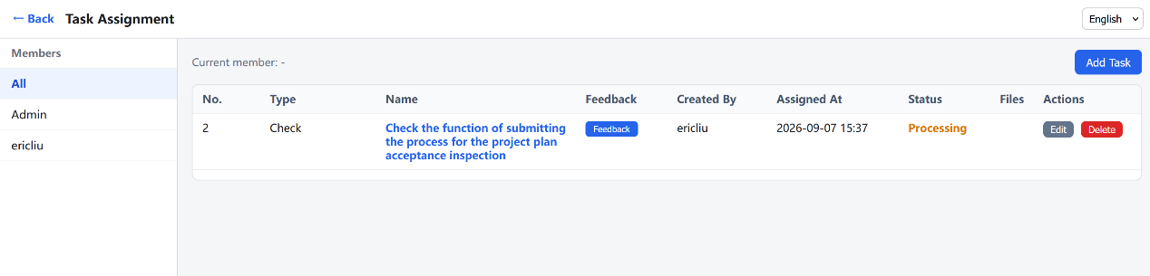
It displays all the tasks you have created. In the member list on the left, select the member to whom you want to assign a task, and click the Add Task button to assign a task to this member.
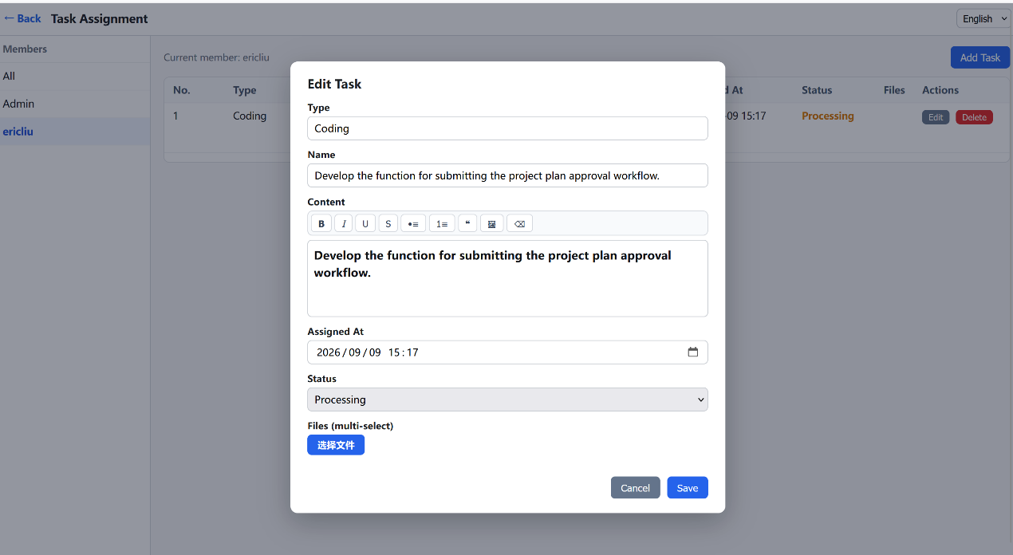
You can also click the Feedback button in the task list to review how this member completed the task, and enter your requirements and comments, as shown below. The operation is the same as above!

5. Operations for Other Members
Members added by the admin on the management page, such as the ericliu added just now, can also log in on the login page. After logging in to the member's management page, as shown below, it is simpler than the management page of the admin user.
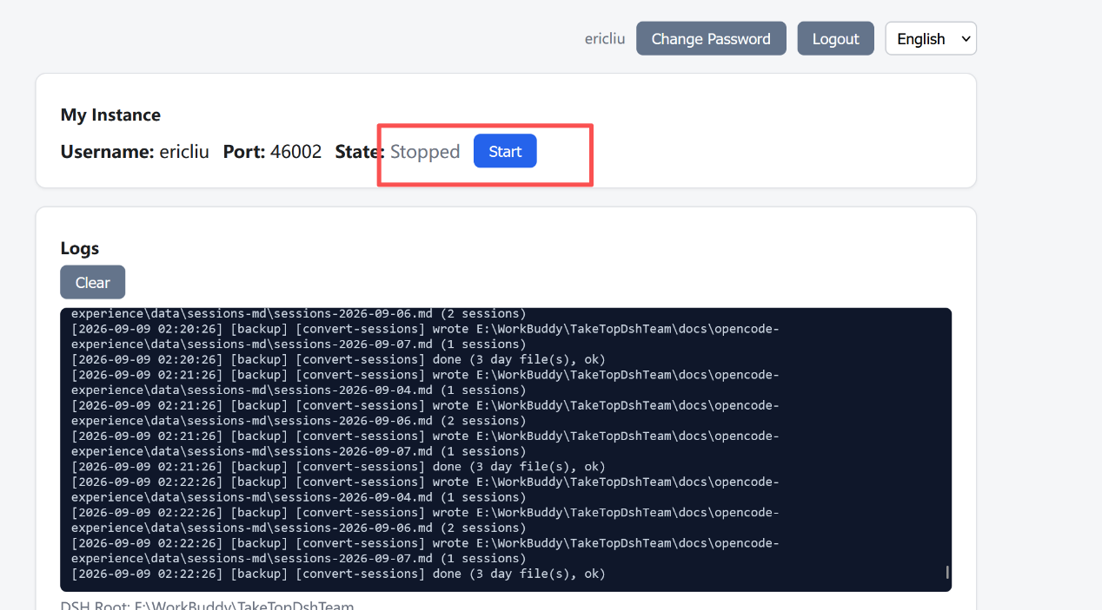
On this management page, you can click the Start button to start the DSH service. The first start will be a bit slow. After it starts, you can open the member's DSH page, as shown below. The operation is the same as for the admin user. However, note that the member can only work in his own file work area and cannot see the file data of other work areas!

6. DSH Operation. After you are familiar with the various functions on the pages above, users can use this AI Harness to work. For example, if you want to modify a code file in the work area directory, you can directly enter the modification instruction you want in the Harness input box, as shown below, and then click the submit arrow button; it will call the associated large model to do the work!
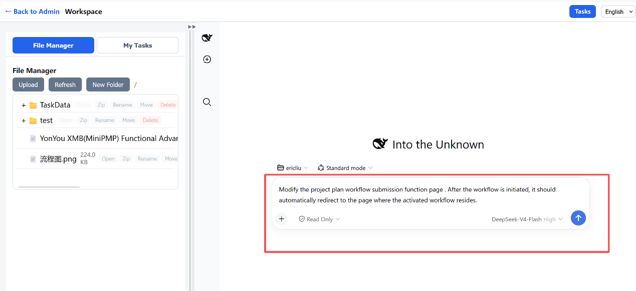
Of course, in addition to software development, you can also do other work, such as modifying a PPT file, creating a new contract file, and so on. You can also complete the tasks assigned to you here!

