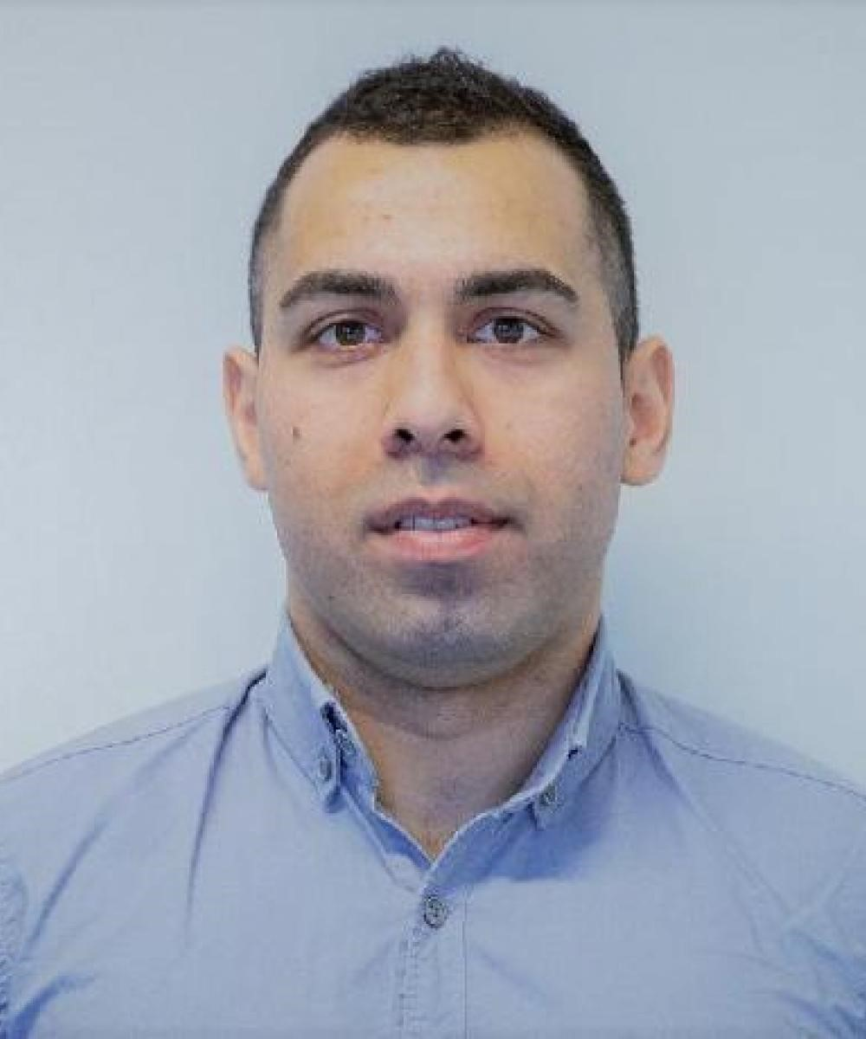**Tanyo Ivanov**

|  |  |
| --- | --- |
|  | [tanyo.takerman.net](https://tanyo.takerman.net) |
|  | [@tanyoivanov](https://www.youtube.com/c/TanyoIvanov) |
|  | [@takermanltd](https://github.com/TakermanLTD) |
|  | [@dev.tanyoivanov](https://www.facebook.com/dev.tanyoivanov) |
|  | [@tanyo-ivanov](https://www.linkedin.com/in/tanyo-ivanov/) |
|  | [@tanyoivanov](https://twitter.com/TanyoIvanov) |

.NET Developer

Email: [tivanov@takerman.net](mailto:tivanov@takerman.net)   
Website: <https://tanyo.takerman.net>   
Phone:   
+359897887191  
+447383721742

Date of birth: 12.01.1991

# Work experience

|  |  |
| --- | --- |
| 01/2019 - 12/2019 | **Application Developer .NET**  **Foster + Partners - SW115DN – UK, London**  Developed and the tested the main Intranet application which has relation with loads of small inhouse developed applications written with different technologies. Renewed, documented and presented a lot of outdated applications used for organisation of the architects. For example, apps for booking meeting rooms, taxis travels, emails etc. Agile methodology.  **Tech:** .NET Core, Design Patterns, ASP.NET, Umbraco, Vue.js, SQL, Selenium, and other common skills |
| 06/2016 - 11/2018 | **.NET Developer**  **BGO Software - 4000 – Bulgaria, Plovdiv**  Developed web system for managing the health researches of the UK and global scientists. The application is used for organising meetings in the UK government. Worked on the development of internal components and fixes of the project. Communicated everyday with the NHS client team. Trained a Junior. Agile methodology.  **Tech:** .NET, Design Patterns, ASP.NET, Ace Admin, SQL, MS Tests, and other common skills |
| 06/2015 - 06/2016 | **.NET Developer**  **Comstream – 41101 – Sweden, Gothenburg**  Built web and mobile applications for Smart Houses and Energy consumption optimisation. Worked onsite from the client location in Sweden. Trained a junior. Internet of Things devices integration. Agile methodology.  **Tech:** .NET, Design Patterns, ASP.NET, SQL, IoT, and other common skills |
| 01/2013 - 06/2015  **Education** | **.NET Developer**  **BuCons - 4000 - Remote**  Developed, documented and delivered a lot of applications for the company clients. The main application was a Desktop WinForms application used for the administration of the scores and the profiles of the students. Worked with the team of HSO from Switzerland remotely until the delivery.  Trained a junior. Waterfall methodology.  **Tech:** .NET, WinForms, ASP.NET, DotNetNuke, SQL, WPF, XBAP and other common skills |
| 10/2010 - 06/2014  09/2005 - 06/2009  **Languages** | **Business Information Technologies, Bachelor in Informatics**  **University of Plovdiv - Plovdiv**  Programming, Economics, Banking, Excel, 3D Software, English  **Information Technologies**  **Asen Zlatarov’s High School – Parvomay**  Programming, MS Office, 3D Software and design |

* **Bulgarian** (Native language)
* **English** (Fluent)

# Skills

|  |  |  |
| --- | --- | --- |
| * NET Framework * ASP.NET * Bash * CSS * HTML5 * Internet of Things * JavaScript * MVC * SQL * SQL Server * Selenium * Windows Services * Amazon EC2 * Firebird | * TypeScript * Windows Server * WinForms * Agile Methodologies1 * Test Automation * Unit Testing * Integration Testing * C# * Bootstrap * Entity Framework * ASP.NET Web API * Raspberry Pi * Load Testing * Software Design Patterns | * Entity Framework (EF) Core * .NET Core * ASP.NET Core * Windows Server * jQuery * Docker * Git * Linux * Coded UI Testing |