Chapter 3 Implementation of the Rendering System
3.1 Graphics Context Initialization
3.2 Rendering Basic Primitives
3.3 Shader Implementation
3.4 Transformations and Camera System
3.5 3D Object Rendering
3.6 Lighting Techniques
3.7 Texture Mapping
3.8 Performance Considerations

3.1 Graphics Context Initialization

The first stage of the implementation involved establishing a valid OpenGL rendering context. In modern OpenGL applications, the graphics context must be created before any rendering operations can be performed. This thesis project utilizes the GLFW library for window management and context creation, and GLAD as the OpenGL function loader.

GLFW was responsible for:
-Creating the application window
-Managing input and events
-Initializing the OpenGL context
GLAD was used to:
-Load OpenGL function pointers at runtime
-Provide access to modern OpenGL API functions

The project was configured using Microsoft Visual Studio in x64 Release mode to ensure compatibility with 64-bit OpenGL libraries. After proper configuration of include directories and linking external libraries, the application successfully created an OpenGL context and displayed a window titled “ThesisRenderer”.

At this stage, the application does not yet render graphical primitives. The displayed black window confirms that the OpenGL context has been correctly initialized and the rendering loop is active.
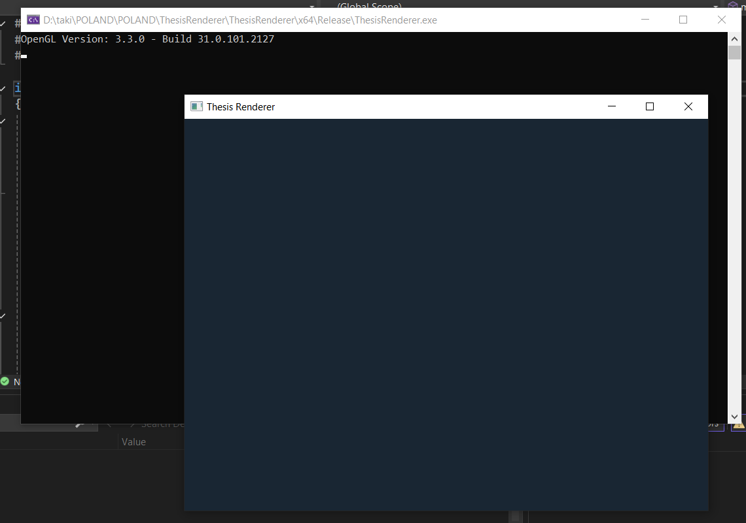

Figure 3.1 presents the initial application window after successful context creation.

3.2 Rendering Basic Primitives
After implementing Vertex Buffer Objects (VBOs) and Vertex Array Objects (VAOs), the project renders its first graphical primitive: a basic triangle.

-Vertex data is transferred from CPU memory to GPU memory using a VBO.

-A VAO defines how vertex attributes are interpreted during rendering.

After the OpenGL context was initialized, a simple triangle is rendered using this pipeline. A basic vertex shader processes vertex positions, while a fragment shader colors the triangle. This milestone demonstrates that the rendering pipeline is fully operational and correctly configured.

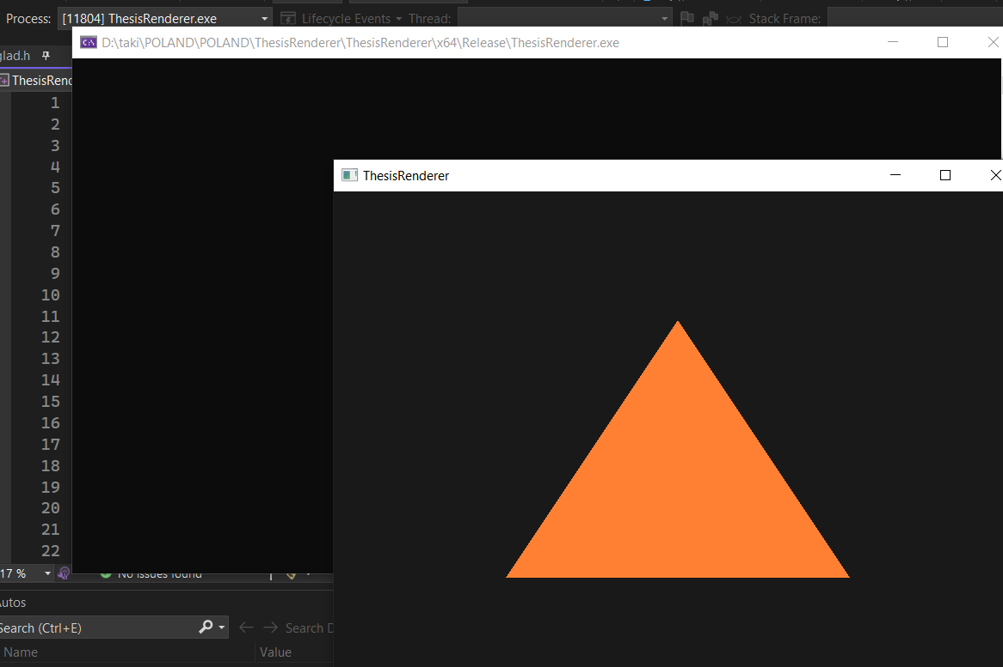
Figure 3.2: First rendered triangle demonstrating VBO and VAO usage in the OpenGL pipeline

