Academic Content Summarisation

SAM LUBBERS, SOPHIE O’DONNELL, DARIEN OPPERMAN, PORNPANIT RASIVISUTH, ALEX SAUBESTRE AND HARRY SHAW

UNIVERSITY OF BATH

Group 1

# **Introduction & Proposal**

# **Introduction & Problem Statement**

A common theme in many modern learning environments is the distribution of dense, content packed, digital documents. These often include PDFs spanning hundreds of pages, or slideshows with large amounts of technical details. When it comes time for assessment, a staple part of many students’ revision scheme involves making notes, and condensing the large swathes of course material. Some students may print out notes and highlight segments, others may simply create key cards straight from the screen.  These processes involve taking a vast amount of content, summarising it, to create material more useful for revision purposes. This leads to our problem statement:

***A large proportion of students’ revision preparation revolves around the condensing and summarising of digital content. We believe this process can be assisted via automation, allowing more time to revise course content***

* 1. **Challenges & Problem Space**

It is possible to define the summarization process with two variables: time taken and output quality. When manually creating summaries, commonly a very large amount of time is invested, to produce a summary of high quality. A possible alternative process involves using a computer to automate the summarization. This can potentially reduce time taken to negligible levels, but the quality is inferior when compared with the manually created one.

Automating the process, whilst maintaining a valuable, useable output is the challenge. Therefore, we have decided to create a system that condenses notes and reading material, reducing time required for users to produce summaries. To combat the issue of summary quality, we plan to have a level of user interaction allowing for further refining and tailoring.

## **Goals & Users**

The goal is to produce a result that is a high-quality summary generated at a very high speed. We believe that a system able to do this would be very valuable to academia in general, regardless of discipline. It would allow for people to learn the fundamentals of topics faster, letting them to spend their time in a more useful manner.

We envisage our primary user-base to be composed of university students, and academics, as they receive the highest amount of material to process. User interaction with the system will need to kept as simple as possible, the higher the complexity of user interaction, the less we can automate. We will model our user interaction on current successful systems, with simple file uploading and functionality designed to resemble widely use text editors. The goal is to allow our users feel familiar within the system environment.

# **Related Work**

# **Introduction**

To aid in our goal of assisting student revision by providing semi-automatic summary of content, we have researched academic work and similar existing systems. This will allow us a broader understanding of methodologies currently employed and help us in designing our system, and eliciting requirements.

## **Academic work**

## **Motivation & Introduction**

Researching academic work in our field has allowed us to find that our system is technically feasible, that is, it is possible to create an automatic summary of text with a density of useful information high enough to be suitable for revision purposes. On top of this, it allowed us to gain insight into potential areas of expansion for our system, such as sharing notes with your peers and the motivational aspects driving the will to share. These appear to be both intrinsically and extrinsically linked to one’s desire to learn more effectively. Allowing others to share your viewpoint on a topic contributes to self-actualisation, and the ability to explore other’s views and opinions on topics allows one to gain a more complete understanding of the topic. Finally, to enable use a deeper understanding of the application of our system we researched revision and studying techniques to discover that digital technologies are already utilised by many students and are often more effective than their physical pen and paper counterparts.

### **Technical Feasibility & Effectiveness**

Inderjeet et al. (1999) examine the effectiveness of real-world applications of automatically summarised content. The key findings were that the product of automatic text summarization has a high practical value, even in examples where the summary was as short as 17% of the full text length. The tests were carried out using relevance assessment tasks, and participants were found to have their decision-making speed improved by nearly a factor of 2.

Inderjeet et al. (1999) discuss the definition of text summarization, and define it as the “process of distilling the most important information from a set of sources to produce an abridged version for particular users and tasks”. (Inderjeet et al., (1999), p77) It also defines the term *compression* as “the ratio of summary length to source length”. (Inderjeet et al., (1999), p77)

The paper posits that the most accurate summarisers are those that use statistical passage similarity and passage ranking methods, which are common in information retrieval. These methods are certainly subject areas we should research further and potentially look to implement in our system. It also discusses future applications of the findings, such as outputting results of summarisation to a speech synthesis system or in text generation, both potential extensions for our system proposal.

### **Note-Sharing Motivation & Benefits**

Simon et al., (2008) discuss the effect of publicly sharing notes, more specifically in the form of ‘note blogging’, with the ability to aid in the advance of learning. Today, with the development of the web, sharing is a normalized characteristic. Therefore, to aid and develop in education it has been questioned why note sharing should not be a public action.

The concept of note blogging is that users would take handwritten notes in addition to the slides provided in a lecture, and then these would be made available to other students within the class. Similarly, to our concept, this allows for key pieces of information to be highlighted and outlined for a user instead of having to search for the relevant information.

The key points highlighted by Simon et al., (2008) include the motivation behind the students sharing notes, users watching the blog, the quality of notes dispersed, as well as the social effect. As the report suggests users are motivated to share notes as it helps for gaining clarity on topics and concepts. Furthermore, offering alternate explanations and viewpoints, of which may be better suited to the academic level of fellow students, and the peer to peer communication.

It was noted that there was a range of educational levels illustrated in the notes shared, thus this supports users at all levels of academic complexity. Nonetheless, it must be considered that more advanced students are highlighted, to ensure meaningful content is dispersed to the other users.

This alternative approach to studying course content has a plethora of benefits. Helps users learn the relevant course content, further develops effective note taking skills. Moreover, users can learn the necessary content presented to them at a level better suited to them. Also, provides a sense of community, promotes discussion of the course content, and promotes the helping of peers.

### **Factors Involved in Revising**

Daiute, (1986) discusses the difficulties of revising and how the use of word processors and other computer programs can enable students to revise faster and more efficiently. Daiute, (1986) refers to an experiment involving students which compares their use of word processors, revision prompting program, and pen and paper.

Cognitive activities often compete during revision, straining the students limited short-term memory, according to Daiute, (1986), and revising and composing is more effective when broken down into smaller steps, which is what our idea will help to do during student revision.

The experiment that was conducted gave some interesting results. The article claims that students wrote and revised less when using pens and paper compared to using computers. To aid cognitive processing, programs can be developed says Daitue, highlighting the need of our proposal. Results from the experiment also indicated that programs designed to help revision (give advice and prompt the user) engaged the students more than using only a word processor, suggesting that our software proposition will help students to revise by boosting engagement. Daitue says that those involved in the experiment found using automatic editing commands, recopying and formatting options of the word processor made it easier to revise more as making changes is easier than using the pen and paper alternative.

## **Similar Existing Systems**

## **Introduction**

There are many examples of similar software, spanning all the major platforms, including desktop, websites, and mobile applications. Many of these software examples also include other additional features to aid the user in revision. Due to this we believe there may be a potential gap in the market for a specifically designed academic summarisation system. We performed multiple case studies - presented are a few key examples.

### **Summarize – Free summary, any document or file**

Summarize is an intelligent summary generator that will automatically recap the contents of any textbook page or news article that the user takes a photo using the smartphone. Furthermore, it allows the user to edit summarized text and indicates categories, entities, and key topics of an input. Only screenshot of paragraph is accepted, it is not flexibility for university students who will have different format of their lectures notes. Therefore, this system should be implemented to allow other formats of file to be summarize and the user can also choose the format of the file to save summarized text. (Appendix A.1)

### **Free Summarizer**

The website allows the user to input the text or paragraph to the text area, then choose the number of sentences to be summarized. When the user press the button, a summarized

text will be sent to the user’s email. It could be said that it is a simple feature which requires less prior knowledge to use it and respond to usability needs but only text can be accepted. Again, this system should be implemented to allow other formats of input and output. Additional features could be added to allow users to summarize number of text simultaneously. (Appendix A.2)

### **Clipped**

This mobile application summarizes contents of top news with a single click and use bullet points. Also, it allows user to search other news using keywords to be summarized. Apart from summarizing in to paragraph or specific number of sentences, some learners could find it easier for them to read content in bullet points. However, only news is accepted to be processed. The system should have flexibility feature to accept other format of input. (Appendix A.3)

# **Requirements**

## **Introduction & Requirement Gathering**

To establish the requirements of our system, the group followed a certain procedure to ensure that it will suit the needs of our target demographic. The team started brainstorming and discussed all the possible functional and non-functional requirements such a system should have. Many ideas were presented, and after discussion and sourcing we completed a core list of requirements. Once the brainstorming was over, the team decided to look at similar existing systems, allowing us to extend the requirements and make them more concise. The group took note of the other systems’ flaws and strengths by critically analysing them, and analysing the feedback they received. This allowed the group to have a clear idea of what our system would look like. To help create a clearer image of what our system could potentially look like based on certain core requirements, some basic prototyping was completed. (Appendix D, E)

Furthermore, a survey was conducted to see if students would appreciate such a system and what features it should have. Around three quarters of the students who answered the questionnaire would use a summarisation system to facilitate their workload. (Appendix B.4) Moreover, the survey shows that almost all students revise with notes that are made of bullet points rather than directly from the lecture slides making the summarisation system more useful. (Appendix B.5)

From the prototypes that were designed, some group members interviewed individuals to get their opinion on this system and if they would add additional features. The interviews conducted consisted of explaining possible use cases of the prototype. The outcome of this demonstrated that they were pleased with our system and accorded the same degree of importance to our requirements. Finally, a few suggested that our summarisation system could automatically look up for definitions or even put links of related articles when a theory is discussed.

## **Functional Requirements**

When defining the system, the functional requirements were formed from reviewing similar systems currently available, in addition to responses acquired through a questionnaire. Outlining what the system should do. (Appendix C.6)

A recurring problem highlighted with existing summarization systems was the limitation of the accepted input, and the available output for the user to select from. Reviewing the applications currently available, our system has been tailored to allow for other text inputs (pdf’s or word documents) to be accepted. In addition to a plethora of export options, enabling users to export their summarised notes as a pdf or Word document, to their computer, Google Drive, or through email. Making the summarization application a more effective tool, that will also simplify the process of sharing notes between students, and even encourage it.

Moreover, another downfall outlined through research of the existing systems is the capability to recognize features other than text. Including Images, code segments, or math functions; usually only text is accepted in these applications. Thus, illustrated in the functional requirements, the system should be able to recognise these elements and migrate them accordingly into the summary.

In addition to these, another feature considered is the functionality to edit the visual aspect of the text. Considering the font, style, font size, colour, and attributes of the text. Allowing the users to fully customise their summarized text.

These functional requirements aid in the process of defining our system, specifying the functionality of the system necessary for creating an effective application for the user.

## **Non-Functional Requirements**

From looking at existing systems we discovered that performance is a key requirement when implementing our system and thus decided that ensuring the system responds in under 1 second to a user request and limiting the time that the system can summarise content to a maximum of 60 seconds would make our system engaging. Due to the importance of the performance-related requirements they are of high priority. (Appendix C.7)

Existing systems showed us the usability of our system can be an appealing factor for users of the system. The user interface should be simple to use and learn and error messages should be displayed to warn the user of invalid input. Both of which will be given medium priority. After the completion of our questionnaire we concluded that the user must be able, and therefore will have high priority, to upload and export files using a PDF and Word file format. The ability for the system to deal with 16,000 users at the same time is also an important requirement, which will be given medium priority. This was learnt from considering existing systems. Existing systems also highlighted the need for our system to be fully operational 95% of the time (due to the allowance for maintenance). The service hours requirement will be given medium priority.

### 

# **Design and Prototyping**

Following the research of the three design processes: User Centred, Participatory and Collaborative Design processes. Applying these processes to the production of our project, the most applicable was highlighted as the User Centred Design Process.

The collaborative design processes were not applicable since all members of the group are Computer Science students. Thus, there would be less diverse approaches and responses to the problem than if there were members from different fields. Moreover, when developing the user interface, the team formed the initial concept of the design. This was then presented to potential users to evaluate. Building on the feedback from the users another prototype was constructed, this process was iterated several times to create a more advanced prototype. Thus, the Participatory design process was not applicable, as the user is required to each illustrate their individual idea of the system, with no constraints.

To conclude, the User Centered Design process allowed for the user to be included at each stage of the development, aiding with the of gathering requirements, as well as the creation of the user interface. This is beneficial to the development as it ensures that the product that is being built is better suited to the user.

* 1. **Storyboards and Sketching**

##### **IMG_2187.JPG**

Depicted in the image above is the interaction between the user and system, as well as providing a brief overview of the functionality. This storyboard is used as a tool to communicate with the team members, ensuring that everyone understands the details of the system, and the initial design of the application. The forms of user interaction displayed in the image will most likely adapt over the development of the application, as requirements and user interaction change.

* 1. **Paper-based prototype**

The initial prototype constructed was paper based, with each drawing illustrating a different page of the web application, and a scenario to how the user would use the given features on the page. Deriving these initial designs from the functional requirements gathered from discussions with potential users, in addition to existing systems. Following the first prototype (See Appendix D.), users with evaluate the design from there we will make necessary changes to improve the design. Creating several other low fidelity prototypes, as the design is developed and finally constructing a high fidelity prototype. Additionally, the user interface design is influenced by the existing systems (see 2.3 Similar Existing Systems) but also there are some differences as the additional requirements are added to the system.

* 1. **Second Low-fidelity prototype**

Designing the second prototype, the diagrams are based on the initial paper based prototype, alongside the feedback gathered by potential users. Created with the use of JustInMind software application, nonetheless no functionality has been incorporated at this stage. The images below illustrate how the different pages of the web application will look, with each slide displaying an individual page of the application. Once again, this prototype will be presented to users with the intention of gaining feedback on the visual aesthetic of the user interface. Checking to ensure it measures up to the functional and non-functional requirements.

The interviewees consisted of a range of students from the University of Bath, from different departments (Management, Mathematics, Mechanical Engineering, and Computer Science), with a mixture of ages, gender, and technical skills.

Unstructured interviews were carried out, to gain feedback on the second low-fidelity prototype. With no strict set of questions, interviewers could pose additional questions, especially if needing to obtain more information from the user. Initiating the interview, an introduction of the system will be given, followed by questions. These questions will cover the usability of the user interface, and the usability of the application.

Nonetheless this data collection method, has a couple of downfalls. As the questions for this type of interview are not well defined, this can impact on the quality and relevance of the data collected. Furthermore, the data collected is qualitative, thus it is difficult to perform statistical analysis on.

The feedback is summarised, consequently relevant adjustments are made to the prototype, see Appendix E., and implemented for the next prototype with some functionality incorporated.

* 1. **First high-fidelity prototype**

The design is based on the second low-fidelity prototype and the feedback gathered from the potential users. In order to easily visualize what we wanted to design we first created some sketches, see Appendix F, using both our own drawings and designs of already existing systems. We then went on to developing the functional design with Adobe Muse, see Appendix G. We decided to use Adobe Muse as it is a great software to design websites quickly without having to use any code.

Some simple functionality, such as clicking a button to the next page, is implemented which allows the user interact the system directly. Others components on the user interface with more complex functionalities will be implemented on the next high-fidelity prototype.

To gather feedback, structured interviews were carried out, a set of questions were prepared beforehand and the same for all interviewees in order to avoid biases or unrelated questions. At this stage, the design is focused on the structure, colour, font and images of the web page. Furthermore, in order to decide on the colour for our system we carried out A/B testing of two different designs.

The feedback is summarized, see Appendix G, and implemented for the next prototype according to the user’s requirement.

* 1. **Second high-fidelity prototype**

The design of this prototype would be based on the first high-fidelity prototype and the feedback gathered from our users, so we keep on developing our system following a user centred design approach.

We were going to develop our second high-fidelity prototype using Adobe Muse, however, this software is only good for websites that only display information. As our website has a more sophisticated functionality we were not able to further develop it in Muse and we started developing from scratch with HTML, CSS and JavaScript.

Developing our website took longer that expected as we needed to learn new concepts and skills. We have not finalised our design for this deliverable, however, we will have it ready for the next one and we will include it in our final report.

**Appendix**

1. **Screenshots of existing system**

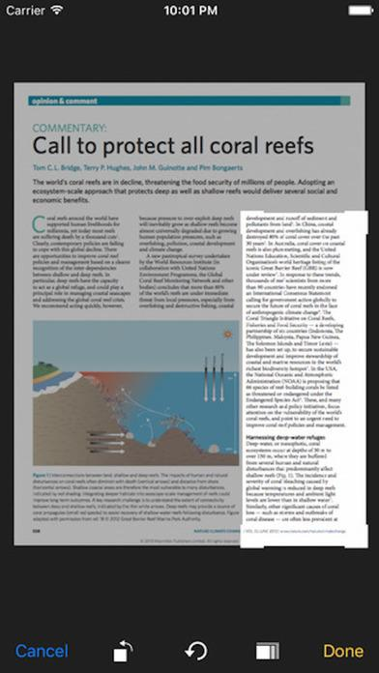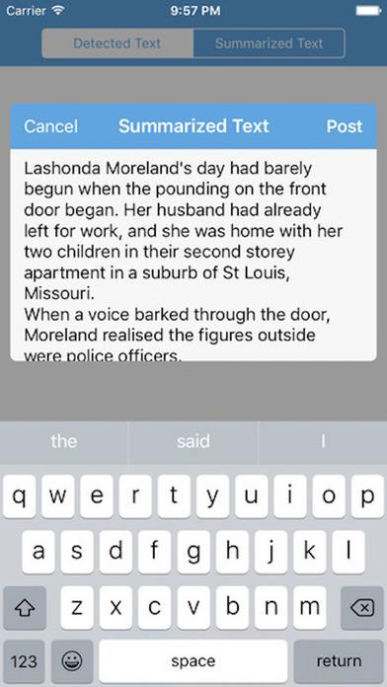

*1 - Screenshots of summarize mobile application on the iOS.*

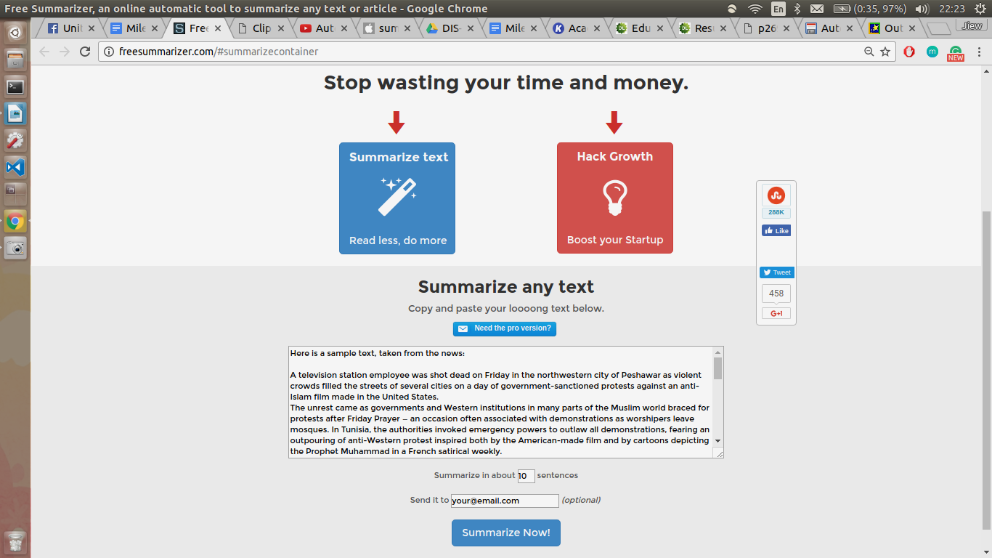

*2 - Screenshots of free summarizer website*





*3 - Screenshots of Clipped mobile application on iOS.*

1. **Example of Survey Result**

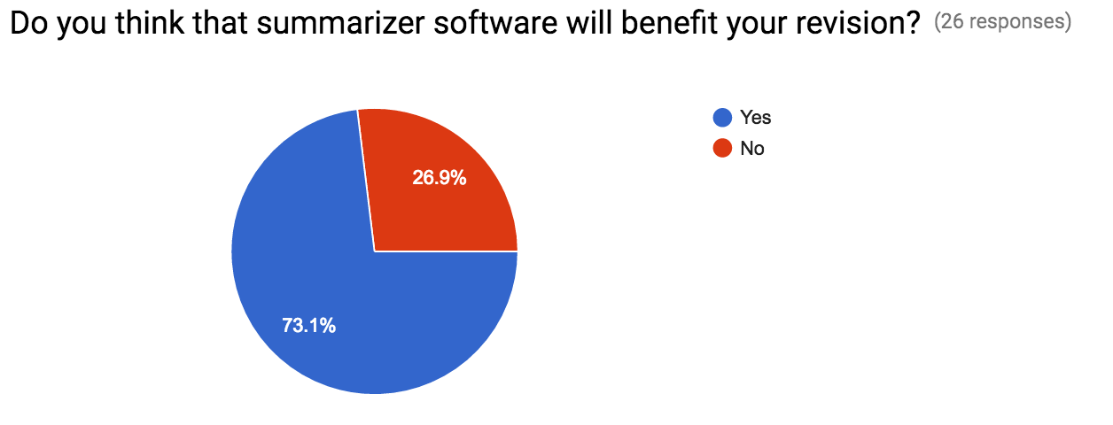

*4 – Statistical analysis of survey responses regarding potential demand for the system*

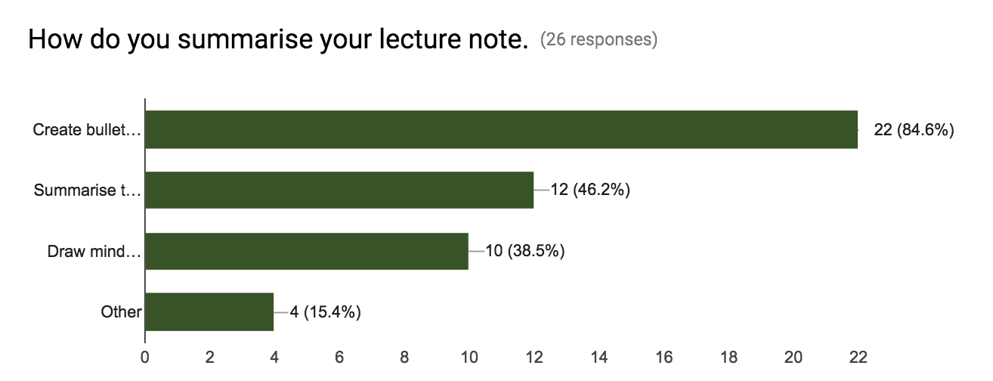

*5 – Statistical analysis of survey regarding revision techniques currently utilised*

1. **Table of requirement**

### **Functional Requirements**

|  |  |  |
| --- | --- | --- |
| Requirements 1 - File Transfer | | |
| 1.1 | **Upload file** | Authors: Darien, Pornpanit |
| The user must be able to upload or drag and drop file to the system. Only one file is accepted at a time. | Priority: HIGH |
| Dependencies: 8.1 |
| Source: Existing system and Questionnaire |
| 1.2 | **Export to computer** | Authors: Pornpanit |
| Export the summarized file onto their own computer. The exported file can have pdf or word format. | Priority: HIGH |
| Dependencies: 8.2 |
| Source: Proposal |
| 1.3 | **Export to google drive** | Authors: Sam |
| Export the summarized file onto the “google drive” external file storage. | Priority: LOW |
| Dependencies: 8.2 |
| Source: Existing system |
| 1.4 | **Export to dropbox** | Authors: Sam |
| Export the summarized file onto the file hosting service “Dropbox”. | Priority: LOW |
| Dependencies: 8.2 |
| Source: Existing system |
| 1.5 | **Display details of export file** | Authors:  Pornpanit |
| Should display details of the file e.g., file name and size of file. | Priority:  MEDIUM |
| Dependencies: 1.1 |
| Source: Existing system |
| 1.6 | **Print the file** | Authors: Alex |
| The system may be able to print summarized file. | Priority:  LOW |
| Dependencies:  2.8 |
| Source: Existing system |
| Requirements 2 - Summarization | | |
| 2.1 | **Summarize text** | Authors: Darien, Sam |
| The system should be able to recognize text and summarize it. | Priority: HIGH |
| Dependencies: 1.1, 2.6 |
| Source: Questionnaire |
| 2.2 | **Migrate images to summary** | Authors: Sam, Pornpanit |
| The system should be able to recognize images in the slides and migrate them to the summary. | Priority: LOW |
| Dependencies: 1.1 |
| Source: Questionnaire |
| 2.3 | **Migrate code to summary** | Authors: Sam |
| The system should be able to recognize computer code and insert that into the summary. | Priority: LOW |
| Dependencies: 1.1 |
| Source: Questionnaire |
| 2.4 | **Migrate math functions to summary** | Authors: Sam |
| It should be able to recognize mathematical functions and insert them onto the summary. | Priority: LOW |
| Dependencies: 1.1 |
| Source: Questionnaire |
| 2.5 | **Summary headings** | Authors: Sam |
| The system should directly create headings for the different sections of the summary. | Priority: MEDIUM |
| Dependencies: 1.1 |
| Source: Academic paper |
| 2.6 | **Select summary proportion** | Authors: Darien |
| The user must be able to choose how condensed they want their summary. The different options are: low, medium and high.. | Priority:  LOW |
| Dependencies: NONE |
| Source: Existing system |
| 2.7 | **Cancel summary process** | Authors: Pornpanit |
| The user must be able to cancel the summarization process. After cancelling it should take the user back to the main page. | Priority: LOW |
| Dependencies: 2.1 |
| Source: Existing system |
| 2.8 | **Display finished summarise note** | Authors: Pornpanit |
| Must display summarised text on one side of dual display and ready for the user to edit text. | Priority: HIGH |
| Dependencies: 2.1 |
| Source: Proposal |
| 2.9 | **Start over** | Authors: Sam |
| Once the summary has been made and exported the user must be able to directly go back to the main screen in order to generate a new summary. | Priority: MEDIUM |
| Dependencies: 2.1 |
| Source: Existing system |
| Requirements 3 - Editing | | |
| 3.1 | **Edit summary** | Authors: Sam |
| The user should be able to make any changes to the automatically generated summarized notes. | Priority:  HIGH |
| Dependencies: 2.9 |
| Source: Academic paper |
| 3.2 | **Edit font style** | Authors: Pornpanit |
| Should allow the user to change font style of the text e.g., title, subtitle, heading and paragraph. | Priority:  MEDIUM |
| Dependencies: 3.1 |
| Source: Existing system |
| 3.3 | **Edit font size** | Authors: Pornpanit |
| Should allow the user to change size of the text. | Priority:  MEDIUM |
| Dependencies: 3.1 |
| Source: Existing system |
| 3.4 | **Edit font color** | Authors: Pornpanit |
| Should allow the user to change color of the text. | Priority: MEDIUM |
| Dependencies: 3.1 |
| Source: Existing system |
| 3.5 | **Edit font attribute** | Authors: Pornpanit |
| Should allow the user to change attributes of the text e.g., bold, italic and underline. | Priority: MEDIUM |
| Dependencies: 3.1 |
| Source: Existing system |
| 3.6 | **Bulleted and numbered list** | Authors: Pornpanit |
| Should allow the user to insert bulleted or numbered list on the note. | Priority: LOW |
| Dependencies: 3.1 |
| Source: Existing system |
| 3.7 | **Dual display** | Authors: Pornpanit |
| Must display both summarized note and original content from uploaded file on the same page. | Priority:  HIGH |
| Dependencies: 3.1 |
| Source: Existing system |
| 3.8 | **Proportional Scroll** | Authors: Sam |
| On the dual display interface, while scrolling through the original notes or the summary, both files should show scroll at the same time so that both display the same information. | Priority:  LOW |
| Dependencies: 3.1, 3.7 |
| Source: Proposal |
| 3.9 | **Save changes of summarized notes** | Authors: Pornpanit |
| While editing the notes the user should be able to save any changes made. | Priority: HIGH |
| Dependencies: 3.1 |
| Source: Existing system |

*6 – Table of Functional Requirements*

### **Non Functional Requirements**

|  |  |  |
| --- | --- | --- |
| Requirements 4 -  Performance | | |
| 4.1 | **Response time to user request** | Authors:  Pornpanit |
| Must respond to the user request no more than 1 seconds. | Priority:  HIGH |
| Dependencies: 5.1 |
| Source: Existing system |
| 4.2 | **Response time to summarise content** | Authors: Pornpanit |
| Must be able to summarise content within 60 seconds. | Priority: HIGH |
| Dependencies: 8.1 |
| Source: Existing system |
| Requirements 5 - Concurrency | | |
| 5.1 | **Multiple users** | Authors: Pornpanit |
| Should allow 16,000 users to user the system at the same time. | Priority: MEDIUM |
| Dependencies: NONE |
| Source:  Existing system |
| Requirements 6 - Availability | | |
| 6.1 | **Service hours** | Authors: Pornpanit |
| The service should be fully operational for 95% of the service hours. | Priority: MEDIUM |
| Dependencies: NONE |
| Source: Existing system |
| Requirements 7 - Usability | | |
| 7.1 | **User Interface** | Authors: Pornpanit |
| Components (e.g., buttons, headings, error messages) on the web page are simple to understand, learn and navigate. | Priority: MEDIUM |
| Dependencies: 7.2 |
| Source: Existing System |
| 7.2 | **Error messages** | Authors: Pornpanit |
| Should display error message if any input is invalid or the system fail to proceed. | Priority: MEDIUM |
| Dependencies: NONE |
| Source: Existing System |
| Requirements 8 - Compatibility | | |
| 8.1 | **Uploaded file Compatibility** | Authors: Darien |
| Must be compatible with uploads of PDF, Word or PowerPoint file format. | Priority: HIGH |
| Dependencies: NONE |
| Source: Questionnaire |
| 8.2 | **Export file Compatibility** | Authors: Darien |
| Must be compatible of creating and exporting files for user download in either PDF or Word file format. | Priority: MEDIUM |
| Dependencies: NONE |
| Source: Questionnaire |

*7 – Table of Non-Functional Requirements*

**Changes of functional requirement**

|  |  |  |
| --- | --- | --- |
| 1.5 | **Share file through email** | Authors: Pornpanit |
| Along with the different export settings, the user should also be able to share the summarized notes to different e-mails. | Priority: MEDIUM |
| Dependencies: 1.2 |
| Source: Existing system |

This functionality is now ***removed***. The evidence, i.e. user feedback, showed that most users prefer to export the file to computer, Google Drive and Dropbox rather than sharing to other users through email.

|  |  |  |
| --- | --- | --- |
| 2.5 | **Summary highlighting** | Authors: Sam |
| Important parts should be highlighted in a fluorescent color. | Priority: MEDIUM |
| Dependencies: 2.1, 3.1 |
| Source: Academic paper |

Based on the result of discussion in the team decided that this functionality is ***removed***. There are many user cases should be considered and it is difficult to meet all user’s needs. For example, if the system automatically highlights only the definition, it could be unnecessary for the users, they have to spend more time on editing the text.

|  |  |  |
| --- | --- | --- |
| 2.7 | **Select summary proportion** | Authors: Darien |
| The user must be able to choose how condensed they want their summary. The different options are: compressed, average and dense. | Priority:  LOW |
| Dependencies: 2.1 |
| Source: Existing system |

The functionality is ***changed*** from indicating the percentage to the given 3 choices - Low, Medium and High. For example, if the user selects 0%, it means that the system will not do any summarization on the uploaded file.

|  |  |  |
| --- | --- | --- |
| 2.9 | **Display finished summarise note** | Authors: Pornpanit |
| Must display summarised text before editing or exporting it. | Priority: HIGH |
| Dependencies: 1.6 |
| Source: Proposal |

The user interface to show finished note is now removed due to the latest user feedback, the system will display the finished note and allow the user can edit the summary at the same time. This reduce the number of user interaction on the system and avoid confusing. This functionality is now **changed** to meet the user’s needs.

|  |  |  |
| --- | --- | --- |
| 1.6 | **Print the file** | Authors: Alex |
| The system may be able to print summarized file. | Priority:  LOW |
| Dependencies:  2.8 |
| Source: Existing system |

|  |  |  |
| --- | --- | --- |
| 3.6 | **Bulleted and numbered list** | Authors: Pornpanit |
| Should allow the user to insert bulleted or numbered list on the note. | Priority: LOW |
| Dependencies: 3.1 |
| Source: Existing system |

Both ***new*** features will be implemented in the system to give more useful and convenient functionality for the user to editing the file and print it when it is completed. Again, these new functionalities are from the latest feedback on the user interface design.

1. **Paper-based prototype**

Below are the initial designs formed for each page of the website application, the first low fidelity paper-based prototype:

#### **Page 1 - Upload a file**

The first page of the web application, allowing the user to upload a file, with some additional functions to manipulate the file (i.e. format of the summarized notes, e.g. bullet points, pages of the document to be summarized, etc.):

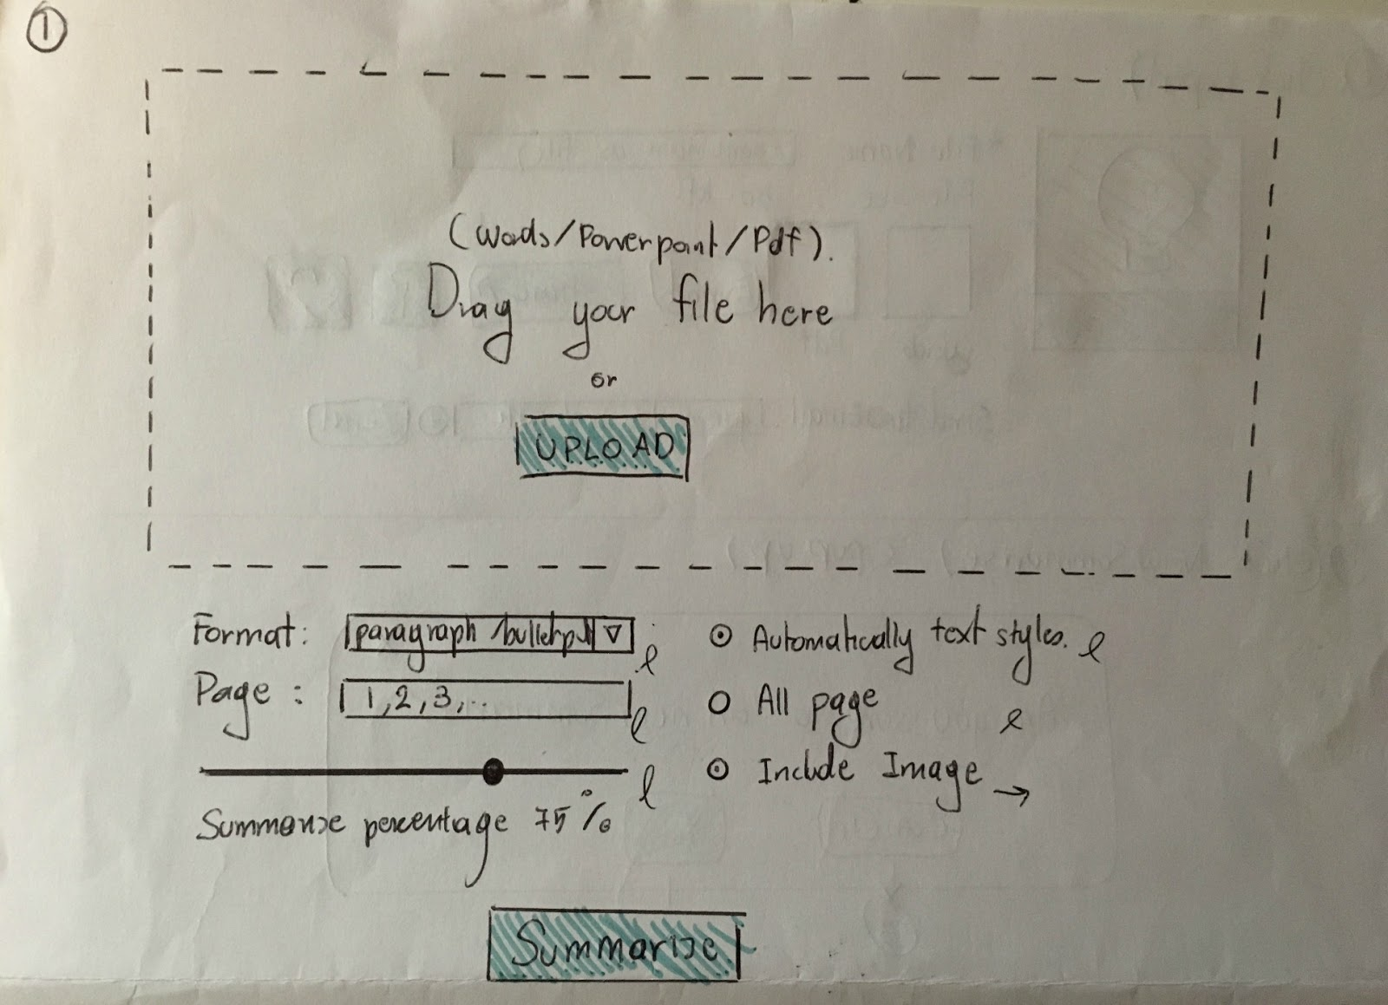

Providing the option to either manually upload a file, using the ‘upload’ button, or to simply drag and drop a file to the box. Below the main box there are a plethora of options allowing the user to adapt their summarized notes.

Elements such as drop-down menu’s and radio button will be utilized to allow the user to interact with the application, selecting the necessary functions. The drop-down menu’s, enables for the choice of format, whether the text be summarized into paragraphs or bullet points. The radio buttons allow for the user to select whether or not images are included, and selecting ‘Automatically text Styles’, the algorithm will be able to recognise headings, titles, subtitles, and paragraphs. The slider allows the user to select the percentage of the document to be summarized. Finally, the summarize button, will begin the process of summarization.

**Comparison to existing systems**:

Compared to existing systems currently available, the summarizer application allows for the user to directly upload the necessary file, instead of typing the notes into a designated area (Free Summarizer). Furthermore, the application allows for a percentage of the document to be selected instead of stating a number of sentences (Free Summarizer). On the other hand, a feature influenced by the existing mobile application, Clipped, is the option to allow the user to format the text into bullet points, helping to adjust to user’s different learning styles.

**Suggested Edits:**

Highlighted in the user feedback was the suggestion to remove the feature that allows for users to select to include images in the final. Instead all images will be included, but the user is able to remove any images they wish to on the ‘Edit’ page of the application. Another number input field of summary proportion should be added, so the user can use either slider or this field.

#### **Page 2 - Progress of summarization**

Displayed on this page is a progress bar, demonstrating the progression of the summarization to the user.

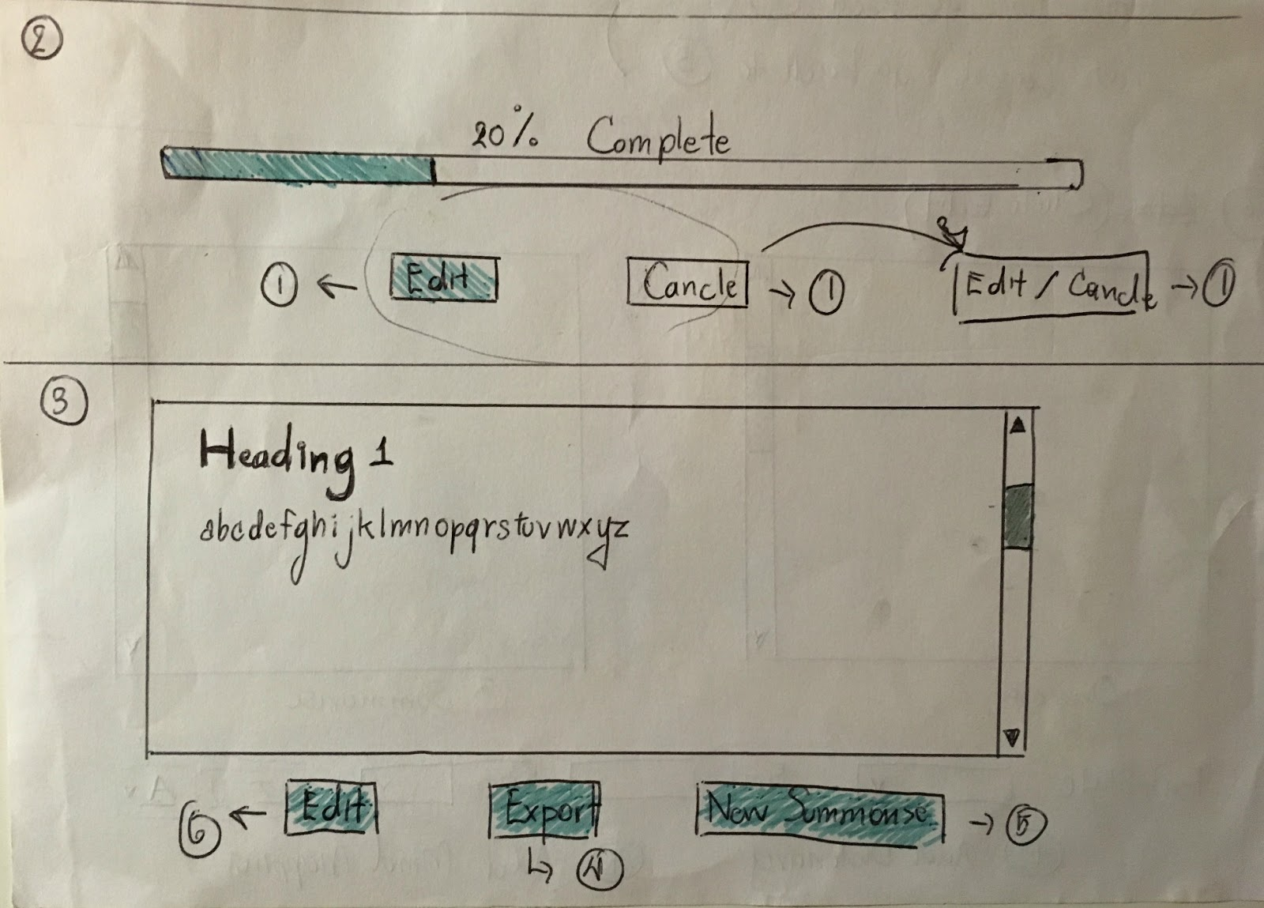

The two elements on this page are buttons, the ‘Edit’ button enables the user to revisit the previous page, to modify the document or the settings. Additionally, the ‘Cancel’ button also takes the user back to page one to upload another document, however selecting this button will cancel the existing document, with the user being required to upload another document.

**Comparison to existing systems**:

Comparing to the existing systems viewed, this feature has not been incorporated. Users would benefit from this feature, allowing them to view the progression of the summarization process for their document.

**Suggested edits:**

Firstly, the misspelling of ‘Cancel’ on the button was brought to attention. Moreover, it was suggested in the user feedback for the two buttons to be combined together, as both have almost identical functionality. As a result, the amended button will return the user to page one, with the document and details is remembered.

#### **Page 3 - Edit the note**

Allows the user to adjust the summarised note before it is exported.

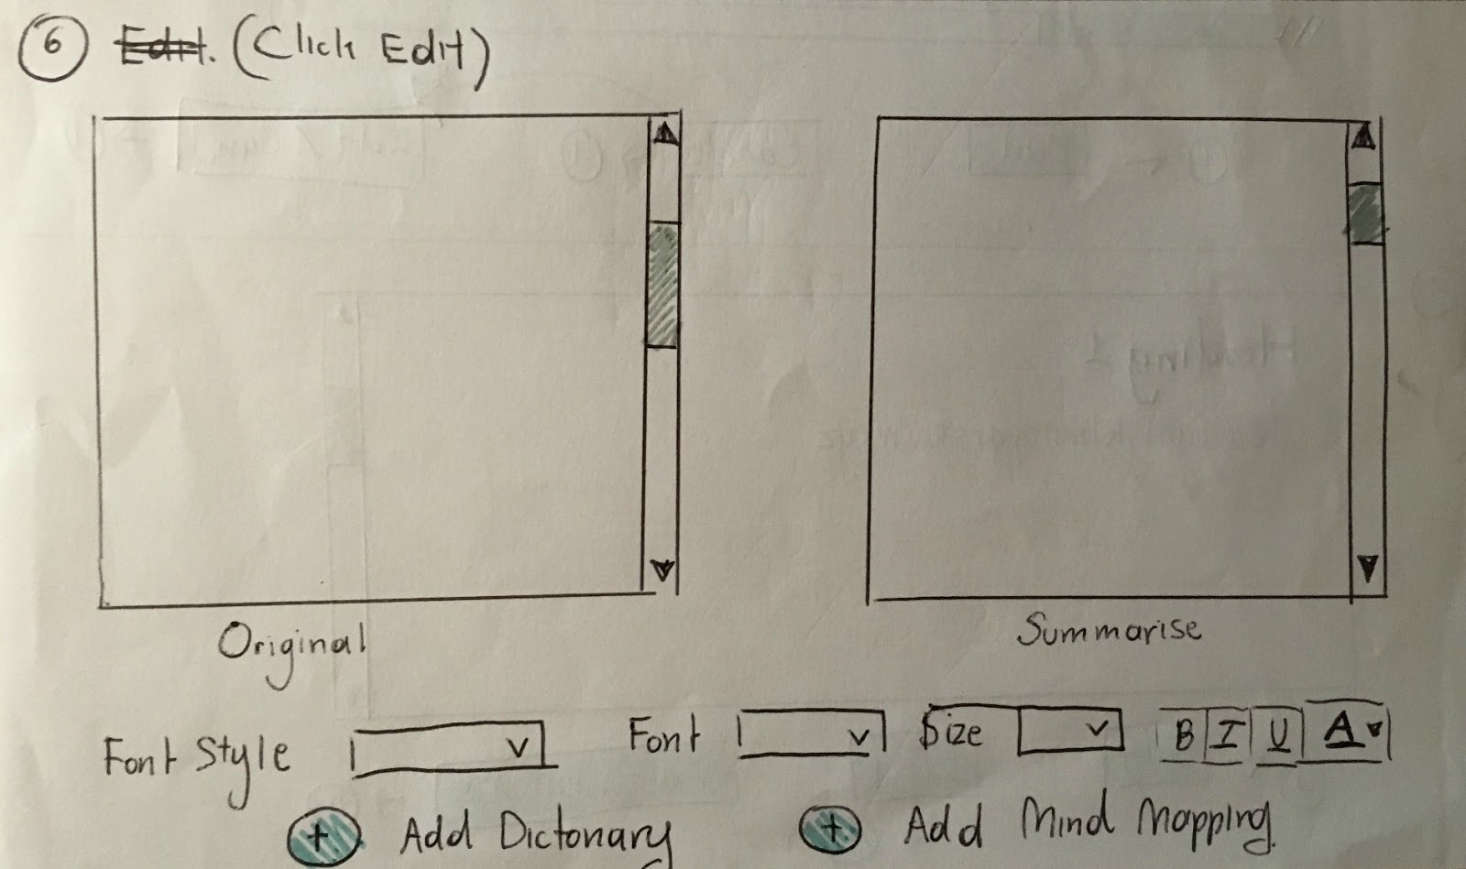

This page displays the original file to the left of the page, with the summarised notes on the right. Allowing the user to check the new summarised notes against the original file. The elements at the bottom of the page enable the user to edit the font style, size, attribute (bold, italic and underline), colour and highlight.

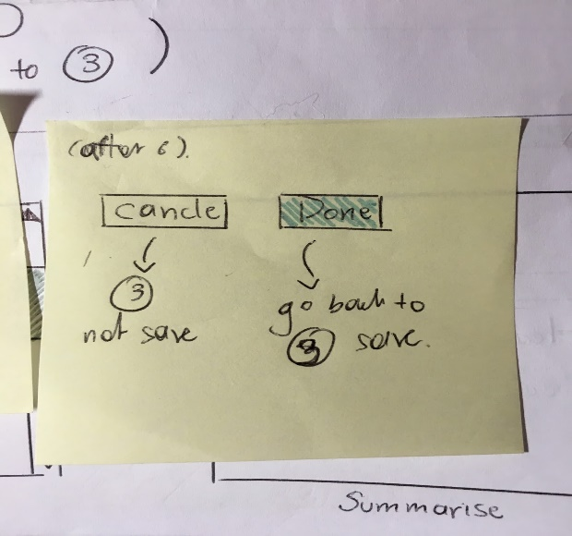

Beneath the editing features are two buttons, by selecting the ‘Cancel’ button the user will be taken to the ‘Show the finished note’ page without any changes being saved. However, by selecting the ‘Done’ button, the user will be taken to the same page but any modifications will be saved.

**Comparison to existing systems**:

Influenced by the mobile application ‘Summarize’, the functionality to allow the user to manipulate the aesthetic of the text has been incorporated. Nonetheless there have not been any existing systems that presents the original text next the summarized notes, this will be beneficial to the user as they will be able to easily compare the two documents, seeing if anything is missing.

**Feedback and suggested changes for prototype:**

Following the feedback both the ‘Add Dictionary’ and ‘Add Mind Mapping’ buttons have been removed, as they do not meet the user requirements. Text on the cancel button is misspelled, and is replaced with ‘Reset’.

#### **Page 4 - Show the finished note**

The purpose of this page is to display the finalised note, allowing the user to edit the text. Once finalised the user is able to export the file, or initiate a new summarization.



The finalised note is displayed within textbox, resizing accordingly with the use of a scrollbar to the right of the box. Three buttons are positioned beneath the textbox, the ‘Edit’ button will take the user to a previous page to edit the notes further, whereas the ‘Export’ button will confirm the summarization and export the note. Finally, the ‘New Summarise’ button takes the user back to the first page to begin a new summary.

**Comparison to existing systems**:

‘Free Summarizer’ software has this feature to show the output of the process. However, the user may not satisfy the result. Editing option should be added similar to ‘summarize’ mobile application.

**Suggested Edits:**

Following some suggestions, the button ‘New Summarise’ has been removed. Instead the user can begin a new summary after progressing to the final page.

#### **Page 5 - Export the note**

The final page enables the user to export their file. With the option of the file type to export to, as well as the ability to share the notes via Social Media or email.

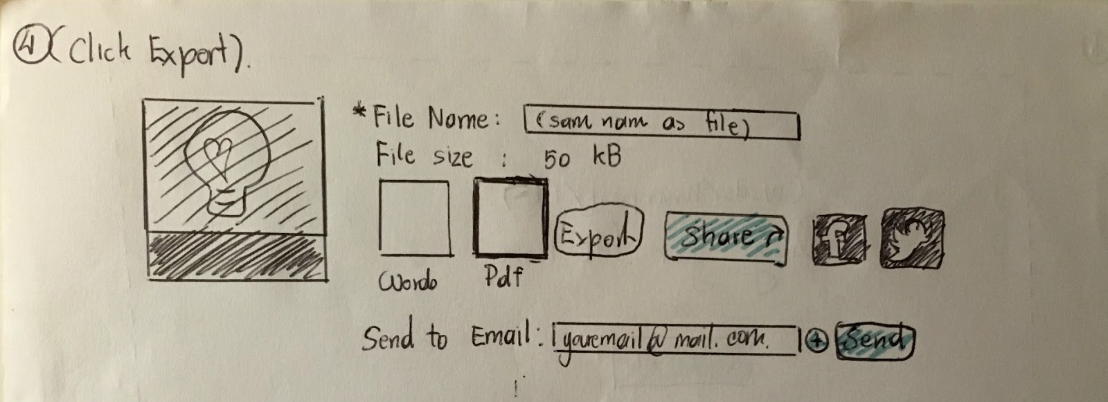

There is a plethora of elements included in this page. Firstly, the file name, initially this will be the same as the name of the file uploaded, nonetheless the user is able to adapt this. Additionally, the user is able to choose what file type they wish to export their file as, with the size of the file also being stated. The Social media buttons (Facebook and Twitter), allow the user to share the file via social media. Additionally, the user has the option to share the summarized notes via email, this is not just limited to one email address.

**Comparisons to existing systems**:

Similarly, to the ‘Free Summariser’ application, the ability to send the notes via email, however that existing system does not allow the user to send to multiple email addresses like our application. The rest of the components have been derived from the user requirements.

**Suggested Edits:**

As suggested in the feedback from the users, instead of an image of a file the icons representing word and pdf documents should be used instead to represent the file types. Another button should be included that allows the user to begin a new document summary.

#### **Page 6 - Dialog prompt**

A message prompt to notify the user that they will be moving away from the current page, and will lose their current summarized notes.

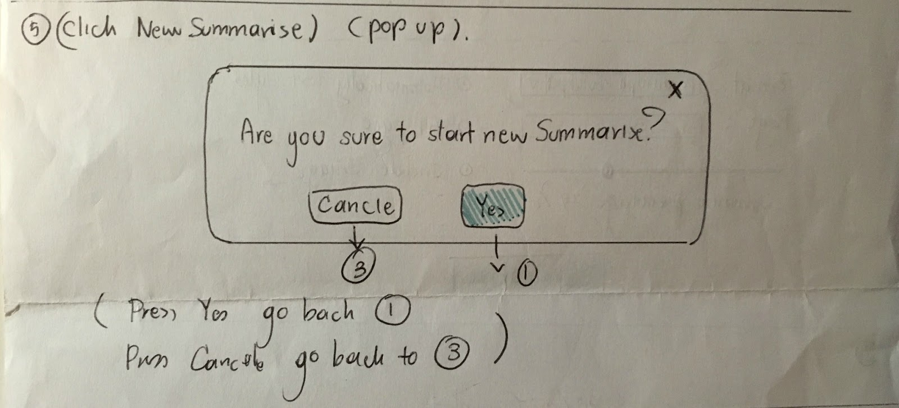

**Comparison to existing systems**:

Current systems have not included this feature, by incorporating this element it will help to prevent the user from accidentally losing any work.

**Suggested Edits:**

As highlighted there is a spelling mistake on the cancel button.

## **Overall feedback and changes of initial prototype:**

To conclude all pages should include a banner at the top of the page, this will also display the name of the application, in addition to displaying the current stage of the summarization process. Moreover, when designing the next prototype an appropriate colour scheme needs to be chosen.

1. **Second low-fidelity prototype**

Below are the designs created for the second low-fidelity prototype of the web application, created with the software application JustInMind:

#### **15356826_1323940784325264_1306958481_n.pngPage 1 -Upload the file**

**Feedback:**

The initial page that a user will see, the ability to simply drag and drop a file to summarize was highlighted as a very beneficial element by several users. On the other hand, several users noted feeling some confusion on how to utilize the application, with little text on the page to describe the purpose as well as no instructions. Also, suggesting the use of mouse over help aids, to describe the functionality of elements. Additionally, some of the potential users expressed confusion in how selecting a percentage of work to summarize would work, instead suggesting to change it to the options of small, medium, or large. Another concern expressed was the format of the summarization, and how images and mathematical images are included.

**Changes to the prototype**:

For the next prototype ensure that information regarding the acceptable file formats, as well as the maximum file that will be accepted by the application. Also, change the percentage selection to instead allow the user to select between small, medium, or large, for the proportion of summarization. Finally, remove the option ‘Summarize format’, due to an update in the user's requirements.

#### **Page 2 - Progress of summarization**

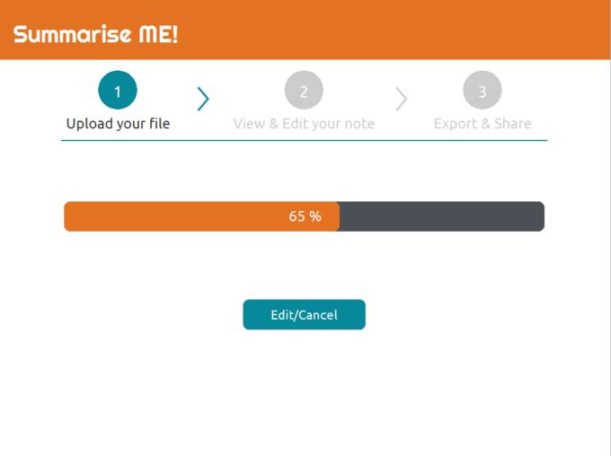

**Feedback**:

There were some mixed views about this page, some users thought it was simplistic with no changes necessary, whereas other thought it was redundant. Suggesting that the progress bar could be displayed in the drag and drop file box on the first page, some questioned why a new page was required for it. Moreover, some users suggested that instead of displaying the percentage complete, instead display the time left till the summarization is complete. Also, there was some confusion with the regard to the functionality of the ‘Edit/cancel’ button, this element needs to be changed for the next prototype.

**Changes to the prototype**:

Many of the users commented that this page was unnecessary, however suggesting to keep the feature but incorporate it into the initial page of the application. Also, changing the text of the button to ‘Cancel’ instead.

#### **15356083_1323941854325157_203043419_n.pngPage 3 - Show the finished note**

**Feedback**:

There was some confusion between this page, and the following edit page, as the functionality of this page is also available to the user at the subsequent page. There was the suggestion to include a ‘Cancel’ button to allow the user to return to the initial page if the wrong document was accidentally uploaded. Also, a suggestion was made in regard to the size of the text box, it should occupy a larger proportion of the screen, even including a scrollbar.

**Changes to the prototype**:

Strongly suggested by most users interviewed, the functionality of this page can be combined with editing page. With many users expressing some confusion as to the purpose of this page. It was strongly suggested to remove this page.

#### **15355939_1323949710991038_396390996_n.pngPage 4 - Edit the note**

**Feedback**:

Overall this page was very popular with the potential users, with many expressing how handy it is to present the original file next to the summarized notes, allowing for easy comparison of the pieces of text. However, it was suggested that the focus should be more so on the summarized notes, as this is what the user would be more interested in. Instead having the original file viewable upon the user's request.

Additional features were suggested, for example an undo, and redo button should be included, as well as the option to include bullet points. Also, it was suggested to move the editing options to above the text box.

**Changes to the prototype**:

The summarized note should occupy the whole page, with a button to display or hide the original document. Moreover, additional editing options should be included (i.e. bullet points, numbered lists, highlighter, undo, and redo buttons). Also, incorporating a scrollbar into the text box.

#### **15319335_1323946050991404_1210751231_n.pngPage 5 - Export the note**

**Feedback**:

Cluttered with unnecessary elements, majority of the users interviewed, expressed no interest in sharing notes to social media platforms such as Facebook, or Twitter. Moreover, many did not see the necessity of having the email option. On the other hand, the ability to save the notes to a Google Drive would be very beneficial. Furthermore, other suggestions include the option to print notes, as well as having the option to preview the final document.

**Changes to the prototype**:

Following the suggestions in the feedback, the email, Twitter, and Facebook features will be removed due to a change in requirements. Replacing with the option to export to Google Drive and Dropbox instead. In addition to allowing the user to directly print notes from the application.

#### **15300601_1323947587657917_196485404_n.pngPage 6 - Dialog prompt**

**Feedback**:

Few comments were made about this feature, however users expressed an interest, especially as this would prevent accidental loss of a summary. The grammatical error in the question was also brought to attention.

**Changers to the prototype**:

Change the question to “Are you sure you wish to start a new note summary?”.

**Overall**

**Feedback**:

In addition to receiving feedback for each individual page, feedback regarding the application was also collected. These are suggestions that may be applicable to several of the pages. Nonetheless, there were some contradictions found between some of the user feedback.

With regards to the aesthetics of the application, the colour scheme chosen did not appeal to all users, with comments of it looking more childish than professional. On the other hand, some users liked the colour scheme. A similar view was expressed with the font utilized, suggesting a change in the font.

Many found the incorporation of the progress bar at the top of every page to be of great use, helping the user to know what stage they are currently at. Nonetheless, the size of the element was an issue, therefore reducing the size would allow for other elements to be included. Many users suggested the need for a help function, present on every page, providing helpful guidance to any confused users.

**Changes to the prototype**:

Following the feedback received from potential users, amendments have been made ready to develop the following prototype.

Adapting the user interface, with the aid of utilizing a grid system will help to streamline the pages of the application. Also, helping to organise the position of the elements on the page. Furthermore, both the colour scheme and font style should be adapted, giving the application a more professional finish and ensuring the text is easily legible for all users. Additionally, the size of the banner at the top of the page should be reduced in size, with the progress bar being removed altogether. Instead helpful aids will be included on the initial page of application to guide the user through the process.

Finally, the new prototype should display error messages to illustrate to the user the problem that has occurred, alongside how to resolve the issue.

1. **High Fidelity Prototype Sketches**

#### **Page 1 - Upload the file**

**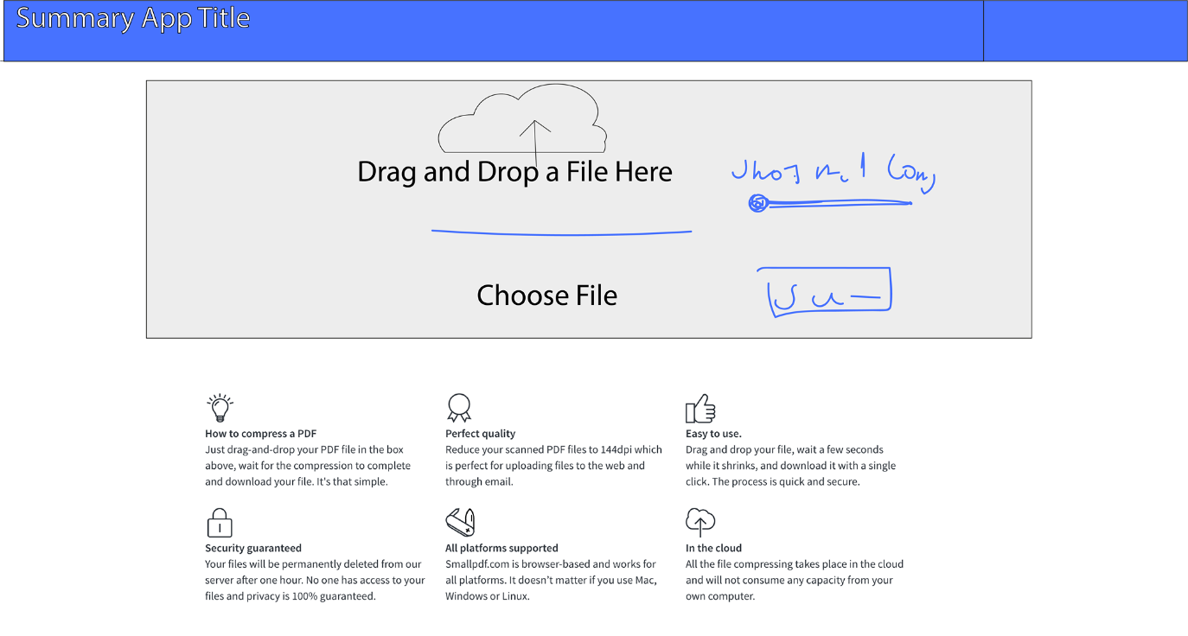**

#### **Page 2 – Edit Summary**

**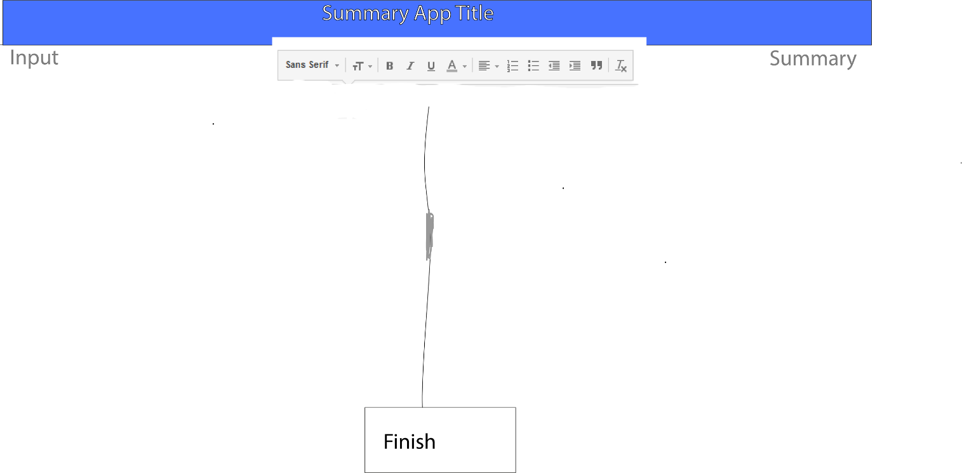**

#### **Page 3 – Export summary**

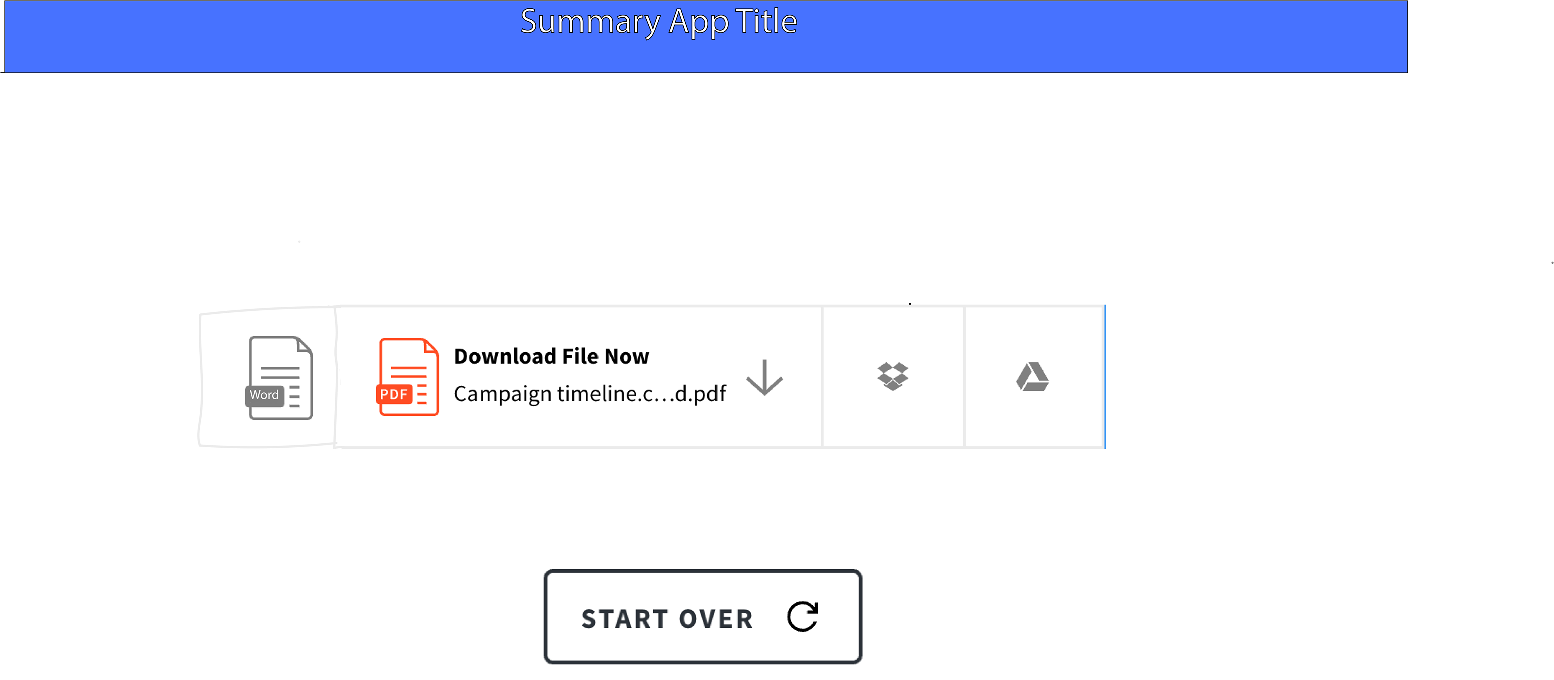

1. **High Fidelity Prototype**

#### **Page 1 - Upload the file**

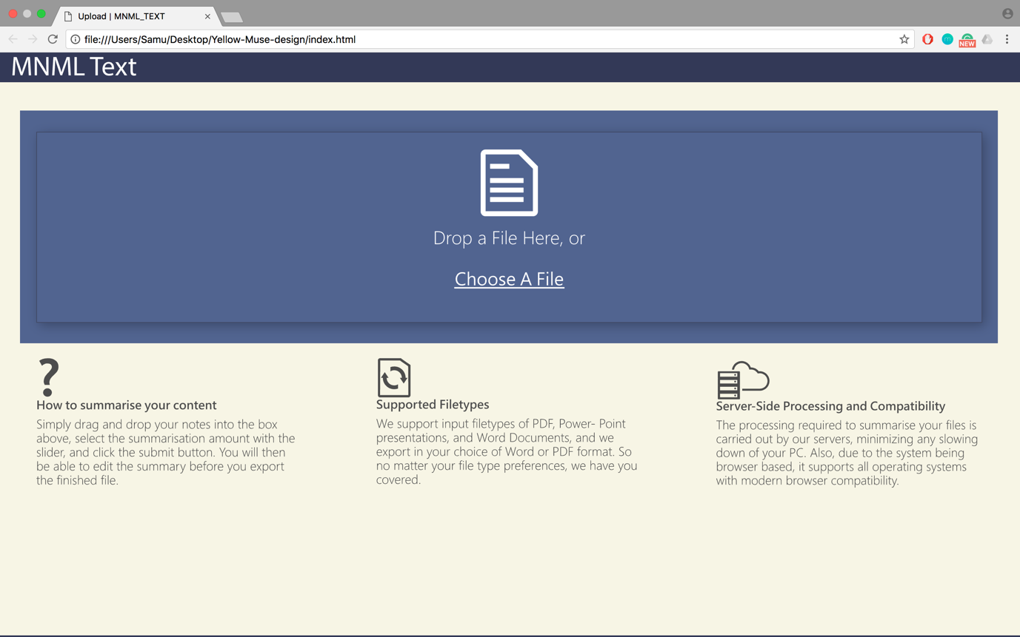

**Feedback**:

Users found it really clear to understand how the system worked as we have useful instructions right on the page. Some observed that the upload button was too large, however, this will be really convenient for when users can drag and drop files onto the system.

Due to the limited functionality the users could not fully interact with the system, therefore, some of them did not understand how it would fully work

**Changers to the prototype**:

For the next prototype we will include more functionalities such as dragging and dropping files and selecting the proportion of text you want summarised.

#### **Page 2 – Edit Summary**

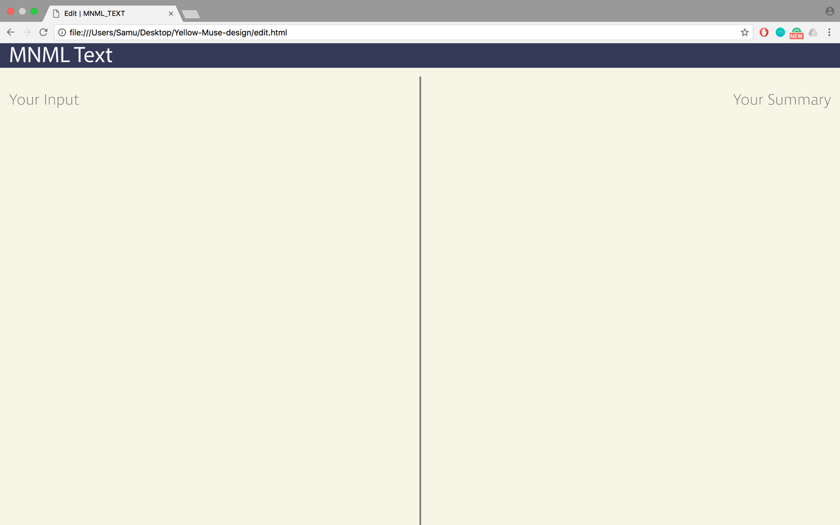

**Feedback**:

Due to the limited functionality of the system we were not able to display how the original notes and summary would look like. Nevertheless, most users liked the clean design.

We were lacking some major functionalities such as the ability to edit and format the text of the summary.

As the finish button was outside of the main page users struggled to move onto the export page of our system.

**Changers to the prototype**:

We will reshape the design so that all the content fits in one page.

Furthermore, we will add missing functionalities such as the display and edit of notes so that users can properly interact with our system and give better feedback

#### **Page 3 – Export summary**

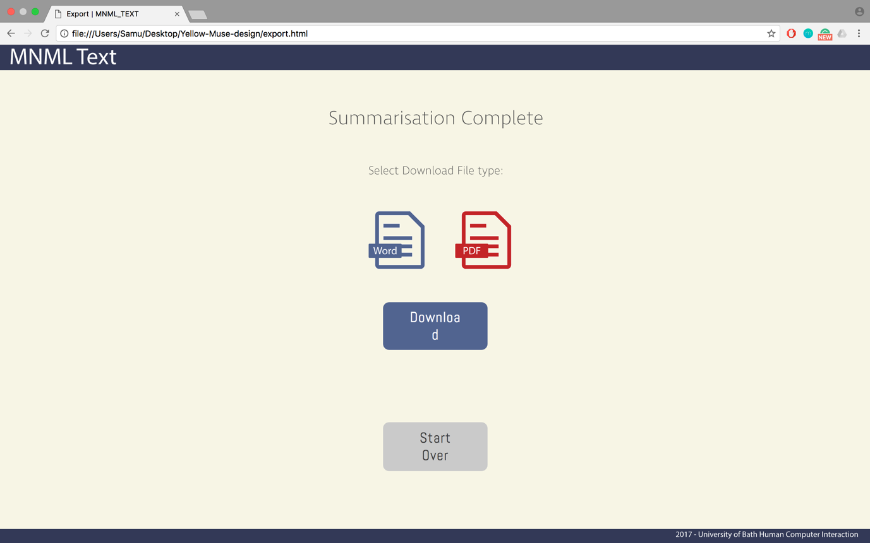

**Feedback**:

The main report was of course that the Download button wasn’t displayed properly.

The users found it intuitive to select the file type and knew exactly how they could export it.

**Changers to the prototype**:

We will reshape the download button so it is displayed properly.

**References**

* Anon. Free Summarizer [computer program]. [*http://freesummarizer.com/#summarizecontainer*](http://freesummarizer.com/#summarizecontainer) [Accessed 11/11/16].
* Bauer, A. and Koedinger, K., 2006. Evaluating the effect of technology on note-taking and learning. *Proceedings in CHI '06 Extended Abstracts on Human Factors in Computing Systems* *(CHI EA '06)*, 22-27 April 2006 Montréal. New York: ACM, pp.520-525.
* Clipped. *Clipped* (v.2.1) [Computer Program]. [*https://itunes.apple.com/us/app/clipped/id583616193*](https://itunes.apple.com/us/app/clipped/id583616193)[Accessed 13/11/16].
* Daiute, C. (1986). Physical and Cognitive Factors in Revising: Insights from Studies with Computers. *Research in the Teaching of English,* *20*(2), 141-159. Retrieved from <http://www.jstor.org/stable/40171074>

## Hexatech slay. *summarize - Free summary any document or file summize* (v.1.4.1) [computer program].[*https://itunes.apple.com/us/app/summarize-free-summary-any/id1101662797?mt=8*](https://itunes.apple.com/us/app/summarize-free-summary-any/id1101662797?mt=8) [Accessed 11/11/16].

* Inderjeet, M. , House D. , Klein, G. , Hirschman, L. , Firmin T. and Sundheim, B. , 1999. The TIPSTER SUMMAC Text Summarization Evaluation. *EACL '99 Proceedings of the ninth conference on European chapter of the Association for Computational Linguistics*, 8-12 June 1999 Bergen. Stroudsburg, PA: Association for Computational Linguistics. Pages, pp.77-85.
* Simon, B., Davis, K., Griswold, W.G., Kelly, M. and Malani, R., 2008. Noteblogging: taking note taking public. *Proceedings of the 39th SIGCSE technical symposium on Computer science education (SIGCSE '08)*, 12 - 15 March 2008 Portland. New York: ACM, pp.417-421.
* The Pennsylvania Higher Education Assistance Agency, n.d. *Self-Assessments* [Online]. Harrisburg, PA. Available from: [*http://www.educationplanner.org/students/self-assessments/index.shtml*](http://www.educationplanner.org/students/self-assessments/index.shtml)[Accessed 12/11/2016].
* Yu, T. and Jo, I.H., 2014. Educational technology approach toward learning analytics: relationship between student online behaviour and learning performance in higher education. *Proceedings of the Fourth International Conference on Learning Analytics And Knowledge*, 24-28 March 2014 Indianapolis. New York: ACM, pp.269-170.