STEPS to FOLLOW in the goal to get access to iMMAP Training Chanel

(Videos, Documentation)

1. Disconnect from TEAMS if already connected
2. If Having Team already installed, please download and install it, or connect online by following this link : <https://www.microsoft.com/en-ww/microsoft-teams/log-in>

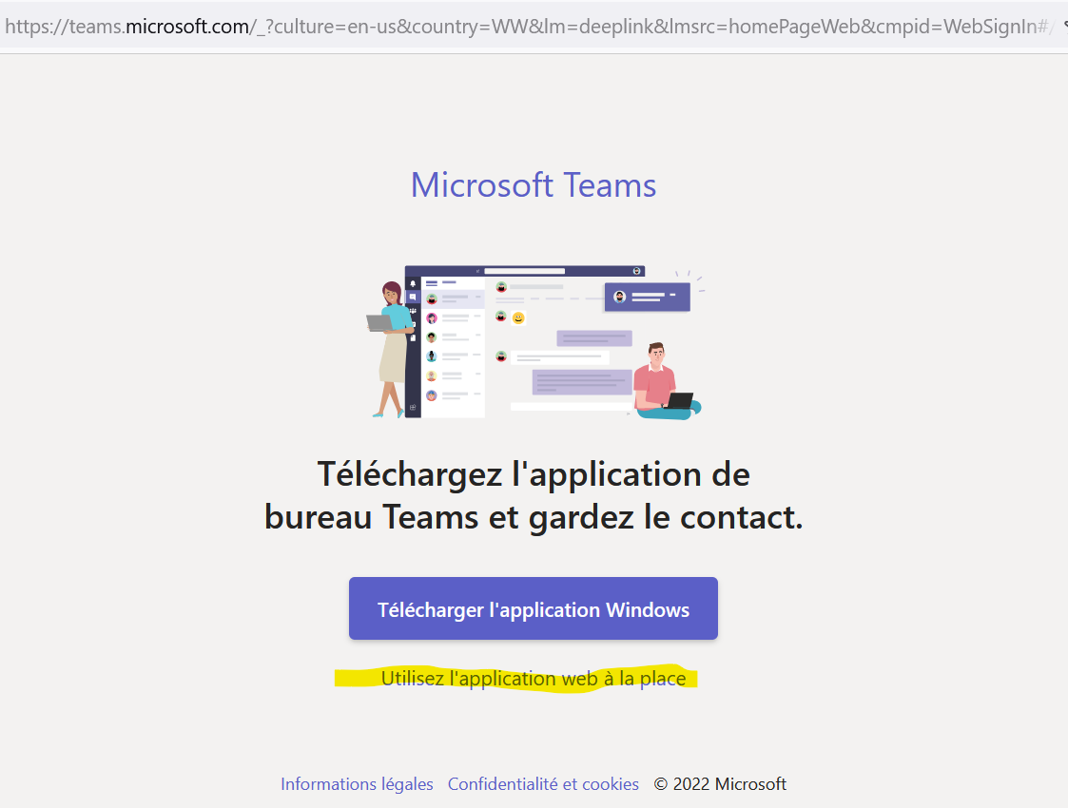

1. Click on Sign-in

1. Provide your account (email) and then your password

1. Choose “iMMAP (Guest)” or iMMAP (Invité)” under the dropdown menu

1. And then continue (You could have a similar window or not, depending if you used to connect on TEAMS or not)

1. You may have the following

Click on **“KOBO Advanced”**, then on **“Files”** or **“Fichiers”**. The folder ***[Recordings]*** holds the video of your training days. The folder ***[Librairies]*** holds files.

Click on **“Wiki”** to get useful links.

