

Institute of Engineering

Pulchowk Campus

Lalitpur, Nepal

Semester III OOP project:

**Hotel Management System**

**Submitted to:**

Mr. Daya Sagar Baral

Department of Computer Engineering

**Submitted by:**

Saurav Kunwar (076BCT074)

Sayoush Subedi (076BCT075)

Takshak Bikram Bist(076BCT093)

**ACKNOWLEDGEMENT**

First of all, we would like to thank our teacher Mr. Daya Sagar Baral for teaching us the important concepts of objected oriented programming without which this project would be obsolete. Secondly, we would like to thank our lab teachers Mr. Lok Nath Regmi and Ms. Shanti Tamang for providing the platform for solving the problems using the concepts of object-oriented programming. We would like to thanks IOE, Pulchowk Campus for providing necessary materials.

Last but not least, we would like to thank all our friends and mentors who helped us in this project.

-Saurav Kunwar (076BCT074)

-Sayoush Subedi (076BCT075)

-Takshak Bikram Bist(076BCT093)

**Table of Contents**

1. ACKNOWLEDGEMENTS……………………………………………….1
2. INTRODUCTION…………………………………………………………3
3. OBJECTIVES…………………………………………………………….3
4. EXISTING SYSTEM …………………………………………………….3
5. PROPOSED SYSTEM…………………………………………………….4
6. Description………………………………………………...4
7. System Block Diagram ……………………………………5
8. METHODOLOGY………………………………………………………...6
9. PROJECT SCOPE…………………………………………………………7
10. PROJECT SCHEDULE …………………………………………………...

**INTRODUCTION**

In this project, we are going to develop an application called Hotel Management System which as the name suggest will do almost everything a hotel management software need. It will have features such as manage rooms which will add rooms and search for the information of the rooms, and features such as check-in and check-out and search for the information about the person staying in rooms.

**OBJECTIVES**

The following were our objectives while doing this project:

* To learn how to operate as a team while doing projects.
* To implement the concepts of object-oriented programming.
* To learn how to write code efficiently.
* To make an attractive GUI for user interaction.
* To be familiar with the graphical library in C++.

**EXISTING SYSTEM**

At present, there are various similar platform for Hotel Management System developed by tech giants such as ORACLE and others which most of them are web based and have modified additional features and user-friendly GUI.

**PROPOSED SYSTEM**

**Description:**

Upon starting the program, a window will open which will have options such as manage rooms, check in, check out, search costumers and available rooms.

Under **manage rooms** there will be options such as **add rooms** and **search rooms**. And to navigate back an option will be there called **Back to main menu**. Add room will add the room where search room will search the room id and give its details such as if it has ac or not.

**Check in** feature will take the details of costumers such as name and phone number and what room they will stay in.

**Search costumers** will take the name of costumer who are staying in hotel and give the information about them such as phone number and room id.

**Available rooms** feature will take room id as input and will tell if the room is available or not.

Finally, the **Check-out** feature will delete the costumer information.

**System Block Diagram:**

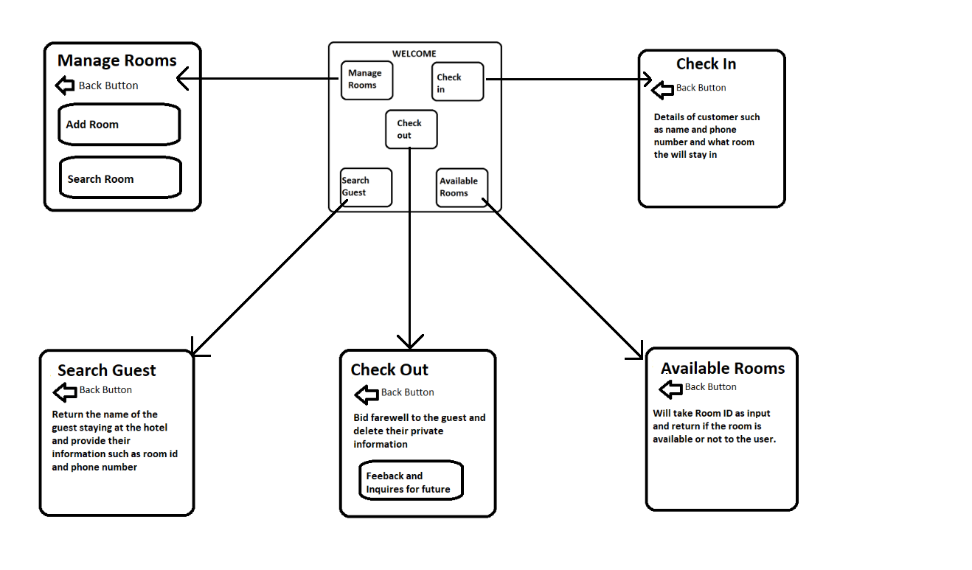

**METHODOLOGY**

This project is based on C++ programming language utilizing “Object Oriented Programming” concept. Hence, different classes will be created with required number of private and public member data and member functions for smooth running of the program preserving the concept of data hiding. The concept of “code reusability”, is used has been utilized. The events for each object will have been handled by the different member functions so that they form a final outlook working together simultaneously.

We will also use the books that are physically available to us or we will use online books. Various technology forums will be visited and will be taken reference from sites such as stackoverflow.

The Compiler, IDE and Operating system that will be used during this project will be MSVC, Visual Studio and Windows 10. Since the platform we are using for GUI is wxWidget, the application will be nearly cross-platform meaning that with a little change of code we can run it in MacOS or any Linux Distro. Since we are using Object oriented paradigm, the coding will be done utilizing all the features of C++ like objects, classes, data abstraction and encapsulation, polymorphism, dynamic binding, message passing etc.

**PROJECT SCOPE**

This project was created in order to fulfill the learn the team work while creating a program. The project will show the level of understanding we have in object-oriented programming and how efficiently we operate as a team.

Project Constrains:

The project constrains will be:

* Lack of time due to assessments
* Use of wxWidget as we are very less familiar with this framework

Project Deliverables:

This project will deliver an application called Hotel Management System which will be very useful for real hotels.

**PROJECT SCHEDULE**