Frontend Web Developer Internship · Week 2
Implementation of Responsive Web Design
Technical documentation for “Northwind Trails”, a mobile-first landing page for a trekking company
Item | Details
Prepared by | Takshak Singhania
Project | Northwind Trails — landing page for a fictional small-group Himalayan trekking company
Technologies | HTML5, CSS3 (Grid, Flexbox, container queries, media queries, clamp(), scroll snap), responsive WebP images
Repository | https://github.com/TakshakSinghania/frontend-internship-week2-responsive-design
Local folder | Frontend-Internship-Tasks/week-2-responsive-web-design
Date | October 2026

1. Assignment Objective
The Week 2 task is to build a website from scratch whose layout adapts gracefully to desktops, tablets and smartphones, using media queries, flexible grids and fluid images. The deliverables are an HTML file, a CSS file that uses advanced CSS features and media queries, and documentation of the methods used, the layout adjustments and examples of how the design changes on different devices.
The evaluation looks at how effective the responsive implementation is, correct use of media queries, the clarity of the HTML, the validity and efficiency of the CSS, and how well the responsive strategy is explained.

2. Project Overview
Northwind Trails is a one-page site for a fictional company that runs small-group Himalayan treks. It is a new project, not a modified copy of the Week 1 page: the content, visual style, layout system and CSS approach are all different.
The page contains a header with navigation, an art-directed hero, a facts strip, a feature list, five trek cards (one featured), a five-day sample itinerary, three group plans, a photo-style gallery, trekker stories, an FAQ, a call-to-action band and a four-column footer.
The sections were chosen so that each one needs a different responsive technique, which makes the page a practical catalogue of responsive patterns rather than one layout repeated with a few media queries.

3. Technologies Used
Technology | Use in this project
HTML5 | Landmarks, sections labelled by headings, article cards, ordered list for the itinerary, picture/source for art direction, img srcset/sizes, figure/blockquote for stories, native details/summary for the FAQ.
CSS3 layout | Flexbox for rows of buttons, meta lists and the swipeable story row; CSS Grid (including named template areas) for the header, card grids, plans, gallery mosaic, timeline and footer.
Container queries | Each trek card switches from stacked to side-by-side when its own container is at least 34 rem wide, independent of the viewport.
Fluid sizing | clamp() for type, gutters and section spacing; min() for the content width; auto-fit/minmax() for an intrinsic feature grid.
Responsive images | picture with a wide (16:7) and tall (4:5) composition for the hero; srcset/sizes for 27 WebP files (144 KB in total); aspect-ratio and object-fit for consistent crops.
Scroll snap | Swipeable navigation strip and story carousel on small screens, with no JavaScript.
Tooling (dev only) | sharp to render the SVG landscape illustrations to WebP at several widths; html-validate and csstree-validator; Puppeteer driving Google Chrome 156 for automated viewport tests and screenshots.

The page itself has no JavaScript, no web fonts and no third-party requests.

4. Project Structure
week-2-responsive-web-design/
├── index.html page markup
├── css/styles.css mobile-first stylesheet (759 lines)
├── assets/
│ ├── img/*.webp 27 responsive images (hero, treks, gallery)
│ ├── icons/*.svg feature icons
│ └── logo.svg
├── scripts/generate-images.mjs draws the landscapes and exports WebP sizes
├── tests/responsive-check.mjs automated checks at 7 viewport settings
├── docs/screenshots/ full-page screenshots at 6 widths
├── package.json .htmlvalidate.json .gitignore
└── report.docx README.md TESTING.md
The stylesheet is organised in seven commented sections: tokens, base, utilities, components, section styles for the mobile layout, breakpoints, and motion preferences. Because the base rules describe the mobile layout, every breakpoint only adds or changes what is needed at larger sizes.

5. Planning the Layout

5.1 Mobile-first approach
I designed the smallest layout first. On a 320–375 px screen almost everything is a single column, so the mobile CSS is short. Larger layouts are then built up in min-width media queries. This is the opposite of the Week 1 page, which was written desktop-first with max-width queries, and in practice it produced fewer overrides: each breakpoint adds columns rather than undoing them.

5.2 Content-driven breakpoints
Breakpoints were placed where the content needed them, found by resizing the page and noting where something started to look cramped or stretched. They are written in em units so they also respond to a user’s browser font-size setting.
Breakpoint | Why here | What changes
Base (< 36em) | Phones | Single column; nav is a swipeable pill strip; stacked buttons; tall hero image; stories swipe sideways
min-width: 36em (576 px) | Two trek cards fit side by side at ~260 px each | Trek grid 2 columns; featured card spans both columns; footer 2 columns; buttons sit in a row
min-width: 52em (832 px) | Logo, six nav links and the CTA fit on one row | Sticky single-row header; wide hero image and side gradient; facts 4 columns; plans 3 columns; 4-column gallery mosaic; stories become a 3-column grid
min-width: 68em (1088 px) | Five itinerary days fit across at ~200 px each | Trek grid 3 columns; horizontal timeline; FAQ in two columns; footer 4 columns
max-height: 40em (640 px) | Short screens: small phones and phones in landscape | Less hero padding so the call to action stays on the first screen
prefers-reduced-motion | User preference | Smooth scrolling and button transitions turned off

Two parts of the page need no media query at all: the feature grid uses repeat(auto-fit, minmax(min(100%, 15rem), 1fr)), so it shows as many 15 rem columns as fit, and the trek cards change layout through a container query, so they react to the width of their grid cell rather than the window.

6. Responsive Techniques Used
- Fluid container: width: min(100% - 2 * var(--gutter), 76rem) where the gutter itself is clamp(1rem, 4vw, 2rem). Side margins grow with the screen without any media query.
- Fluid typography: every font size is a clamp() value. Measured in Chrome, the h1 is 36 px at 320 px, 38 px at 375 px, 55 px at 768 px, 65 px at 1024 px and caps at 72 px from 1440 px; body text goes from 16 px to 18 px.
- Grid template areas: the header is one grid whose areas change from "logo cta / nav nav" on phones to "logo nav cta" on wider screens, so the HTML order never changes.
- Container queries: the trek card markup is identical for all five cards; the featured card turns horizontal only because its grid cell is wider. The card title also uses cqi units to scale with the card.
- Art direction with picture: the hero uses a separately composed 4:5 illustration on phones and tablets and a 16:7 panorama from 52em, instead of cropping one image.
- Resolution switching with srcset/sizes: each image is available in two or three widths, and the sizes attribute tells the browser how wide it will be shown, so phones download smaller files.
- object-fit and aspect-ratio: cards keep a 3:2 image, gallery tiles fill their grid areas, and the hero image covers whatever height the text needs.
- Scroll snap: the mobile nav strip and the story cards scroll horizontally inside their own containers, snapping to each item, while the page itself never scrolls sideways.
- Touch-friendly controls: buttons, nav pills and FAQ summaries are at least 44 px tall at every width.

7. Layout Transformations by Device
The values in the following table were read from the rendered page in Chrome by the automated test (computed grid columns and display values), not estimated.
Viewport | Header | Treks | Featured card | Timeline | Plans | Gallery | Stories | Footer
320 | static, swipe nav | 1 col | stacked | vertical | 1 | 2 col | swipe row | 1
375 | static, swipe nav | 1 col | stacked | vertical | 1 | 2 col | swipe row | 1
768 | static, swipe nav | 2 col | side by side | vertical | 1 | 2 col | swipe row | 2
1024 | sticky, one row | 2 col | side by side | vertical | 3 | 4 col | 3-col grid | 2
1440 | sticky, one row | 3 col | side by side | 5 across | 3 | 4 col | 3-col grid | 4
1920 | sticky, one row | 3 col | side by side | 5 across | 3 | 4 col | 3-col grid | 4

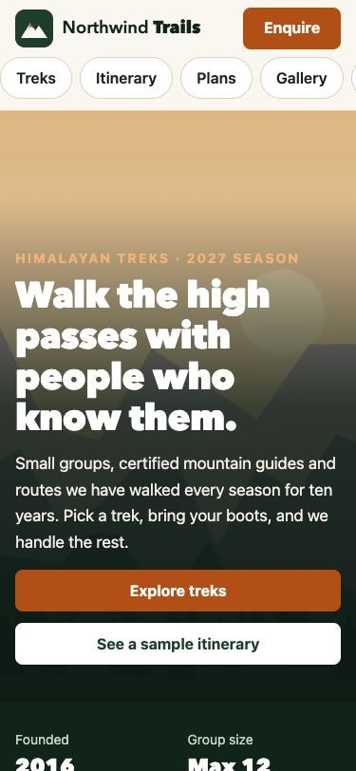
Figure 1 — 375 × 812: two-row header with a swipeable nav strip; tall hero composition.
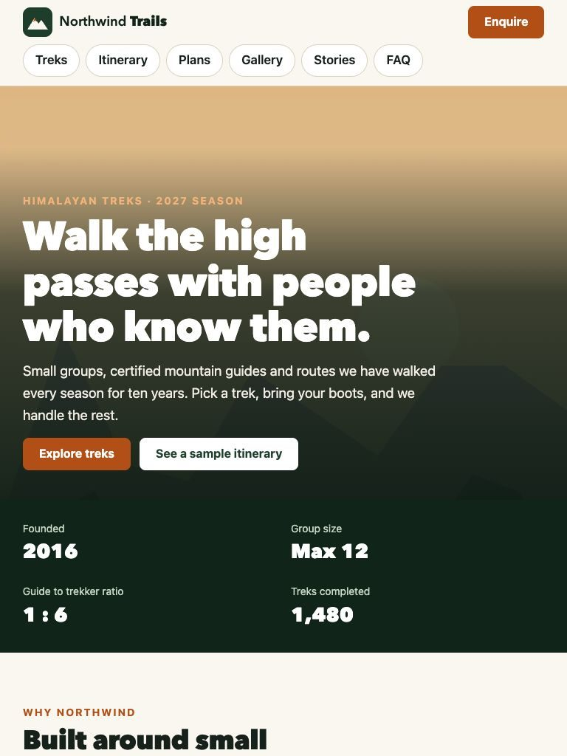
Figure 2 — 768 × 1024: same structure with larger fluid type; the buttons sit in a row.
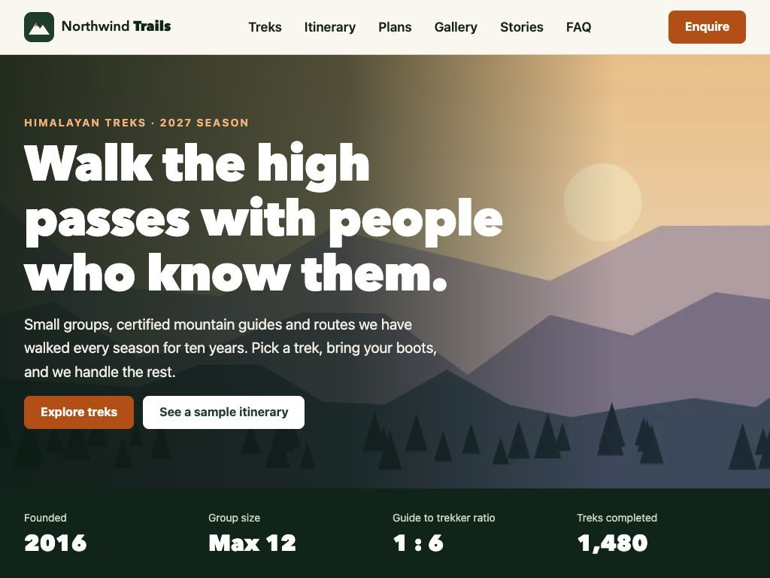
Figure 3 — 1024 × 768: single-row sticky header and the wide hero panorama.
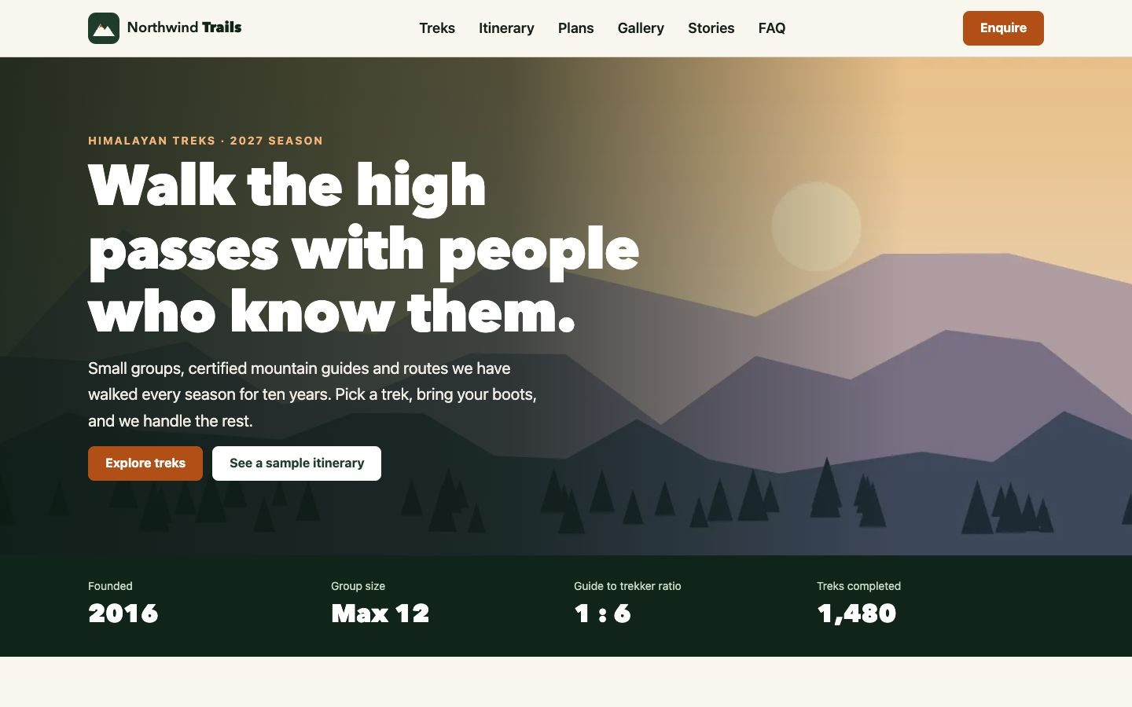
Figure 4 — 1440 × 900 desktop layout.

7.1 Component examples
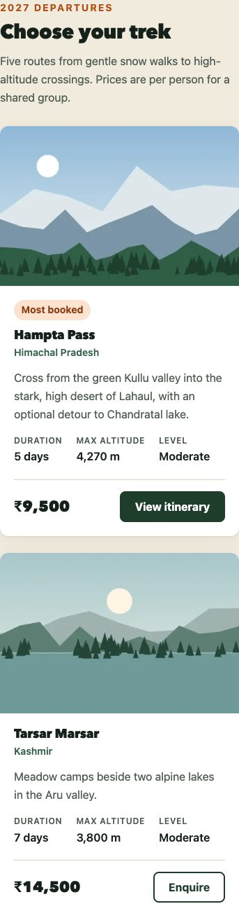
Figure 5 — Trek cards at 375 px: one column, featured card stacked (top of section).
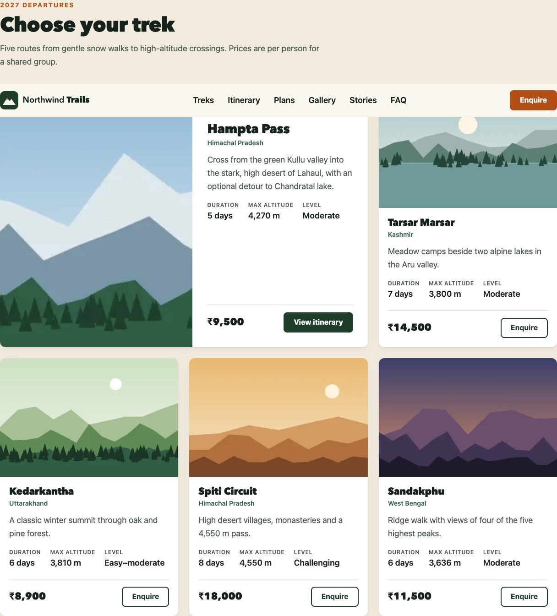
Figure 6 — The same markup at 1440 px: three columns, featured card spans two and turns horizontal via its container query.
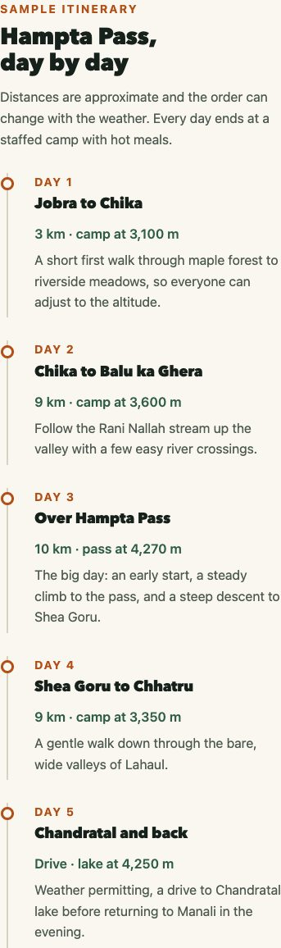
Figure 7 — Itinerary at 375 px: vertical timeline.
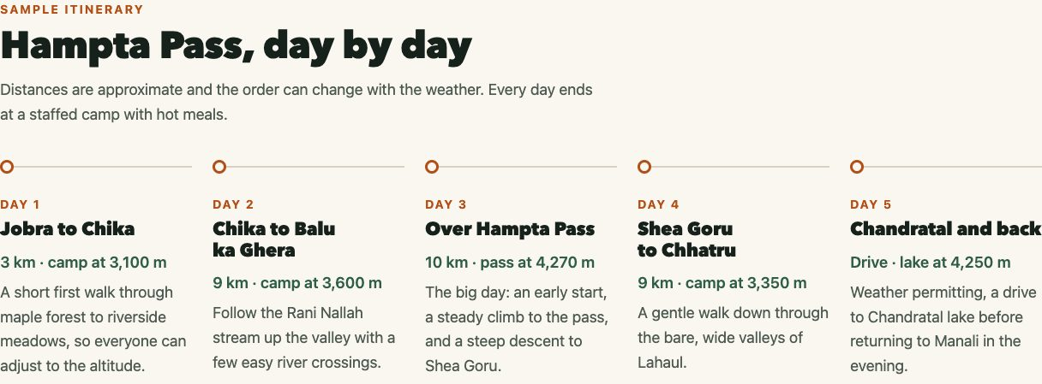
Figure 8 — Itinerary at 1440 px: five days across a horizontal timeline.
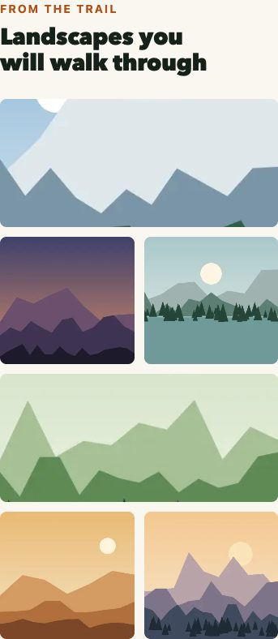
Figure 9 — Gallery at 375 px: two-column mosaic with full-width feature tiles.
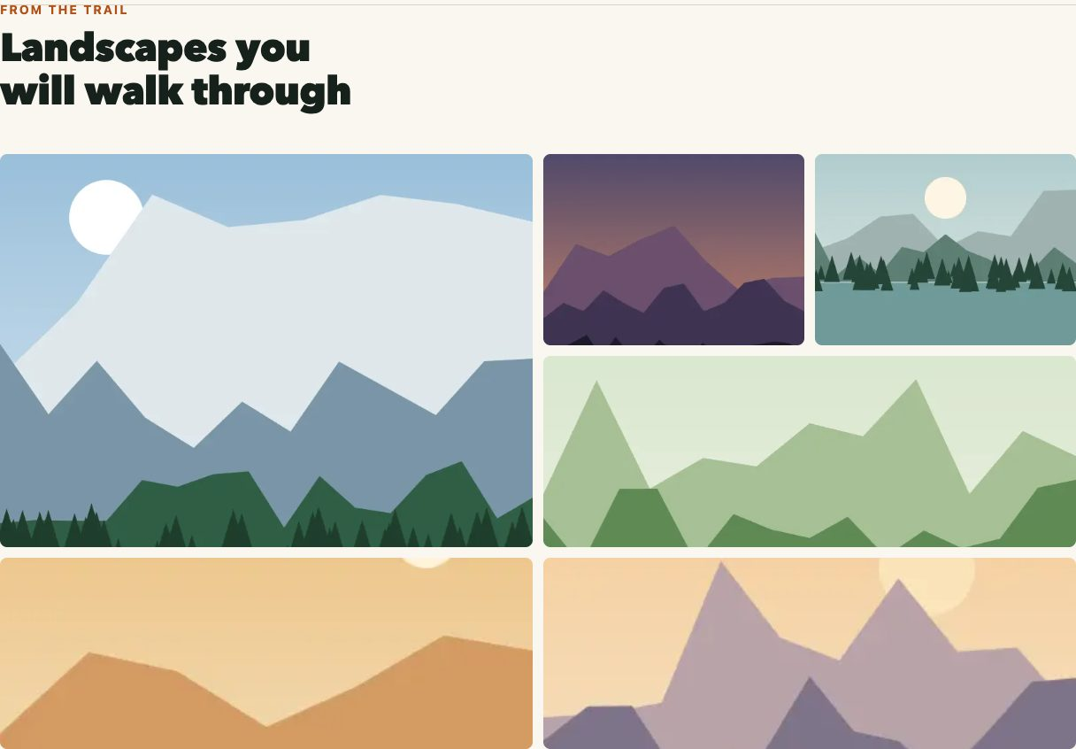
Figure 10 — Gallery at 1440 px: four-column mosaic with one 2 × 2 tile.

8. Fluid and Responsive Images
The landscape illustrations are drawn in SVG by scripts/generate-images.mjs and exported to WebP with sharp at the widths listed in srcset. Each image has width and height attributes so the browser reserves space before it loads, and everything below the hero uses loading="lazy".
Viewport | Hero file chosen | Card file chosen | WebP downloaded (12 images)
375 px, 1× | hero-tall-480.webp | trek-tarsar-480.webp | 36.4 KB
375 px, 2× (retina) | hero-tall-800.webp | trek-tarsar-800.webp | 60.7 KB
768 px, 1× | hero-tall-800.webp | trek-tarsar-480.webp | 51.1 KB
1440 px, 1× | hero-wide-1600.webp | trek-tarsar-480.webp | 50.7 KB
1920 px, 1× | hero-wide-2400.webp | trek-tarsar-480.webp | 57.8 KB

File choices are the image currentSrc reported by Chrome. Download sizes were measured by summing the WebP response bodies after scrolling the whole page with the cache disabled. A 1× phone downloads about 28% less image data than a 1440 px desktop, and a retina phone gets sharper files automatically.

9. Accessibility and Usability Considerations
- Skip link, one h1, logical heading order, named navigation landmarks and descriptive alt text on informative images (decorative hero and icons use empty alt).
- Measured contrast: body text 15.46:1, muted text 6.78:1, white on the ember buttons 5.22:1 and white on the forest green 11.93:1, all above the 4.5:1 AA threshold.
- Visible focus outlines with a lighter focus colour on dark sections, so the ring is never lost.
- The scrollable story row is focusable and labelled, so keyboard users can scroll it with the arrow keys (each ArrowRight moved to the next card in the test).
- The FAQ uses native details/summary, which works with the keyboard and screen readers without any script.
- “Enquire” links include visually hidden text (e.g. “about Kedarkantha”) so each link name is unique.
- Layout order never differs from the HTML order, so keyboard focus always moves in the visual order.

10. Testing Methodology
Type | Tool / method | What it covers
Static analysis | html-validate 11.17 (recommended rules) | HTML validity and best practices
Static analysis | csstree-validator 4.0.1 | CSS syntax and property values
Automated viewport test | tests/responsive-check.mjs (Puppeteer 25, Chrome 156 headless) | 320×640, 375×812, 375×812 at 2× density, 768×1024, 1024×768, 1440×900, 1920×1080: horizontal overflow, broken images, links to missing ids, console and HTTP errors, layout state of every component, font sizes, image file chosen, hero height, whether the hero call to action is on the first screen, smallest touch target
Automated measurement | Puppeteer script with the cache disabled | Image bytes downloaded per viewport; keyboard scrolling of the story row
Manual visual review | Built-in Chromium browser with device emulation | Every section at 1440, 768 and 375 px; FAQ toggled with the keyboard

11. Testing Results
Viewport | Overflow | Body / h1 / h2 (px) | Hero height | CTA on 1st screen | Min target | Errors
320×640 | 0 px | 16 / 36 / 28 | 558 px | Yes | 44 px | 0
375×812 | 0 px | 16.1 / 38.2 / 28.3 | 623 px | Yes | 44 px | 0
375×812 @2× | 0 px | 16.1 / 38.2 / 28.3 | 623 px | Yes | 44 px | 0
768×1024 | 0 px | 16.9 / 54.7 / 36.2 | 560 px | Yes | 44 px | 0
1024×768 | 0 px | 17.4 / 65.4 / 41.3 | 576 px | Yes | 44 px | 0
1440×900 | 0 px | 18 / 72 / 44 | 634 px | Yes | 44 px | 0
1920×1080 | 0 px | 18 / 72 / 44 | 768 px | Yes | 44 px | 0

- html-validate: 0 errors. csstree-validator: 0 errors.
- All 12 images loaded at every viewport; every in-page link points to an existing id.
- Keyboard: the FAQ opens and closes with Enter; the focused story row scrolled 0 → 308 → 564 px with ArrowRight and back with ArrowLeft.
- Not tested: Safari/WebKit, Firefox, physical phones and tablets, and screen readers. Only Chromium-based browsers were available.

12. Challenges and Solutions
Problem found | Cause | Solution
At 768 × 1024 the hero was about 960 px tall and the buttons fell below the first screen | The 4:5 tall image set the height of the hero grid cell (768 × 1.25) | The hero image is now absolutely positioned inside the picture element and covers the cell, so the text decides the height. The hero is now 560 px at 768 px
At 320 × 640 the call to action was still below the first screen | Fixed top padding that leaves room for the illustration | Added a max-height: 40em media query that reduces hero padding on short screens (also helps phones in landscape)
On phones the overlay made the hero almost entirely dark | Gradient opacity too high at the top | Lighter top gradient and more top padding so the mountains show above the headline
“Most booked” badge stretched across the whole card | Flex column children stretch by default | align-self: flex-start on .badge
First automated run timed out waiting for lazy images | The page’s smooth scrolling meant the test’s scroll steps barely moved, so lazy images never entered the viewport | The test turns smooth scrolling off before scrolling (test fix, not a page bug)
Screenshots were 7.7 MB as PNG | Lossless full-page captures | Saved as JPEG at quality 80 (3.4 MB)

The main design challenge was the featured trek card. With a viewport media query it would have needed different rules for each grid width; with a container query the same component simply responds to the space its grid cell gives it, which is how the featured card can be horizontal at 768 px (spanning two columns) and the other cards stay vertical.

13. Limitations and Future Improvements
- Company, prices, stories and contact details are fictional; images are generated illustrations, not photographs.
- Enquiries open the user’s email app (mailto links); a real site would need a booking form and backend.
- Container queries and the cqi unit need a 2023 or newer browser; older browsers would show the stacked card layout, which still works.
- Testing was done only in Chromium-based browsers and device emulation; Safari on a real iPhone and Firefox should be checked.
- The swipe-only nav strip hides some links off-screen on phones; a future version could add a visible scroll hint or a menu button (which would need JavaScript).

14. Conclusion
Northwind Trails adapts from a 320 px phone to a 1920 px desktop without horizontal overflow, with each section rearranging itself in a way that suits its content: cards gain columns, the featured card turns horizontal through a container query, the itinerary turns from a vertical into a horizontal timeline, the gallery becomes a mosaic, and the story carousel becomes a grid. Type and spacing scale fluidly, the browser picks appropriately sized images, and every interactive element stays at least 44 px tall. All of this was confirmed with automated measurements at seven viewport settings, and six problems found during testing were fixed.

