Frontend Web Developer Internship · Week 4
Enhancing Web Page Performance and Accessibility
Audit and optimisation report for the “Riverside Public Library” page, with measured before/after results
Item | Details
Prepared by | Takshak Singhania
Project | Riverside Public Library — information and sign-up page for a fictional public library
Technologies | HTML5, CSS3, vanilla JavaScript; esbuild, sharp; Lighthouse 13.5, axe-core 4.14, html-validate, csstree-validator
Repository | https://github.com/TakshakSinghania/frontend-internship-week4-performance-accessibility
Local folder | Frontend-Internship-Tasks/week-4-performance-accessibility
Live site | https://takshaksinghania.github.io/frontend-internship-week4-performance-accessibility/ (baseline at /baseline/)
Audit dates | Local Lighthouse/axe: 23 October 2026 (reports/audit-summary.json). Hosted WAVE/WebPageTest: 22–23 October 2026 UTC (reports/hosted-tests.json)

1. Assignment Objective
The Week 4 task is to optimise a static web page for performance and accessibility: improve load speed, use semantic HTML, and apply accessibility best practices so the page works for a wider audience, including people with disabilities. Deliverables are an accessible HTML file, a CSS file with optimised styling and minimal redundancy, and a report describing the performance steps (such as minification and image optimisation), the accessibility features (such as ARIA, alt text and keyboard navigation), and the testing tools used.
The work is evaluated on the effectiveness of the performance improvements, adherence to accessibility guidelines, code cleanliness, and how well the process and lessons are documented.

2. Project Overview and Method
The page is for a fictional public library: opening hours with a live “open now” status, a location map, events, services, accessibility information, a library card sign-up form and an FAQ.
To measure real improvements, the project contains two versions with the same content:
- baseline/ — the unoptimised starting page, built the way many quick sites are built: the full Bootstrap and jQuery libraries for a few styles and two click handlers, multi-megabyte PNG images, and a set of common accessibility mistakes. It is kept only for comparison and is clearly labelled as such.
- index.html (project root) — the optimised page, rebuilt from the audit findings.
Both versions were audited with the same tools, the same local server (gzip enabled, as on typical static hosting) and the same settings. All numbers in this report come from those runs; none are estimates.
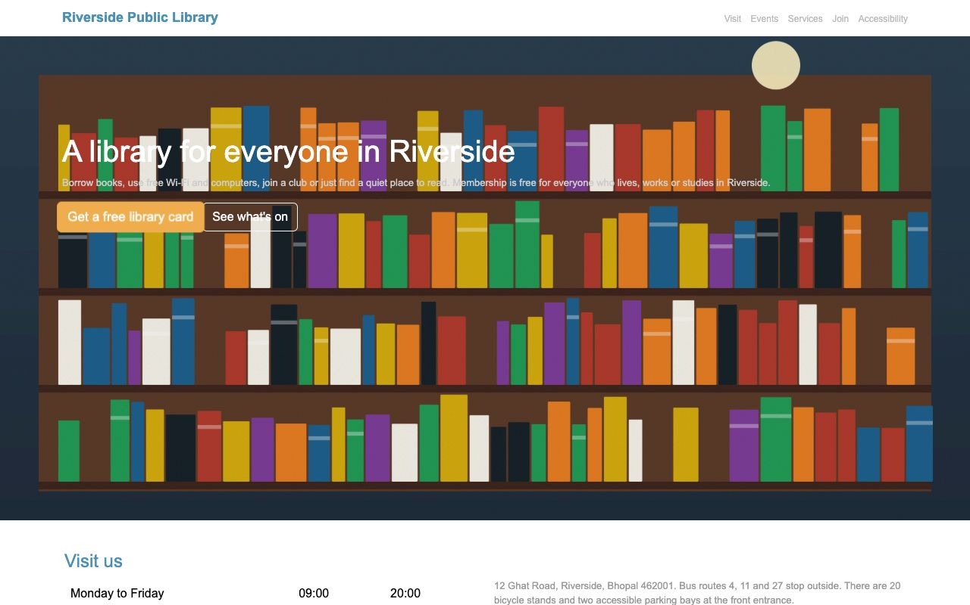
Figure 1 — Baseline at 1280 px: low-contrast grey text, text over a busy image, tiny pale navigation.
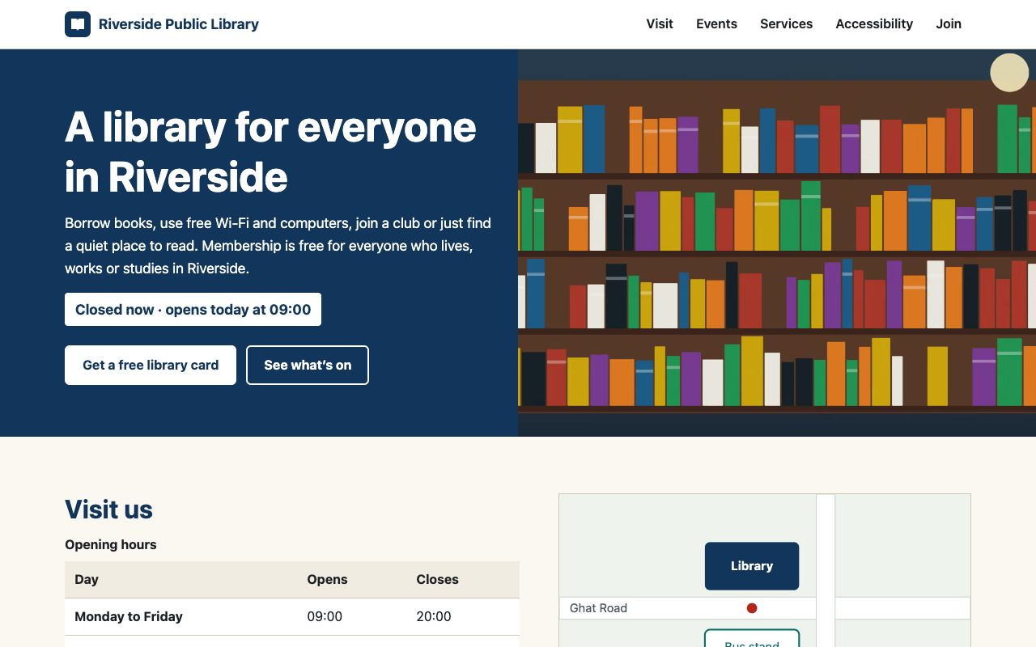
Figure 2 — Optimised page at 1280 px: same content, solid high-contrast hero panel, live opening status.

3. Technologies and Tools
Tool | Version | Purpose
Lighthouse (Node API) | 13.5.0 | Performance, accessibility, best-practice and SEO scores; Core Web Vitals; opportunities
Google Chrome (headless) | 156 | Browser used by Lighthouse, axe and the tests
axe-core | 4.14.0 | Automated WCAG 2.0/2.1/2.2 A and AA plus best-practice rules
html-validate / csstree-validator | 11.17.0 / 4.0.1 | HTML and CSS validity
Puppeteer + node:test | 25.16 / Node 26 | Keyboard, focus, form, reflow and loading-behaviour tests
sharp | 0.35.5 | Image resizing and AVIF/WebP/JPEG encoding
WAVE (wave.webaim.org) | web interface | Accessibility evaluation of the hosted pages: errors, contrast errors, alerts, structure
WebPageTest (webpagetest.org) | anonymous test, Chrome 152 | Real-network page loads of the hosted pages from Singapore (mobile, 4G) and Tokyo (desktop, WiFi)
esbuild | 0.28.2 | CSS and JavaScript minification

Lighthouse, axe and the validators ran locally. WAVE and WebPageTest need a public URL, so both versions were published with GitHub Pages and tested there (Section 9.3).

4. Project Structure
week-4-performance-accessibility/
├── index.html optimised page (CSS inlined at build time)
├── css/styles.css stylesheet source (7.4 KB; 1.9 KB gzip after minifying)
├── js/main.js, main.min.js progressive enhancements (1.7 KB minified)
├── assets/ AVIF/WebP/JPEG images in 2–3 sizes, map, favicon
├── baseline/ unoptimised starting version (for comparison only)
├── scripts/
│ ├── generate-images.mjs draws the illustrations, exports PNG and AVIF/WebP/JPEG
│ ├── build.mjs minifies JS, minifies and inlines CSS
│ ├── serve.mjs static server with gzip used for audits
│ ├── audit.mjs Lighthouse ×3 runs, axe and validators for both versions
│ └── screenshots.mjs
├── tests/a11y.test.mjs 9 accessibility and loading tests
├── reports/ audit-summary.json + Lighthouse HTML reports (median runs)
└── report.docx README.md TESTING.md

5. Analysis: Issues Found in the Baseline
The baseline was audited first. The tools reported these problems (Lighthouse audit ids and axe rule ids in brackets):

Performance
Issue | Evidence from the audit
Oversized images | Four PNGs of 1.3–1.9 MB at 1600–2400 px wide: 6,372 KB of the 6,491 KB page. “Improve image delivery”: estimated saving 6,185 KB
Render-blocking resources | bootstrap.css (280 KB), style.css, jquery.js (285 KB) and script.js all loaded synchronously in head. Estimated saving 1,040 ms on mobile
Unused code | Unused CSS (≈31 KB) and unused JavaScript (≈57 KB) flagged: the page uses a handful of Bootstrap classes and two jQuery handlers
Unminified code | Unminified CSS (≈6 KB) and JavaScript (≈42 KB) savings flagged
Unsized images | No width/height attributes on any image (layout-shift risk)
Slow LCP | LCP element was the 1.9 MB hero PNG: 35.1 s on the mobile profile, 5.9 s on desktop

Accessibility
axe rule (impact) | Elements | Problem
color-contrast (serious) | 23 | Grey text (#999/#aaa/#bbb) on white and white text on orange buttons
region (moderate) | 17 | Content outside landmarks: header, nav, main and footer were plain divs
label (critical) | 2 | Inputs with placeholders but no labels
select-name (critical) | 1 | Branch drop-down had no accessible name
image-alt (critical) | 1 | Hero image had no alt attribute
html-has-lang (serious) | 1 | No lang attribute on html
meta-viewport (moderate) | 1 | user-scalable=no and maximum-scale=1 blocked zooming
heading-order (moderate) | 1 | h1 followed directly by h4
landmark-one-main (moderate) | 1 | No main landmark

In total axe reported 9 rules failing on 48 elements. Several further problems are invisible to automated tools and were found by manual review and keyboard testing: “Click here” and three identical “Read more” links; FAQ answers that only opened on mouse click on div elements; a div used as the submit button; all focus outlines removed with outline: none; errors shown with alert(); an infinitely pulsing button that ignored reduced-motion settings; duplicate id="event"; and event images with the meaningless alt text “image”. html-validate also reported 6 errors (duplicate ids, missing alt, form without a submit button, table without tbody).

6. Accessibility Improvements
Area | What was changed | Guideline
Language and zoom | lang="en"; viewport no longer blocks zoom | WCAG 3.1.1, 1.4.4
Structure | header, nav (labelled “Main”), main, footer; sections labelled by their headings; one h1 then h2/h3 with no skipped levels | 1.3.1, 2.4.6
Skip link | First focusable element; becomes visible on focus and moves focus to main (tabindex="-1") | 2.4.1
Text alternatives | The location map is the one informative image and gets a full description (“the library is on the north side of Ghat Road, directly opposite the bus stand…”). Hero and event images are decorative because the text beside them says everything, so they use alt="" and are skipped by screen readers. The logo SVG is aria-hidden and the link text names the library. | 1.1.1
Contrast | New palette; every text pair measured: body 15.62:1, muted text 7.18:1, white on navy 12.46:1, white on teal buttons 6.09:1, error red 6.17:1. Text is never placed over the image | 1.4.3
Links | Descriptive link text, e.g. “Read about step-free access and other accessibility services”, “Book a place at Coding Club” | 2.4.4
Keyboard | All controls are native elements (a, button, input, select, summary); FAQ uses details/summary, so it opens with Enter/Space without JavaScript | 2.1.1, 4.1.2
Focus visible | One strong focus style for everything: dark 3 px outline plus a yellow 6 px ring, visible on light and dark backgrounds | 2.4.7
Forms | Visible labels for every field, “required” written in text (not colour only), a hint for the phone format, fieldset/legend for checkboxes, autocomplete attributes | 1.3.5, 3.3.2
Error handling | Errors appear next to each field, are linked by aria-describedby, the field gets aria-invalid, focus moves to the first problem, and a role="status" message announces how many fields need attention. Messages clear as soon as the field is fixed | 3.3.1, 3.3.3, 4.1.3
Tables | Opening hours table has a caption and th with scope | 1.3.1
Target size | Navigation links, buttons, inputs and summaries are at least 44–48 px tall | 2.5.8
Motion | No infinite animation; smooth scrolling only inside prefers-reduced-motion: no-preference | 2.2.2, 2.3.3
Reflow | Single-column layout down to 320 px with no horizontal scrolling | 1.4.10

ARIA only where needed. ARIA is used only where HTML has no native equivalent: aria-label on the nav, aria-labelledby on sections, aria-describedby and aria-invalid on fields, role="status" for the form message, and aria-hidden on the decorative logo. Everything else (buttons, the disclosure widget, table semantics, landmarks) comes from native elements, which are more robust than ARIA retrofitted onto divs.

Figure 3 — Keyboard focus on a navigation link: dark outline plus yellow ring.
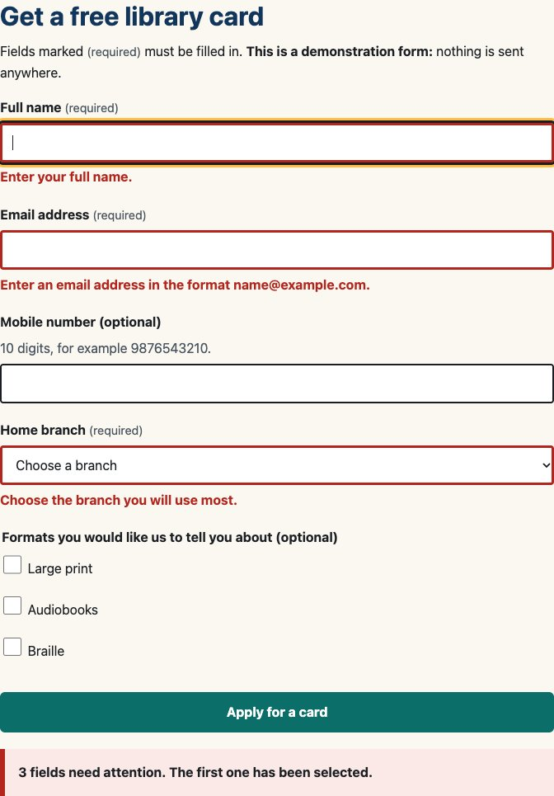
Figure 4 — Form after an empty submit: inline errors, invalid borders and a status message.

7. Performance Optimisations
Optimisation | Before | After
Remove frameworks | Bootstrap CSS 280 KB + jQuery 285 KB (unminified) | Hand-written CSS 7.4 KB source; 3.1 KB of vanilla JS
Image size and format | 4 PNGs, 1,290–1,930 KB each, 6.2 MB total | AVIF with WebP and JPEG fallbacks via picture; 2–3 widths each; the AVIF files are 5–12 KB each (76 KB for all nine sizes)
Responsive selection | One 2400 px image for every screen | srcset/sizes, so a phone gets the 640/1024 px hero and 400/800 px event images
Lazy loading | Everything loaded immediately | loading="lazy" and decoding="async" on below-the-fold images; hero (the LCP element) gets fetchpriority="high" and is never lazy
Layout stability | No image dimensions | width/height on every image plus CSS aspect-ratio
Render blocking | 4 blocking files in head | JS loaded with defer; CSS minified and inlined in head (no CSS request at all)
Minification | None | esbuild: CSS 7.4 → 5.7 KB (1.9 KB gzip); JS 3.1 → 1.7 KB (0.9 KB gzip)
Third parties and fonts | None used, but two large libraries | None; system font stack, so no font downloads
Selectors | Bootstrap’s thousands of rules | Short class selectors, no deep nesting, no unused rules

7.1 Critical CSS: a decision made from measurement
The first optimised version linked one small external stylesheet. Lighthouse still reported about 150 ms of render-blocking time on the mobile profile for that single request. Because the entire minified stylesheet is only 1.9 KB gzipped, all of it counts as critical, so build.mjs now minifies css/styles.css straight into a <style> block in the head. I re-ran the full audit after this change:
Optimised page, median run | External CSS (step 1) | Inlined CSS (final) | Change
Mobile FCP | 915 ms | 766 ms | −149 ms
Mobile LCP | 1,126 ms | 984 ms | −142 ms
Desktop FCP | 245 ms | 205 ms | −40 ms
Desktop LCP | 263 ms | 245 ms | −18 ms
Requests | 9 | 8 | −1

Trade-off: inlined CSS cannot be cached separately, so it is re-downloaded with each HTML request. At 1.9 KB this costs less than the extra round trip it saves. For a multi-page site with a larger stylesheet, splitting critical from non-critical CSS would be the better choice.

8. Testing Methodology
- Environment: macOS, Node 26.8.2, Google Chrome 156 headless. Both pages were served by scripts/serve.mjs on 127.0.0.1 with gzip for text files and Cache-Control: no-cache.
- Lighthouse: Node API, version 13.5.0. Mobile used the default settings: Moto G Power-class screen 412 × 823 at 1.75× density, simulated throttling of 150 ms RTT, ~1.6 Mbps and 4× CPU slowdown. Desktop used the official desktop preset (1350 × 940, 40 ms RTT, 10 Mbps, no CPU slowdown). Each of the four combinations was run 3 times and Lighthouse’s own computeMedianRun() picked the median run, whose HTML report is saved in reports/.
- axe-core 4.14: injected into the page at 1280 × 900 with the wcag2a, wcag2aa, wcag21a, wcag21aa, wcag22aa and best-practice rule sets.
- Validators: html-validate (recommended rules, same config for both pages) and csstree-validator.
- Automated a11y tests (tests/a11y.test.mjs): axe at 375 and 1280 px; lang, zoom, landmarks and heading order; alt/size/lazy attributes; full keyboard walk-through checking that every control receives a visible focus indicator and focus is not trapped; FAQ keyboard toggling; form labels, errors, focus and success; opening-status logic with a frozen clock (6 day/time cases); 320 px reflow; reduced-motion behaviour.
- Manual checks: both pages viewed in the browser pane of the Claude desktop app; keyboard check of the skip link and focus ring.
- Hosted tests: the repository was published with GitHub Pages (built from commit 9e98b41; text files served gzipped with cache-control: max-age=600). WAVE’s web interface evaluated both URLs. WebPageTest’s anonymous test, which allows one run per test, loaded each page on two profiles: iPhone 15 on 4G (9 Mbps, 170 ms RTT) from Singapore, and desktop on WiFi from Tokyo.
The local Lighthouse runs measure the page itself under simulated throttling; the WebPageTest runs add a real host and real network. Neither is field data from real visitors, so the comparison between the two versions matters more than the absolute values.

9. Actual Results

9.1 Lighthouse (median of 3 runs)
Metric | Baseline mobile | Optimised mobile | Baseline desktop | Optimised desktop
Performance | 74 | 100 | 76 | 100
Accessibility | 39 | 100 | 39 | 100
Best practices | 100 | 100 | 100 | 100
SEO | 82 | 100 | 82 | 100
First Contentful Paint | 1,669 ms | 766 ms | 369 ms | 205 ms
Largest Contentful Paint | 35,106 ms | 984 ms | 5,926 ms | 245 ms
Total Blocking Time | 0 ms | 0 ms | 0 ms | 0 ms
Cumulative Layout Shift | 0 | 0 | 0 | 0
Speed Index | 1,669 ms | 766 ms | 369 ms | 205 ms
Total transfer | 6,491 KB | 49 KB | 6,491 KB | 37 KB
Requests | 9 | 8 | 9 | 8

All three runs of each configuration produced the same performance score (baseline 74/74/74 mobile and 76/76/76 desktop; optimised 100/100/100 for both).
Reading the numbers. The largest gain is LCP on mobile: 35.1 s → 0.98 s. Under the simulated 1.6 Mbps connection, downloading the 6.2 MB of PNGs alone takes over 30 s, while the optimised hero is a 9.5 KB AVIF. Total transfer fell by 99.2% on mobile (6,491 → 49 KB). The optimised mobile page downloads more than desktop (49 vs 37 KB) because the emulated phone has a 1.75× screen, so srcset correctly picks the larger 800 px event images.
Results that did not change. TBT was 0 ms for both versions because neither runs heavy JavaScript; jQuery’s cost was in download and parsing, not long tasks. CLS was also measured as 0 for the baseline: on a local server the unsized images arrived before the first render. Lighthouse still flagged “unsized-images” as a layout-shift risk, which on a slow real network would cause visible jumps. Best practices was 100 for both because the issues it checks (HTTPS errors, console errors, deprecated APIs) were not present in either. Lighthouse 13 also shows a new “Agentic browsing” category (baseline 50, optimised 100), which is outside this task.

9.2 axe-core, validators and tests
Check | Baseline | Optimised
axe violations (rules / elements) | 9 / 48 | 0 / 0
axe rules passed | 20 | 51
html-validate errors | 6 | 0
csstree-validator errors (own CSS) | 0 | 0
Accessibility test suite (9 tests) | not applicable | 9 passed, 0 failed

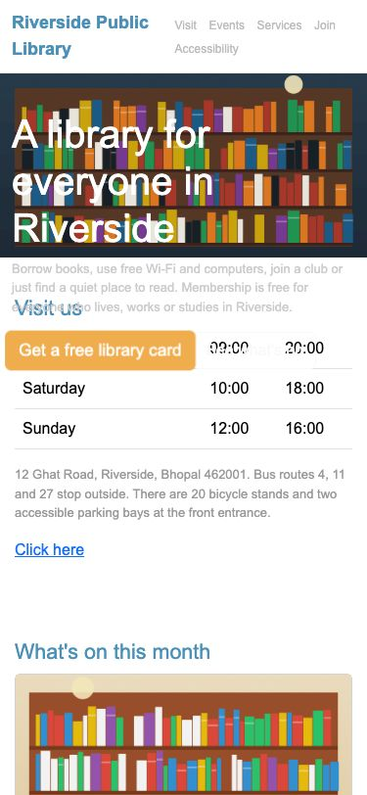
Figure 5 — Baseline at 375 px.

Figure 6 — Optimised page at 375 px.

9.3 Hosted tests: WAVE and WebPageTest
Both versions were tested on GitHub Pages: https://takshaksinghania.github.io/frontend-internship-week4-performance-accessibility/ and the same address with /baseline/. Raw numbers and links to the public result pages are in reports/hosted-tests.json.

WAVE
WAVE result | Baseline | Optimised
Errors | 7 (missing alt 1, missing form label 5, language missing 1) | 0
Contrast errors | 32 | 0
Alerts | 15 | 3
Features / structural elements / ARIA | 0 / 7 / 0 | 16 / 32 / 15
AIM score | 3.4 / 10 | 10 / 10

The baseline’s 15 alerts were: select missing label, suspicious alternative text (×3), nearby image with the same alternative text (×2), no page regions, skipped heading level, suspicious link text (×4), redundant link (×2) and a layout table. The optimised page’s 3 alerts were reviewed one by one. “Long alternative text” is the location map, kept long on purpose because it is the only informative image. “Possible heading” is the bold opening-status line, which is a status message and correctly stays a paragraph. “Noscript element” is the intended fallback notice for the sign-up form.
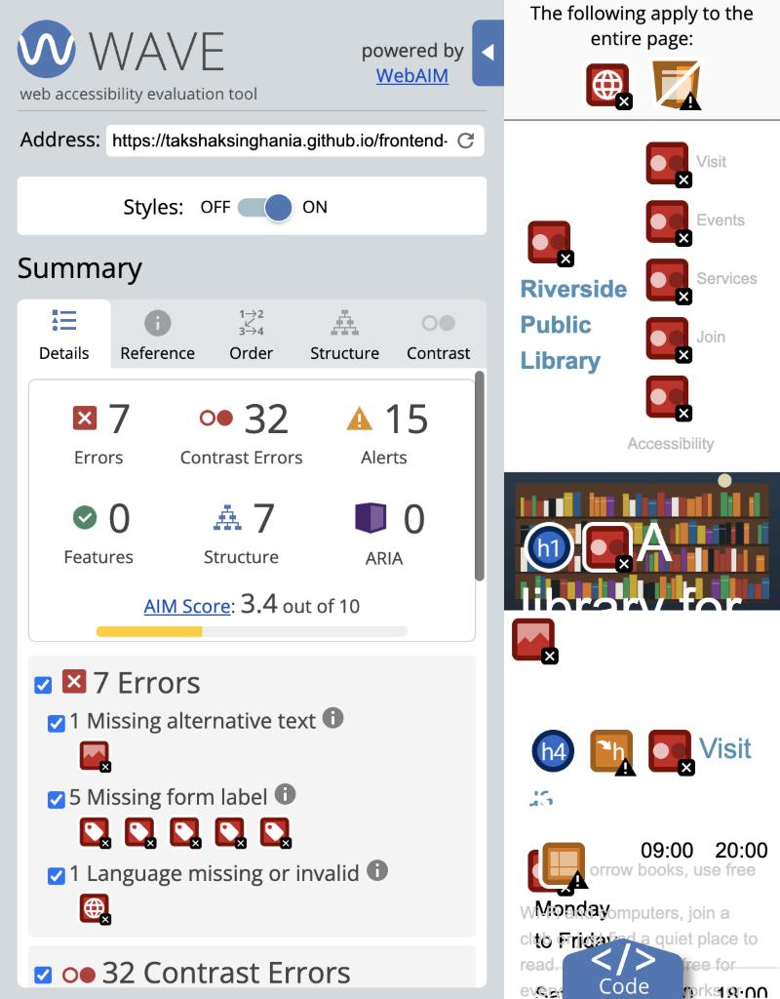
Figure 7 — WAVE summary for the hosted baseline.
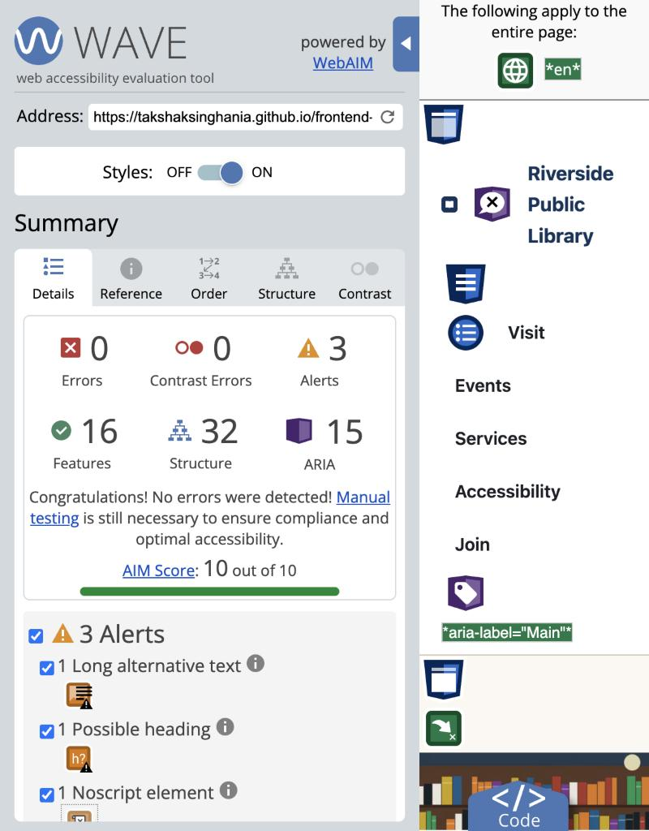
Figure 8 — WAVE summary for the hosted optimised page.

WebPageTest (one run per test)
Metric | Baseline mobile | Optimised mobile | Baseline desktop | Optimised desktop
First Contentful Paint | 2.210 s | 1.122 s | 0.665 s | 0.355 s
Largest Contentful Paint | 5.109 s | 1.630 s | 1.156 s | 0.572 s
Cumulative Layout Shift | 0 | 0 | 0.439 | 0
Speed Index | 3.624 s | 1.300 s | 1.071 s | 0.441 s
Time to First Byte | 0.950 s | 0.955 s | 0.213 s | 0.222 s
Total Blocking Time | 0 s | 0 s | 0 s | 0 s
Page weight | 6,652,435 B | 18,336 B | 6,647,293 B | 35,196 B
Requests (HTTP 4xx) | 10 (1) | 5 (0) | 10 (1) | 8 (0)
Render-blocking requests | 4 | 0 | 4 | 0

Mobile profile: iPhone 15, Chrome 152, 4G (9 Mbps, 170 ms RTT), Singapore. Desktop profile: Chrome 152, WiFi (240/120 Mbps, 2 ms RTT), Tokyo. Anonymous WebPageTest allows a single run per test, so these values have no median and are more variable than the three-run Lighthouse results.
What the hosted tests showed that the local tests did not.
- A real layout shift on the baseline. Lighthouse measured CLS 0 locally because the images arrived before the first paint. On the real network the desktop baseline scored CLS 0.439 (“major layout shifts”) as the unsized images loaded and pushed the content down. The optimised page, which sets width and height on every image, stayed at 0.
- A missing favicon on the baseline. Without a <link rel="icon">, the browser requested takshaksinghania.github.io/favicon.ico from the domain root, which returned 404. This only appears when the site is hosted below a domain root. The optimised page links its own favicon and had no failed requests.
- Lazy loading on a real network. The optimised mobile run downloaded only the HTML, the script, the 1600 px AVIF hero (the right size for the iPhone 15’s 3× screen), the map and the favicon: 18 KB in 5 requests. The event images further down were never requested.
- The server is not the difference. Time to first byte was the same for both pages (about 0.95 s on mobile, 0.22 s on desktop) because it reflects GitHub Pages and the network. The gap in FCP, LCP and Speed Index comes entirely from what each page loads after the first byte: 4 render-blocking files and 6.3 MB of images for the baseline, against none and 18–34 KB for the optimised page.
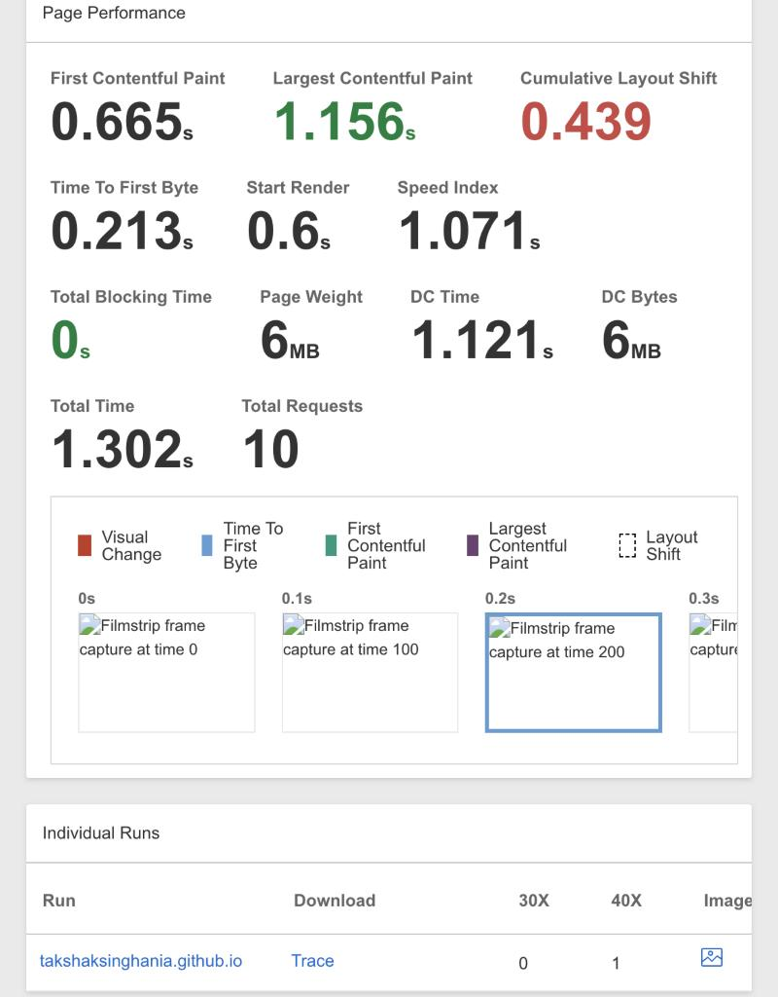
Figure 9 — WebPageTest, baseline on desktop: CLS 0.439 from unsized images.
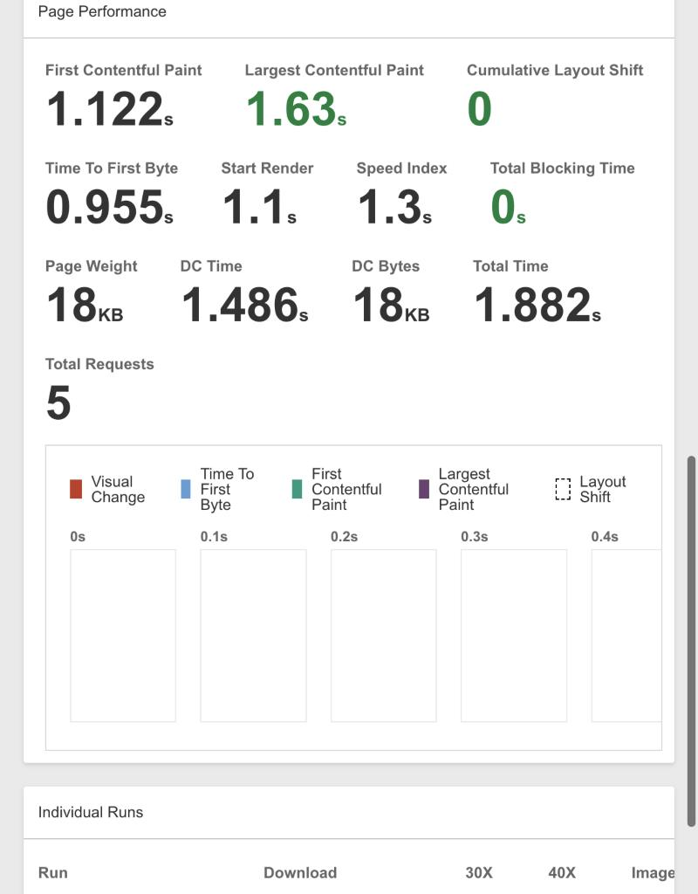
Figure 10 — WebPageTest, optimised page on iPhone 15 / 4G: LCP 1.63 s, 18 KB.

10. Challenges and Solutions
Challenge | Solution
Making before/after numbers meaningful | Kept a real baseline page with identical content and audited both with the same server, tools and settings; three runs per configuration with Lighthouse’s median-run selection.
Deciding whether to inline CSS | Measured first. One 1.9 KB stylesheet still cost ~150 ms render-blocking on mobile, so it was inlined and the audit re-run to confirm the gain (FCP −149 ms).
Text over the hero image could never guarantee contrast | Moved the hero text onto a solid navy panel beside the image instead of on top of it.
Accessible errors without alert() | Native constraint validation (required, type="email", pattern) for the rules, plus custom messages, aria-invalid, aria-describedby, focus on the first problem and a role="status" summary.
Testing time-dependent “open now” text | The test freezes the browser clock with evaluateOnNewDocument and checks six day/time cases, including closing time and the Saturday→Sunday and Sunday→Monday transitions.
An audit-script bug | The first audit run validated the optimised HTML without loading the project’s html-validate config and wrongly reported 2 errors for the checkbox group (checkboxes legitimately share one name). The script now loads the config for both pages, and the final result is 0 errors.
Problems that only appear on a real host | Published both versions with GitHub Pages and ran WAVE and WebPageTest there. This revealed a 0.439 layout shift and a favicon 404 on the baseline that the local tests could not show, and confirmed the optimised page has neither.
Photo-like file sizes from illustrations | Flat illustrations compress unrealistically well, so a light grain filter was added before export so the files behave like photographs. This keeps the image-optimisation comparison realistic.

11. Limitations and Future Improvements
- WebPageTest was run anonymously, which allows one run per test and a fixed list of devices. Signing in to a free account would allow 3+ runs per profile and a median, as was done with Lighthouse.
- Screen-reader output was not checked with NVDA, JAWS or VoiceOver; only the ARIA attributes and accessible names were tested automatically. A manual screen-reader pass is the next step.
- Automated tools cannot judge everything (for example, whether alt text is helpful). Those items were reviewed by hand but not by users with disabilities.
- All performance results are lab measurements (local Lighthouse and WebPageTest’s emulated devices). Field data (real-user Core Web Vitals) would need real visitors to the hosted page.
- Possible next optimisations: long-lived Cache-Control headers for the hashed image files, and a service worker for offline opening hours.
- The sign-up form is a demonstration with no backend. Without JavaScript it shows a notice instead of submitting.

12. Conclusion
Starting from a baseline with 9 failing axe rules, 6 validation errors, 6.5 MB of transfer and a 35-second mobile LCP, the optimised page reaches 100 in all four main Lighthouse categories on both mobile and desktop, has zero axe violations and zero validation errors, and transfers 49 KB on mobile. On the public GitHub Pages copy, WAVE reports 0 errors and 0 contrast errors (against 7 and 32 for the baseline), and WebPageTest on a real 4G profile measured LCP of 1.63 s against 5.11 s for the baseline, with no render-blocking requests and no layout shift. Most of the gain came from three changes: replacing oversized PNGs with responsive AVIF images, removing two unused libraries, and loading the remaining tiny CSS and JavaScript without blocking rendering. Most of the accessibility work was making the page semantic and native: real landmarks, headings, labels, buttons and details elements, a visible focus style, sufficient contrast, and form errors that are announced and linked. The main lesson is to measure before and after every change: the critical-CSS decision, for example, was justified by a measured 149 ms improvement rather than by habit.

