Frontend Web Developer Internship · Week 5
Developing a Single Page Application Simulation
Technical report for “Shelf”, a reading tracker with client-side routing, browser history and dynamic content in vanilla JavaScript
Item | Details
Prepared by | Takshak Singhania
Project | Shelf — a single-page reading tracker
Technologies | HTML5, CSS3, vanilla JavaScript ES modules, History/Location APIs, Fetch, localStorage, <dialog>
Repository | https://github.com/TakshakSinghania/frontend-internship-week5-single-page-application
Archive | week-5-single-page-application.zip (in the project folder)
Date | October 2026

1. Assignment Objective
The final task is to simulate a small Single Page Application (SPA): one HTML page that loads and displays different content without full page reloads. The focus is on structuring the application correctly, using JavaScript to manage the browser history and the DOM, and making transitions between content smooth. Deliverables are a ZIP of the complete project, an HTML container for dynamic content, a CSS file that styles the whole app consistently, a JavaScript file managing dynamic loading, URL changes and state, and a technical report on the plan, challenges and approach.
Evaluation focuses on dynamic content loading, seamless transitions, clear routing logic, error handling, overall UI polish and the quality of the documentation.

2. Project Plan and Overview
Shelf is a reading tracker. It has six real views and two fallback views, all rendered by JavaScript into one <main> element:
Route | View | What the user can do
#/ | Dashboard | See books being read with progress, the yearly goal, pages read and recently finished books
#/library?status=&q=&sort= | Library | Filter by status, search by title or author, and sort; the filters live in the URL
#/book/:id | Book | Change status, update the current page, rate finished books, keep notes, delete with confirmation
#/add | Add book | Add a book with validation; afterwards the app navigates to the new book’s page
#/stats | Stats | Edit the yearly goal; see counts by status, average rating and pages read per genre
#/about | About | Read how the app works; reset the demo data
anything else | Not found | A “page not found” view showing the requested address, with links back
#/book/<unknown> | Book not found | Shown for ids that do not exist, such as deleted books or “abc”

The plan was: (1) design the app shell and navigation, (2) write a router and a store as independent modules, (3) build each view as a function of state, (4) add loading, error and empty states, (5) test every routing behaviour in a real browser, and (6) document and package the project.
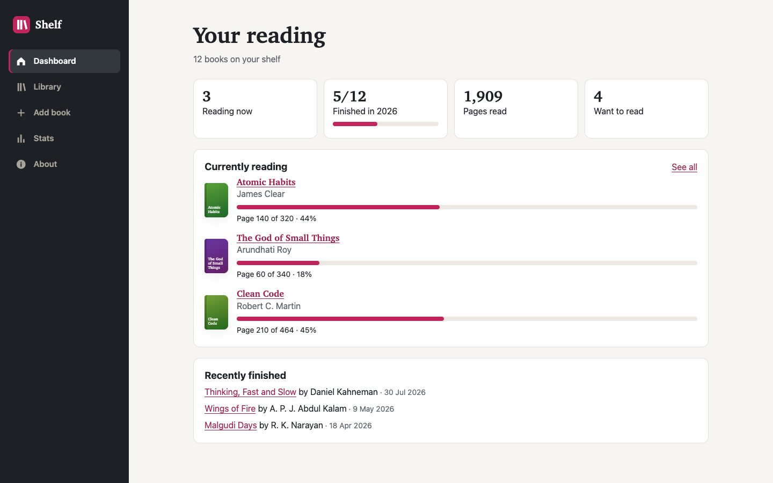
Figure 1 — Dashboard at 1440 px with the sidebar navigation.

3. Technologies Used
Technology | Use
HTML5 | index.html is the app shell: header/sidebar, navigation, the <main id="view"> outlet, a toast live region and a native <dialog> for confirmations
CSS3 | One stylesheet (261 lines) with custom properties, Grid/Flexbox, a mobile bottom tab bar that becomes a sidebar at 60em, :has() for custom radio controls, and short view-enter animations disabled under prefers-reduced-motion
JavaScript (ES modules) | 13 small modules in js/ (881 lines in total). No frameworks or libraries
Browser APIs | location.hash + hashchange, history.replaceState, fetch, URLSearchParams, localStorage, <dialog>.showModal(), Intl date formatting
Testing (dev only) | Node’s test runner + Puppeteer 25 driving headless Chrome 156; html-validate; csstree-validator; axe-core 4.14 (one-off scan)

A framework was not needed. The routing, state and rendering needed for six views fit in a few hundred lines of plain JavaScript, and writing them by hand was the point of the exercise.

4. Project Structure and Architecture
week-5-single-page-application/
├── index.html app shell and <main id="view"> outlet
├── css/styles.css styles for every view
├── js/
│ ├── main.js entry point: creates store + router, registers routes
│ ├── router.js hash router: matching, params, query, history, focus
│ ├── store.js state, loading, persistence, actions
│ ├── dom.js el() builder and small shared components
│ ├── ui.js toasts and confirmation dialog
│ └── views/ dashboard, library, book, add, stats, about,
│ not-found, status (loading/error)
├── data/books.json sample data loaded with fetch on first run
├── assets/favicon.svg
├── tests/spa.test.mjs 14 end-to-end tests
├── tests/screenshots.mjs
├── docs/screenshots/
├── report.docx README.md TESTING.md
└── week-5-single-page-application.zip
The app has three layers that only talk through small interfaces:
- Router (router.js) knows about URLs, not about books. It turns the address into { path, params, query }, picks a view function and puts the returned DOM node into the outlet.
- Store (store.js) knows about books, not about the DOM. It loads data, applies the business rules (for example, reaching the last page marks a book finished), saves to localStorage and notifies subscribers.
- Views (views/*.js) are functions that receive { store, params, query, navigate } and return { title, node, update?, destroy? }. They read state, build DOM and call store actions.
main.js connects them. It registers the routes, gives every view access to the store, shows a loading or error screen through a router guard until the data is ready, and redraws the current route when the store’s loading status changes.

5. Routing and Browser History

5.1 Why hash-based routing
URLs have the form index.html#/book/3. The part after # is never sent to the server, so any static host (python -m http.server, GitHub Pages, a ZIP opened through a local server) always returns the same index.html. This means refreshing a route, bookmarking it or opening it directly works without any server configuration. The History API alternative (/book/3 with pushState) gives cleaner URLs, but a refresh would ask the server for /book/3 and get a 404 unless the server is configured to fall back to index.html. That configuration is not possible on many static hosts and is documented as a limitation.

5.2 How the router works
- Route patterns such as /book/:id are compiled once into regular expressions with named keys.
- On load and on every hashchange event, parseHash() splits the hash into a path and a query string. The path is decoded with decodeURIComponent; malformed escapes such as %E0%A4 are caught and treated as an unknown path instead of crashing. Trailing slashes are removed, so #/library/ and #/library are the same route.
- The first matching route provides { params }; no match uses the not-found view.
- If the route and params are unchanged and only the query string differs, the router calls the existing view’s update() instead of rebuilding it. This is how the library search box keeps focus while the list filters.
- Otherwise the previous view’s destroy() runs, the new view is rendered, the node gets a short entry animation, document.title is updated, the active navigation link gets aria-current="page", the page scrolls to the top, and focus moves to the new h1.
function render({ focus = true } = {}) {
if (!location.hash || location.hash === '#') history.replaceState(null, '', '#/');
const { path, query } = parseHash(location.hash);
const found = match(path);
const ctx = { path, query, params: found?.params ?? {}, navigate };
const sameRoute = current && found && current.route === found.route
&& JSON.stringify(current.params) === JSON.stringify(found.params);
if (sameRoute && current.view.update) return current.view.update(ctx);
current?.view.destroy?.();
const view = guard?.(ctx) || (found ? found.route.view(ctx) : notFound(ctx));
...
}

5.3 History behaviour
Situation | History API used | Result
First visit to index.html (no hash) | replaceState → #/ | Address becomes #/ without adding a history entry
Clicking a link or calling navigate(path) | location.hash = path (push) | New entry; Back returns to the previous view
Typing in the library search box, changing sort | navigate(path, { replace: true }) → replaceState | The URL always reflects the search, but Back skips all the keystrokes
Back / Forward buttons | hashchange fires | The router renders the stored route; the page is never reloaded
Deleting a book, then pressing Back | normal hashchange | #/book/13 now shows the “Book not found” fallback

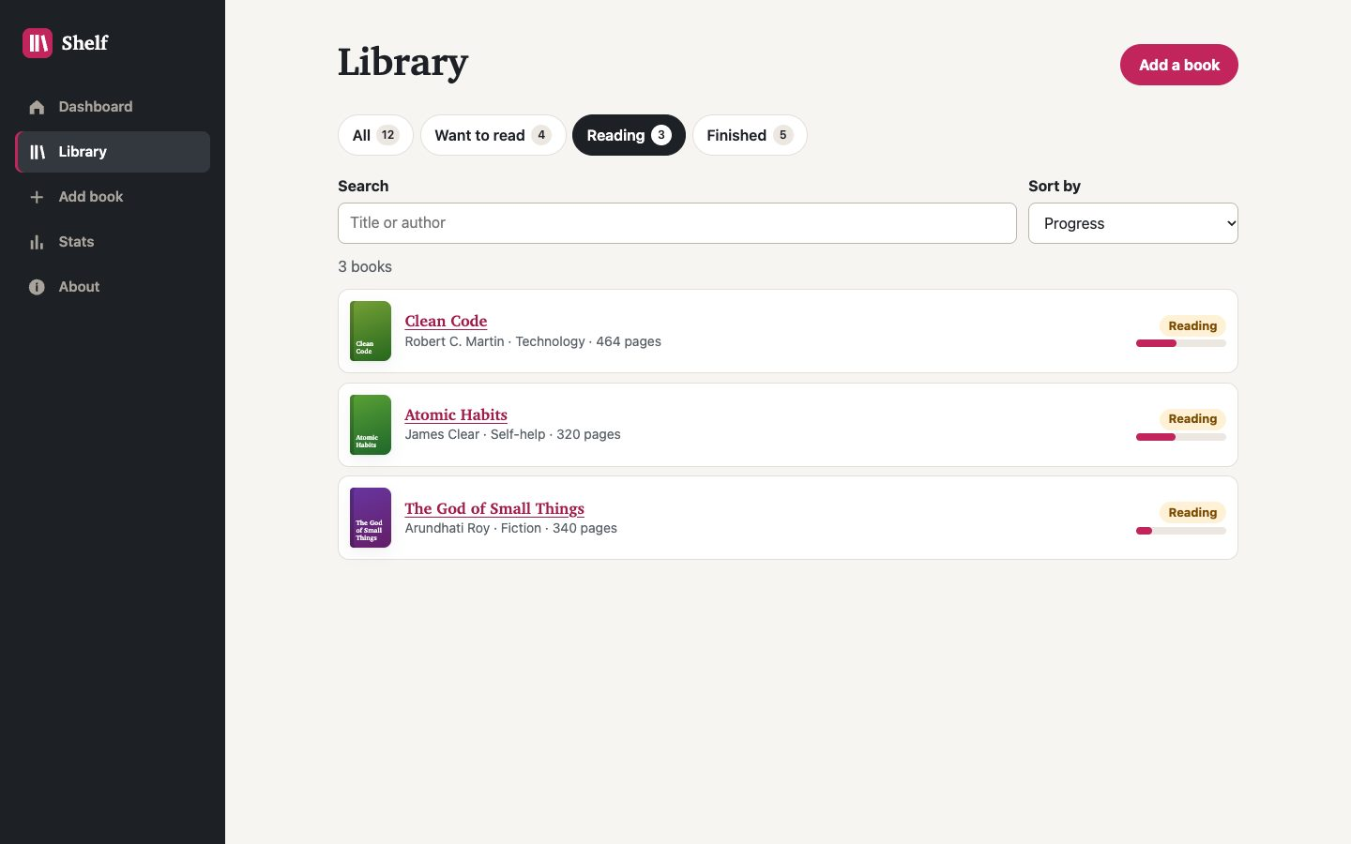
Figure 2 — #/library?status=reading&sort=progress: the filter and sort come from the URL, so this state can be refreshed or bookmarked.

6. State Management and Dynamic Content
- Single source of truth: the store holds { status, error, books, goal }. Views never keep their own copy of a book; they read store.state or store.find(id) each time they paint.
- Loading lifecycle: status moves from idle to loading to ready or error. While it is not ready, the router guard shows a loading screen (skeleton rows, aria-busy, a status message) or an error screen with the server’s message and a Try again button. When it becomes ready, main.js calls router.refresh() so whichever route is in the address is drawn, which is how direct links work even on the very first load.
- Business rules in one place: store.update() handles side effects. Setting status to finished fills progress and records the date; reaching the last page marks the book finished; moving back to “want” resets progress and rating. Views therefore stay simple.
- Persistence: after the first fetch, every change is saved to localStorage. On load, saved data is passed through sanitize(), which drops malformed books, clamps numbers and rejects unknown statuses, because anything in storage could have been edited by hand. The About page can reset to the original data/books.json.
- Rendering: views build DOM with a small el(tag, attrs, ...children) helper that sets text through text nodes, so user-entered titles and notes can never inject HTML. Lists are replaced in one replaceChildren() call.
- Focus after updates: when a view repaints itself after an action (status change, progress update, rating), it puts focus back on the control the user just used, so keyboard users are not thrown back to the top.
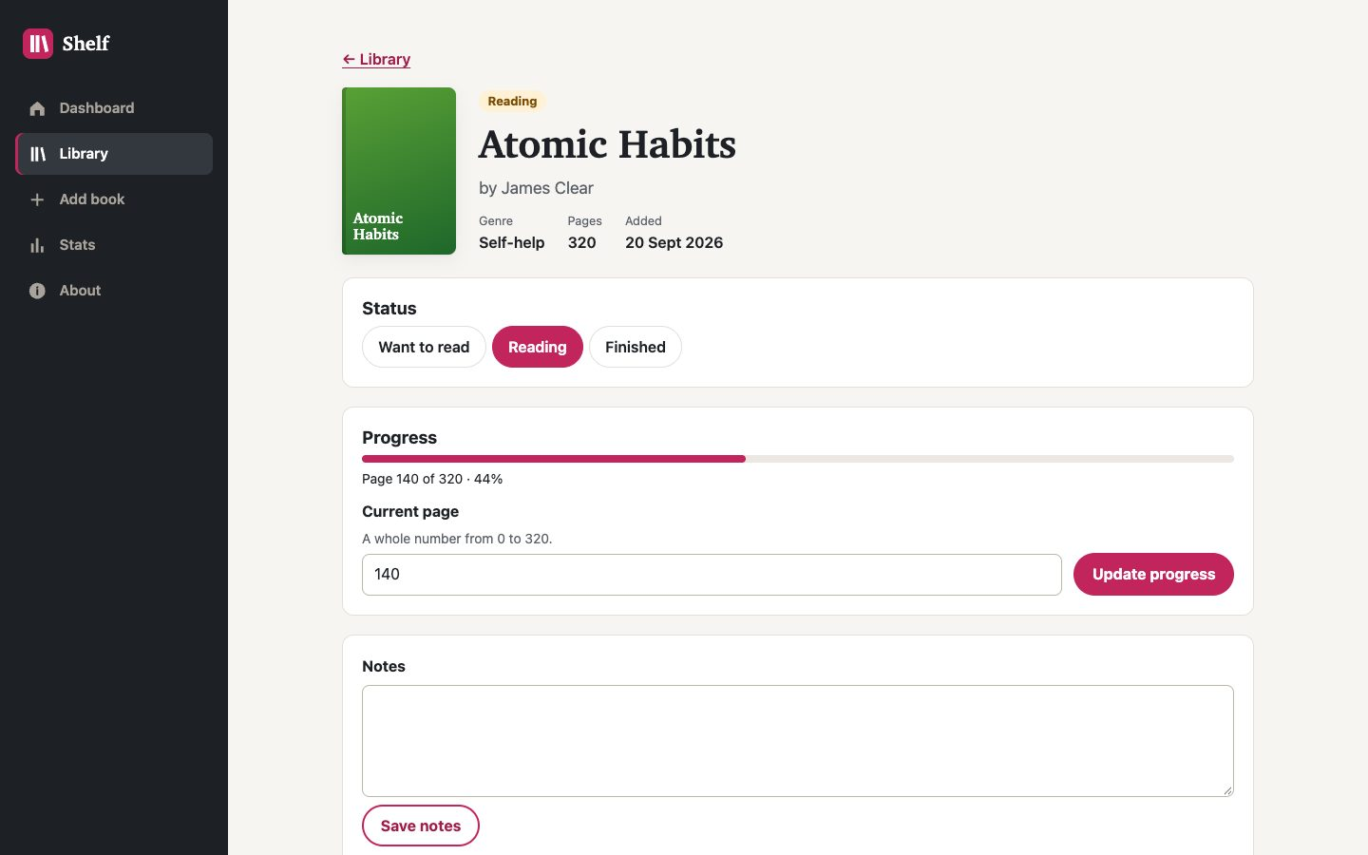
Figure 3 — Book view (#/book/3) with status, progress, notes and delete actions.

7. Transitions, Feedback and Error Handling
- Transitions: each new view fades in and moves up 6 px over 180 ms (CSS keyframes on a .view-enter class). This is long enough to show that the content changed and short enough not to slow anyone down. Under prefers-reduced-motion the animation is removed.
- Feedback: every action produces a toast in a polite live region, e.g. “Progress saved: page 200 (63%).” or “Deleted “Nirmala”.”.
- Destructive actions use a native modal <dialog> with the Cancel button focused first; Esc or a click outside cancels, and focus returns to the button that opened it.
- Form validation (add book, progress, goal) shows inline messages linked with aria-describedby, marks fields aria-invalid and moves focus to the first problem. It also catches duplicates (same title and author) and impossible values (page 400 of a 320-page book, decimals, a goal outside 1–365).
- Unknown and invalid routes: unmatched paths, malformed encoding, unknown book ids and non-numeric ids all show a fallback view that explains what happened and links back. Unknown filter values such as ?status=bogus are ignored with a visible notice rather than an empty list.
- Data errors: an HTTP error or unexpected JSON shape shows the error view; Try again re-runs the request.
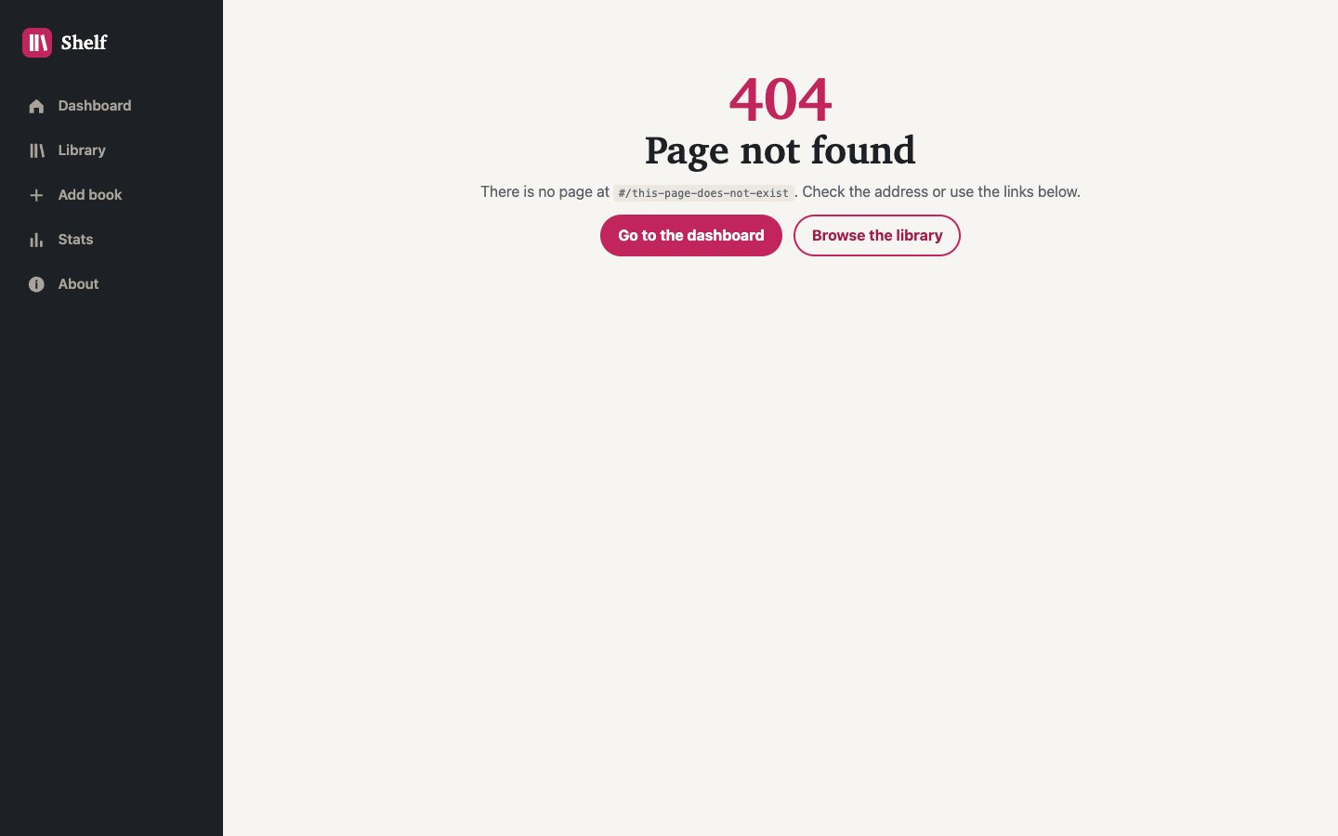
Figure 4 — Fallback for an unknown route.
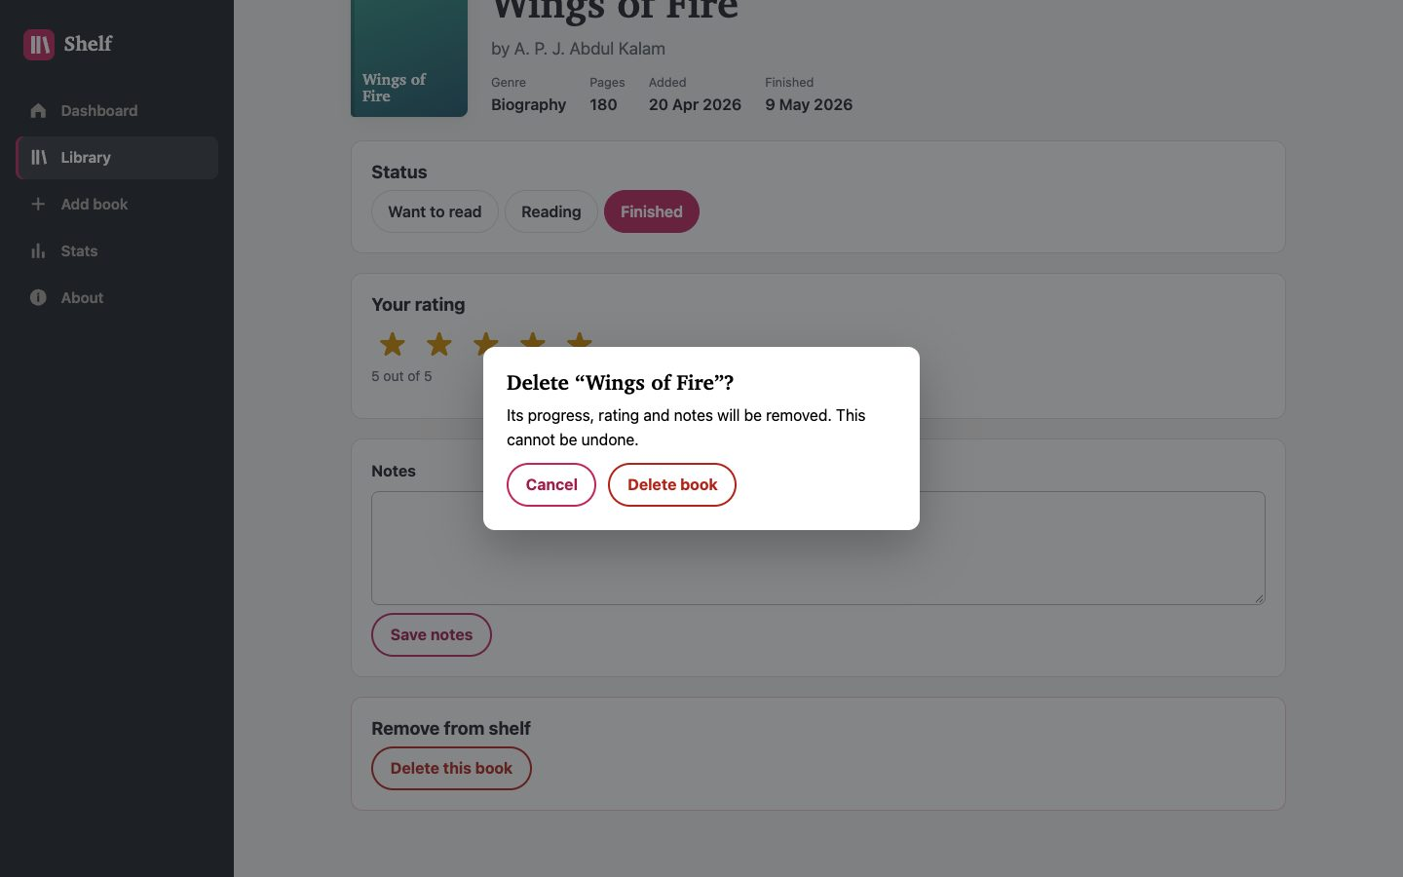
Figure 5 — Confirmation dialog before deleting a book.

8. Responsive Layout and Accessibility
On phones the navigation is a fixed bottom tab bar with icons and labels (each item at least 44 px tall). From 60em it becomes a 15 rem sidebar. Stats grids go from two to four columns, and forms switch to two-column rows when there is room.
- After each navigation, focus moves to the new h1 (tabindex="-1"), so screen-reader users hear the new page name and keyboard users continue from the top of the new content.
- The skip link cannot be a plain href="#view" (the router would treat it as a route and show “not found”), so a small click handler focuses the heading instead. This was a deliberate SPA-specific fix.
- Navigation uses real links with aria-current="page"; status and rating controls are native radio buttons styled with :has(); progress bars have role="progressbar" with values and labels.
- An extra one-off axe-core 4.14 scan of nine routes (WCAG 2.0–2.2 A/AA + best practice) found 0 violations.
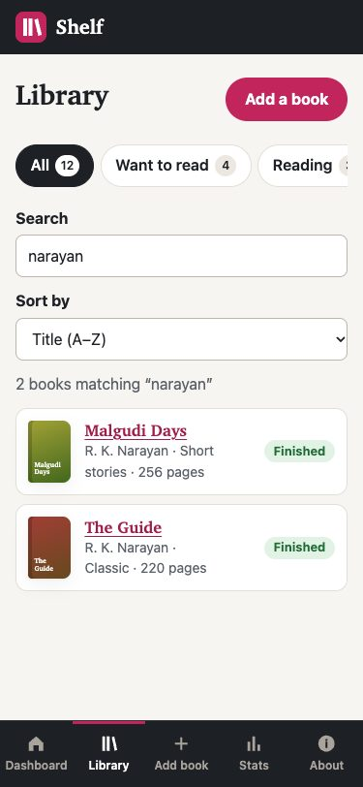
Figure 6 — Library at 375 px with the bottom tab bar.

9. Testing Methodology
Type | Tool | Coverage
Static analysis | html-validate 11.17, csstree-validator 4.0.1, node --check | Markup, CSS and JS syntax
End-to-end | tests/spa.test.mjs: node:test + Puppeteer 25 + Chrome 156 headless, local static server | 14 tests, each in a fresh browser context with empty storage; request interception to delay or fail the data request
Accessibility scan | axe-core 4.14 injected on 9 routes (one-off script) | WCAG 2.0/2.1/2.2 A and AA, best practice
Manual | Built-in Chromium browser pane | Navigation, Back/Forward in the same document, visual review of every screenshot in docs/screenshots
Archive | unzip -l, unzip -t, then extract and run the extracted copy | Contents and that the extracted app works

10. Testing Results
Each of the ten required checks maps to at least one automated test:
Required check | How it was verified | Result
1. Initial loading | Data request held back: the loading screen appears, the empty hash becomes #/ without a history entry, then the dashboard renders | Pass
2. Navigation between all views | Each nav link: heading, URL, title, a single aria-current link, focus on h1; a marker on window proves no reload | Pass
3. URL updates | Asserted after every navigation, filter click, search keystroke and sort change | Pass
4. Back and Forward | Dashboard → Library → Book → Stats, then Back ×3 and Forward ×2, same document throughout | Pass
5. Refreshing routes | #/library?status=reading&sort=progress reloaded: same tab, sort and order of results | Pass
6. Direct navigation | Fresh tabs opened at #/book/9, #/stats, #/library/ and #/add | Pass
7. Unknown routes | #/nope, #/book/999, #/book/abc, #/book, malformed %E0%A4%A, and ?status=bogus&sort=price | Pass
8. State updates | Progress validation, progress save, finishing a book, rating, dashboard totals, persistence after reload, add with duplicate check, delete with dialog (Esc cancels), Back to a deleted book, reset demo data | Pass
9. Console errors and broken assets | Every test collects console errors, page errors and HTTP ≥ 400; a dedicated test visits every view and also checks that no “false/null/undefined/NaN” text leaks into the page. A failing data request shows the error view and Try again recovers | Pass
10. Responsive behaviour | No horizontal overflow at 375, 768 and 1440 px; bottom tab bar fixed on phone/tablet, sidebar on desktop | Pass

Final run: 14 tests, 14 passed, 0 failed. html-validate and csstree-validator: 0 errors. axe-core: 0 violations on all 9 routes scanned.

11. Challenges and Solutions
Problem | Cause | Solution
A “false” label appeared on finished and want-to-read book pages | Optional panels were written as condition && panel(); replaceChildren() turned the false into text | Filter the children before replaceChildren(), plus a regression test that fails if “false/null/undefined/NaN” text appears on any view. Found during visual review of the screenshots
After pressing Back, the search box still showed old text | The library view avoided overwriting the box while it had focus, so a Back press while focused left stale text | A typing flag: only updates caused by typing skip syncing; Back/Forward and tab links always sync
Typing in search would add a history entry per keystroke and lose focus | Every hash change is a history entry and normally a full re-render | Search and sort use replaceState; same-route query changes call view.update() instead of re-rendering
Filter tabs lost keyboard focus when clicked | The tab links are rebuilt on each update | The focused tab’s key is remembered and the new link is focused
Cover thumbnails stretched across half the row on the dashboard | A generic “.reading-item > div” rule also matched the cover div | A specific .reading-info class for the text column
A normal skip link would break routing | #view would be routed as an unknown page | JavaScript skip link that focuses the heading and leaves the URL alone
Malformed URLs could throw | decodeURIComponent throws on bad escapes | Caught and treated as an unknown route

Two first-run test failures were bugs in the tests, not the app. A new Puppeteer tab starts with about:blank in its history, so the history-length check now compares against a page opened at #/. And location.hash changes as soon as a link is clicked, before the app handles hashchange, so the tests now wait for the visible UI (the active tab) instead of the URL.

12. Limitations and Future Improvements
- Hash URLs (#/book/3) are less tidy than path URLs. Moving to the History API would need a server rewrite rule (or a 404.html redirect trick on GitHub Pages).
- The app must be opened through a web server: browsers block ES modules and fetch on file:// pages. The page shows this message if it is opened directly, and the README gives the one-line server command.
- Scroll position is reset to the top on every navigation, including Back; restoring per-entry scroll positions would be a good next step.
- Data lives in one browser’s localStorage; a backend would allow syncing between devices.
- Not tested in Safari or Firefox, on physical devices, or with a screen reader.

13. Conclusion
Shelf is a working single-page application: one HTML file, eight views rendered from data, and a hash router that keeps the URL, browser history, page title, active navigation and keyboard focus in step with what is on screen. Refreshing, bookmarking and direct links work on any static server; unknown routes, missing books, bad filters and failed data requests each have a clear fallback; and state changes persist between visits. The fourteen end-to-end tests cover all ten required verification points. Writing the router and store by hand showed which problems a framework normally solves (history entries while typing, focus after re-rendering, stale inputs after Back) and how to solve them with a few lines of plain JavaScript.

