Student Hub Portal
Practical File
Complete HTML and CSS Project File
All HTML pages and the common stylesheet have been arranged practical-wise.
Student Hub Portal Source Code

Home Page (index.html)
Question: Create the home page of the Student Hub Portal using HTML and an external CSS file so the page shows a header, navigation bar, hero area, notice section, quick links, and footer.
HTML Code - index.html
<!DOCTYPE html>
<html lang="en">
<head>
<title>Student Hub Portal - Home</title>
<link rel="stylesheet" href="style.css">
</head>
<body>
<header>
<div class="header">
<a href="index.html"><img src="logo.jpg" alt="Student Hub Portal Logo" height="45" style="vertical-align: middle; margin-right: 20px;"></a>
<strong style="margin: 10px;">Student Hub Portal</strong>
</div>
<div class="headerlinks">
<button><a href="login.html">Login</a></button>
<button><a href="register.html">Register</a></button>
</div>
</header>

<div class="navlinks">
<nav align="center">
<a href="index.html">Home</a> |
<a href="about.html">About</a> |
<a href="events.html">Events</a> |
<a href="faq.html">FAQ</a> |
<a href="contact.html">Contact</a> |
<a href="contact.html#feedback">Feedback</a> |
</nav>
</div>

<main>
<div class="main">
<section align="center">
<h1 style="font-size: 45px;">Student Hub Portal</h1>
<p style="font-size: 18px; font-weight: 500;">Manage Students &amp; College Events Easily</p>
</section>
</div>

<br>

<div style="display: flex; gap: 20px;">

<div class="box">
<h3 align="center" style="font-size:30px; text-decoration: underline;">Latest Notice</h3>
<ul>
<li class="t1">Notice 1</li>
<li class="t1">Notice 2</li>
<li class="t1">Notice 3</li>
</ul>
</div>

<div class="box">
<h3 align="center" style="font-size:30px; text-decoration: underline;">Upcoming Events</h3>
<ul>
<li class="t1">Tech Fest</li>
<li class="t1">Workshop</li>
<li class="t1">Seminar</li>
</ul>
</div>

<div class="box">
<h3 align="center" style="font-size:30px; text-decoration: underline;">Quick Links</h3>
<ul>
<li class="t1links"><a href="dashboard.html">Student Portal</a></li>
<li class="t1links"><a href="events.html">Events</a></li>
</ul>
</div>

</div>
</main>

<br><br>
<div class="footer">
<footer align="center">
<p><a href="about.html">About</a>
<a href="contact.html">Contact</a> Copyright &copy; Student Hub Portal</p>
</footer>
</div>
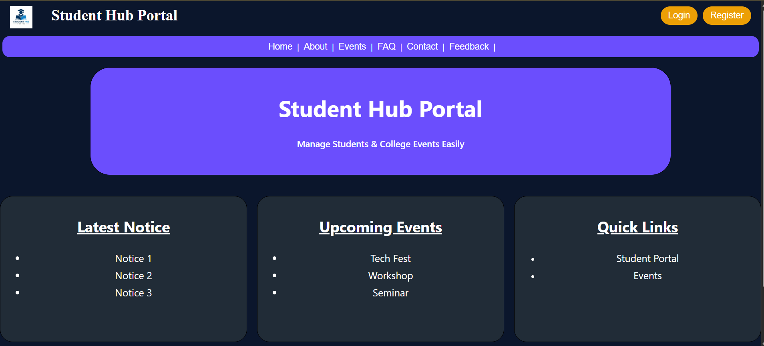
</body>
</html>

About Page (about.html)
Question: Create the About page to present the mission and vision of Student Hub Portal in a simple, readable layout.
HTML Code - about.html
<!DOCTYPE html>
<html lang="en">
<head>
<meta charset="UTF-8">
<meta name="viewport" content="width=device-width, initial-scale=1.0">
<title>Student Hub Portal - About</title>
<link rel="stylesheet" href="style.css">
</head>
<body>
<header>
<div class="header">
<a href="index.html"><img src="logo.jpg" alt="Student Hub Portal Logo" height="45" style="vertical-align: middle; margin-right: 8px;"></a>
<strong style="margin: 10px;">Student Hub Portal</strong>
</div>
<div class="headerlinks">
<button><a href="login.html">Login</a></button>
<button><a href="register.html">Register</a></button>
</div>
</header>

<div class="navlinks">
<nav align="center">
<a href="index.html">Home</a> |
<a href="about.html">About</a> |
<a href="events.html">Events</a> |
<a href="contact.html">Contact</a>
</nav>
</div>

<main align="center">
<h3>About Student Hub</h3>
<br>
<div style="display: flex; gap: 20px;">

<div class="boxes2">
<p style="font-size: 30px;">Our Mission</h2></p>
<p style="font-size: 22px;">To eliminate communication gaps across campus by delivering real-time
updates and effortless management tools for every student.</p>
</div>
<div class="boxes2">
<p style="font-size: 30px;">Our Vision</p>
<p style="font-size: 22px;">To build a modern, fully digital campus ecosystem where information
is accessible anywhere, anytime with zero operational friction.</p>

</div>
</div>

</main>

<br>
<div class="footer">
<footer align="center">
<p>Footer : <a href="about.html">About</a> | <a href="contact.html">Contact</a> | Copyright &copy; StudentHub Portal</p>
</footer>
</div>
</body>
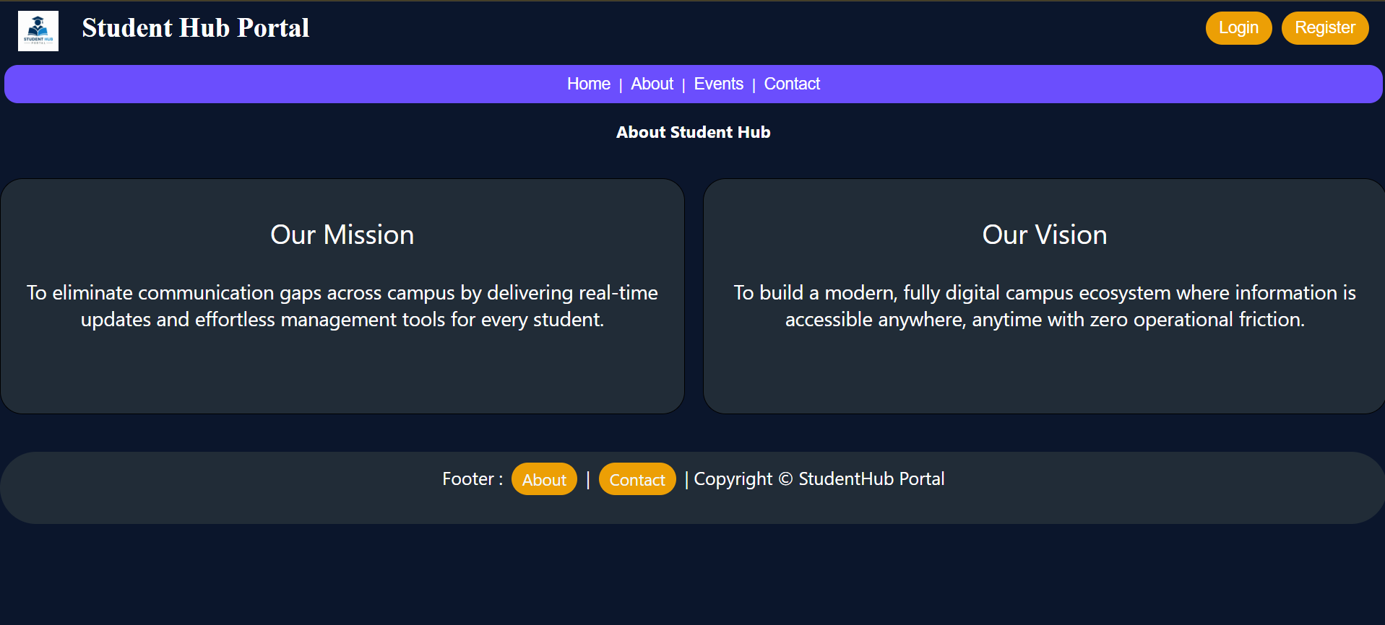
</html>

Events Page (events.html)
Question: Create the Events page so students can search events, view event details, and register from a clean table layout.
HTML Code - events.html
<!DOCTYPE html>
<html lang="en">

<head>
<meta charset="UTF-8">
<meta name="viewport" content="width=device-width, initial-scale=1.0">
<title>Student Hub Portal - Events</title>
<link rel="stylesheet" href="style.css">
</head>

<body>

<header>
<div class="header">
<a href="index.html"><img src="logo.jpg" alt="Student Hub Portal Logo" height="45" style="vertical-align: middle; margin-right: 8px;"></a>
<strong style="margin: 10px;">Student Hub Portal</strong>
</div>
<div class="headerlinks">
<button><a href="login.html">Logout</a></button>
</div>
</header>

<div class="navlinks">
<nav align="center">
<a href="index.html">Home</a> |
<a href="about.html">About</a> |
<a href="events.html">Events</a> |
<a href="dashboard.html">Dashboard</a> |
<a href="faq.html">FAQ</a> |
<a href="contact.html">Contact</a> |
<a href="contact.html#feedback">Feedback</a>
</nav>
</div>

<main style="max-width: 1000px; margin: 20px auto; padding: 10px;">
<h1 style="font-size: 36px; text-align: center; color: white;">College Events</h1>

<!-- Search Bar Card -->
<div class="table1" style="padding: 15px 25px; text-align: center;">
<label for="search" style="font-size: 18px; margin-right: 10px;"><strong>Search Events:</strong></label>
<input type="text" id="search" placeholder="Search events by name, date or category..." style="width: 60%; max-width: 400px; margin-right: 10px;">
<button style="padding: 10px 20px; font-size: 16px;">Search</button>
</div>

<br>

<!-- Events List Container -->
<div class="table1" style="padding: 25px;">
<table width="100%" cellpadding="15" style="border-collapse: collapse;">

<!-- Event 1 -->
<tr>
<td width="20%" align="center" valign="middle">
<div style="width: 110px; height: 90px; background-color: #0B162C; border: 2px solid #6B4EFD; border-radius: 15px; display: flex; align-items: center; justify-content: center; color: #EC9F05; font-weight: bold;">
IMAGE
</div>
</td>
<td width="60%" valign="top">
<h3 style="font-size: 24px; color: #EC9F05; margin: 0 0 10px 0;">SPOURAL–2026</h3>
<p style="font-size: 16px; margin: 4px 0;"><strong>Date:</strong> October 25, 2026</p>
<p style="font-size: 16px; margin: 4px 0;"><strong>Venue:</strong> College Main Ground</p>
<p style="font-size: 16px; margin: 4px 0;"><strong>Category:</strong> Sports Festival</p>
</td>
<td width="20%" align="center" valign="middle">
<button style="padding: 12px 24px; font-size: 18px;">Register</button>
</td>
</tr>

<tr>
<td colspan="3"><hr style="border-color: #6B4EFD; margin: 10px 0;"></td>
</tr>

<!-- Event 2 -->
<tr>
<td width="20%" align="center" valign="middle">
<div style="width: 110px; height: 90px; background-color: #0B162C; border: 2px solid #6B4EFD; border-radius: 15px; display: flex; align-items: center; justify-content: center; color: #EC9F05; font-weight: bold;">
IMAGE
</div>
</td>
<td width="60%" valign="top">
<h3 style="font-size: 24px; color: #EC9F05; margin: 0 0 10px 0;">Cyber-Security</h3>
<p style="font-size: 16px; margin: 4px 0;"><strong>Date:</strong> November 10, 2026</p>
<p style="font-size: 16px; margin: 4px 0;"><strong>Venue:</strong> Auditorium B</p>
<p style="font-size: 16px; margin: 4px 0;"><strong>Category:</strong> Tech Workshop</p>
</td>
<td width="20%" align="center" valign="middle">
<button style="padding: 12px 24px; font-size: 18px;">Register</button>
</td>
</tr>

</table>
</div>
</main>

<br>

<div class="footer">
<footer align="center">
<p>Footer : <a href="about.html">About</a> | <a href="contact.html">Contact</a> | Copyright &copy; StudentHub Portal</p>
</footer>
</div>
</body>

</html>

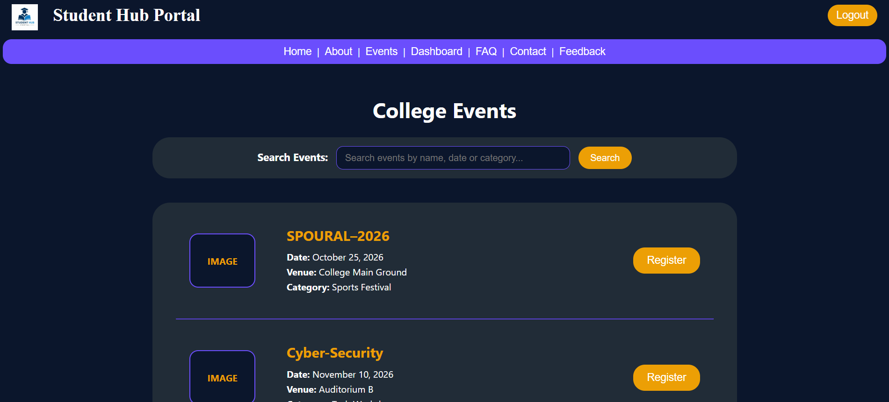
FAQ Page (faq.html)
Question: Create the FAQ page and answer the common questions students may ask about registration, login, events, and contact options.
HTML Code - faq.html
<!DOCTYPE html>
<html lang="en">
<head>
<meta charset="UTF-8">
<meta name="viewport" content="width=device-width, initial-scale=1.0">
<title>Student Hub Portal - FAQ</title>
<link rel="stylesheet" href="style.css">
</head>
<body>

<header>
<div class="header">
<a href="index.html"><img src="logo.jpg" alt="Student Hub Portal Logo" height="45" style="vertical-align: middle; margin-right: 8px;"></a>
<strong style="margin: 10px;">Student Hub Portal</strong>
</div>
<div class="headerlinks">
<button><a href="login.html">Login</a></button>
<button><a href="register.html">Register</a></button>
</div>
</header>

<div class="navlinks">
<nav align="center">
<a href="index.html">Home</a> |
<a href="about.html">About</a> |
<a href="events.html">Events</a> |
<a href="faq.html">FAQ</a> |
<a href="contact.html">Contact</a> |
<a href="contact.html#feedback">Feedback</a>
</nav>
</div>

<main align="center" style="max-width: 900px; margin: 0 auto; padding: 20px;">
<h1 style="font-size: 36px; color: white;">FAQ</h1>
<br>

<div class="table1" style="text-align: left; padding: 30px;">
<p style="font-size: 20px;"><strong style="color: #EC9F05;">Q. How do I register?</strong></p>
<p style="font-size: 18px; color: #e2e8f0;">Click on the 'Register' button on the navigation bar and fill out your student details to create an account.</p>
<hr style="border-color: #6B4EFD; margin: 20px 0;">

<p style="font-size: 20px;"><strong style="color: #EC9F05;">Q. How do I login?</strong></p>
<p style="font-size: 18px; color: #e2e8f0;">Go to the Login page, enter your registered email address and password, then click 'Login'.</p>
<hr style="border-color: #6B4EFD; margin: 20px 0;">

<p style="font-size: 20px;"><strong style="color: #EC9F05;">Q. How do I join events?</strong></p>
<p style="font-size: 18px; color: #e2e8f0;">Navigate to the Events page, browse available activities, and click the 'Register' button on your chosen event.</p>
<hr style="border-color: #6B4EFD; margin: 20px 0;">

<p style="font-size: 20px;"><strong style="color: #EC9F05;">Q. How to contact admin?</strong></p>
<p style="font-size: 18px; color: #e2e8f0;">You can use the 'Contact' or 'Feedback' form from the navigation menu to send a direct message to system admins.</p>
</div>
</main>

<br>

<div class="footer">
<footer align="center">
<p>Footer : <a href="about.html">About</a> | <a href="contact.html">Contact</a> | Copyright &copy; StudentHub Portal</p>
</footer>
</div>
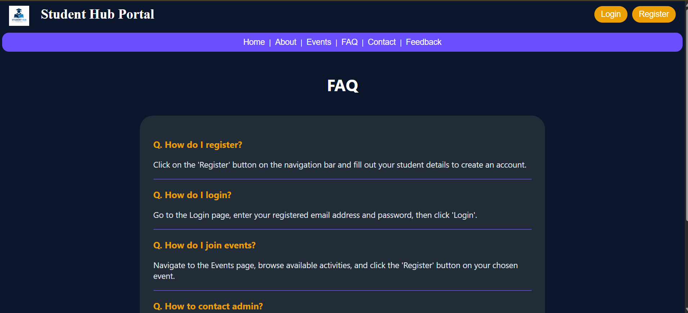
</body>
</html>

Contact & Feedback Page (contact.html)
Question: Create the Contact and Feedback page so users can find contact details and submit feedback through a form.
HTML Code - contact.html
<!DOCTYPE html>
<html lang="en">
<head>
<meta charset="UTF-8">
<meta name="viewport" content="width=device-width, initial-scale=1.0">
<title>Student Hub Portal - Contact &amp; Feedback</title>
<link rel="stylesheet" href="style.css">
</head>
<body>

<header>
<div class="header">
<a href="index.html"><img src="logo.jpg" alt="Student Hub Portal Logo" height="45" style="vertical-align: middle; margin-right: 8px;"></a>
<strong style="margin: 10px;">Student Hub Portal</strong>
</div>
<div class="headerlinks">
<button><a href="login.html">Login</a></button>
<button><a href="register.html">Register</a></button>
</div>
</header>

<div class="navlinks">
<nav align="center">
<a href="index.html">Home</a> |
<a href="about.html">About</a> |
<a href="events.html">Events</a> |
<a href="contact.html">Contact</a> |
<a href="contact.html#feedback">Feedback</a>
</nav>
</div>

<main style="max-width: 900px; margin: 0 auto; padding: 20px;">

<!-- Contact Info Card -->
<div class="table1" style="padding: 25px;">
<h2 style="font-size: 28px; margin-top: 0; color: #EC9F05;">Contact Information</h2>
<hr style="border-color: #6B4EFD; margin: 15px 0;">
<p style="font-size: 18px;"><strong>Email :</strong> support@studenthub.com</p>
<p style="font-size: 18px;"><strong>Phone :</strong> +1 234 567 8900</p>
<p style="font-size: 18px;"><strong>Address :</strong> Campus Center, Student Block 4</p>
</div>

<br>

<!-- Feedback Form Card -->
<div class="table1" id="feedback" style="padding: 25px;">
<h2 style="font-size: 28px; margin-top: 0; color: #EC9F05;">Feedback</h2>
<form action="#">
<p>
<label for="fb-name"><strong>Name</strong></label><br>
<input type="text" id="fb-name" required style="width: 100%; margin-top: 6px;">
</p>
<p>
<label for="fb-email"><strong>Email</strong></label><br>
<input type="email" id="fb-email" required style="width: 100%; margin-top: 6px;">
</p>
<p>
<label for="fb-message"><strong>Message</strong></label><br>
<textarea id="fb-message" rows="4" required style="width: 100%; margin-top: 6px;"></textarea>
</p>
<p align="center" style="margin-top: 20px;">
<button type="submit" style="padding: 10px 30px; font-size: 18px;">Send</button>
</p>
</form>
</div>

</main>

<br>

<div class="footer">
<footer align="center">
<p>Footer : <a href="about.html">About</a> | <a href="contact.html">Contact</a> | Copyright &copy; StudentHub Portal</p>
</footer>
</div>
</body>
</html>

Login Page (login.html)
Question: Create a login page for the Student Hub Portal with fields for email and password, a remember-me option, a login button, and helpful navigation links.
HTML Code - login.html
<!DOCTYPE html>
<html lang="en">
<head>
<meta charset="UTF-8">
<meta name="viewport" content="width=device-width, initial-scale=1.0">
<title>Student Hub Portal - Login</title>
<link rel="stylesheet" href="style.css">
</head>
<body>

<header>
<div class="header">
<a href="index.html"><img src="logo.jpg" alt="Student Hub Portal Logo" height="45" style="vertical-align: middle; margin-right: 8px;"></a>
<strong style="margin: 10px;">Student Hub Portal</strong>
</div>
<div class="headerlinks">
<button><a href="login.html">Login</a></button>
<button><a href="register.html">Register</a></button>
</div>
</header>

<div class="navlinks">
<nav align="center">
<a href="index.html">Home</a> |
<a href="about.html">About</a> |
<a href="events.html">Events</a> |
<a href="register.html">Register</a>
</nav>
</div>

<main align="center" style="max-width: 500px; margin: 30px auto; padding: 10px;">
<div class="table1" style="padding: 30px;">
<h2 style="font-size: 32px; color: #EC9F05; margin-top: 0;">LOGIN</h2>
<br>

<form action="dashboard.html">
<table cellpadding="10" align="center" style="width: 100%;">
<tr>
<td align="right" width="35%"><label for="email"><strong>Email:</strong></label></td>
<td align="left"><input type="email" id="email" required style="width: 100%;"></td>
</tr>
<tr>
<td align="right"><label for="password"><strong>Password:</strong></label></td>
<td align="left"><input type="password" id="password" required style="width: 100%;"></td>
</tr>
<tr>
<td colspan="2" align="center">
<input type="checkbox" id="remember">
<label for="remember">Remember Me</label>
</td>
</tr>
<tr>
<td colspan="2" align="center" style="padding-top: 15px;">
<button type="submit" style="width: 60%; padding: 10px; font-size: 18px;">Login</button>
</td>
</tr>
</table>

<br>
<p><a href="#" style="color: #EC9F05;">Forgot Password?</a></p>
<p>Don't have an account? <a href="register.html" style="color: #EC9F05;">Register here</a></p>
</form>
</div>
</main>

<br>

<div class="footer">
<footer align="center">
<p>Footer : <a href="about.html">About</a> | <a href="contact.html">Contact</a> | Copyright &copy; StudentHub Portal</p>
</footer>
</div>
</body>
</html>
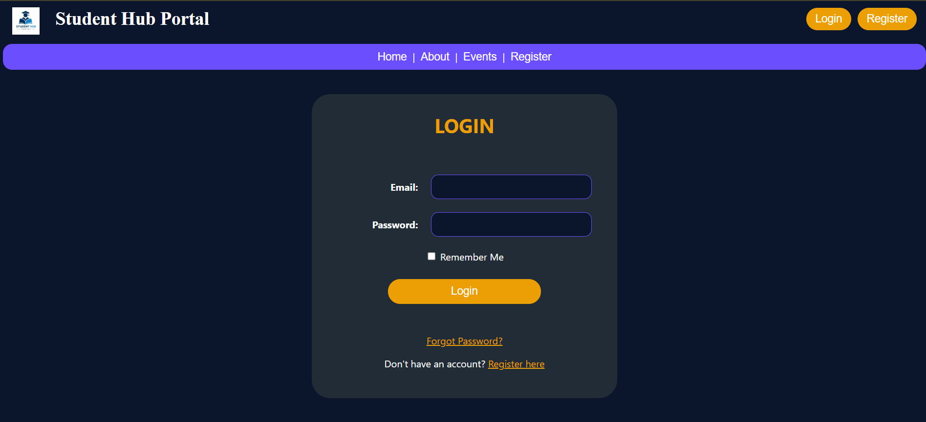

Student Registration Page (register.html)
Question: Create a student registration form that collects personal details, course information, gender, password confirmation, and terms acceptance before submission.
HTML Code - register.html
<!DOCTYPE html>
<html lang="en">
<head>
<meta charset="UTF-8">
<meta name="viewport" content="width=device-width, initial-scale=1.0">
<title>Student Hub Portal - Student Registration</title>
<link rel="stylesheet" href="style.css">
</head>
<body>

<header>
<div class="header">
<a href="index.html"><img src="logo.jpg" alt="Student Hub Portal Logo" height="45" style="vertical-align: middle; margin-right: 8px;"></a>
<strong style="margin: 10px;">Student Hub Portal</strong>
</div>
<div class="headerlinks">
<button><a href="login.html">Login</a></button>
<button><a href="register.html">Register</a></button>
</div>
</header>

<div class="navlinks">
<nav align="center">
<a href="index.html">Home</a> |
<a href="about.html">About</a> |
<a href="events.html">Events</a> |
<a href="login.html">Login</a>
</nav>
</div>

<main align="center" style="max-width: 600px; margin: 30px auto; padding: 10px;">
<div class="table1" style="padding: 30px;">
<h2 style="font-size: 32px; color: #EC9F05; margin-top: 0;">STUDENT REGISTRATION</h2>
<br>

<form action="dashboard.html">
<table cellpadding="8" align="center" style="width: 100%;">
<tr>
<td align="right" width="40%"><label for="name"><strong>Name:</strong></label></td>
<td align="left"><input type="text" id="name" required style="width: 100%;"></td>
</tr>
<tr>
<td align="right"><label for="email"><strong>Email:</strong></label></td>
<td align="left"><input type="email" id="email" required style="width: 100%;"></td>
</tr>
<tr>
<td align="right"><label for="mobile"><strong>Mobile:</strong></label></td>
<td align="left"><input type="tel" id="mobile" required style="width: 100%;"></td>
</tr>
<tr>
<td align="right"><label for="course"><strong>Course:</strong></label></td>
<td align="left"><input type="text" id="course" required style="width: 100%;"></td>
</tr>
<tr>
<td align="right"><label for="semester"><strong>Semester:</strong></label></td>
<td align="left"><input type="number" id="semester" required style="width: 100%;"></td>
</tr>
<tr>
<td align="right"><label><strong>Gender:</strong></label></td>
<td align="left">
<input type="radio" name="gender" id="male" value="male" required> <label for="male">Male</label>
&nbsp;&nbsp;
<input type="radio" name="gender" id="female" value="female"> <label for="female">Female</label>
</td>
</tr>
<tr>
<td align="right"><label for="password"><strong>Password:</strong></label></td>
<td align="left"><input type="password" id="password" required style="width: 100%;"></td>
</tr>
<tr>
<td align="right"><label for="confirm-password"><strong>Confirm Password:</strong></label></td>
<td align="left"><input type="password" id="confirm-password" required style="width: 100%;"></td>
</tr>
<tr>
<td colspan="2" align="center" style="padding-top: 10px;">
<input type="checkbox" id="terms" required>
<label for="terms">I accept the Terms &amp; Conditions</label>
</td>
</tr>
<tr>
<td colspan="2" align="center" style="padding-top: 15px;">
<button type="submit" style="width: 60%; padding: 10px; font-size: 18px;">Register</button>
</td>
</tr>
</table>

<br>
<p>
<a href="login.html" style="color: #EC9F05;">Already registered? Login here</a>
</p>
</form>
</div>
</main>

<br>

<div class="footer">
<footer align="center">
<p>Footer : <a href="about.html">About</a> | <a href="contact.html">Contact</a> | Copyright &copy; StudentHub Portal</p>
</footer>
</div>
</body>
</html>
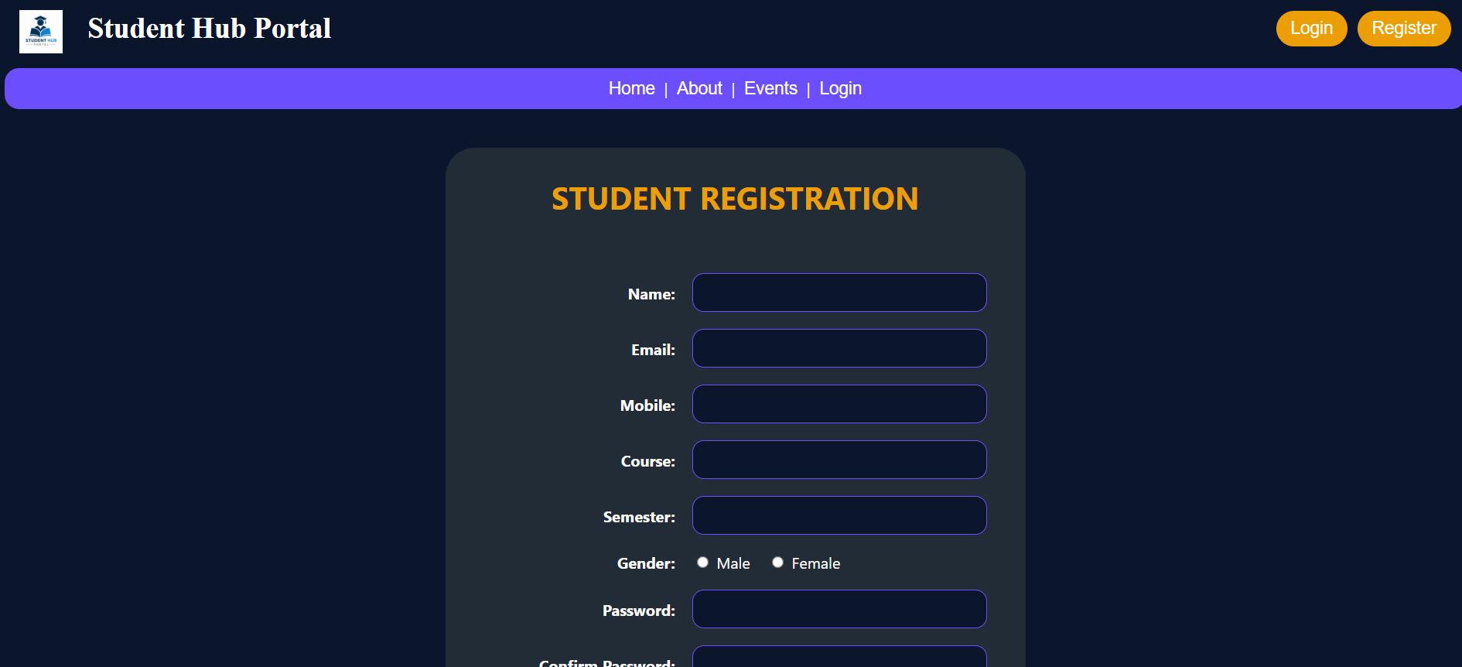
Dashboard Page (dashboard.html)
Question: Create the student dashboard page to display menu options, summary cards, upcoming events, and important notices after login.
HTML Code - dashboard.html
<!DOCTYPE html>
<html lang="en">

<head>
<meta charset="UTF-8">
<meta name="viewport" content="width=device-width, initial-scale=1.0">
<link rel="stylesheet" href="style.css">
<title>Student Hub Portal - Dashboard</title>
</head>

<body>

<header>
<div class="header">
<a href="index.html"><img src="logo.jpg" alt="Student Hub Portal Logo" height="45" style="vertical-align: middle; margin-right: 8px;"></a>
<strong style="margin: 10px;">Dashboard</strong>
</div>

<div class="headerlinks">
<button><a href="login.html">Logout</a></button>
</div>
</header>

<main>
<table width="100%" cellpadding="15">
<tr>
<td width="20%" valign="top">
<div class="table1" style="height: 650px;">
<div class="tablebutton">
<br>
<p><a href="index.html"><button >Home</button></a></p>
<p><a href="profile.html"><button>Profile</button></a></p>
<p><a href="events.html"><button>Events</button></a></p>
<p><a href="index.html"><button>Notices</button></a></p>
<p><a href="login.html"><button>Logout</button></a></p>
</div>
</div>
</td>

<td width="75%" valign="top">
<h1 align="center">Welcome Student</h1>
<br>

<div style="display: flex; gap: 15px;">
<div class="table1" style="flex: 1;">
<table width="100%" cellpadding="10">
<tr>
<td align="center">
<p style="font-size: 27px;">Total Events</p>
<h1>20</h1>
</td>
</tr>
</table>
</div>

<div class="table1" style="flex: 1;">
<table width="100%" cellpadding="10">
<tr>
<td align="center" style="height: 200px;">
<p style="font-size: 27px;">Registered</p>
<h1>5</h1>
</td>
</tr>
</table>
</div>
</div>

<br>
<div style="display: flex; gap: 15px;">
<div class="table1" style="flex: 1;">
<table width="100%" cellpadding="10" style="height: 180px;">
<tr>
<td>
<center>
<h2 style="font-size: 27px;">Upcoming Event</h2>
<p><strong>AI Workshop</strong></p>
</center>
</td>
</tr>
</table>
</div>

<br>

<div class="table1" style="flex: 1;">
<table width="100%" cellpadding="10" style="height: 180px;">
<tr>
<td>
<center>
<h2 style="font-size: 27px;">Latest Notice</h2>
<p>....</p>
</center>
</td>
</tr>
</table>
</div>
</div>
</td>
</tr>
</table>
</main>

<br>

<footer align="center">
<div class="footer">
<p>Footer : <a href="about.html">About</a> | <a href="contact.html">Contact</a> | Copyright &copy; StudentHub
Portal</p>
</div>
</footer>

</body>

</html>
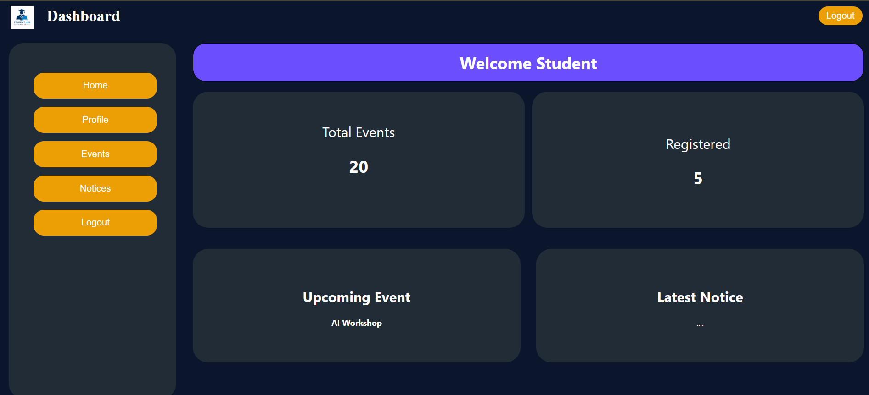
Profile Page (profile.html)
Question: Create the profile page to show the student photo area, personal details, and an Edit Profile button in a centered layout.
HTML Code - profile.html
<!DOCTYPE html>
<html lang="en">
<head>
<meta charset="UTF-8">
<meta name="viewport" content="width=device-width, initial-scale=1.0">
<title>Student Hub Portal - Profile</title>
<link rel="stylesheet" href="style.css">
</head>
<body>

<header>
<div class="header">
<a href="index.html"><img src="logo.jpg" alt="Student Hub Portal Logo" height="45" style="vertical-align: middle; margin-right: 8px;"></a>
<strong style="margin: 10px;">Student Hub Portal</strong>
</div>
<div class="headerlinks">
<button><a href="login.html">Logout</a></button>
</div>
</header>

<div class="navlinks">
<nav align="center">
<a href="index.html">Home</a> |
<a href="about.html">About</a> |
<a href="events.html">Events</a> |
<a href="dashboard.html">Dashboard</a>
</nav>
</div>

<main align="center" style="max-width: 500px; margin: 30px auto; padding: 10px;">
<div class="table1" style="padding: 30px;">
<!-- Profile Picture Circle Box -->
<div style="width: 120px; height: 120px; border-radius: 50%; background-color: #6B4EFD; color: white; display: flex; align-items: center; justify-content: center; margin: 0 auto; border: 3px solid #EC9F05; font-weight: bold; text-align: center;">
Profile<br>Picture
</div>

<hr style="border-color: #6B4EFD; margin: 20px 0;">

<table width="100%" cellpadding="8" style="text-align: left; font-size: 18px;">
<tr>
<td width="35%" style="color: #EC9F05;"><strong>Name :</strong></td>
<td>John Doe</td>
</tr>
<tr>
<td style="color: #EC9F05;"><strong>Email :</strong></td>
<td>john.doe@studenthub.edu</td>
</tr>
<tr>
<td style="color: #EC9F05;"><strong>Mobile :</strong></td>
<td>+1 987 654 3210</td>
</tr>
<tr>
<td style="color: #EC9F05;"><strong>Course :</strong></td>
<td>B.Tech Computer Science</td>
</tr>
<tr>
<td style="color: #EC9F05;"><strong>Semester :</strong></td>
<td>5th Semester</td>
</tr>
</table>

<br>
<button style="padding: 10px 25px; font-size: 18px;">Edit Profile</button>
</div>
</main>

<br>

<div class="footer">
<footer align="center">
<p>Footer : <a href="about.html">About</a> | <a href="contact.html">Contact</a> | Copyright &copy; StudentHub Portal</p>
</footer>
</div>
</body>
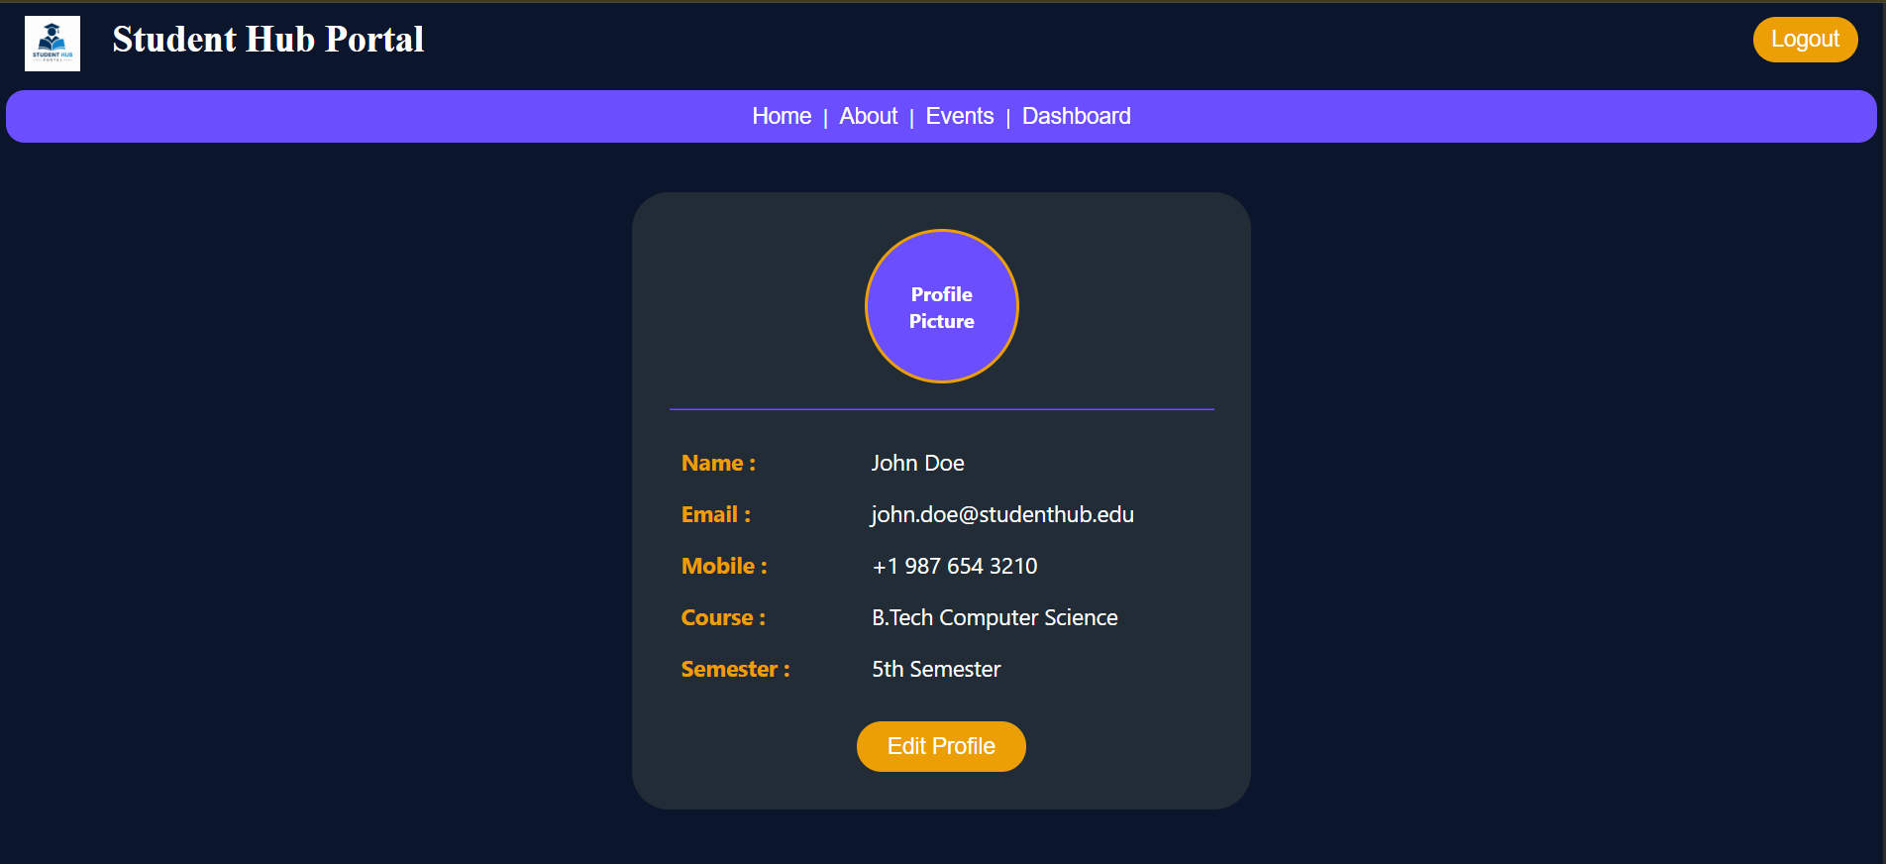
</html>

Admin Panel (admin.html)
Question: Create the admin panel page to show summary counters, recent activities, and navigation for administration tasks.
HTML Code - admin.html
<!DOCTYPE html>
<html lang="en">
<head>
<meta charset="UTF-8">
<meta name="viewport" content="width=device-width, initial-scale=1.0">
<title>Student Hub Portal - Admin Panel</title>
<link rel="stylesheet" href="style.css">
</head>
<body>

<header>
<div class="header">
<a href="index.html"><img src="logo.jpg" alt="Student Hub Portal Logo" height="45" style="vertical-align: middle; margin-right: 8px;"></a>
<strong style="margin: 10px;">Admin Panel</strong>
</div>
<div class="headerlinks">
<button><a href="login.html">Logout</a></button>
</div>
</header>

<div class="navlinks">
<nav align="center">
<a href="admin.html">Dashboard</a> |
<a href="events.html">Events</a> |
<a href="index.html">Home</a>
</nav>
</div>

<main style="max-width: 1000px; margin: 20px auto; padding: 10px;">

<!-- Stats Grid -->
<div style="display: flex; gap: 15px; flex-wrap: wrap;">
<div class="table1" style="flex: 1; text-align: center; min-width: 200px; padding: 20px;">
<h3 style="font-size: 22px; color: #EC9F05; margin: 0;">Students</h3>
<h1 style="font-size: 42px; margin: 10px 0 0 0;">250</h1>
</div>
<div class="table1" style="flex: 1; text-align: center; min-width: 200px; padding: 20px;">
<h3 style="font-size: 22px; color: #EC9F05; margin: 0;">Events</h3>
<h1 style="font-size: 42px; margin: 10px 0 0 0;">12</h1>
</div>
<div class="table1" style="flex: 1; text-align: center; min-width: 200px; padding: 20px;">
<h3 style="font-size: 22px; color: #EC9F05; margin: 0;">Feedback</h3>
<h1 style="font-size: 42px; margin: 10px 0 0 0;">18</h1>
</div>
<div class="table1" style="flex: 1; text-align: center; min-width: 200px; padding: 20px;">
<h3 style="font-size: 22px; color: #EC9F05; margin: 0;">Notices</h3>
<h1 style="font-size: 42px; margin: 10px 0 0 0;">7</h1>
</div>
</div>

<br>

<!-- Recent Activities Card -->
<div class="table1" style="padding: 25px;">
<h3 style="font-size: 26px; color: #EC9F05; margin-top: 0;">Recent Activities</h3>
<ul style="font-size: 18px; line-height: 1.8;">
<li>Student Registered</li>
<li>Event Added</li>
<li>Feedback Submitted</li>
</ul>
</div>

</main>

<br>

<div class="footer">
<footer align="center">
<p>Footer : <a href="about.html">About</a> | <a href="contact.html">Contact</a> | Copyright &copy; StudentHub Portal</p>
</footer>
</div>
</body>
</html>

Common Stylesheet (style.css)
Question: Create the external stylesheet used across the Student Hub Portal pages so the navigation, buttons, cards, forms, and footer share one consistent visual style.
CSS Code - style.css
/* User Defined Color Theme & Global Styles */
body {
background-color: #0B162C;
color: white;
font-family: system-ui, -apple-system, BlinkMacSystemFont, 'Segoe UI', Roboto, sans-serif;
margin: 0;
padding: 0;
}

/* Header Styles */
.header {
vertical-align: middle;
margin-right: 20px;
font-family: serif;
font-size: 30px;
padding: 10px 20px;
}

.headerlinks {
position: absolute;
top: 11px;
right: 20px;
display: flex;
gap: 10px;
}

.headerlinks button {
background-color: #EC9F05;
color: white;
border: none;
border-radius: 20px;
font-size: 18px;
padding: 8px 15px;
cursor: pointer;
}

.headerlinks table tr td button a {
background-color: #EC9F05;
color: white;
border: none;
border-radius: 20px;
font-size: 18px;
padding: 8px 15px;
}

.headerlinks a {
color: white;
text-decoration: none;
font-size: 18px;
}

/* Navigation Bar */
.navlinks {
background-color: #6B4EFD;
justify-content: center;
margin: 5px;
padding: 10px;
border-radius: 15px;
}

.navlinks button {
background-color: #6B4EFD;
border-radius: 20px;
margin: 5px;
}

.navlinks a {
font-family: sans-serif;
color: white;
font-size: 18px;
text-decoration: none;
border-color: #DAF264;
margin: 0 5px;
}

.navlinks a:hover {
color: #DAF264;
text-decoration: underline;
}

/* Main Hero Banner */
.main {
text-align: center;
height: 175px;
border-radius: 40px;
margin: 20px 180px 20px 180px;
background-color: #6B4EFD;
border: 1px solid black;
padding: 20px;
}

/* Cards and Boxes */
.box {
text-align: center;
width: 33%;
height: 270px;
background-color: #212C37;
border-radius: 25px;
border: 1px solid black;
padding: 10px;
justify-content: center;
}

.boxes2 {
text-align: center;
width: 50%;
height: 240px;
background-color: #212C37;
border-radius: 25px;
border: 1px solid black;
padding: 10px;
justify-content: center;
}

.table1 {
background-color: #212C37;
border-radius: 30px;
padding: 20px;
margin-bottom: 20px;
}

.t1 {
font-size: 20px;
margin-bottom: 8px;
}

.t1links a {
font-size: 20px;
margin-bottom: 8px;
text-decoration: none;
color: white;
display: inline-block;
}

.t1links a:hover {
color: #EC9F05;
text-decoration: underline;
}

/* Sidebar buttons */
.tablebutton p a button {
background-color: #EC9F05;
color: white;
border: none;
border-radius: 20px;
font-size: 18px;
padding-bottom: 15px;
padding-top: 15px;
width: 84%;
margin-left: 10%;
margin-right: 10%;
cursor: pointer;
}

.tablebutton p a button:hover {
background-color: #d88e04;
}

/* General Buttons and Form Inputs */
button {
background-color: #EC9F05;
color: white;
border: none;
border-radius: 20px;
font-size: 16px;
padding: 8px 18px;
cursor: pointer;
transition: background-color 0.2s;
}

button:hover {
background-color: #d88e04;
}

input[type="text"],
input[type="email"],
input[type="password"],
input[type="number"],
input[type="tel"],
textarea {
background-color: #0B162C;
color: white;
border: 1px solid #6B4EFD;
border-radius: 12px;
padding: 10px 14px;
font-size: 16px;
outline: none;
box-sizing: border-box;
}

input[type="text"]:focus,
input[type="email"]:focus,
input[type="password"]:focus,
input[type="number"]:focus,
input[type="tel"]:focus,
textarea:focus {
border-color: #EC9F05;
}

label {
font-size: 16px;
color: white;
}

a {
color: #EC9F05;
}

a:hover {
text-decoration: underline;
}

/* Footer Styles */
.footer {
background-color: #212C37;
height: 50px;
font-size: 20px;
padding-bottom: 15px;
padding-top: 15px;
border-radius: 50px;
margin-top: 20px;
}

.footer p {
margin: 0;
}

.footer p a {
text-decoration: none;
color: aliceblue;
background-color: #EC9F05;
border-radius: 20px;
font-size: 18px;
padding: 6px 12px;
margin: 0 4px;
}

.footer p a:hover {
background-color: #d88e04;
}

