Name: Taksim Islam Humber Id: N01523847

GitHub:

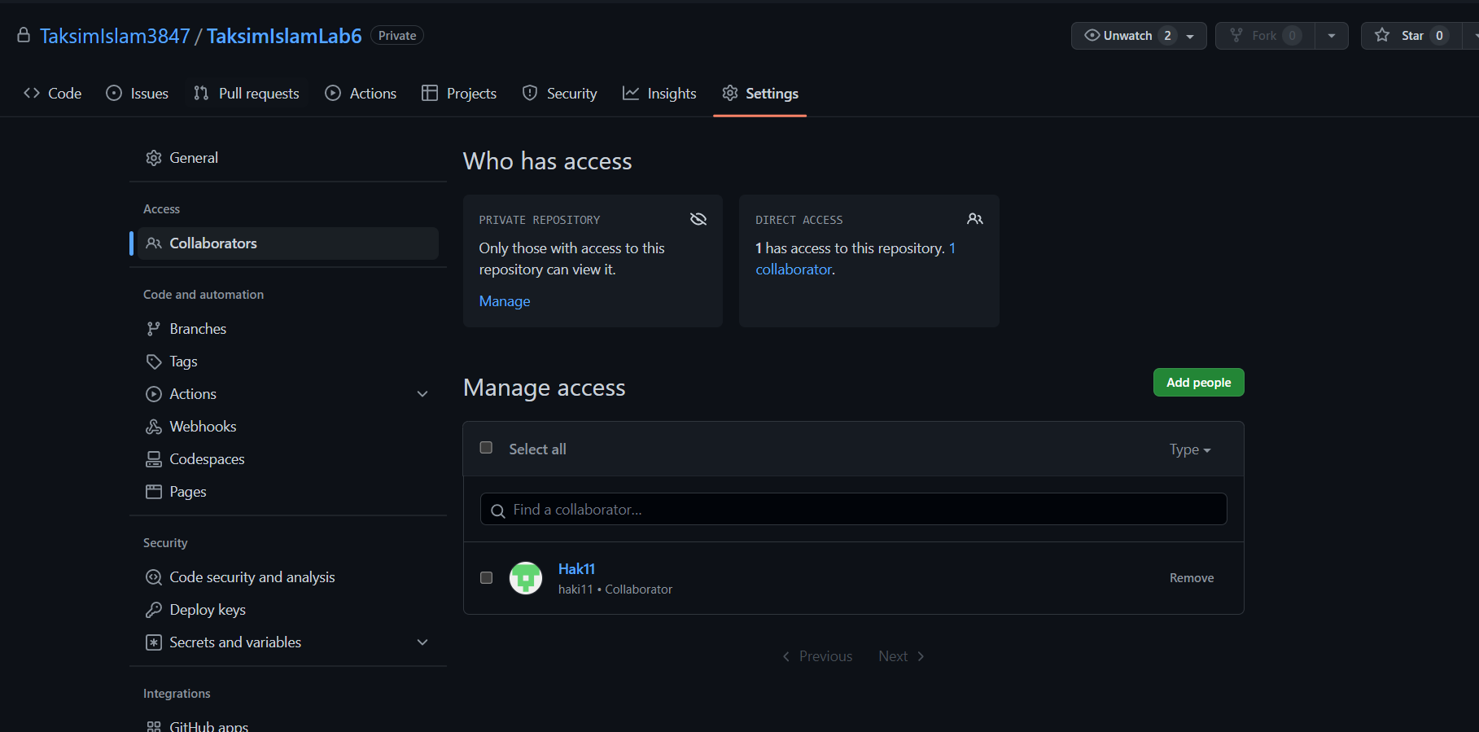

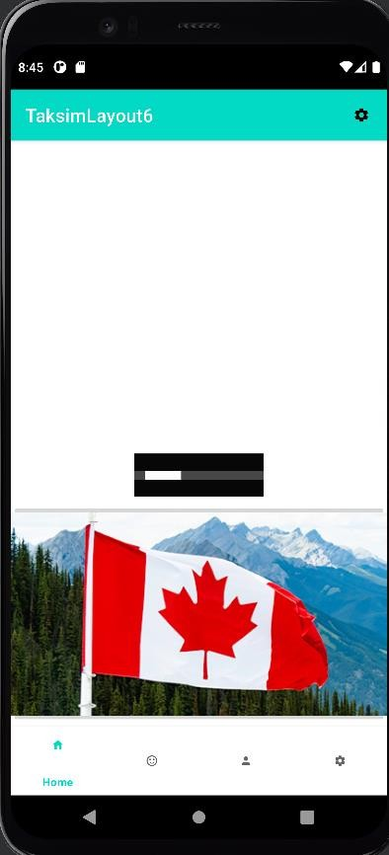

First Screen with image button and progress bar

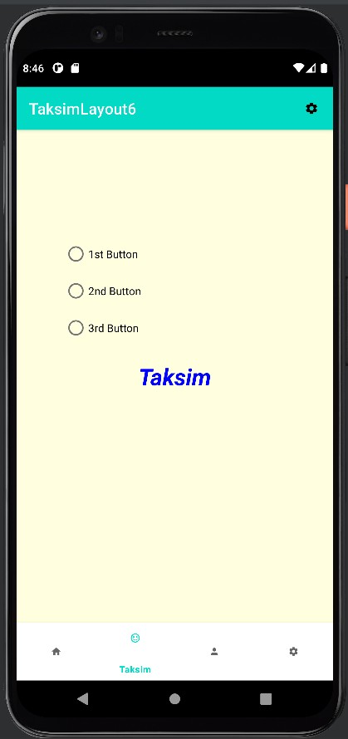

2nd page with three radio button with radio group

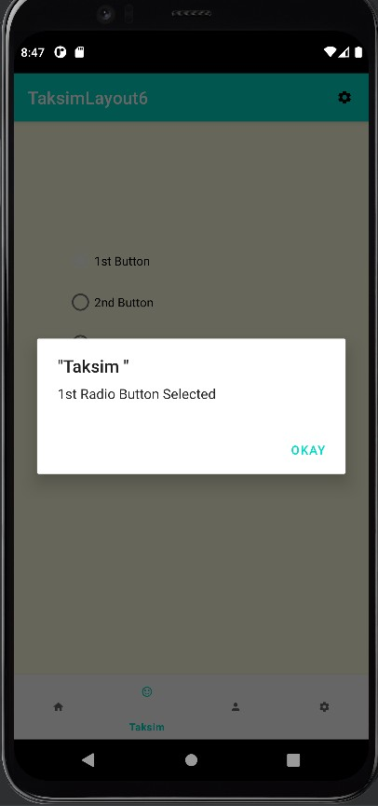

Alert Dialog with radio button seleted