2020/08/07

Taku Yonemoto

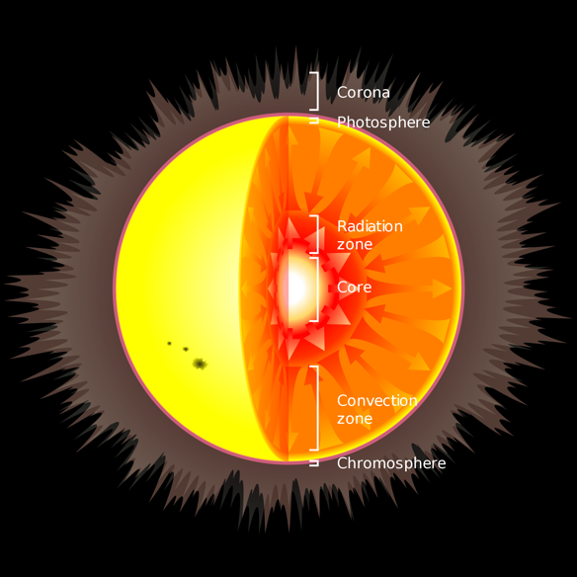**Why is the Sun’s Corona So Hot?**

Observational studies of the sun have been conducted since ancient times, beginning with the sketched observations of sunspots by Galileo Galilei about 400 years ago.

However, many features of the sun, such as the mystery of the hotness of the solar corona, are unsolved. The corona is the place where flares, or solar surface explosions, cause sudden energy release (Fig.1), and these mass ejections are closely related to the occurrence of magnetic storms on Earth.

Fig.1 The Sun’s structure

Although the reason is unknown, the sun’s corona is hotter by a factor 150~450 than the effective temperature of the surface of the sun. The photosphere’s average temperature is 5,800 Kelvin, while the corona is 1-3 million Kelvin. Because the density of the corona is 10-12 times lower than the photosphere, the corona produces 10-6 times as much visible light as the photosphere, so the corona can be observed well with soft X-rays. The corona is separated from the photosphere by the relatively shallow chromosphere. The thin region in which the temperature increases is known as the transition region, which ranges from only tens to hundreds of kilometers thick. The amount of power required to heat the corona can be easily calculated as the difference between coronal radiative losses and heating by thermal conduction toward the chromosphere through the transition region. It is about one kilowatt for every square meter of surface area on the sun's chromosphere, or 1/40000 of the amount of light energy that escapes the sun. Energy cannot be transferred from the cooler photosphere to the corona by conventional heat transfer as this would violate the second law of thermodynamics. An analogy would be a light bulb raising the temperature of the air surrounding it to something greater than its glass surface. Hence, some other manner of energy transfer must be involved in the heating of the corona. Many coronal heating theories have been proposed, but two theories have emerged as the most likely candidates: *wave heating* and *magnetic reconnection* (or nanoflares).

*Wave heating theory* was proposedin 1949 by Evry Schatzman, where waves carry energy from the solar interior to the solar chromosphere and corona.[2] The sun is made of plasma rather than ordinary gas, so it supports several types of waves analogous to sound waves in air. The most important types of waves are magneto-acoustic waves and Alfvén waves. Magneto-acoustic waves are sound waves that have been modified by the presence of a magnetic field, and Alfvén waves are similar to ultra-low frequency radio waves that have been modified by interactions with matter in the plasma. Both types of waves can be launched by the turbulence of granulation and super granulation at the solar photosphere, and they can carry energy for some distance through the solar atmosphere before turning into shock waves that dissipate their energy as heat.

*The Magnetic reconnection theory* is hypothesized to be the mechanism behind solar flares, the largest explosions in the solar system.[3] Furthermore, the surface of the sun is covered with millions of small magnetized regions that are 50–1000 km across. These small magnetic poles are buffeted and churned by constant granulation. The magnetic field in the solar corona must undergo nearly constant reconnection to match the motion of this "magnetic carpet", so the energy released by the reconnection is a natural candidate for increasing the coronal heat, perhaps as a series of "microflares" that individually provide very little energy but together account for the required energy. The idea that nanoflares might heat the corona was proposed by Eugene Parker in the 1980s and remains controversial.

Both of these ideas cannot fully explain observations. It is believed that the fundamental sources of the corona heating and activity are the sun’s surface (the photosphere) below the corona and the convective layer below the photosphere. In the photosphere, vigorous gas movement due to convection occurs and the magnetic field lines generated from the surface will be twisted or mixed by the intense convection motion. As a result, magnetic fluid waves may be excited by the lines of magnetic force, or the lines of magnetic force may be cluttered by the corona in the sky, resulting in the formation of many discontinuous surfaces. Understanding phenomena will give us the key to solving the mystery of corona heating.

Recently, as astronauts have more opportunities to work in outer space, such as for the construction of the International Space Station, the importance of understanding the space environment is increasing. Investigation of the sun’s corona will help us to know more about the environment between the sun and the earth, and perhaps forecast the “space weather” near the earth.

References

[1] Schatzman, E. (1949) The heating of the solar corona and chromosphere. *Annales d'Astrophysique*, **12**, 203-218.

[2] Malara, F.; Velli, M. (2001). Observations and Models of Coronal Heating. *Symposium - International Astronomical Union*, **203**, 456-466. doi:10.1017/S0074180900219785