Creating a world length calculator.

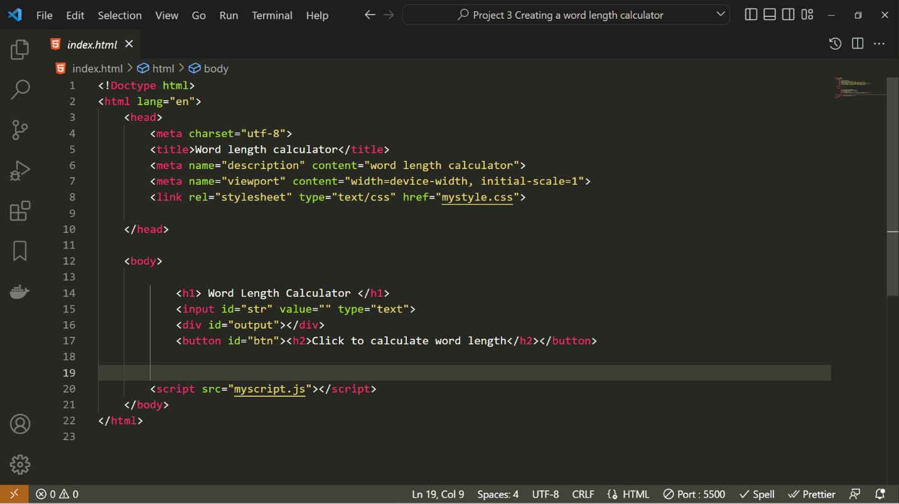HTML:

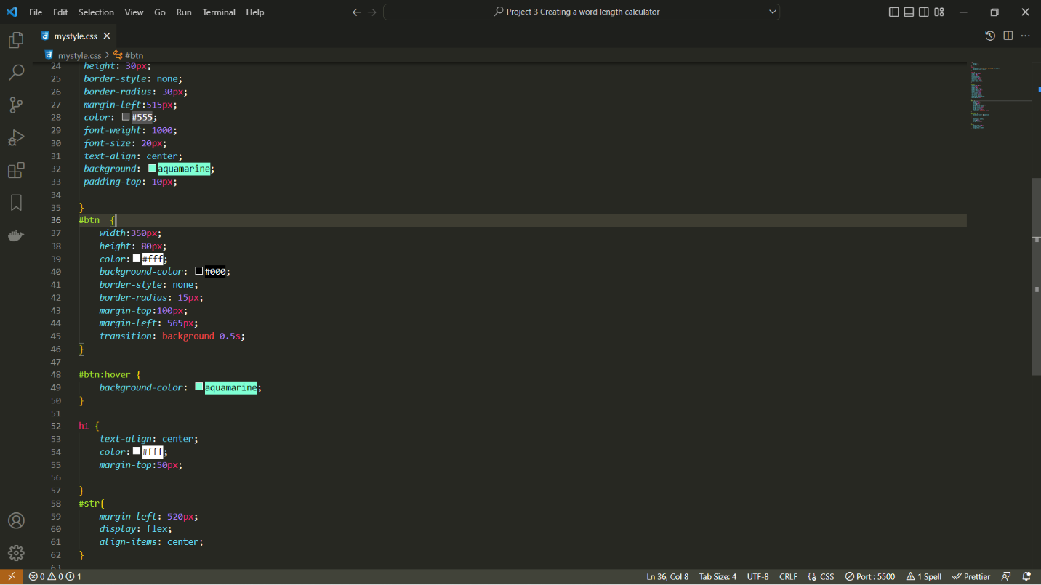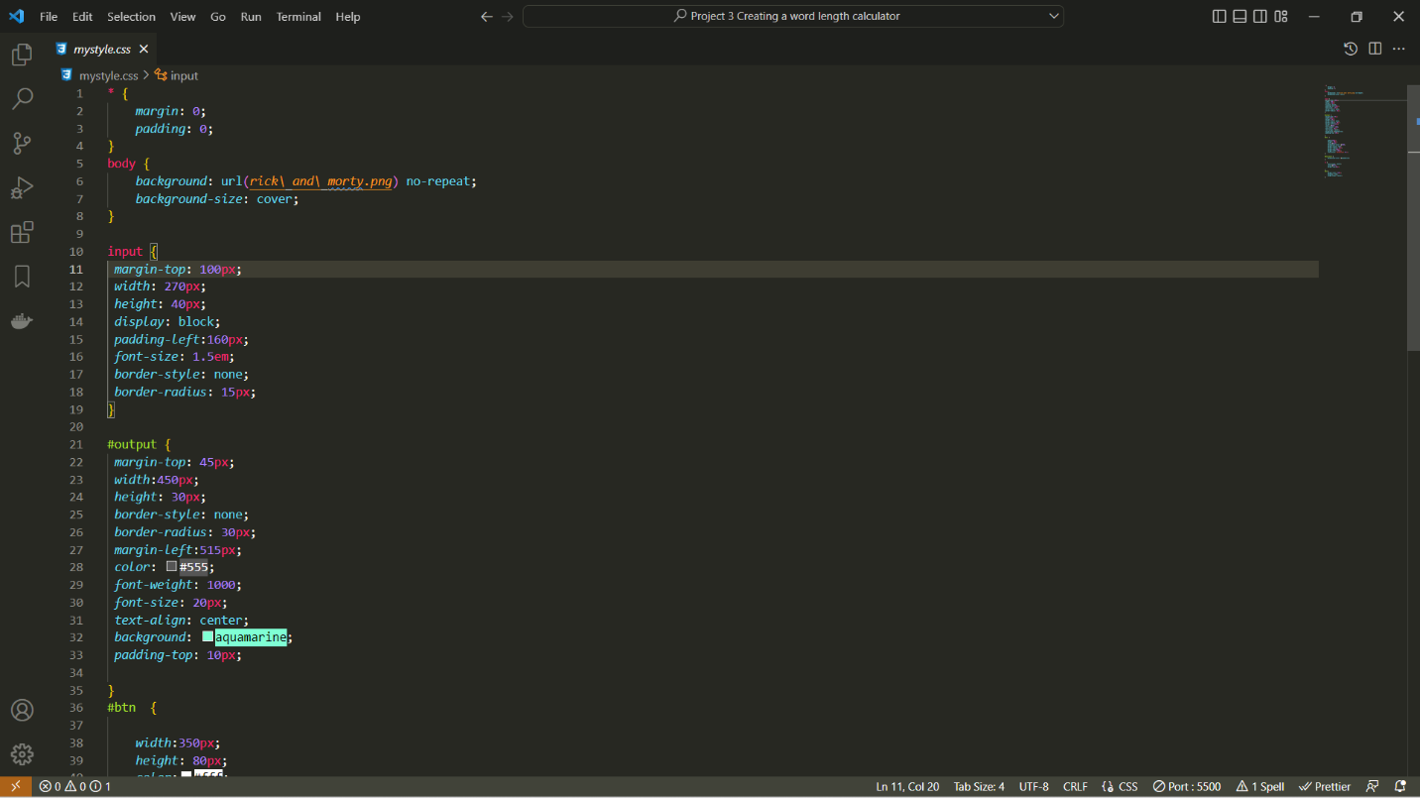CSS:

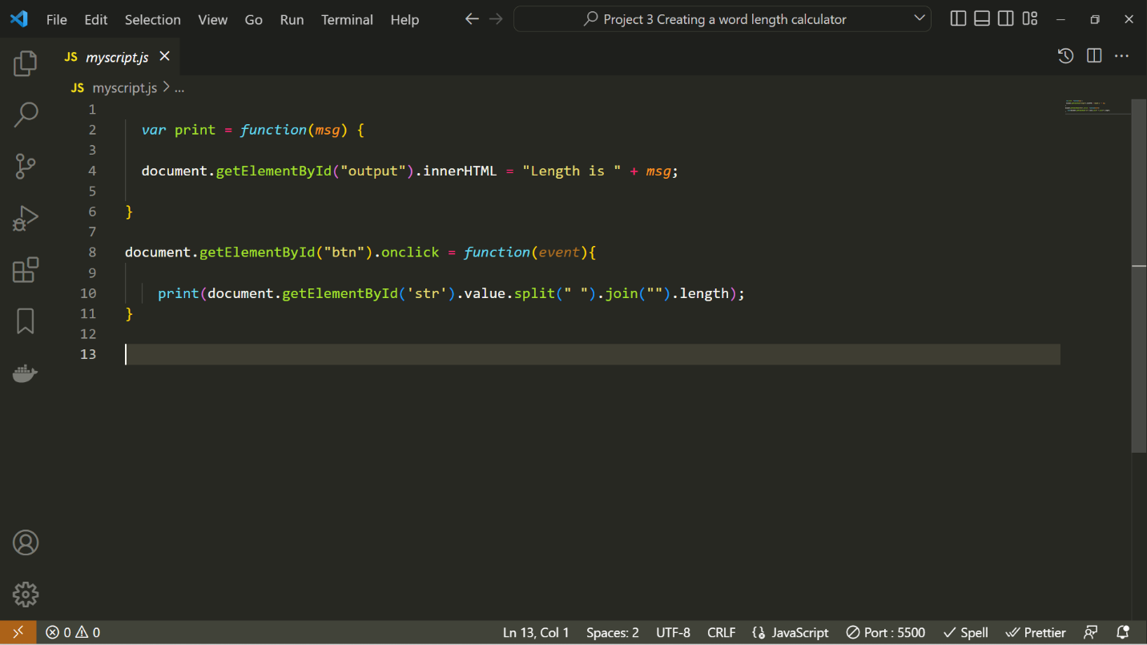JavaScript:

In the var print = function(msg)

The document.getElementById(“output”).innerHTML looks for the string with the id (“output”) from the html and attaches “Length is “ + the argument when the function is called.

In the document.getElementById(“btn”).onclick looks for the string with the id(“btn”) from the html when it is clicked upon.

Now the within the print function the document.getElementById(‘str’) looks for the id (‘str’) and first the split(“ ”) splits the word where " " is present and puts them into an array. Second the join("") function as, its name states, joins the elements of the array together. Now due to this ->("") it joins the elements together with no space between them.