BUSINESS REQUIREMENTS DOCUMENT
BRD-EDR-001

Blockchain-Based Electronic Dental Record (EDR)
Sharing and Management System

OpenUAE Research & Development Group - University of Sharjah

Document ID | BRD-EDR-001
Version | 1.0
Date | March 2025
Project | Blockchain-Based EDR System
Prepared by | Takua Mokhamed
Status | Final

1. Executive Summary
The Blockchain-Based Electronic Dental Record (EDR) Sharing and Management System is a fully implemented, decentralized healthcare information platform developed at the University of Sharjah. The system leverages Hyperledger Fabric, a permissioned enterprise blockchain framework, to enable secure, interoperable, and patient-consented sharing of dental records across multiple dental clinics and healthcare organizations.

Traditional centralized EDR systems suffer from data fragmentation, lack of interoperability, single points of failure, and unauthorized access vulnerabilities. This system directly addresses these challenges by providing a tamper-evident, auditable, and consent-driven data exchange mechanism that places patients in control of their own health information.

The platform has been fully implemented and benchmarked using Hyperledger Caliper, demonstrating a peak read throughput of 43.5 TPS with negligible latency. The system is fully compliant with HIPAA and GDPR principles through its role-based access control, on-chain/off-chain hybrid data architecture, and patient-driven consent workflow.

2. Business Context and Problem Statement

2.1 Background
In modern dental healthcare, patient records span multiple clinics, specialists, and institutions throughout a patient's lifetime. The lack of interoperability between existing Electronic Dental Record (EDR) systems results in fragmented patient histories, redundant diagnostic procedures (e.g., repeated radiography), increased treatment costs, and delayed care. Centralized database architectures are vulnerable to unauthorized access, data breaches, and represent single points of failure.

2.2 Problem Statement
The core business problem is the absence of a secure, interoperable, and patient-consented mechanism for dental record sharing between dental institutions. Specific pain points include:
- Dentists cannot access a patient's comprehensive dental history when the patient visits from another clinic.
- Patients must undergo repeated diagnostic tests due to unavailability of prior records.
- Centralized systems create single points of failure and are prone to data breaches.
- There is no enforced patient consent mechanism for inter-organizational data sharing.
- Audit trails for data access are non-existent or easily manipulated in legacy systems.

2.3 Business Objectives
The system is designed to meet the following key business objectives:
- Enable secure, cross-institutional dental record sharing with full patient consent.
- Eliminate data redundancy and fragmentation through a unified, blockchain-backed patient record system.
- Enforce role-based access control (RBAC) for all clinical and administrative operations.
- Maintain a tamper-evident, immutable audit log of all data access and consent transactions.
- Ensure compliance with HIPAA, GDPR, and applicable UAE healthcare data regulations.
- Deliver a performant and scalable system capable of handling multi-clinic transaction loads.

2.4 Business Scope
The system spans the following functional domains within the dental healthcare sector:
- Patient registration and record management across dental clinics.
- Doctor and administrator onboarding and role assignment.
- Inter-organizational dental data access with a three-tier approval workflow.
- Patient consent management via a dedicated mobile application.
- Appointment scheduling and clinical documentation management.
- Performance-verified blockchain transaction processing.

3. Stakeholders and User Roles
The system defines three primary actors, each with specific permissions and responsibilities enforced through blockchain smart contracts and JWT-based role validation:

Actor | Role Type | Key Responsibilities
Administrator | System Authority | Register patients/doctors, approve/reject inter-clinic data access requests, view audit logs, manage appointments and clinic associations.
Doctor / Dentist | Clinical User | View assigned patient records, add/update medical and dental history, submit clinical record, initiate data access requests to other institutions.
Patient | Data Owner | Approve or deny data sharing requests via mobile app, view own medical and dental records, review past and upcoming appointments, manage consent preferences.
Dental Clinic / Organization | Participating Node | Operates a peer node in the Hyperledger Fabric network, maintains its own Certificate Authority (CA), participates in shared consensus and data sharing channels.

4. Business Requirements

4.1 Functional Business Requirements

4.1.1 Patient Management
- The system shall allow administrators to register new patients, capturing demographics, contact details, medical and dental history, insurance information, and clinic associations.
- Patient records shall be uniquely identifiable across all participating organizations.
- The system shall allow administrators to update or deactivate patient records as needed.

4.1.2 Doctor Management
- Administrators shall be able to register doctors with their specialization, clinic affiliation, and contact information.
- Doctors shall be assigned to specific patients within their clinic by the administrator.
- Doctors shall be able to view only the patients assigned to them.

4.1.3 Clinical Record Management
- Doctors shall be able to add and update medical records, including medical history, allergies, medications, and lab results.
- Doctors shall be able to add and update dental chart entries, including treatment phases, procedure codes, diagnostic images, and prescriptions.
- All clinical data shall be stored in the off-chain MySQL database, with cryptographic hashes stored on-chain for integrity verification.
- DICOM and radiographic files shall be stored off-chain, with their SHA-256 hash referenced on-chain.

4.1.4 Cross-Institutional Data Sharing
- A doctor from any participating clinic shall be able to initiate a data access request for a patient whose records are held at another clinic.
- All data access requests must be approved by the patient-holding clinic's administrator before proceeding to the patient.
- Patients must explicitly provide consent before any data is shared with the requesting clinic.
- The three-tier approval process (Doctor Request → Admin Approval → Patient Consent) shall be enforced by smart contracts on the blockchain.
- Approved data access shall be time-bound and logged immutably on the blockchain ledger.

4.1.5 Appointment Management
- Administrators shall be able to create, update, and manage patient appointments.
- Patients shall be able to view their upcoming and past appointments via the mobile application.

4.2 Non-Functional Business Requirements

ID | Category | Requirement
NFR-01 | Security | All data access must be authenticated via JWT tokens signed with Hyperledger Fabric MSP certificates.
NFR-02 | Privacy | No Personally Identifiable Information (PII) shall be stored directly on the blockchain.
NFR-03 | Compliance | The system shall comply with HIPAA and GDPR principles for healthcare data management.
NFR-04 | Performance | Read operations shall support at least 40 TPS, write operations shall achieve at least 20 TPS under a load of 200 transactions.
NFR-05 | Availability | The system shall tolerate individual peer node failures through dual-peer fault-tolerance per organization.
NFR-06 | Auditability | All consent, access, and record-modification transactions shall be permanently and immutably recorded on the blockchain.
NFR-07 | Usability | Web and mobile interfaces shall comply with WCAG 2.1 accessibility guidelines.
NFR-08 | Scalability | The architecture shall support onboarding of additional dental clinic organizations without degrading performance.

5. Business Process Flows

5.1 Patient Registration Flow
- Administrator logs in to the web application and navigates to Patient Management.
- Administrator submits patient details (demographics, medical history, dental history, insurance).
- The application service layer calls the addPatient chaincode function via the Fabric SDK.
- The patient record is registered on the blockchain ledger, detailed data is stored in the MySQL database.
- A cryptographic reference linking the patient ID to their off-chain data is stored on-chain.

5.2 Cross-Institutional Data Sharing Flow (Three-Tier Consent)
STEP 1: Request: A doctor from Clinic B submits a data access request for a patient registered at Clinic A via the web portal.
STEP 2 : Blockchain Logging: The RequestDataAccess chaincode function is executed, the request is recorded immutably on the blockchain ledger.
STEP 3: Admin Review: The administrator of Clinic A receives a notification and reviews the request. The admin approves or rejects using the ApproveRequest or RejectRequest chaincode function.
STEP 4: Patient Notification: If approved by the admin, the patient at Clinic A receives a push notification on their mobile application detailing the requesting clinic, doctor, and purpose.
STEP 5: Patient Consent: The patient grants or denies consent using the ProvideConsent or RejectConsent chaincode function. The consent decision is recorded on-chain with a timestamp and cryptographic signature.
STEP 6: Data Access: If all approvals are obtained, Clinic B's doctor is granted access to the patient's records. The access is logged via the LogAccess chaincode function.

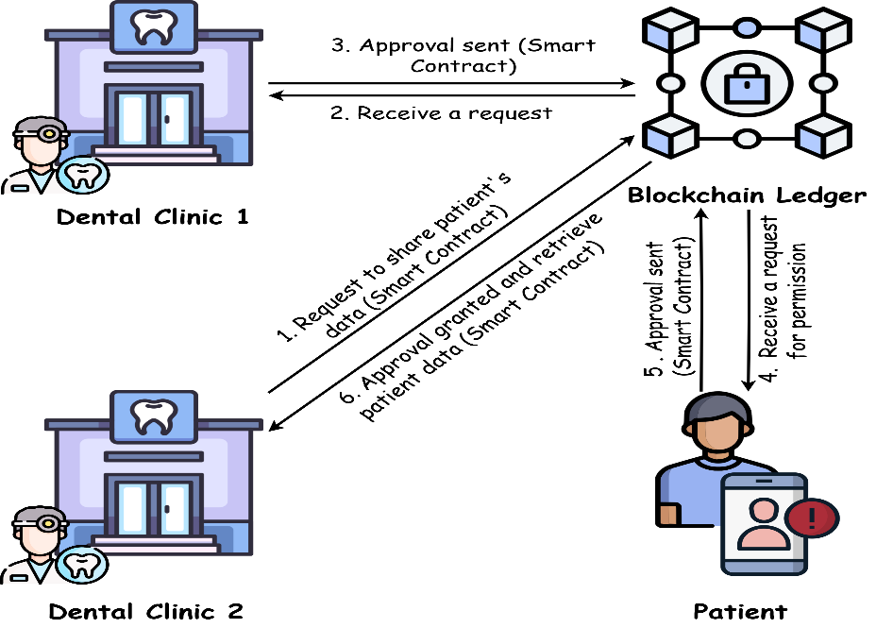
Fig. 1. Consent-driven data sharing process between dental clinics using blockchain. The process involves smart contract execution and explicit patient approval for accessing electronic dental records (EDRs) across organizational boundaries.

5.3 Clinical Record Update Flow
- Doctor logs in and navigates to the assigned patient's profile.
- Doctor adds or updates medical history, dental chart, or lab results.
- Data is submitted to the Node.js API, which stores detailed clinical data in MySQL.
- A SHA-256 hash of the uploaded file or record is computed and stored on-chain via AddMedicalRecord or AddDentalChartEntry chaincode.
- Any future verification of data integrity checks the hash on-chain against the off-chain content.

6. Constraints and Assumptions

6.1 Constraints
- The system operates on a permissioned Hyperledger Fabric network, public or anonymous access is not supported.
- All participating organizations must operate peer nodes and Certificate Authorities within the Fabric network.
- DICOM and large radiographic files are stored off-chain due to blockchain payload size limitations.
- System setup requires Docker, Node.js, and Hyperledger Fabric 2.5 or later.

6.2 Assumptions
- Each participating dental clinic has the technical capacity to operate a Hyperledger Fabric peer node.
- Patients have access to a mobile device capable of running the React Native patient application.
- All users have valid digital certificates issued by their organization's Certificate Authority.
- Internet connectivity is available for real-time blockchain transaction submission.

7. Glossary
Term | Definition
EDR | Electronic Dental Record - a digital record of a patient's dental health information.
EHR | Electronic Health Record - a comprehensive digital record of a patient's health history.
Hyperledger Fabric | An enterprise-grade permissioned blockchain framework maintained by the Linux Foundation.
Chaincode | Smart contracts in Hyperledger Fabric that encode business rules for data access and management.
MSP | Membership Service Provider - manages identity and access policies in Hyperledger Fabric.
CA | Certificate Authority - issues digital certificates for network participants.
JWT | JSON Web Token - used for stateless user authentication in the application service layer.
TPS | Transactions Per Second - a measure of blockchain throughput performance.
HIPAA | Health Insurance Portability and Accountability Act - US healthcare data privacy regulation.
GDPR | General Data Protection Regulation - EU data privacy and protection regulation.
RBAC | Role-Based Access Control - restricts system access based on user roles.
DICOM | Digital Imaging and Communications in Medicine - standard for dental/medical imaging files.
IPFS | InterPlanetary File System - decentralized file storage considered for off-chain large files.

