TESTING DELIVERABLES SPECIFICATION
Output Artefacts · Formats · Sample Templates · Field Definitions

Blockchain-Based Electronic Dental Record (EDR) System

Prepared for: Synergic Professionals
University of Sharjah - OpenUAE R&D

Prepared by | Takua Mokhamed
Supervisors | Dr. Manar Abu Talib, Prof Qassim
Testing Partner | Synergic Professionals
Version | 1.0 - Detailed Specification
Duration | 6–8 weeks

Purpose of this document: This document specifies exactly what each deliverable must contain, the required file formats, the column and field definitions for every report, and sample templates. It supersedes the earlier artefacts discussion document and is intended as the binding reference for Synergic Professionals during execution.

1. Context: A Benchmarking Framework for Blockchain-Based Dental Applications
Dental Applications

This testing engagement is designed to serve two purposes simultaneously. The first is to provide independent external validation and enhancements of the Blockchain-Based EDR system developed at the University of Sharjah. The second, and broader, purpose is to produce the foundational artifacts of a reusable Benchmarking and Evaluation Framework for blockchain-based dental applications, referred to throughout this document as the BDF Framework.

The BDF Framework is intended to be generalizable: any researcher or developer building a blockchain-based dental application should be able to apply the same evaluation method, use the same workload profiles and compliance matrix, and produce a score that is directly comparable to the results produced here. The deliverables you produce during this engagement are the first validated instance of that framework.

What this means for Synergic Professionals: The deliverables you produce are not just a testing report for one system. They are the first validated instance of a domain-level benchmarking framework. The workload profiles you define, the compliance matrix you complete, and the scoring data you generate will be published as a reusable toolkit. Your deliverables must therefore be thorough, reproducible, and documented at a level suitable for academic citation.

1.1 The Five Evaluation Dimensions
The BDF Framework evaluates any blockchain-based dental application across five dimensions. The diagram below shows each dimension, its key metrics, the tool or method used, and its proposed weight in the overall readiness score.

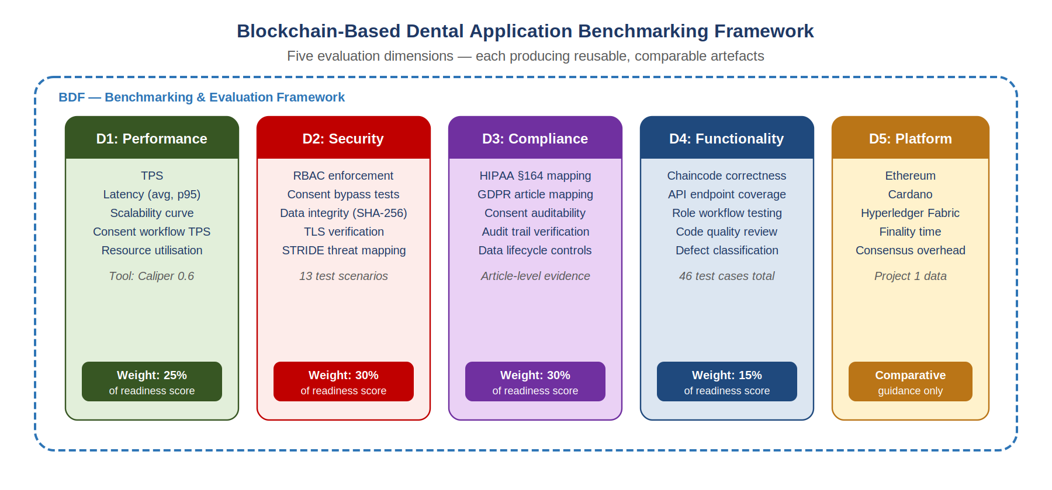
Figure 1. BDF Framework: five evaluation dimensions, key metrics, and proposed readiness score weights

1.2 Testing Workflow: From Input to Framework Artifact
The diagram below shows how each testing activity in this engagement maps from input data through test execution to a generalizable framework artifact, and ultimately to the BDF Toolkit, a public GitHub repository containing all scripts, templates, and scoring tools. Note, the caliper tool is only an example, and any other tool can be used for testing blockchain network performance.

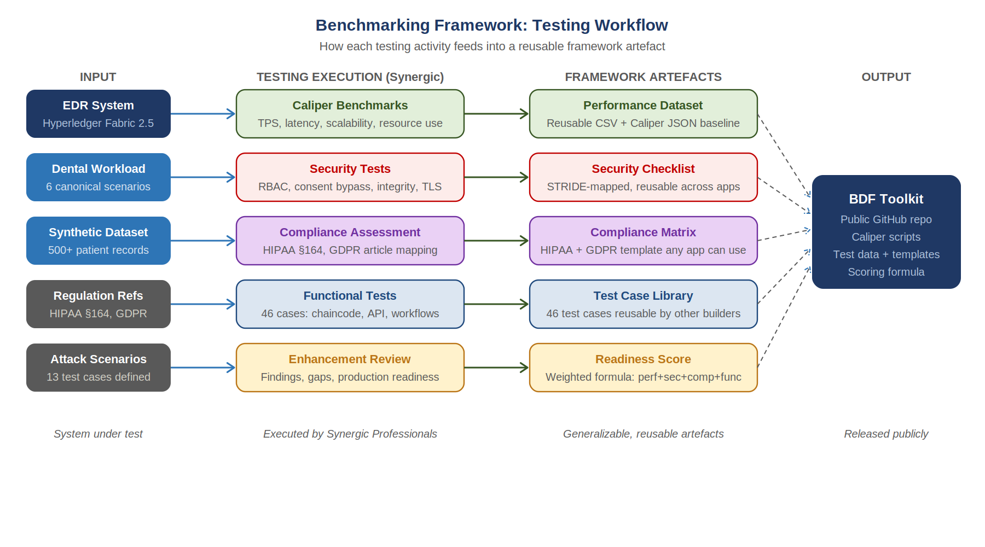
Figure 2. BDF Framework testing workflow: inputs, Synergic execution, reusable artifacts, and toolkit output

1.3 The Readiness Score Formula
The framework produces a single comparable readiness score by combining the four measurable dimensions using the weighted formula shown below. A system scoring above 70 out of 100 is considered ready for pilot deployment. A score above 85 indicates production readiness.

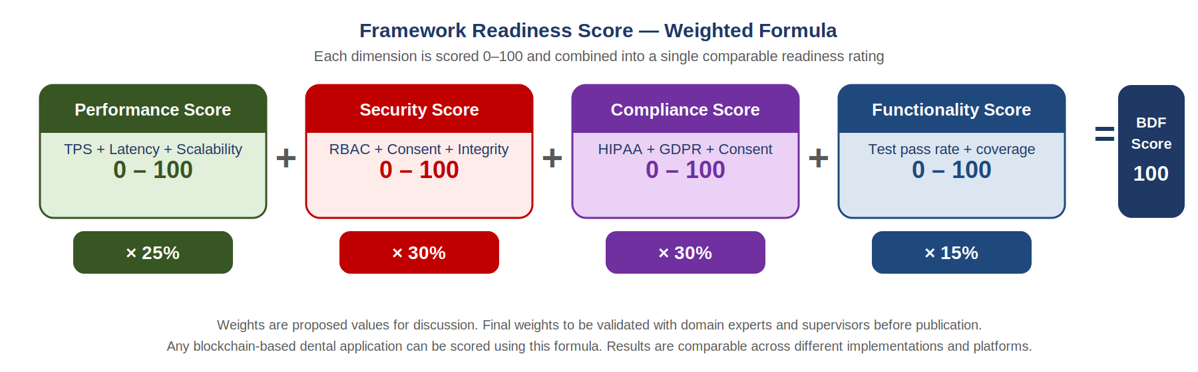
Figure 3. BDF Readiness Score formula: weighted combination of Performance (25%), Security (30%), Compliance (30%), and Functionality (15%)
The weights shown are the proposed values to be validated with domain experts and supervisors before publication. Synergic Professionals is not required to calculate or validate the weights. Your role is to produce the raw scores per dimension that feed into this formula.

1.4 The Six Canonical Dental Workloads
A key contribution of the BDF Framework is the definition of standard workloads that represent actual clinical transactions in a dental setting. These workloads must be used consistently in all Caliper benchmarks so that results are comparable across different systems and platforms. The following six workloads are defined as the canonical dental transaction set:

ID | Workload Name | Description | Chaincode Function | Transaction Type
W1 | Patient registration | New patient onboarding with demographics and clinic association | addPatient | Write
W2 | Dental record entry | Doctor adds dental chart entry for an assigned patient | AddDentalChartEntry | Write
W3 | Radiograph upload | Off-chain DICOM file referenced; SHA-256 hash stored on-chain | AddMedicalRecord | Write
W4 | Cross-clinic data request | Doctor initiates data access request to another clinic | RequestDataAccess | Write
W5 | Patient consent grant | Patient approves data sharing via signed consent transaction | ProvideConsent | Write
W6 | Record retrieval | Doctor retrieves dental chart for an assigned patient | GetAllDentalChartData | Read

Required action: Synergic Professionals must implement these six workloads as named Caliper workload modules in the caliper/workloads/ folder of the delivery package. Each workload module must be documented with its transaction definition, input parameters, and expected ledger state. These modules will be published as part of the BDF Toolkit.

1.5 How This Document Is Organized
The remainder of this document specifies each of the 12 deliverables in detail: the required file formats, column definitions, sample templates, and acceptance criteria. Each deliverable is labeled with the framework dimension it contributes to.

2. Deliverables Overview
Twelve artefacts are required across two milestones. Every artefact must be delivered in both a human-readable PDF and a machine-readable raw data format (Excel, CSV, or JSON as specified per artefact). The raw data files are mandatory, as summary PDFs without accompanying raw data do not fulfil this specification.

# | Artefact Name | Objective | Milestone | File Formats | Key Output
Milestone 1 - End of Week 4
1 | Functional Test Report | Objective 1 | Week 4 | PDF + XLSX | Pass/fail matrix, coverage %
2 | Smart Contract Code Review | Objective 1 | Week 4 | PDF | Findings + severity list
3 | Extended Performance Benchmark (Part 1) | Objective 2 | Week 4 | PDF + CSV + raw tool output | TPS/latency 300–500 TX
4 | Interim Progress Report | All | Week 4 | PDF | Status, blockers, issues found
Milestone 2 - End of Week 7 | Final Delivery
5 | Consent Workflow Benchmark | Objective 2 | Week 7 | PDF + JSON + CSV | Consent ops TPS ,new data
6 | Multi-Clinic Scalability Report | Objective 2 | Week 7 | PDF + JSON + CSV | 2/4/6 org performance curve
7 | Security Test Report | Objective 3 | Week 7 | PDF | STRIDE-mapped attack results
8 | HIPAA / GDPR Compliance Matrix | Objective 4 | Week 7 | PDF + XLSX | Article-level PASS/PARTIAL/FAIL
9 | Consent Workflow Verification | Objective 4 | Week 7 | PDF + screenshots | Ledger TX IDs for 5 scenarios
10 | Enhancement Implemenation Report | Objective 5 | Week 7 | PDF + XLSX | Findings + Implemented Fix + before/after evidence
11 | Defect & Finding Log | All | Week 7 | XLSX | All issues with severity + status
12 | Raw Data & Evidence Package | All | Week 7 | ZIP archive | All JSON, CSV, logs, screenshots

3. Objective 1 - Functional Testing Artefacts
Verify correct system behavior across all roles, smart contract functions, and API endpoints using positive, negative, and boundary test cases.

ARTEFACT 1 - Functional Test Report

Required files
- functional_test_report.pdf: formatted report with executive summary
- functional_test_results.xlsx: machine-readable test case matrix

PDF report structure (sections required)
- Cover page: project name, tester name, date, system version tested
- Executive summary: total test cases, pass %, fail %, coverage % per module
- Test results by module: Chaincode Functions, API Endpoints, User Workflows
- Defect summary: count by severity with reference to Artifact 11
- Appendix: environment details (Fabric version, Node.js version, Docker version)

XLSX sheet structure (required columns)
Column name | Data type | Description / allowed values | Example | Mandatory?
Test ID | Text | Unique ID using pattern TC-[MODULE]-[NUM]. Module codes: CC (chaincode), API, WF (workflow) | TC-CC-07 | Yes
Test Module | Text | One of: Chaincode Functions | API Endpoints | User Workflows | Chaincode Functions | Yes
Function / Endpoint | Text | Exact function name or API path being tested | ApproveRequest | Yes
Test Type | Text | One of: Positive | Negative | Boundary | Negative | Yes
Description | Text | What the test does in plain language | Doctor role attempts to invoke Admin-only ApproveRequest function | Yes
Input / Precondition | Text | Exact input or state required before test runs | JWT token with Doctor role; request REQ001 in PENDING state | Yes
Expected Result | Text | What the system should do | Chaincode returns error: unauthorized role | Yes
Actual Result | Text | What the system actually did | Error: Org1MSP Doctor role not permitted | Yes
Status | Text | One of: PASS | FAIL | BLOCKED | SKIPPED | PASS | Yes
Severity if FAIL | Text | One of: Critical | High | Medium | Low | N/A | N/A | Yes
Defect ID | Text | Reference to row in Artefact 11 if Status = FAIL. Otherwise N/A | N/A | Yes
Tester | Text | Name of tester who executed this case | [Synergic tester name] | Yes
Date Executed | Date | DD-MMM-YYYY | 12-May-2025 | Yes
Evidence | Text | Screenshot filename or 'N/A' if not applicable | screenshot_TC-CC-07.png | Recommended

Coverage summary tab (required in the same XLSX file)
Module | Total cases | Passed | Coverage %
Chaincode Functions (TC-CC-xx) | 25 | [number] | [auto calc]
API Endpoints (TC-API-xx) | 15 | [number] | [auto calc]
User Workflows (TC-WF-xx) | 6 | [number] | [auto calc]
TOTAL | 46 | [number] | [auto calc]

Note: Test case IDs TC-CC-01 through TC-CC-25, TC-API-01 through TC-API-15, and TC-WF-01 through TC-WF-06 are defined in the accompanying document TP-EDR-001. Use these IDs exactly in the report.

ARTEFACT 2 - Smart Contract Code Review Report

Required files
- chaincode_code_review_report.pdf : structured findings report
- eslint_output.txt : raw ESLint output from running: npx eslint ./lib/ :ext .js
- npm_audit_output.json : raw output from: npm audit :json inside chaincode-javascript/

PDF report structure (sections required)
- Tool versions: ESLint version, plugins used, Node.js version
- Static analysis findings table (see columns below)
- npm audit summary: total vulnerabilities by severity
- OWASP Smart Contract Top 10 manual review checklist (see below)
- Overall code quality rating: Acceptable / Needs Improvement / Critical Issues Found

Static analysis findings table (required columns)
Finding ID | File | Line(s) | Severity | Description | Recommendation
CR-001 | dentalRecordSharing.js | 142–145 | Medium | [describe finding] | [specific fix]
CR-002 | [file name] | [line] | [severity] | [describe finding] | [specific fix]

OWASP Smart Contract Top 10 manual review checklist
# | OWASP Item | Status | Tester Notes
SC01 | Reentrancy - function calls external contracts before updating state | PASS / FAIL / N/A | [tester notes]
SC02 | Access Control - functions restricted to correct roles via MSP checks | PASS / FAIL / N/A | [tester notes]
SC03 | Arithmetic / Integer Overflow - unchecked math operations | PASS / FAIL / N/A | [tester notes]
SC04 | Unhandled Exceptions - errors caught and returned, not swallowed | PASS / FAIL / N/A | [tester notes]
SC05 | Denial of Service - loops without bounds that could hang chaincode | PASS / FAIL / N/A | [tester notes]
SC06 | Bad Randomness - use of Math.random() or timestamp as seed | PASS / FAIL / N/A | [tester notes]
SC07 | Front Running - ordering-sensitive logic vulnerabilities | PASS / FAIL / N/A | [tester notes]
SC08 | Short Address Attack - input validation on all function arguments | PASS / FAIL / N/A | [tester notes]
SC09 | Improper Event Logging - critical state changes emit log entries | PASS / FAIL / N/A | [tester notes]
SC10 | Insecure Dependencies - third-party packages with known CVEs | PASS / FAIL / N/A | [tester notes]

4. Objective 2 - Performance Benchmarking Artefacts
Measure system performance under varying loads. Performance benchmarks for addPatient, readPatient, and deletePatient at 1–200 TX already exist from prior research. Do NOT repeat these. Focus exclusively on the new scenarios listed below.

Tool note: Synergic Professionals may use any performance testing tool suitable for Hyperledger Fabric (e.g. custom Node.js scripts, k6, JMeter, or Hyperledger Caliper). The tool used must be stated in the report. Regardless of tool choice, all metrics listed in this specification must be measured and the raw output files must be included in the delivery.

ARTEFACT 3 - Extended Performance Benchmark Report (Part 1) - Milestone 1

Required files
- performance_benchmark_report.pdf : formatted report including charts and written analysis
- performance_benchmark_results.csv : machine-readable results (see columns below)
- performance_tool_raw_output/ : raw output files from whichever tool was used (JSON, HTML, XML, or TXT as applicable)
- docker_stats_peak.csv : Docker container resource stats captured during peak load

Benchmark scenarios for this artefact
Scenario ID | Operation | TX Loads | Send Rate | Rounds
PERF-01 | readPatient | 300 TX, 500 TX | Fixed (10 TPS) | 3 rounds per load
PERF-02 | addPatient | 300 TX, 500 TX | Fixed (10 TPS) | 3 rounds per load
PERF-03 | deletePatient | 300 TX, 500 TX | Fixed (10 TPS) | 3 rounds per load

CSV required columns (performance_benchmark_results.csv)
Column | Unit | Description | Example | Source
scenario_id | text | Scenario ID from table above | PERF-01 | Manual
operation | text | Chaincode function name | readPatient | Manual
tx_load | integer | Total transactions submitted in this run | 300 | Tool
round | integer | Round number (1, 2, or 3) | 2 | Manual
throughput_tps | decimal | Transactions per second, succeeded | 38.4 | Tool
latency_avg_s | decimal | Average latency in seconds | 0.026 | Tool
latency_min_s | decimal | Minimum latency in seconds | 0.011 | Tool
latency_max_s | decimal | Maximum latency in seconds | 0.184 | Tool
latency_p50_s | decimal | 50th percentile latency | 0.022 | Tool
latency_p95_s | decimal | 95th percentile latency | 0.072 | Tool
success_count | integer | Number of transactions confirmed | 297 | Tool
fail_count | integer | Number of failed transactions | 3 | Tool
success_rate_pct | decimal | success_count / tx_load × 100 | 99.0 | Calc
test_date | date | YYYY-MM-DD | 2025-05-14 | Manual
tool_name | text | Name and version of the benchmarking tool used | k6 v0.50 / JMeter 5.6 / custom Node.js script | Manual
fabric_version | text | Fabric network version | 2.5.0 | Manual

Docker stats CSV - docker_stats_peak.csv (required columns)
Column | Unit | Description | Example | Source
container_name | text | Docker container name | peer0.org1.example.com | docker stats
cpu_avg_pct | decimal | Average CPU % during test window | 34.2 | docker stats
cpu_peak_pct | decimal | Maximum CPU % during test window | 71.8 | docker stats
memory_avg_mb | decimal | Average memory usage in MB | 412.3 | docker stats
memory_peak_mb | decimal | Peak memory usage in MB | 588.1 | docker stats
scenario_id | text | Which scenario was running | PERF-02 | Manual
tx_load | integer | TX load during this measurement | 500 | Manual

ARTEFACT 5 - Consent Workflow Performance Report - NEW DATA

Required files
- consent_benchmark_report.pdf : formatted report with charts
- consent_benchmark_results.csv: same column structure as performance_benchmark_results.csv above
- performance_tool_raw_output/ : raw output from the benchmarking tool for each load (50, 100, 200 TX)

Benchmark scenarios for this artefact
Scenario ID | Operation | TX Loads | Type | Notes
PERF-04 | RequestDataAccess | 50, 100, 200 TX | Write | Multi-step - logs to ledger
PERF-05 | ApproveRequest (Admin) | 50, 100, 200 TX | Write | State change transaction
PERF-06 | ProvideConsent (Patient) | 50, 100, 200 TX | Write | Cryptographic signature required
PERF-07 | Mixed: 70% read / 20% write / 10% consent | 200 TX total | Mixed | Simulate real clinic load

PDF report must include
- Bar chart: TPS comparison across all 4 consent operations at each TX load
- Line chart: latency (avg, p95) vs TX load for each operation
- Comparison table: consent workflow TPS vs read/write TPS (from existing results)
- Written analysis: why consent operations are slower than simple reads (consensus overhead explanation)

ARTEFACT 6 - Multi-Clinic Scalability Report - NEW DATA

Required files
- scalability_report.pdf : formatted report with performance curves
- scalability_results.csv : one row per (operation × org_count × tx_load) combination

Benchmark scenarios
Scenario ID | Operation | Org Counts | TX Loads per org count | Metric | ★
SCALE-01 | readPatient | 2 orgs, 4 orgs, 6 orgs | 100 TX, 200 TX | TPS + avg latency | ★
SCALE-02 | addPatient | 2 orgs, 4 orgs, 6 orgs | 100 TX, 200 TX | TPS + avg latency | ★
SCALE-03 | ProvideConsent | 2 orgs, 4 orgs, 6 orgs | 100 TX, 200 TX | TPS + avg latency | ★

Scalability CSV - required columns (in addition to base performance_benchmark_results.csv columns)
- org_count - integer: number of Hyperledger Fabric organizations in the network (2, 4, or 6)
- peer_count_total - integer: total peers across all orgs
- tps_change_vs_2org_pct - decimal: percentage TPS change compared to 2-org baseline

PDF report must include
- Line chart: TPS vs number of organizations for each operation (3 lines on one chart)
- Line chart: average latency vs number of organizations
- Written analysis: degradation curve interpretation and projection to 8–10 orgs
- Production readiness statement: is the system viable at 6-org national scale?

5. Objective 3 - Security Testing Artefacts

ARTEFACT 7 - Security Test Report

Required files
- security_test_report.pdf - structured report
- security_screenshots/ - folder of evidence screenshots (included in ZIP, Artefact 12)

PDF report structure
- Executive summary: total attack scenarios tested, PASS/FAIL count, critical findings
- Attack test results table (see template below)
- STRIDE threat model mapping table (see template below)
- Written narrative: for each FAIL finding, describe the vulnerability and recommended fix

Attack test results table ( required in PDF)
Test ID | Attack Scenario | Method Used | Result | Evidence File | Finding ID
SEC-01 | Doctor invokes Admin-only ApproveRequest | Direct peer CLI invoke with Doctor MSP cert | PASS | sec_01_screenshot.png | N/A
SEC-02 | Patient invokes Doctor-only AddMedicalRecord | API call with Patient JWT token | [RESULT] | [filename] | [ID or N/A]
SEC-03 | Unauthenticated API call | HTTP request with no Authorization header | [RESULT] | [filename] | [ID or N/A]
SEC-04 | Expired JWT token | API call with token manually expired | [RESULT] | [filename] | [ID or N/A]
SEC-05 | Tampered JWT token payload | Decode, modify role claim, re-sign with wrong key | [RESULT] | [filename] | [ID or N/A]
SEC-06 | Cross-org identity spoofing | Org2 certificate used against Org1 peer endpoint | [RESULT] | [filename] | [ID or N/A]
SEC-07 | Access data without consent | GetMedicalRecords before ProvideConsent on ledger | [RESULT] | [filename] | [ID or N/A]
SEC-08 | Bypass admin approval step | Call ProvideConsent before ApproveRequest | [RESULT] | [filename] | [ID or N/A]
SEC-09 | Consent replay attack | Re-submit identical ProvideConsent transaction | [RESULT] | [filename] | [ID or N/A]
SEC-10 | Access after consent revocation | GetMedicalRecords after RejectConsent recorded | [RESULT] | [filename] | [ID or N/A]
SEC-11 | Off-chain data tampering | Modify MySQL record; verify SHA-256 hash mismatch | [RESULT] | [filename] | [ID or N/A]
SEC-12 | Ledger immutability | Attempt direct peer ledger state modification | [RESULT] | [filename] | [ID or N/A]
SEC-13 | TLS interception | Node-to-node call without valid TLS certificate | [RESULT] | [filename] | [ID or N/A]

STRIDE threat model mapping table ( required in PDF)
Threat | STRIDE Category | Test IDs | System Mitigation | Verified? | Evidence
Identity impersonation | Spoofing | SEC-01, SEC-06 | MSP certificate validation via Fabric CA | [Y/N] | [file]
JWT token forgery | Tampering | SEC-04, SEC-05 | JWT signature with org certificate | [Y/N] | [file]
Unauthorized data access | Elevation of Privilege | SEC-01–SEC-06 | RBAC enforcement in chaincode | [Y/N] | [file]
Consent workflow bypass | Tampering | SEC-07–SEC-10 | Smart contract consent state machine | [Y/N] | [file]
Off-chain data tampering | Tampering | SEC-11 | SHA-256 on-chain hash verification | [Y/N] | [file]
Ledger manipulation | Repudiation | SEC-12 | Hyperledger Fabric immutable ledger | [Y/N] | [file]
Eavesdropping in transit | Information Disclosure | SEC-13 | Mutual TLS (mTLS) between peers | [Y/N] | [file]

6. Objective 4 - Compliance & Consent Artefacts

ARTEFACT 8 - HIPAA / GDPR Compliance Matrix

Required files
- compliance_matrix.pdf : formatted compliance assessment
- compliance_matrix.xlsx : machine-readable matrix (two sheets: HIPAA and GDPR)

XLSX Sheet 1 - HIPAA §164 Technical Safeguards ( required columns)
HIPAA Ref | Safeguard Requirement | EDR System Control | Test Evidence | Status | Gap / Note
§164.312(a)(1) | Access Control - unique user identification | JWT token + MSP certificate per user | SEC-01 to SEC-06 | PASS | —
§164.312(a)(1) | Access Control - automatic logoff | JWT token expiry enforced | SEC-04 | PASS | —
§164.312(a)(2)(iv) | Encryption and Decryption of ePHI | TLS in transit; SHA-256 hash on-chain | SEC-13 | [STATUS] | [note]
§164.312(b) | Audit Controls - hardware/software activity records | Blockchain immutable audit log | TC-CC-20 | [STATUS] | [note]
§164.312(c)(1) | Integrity - protect ePHI from alteration | SHA-256 on-chain hash | SEC-11, SEC-12 | [STATUS] | [note]
§164.312(c)(2) | Integrity - mechanism to authenticate ePHI | Hash verification endpoint | SEC-11 | [STATUS] | [note]
§164.312(e)(1) | Transmission Security - guard against unauthorized access | mTLS between Fabric peers | SEC-13 | [STATUS] | [note]

XLSX Sheet 2 - GDPR Articles ( required columns)
GDPR Article | Requirement | EDR System Control | Test Evidence | Status | Gap / Note
Art. 5(1)(f) | Integrity and confidentiality of personal data | No PII stored on-chain, SHA-256 hash only | SEC-11 | [STATUS] | [note]
Art. 6 | Lawful basis for processing, explicit consent | 3-tier consent workflow on-chain | TC-CC-12, A9 | [STATUS] | [note]
Art. 17 | Right to erasure | DeletePatient chaincode + MySQL removal | TC-CC-21 | [STATUS] | [note if limitation]
Art. 25 | Privacy by design and by default | Hybrid architecture: PII off-chain only | Architecture review | [STATUS] | [note]
Art. 32 | Security of processing, appropriate technical measures | TLS + RBAC + on-chain audit trail | SEC-01–SEC-13 | [STATUS] | [note]

Note on Art. 17 (right to erasure): Blockchain is inherently immutable - on-chain transaction history cannot be deleted by design. This is GDPR-compliant because no PII is stored on-chain (only SHA-256 hashes and metadata). The erasure right applies to the off-chain MySQL data only. The report must clearly document this architectural decision as compliant, not as a gap.

ARTEFACT 9 - Consent Workflow Verification Report

Required files
- consent_verification_report.pdf: scenario-by-scenario verification with ledger evidence
- consent_ledger_screenshots/: one screenshot per consent scenario (in ZIP, Artefact 12)

Five consent scenarios ( ALL must be tested and documented)
ID | Admin Decision | Patient Decision | Expected Outcome | Required Ledger Evidence | State Transitions
S1 | Approve | Grant | AccessGranted - doctor receives data | LogAccess TX ID + timestamp | PENDING→APPROVED→GRANTED
S2 | Reject | N/A | AccessDenied - rejection logged | RejectRequest TX ID | PENDING→REJECTED
S3 | Approve | Reject | AccessDenied - patient denial logged | RejectConsent TX ID + patient MSP identity | PENDING→APPROVED→DENIED
S4 | Approve | No response (timeout) | AccessDenied - status remains PENDING | Ledger screenshot showing PENDING state | PENDING→APPROVED→PENDING
S5 | Approve, then Revoke | Grant then Revoke | Access withdrawn - revocation logged | ProvideConsent + RejectConsent TX IDs | GRANTED→REVOKED

What must be captured for each scenario
- Blockchain transaction ID (full hash) for every state-changing event
- Timestamp of each transaction (from ledger, not system clock)
- MSP identity of the actor who submitted each transaction
- Final ledger state screenshot showing the consent record
- API response body confirming the outcome (screenshot or copy)

PDF report structure per scenario
For each of the 5 scenarios, the report must contain a dedicated subsection with:
- Scenario description and steps executed
- Step-by-step execution log with timestamps
- Ledger evidence: transaction hash, block number, and state screenshot
- Pass/fail verdict with written confirmation that the outcome matches expected behaviour

7. Objective 5 - Enhancement, Defects, and Raw Data Artefacts
Based on all testing findings, Synergic Professionals will identify concrete improvements across security, performance, compliance, functionality, scalability, and production readiness, and implement them. Every finding rated Critical or High must be resolved before final delivery. Medium and Low findings must be documented with a specific implementation plan and estimated effort even if not fully implemented within the engagement timeline.

ARTEFACT 10 - Enhancement Recommendations Report

Required files
- enhancement_report.pdf : narrative report
- enhancement_recommendations.xlsx : structured recommendations log

XLSX (required columns per recommendation)
ID | Category | Priority | Description | Specific Recommendation | Effort
ENH-SEC-01 | Security | High | [Finding observed during testing] | [Exact code-level or config change recommended] | Medium
ENH-PERF-01 | Performance | Medium | [Bottleneck found at 500 TX] | [Specific tuning: batch size, endorsement policy, etc.] | Low
ENH-COMP-01 | Compliance | High | [GDPR Article X gap identified] | [Specific implementation change needed] | High
ENH-FUNC-01 | Functionality | Low | [Missing feature found in testing] | [Feature description and implementation suggestion] | Medium
ENH-SCALE-01 | Scalability | Medium | [Degradation at 6 orgs] | [Architecture change for production scale] | High
ENH-PROD-01 | Production Readiness | High | [Pre-deployment gap] | [Specific step to address before national deployment] | Medium

Category definitions
Category | What to include
Security | Vulnerabilities or weaknesses found in security testing. Each must have a specific code change or configuration fix.
Performance | Bottlenecks observed at high load. Include tuning parameters (block batch size, endorsement policy, caching).
Compliance | HIPAA/GDPR controls that are PARTIAL or FAIL. Include specific article reference and implementation fix.
Functionality | Workflows that failed testing or features missing from the system. Include implementation suggestion.
Scalability | Architecture changes needed for deployment beyond 6 organizations.
Production Readiness | Any gap that must be closed before the system can be deployed in a real clinical setting.

PDF report must include
- Production readiness score: a rating from 1–10 with written justification
- Prioritised action plan: top 5 changes that would have the highest impact
- Statement: is the system ready for pilot deployment in a real dental clinic? Yes / No / Conditional

ARTEFACT 11 - Defect & Finding Log

Required file
- defect_log.xlsx (single Excel file, updated throughout the engagement)

XLSX ( required columns)
Defect ID | Source Test | Severity | Description | Steps to Reproduce | Status | Date Found
DEF-001 | TC-CC-11 | High | [Describe defect clearly] | [Exact steps] | Open | [date]
DEF-002 | SEC-07 | Critical | [Describe defect clearly] | [Exact steps] | Confirmed | [date]

Severity definitions:
- Critical: Security vulnerability or data loss; system unusable for that function
- High: Core function fails, no workaround
- Medium: Function fails, but a workaround exists
- Low: Minor issue, cosmetic, or edge case

ARTEFACT 12 - Raw Data & Evidence Package

Required file
- EDR_Testing_RawData_[YYYYMMDD].zip: complete archive

Required folder structure inside the ZIP
EDR_Testing_RawData_YYYYMMDD/
├── performance_tool_raw/
│ ├── benchmark_300tx.[ext] (raw tool output — format depends on tool used)
│ ├── benchmark_500tx.[ext]
│ ├── consent_50tx.[ext]
│ ├── consent_100tx.[ext]
│ ├── consent_200tx.[ext]
│ ├── scalability_2org.[ext]
│ ├── scalability_4org.[ext]
│ └── scalability_6org.[ext]
├── performance/
│ ├── performance_benchmark_results.csv
│ ├── consent_benchmark_results.csv
│ ├── scalability_results.csv
│ └── docker_stats_peak.csv
├── security/
│ ├── eslint_output.txt
│ ├── npm_audit_output.json
│ └── sec_[TEST_ID]_screenshot.png (one per test)
├── consent_ledger/
│ └── consent_s[N]_[step]_screenshot.png (per scenario per step)
├── functional/
│ └── tc_[TEST_ID]_screenshot.png (for failed tests)
└── README.txt (describes each file and how it was generated)

Mandatory README.txt: The ZIP must contain a README.txt file that describes each data file: what tool generated it, the exact command used, the date, the tester name, and the system version under test. This is required for academic reproducibility.

8. Interim Report (Artefact 4) & General Report Standards

ARTEFACT 4 - Interim Progress Report -Milestone 1

Required file
- interim_progress_report.pdf: maximum 3 pages

Required sections
- Work completed: list of test cases executed, scenarios benchmarked, code reviewed
- Deliverables ready: confirm which of D1, D2, D3 are complete and attached
- Issues and blockers: any environment issues, unclear test cases, access problems
- Preliminary findings: top 3 significant findings to date (security, performance, or defects)
- Plan for Weeks 5–7: confirmation of remaining activities and schedule

8.1 General Report Standards ( Applied to All PDF Artefacts)
Every PDF report delivered under this engagement must meet the following standards to be accepted:

Standard | Requirement
Cover page | Must include: project name, artefact name and number, tester organisation (Synergic Professionals), tester name, date, system version under test (Fabric 2.5, chaincode version)
Language | Written in clear English. Technical findings must be stated precisely, no vague phrases such as 'may have issues' or 'could be improved'.
Evidence | Every PASS/FAIL verdict must reference a specific screenshot filename or test log entry. Unsubstantiated results are not accepted.
Tool versions | Each report must state the exact version of every tool used (Caliper, ESLint, npm, Docker, Fabric peer CLI).
Reproducibility | Performance reports must include the tool used (name + version), exact test configuration (send rate, duration, warm-up period, TX load), and the raw output files — so any researcher can reproduce the results independently.
Charts | All charts must include axis labels with units, legend, and a title. Raw data CSV must accompany every chart.
Academic language | Reports will be cited in academic publications. Avoid marketing language. Write in objective, third-person, factual tone.
File naming | Use the exact filenames specified in this document. Do not use spaces in filenames. Use underscores.

8.2 Acceptance Criteria
Each artefact will be reviewed against this checklist before acceptance:
- All required files are present (PDF + raw data formats as specified)
- All required columns are present in each XLSX/CSV with no missing values
- Every test result has a corresponding evidence reference (screenshot or log file)
- Raw performance tool output files are included alongside the CSV results and PDF reports
- All findings use the exact Test IDs from TP-EDR-001
- The ZIP archive contains a README.txt describing all files
- All PDF reports include tool version information

Rejection policy: Any artefact that does not include its specified raw data file (JSON, CSV, or XLSX) alongside the PDF will be returned for revision. The milestone payment will not be released until all artefacts pass the acceptance checklist above.

