SOFTWARE REQUIREMENTS SPECIFICATION
SRS-EDR-001

Blockchain-Based Electronic Dental Record (EDR)
Sharing and Management System

OpenUAE Research & Development Group - University of Sharjah

Document ID | SRS-EDR-001
Version | 1.0
Date | March 2025
Corresponds to | BRD-EDR-001
Prepared by | Takua Mokhamed
Status | Final

1. Introduction

1.1 Purpose
This Software Requirements Specification (SRS) defines the complete functional and non-functional requirements for the Blockchain-Based Electronic Dental Record (EDR) Sharing and Management System. It serves as the primary technical reference for development, testing, and evaluation of the system, and is intended for use by software developers, quality assurance teams, and system administrators.

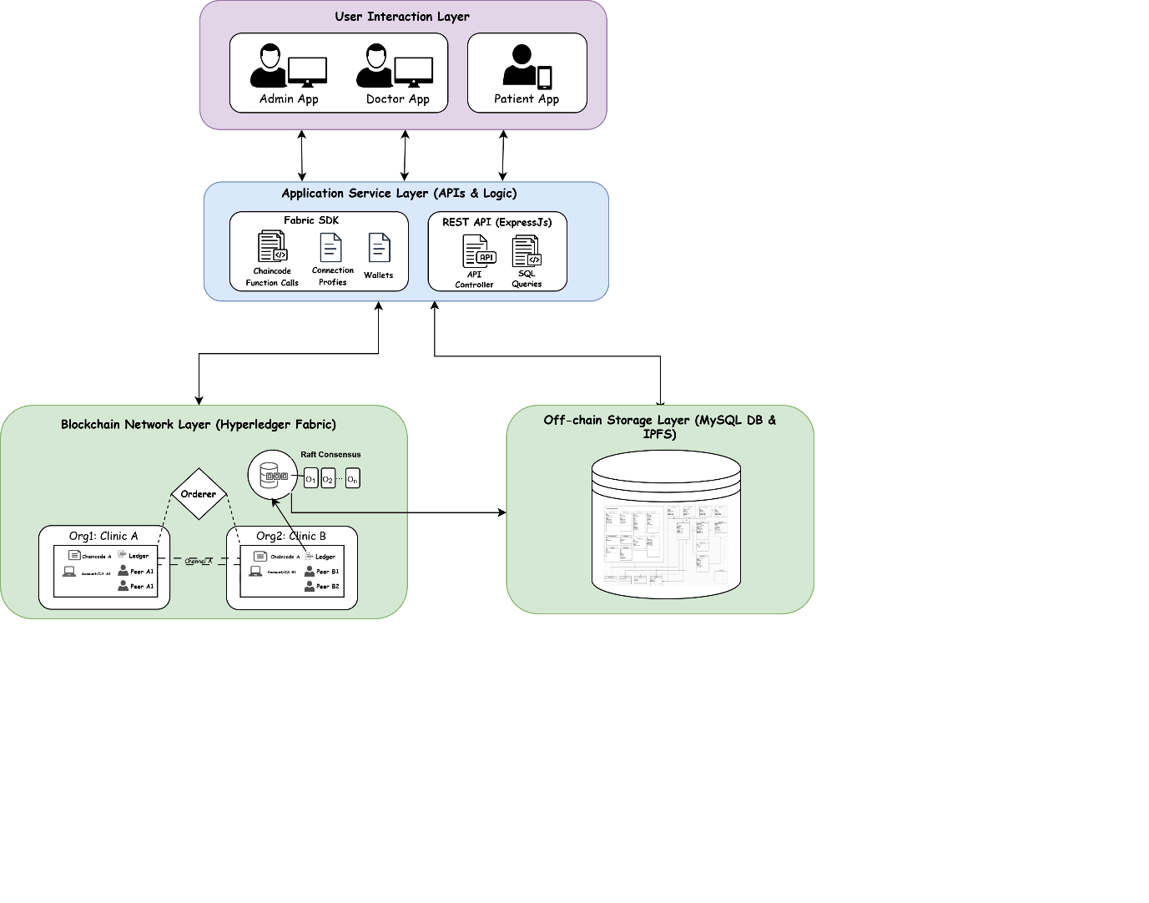
Fig. 1. System Architecture Overview

1.2 Scope
The system is a fully implemented, multi-layered software platform composed of:
- A Hyperledger Fabric 2.5 permissioned blockchain network (chaincode in JavaScript).
- A Node.js (v22.5.1) / Express.js (v4.21.2) RESTful API application service layer.
- A MySQL (v9.0.1) off-chain relational database.
- A React.js (v18.3.1) web application for administrators and doctors.
- A React Native (v0.76.7) mobile application for patients.

1.3 Definitions and Acronyms
See BRD-EDR-001 Glossary. Additional technical terms:
- Chaincode: Hyperledger Fabric's implementation of smart contracts.
- World State: The current state database maintained by Hyperledger Fabric peers (LevelDB).
- Endorsing Peer: A Fabric peer that simulates and signs transactions before ordering.
- Orderer: The Fabric component that establishes consensus and batches transactions into blocks.
- Raft: The consensus algorithm used by the ordering service (crash fault tolerant).
- CouchDB / LevelDB: Supported state databases for the Fabric world state.

1.4 System Overview
The system employs a four-layer architecture: (1) Off-Chain Storage Layer, (2) Blockchain Network Layer, (3) Application Service Layer, and (4) User Interaction Layer. This layered design separates concerns, ensures security isolation, and allows independent scaling of each component.

2. System Architecture

2.1 Architectural Overview
The system follows a hybrid on-chain/off-chain data architecture to balance performance, privacy, and auditability requirements inherent to healthcare data management. The four layers are:

Layer | Technology Stack | Responsibility
Off-Chain Storage | MySQL v9.0.1 | Stores all detailed clinical and administrative data. Integrity enforced via on-chain hashes.
Blockchain Network | Hyperledger Fabric 2.5, JavaScript Chaincode | Stores metadata, hashes, consent records, and access logs immutably. Enforces RBAC via smart contracts.
Application Service | Node.js v22.5.1, Express.js v4.21.2, Fabric SDK | RESTful API gateway mediating between frontend and blockchain/database backends.
User Interaction | React.js v18.3.1 (Web), React Native v0.76.7 (Mobile) | Role-specific interfaces for administrators, doctors, and patients.

2.2 Blockchain Network Architecture
The Hyperledger Fabric network is configured as follows:
- Organizations: Two or more dental clinic organizations, each with:
  - Two endorsing peer nodes (for fault tolerance and load distribution).
  - One Certificate Authority (CA) per organization.
  - One Membership Service Provider (MSP) configuration.
- Ordering Service: A Raft-based ordering service providing crash fault tolerance.
- Channel Configuration: Shared channel for cross-organizational transaction processing.
- Chaincode Deployment: JavaScript chaincode deployed via Fabric's lifecycle management process.
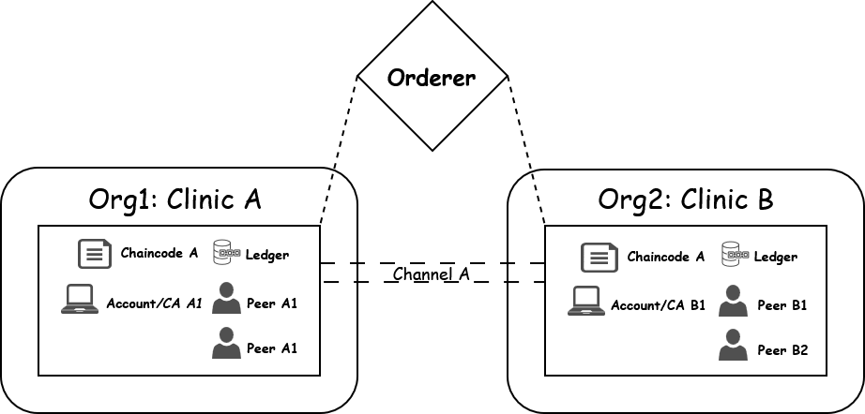
Fig. 2. Blockchain Network Topology in Hyperledger Fabric

2.3 Data Architecture

2.3.1 On-Chain Data
The blockchain ledger stores only critical metadata and transactional records requiring immutability:
- Patient and doctor registration metadata (IDs, clinic association, certificate references).
- Consent transaction records (grantConsent, revokeConsent) with timestamps and actor IDs.
- Inter-organizational data access request records (who, what, when, why).
- SHA-256 hashes of off-chain clinical documents for integrity verification.
- Audit log entries for all access and modification events.

2.3.2 Off-Chain Data (MySQL)
The MySQL relational database stores detailed operational and clinical data:
- User Information: Patient, doctor, and admin profiles (demographics, contact, specialty).
- Clinical Data: Medical history, allergies, medications, dental charts, lab results, prescriptions, DICOM references.
- Administrative Records: Appointments, request logs, notifications, insurance information, financial summaries.
A zoomed-in database entity-relationship model (ERD) as illustrated in the diagram of Fig. 3 and Fig. 4, show key tables (e.g., User, Medical History, Dental Chart), attributes (e.g., Category, Status, Verified Date), and their relations.

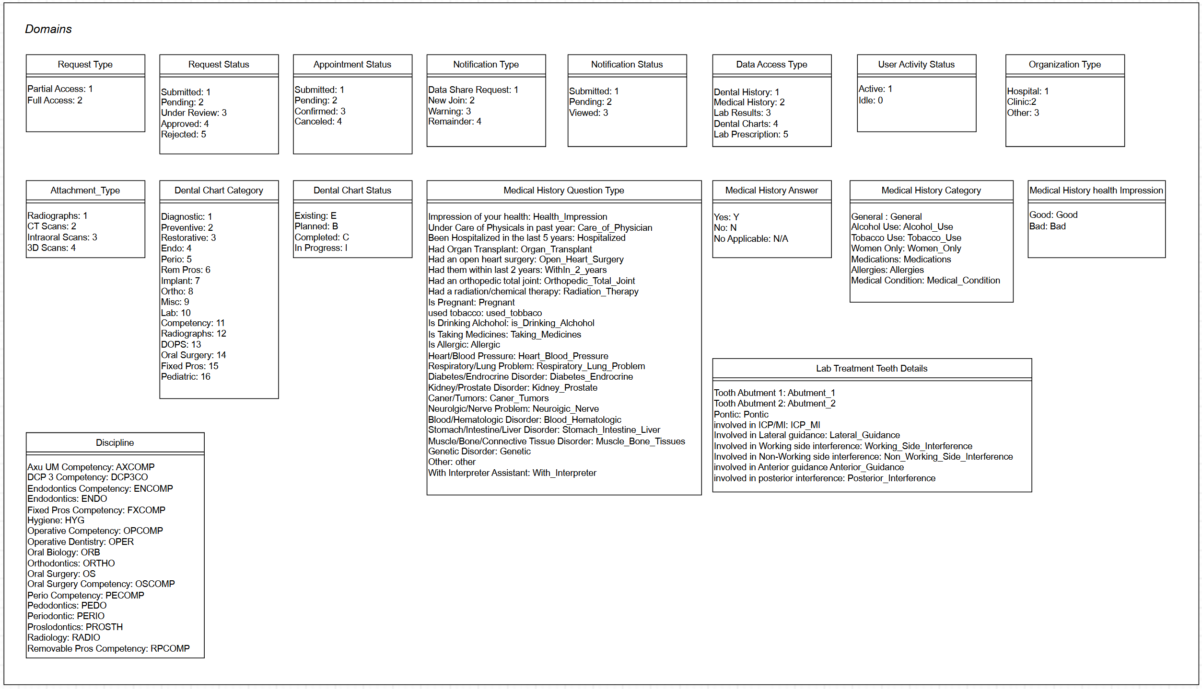
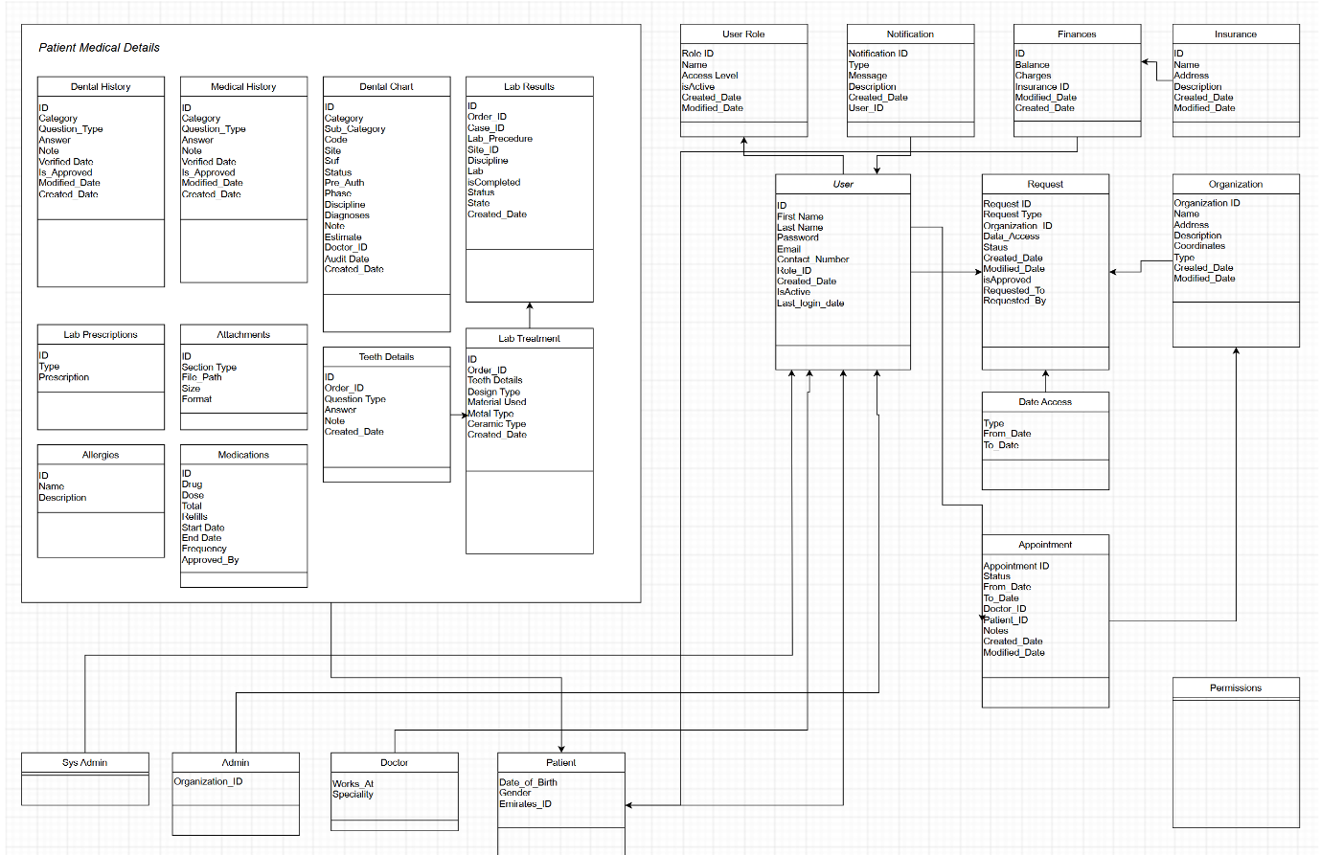
Fig. 4. Off-Chain Storage Schema: Domain-Specific of Data Classification for EDR Records.
Fig. 3. Off-Chain Storage Schema: Entity-Relationship (ER) Diagram of the Off-Chain Data Architecture
The integrity formula linking off-chain to on-chain storage is:
H_d = SHA256(Data_off-chain)
Where H_d is the hash digest stored on the blockchain, and Data_off-chain is the clinical record stored in MySQL or file storage.

3. Functional Requirements

3.1 User Authentication and Session Management
FR-ID | Requirement Description | Role | Priority
FR-01 | The system shall authenticate all users via username/password credentials validated against organizational records. | All | HIGH
FR-02 | Upon successful authentication, the system shall issue a JWT token signed with the user's MSP digital certificate. | All | HIGH
FR-03 | The system shall enforce role-based UI rendering, displaying only the features and data permitted for the authenticated user's role. | All | HIGH
FR-04 | JWT tokens shall expire after a configurable session timeout period. | All | MED

3.2 Patient Management
FR-ID | Requirement Description | Role | Priority
FR-05 | Admins shall be able to add a new patient with: full name, date of birth, gender, contact details, Emirates ID, nationality, address, blood type, medical history, allergies, medications, insurance details, and clinic association. | Admin | HIGH
FR-06 | The system shall invoke the addPatient chaincode function, registering the patient on the blockchain ledger and generating a unique patient ID. | Admin | HIGH
FR-07 | Admins shall be able to update patient demographic and insurance information via UpdatePatientInfo. | Admin | HIGH
FR-08 | The system shall support retrieval of all patients via getAllPatients and individual patient lookup via getPatientByID. | Admin, Doctor | HIGH
FR-09 | The system shall support assigning a patient to one or more doctors within their clinic via AssignPatientToDoctor. | Admin | HIGH
FR-10 | Admins shall be able to delete patient records from the blockchain ledger via DeletePatient. | Admin | MED

3.3 Doctor Management
FR-ID | Requirement Description | Role | Priority
FR-11 | Admins shall be able to register new doctors with: name, specialty, clinic affiliation, contact information, and license number via addDoctor. | Admin | HIGH
FR-12 | Admins shall be able to update doctor profiles via UpdateDoctorInfo. | Admin | MED
FR-13 | Doctors shall be able to retrieve the list of patients assigned to them via GetPatientsAssignedToDoctor. | Doctor | HIGH
FR-14 | Admins shall be able to delete doctor records via DeleteDoctor. | Admin | LOW

3.4 Clinical Record Management
FR-ID | Requirement Description | Role | Priority
FR-15 | Doctors shall be able to add medical records (medical history, allergies, lab results, medications) for assigned patients via AddMedicalRecord. | Doctor | HIGH
FR-16 | Doctors shall be able to retrieve medical records for patients (subject to consent) via GetMedicalRecords. | Doctor, Patient | HIGH
FR-17 | Doctors shall be able to add dental chart entries (treatment phases, procedure codes, tooth involvement, ceramic type, prescriptions, diagnostics) via AddDentalChartEntry. | Doctor | HIGH
FR-18 | The complete dental chart history for a patient shall be retrievable via GetAllDentalChartData. | Doctor, Patient | HIGH
FR-19 | DICOM images and radiographic files shall be stored off-chain, the system shall compute and store a SHA-256 hash on-chain for integrity verification. | Doctor | HIGH
FR-20 | The system shall support integrity verification by comparing the on-chain hash against the current off-chain file content on demand. | System | HIGH

3.5 Cross-Institutional Data Sharing and Consent
FR-ID | Requirement Description | Role | Priority
FR-21 | Doctors shall be able to initiate a data access request for a patient at another clinic via RequestDataAccess chaincode. | Doctor | HIGH
FR-22 | The patient-holding clinic's administrator shall receive a notification and approve or reject the request via ApproveRequest / RejectRequest. | Admin | HIGH
FR-23 | Following admin approval, the patient shall receive a notification on their mobile application with full details of the requesting party. | System | HIGH
FR-24 | Patients shall be able to grant or reject consent via ProvideConsent / RejectConsent, the decision shall be recorded on the blockchain with a cryptographic signature. | Patient | HIGH
FR-25 | Data access shall only be granted when both admin approval and patient consent are confirmed (AccessGranted = A_dec == Approve AND P_consent == True). | System | HIGH
FR-26 | All access events shall be logged immutably via LogAccess. | System | HIGH
FR-27 | Patients shall be able to retrieve all incoming/outgoing access requests via GetAllRequestsForPatient. | Patient | MED
FR-28 | Admins shall be able to view all active requests for their organization via GetRequestsForAdmin. | Admin | MED

3.6 Appointment Management
FR-ID | Requirement Description | Role | Priority
FR-29 | Administrators shall be able to create new appointments linking a patient, a doctor, a date/time, and a specialty. | Admin | HIGH
FR-30 | Patients shall be able to view upcoming and past appointments, organized by specialty and date, via the mobile application. | Patient | HIGH
FR-31 | Administrators shall be able to update or cancel appointments. | Admin | MED

4. Smart Contract (Chaincode) Specifications

4.1 Chaincode Overview
The chaincode is implemented in JavaScript and deployed on the Hyperledger Fabric network. It constitutes the authoritative business logic layer, enforcing all access control policies, consent rules, and data integrity checks. Each function includes identity verification via MSP certificates, role validation, and error handling. The chaincode runs in isolated Docker containers.

4.2 Chaincode Function Registry
Function Name | Description | Authorized Role(s) | Transaction Type
addDoctor | Add new doctor profile and clinic association to the ledger. | Admin | Write
UpdateDoctorInfo | Update existing doctor profile information. | Admin | Write
ReadDoctor | Retrieve detailed doctor profile from the ledger. | Admin, Doctor | Read
DeleteDoctor | Remove a doctor record from the blockchain ledger. | Admin | Delete
addPatient | Register a new patient on the blockchain ledger with unique ID. | Admin | Write
UpdatePatientInfo | Update patient demographic and metadata information. | Admin | Write
ReadPatient | Retrieve detailed patient profile from the ledger. | Admin, Doctor | Read
DeletePatient | Remove patient record from the blockchain ledger. | Admin | Delete
RegisterPatientInClinic | Register a patient under a specific institutional network. | Admin | Write
AssignPatientToDoctor | Link a doctor to specific patients within their clinic. | Admin | Write
GetPatientsAssignedToDoctor | Return list of patients under a doctor's supervision. | Doctor | Read
RequestDataAccess | Initiate inter-clinic data access request, logged on ledger. | Doctor | Write
ApproveRequest | Admin approves incoming data access request. | Admin | Write
RejectRequest | Admin rejects incoming data access request. | Admin | Write
ProvideConsent | Patient grants consent, recorded with cryptographic signature. | Patient | Write
RejectConsent | Patient denies consent, recorded on ledger. | Patient | Write
LogAccess | System logs metadata of each access event immutably. | System | Write
AddMedicalRecord | Store medical record hash and metadata on-chain. | Doctor | Write
GetMedicalRecords | Retrieve medical records (subject to consent). | Doctor, Patient | Read
AddDentalChartEntry | Add treatment records and diagnostics to dental chart. | Doctor | Write
GetAllDentalChartData | View complete dental chart history for a patient. | Doctor, Patient | Read
GetAllRequestsForPatient | Retrieve all access requests for the logged-in patient. | Patient | Read
GetPendingRequestsForPatient | View only unprocessed consent requests. | Patient | Read
GetRequestsForAdmin | View all active requests related to the organization. | Admin | Read
InitLedger / InitDoctors / InitPatients | Populate blockchain with initial data during bootstrapping. | Admin/System | Write

5. Application Service Layer - RESTful API Specifications

5.1 API Gateway Overview
The Node.js/Express.js application service layer exposes a RESTful API gateway. All endpoints require a valid JWT token in the Authorization header. API calls are categorized by functional domain and map directly to corresponding chaincode functions via the Hyperledger Fabric Node.js SDK.

Method | Endpoint | Description | Chaincode Function | Auth Role
POST | /login | Authenticate user and issue JWT token. | N/A | All
POST | /registerDoctor | Register a new doctor on the blockchain. | addDoctor | Admin
POST | /addPatient | Register a new patient on the blockchain. | addPatient | Admin
POST | /assignPatientToDoctor | Assign a patient to a doctor. | AssignPatientToDoctor | Admin
GET | /getAllPatients | Retrieve all registered patients. | getAllPatients | Admin
GET | /getPatientByID/:id | Retrieve patient details by unique ID. | ReadPatient | Admin, Doctor
POST | /addMedicalRecord | Add a medical record and store hash on-chain. | AddMedicalRecord | Doctor
GET | /getDentalChartData/:id | Retrieve full dental chart for a patient. | GetAllDentalChartData | Doctor, Patient
POST | /requestAccess | Initiate inter-clinic data access request. | RequestDataAccess | Doctor
POST | /approveRequest | Admin approves a data access request. | ApproveRequest | Admin
POST | /grantConsent | Patient grants consent for data sharing. | ProvideConsent | Patient
GET | /getPendingRequests | Retrieve pending consent requests for a patient. | GetPendingRequestsForPatient | Patient

6. Non-Functional Requirements

6.1 Performance Requirements
Based on Hyperledger Caliper benchmarking results conducted on a dual-organization, four-peer Fabric 2.5 network (Ubuntu 20.04, Intel Xeon W-2102 @ 2.90GHz, 16GB RAM):
Operation | Transaction Load | Target Throughput (TPS) | Target Avg Latency (s)
Read (readPatient) | 1 – 200 TX | ≥ 40 TPS | ≤ 0.05 s
Write (addPatient) | 1 – 200 TX | ≥ 20 TPS | ≤ 1.0 s
Delete (deletePatient) | 1 – 200 TX | ≥ 20 TPS | ≤ 1.0 s

6.2 Security Requirements
SEC-ID | Requirement | Implementation
SEC-01 | All API endpoints shall require JWT authentication with role validation. | Express.js middleware
SEC-02 | All chaincode functions shall verify the invoker's MSP identity before executing. | Fabric MSP + CA
SEC-03 | No PII shall be stored directly on the blockchain ledger. | Hybrid architecture
SEC-04 | Data integrity of off-chain records shall be verifiable via SHA-256 hashes stored on-chain. | Chaincode hashing
SEC-05 | The system shall prevent replay attacks through transaction uniqueness enforcement (nonces, timestamps). | Fabric ordering
SEC-06 | The system shall prevent impersonation attacks through cryptographic certificate-based identity. | Fabric MSP + CA
SEC-07 | Communication between all system layers shall be encrypted using TLS. | Fabric TLS config
SEC-08 | Patient data sharing shall be restricted to authorized personnel with explicit patient consent on-chain. | Consent chaincode

6.3 Reliability and Availability
- Each organization shall maintain at least two peer nodes to provide fault tolerance.
- The system shall operate using a Raft-based ordering service for crash fault tolerance.
- The off-chain MySQL database shall be configured with backup and recovery procedures.

6.4 Scalability
- Additional dental clinic organizations shall be onboardable without modifying existing chaincode or network infrastructure.
- The system shall support horizontal scaling of peer nodes to accommodate increased transaction loads.
- The off-chain MySQL database shall be designed with normalized schemas capable of accommodating growth in patient, clinical, and administrative records.

6.4 User Interface Screens
The following figures show the implemented application screens across all user roles.

6.4.1 Web Application- Administrators and Doctors
The React.js web portal provides role-specific dashboards. Administrators have access to the full system including the Data Requests Panel and patient overview. Doctors access assigned patient profiles and detailed dental/medical records.

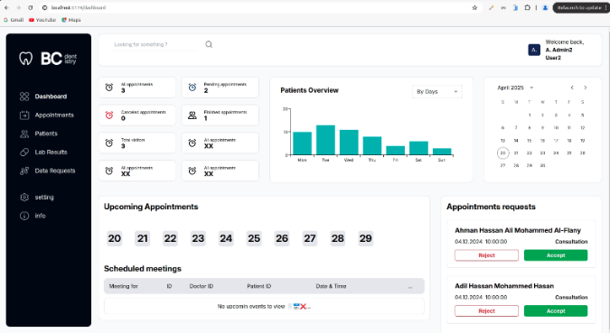
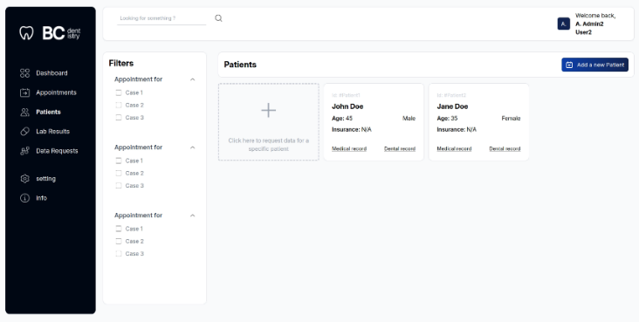
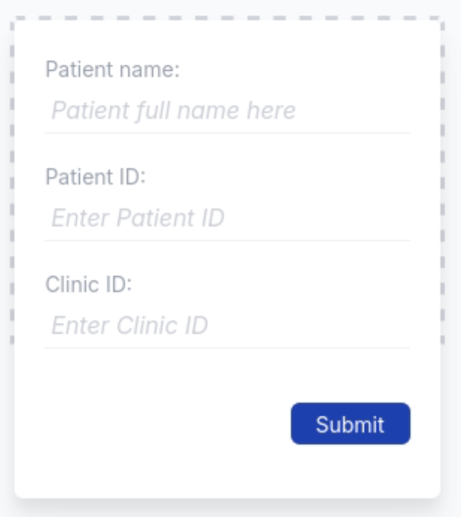
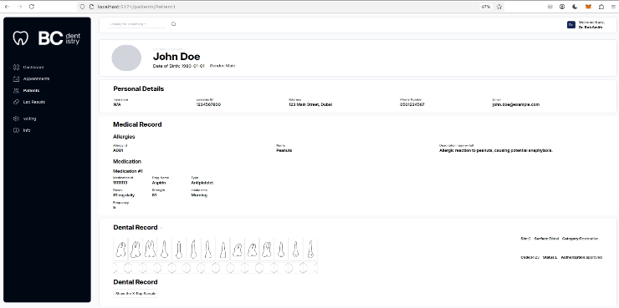
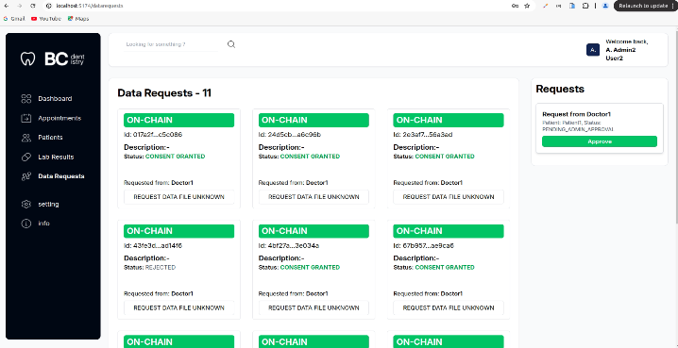
Fig. 6. Admin Dashboard
Fig. 5. Doctor View: Patients List and Application for Requesting Data fr om Another Hospital
Fig. 8. Doctor View : Detailed Patient Profile
Fig. 7. Admin View: Data Requests Panel

6.4.2 Mobile Application - Patients
The React Native mobile application provides patients with a secure, consent-driven interface. Patients can view their personal health information, manage upcoming and past appointments, and respond to data access consent requests from other clinics.
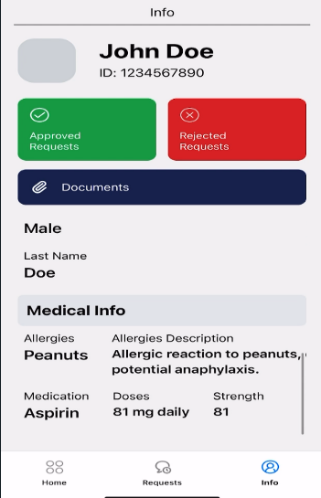
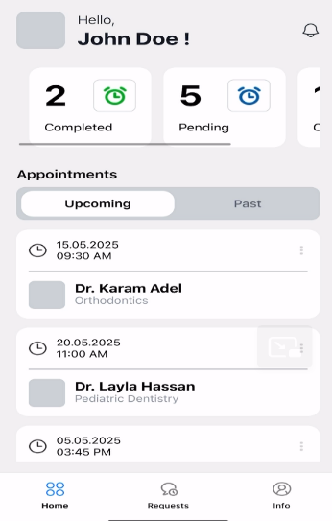
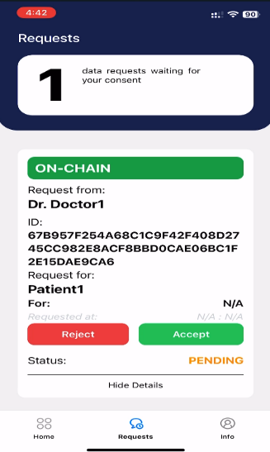
Fig. 9. Patient Mobile : Patient’s Information View
Fig. 10. Patient Mobile : Appointment Management
Fig. 11. Patient Mobile : Consent Request View

6.5 Usability
- All web interfaces shall be developed using React.js with responsive design for desktop and tablet use.
- The patient mobile application shall be developed in React Native, targeting Android and iOS platforms.
- Interfaces shall comply with WCAG 2.1 Level AA accessibility guidelines.
- Consent status indicators shall use color-coded visual cues: green (approved), red (rejected), blue (pending).

6.6 Compliance
- The system architecture shall comply with HIPAA's minimum necessary standard by storing PII off-chain with access control enforced on-chain.
- The system shall support GDPR's right to audit through immutable blockchain transaction logs.
- The patient consent mechanism shall satisfy GDPR's requirement for explicit, informed, and revocable consent.

7. Technology Stack
Component | Technology / Version | Role / Notes
Blockchain Platform | Hyperledger Fabric 2.5 | Core permissioned blockchain framework, Raft consensus, MSP-based RBAC.
Chaincode Language | JavaScript (Node.js) | Smart contract implementation, deployed via Fabric lifecycle.
Consensus Mechanism | Raft (CFT) | Crash fault tolerant ordering service.
Backend API | Node.js v22.5.1, Express.js v4.21.2 | RESTful API gateway, Fabric SDK integration, JWT authentication.
Off-chain Database | MySQL v9.0.1 | Relational storage for clinical, administrative, and user data.
Web Frontend | React.js v18.3.1 | Role-specific web application for admins and doctors.
Mobile Frontend | React Native v0.76.7 | Patient-facing consent and record-viewing mobile application.
Containerization | Docker Engine Community v26.0.0 | Container runtime for all Fabric components (peers, orderers, CA, chaincode).
Benchmarking Tool | Hyperledger Caliper | Performance evaluation: throughput, latency, resource utilization.
Hashing Algorithm | SHA-256 | Off-chain record integrity fingerprinting stored on-chain.
Authentication | JWT + MSP Certificates | Session management and blockchain identity verification.
Operating System (Dev) | Ubuntu 20.04 LTS | Development and benchmarking test environment.

8. Testing Requirements

8.1 Functional Testing
Each chaincode function and corresponding REST API endpoint shall be subject to unit and integration testing. Test coverage shall include:
- Positive test cases: valid inputs, authorized roles, expected blockchain state changes.
- Negative test cases: invalid inputs, unauthorized role attempts, missing consent.
- Boundary test cases: maximum record sizes, concurrent requests, expired tokens.

8.2 Performance Testing
Hyperledger Caliper shall be used to benchmark the following transaction types under variable load:
- Read operations (readPatient): 1, 10, 50, 100, 200 transactions.
- Write operations (addPatient): 1, 10, 50, 100, 200 transactions.
- Delete operations (deletePatient): 1, 10, 50, 100, 200 transactions.
Metrics to be collected: Throughput (TPS), Average Latency (s), Success Rate (%), CPU utilization, Memory utilization per Docker container.

8.3 Security Testing
- Role violation testing: Attempt to invoke admin-restricted chaincode functions with doctor or patient certificates.
- Consent bypass testing: Attempt to access patient data without fulfilled consent chain.
- Hash integrity testing: Modify off-chain content and verify on-chain hash mismatch detection.
- Replay attack testing: Submit duplicate transactions and verify Fabric ordering service rejection.

8.4 Usability Testing
- Administrator workflow: End-to-end patient registration, doctor assignment, and request management.
- Doctor workflow: Record addition, cross-clinic access request initiation, and patient data retrieval.
- Patient workflow: Viewing records, receiving consent requests, approving/denying via mobile application.

8.5 Test Environment
Parameter | Specification
Operating System | Ubuntu 20.04 LTS
CPU | Intel Xeon W-2102 @ 2.90GHz (4 cores) or equivalent
RAM | Minimum 16 GB
Storage | SSD, minimum 50 GB available
Docker | Docker Engine Community v26.0.0+
Hyperledger Fabric | Version 2.5 (fabric-samples test-network)
Node.js | v22.5.1 or later
MySQL | v9.0.1 or later
Network | 2 Organizations, 2 Peers each, 1 Orderer (Raft), 1 Channel

9. System Constraints and Dependencies

9.1 Technical Constraints
- The system requires Docker and Docker Compose for all Hyperledger Fabric network components.
- Chaincode is implemented in JavaScript and requires Node.js chaincode runtime support.
- Large medical files (DICOM) must remain off-chain, on-chain storage is limited to metadata and hashes.
- The Raft consensus mechanism requires a minimum of three orderer nodes for crash fault tolerance in production deployments.

9.2 External Dependencies
- Hyperledger Fabric 2.5 fabric-samples test-network for development and testing.
- Hyperledger Caliper for performance benchmarking.
- MySQL v9.0.1 for off-chain data storage.
- React.js and React Native for frontend development.

