AcePharm
QA Testing Report — Issues
QA Officer: Owais Arshad | Developer: _____ | Date: 09/23/2026

AP-01
Issue Name | Homepage Banner – CTA Buttons Not Centered
Description | On the homepage banner, the two call-to-action buttons are aligned to the left side instead of being centered, which gives a poor first impression and looks like a UI bug.
Steps to Reproduce | 1. Open the homepage.  2. Observe the two buttons in the banner section.
Severity | Low
Expected Result | The two banner buttons should be center-aligned for a better first impression.
Actual Result | The two banner buttons are aligned to the left instead of the center.
Screenshot | 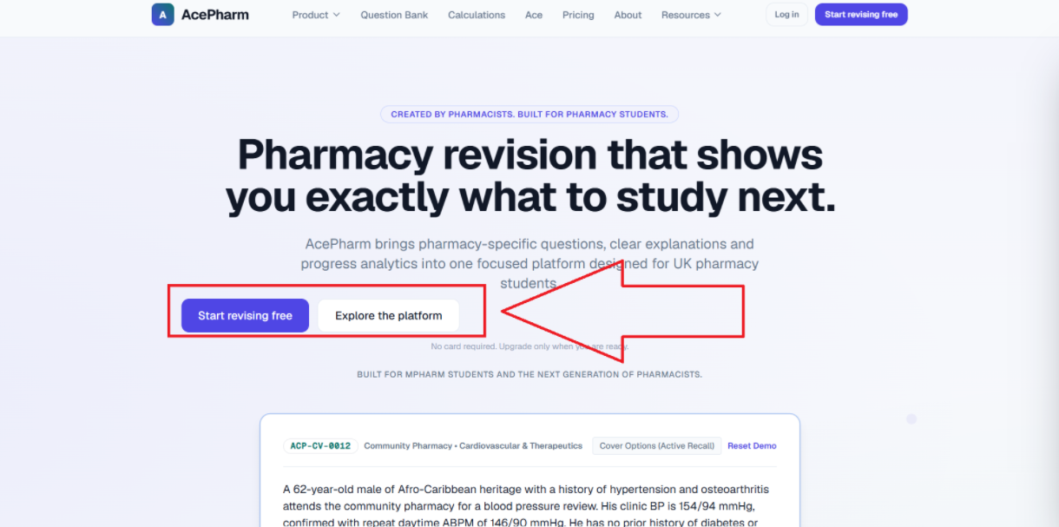

AP-02
Issue Name | Header – Product Dropdown Duplicates Header Navigation Links
Description | In the header, the first "Product" page's dropdown lists the exact same pages that are already listed in the header navigation, which is a bug/duplication.
Steps to Reproduce | 1. Open the website.  2. Hover/click on the "Product" item in the header.  3. Observe the dropdown list.  4. Compare with the header navigation items.
Severity | Medium
Expected Result | The Product dropdown should show relevant sub-items specific to Product, not duplicate the entire header navigation.
Actual Result | The Product dropdown lists the same pages already available in the header.
Screenshot | 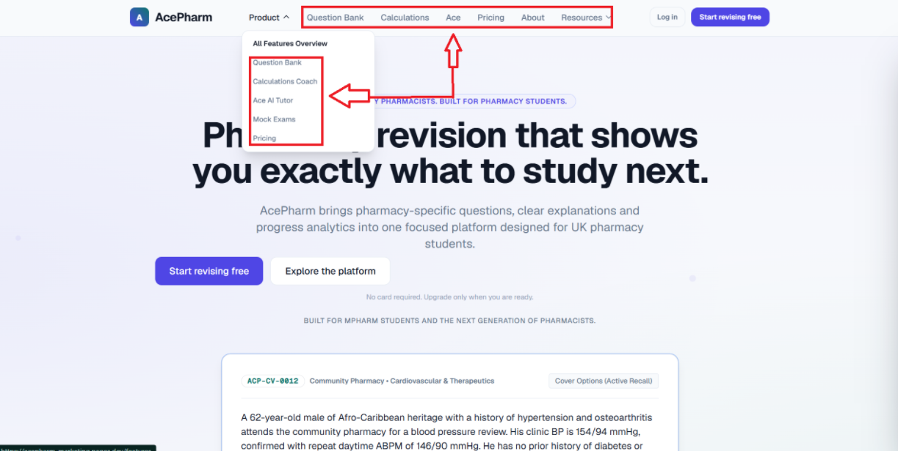

AP-03
Issue Name | Header – Resources Dropdown Has a Page Pre-Selected by Default
Description | When the user opens the Resources dropdown in the header, the "Revision Guides & Blog" page is already selected/highlighted by default, instead of no page being pre-selected.
Steps to Reproduce | 1. Open the website.  2. Click the Resources dropdown in the header.  3. Observe the default state.
Severity | Low
Expected Result | No item should be pre-selected by default when opening the Resources dropdown.
Actual Result | "Revision Guides & Blog" appears pre-selected by default.
Screenshot | 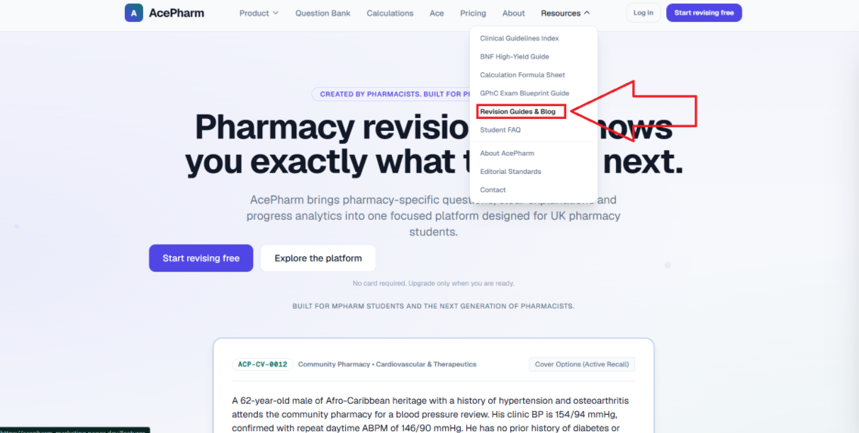

AP-04
Issue Name | Header – Resources Dropdown Items Not Functional
Description | In the header, clicking the pages listed inside the Resources dropdown does nothing — the user stays on the same page. These non-functional pages should be removed from the dropdown; it should only contain the Resources page, Editorial Standards, and Contact page.
Steps to Reproduce | 1. Open the website.  2. Click the Resources dropdown in the header.  3. Click on any of the listed pages.  4. Observe that nothing happens.
Severity | Medium
Expected Result | Clicking the listed items in the Resources dropdown should take the user to the corresponding page. Non-functional items should be removed, keeping only Resources, Editorial Standards, and Contact.
Actual Result | Clicking dropdown items does nothing; the user remains on the same page.
Screenshot | 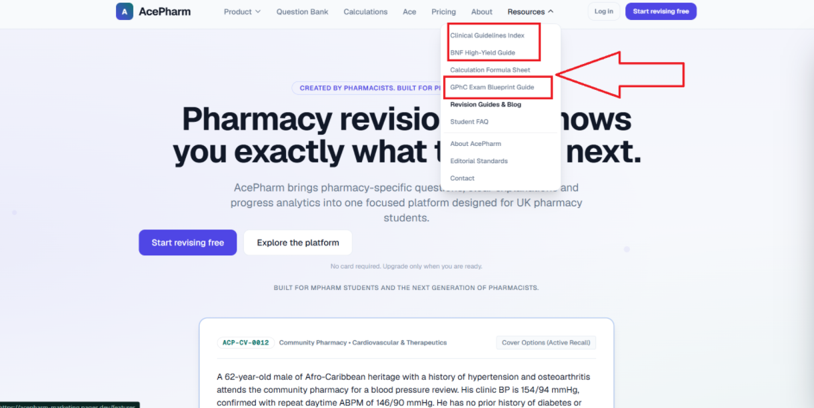

AP-05
Issue Name | Header – Resources Dropdown Duplicates an Existing Header Item
Description | The page listed inside the Resources dropdown is already present in the header itself, creating duplication, which is not user-friendly.
Steps to Reproduce | 1. Open the website.  2. Click the Resources dropdown.  3. Compare its listed page with the main header items.
Severity | Low
Expected Result | The Resources dropdown should not duplicate an item that already exists in the main header.
Actual Result | A page already present in the header is duplicated inside the Resources dropdown.
Screenshot | 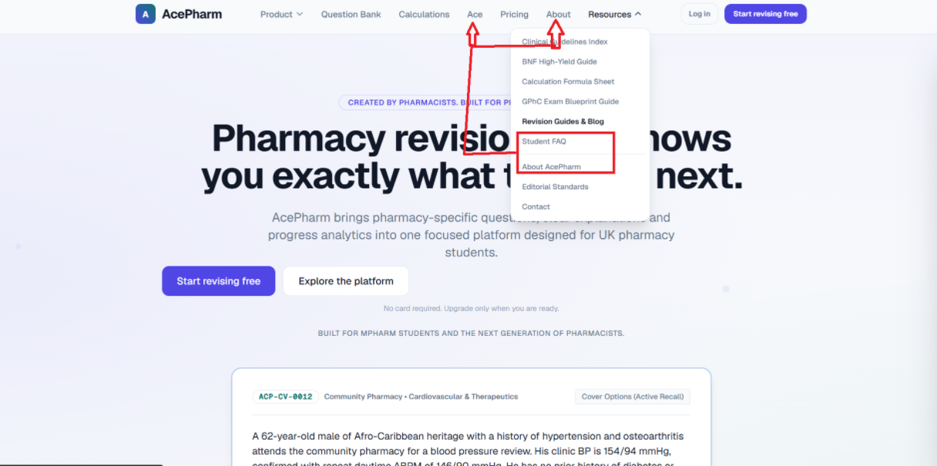

AP-06
Issue Name | Header – Transparent Background Causes Readability Issue on Scroll
Description | Across the whole website, the header is transparent. When the user scrolls the page, content/text behind the header shows through and visually clashes with the header, making the header text hard to read.
Steps to Reproduce | 1. Open any page.  2. Scroll down so page content passes behind the header.  3. Observe the header's readability.
Severity | Medium
Expected Result | The header should have a solid/opaque background so its content remains clearly readable when the user scrolls.
Actual Result | The header stays transparent, and scrolling content behind it makes the header text hard to see.
Screenshot | 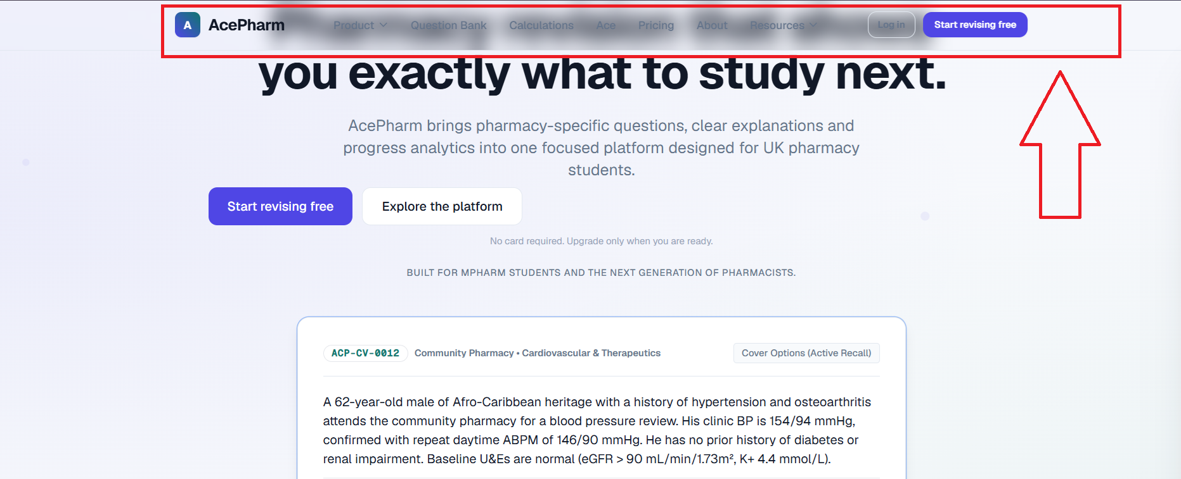

AP-07
Issue Name | Pills (Sitewide) – Border Partially Not Visible on Interaction
Description | On all pages, in the banner, the pills have an issue — when the user clicks/interacts with a pill's border, some portion of the border is not visible, which is not user-friendly.
Steps to Reproduce | 1. Open any page with pills in the banner.  2. Click on a pill.  3. Observe the border of the pill.
Severity | Low
Expected Result | The pill's border should be fully visible at all times, including during interaction.
Actual Result | Part of the pill's border becomes not visible when clicked.
Screenshot | 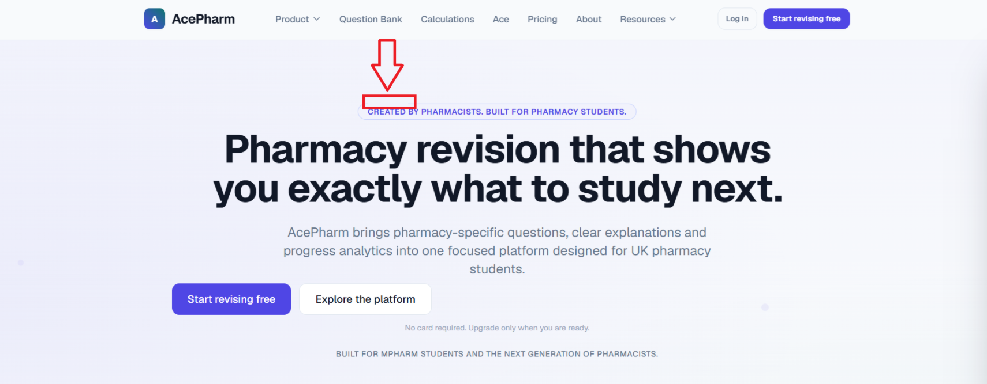

AP-08
Issue Name | Home Page – "Cover Options" Button Does Not Look Clickable
Description | On the home page, on the card, the "cover options" button does not look like a button — it looks like plain text inside a box, which does not indicate it is clickable.
Steps to Reproduce | 1. Open the home page.  2. Locate the card with the "cover options" option.  3. Observe how it is styled.
Severity | Low
Expected Result | The "cover options" element should be styled clearly as a button so users recognize it as clickable.
Actual Result | It looks like plain text in a box rather than a button.
Screenshot | 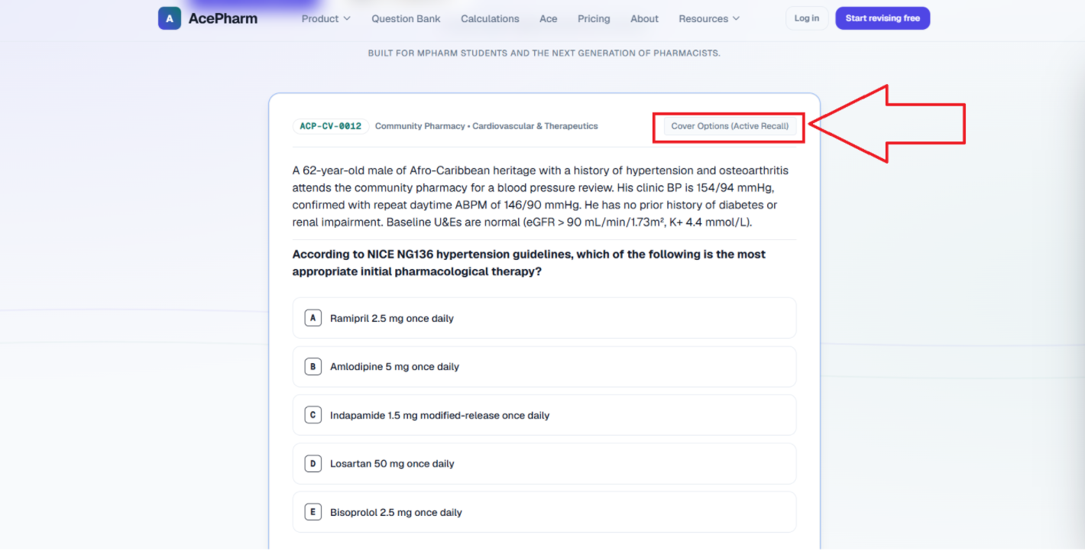

AP-09
Issue Name | Demo Question Card – "Reset Demo" Option Placement Hard to Notice
Description | After the user selects an answer, a small "reset demo" option appears above the card, which is easy for the user to miss. It should instead appear below the card after the user answers.
Steps to Reproduce | 1. Open the demo question on the home page.  2. Select an answer.  3. Observe the position of the "reset demo" option.
Severity | Low
Expected Result | The "reset demo" option should appear below the card (in a more noticeable location) after the user answers.
Actual Result | The "reset demo" option appears above the card in a location that is easy to miss.
Screenshot | 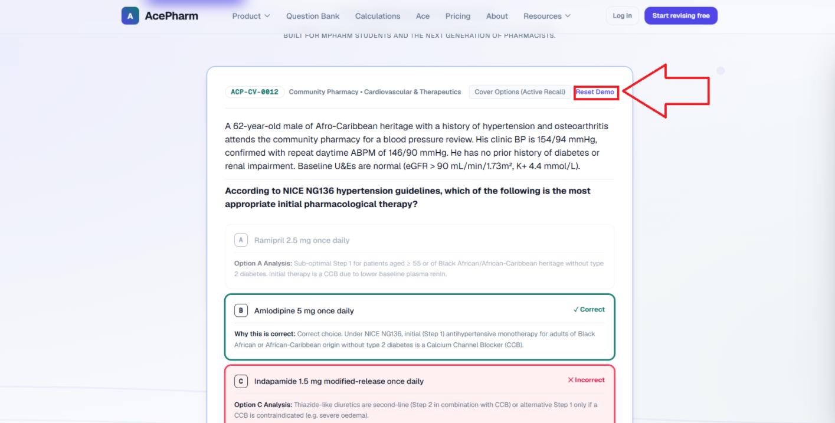

AP-10
Issue Name | Demo Question Card – Button Arrow Icon Wraps to Second Line
Description | When the user selects a wrong answer, the "Start Full Free Revision Bank" button that appears inside the card has an arrow icon that wraps onto a second line instead of staying on the same line as the button text.
Steps to Reproduce | 1. Open the demo question.  2. Select a wrong answer.  3. Observe the "Start Full Free Revision Bank" button.
Severity | Low
Expected Result | The button text and arrow icon should display on a single line.
Actual Result | The arrow icon wraps to a second line, separate from the button text.
Screenshot | 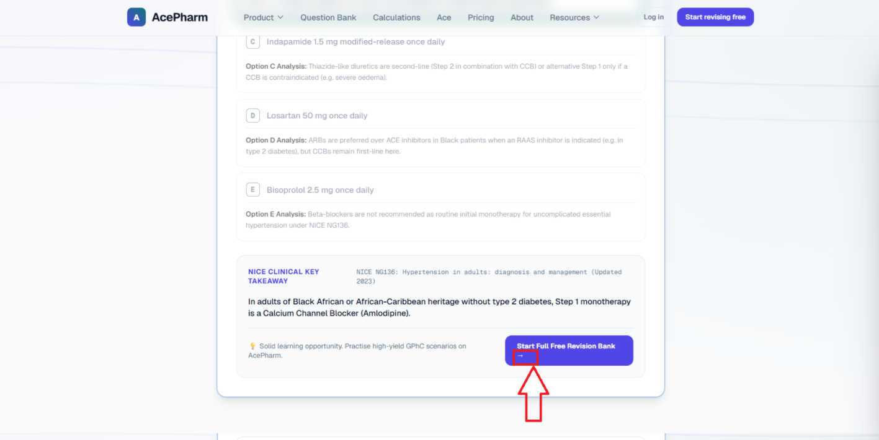

AP-11
Issue Name | Demo Question Card – Feedback Text Wraps Awkwardly
Description | When the user selects a wrong option, the feedback line's text should display on a single line, but one word wraps onto a second line.
Steps to Reproduce | 1. Open the demo question.  2. Select a wrong option.  3. Observe the feedback text line.
Severity | Low
Expected Result | The feedback line's text should fit on a single line without an awkward word wrap.
Actual Result | One word from the feedback line wraps to a second line.
Screenshot | 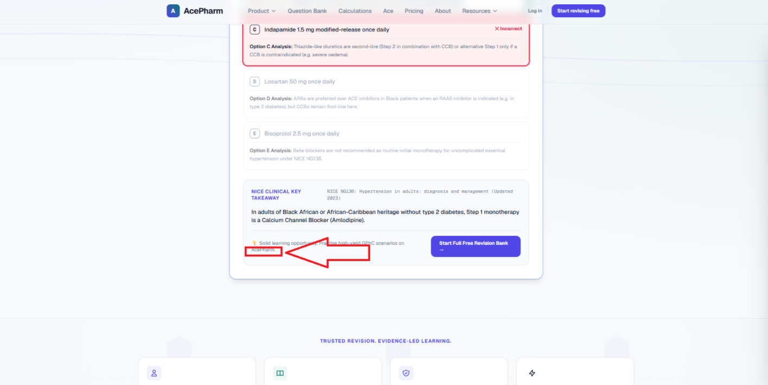

AP-12
Issue Name | Sitewide – Icons Look AI-Generated, Should Use Real Related Images
Description | Throughout the website, wherever these icons are used, they should be removed and replaced with real, related images. The current icons look AI-generated; adding proper images would make the website more attractive and user-friendly.
Steps to Reproduce | 1. Browse through the website pages.  2. Observe the icons used throughout.
Severity | Low (Suggestion)
Expected Result | Icons should be replaced with proper, professional, related images to improve visual appeal and user trust.
Actual Result | The current icons look AI-generated and do not look professional.
Screenshot | 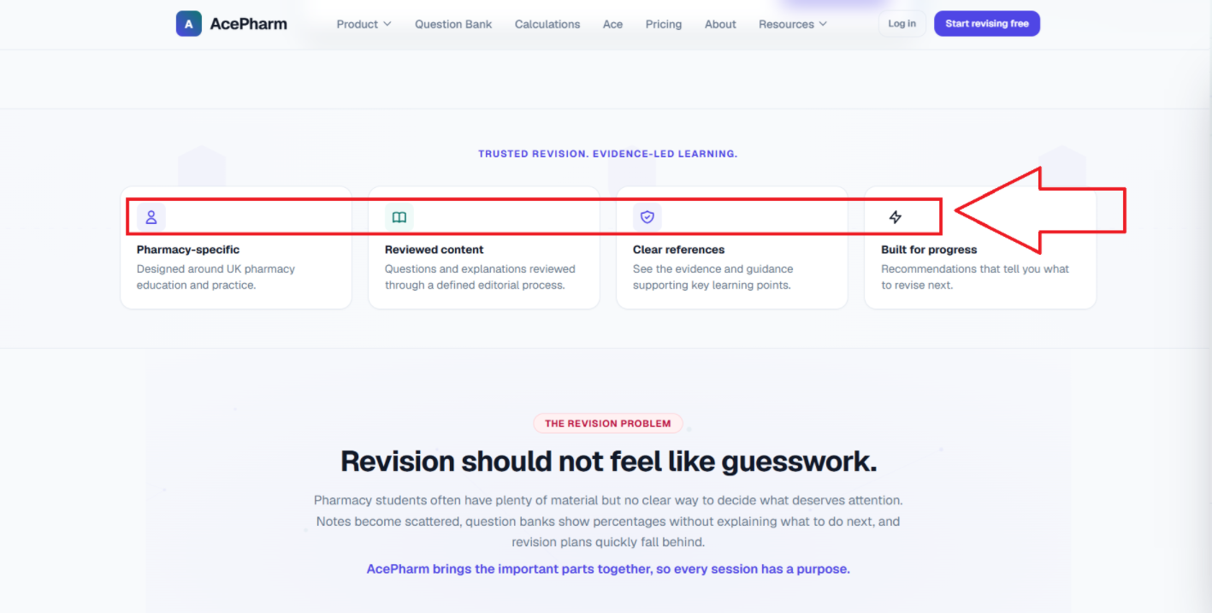

AP-13
Issue Name | Sample Question – Claims No Login Required but Redirects to Login
Description | The site states it "navigates to a sample question experience without requiring login," but when the user clicks it, they are taken to the login page instead.
Steps to Reproduce | 1. Find the element/link claiming to offer a sample question without login.  2. Click it.  3. Observe where it redirects.
Severity | Medium
Expected Result | Clicking this should take the user directly to a sample question without requiring login, as stated.
Actual Result | Clicking it redirects the user to the login page.
Screenshot | 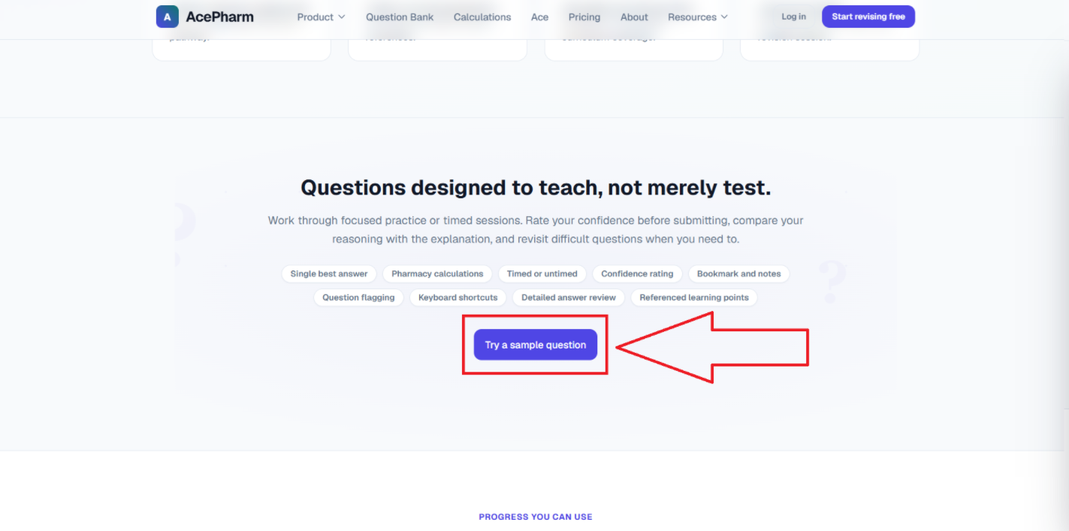

AP-14
Issue Name | Home Page – FAQ's Should Expand/Collapse as Accordion
Description | On the home page, the FAQ boxes should function as a dropdown/accordion — clicking a question should show the answer below it, and clicking again should hide it.
Steps to Reproduce | 1. Open the home page.  2. Scroll to the FAQ's section.  3. Click on any FAQ question.
Severity | Low
Expected Result | Clicking a FAQ question should expand to show the answer, and clicking again should collapse/hide it.
Actual Result | The FAQ boxes do not currently function as an expandable/collapsible accordion.
Screenshot | 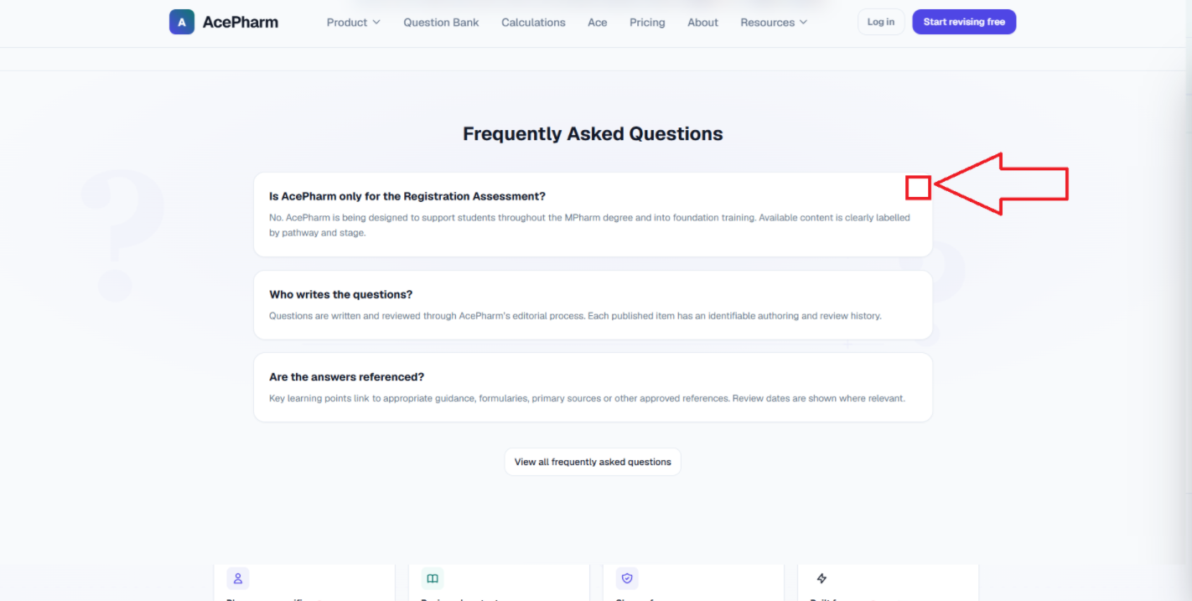

AP-15
Issue Name | Home Page – Redundant Section Should Be Removed
Description | On the home page, this section is not needed because the pricing cards are already present in an upper section. It should be removed.
Steps to Reproduce | 1. Open the home page.  2. Scroll to the section that duplicates the upper pricing section.
Severity | Low (Suggestion)
Expected Result | The redundant section should be removed since the pricing cards already exist higher on the page.
Actual Result | The redundant section is still present on the home page.
Screenshot | 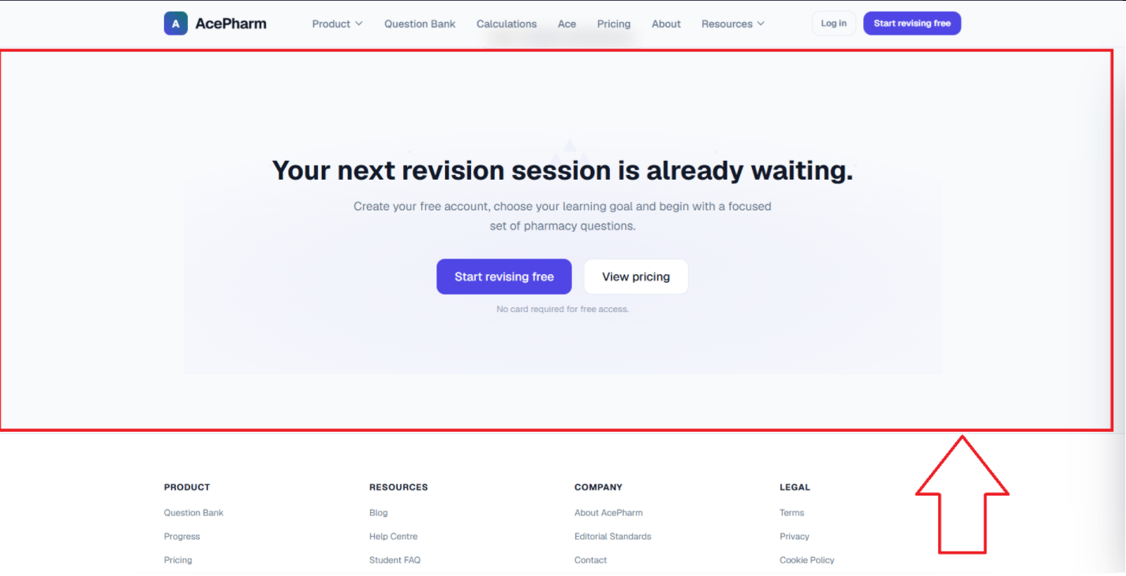

AP-16
Issue Name | Header – No Dedicated "Home" Link; Product Link Opens Features Page
Description | On the homepage, the user can only navigate back home by clicking the logo, which is not user-friendly — a "Home" option should exist in the header. Additionally, clicking the Product page opens the Features page instead, which confuses the user.
Steps to Reproduce | 1. Navigate away from the home page.  2. Look for a "Home" option in the header (other than the logo).  3. Click on the "Product" page in the header and observe which page opens.
Severity | Medium
Expected Result | The header should have a dedicated "Home" link, and clicking "Product" should open the Product page, not the Features page.
Actual Result | Only the logo navigates home, and clicking "Product" opens the Features page instead.
Screenshot | 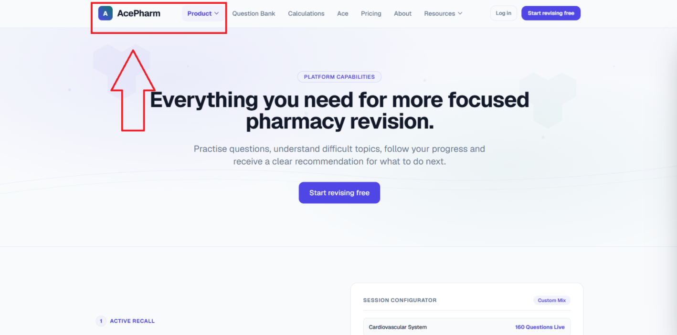

AP-17
Issue Name | Question Bank Page – "Choose Your Path" Cards Have Poor Highlighting/Color Contrast
Description | On the Question Bank page, in the "Choose Your Path" section, one card is already highlighted by default. On the other cards, the "coming later" text has poor color contrast and is not clearly visible. These cards should have pills (e.g., "Active") and better, more noticeable colors.
Steps to Reproduce | 1. Navigate to the Question Bank page.  2. Observe the "Choose Your Path" section cards.  3. Check the highlighted card and the "coming later" text color on other cards.
Severity | Medium
Expected Result | Cards should have clear status pills (e.g., "Active"), and text color should have good contrast and be clearly visible on all cards.
Actual Result | One card is pre-highlighted with no clear pill, and the "coming later" text on other cards has poor visibility due to bad color contrast.
Screenshot | 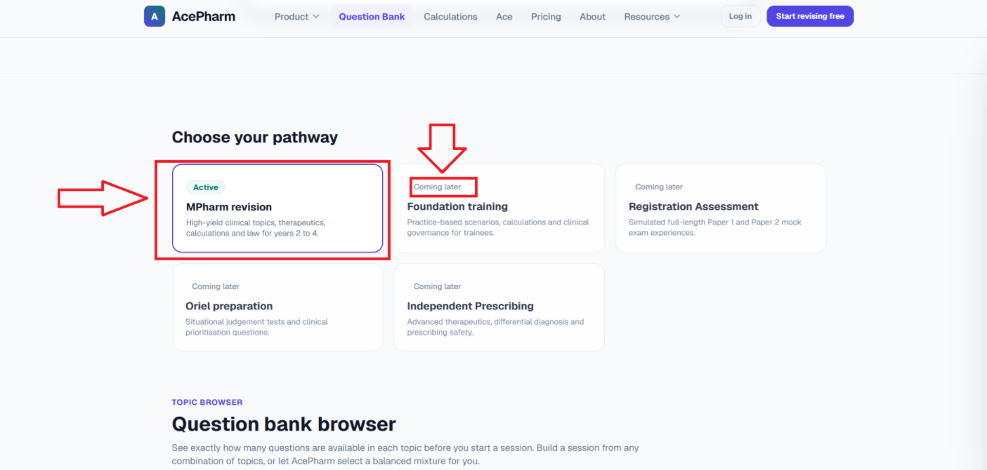

AP-18
Issue Name | Question Bank Page – "Practise Topic" CTA Is a Text Link Instead of a Button
Description | In the Question Bank Browser section, the "Practise Topic" option is currently displayed as a simple underlined text link. Since this is the primary call-to-action (CTA) for the user, it should be designed as a proper solid button instead of a text link, improving visibility and click-ability.
Steps to Reproduce | 1. Navigate to the Question Bank page.  2. Go to the Question Bank Browser section.  3. Observe the "Practise Topic" link styling.
Severity | Medium
Expected Result | "Practise Topic" should be styled as a solid, clearly visible button.
Actual Result | "Practise Topic" is currently just an underlined text link.
Screenshot | 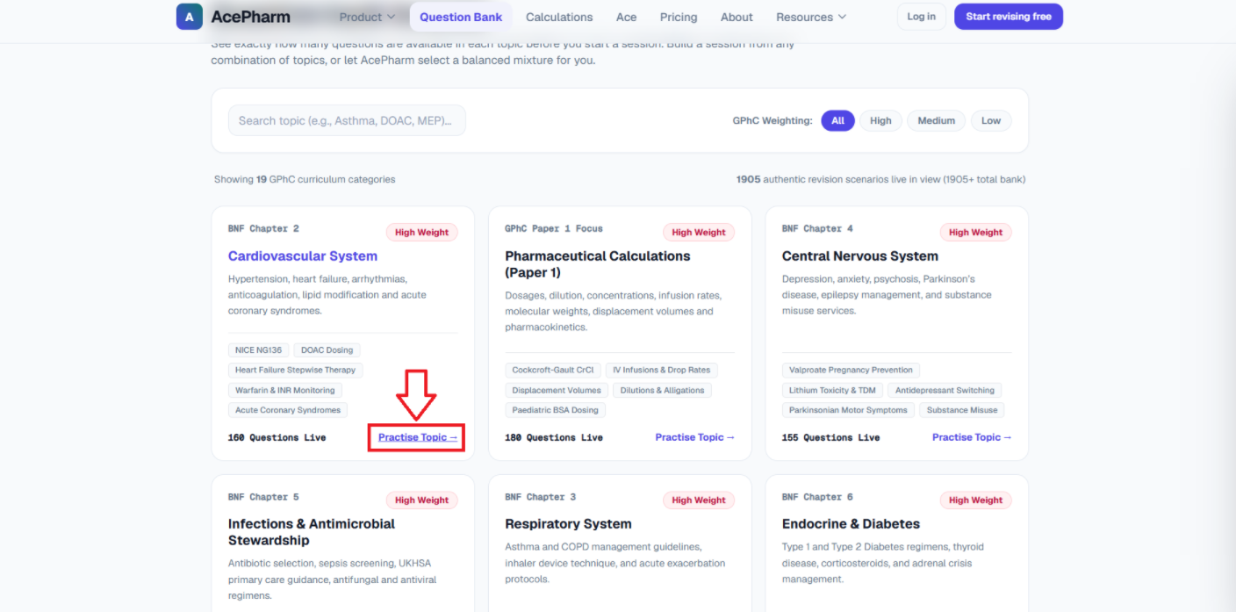

AP-19
Issue Name | Question Bank Page – Two Buttons Both Redirect to Login Page
Description | At the end of the Question Bank page, there are two buttons; clicking either one redirects the user to the login page. There should only be one button here instead of two identical/duplicate ones.
Steps to Reproduce | 1. Navigate to the Question Bank page.  2. Scroll to the end of the page.  3. Observe the two buttons and click each.
Severity | Low
Expected Result | A single, clear button should be shown instead of two buttons that both lead to login.
Actual Result | Two buttons are displayed, both redirecting to the login page.
Screenshot | 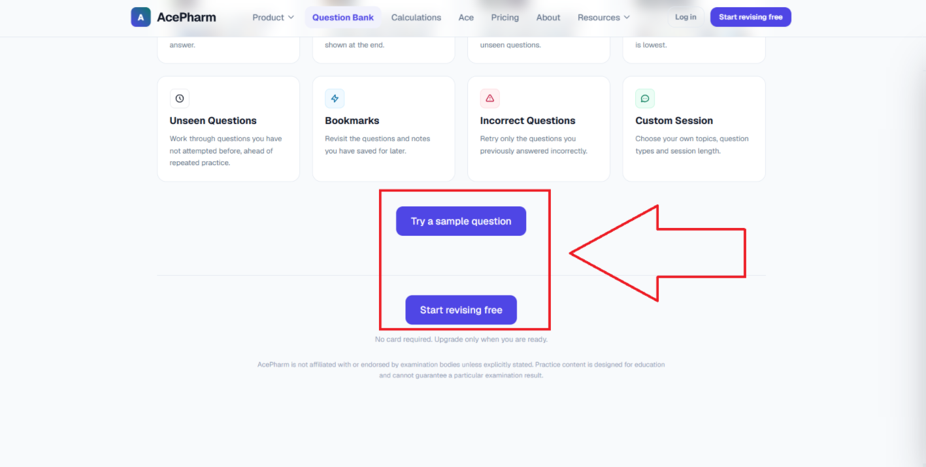

AP-20
Issue Name | Ace Page – "Try Ace on a Real Question" Button Skips Login
Description | On the Ace page banner, clicking the "Try Ace on a Real Question" button takes the user directly to the dashboard without requiring login. This button should redirect to the login page instead.
Steps to Reproduce | 1. Navigate to the Ace page.  2. Click the "Try Ace on a Real Question" button in the banner.  3. Observe where it redirects (while logged out).
Severity | Medium
Expected Result | Clicking this button should take the user to the login page if they are not logged in.
Actual Result | The button takes the user directly to the dashboard without login.
Screenshot | 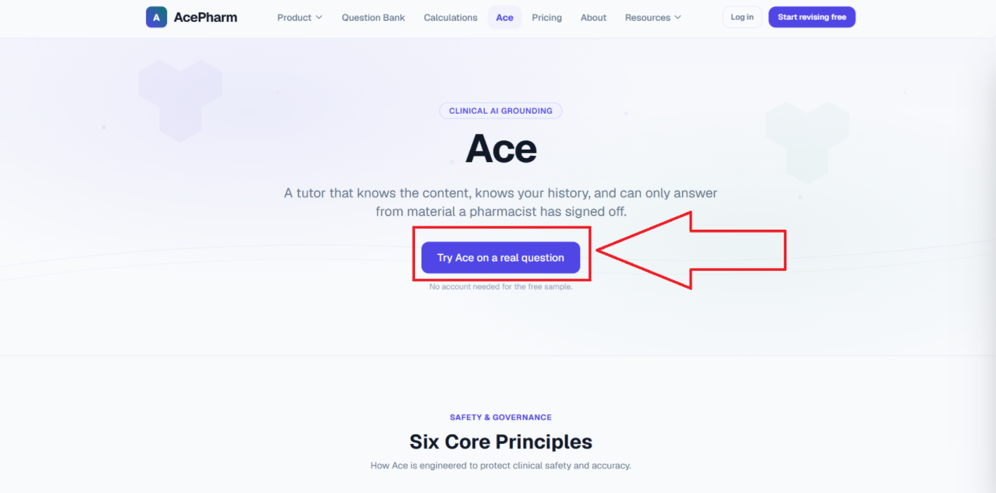

AP-21
Issue Name | Pricing Page – Feature Comparison Matrix Layout Looks Complex
Description | Below the pricing plan cards, the Feature Comparison Matrix is displayed as a single large card, which does not look good and appears overly complex. It should be displayed as a proper table instead.
Steps to Reproduce | 1. Navigate to the Pricing page.  2. Scroll to the Feature Comparison Matrix below the pricing cards.  3. Observe its layout.
Severity | Low
Expected Result | The Feature Comparison Matrix should be displayed as a clean, proper table format.
Actual Result | It is currently displayed as one complex-looking card.
Screenshot | 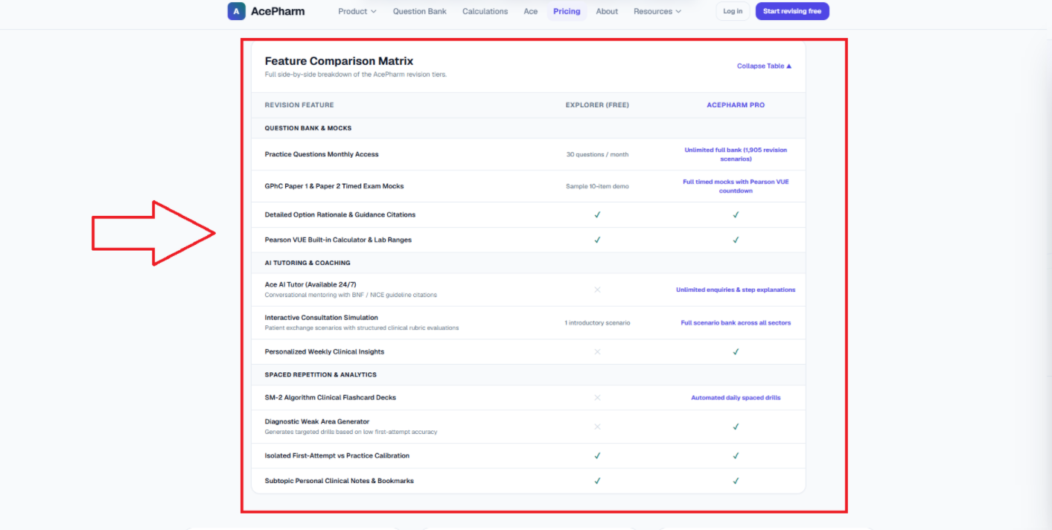

AP-22
Issue Name | Pricing Page – Yearly Plan Name and "Most Popular" Pill Text Wrap to Second Line
Description | On the Pricing page, in the yearly plan card, the plan name text wraps onto a second line. Similarly, the "Most Popular" pill's text also wraps, with "Popular" going to a second line.
Steps to Reproduce | 1. Navigate to the Pricing page.  2. Observe the yearly plan card's name text and the "Most Popular" pill.
Severity | Low
Expected Result | Both the plan name and the "Most Popular" pill text should display fully on a single line.
Actual Result | The plan name text wraps to a second line, and "Popular" in the "Most Popular" pill also wraps to a second line.
Screenshot | 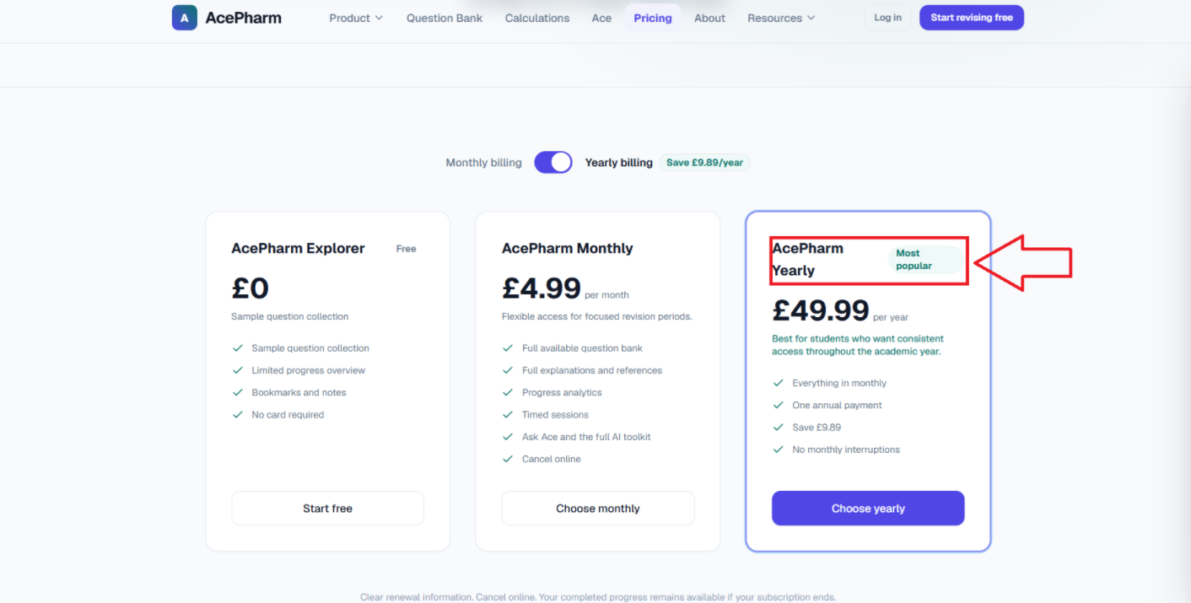

AP-23
Issue Name | Resource Page – "Read Revision Guide" CTA Is a Text Link Instead of a Button
Description | On the Resource page, the "Read Revision Guide" option is currently displayed as a simple text link. Since this is the primary CTA for each card, it should be designed as a proper solid button instead of a text link, improving visibility and click-ability.
Steps to Reproduce | 1. Navigate to the Resource page.  2. Observe the "Read Revision Guide" link on any card.
Severity | Medium
Expected Result | "Read Revision Guide" should be styled as a solid, clearly visible button.
Actual Result | It is currently just a text link.
Screenshot | 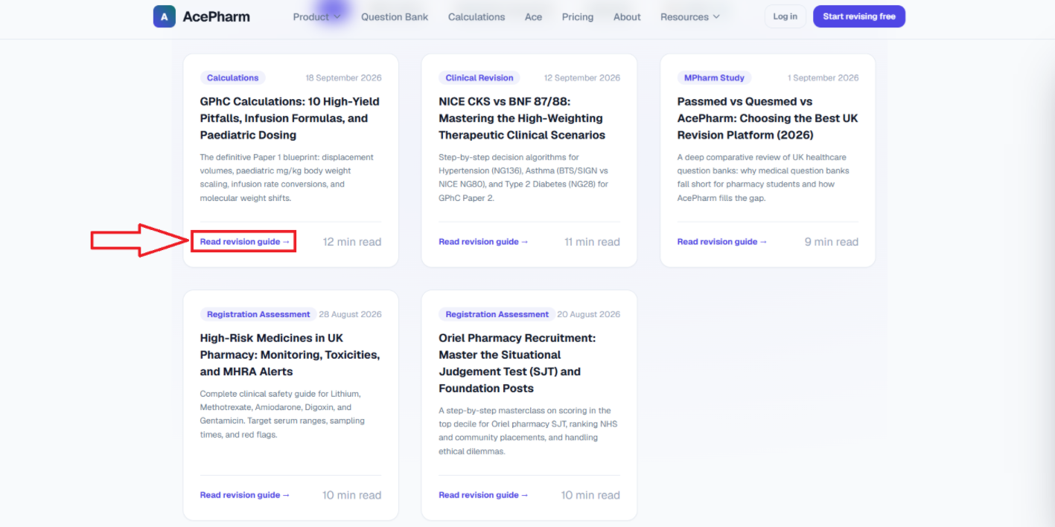

AP-24
Issue Name | Resource Page – Category Tags Styled as Pills but Not Interactive
Description | In each card, the category tags (Calculations, GPhC Paper 1, Paediatrics, BNF) are styled to look like clickable pills, but they are not actually interactive. To avoid confusing users, their design should be simplified so they look like plain text labels instead.
Steps to Reproduce | 1. Navigate to the Resource page.  2. Observe the category tags on any card.  3. Try clicking a tag.
Severity | Low
Expected Result | Category tags should either be made interactive or restyled as plain (non-clickable-looking) text labels.
Actual Result | Category tags look like clickable pills but do nothing when clicked.
Screenshot | 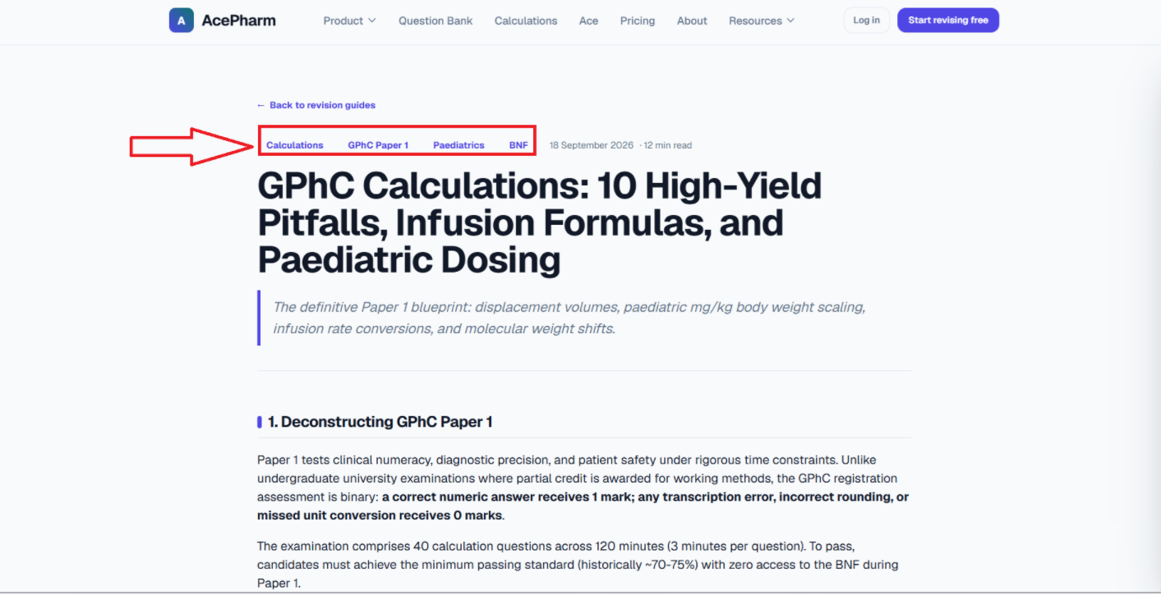

AP-25
Issue Name | Resource Page – "Read Revision Guide" Redirects Back to Same Page Instead of Its Own Content
Description | On the Resource page, clicking a card's "Read Revision Guide" link redirects back to the same Resources page instead of opening the guide's own dedicated page. It should be linked to its correct/own page.
Steps to Reproduce | 1. Navigate to the Resource page.  2. Click "Read Revision Guide" on any card.  3. Observe where it redirects.
Severity | Medium
Expected Result | Clicking "Read Revision Guide" should open that specific guide's own dedicated page.
Actual Result | It redirects back to the same Resources page.
Screenshot | 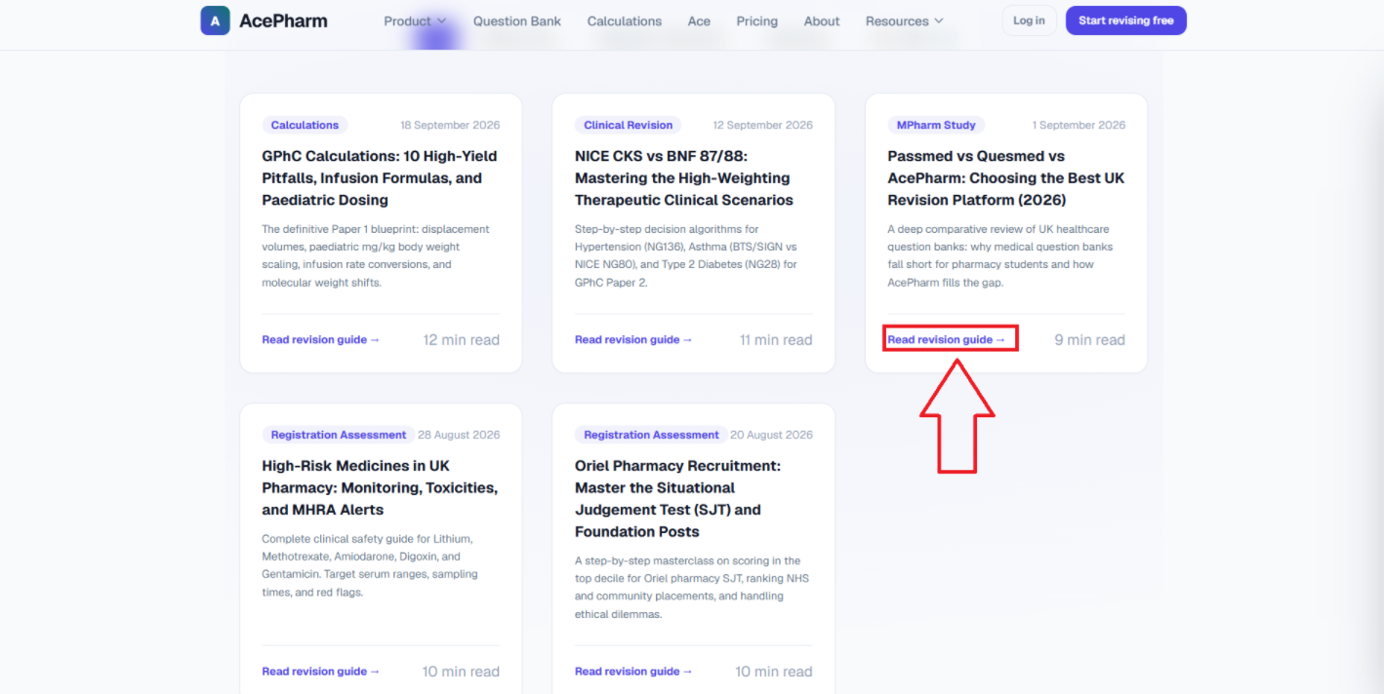

AP-26
Issue Name | Contact Page – Email Displayed Prominently in First Section (Spam Risk)
Description | On the Contact page, the email address is written out in the very first section and is styled to look like a clickable link, which is not user-friendly. It should be removed from here and moved to the footer instead, since a visible email in this format can be scraped by bots/AI agents and lead to spam.
Steps to Reproduce | 1. Navigate to the Contact page.  2. Observe the first section for the visible email address/link.
Severity | Medium
Expected Result | The email address should be removed from the top section and placed in the footer to reduce spam/scraping risk.
Actual Result | The email address is prominently displayed and link-styled in the first section of the Contact page.
Screenshot | 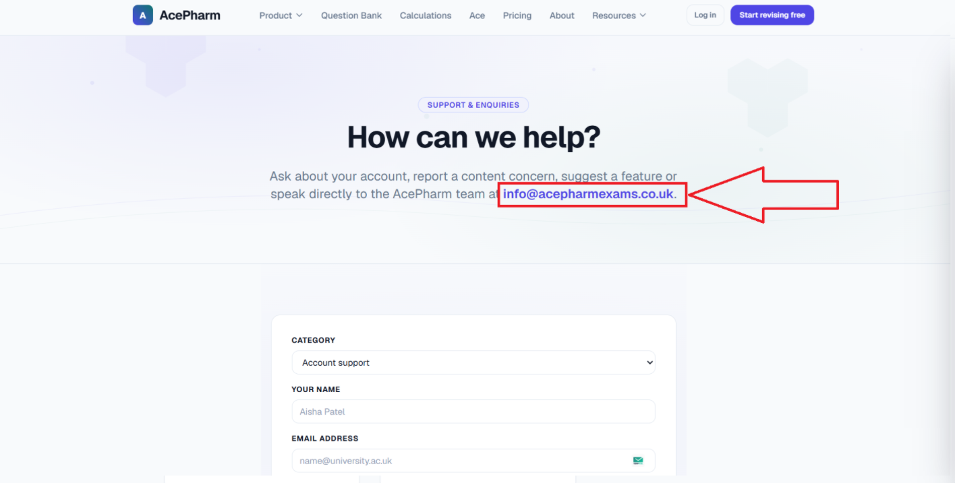

AP-27
Issue Name | Contact Us Form – No Mandatory Field Indication
Description | On the Contact page, the Contact Us form does not indicate which fields are mandatory and which are optional.
Steps to Reproduce | 1. Navigate to the Contact page.  2. Observe the Contact Us form fields.
Severity | Medium
Expected Result | Mandatory fields should be marked with an asterisk (*) or similar indicator.
Actual Result | There is no indication of which fields are mandatory.
Screenshot | 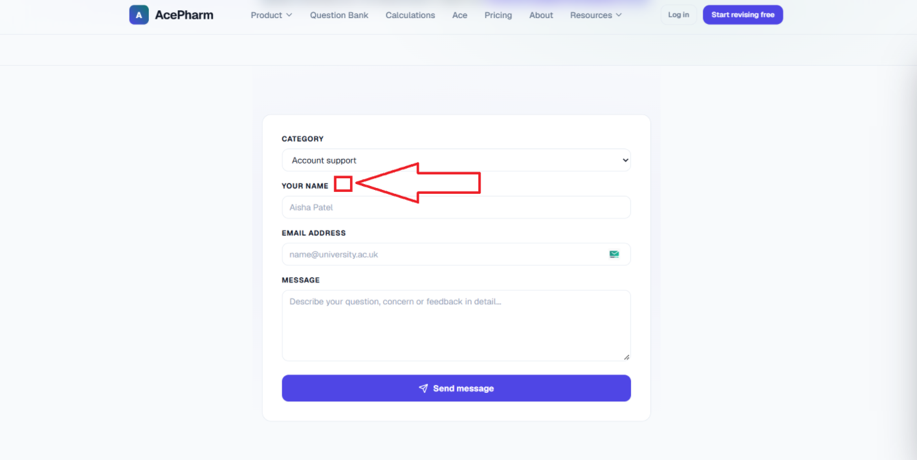

AP-28
Issue Name | Contact Us Form – Success Message Does Not Disappear or Close
Description | After submitting the Contact Us form, the success message that appears does not disappear on its own, and there is no option to close/cross it out. The message keeps showing until the user refreshes the website, which is a bad experience. It should either disappear automatically after a few seconds, or have a close (X) option.
Steps to Reproduce | 1. Navigate to the Contact page.  2. Fill in and submit the Contact Us form.  3. Observe the success message behavior.
Severity | Low
Expected Result | The success message should automatically disappear after a few seconds, or provide a close (X) option.
Actual Result | The success message stays on screen indefinitely with no way to close it, until the page is refreshed.
Screenshot | 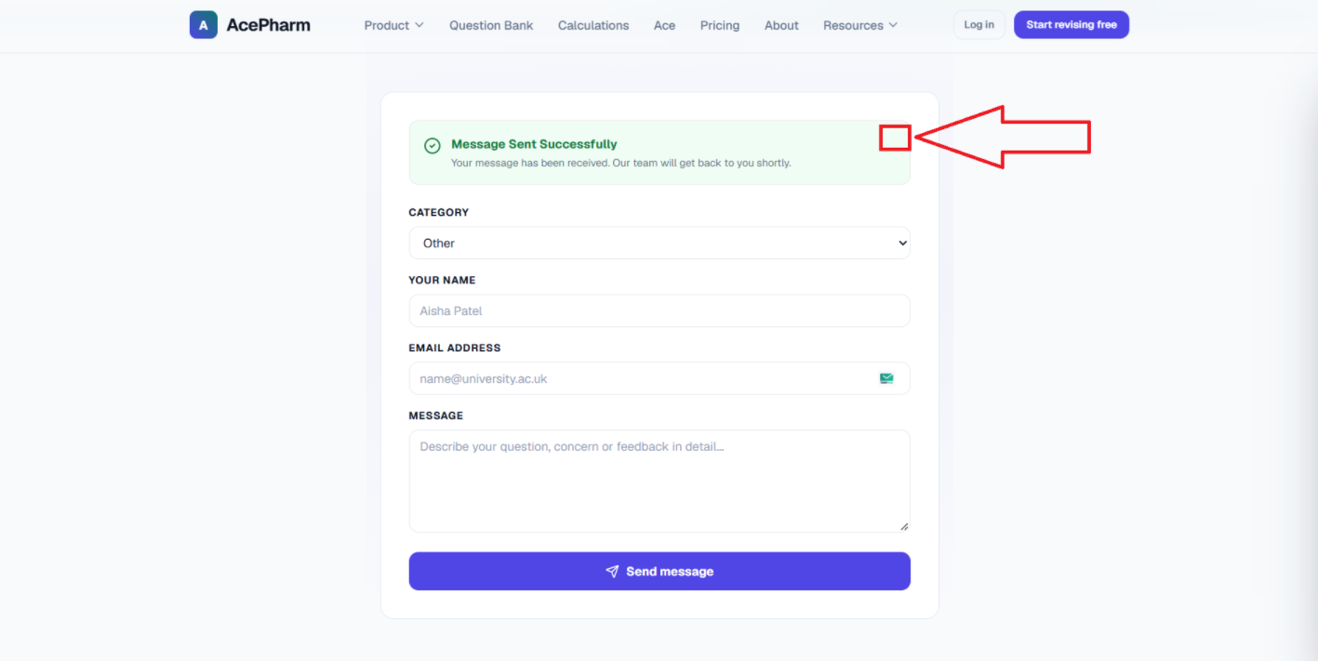

AP-29
Issue Name | Login & Register Pages – No Back Button
Description | On the Login and Register pages, there is no back button; users have to use the browser's back button to navigate back.
Steps to Reproduce | 1. Navigate to the Login or Register page.  2. Look for an in-page back/navigation option.
Severity | Low
Expected Result | A back button should be available on the Login and Register pages.
Actual Result | No back button exists; the user must rely on the browser's back button.
Screenshot | 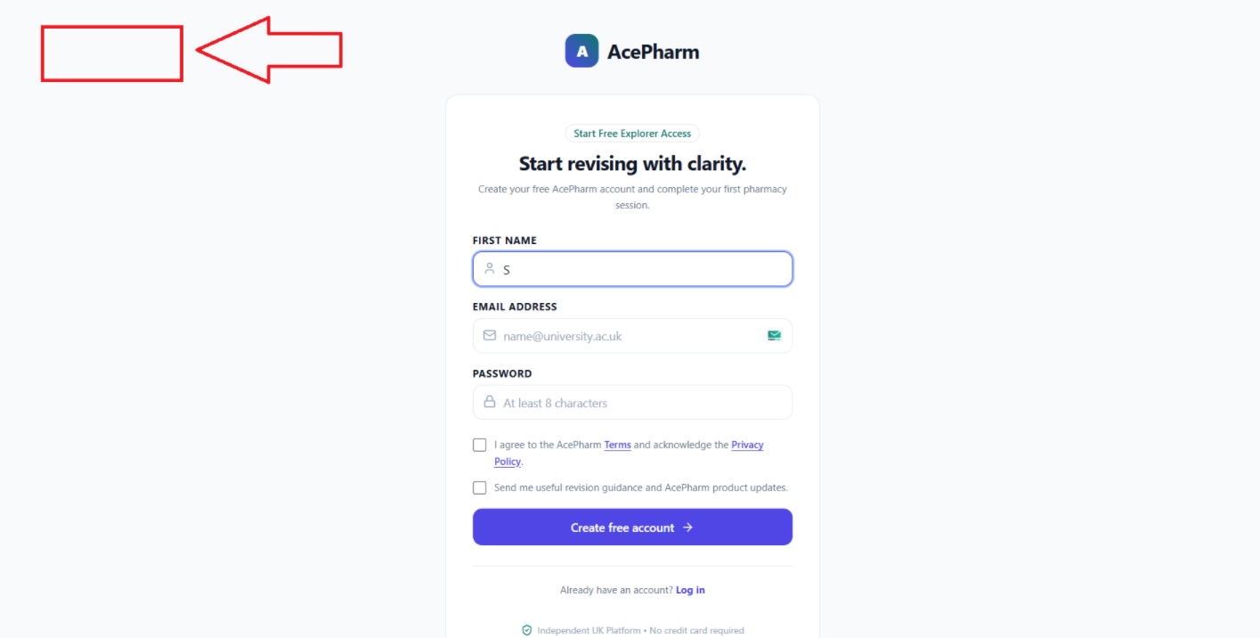

AP-30
Issue Name | Login & Register Pages – Password Field Missing Show/Hide Eye Icon
Description | On both the Login and Register pages, the password field currently has no "eye icon" to show or hide the password characters. To improve user experience and ensure accuracy while typing, a toggle visibility eye icon should be added at the end of the password input box.
Steps to Reproduce | 1. Navigate to the Login or Register page.  2. Observe the password field.
Severity | Medium
Expected Result | A toggle visibility (eye) icon should be present in the password field to show/hide the entered password.
Actual Result | No eye icon is present in the password field.
Screenshot | 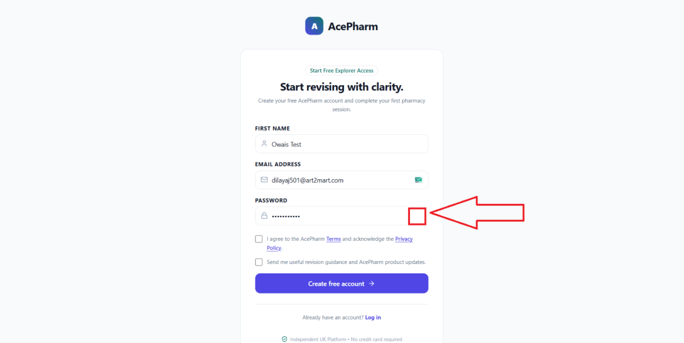

AP-31
Issue Name | Sign-Up – No Email Verification Indication Before Dashboard Access
Description | A verification email is sent after sign-up, but there is no indication to the user that they need to verify their email before using the account. When the user clicks "Create Free Account," they land directly on the dashboard without any verification step being enforced or communicated.
Steps to Reproduce | 1. Sign up for a new account.  2. Click "Create Free Account."  3. Observe whether any email verification message/indication is shown before dashboard access.
Severity | Medium
Expected Result | The user should be clearly informed that they need to verify their email, ideally before or immediately after landing on the dashboard.
Actual Result | No verification indication is shown; the user lands directly on the dashboard after account creation.
Screenshot | 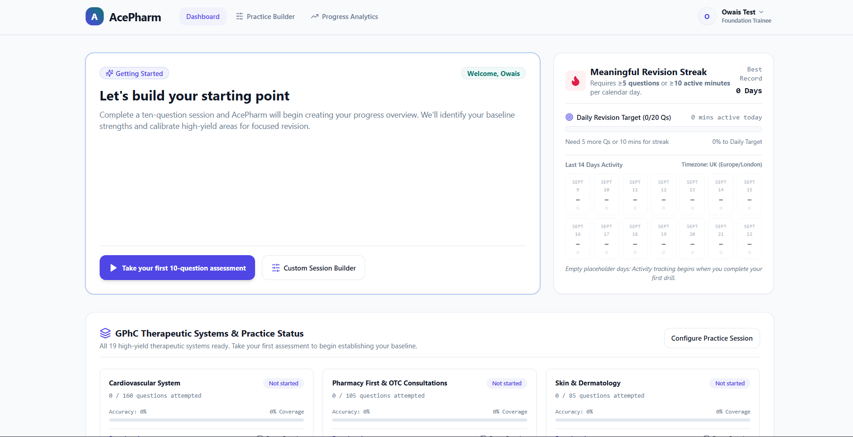

AP-32
Issue Name | Cookies Popup – Privacy Policy Link Returns 404
Description | After logging in, a cookies popup appears on the dashboard. When the user clicks the Privacy Policy link/page within it, a 404 page is returned instead of the actual Privacy Policy page.
Steps to Reproduce | 1. Log in to the dashboard.  2. Observe the cookies popup.  3. Click the "Privacy Policy" link inside it.
Severity | Medium
Expected Result | Clicking "Privacy Policy" should take the user to the actual Privacy Policy page.
Actual Result | A 404 page is returned instead.
Screenshot | 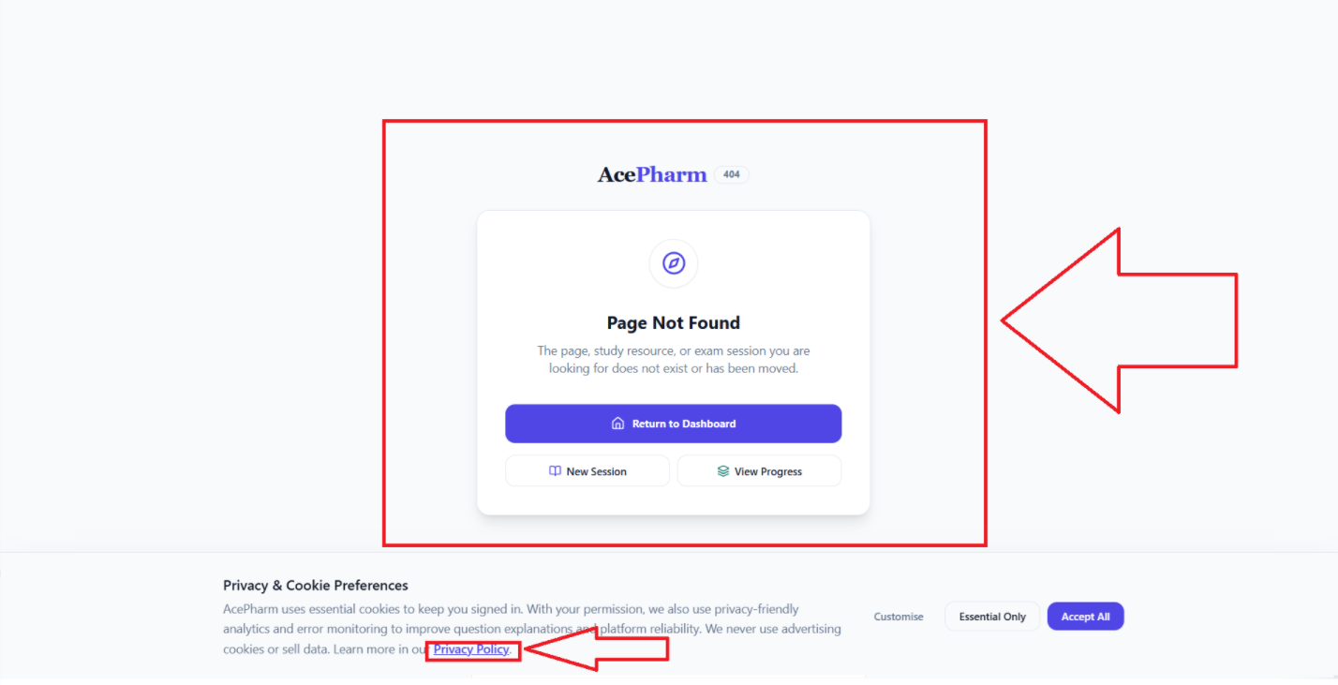

AP-33
Issue Name | Practice Builder – Question with Explanation Displays Twice After Submission
Description | On the dashboard, when the user opens the Practice Builder page and starts a quiz, after selecting an option and submitting, the question along with its explanation is displayed twice instead of once, which is not user-friendly.
Steps to Reproduce | 1. Log in and open the Practice Builder page.  2. Start a quiz.  3. Select an option and submit.  4. Observe how many times the question with explanation appears.
Severity | Medium
Expected Result | The question with explanation should be shown only once after the user submits their answer.
Actual Result | The question with explanation is displayed twice.
Screenshot | 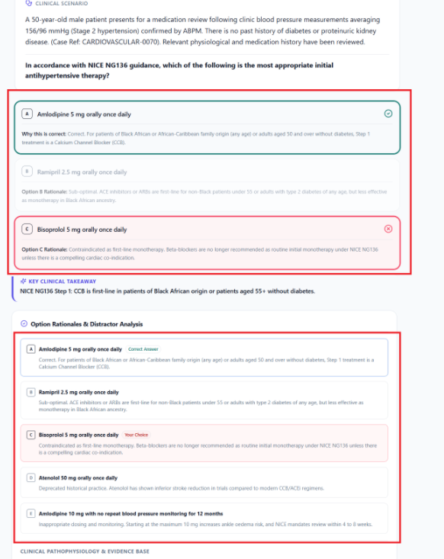

AP-34
Issue Name | Question Page – "Ask Ace" Chat Box Requires Scrolling to Find
Description | After the user selects an answer option, the "Ask Ace" AI chat box appears below the page, requiring the user to scroll down to see it. After submitting an answer, it should instead appear on the right side of the question so the user can easily see it and interact with it.
Steps to Reproduce | 1. Open a question.  2. Select an option and submit.  3. Observe where the "Ask Ace" chat box appears.
Severity | Low
Expected Result | The "Ask Ace" chat box should appear on the right side of the question after submission, without requiring the user to scroll.
Actual Result | The chat box appears below the page and requires scrolling to be seen.
Screenshot | 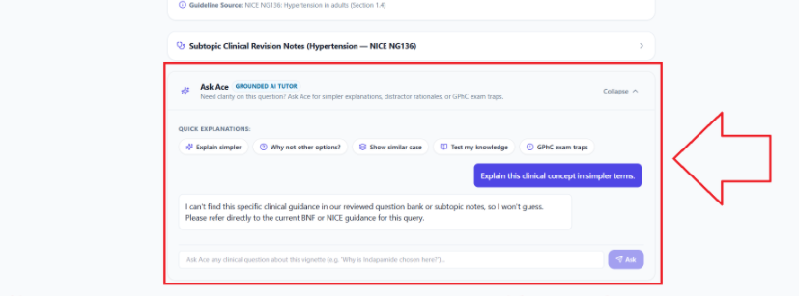

AP-35
Issue Name | Ask Ace AI – Not Responding Correctly to Questions
Description | The Ask Ace AI is not responding as expected — whatever question is asked, it gives the same fixed statement, which is also invalid/irrelevant.
Steps to Reproduce | 1. Open the Ask Ace AI chat.  2. Ask any question.  3. Observe the response.
Severity | High
Expected Result | Ask Ace AI should give a relevant, correct response based on the actual question asked.
Actual Result | Ask Ace AI gives the same fixed, invalid response regardless of the question asked.
Screenshot | 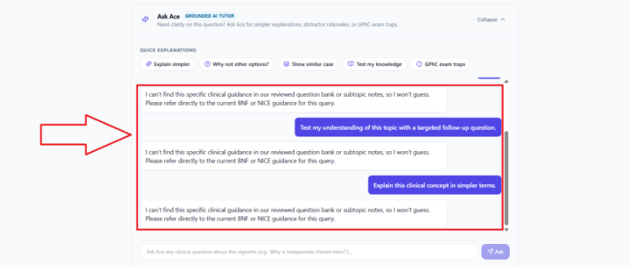

AP-36
Issue Name | Question Navigation – First Option Auto-Selected and Auto-Submitted on Every Question (Critical)
Description | When the user selects an option and moves to the next question, the first option is selected by default on every subsequent question, and this happens automatically for all next questions — the user cannot change the selected option. The first option also appears to be auto-submitted already. This means the student cannot properly attempt any question.
Steps to Reproduce | 1. Start a quiz/practice session.  2. Select an option on question 1 and move to question 2.  3. Observe the default option state on question 2 and beyond.  4. Try changing the selected option.
Severity | Critical
Expected Result | Each new question should load with no option pre-selected/pre-submitted, allowing the user to freely choose and submit their own answer.
Actual Result | The first option is automatically selected and submitted on every question, and the user cannot change it.
Screenshot | 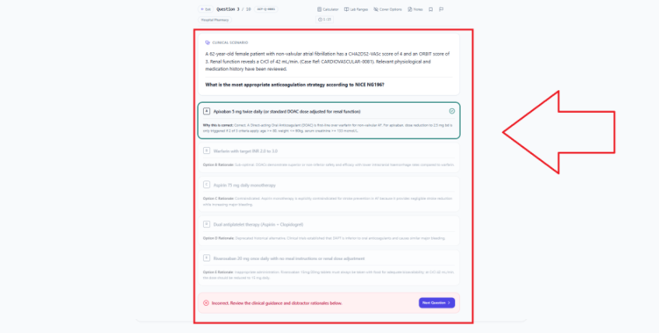

AP-37
Issue Name | Question Page – No Indication That Double-Clicking a Word Opens "Ask Ace"
Description | There is no indication to the user that double-clicking any word brings up an "Ask Ace about this" widget/option, which would let them ask the AI something related to that word.
Steps to Reproduce | 1. Open a question.  2. Double-click on any word in the question text.  3. Observe whether any indication/hint was given beforehand.
Severity | Low
Expected Result | The website should indicate to users (e.g., via a tooltip or hint) that double-clicking a word offers an "Ask Ace" option.
Actual Result | No such indication exists; users would not know this feature exists unless they discover it by accident.
Screenshot | 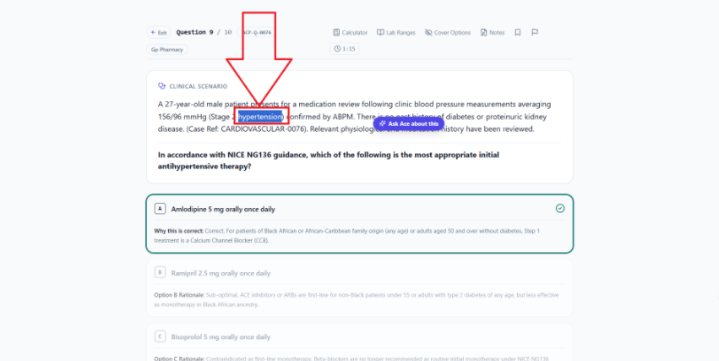

AP-38
Issue Name | Question Page – No Indication That "Ask Ace" Chatbot Appears Only After Answer Submission
Description | When the user clicks "Ask Ace" on a word, no indication is shown that the AI chatbot will only become visible after the answer has been submitted. A clear message should be displayed to inform the user of this. (Note: after submission, the selected word is correctly passed to the chatbot.)
Steps to Reproduce | 1. Open a question.  2. Double-click a word and click "Ask Ace" before submitting an answer.  3. Observe whether any message explains that the chatbot appears only after submission.
Severity | Low
Expected Result | A clear message should inform the user that the "Ask Ace" chatbot will only appear after they submit their answer.
Actual Result | No such message is shown; the user is not informed why the chatbot isn't appearing yet.
Screenshot | 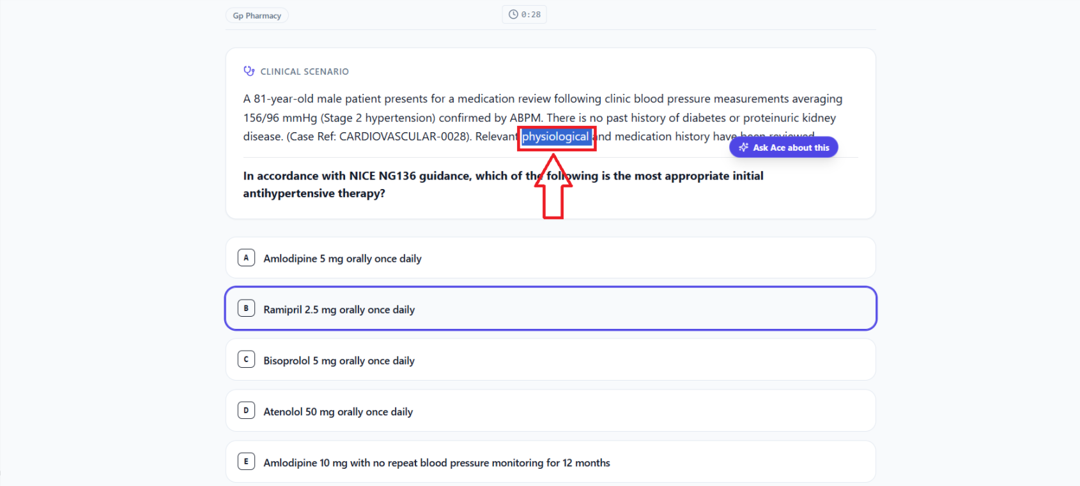  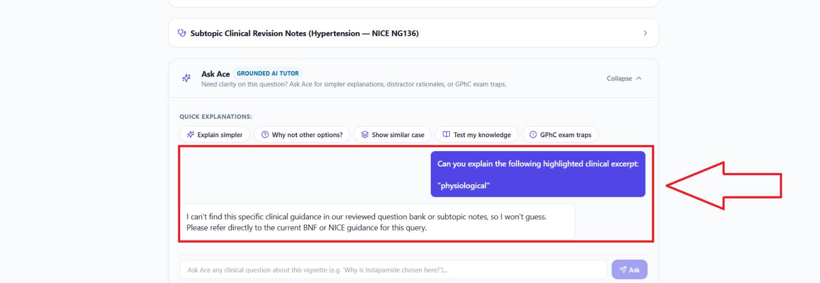

AP-39
Issue Name | Question Page – "Exit" Button Sometimes Shows Dashboard Without Login; Needs Better Visibility
Description | On the question page, when the user clicks the exit button, sometimes the dashboard is shown without requiring login, which is a bug that needs to be fixed. Additionally, the exit button should be adjusted to be more visible and noticeable.
Steps to Reproduce | 1. Open a question page while logged in.  2. Click the "Exit" button across multiple sessions.  3. Observe whether the dashboard is sometimes shown without an active login check.
Severity | High
Expected Result | Clicking "Exit" should always correctly respect the user's login state, and the button itself should be clearly visible.
Actual Result | The dashboard is sometimes shown without login being properly enforced, and the exit button is not easily noticeable.
Screenshot | 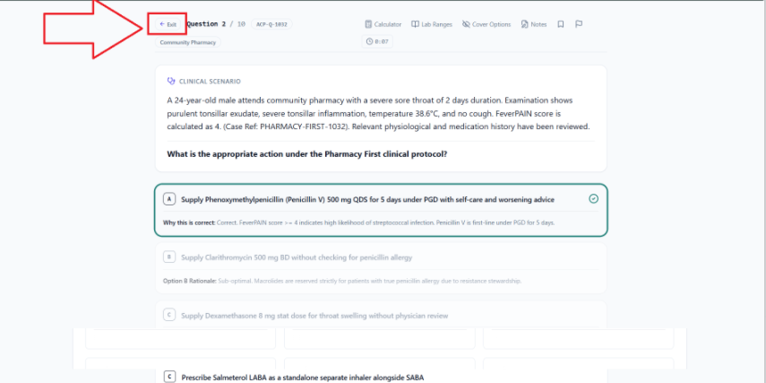  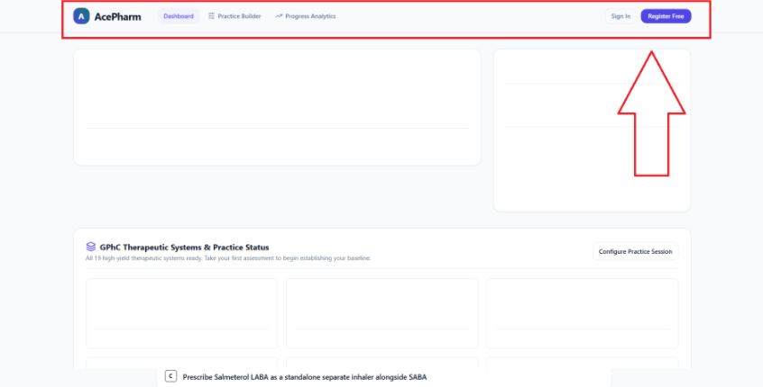

AP-40
Issue Name | Practice Session Summary Page – Stats Are Incorrect/System-Assumed (Critical)
Description | After completing a section, the Practice Session Summary page opens, but none of the displayed data is accurate — the system appears to assume/fabricate values instead of showing real data, including Average Time, Total Time, and Daily Goals.
Steps to Reproduce | 1. Complete a practice section.  2. Open the resulting Practice Session Summary page.  3. Check the Avg Time, Total Time, and Daily Goals values against actual session data.
Severity | Critical
Expected Result | All statistics on the Practice Session Summary page (Avg Time, Total Time, Daily Goals, etc.) should accurately reflect the actual session data.
Actual Result | The displayed statistics do not reflect real data and appear to be system-assumed/incorrect.
Screenshot | 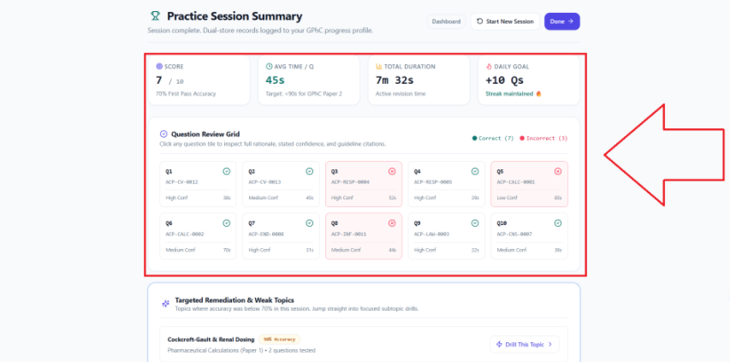

AP-41
Issue Name | Practice Session Summary Page – "Drill This Topic" Button Not Functional
Description | After completing a section, the Practice Session Summary page shows a "Targeted Remediation and Weak Topics" section with 3 cards, each having a "Drill This Topic" button. Clicking this button does not open anything. It should be linked to dedicated pages for each topic.
Steps to Reproduce | 1. Complete a practice section.  2. Open the Practice Session Summary page.  3. Scroll to "Targeted Remediation and Weak Topics."  4. Click "Drill This Topic" on any card.
Severity | Medium
Expected Result | Clicking "Drill This Topic" should open a dedicated page for practicing that specific topic.
Actual Result | Clicking the button does not open anything.
Screenshot | 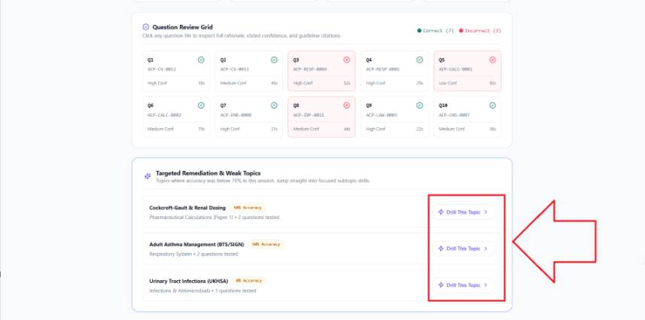

AP-42
Issue Name | Question Page – Notes Box Has No Cancel/Close Button
Description | On the question page, the header has a Notes button; clicking it shows a small box where the user can write and save notes. However, there is no cross/cancel button to close this box — the only way to dismiss it is by clicking the Notes button again.
Steps to Reproduce | 1. Open a question page.  2. Click the Notes button in the header.  3. Observe the notes box.  4. Look for a way to close/cancel it other than the Notes button itself.
Severity | Low
Expected Result | The notes box should have a clear cross/cancel button to close it.
Actual Result | No close/cancel button exists; the box can only be dismissed by clicking the Notes button again.
Screenshot | 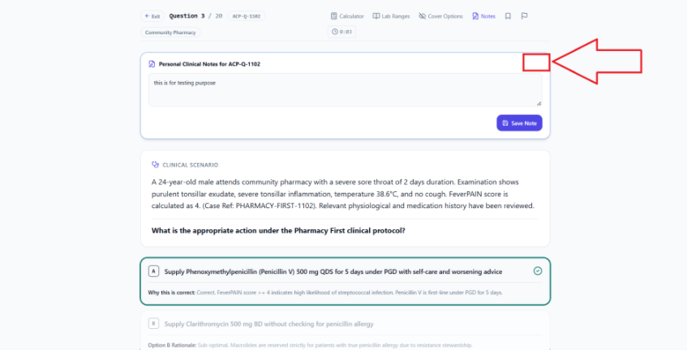

AP-43
Issue Name | Question Page – Exam Toolbar Needs Better Visual Design
Description | On the question page, the Exam Toolbar (where tools are grouped together) should be redesigned to be more visible, using color to improve distinction between the tools.
Steps to Reproduce | 1. Open a question page.  2. Observe the Exam Toolbar.
Severity | Low (Suggestion)
Expected Result | The Exam Toolbar should be redesigned with better use of color to make each tool more visible and distinct.
Actual Result | The Exam Toolbar's current design lacks visibility/distinction between tools.
Screenshot | 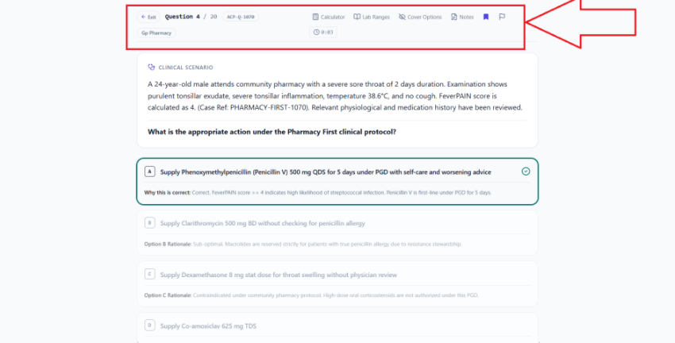

AP-44
Issue Name | Dashboard Home – Daily Streak Box Does Not Update
Description | On the dashboard home page, the Daily Streak box does not update — it does not appear to be working.
Steps to Reproduce | 1. Log in to the dashboard.  2. Complete activity that should count toward the daily streak.  3. Check whether the Daily Streak box updates.
Severity | Medium
Expected Result | The Daily Streak box should update correctly based on the user's activity.
Actual Result | The Daily Streak box does not update.
Screenshot | 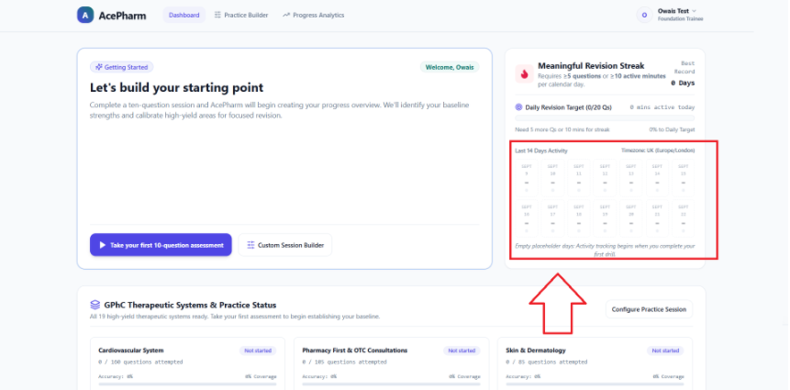

AP-45
Issue Name | Dashboard Home – Progress Bars Not Updating in "GPhC Therapeutic Systems & Practice Status" Section
Description | On the dashboard home page, in the "GPhC Therapeutic Systems & Practice Status" section, the progress bars on the cards do not update. When the user solves a question for a given card/topic, its progress bar should update accordingly.
Steps to Reproduce | 1. Log in to the dashboard.  2. Note the current progress bar state for a card in the "GPhC Therapeutic Systems & Practice Status" section.  3. Solve a question related to that topic.  4. Check whether the progress bar updates.
Severity | Medium
Expected Result | The progress bar should update after the user solves a related question.
Actual Result | The progress bar does not update.
Screenshot | 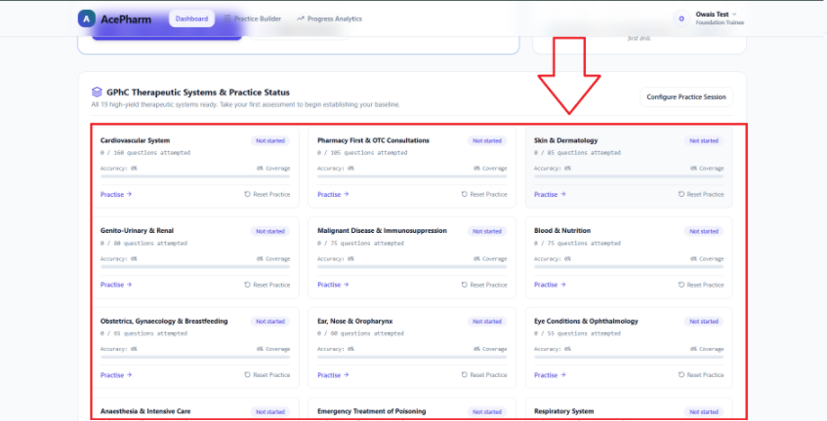

AP-46
Issue Name | Dashboard Home – "Reset Practice" Confirmation Button Stays Disabled After Typing Confirmation Text
Description | On the dashboard home page, in the "GPhC Therapeutic Systems & Practice Status" cards, clicking "Reset Practice" opens a popup asking the user to type "reset" in a field and then click the button to confirm. However, even after typing "reset" correctly, the button remains non-clickable/disabled.
Steps to Reproduce | 1. Log in to the dashboard.  2. Click "Reset Practice" on any card.  3. Type "reset" in the confirmation field as instructed.  4. Try clicking the confirm button.
Severity | Medium
Expected Result | The confirm button should become clickable/enabled once the user correctly types "reset."
Actual Result | The button remains disabled/non-clickable even after typing "reset" correctly.
Screenshot | 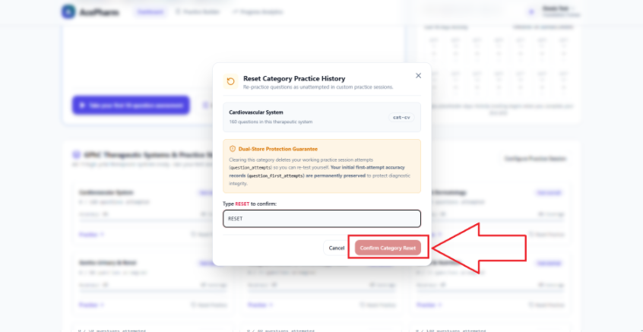

AP-47
Issue Name | Progress Analysis Page – Stats Briefly Show Dummy Data Then Reset to Zero
Description | On the Progress Analysis page, dummy Progress Stats are shown for a few seconds, and then all the Progress Stats reset to zero.
Steps to Reproduce | 1. Log in and navigate to the Progress Analysis page.  2. Observe the Progress Stats immediately on load, then after a few seconds.
Severity | High
Expected Result | The Progress Analysis page should show accurate, real progress stats consistently, without briefly showing dummy data that then resets to zero.
Actual Result | Dummy stats briefly appear and then all reset to zero after a few seconds.
Screenshot | 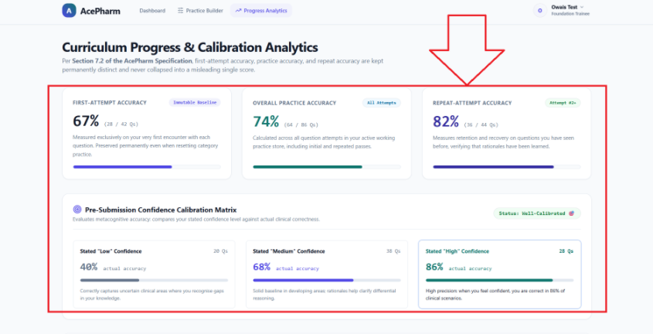

AP-48
Issue Name | Question Page – No Way to View Previously Saved Notes
Description | On the question page, the user can save notes, but there is no option available for the user to go back and view the notes they previously saved.
Steps to Reproduce | 1. Open a question page.  2. Add and save a note.  3. Look for an option to view previously saved notes.
Severity | Medium
Expected Result | The user should have an option/page to view all their previously saved notes.
Actual Result | No such option currently exists.
Screenshot | 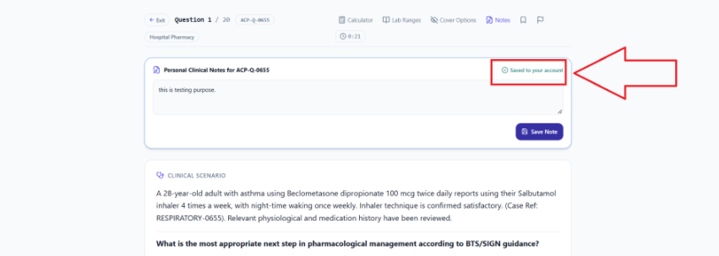  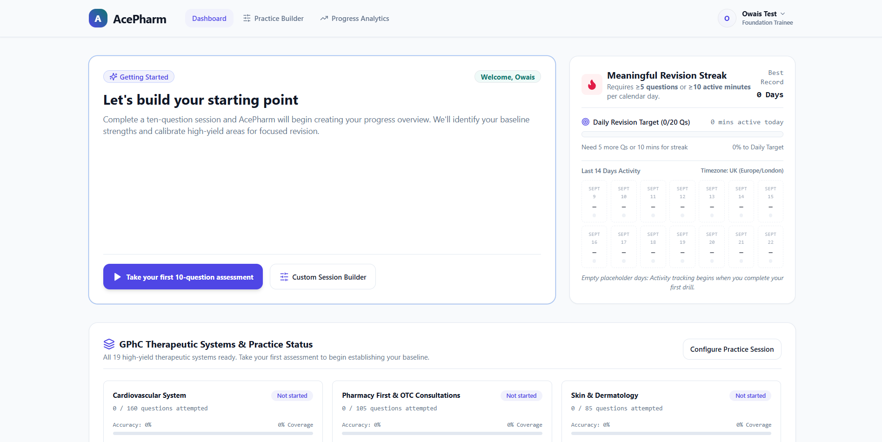

AP-49
Issue Name | Question Page – No Way to View Bookmarked Questions
Description | On the question page, the user can bookmark a question, but there is no option for the user to see which questions they have bookmarked or where these bookmarks are visible.
Steps to Reproduce | 1. Open a question page.  2. Bookmark a question.  3. Look for an option/page to view all bookmarked questions.
Severity | Medium
Expected Result | The user should be able to see a list of all questions they have bookmarked.
Actual Result | No such option currently exists.
Screenshot | 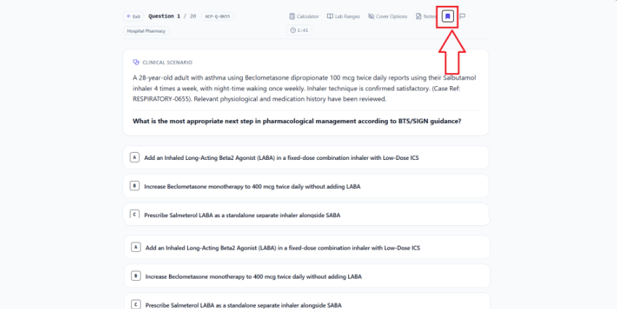

AP-50
Issue Name | New Account – Pre-Attached Bank Card and Pre-Activated Pro Plan (Critical)
Description | When a user creates a new account, a bank account card is already attached by default, instead of the user adding their own payment details. There is also no option to delete this card. Additionally, a new user's account already has the Pro plan active by default, which is a critical billing issue.
Steps to Reproduce | 1. Create a new account.  2. Check the payment/billing section for a pre-attached card.  3. Look for an option to delete/remove the card.  4. Check the active subscription plan for a brand-new account.
Severity | Critical
Expected Result | A new account should have no pre-attached payment card (the user should add their own), a delete-card option should be available, and new accounts should start on the Free plan, not Pro.
Actual Result | A card is pre-attached with no delete option, and new accounts are already on the Pro plan.
Screenshot | 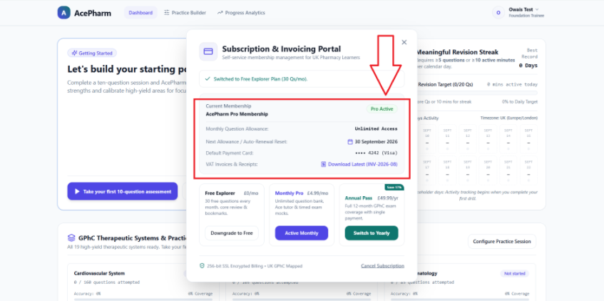

AP-51
Issue Name | Subscription – Selecting Free Plan Does Not Actually Switch the Plan
Description | When the user clicks on the Free plan, a message is shown confirming the free plan, but the account's actual plan remains Pro.
Steps to Reproduce | 1. Log in to an account with the Pro plan.  2. Navigate to plan selection and click "Free Plan."  3. Check the confirmation message and then the actual active plan.
Severity | High
Expected Result | Selecting the Free plan should actually switch the account to the Free plan.
Actual Result | A confirmation message appears, but the account remains on the Pro plan.
Screenshot | 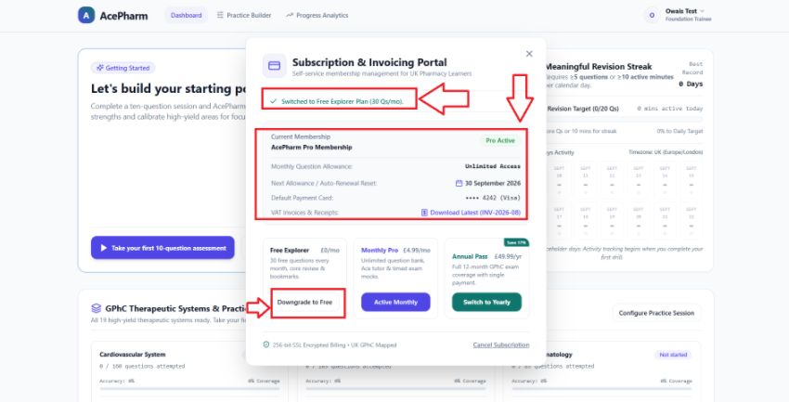

AP-52
Issue Name | Subscription & Invoicing Portal – "Download Latest" Invoice Button Not Working
Description | On the Subscription & Invoicing portal, clicking the "Download Latest (INV-2026-88)" button does not download any receipt — nothing happens when clicked.
Steps to Reproduce | 1. Navigate to the Subscription & Invoicing portal.  2. Click the "Download Latest (INV-2026-88)" button.  3. Observe the result.
Severity | Medium
Expected Result | Clicking the button should download the corresponding invoice/receipt.
Actual Result | Nothing happens when the button is clicked.
Screenshot | 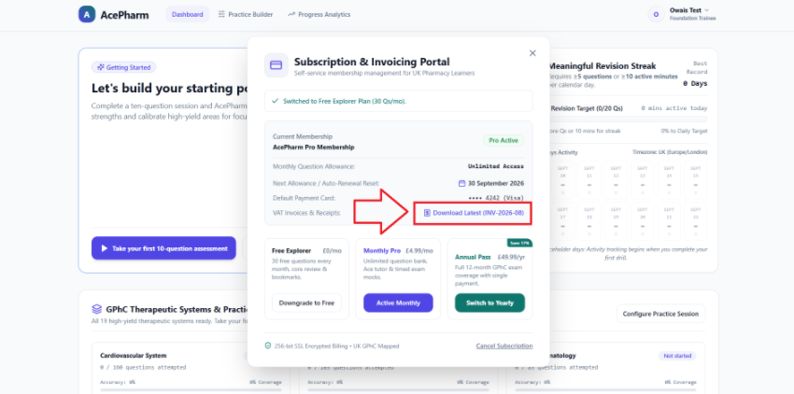

AP-53
Issue Name | Subscription – Checkout Page Slow to Load / Sometimes Fails with Error
Description | When the user clicks the button on an active monthly or yearly plan card, it takes a long time before the checkout page appears. Sometimes, instead of loading, an error is shown: "Unable to start checkout session. Please try again."
Steps to Reproduce | 1. Navigate to plan selection.  2. Click a monthly or yearly plan's button.  3. Observe how long it takes to reach checkout, and note any errors.
Severity | High
Expected Result | The checkout page should load quickly and reliably without errors.
Actual Result | Checkout takes a long time to load, and sometimes fails with an "Unable to start checkout session" error.
Screenshot | 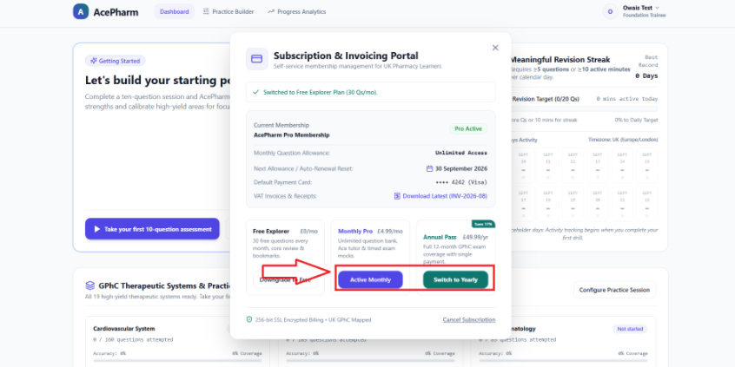

AP-54
Issue Name | Dashboard Header – Add Direct Link to Subscription & Invoicing Portal (Suggestion)
Description | It is suggested that the dashboard header include a link to the Subscription & Invoicing Portal page so the user can easily navigate there.
Steps to Reproduce | 1. Log in to the dashboard.  2. Look for a Subscription & Invoicing Portal link in the header.
Severity | Low (Suggestion)
Expected Result | A direct link to the Subscription & Invoicing Portal should be added to the dashboard header.
Actual Result | No such direct link currently exists in the header.
Screenshot | 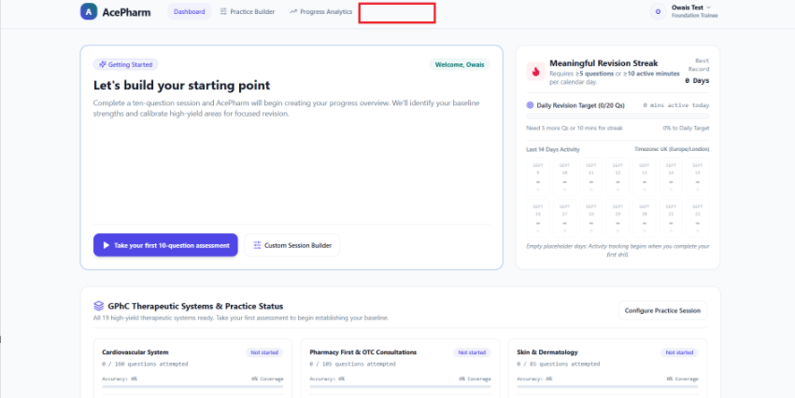

AP-55
Issue Name | Dashboard – No Indication of Active Paid Plan
Description | On the dashboard, when the user has purchased a paid plan, this should be indicated somewhere for clarity.
Steps to Reproduce | 1. Log in with an account that has a paid plan.  2. Observe the dashboard for any indication of the active paid plan.
Severity | Low
Expected Result | The dashboard should clearly indicate when the user has an active paid plan.
Actual Result | There is currently no such indication on the dashboard.
Screenshot | 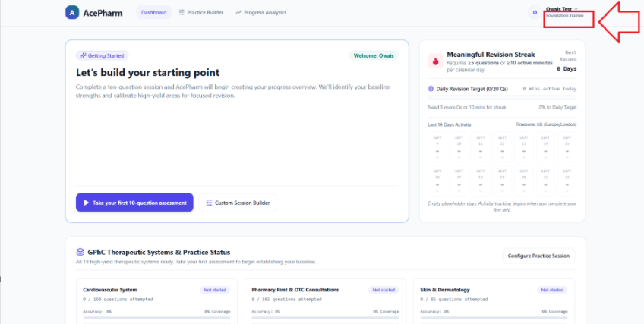

AP-56
Issue Name | Admin Dashboard Link Returns 404 (Not Built Yet)
Description | Opening the Admin dashboard link returns a 404 page — the admin page has not been built yet.
Steps to Reproduce | 1. Navigate to the Admin dashboard link.
Severity | Medium
Expected Result | The Admin dashboard should be built and functional, or the link should be hidden/disabled until it is ready.
Actual Result | A 404 page is returned; the admin dashboard is not built yet.
Screenshot | 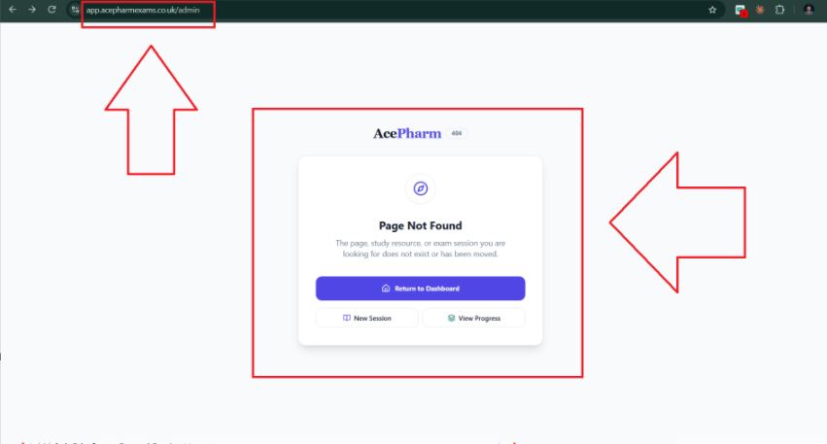

AP-57
Issue Name | Question Page – Add Demo Steps or Video to Guide Students (Suggestion)
Description | It is suggested to add demo steps or a video to the question page so students can easily understand how to use it.
Steps to Reproduce | 1. Open a question page.  2. Observe that there is no demo/guide for first-time users.
Severity | Low (Suggestion)
Expected Result | A short demo (steps or video) should be added to help students understand the question page.
Actual Result | No such demo/guide currently exists.
Screenshot | 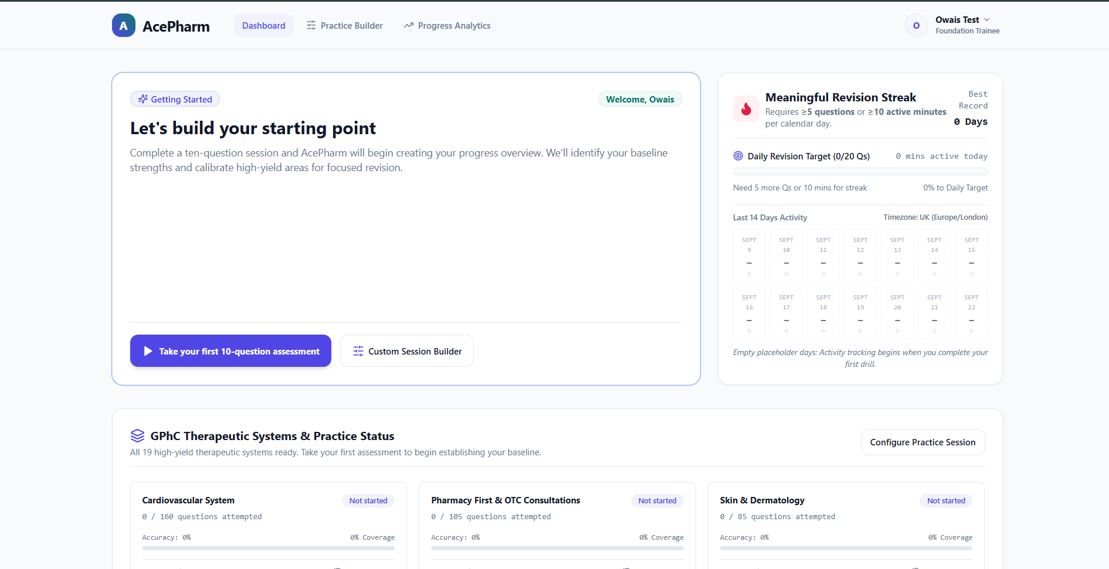

AP-58
Issue Name | Marketing Site – No User Education About the "Ask Ace" AI Feature (Suggestion)
Description | Users have no idea that the "Ask Ace" AI agent exists on the platform, which they could use for guidance. An education/explanation option about this AI agent feature should be added on the marketing site.
Steps to Reproduce | 1. Visit the marketing website as a new visitor.  2. Look for any explanation of the "Ask Ace" AI feature.
Severity | Low (Suggestion)
Expected Result | The marketing site should educate visitors about the "Ask Ace" AI agent feature and its benefits.
Actual Result | No such explanation currently exists on the marketing site.
Screenshot | 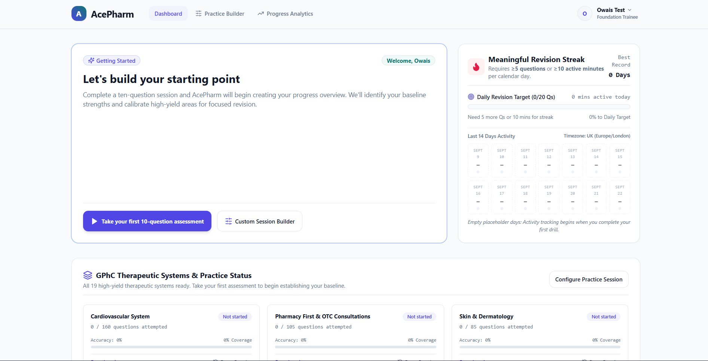

AP-59
Issue Name | Mobile – Home Page Banner Pill Wraps to Second Line
Description | On mobile, on the home page, the pill in the banner wraps onto a second line, which is a UI bug.
Steps to Reproduce | 1. Open the home page on a mobile device/view.  2. Observe the banner pill.
Severity | Low
Expected Result | The banner pill should stay on a single line on mobile.
Actual Result | The banner pill wraps to a second line on mobile.
Screenshot | 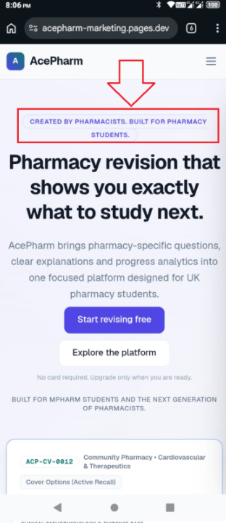

AP-60
Issue Name | Home Page – Demo Question Cover Button and Card Header Text Issues
Description | On the home page, in the demo question, the cover page button is not clearly visible and looks like plain text rather than a button. Also, the text in the card header wraps onto a second line, which is not user-friendly.
Steps to Reproduce | 1. Open the home page.  2. Observe the demo question's cover button.  3. Observe the card header text.
Severity | Low
Expected Result | The cover button should be clearly visible as a button, and the card header text should fit on a single line.
Actual Result | The cover button is not clearly visible, and the card header text wraps to a second line.
Screenshot | 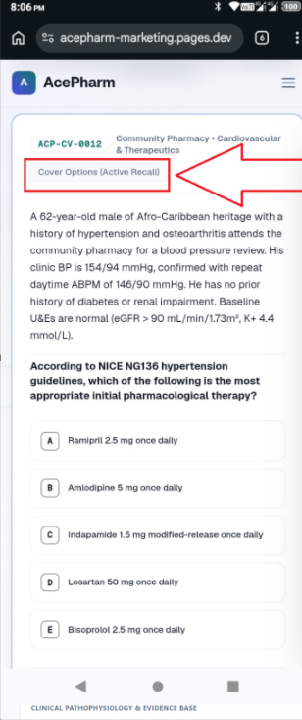

AP-61
Issue Name | Mobile – "Questions Designed to Teach, Not Merely Test" Section Pills Poorly Arranged
Description | On mobile, on the home page, in the "Questions designed to teach, not merely test" section, the pills are not properly arranged and look messy. They should be adjusted for a proper, clean display.
Steps to Reproduce | 1. Open the home page on mobile.  2. Scroll to the "Questions designed to teach, not merely test" section.  3. Observe the pills.
Severity | Low
Expected Result | The pills in this section should be properly arranged and display cleanly on mobile.
Actual Result | The pills are not properly arranged and look messy on mobile.
Screenshot | 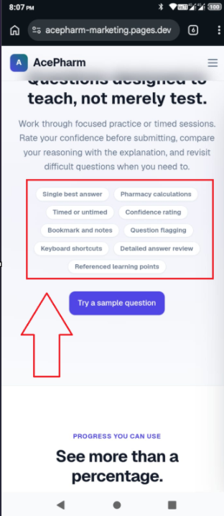

AP-62
Issue Name | Mobile – Hamburger Menu Item Order Differs from Desktop Header
Description | In the mobile hamburger menu, the Product page is not listed in the correct/expected position. On desktop, it is the first item in the header, but on mobile it appears as the 6th item, which creates confusion.
Steps to Reproduce | 1. Open the website on mobile.  2. Open the hamburger menu.  3. Note the position of the "Product" item.  4. Compare with the desktop header order.
Severity | Low
Expected Result | The mobile hamburger menu item order should match the desktop header order (Product should appear in the same relative position).
Actual Result | Product appears as the 6th item on mobile versus 1st on desktop.
Screenshot | 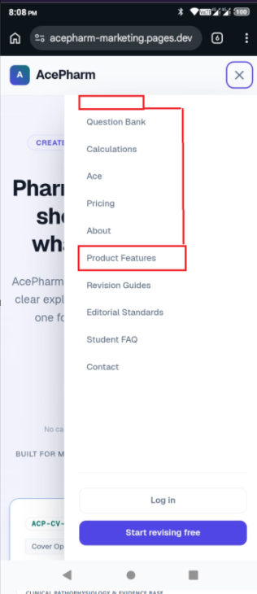

AP-63
Issue Name | Mobile – Calculation Page Pills Wrap to Second Line
Description | On mobile, on the Calculation page, in the "Paper 1 Calculation Syllabus Coverage" section, the pills that list question numbers wrap onto a second line, which does not look good.
Steps to Reproduce | 1. Open the Calculation page on mobile.  2. Scroll to "Paper 1 Calculation Syllabus Coverage."  3. Observe the pills.
Severity | Low
Expected Result | The pills should display fully on a single line.
Actual Result | The pills wrap onto a second line.
Screenshot | 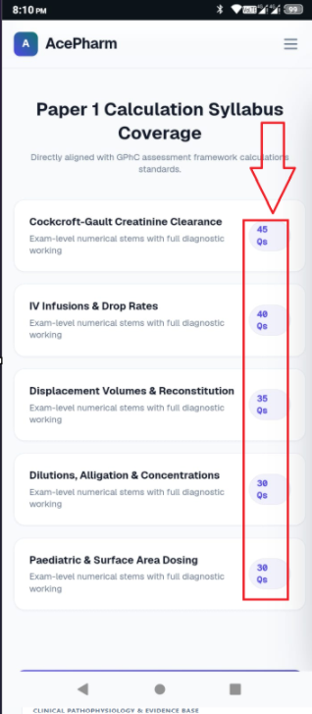

AP-64
Issue Name | Mobile – Question Page Back Button Too Small Relative to Header
Description | On mobile, on the question page, the heading text is large, but the back button is small, making it hard for the user to click. The back button's size should be increased for clearer visibility and easier tapping.
Steps to Reproduce | 1. Open a question page on mobile.  2. Observe the header heading size versus the back button size.  3. Try tapping the back button.
Severity | Low
Expected Result | The back button should be appropriately sized for easy, clear visibility and tapping on mobile.
Actual Result | The back button is too small compared to the header heading.
Screenshot | 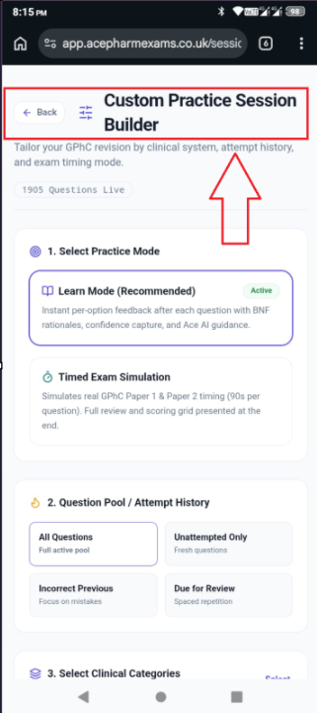

AP-65
Issue Name | Mobile – Exam Tools Too Small and Poorly Positioned
Description | On mobile, on the question page, the Exam Tools are very small in size, making them hard to see clearly, and they are aligned to the left side.
Steps to Reproduce | 1. Open a question page on mobile.  2. Observe the size and alignment of the Exam Tools.
Severity | Low
Expected Result | Exam Tools should be appropriately sized for clear visibility on mobile, with proper alignment/positioning.
Actual Result | Exam Tools are too small and left-aligned, making them hard to see clearly.
Screenshot | 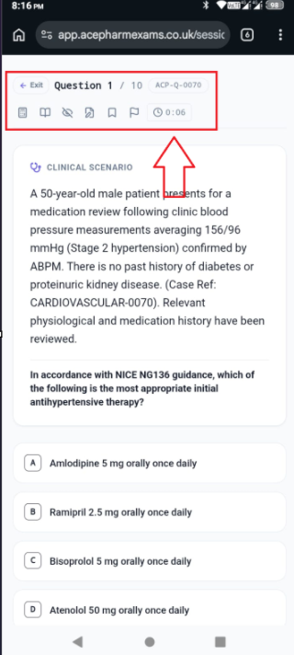

AP-66
Issue Name | Mobile – Excessive Gap Between Options Below Status/Confidence
Description | On mobile, on the question page, below the status/confidence area, there is too much gap between the options, which does not look good.
Steps to Reproduce | 1. Open a question page on mobile.  2. Scroll to the options below the status/confidence area.  3. Observe the spacing between options.
Severity | Low
Expected Result | The spacing between the options should be reduced to a reasonable, visually pleasing gap.
Actual Result | There is excessive gap between the options.
Screenshot | 