REMEMBER QURAN
QA Testing Report — Website Issues
QA Officer: Owais Arshad | Developer: _____ | Date: 09/16/2026
RQ-01
Issue Name | Website Performance – Slow Loading and Page Navigation
Description | The website is too slow to open fully. Navigating from one page to another, or performing any activity, also takes a noticeable amount of time. This issue occurs on both laptop and mobile.
Steps to Reproduce | 1. Open the website on a laptop or mobile device.  2. Navigate between different pages.  3. Observe the loading and response time.
Severity | High
Expected Result | The website should load quickly and page navigation/redirection should happen with minimal delay on both laptop and mobile.
Actual Result | The website takes a long time to fully load, and switching between pages or performing actions is slow.
Screenshot | 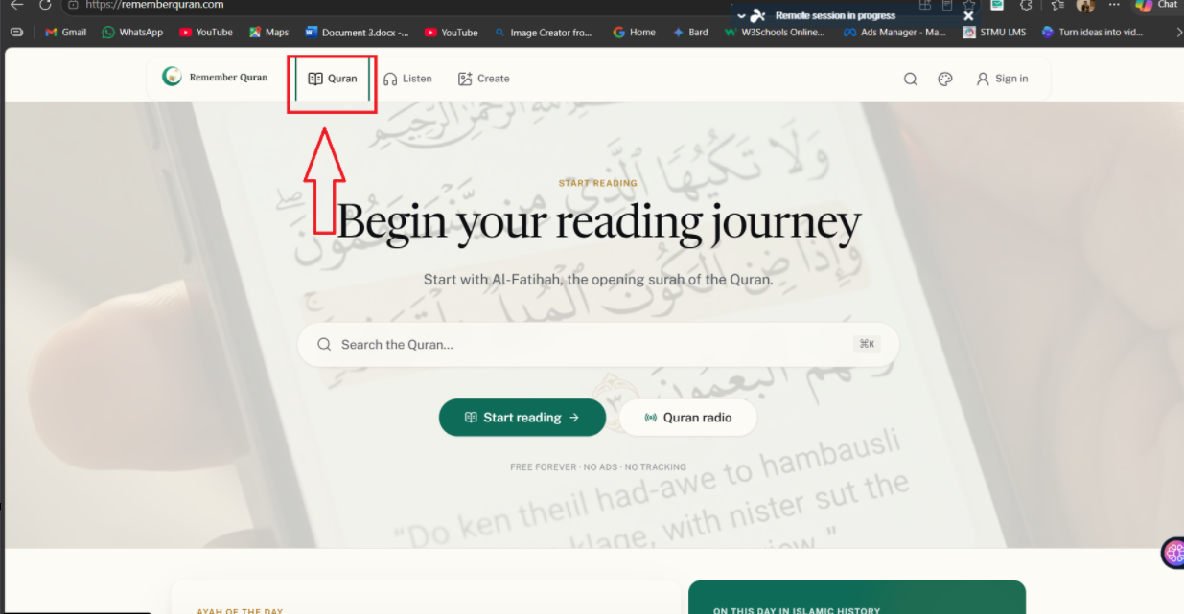

RQ-02
Issue Name | Duplicate Search Bar (Header and Banner)
Description | There is a search option in both the header and the banner. Clicking either one opens a new search bar. There should be only one search bar, the one in the banner.
Steps to Reproduce | 1. Open the Home page.  2. Click the search icon in the header.  3. Click the search icon in the banner.  4. Observe that both open separate search bars.
Severity | Medium
Expected Result | Only one search bar should exist (the one in the banner); the duplicate search option in the header should be removed.
Actual Result | Both the header and the banner have separate search options, resulting in two search bars.
Screenshot | 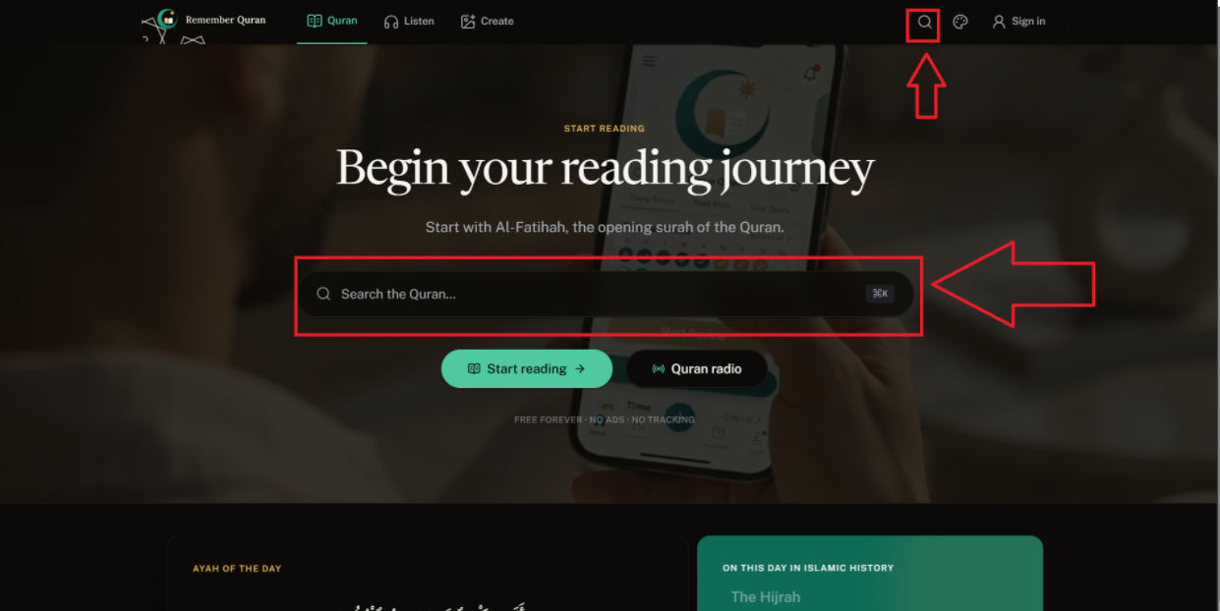

RQ-03
Issue Name | Home Page – Missing Navigation Arrows on Scrolling Cards
Description | On the Home page, the cards inside the green box scroll from left to right automatically, but there are no arrows for the user to manually move forward or backward to read them.
Steps to Reproduce | 1. Open the Home page.  2. Scroll to the green box section with cards.  3. Look for navigation arrows.
Severity | Low
Expected Result | Forward and backward navigation arrows should be added so users can manually move through the cards to read them.
Actual Result | No navigation arrows are present; the cards only scroll automatically.
Screenshot | 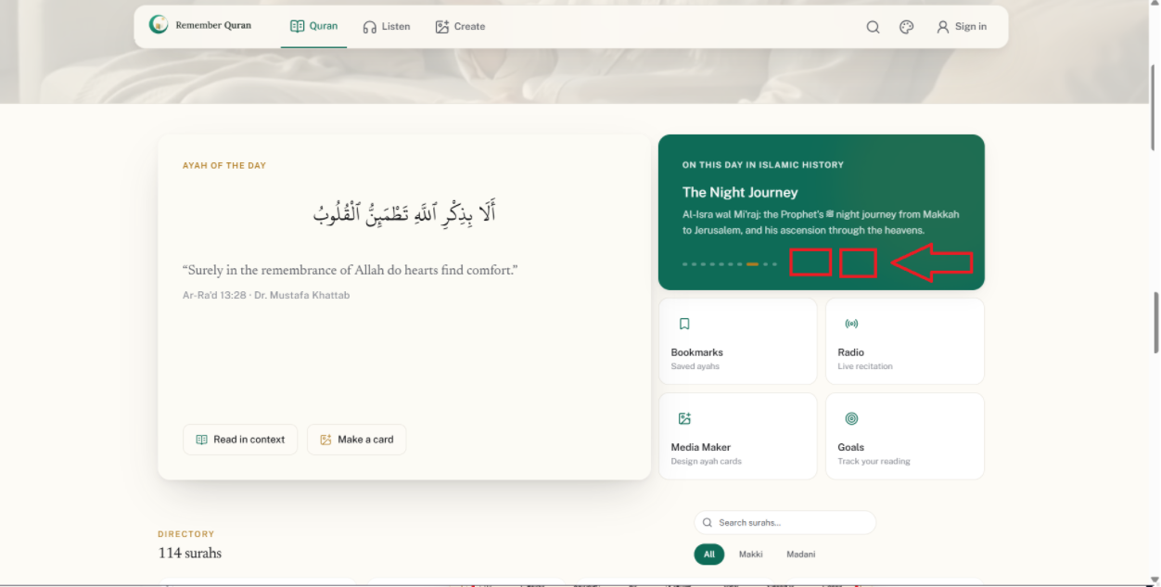

RQ-04
Issue Name | Directory Section – Small Search Bar and Filter Placement
Description | In the directory section, the search bar is very small. Also, the filter should be moved to the left side to make it easier to use and better looking.
Steps to Reproduce | 1. Navigate to the page with the directory section.  2. Observe the size of the search bar and the placement of the filter.
Severity | Low
Expected Result | The search bar should be made larger, and the filter should be repositioned to the left side for better usability and appearance.
Actual Result | The search bar is too small, and the filter is not positioned on the left side.
Screenshot | 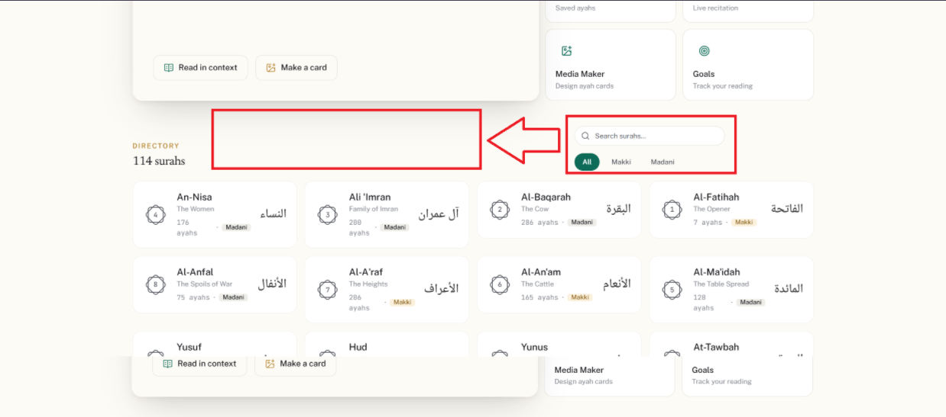

RQ-05
Issue Name | Header – Theme Toggle Button Needs Improvement
Description | The current color-switch button in the header requires the user to click and then choose between dark or light mode. It is suggested to replace this with a simpler toggle (as shown in the reference), where one click switches directly to dark mode and another click switches directly to light mode.
Steps to Reproduce | 1. Open the website.  2. Click the theme/color switch button in the header.  3. Observe how the mode selection works.
Severity | Low
Expected Result | The theme toggle should work with a single click to switch directly between dark and light mode, as shown in the reference.
Actual Result | The current button requires an extra step where the user has to click and then select a mode.
Screenshot | 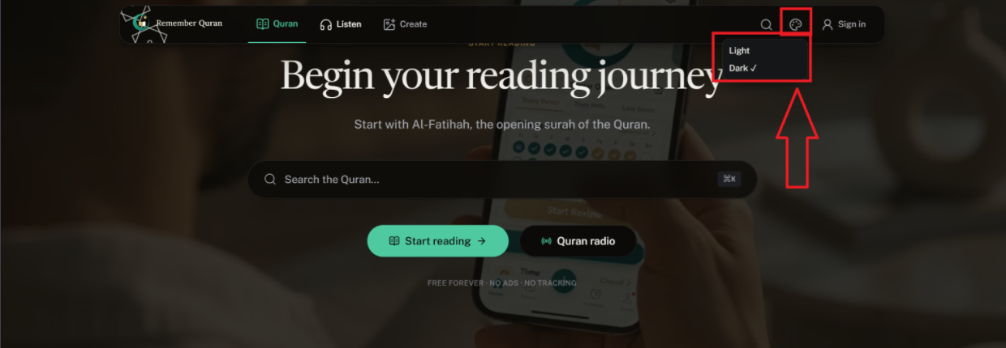
Reference image | 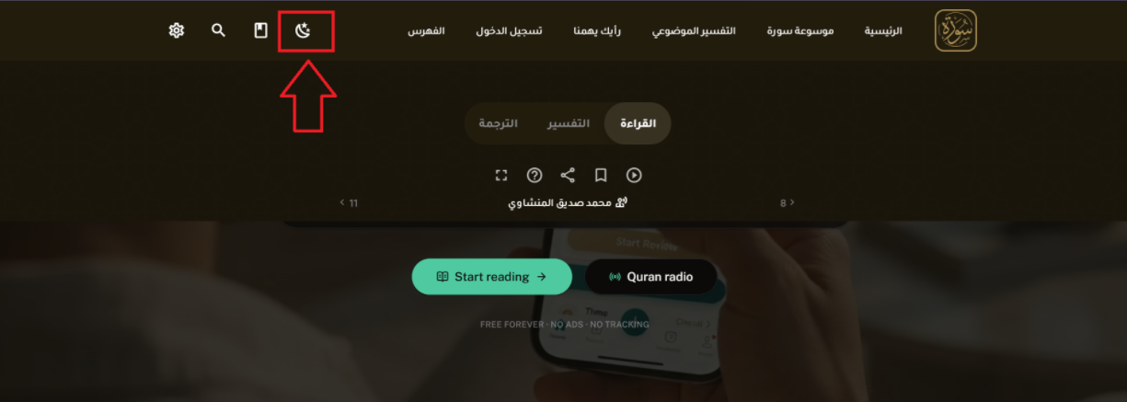

RQ-06
Issue Name | Surah Reading Page – Excessive Word Spacing
Description | When opening any surah to read, there is excessive spacing between the words for some time, which is not user-friendly. This spacing corrects itself after a short while.
Steps to Reproduce | 1. Open the Home page.  2. Open any surah to read.  3. Observe the spacing between words right after the page loads.
Severity | Medium
Expected Result | The word spacing should display correctly from the moment the page loads, without any temporary excessive gaps.
Actual Result | There is excessive spacing between words for a short period after opening a surah, which later corrects itself.
Screenshot | 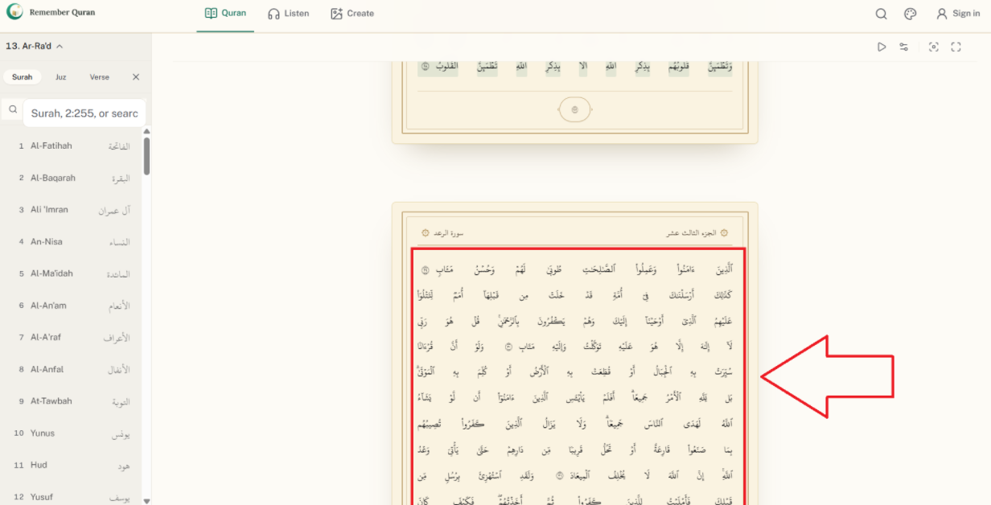

RQ-07
Issue Name | Surah Reading Page – Header Not Visible
Description | When on the surah reading page, the header is not visible. This is not user-friendly, as the header should be visible across the website so users can easily switch to another page.
Steps to Reproduce | 1. Open any surah to read.  2. Scroll or observe the top of the page.  3. Check if the header is visible.
Severity | Medium
Expected Result | The header should remain visible on the surah reading page, as it does on other pages, so users can easily navigate to other pages.
Actual Result | The header is not visible on the surah reading page.
Screenshot | 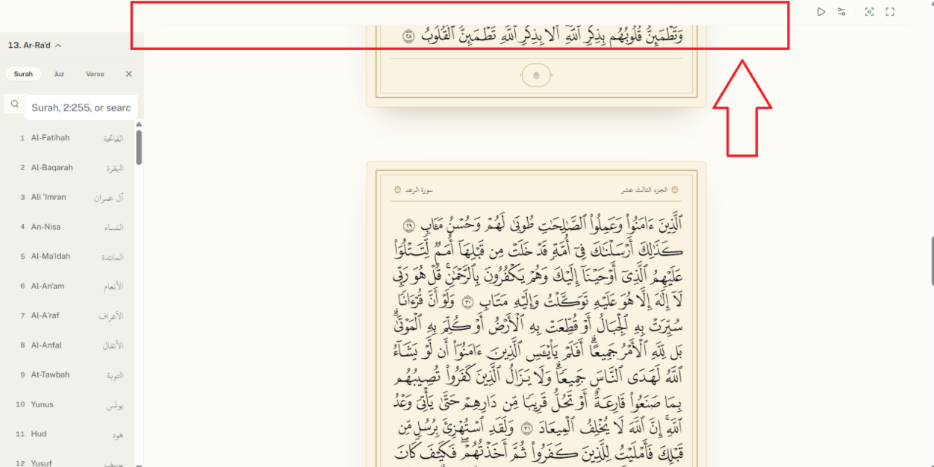

RQ-08
Issue Name | Surah Reading Page – Settings Hard to Find
Description | The settings option on the surah reading page is hard for users to find. As per the reference images provided, it should be displayed as a bar on the right side, with a hide/show button so the user can open it when needed.
Steps to Reproduce | 1. Open the surah reading page.  2. Try to locate the settings option.
Severity | Medium
Expected Result | Settings should be displayed as a collapsible bar on the right side (as per the reference images), with a button to hide/show it.
Actual Result | The settings option is not easy to find on the current page layout.
Screenshot | 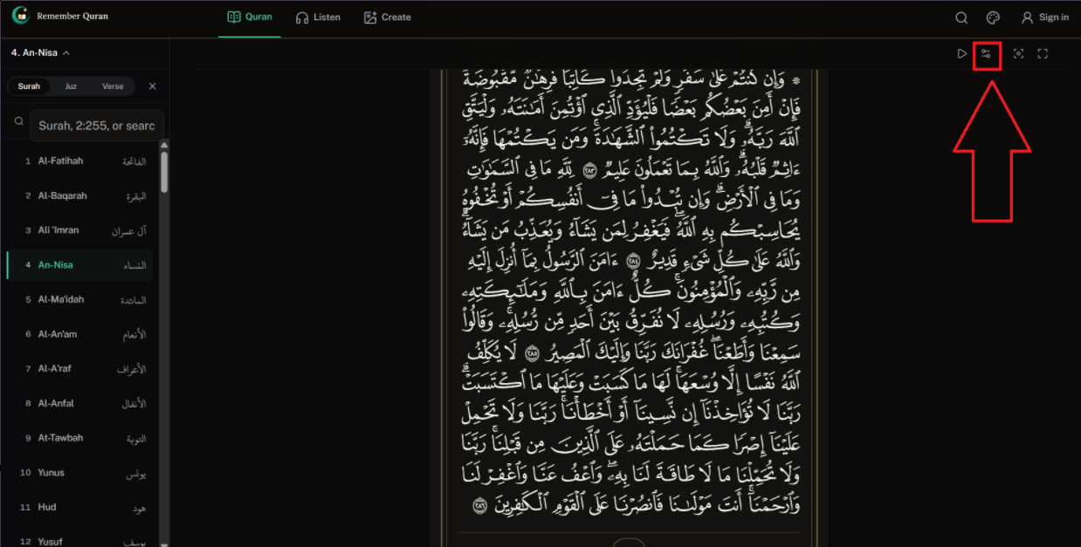
Reference images | 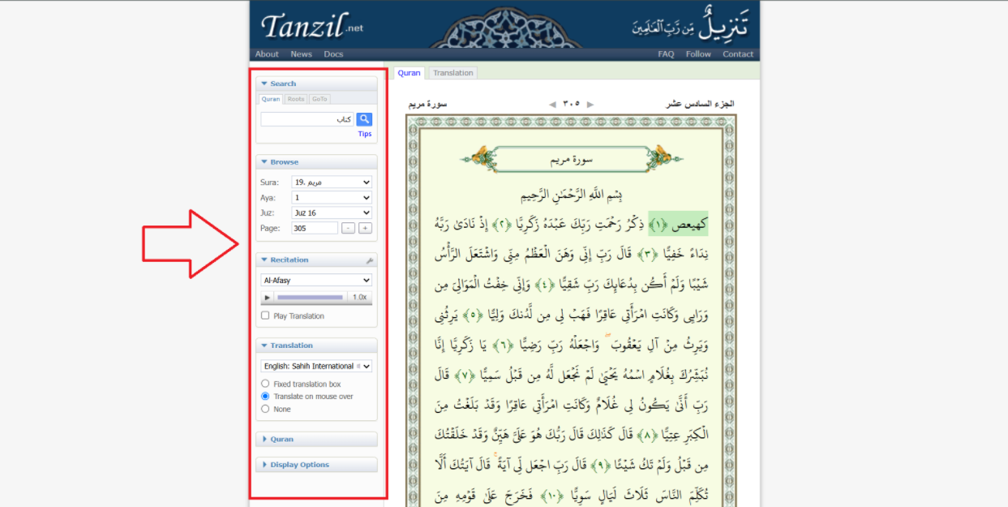

RQ-09
Issue Name | Surah Reading Page – Missing Back Button
Description | There is no back button on the surah reading page. Users have to click the header again to navigate to another page, which is not user-friendly.
Steps to Reproduce | 1. Open any surah to read.  2. Try to find a back button on the page.
Severity | Low
Expected Result | A back button should be added on the surah reading page for easier navigation.
Actual Result | No back button is present; users must use the header to switch pages.
Screenshot | 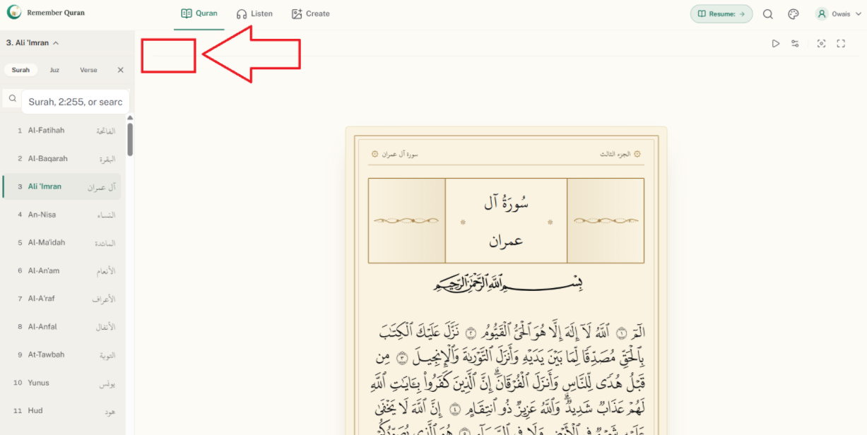

RQ-10
Issue Name | Surah Reading Page – No Tooltip or Demo Video for Features
Description | There is no tooltip or demo video on the Quran/surah reading page explaining how to use the available features, such as clicking on a word to hear its pronunciation.
Steps to Reproduce | 1. Open the surah reading page.  2. Look for any tooltip or demo/help video explaining the features.
Severity | Low
Expected Result | A tooltip or short demo video should be added to guide users on how to use features like word pronunciation.
Actual Result | No tooltip or demo video is present to guide users.
Screenshot | 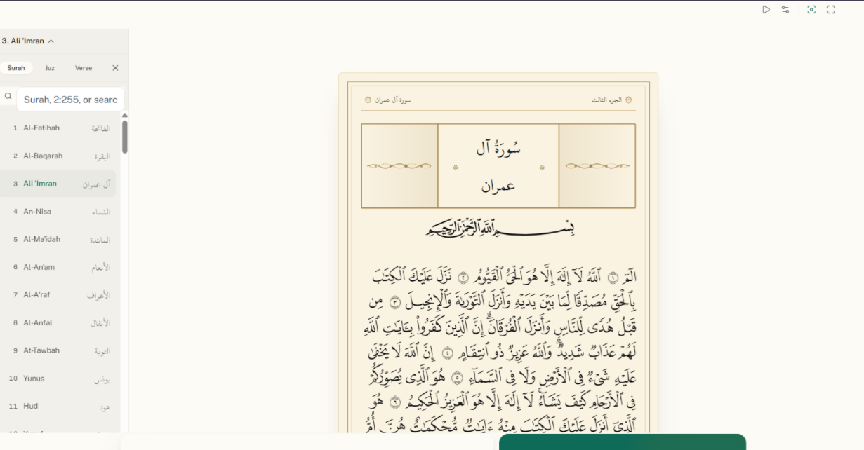

RQ-11
Issue Name | Surah Reading Page – Left Bar Needs Hide/Show Button
Description | On the surah reading page, a button should be added to the left bar to hide it and open it again when needed, so users can read the Quran more easily.
Steps to Reproduce | 1. Open the surah reading page.  2. Observe the left bar.  3. Look for an option to hide/show it.
Severity | Low
Expected Result | A button should be added to hide and show the left bar as needed.
Actual Result | There is currently no option to hide/show the left bar.
Screenshot | 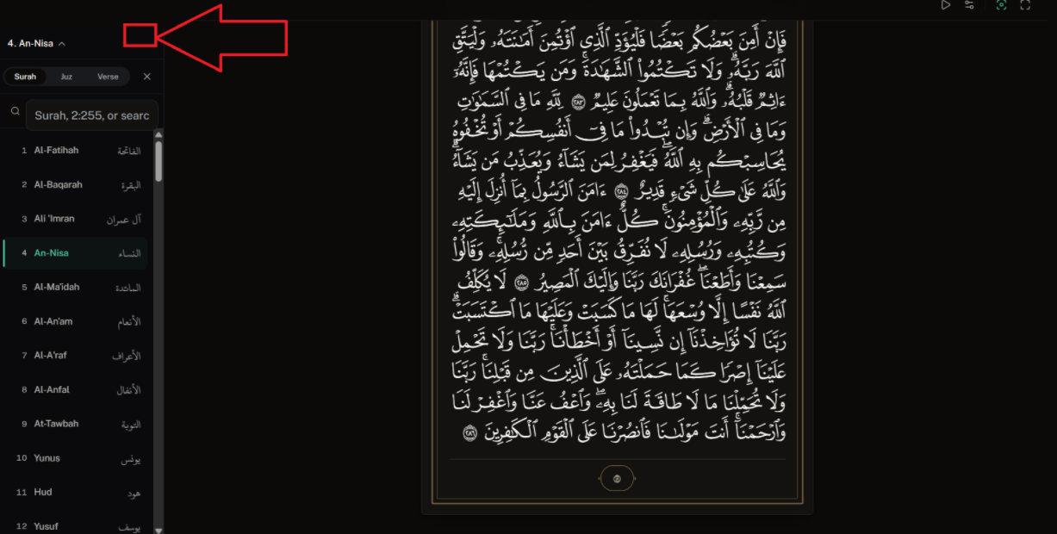

RQ-12
Issue Name | Surah Reading Page – Missing Word Tooltip with Options
Description | There is no tooltip explaining that clicking on a word plays its pronunciation. It is suggested that clicking a word should also show other options, such as "Hear" and "Grammar," as well as a bookmark option, in a popup.
Steps to Reproduce | 1. Open the surah reading page.  2. Click on any word.  3. Observe the available options.
Severity | Medium
Expected Result | Clicking a word should open a popup with a tooltip and options such as pronunciation (Hear), Grammar, and Bookmark.
Actual Result | No tooltip or popup with these options currently appears when a word is clicked.
Screenshot | 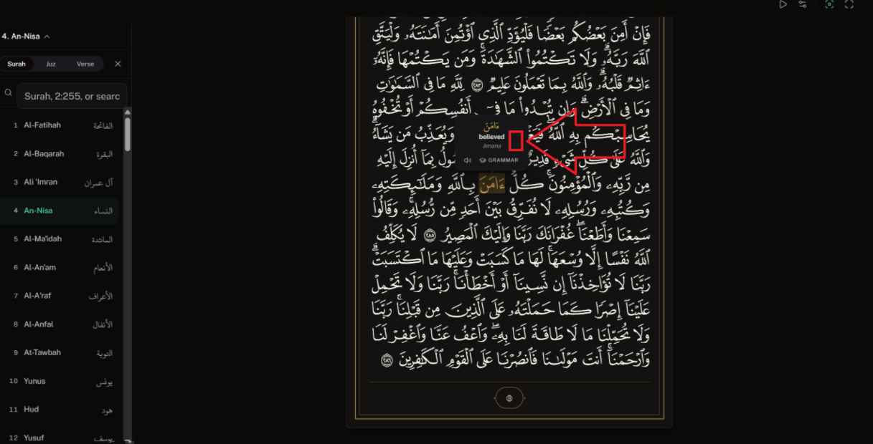

RQ-13
Issue Name | Sidebar Search Bar – Search Icon Looks Like a Separate Field
Description | On the surah reading page, the search bar in the side bar has a search icon behind the field that looks like a separate field instead of part of the search bar. The icon's size is also small compared to the search bar.
Steps to Reproduce | 1. Open the surah reading page.  2. Observe the side bar search field and its search icon.
Severity | Low
Expected Result | The search icon should be aligned properly with the search bar and sized consistently, so it does not look like a separate field.
Actual Result | The search icon appears as a separate, smaller field next to the search bar, which looks inconsistent.
Screenshot | 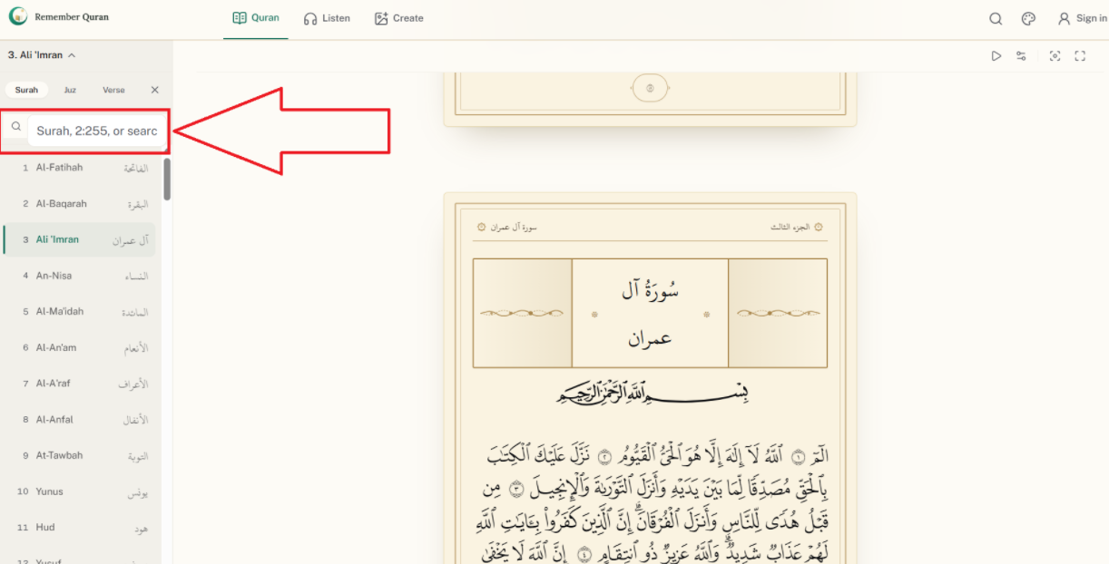

RQ-14
Issue Name | Surah Playback – Controls Bar Too Small
Description | When playing a surah to listen, the playback controls bar appears too small, and its icons should be slightly bigger. The track bar should also remain static so users can easily play/pause from the controls bar without needing to search for the play button elsewhere.
Steps to Reproduce | 1. Open any surah reading page.  2. Play the surah.  3. Observe the playback controls bar size and icons.
Severity | Medium
Expected Result | The playback controls bar and its icons should be larger and more visible, and the track bar should stay static for easy access to playback controls.
Actual Result | The playback controls bar and icons are too small, making it hard to use.
Screenshot | 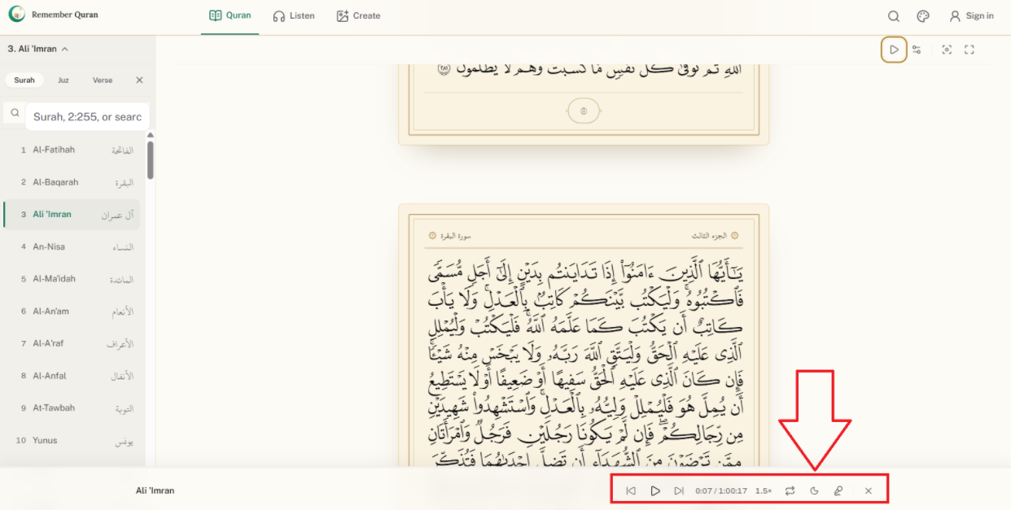

RQ-15
Issue Name | Surah Playback – Missing Volume Controller
Description | On the surah reading and listening pages, the playback controls bar does not have a sound/volume controller, so users cannot adjust the volume.
Steps to Reproduce | 1. Open the surah reading or listen page.  2. Play a surah.  3. Look for a volume control option in the playback controls bar.
Severity | Medium
Expected Result | A volume controller should be added to the playback controls bar so users can increase or decrease the sound.
Actual Result | There is no volume controller available in the playback controls bar.
Screenshot | 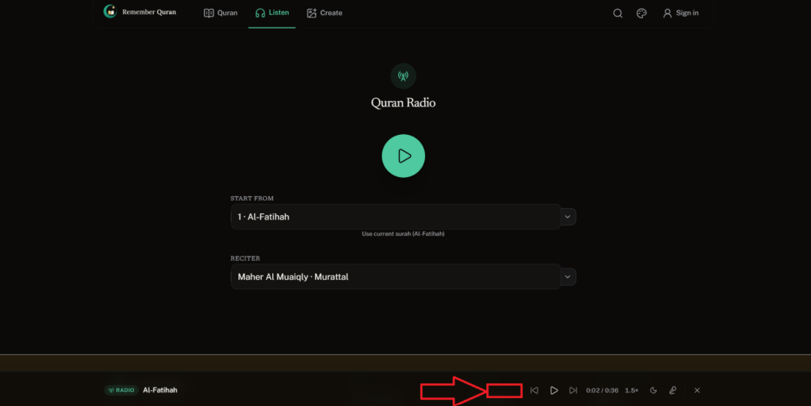

RQ-16
Issue Name | Surah Playback – Previous/Next Ayah Buttons Not Working
Description | On the surah reading and listening pages, the "Previous Ayah" and "Next Ayah" buttons in the playback controls bar are not working.
Steps to Reproduce | 1. Open the surah reading or listen page.  2. Play a surah.  3. Click the "Previous Ayah" or "Next Ayah" button.
Severity | High
Expected Result | The "Previous Ayah" and "Next Ayah" buttons should work correctly, allowing users to move between ayahs easily.
Actual Result | Clicking the "Previous Ayah" and "Next Ayah" buttons does not work.
Screenshot | 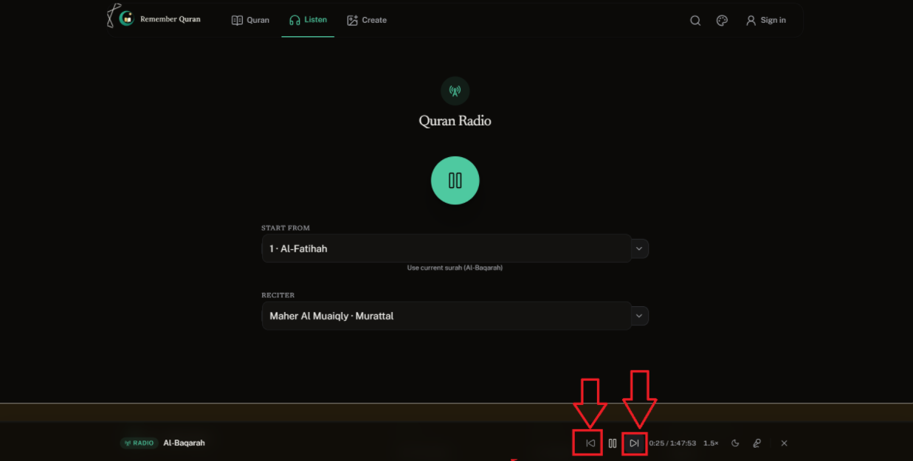

RQ-17
Issue Name | Listen Page – Dropdown Arrow Icon Sizing Issue (UI Bug)
Description | On the Listen page, several dropdown icons appear as if they are in a separate field next to the dropdown, and their size is small compared to the field. This is a UI bug that does not look good.
Steps to Reproduce | 1. Open the Listen page.  2. Observe the dropdown fields and their arrow icons.
Severity | Low
Expected Result | The dropdown arrow icon size should be increased to match the field properly, so it looks integrated and visually consistent.
Actual Result | The dropdown arrow icons appear as separate, smaller elements next to the field, which looks inconsistent.
Screenshot | 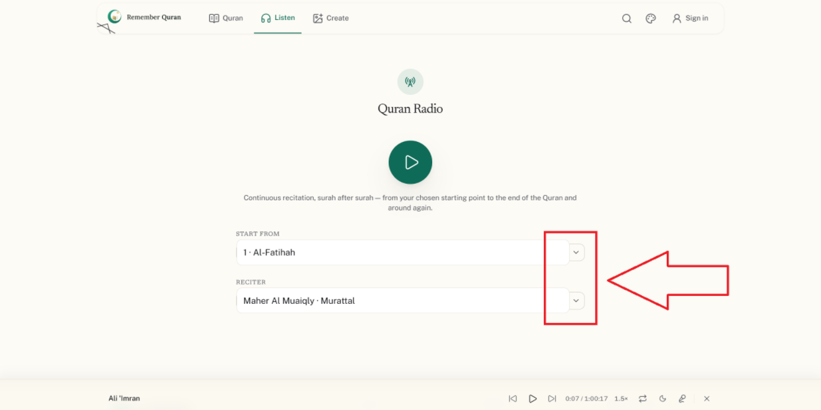

RQ-18
Issue Name | Listen Page – "Start From" Dropdown Needs Ayah Selection Field
Description | On the Listen page, there is a "Start From" dropdown where users select a surah. It is suggested to add a separate field below it that shows all the ayahs of the selected surah, so users can choose a specific ayah to start listening from.
Steps to Reproduce | 1. Open the Listen page.  2. Select a surah from the "Start From" dropdown.  3. Look for an option to select a specific ayah.
Severity | Low
Expected Result | After selecting a surah, a separate dropdown/field should appear showing all its ayahs, allowing the user to select where to start listening.
Actual Result | No ayah-selection field appears after choosing a surah; the user cannot select a specific starting ayah.
Screenshot | 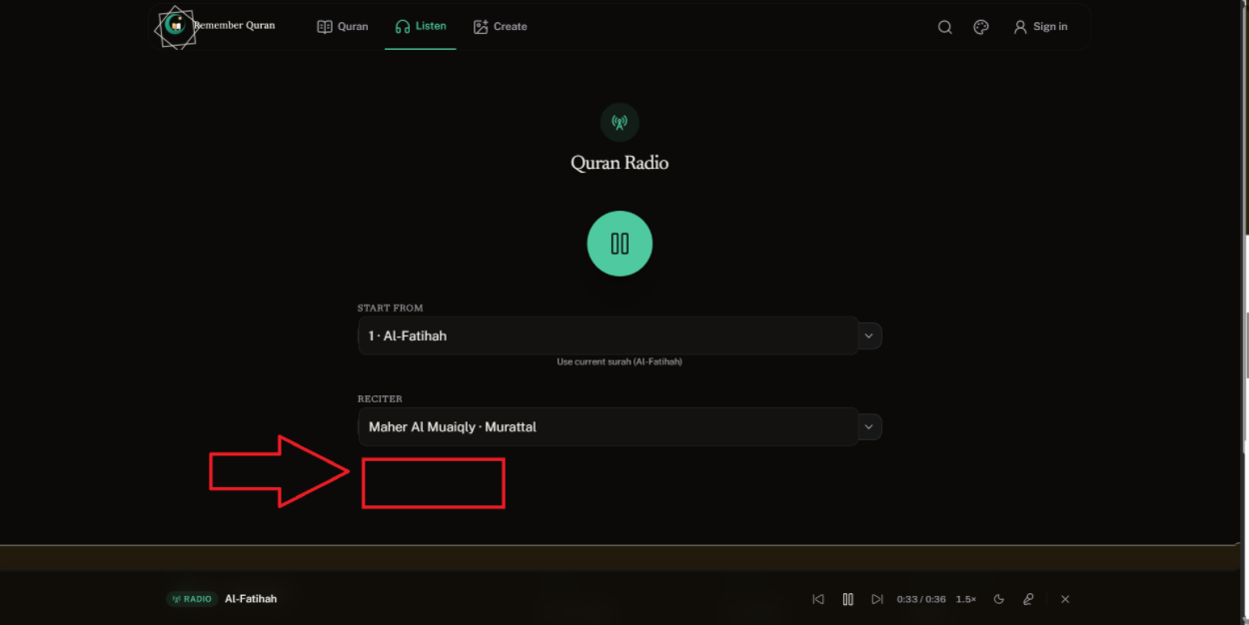

RQ-19
Issue Name | Media Maker – Inconsistent Field Sizes (Surah and Passage Span)
Description | On the Create page, in the Media Maker section, the surah selection dropdown has one size, while the "Passage Span" filter next to it is smaller, making it hard to read and visually unappealing.
Steps to Reproduce | 1. Navigate to the Create page.  2. Go to the Media Maker section.  3. Compare the size of the surah dropdown and the "Passage Span" filter.
Severity | Low
Expected Result | The "Passage Span" filter should be the same size as the surah dropdown for a consistent, user-friendly appearance.
Actual Result | The "Passage Span" filter is noticeably smaller than the surah dropdown, making it hard to read.
Screenshot | 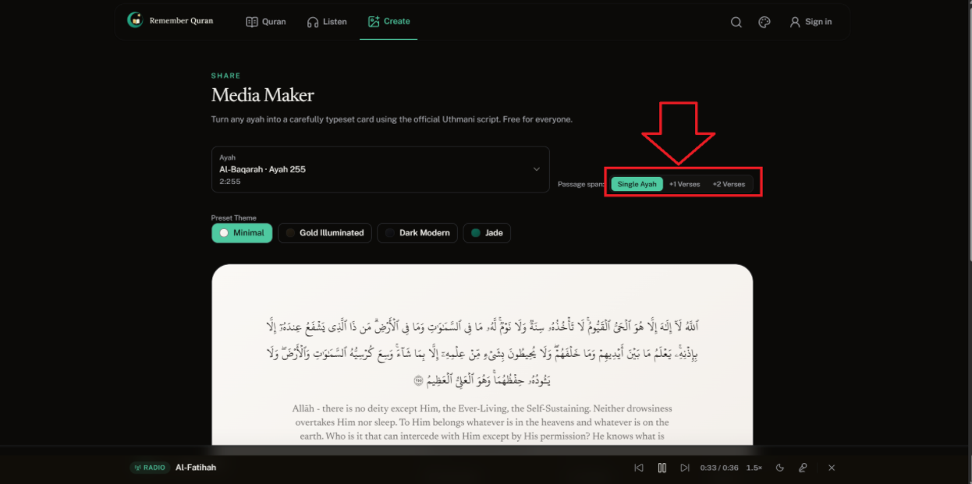

RQ-20
Issue Name | Media Maker – Missing Next/Previous Navigation on Ayah Card
Description | On the Create page, in the Media Maker section, the card that displays the ayah should have next and previous options on its left and right sides, allowing users to easily move to the next or previous ayah.
Steps to Reproduce | 1. Navigate to the Create page.  2. Go to the Media Maker section.  3. Observe the ayah card and look for next/previous navigation.
Severity | Low
Expected Result | Next and previous navigation options should be added on the left and right sides of the ayah card for smoother navigation.
Actual Result | There is no next/previous navigation option on the ayah card.
Screenshot | 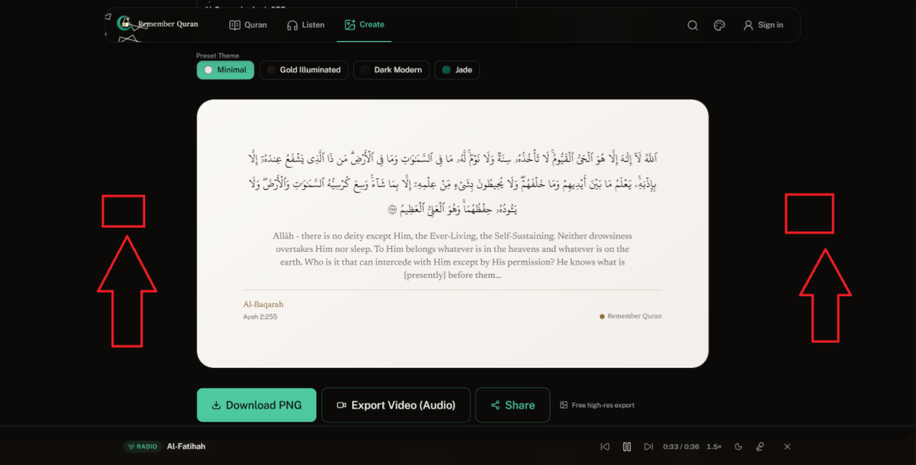

RQ-21
Issue Name | Create Account Form – No Show/Hide Password Option
Description | On the Create Account form, the password field does not have an option for users to view or hide the password they are typing. An eye icon should be added for this purpose.
Steps to Reproduce | 1. Navigate to the Create Account page.  2. Start typing in the password field.  3. Look for a show/hide password option.
Severity | Medium
Expected Result | An eye icon should be added to the password field so users can toggle between showing and hiding their password while typing.
Actual Result | There is no way to view the password while typing; the user cannot see what they are entering.
Screenshot | 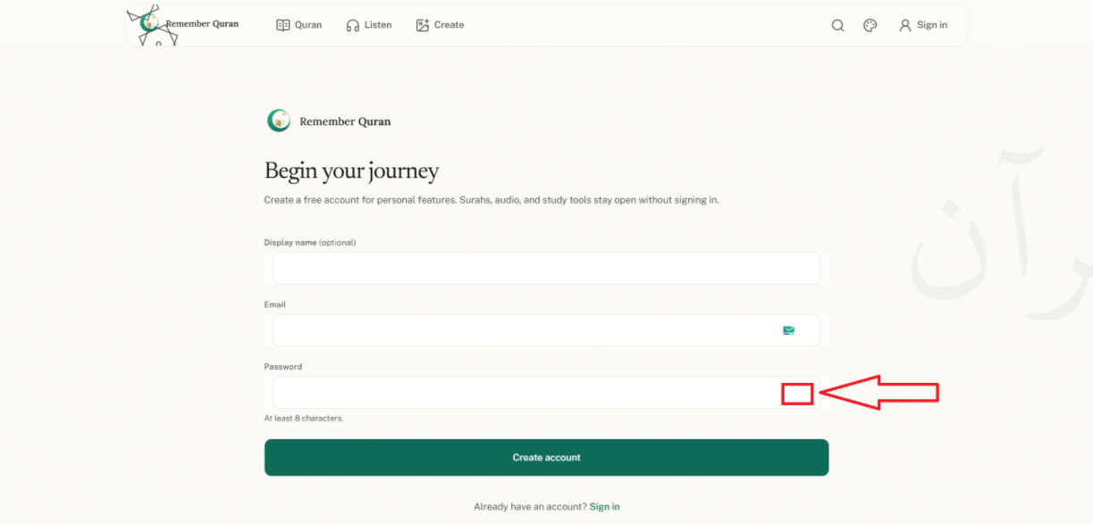

RQ-22
Issue Name | Sign In / Create Account – Broken Field Borders (UI Bug)
Description | On the Sign In and Create Account pages, the input fields look broken, as if separate pieces of the field border are visible at both ends. This is a UI bug affecting usability.
Steps to Reproduce | 1. Navigate to the Sign In page.  2. Navigate to the Create Account page.  3. Observe the borders of the input fields.
Severity | Medium
Expected Result | The input fields should have a clean, continuous border with no visual breaks.
Actual Result | The field borders appear broken, with small separate pieces visible at both ends, which is a UI bug.
Screenshot | 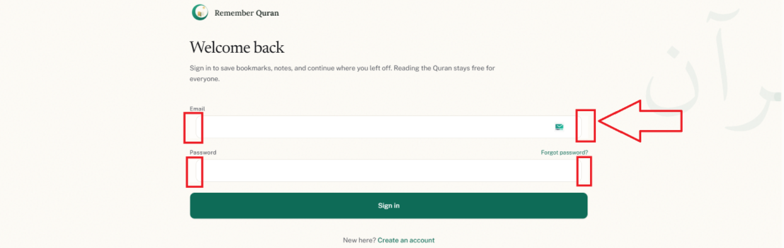

RQ-23
Issue Name | Missing Dashboard Button After Login
Description | After successfully creating an account, there is no dashboard button shown to the user. Currently, users have to click on profile and then go to "Account Overview" to see their details, which is not easy to find. A dashboard button should appear once the user logs in.
Steps to Reproduce | 1. Create a new account or log in.  2. Observe the page/header for a dashboard button.
Severity | Medium
Expected Result | A "Dashboard" button should be shown after the user logs in, providing quick and easy access to their account details.
Actual Result | No dashboard button is shown; users must navigate through profile and account overview to find their details.
Screenshot | 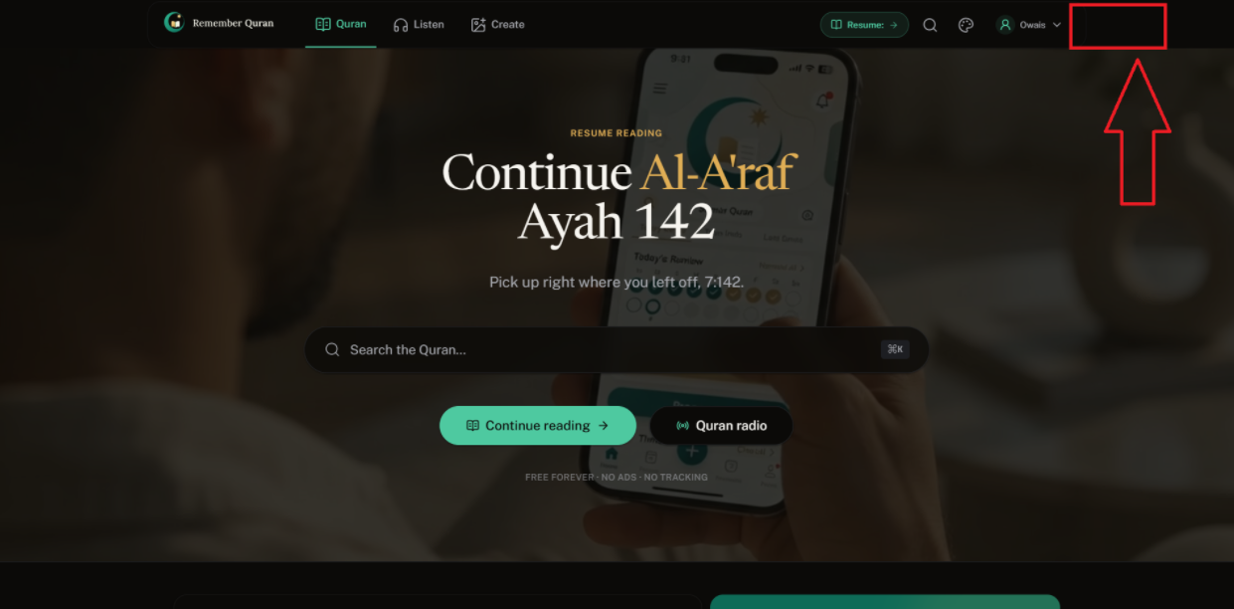

RQ-24
Issue Name | Surah Reading Page – Tafsir Dropdown Text Partially Hidden
Description | On the surah reading page, when a user clicks on a word to open its Tafsir, the text shown in the dropdown field is partially hidden because the field size is too small. Additionally, the dropdown option itself is smaller than the field, which looks inconsistent.
Steps to Reproduce | 1. Open the surah reading page.  2. Click on any word.  3. Open the Tafsir option.  4. Observe the dropdown field and text display.
Severity | Medium
Expected Result | The Tafsir dropdown field should be resized so the text is fully visible, and the dropdown option size should match the field for a better user experience.
Actual Result | The Tafsir text is partially hidden due to a small field size, and the dropdown option is smaller than the field.
Screenshot | 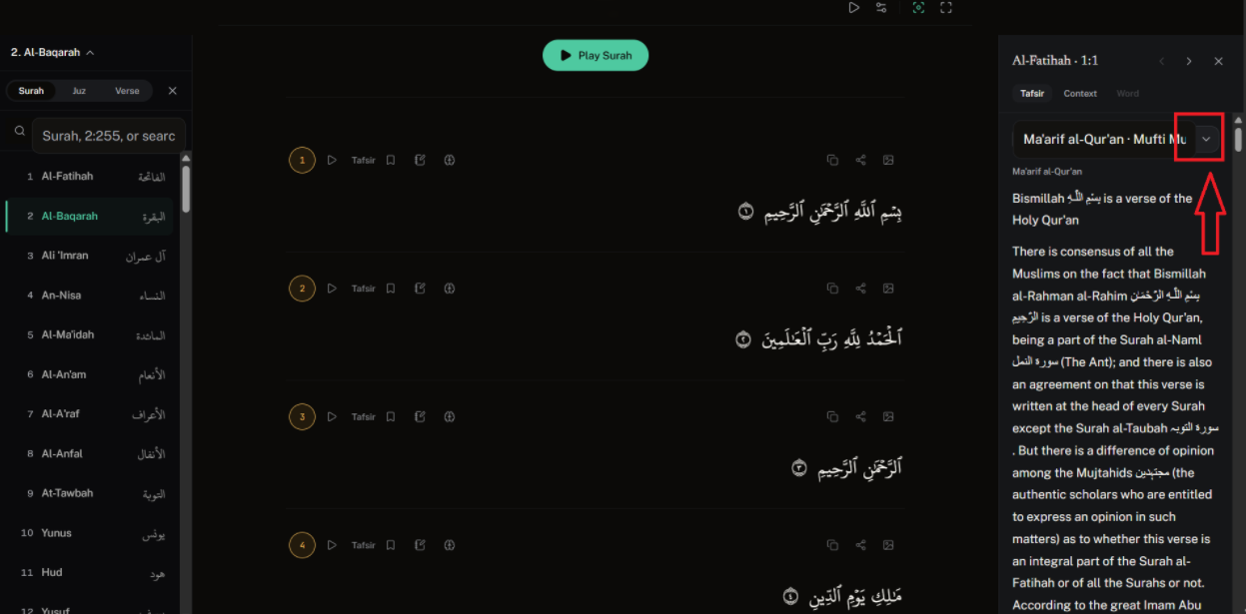

RQ-25
Issue Name | Surah Reading Page – No Option to View Translation by Ayah
Description | Users are unable to find how to view translation ayah by ayah, as there is no tooltip explaining this. It is suggested to add two options when opening any surah to read: one for "Quran Only" and another for "Quran with Translation," as shown in the reference images.
Steps to Reproduce | 1. Open any surah to read.  2. Try to find an option to view translation by ayah.
Severity | Medium
Expected Result | Two clear options, "Quran Only" and "Quran with Translation," should be available when opening a surah, as shown in the reference.
Actual Result | There is no visible or clear option to view translation by ayah, and no tooltip explains how to do so.
Screenshot | 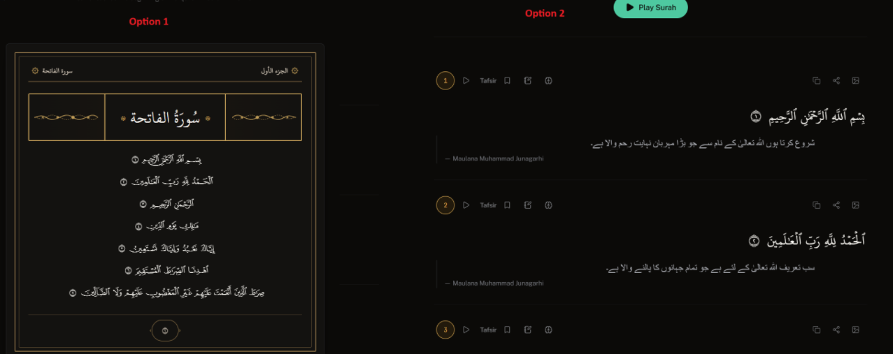
Reference image | 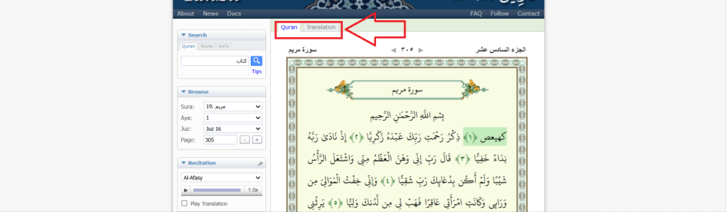

RQ-26
Issue Name | Bookmark – "Add" Button Too Small in New Favorite List Field
Description | After signing in, when a user adds an ayah to bookmarks, they get an option to choose a folder. When creating a new favorite list, the "Add" button next to this field is very small, which is not user-friendly.
Steps to Reproduce | 1. Sign in to the account.  2. Add any ayah to bookmarks.  3. Try to create a new favorite list/folder.  4. Observe the size of the "Add" button.
Severity | Low
Expected Result | The "Add" button should be resized to match the field for a better user experience and appearance.
Actual Result | The "Add" button is currently too small compared to the field.
Screenshot | 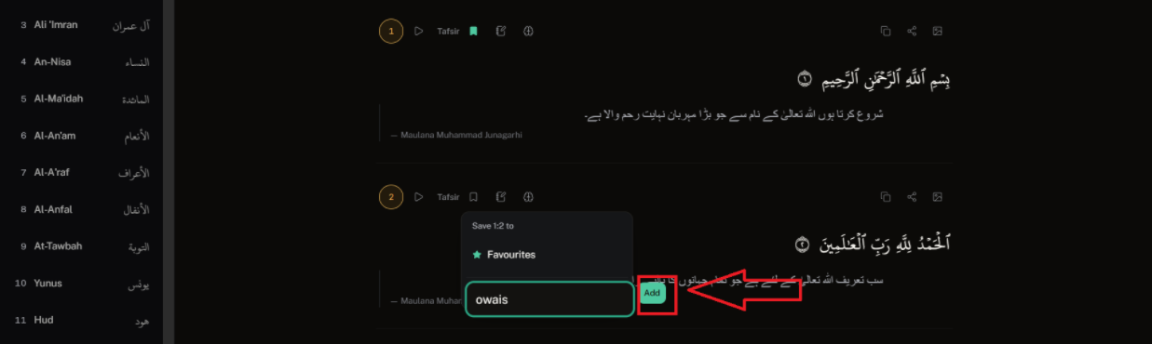

RQ-27
Issue Name | Account Overview – Bookmark Folder Placeholder Text Half Visible
Description | On the Account Overview page, in the Bookmarks section, when a user creates a new bookmark folder, the placeholder text in the field is only half visible instead of being fully shown.
Steps to Reproduce | 1. Navigate to Account Overview.  2. Go to the Bookmarks section.  3. Create a new bookmark folder.  4. Observe the placeholder text in the field.
Severity | Low
Expected Result | The placeholder text should be fully visible in the field.
Actual Result | The placeholder text is only partially visible.
Screenshot | 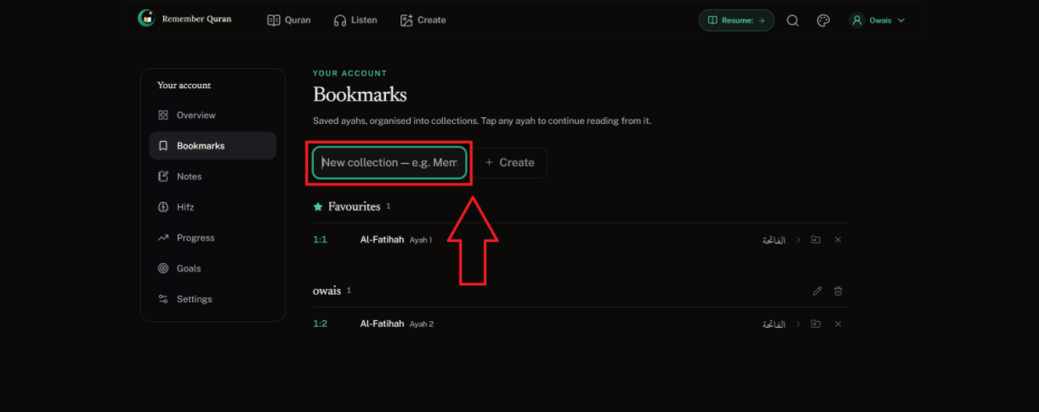

RQ-28
Issue Name | Inconsistent Naming Between "Mark as Memorized" and "Hifz"
Description | On the surah reading page (with translation), users have an option to mark an ayah as "Memorized," but they don't know what this option does. In the Account Overview page, this data is saved under a page called "Hifz." The naming should be consistent between both places.
Steps to Reproduce | 1. Open a surah with translation.  2. Mark any ayah as "Memorized."  3. Navigate to Account Overview and find where this is saved.
Severity | Low
Expected Result | The naming for this feature should be the same in both places (either "Memorized" or "Hifz") so users clearly understand the connection.
Actual Result | The option is called "Memorized" on the reading page but saved under "Hifz" in Account Overview, causing confusion.
Screenshot | 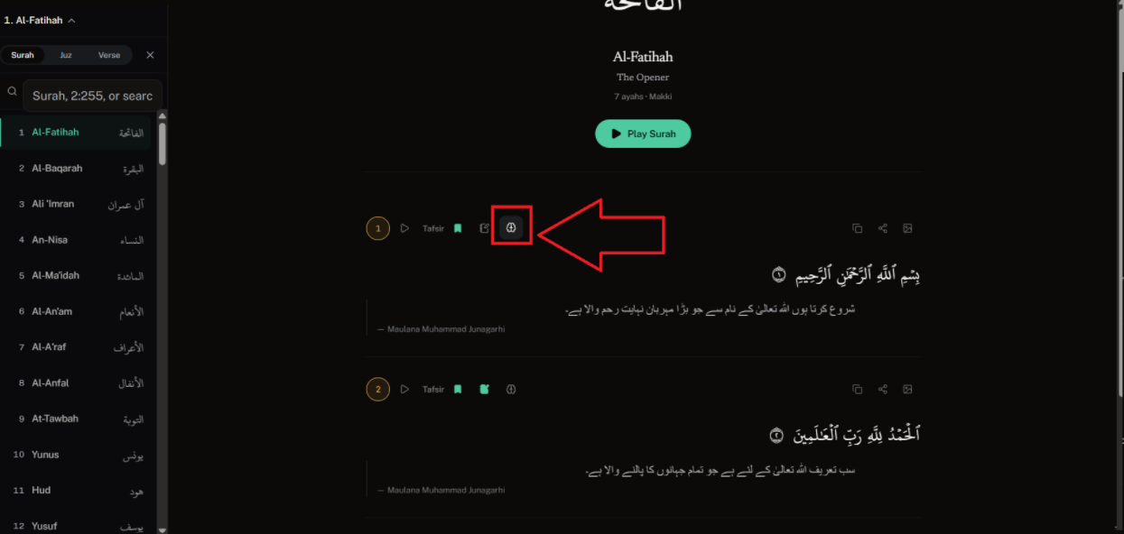

RQ-29
Issue Name | Footer – Poor Color Contrast for Headings
Description | In the footer, the headings are hardly visible due to a poor color combination.
Steps to Reproduce | 1. Scroll to the footer on any page.  2. Observe the visibility of the footer headings.
Severity | Medium
Expected Result | The footer heading colors should be changed to a combination that provides good contrast and visibility.
Actual Result | The footer headings are hard to see due to poor color contrast.
Screenshot | 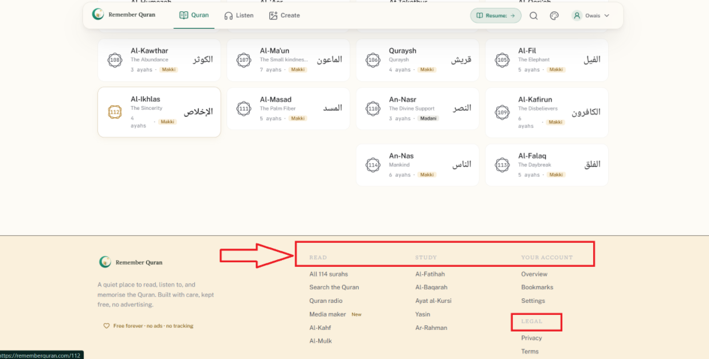

RQ-30
Issue Name | Header – Contact Us Page Missing
Description | The "Contact Us" page is missing from the header. As a result, users have no way to communicate issues or suggestions to the admin. Adding this page would also help with Google SEO.
Steps to Reproduce | 1. Open the website.  2. Check the header for a "Contact Us" link.
Severity | Medium
Expected Result | A "Contact Us" page/link should be added to the header so users can interact with the admin regarding issues or suggestions.
Actual Result | There is no "Contact Us" page available in the header.
Screenshot | 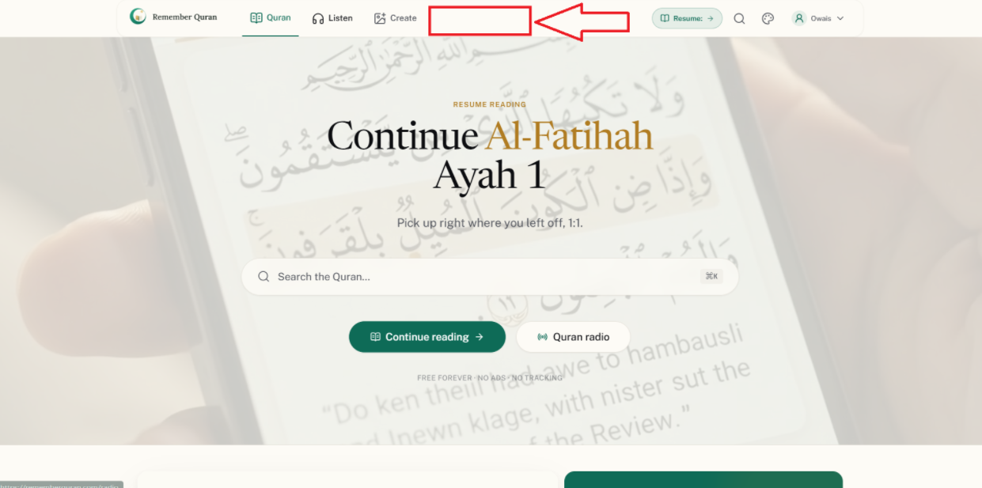

RQ-31
Issue Name | Header – Content Visible in Empty Space Above Header on Scroll
Description | There is a small empty space above the header across the website. When the page is scrolled, some content/text becomes visible in this empty space, which does not look good.
Steps to Reproduce | 1. Open any page.  2. Scroll down and then scroll back up.  3. Observe the small space above the header.
Severity | Low
Expected Result | The empty space above the header should remain empty at all times; no content should appear there while scrolling.
Actual Result | Content/text becomes visible in the empty space above the header when scrolling.
Screenshot | 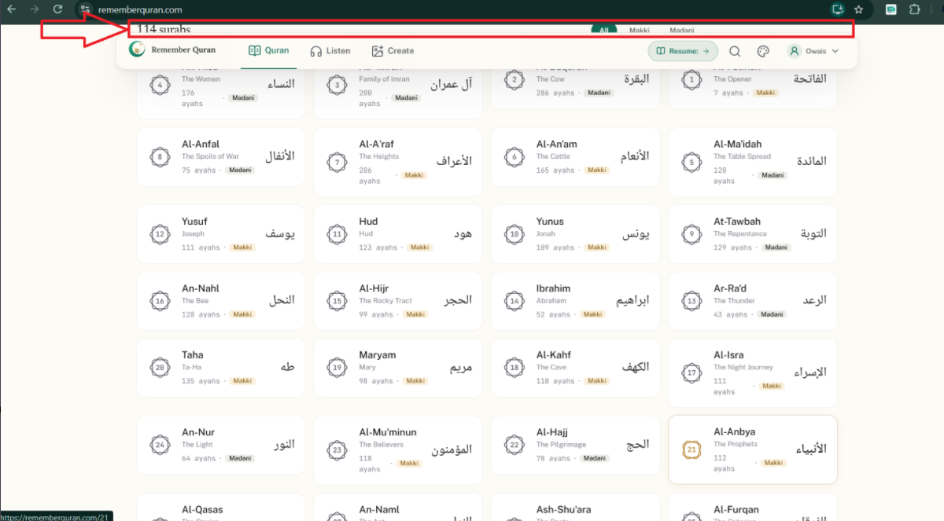

RQ-32
Issue Name | "Back to Top" Button Missing on Surah Reading Page / Hard to Find
Description | A "Back to Top" button is available on the Home page below the footer, but it is missing on the Quran/surah reading page. Also, where the button does exist, it is not easy for users to find.
Steps to Reproduce | 1. Open the Home page and scroll down to check the "Back to Top" button.  2. Open any surah reading page and scroll down to check for the same button.
Severity | Low
Expected Result | The "Back to Top" button should be available on all pages, including the surah reading page, and should be easy for users to find.
Actual Result | The "Back to Top" button is missing on the surah reading page, and where it exists, it is hard to locate.
Screenshot | 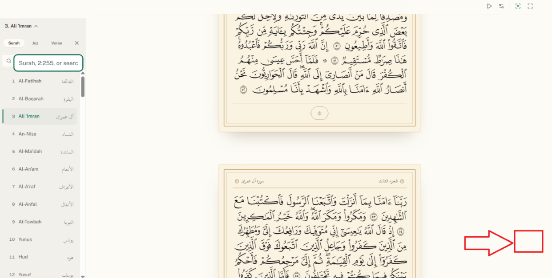  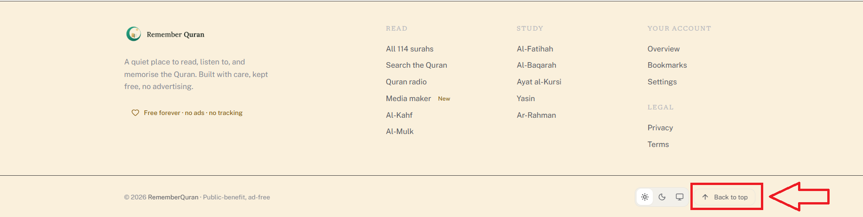

RQ-33
Issue Name | Mobile – Directory Section Search Bar Too Small (Home Page)
Description | On mobile view, in the directory section on the Home page, the search bar is very small and positioned on the left side. It should be made bigger for easier use.
Steps to Reproduce | 1. Open the Home page on a mobile device.  2. Scroll to the directory section.  3. Observe the search bar size and position.
Severity | Low
Expected Result | The search bar should be made larger and easier to use on mobile.
Actual Result | The search bar is small and positioned on the left side, making it harder to use.
Screenshot | 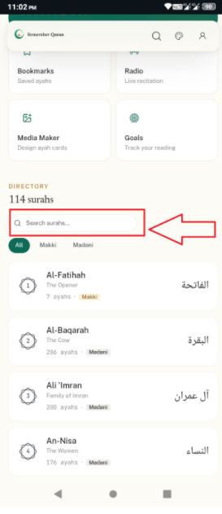

RQ-34
Issue Name | Mobile – Header Navigation Inconsistent on Surah Reading Page
Description | On mobile view, when opening any surah reading page, the header shows only 3 page links on the left side next to the logo, while the remaining pages are shown separately in the footer. It is suggested to add a hamburger menu in the header that lists all the pages together.
Steps to Reproduce | 1. Open a surah reading page on a mobile device.  2. Observe the header menu items and compare with the footer links.
Severity | Medium
Expected Result | All header page links should be available together in a hamburger menu on mobile, rather than being split between the header and footer.
Actual Result | Only 3 page links appear in the header next to the logo; the rest are shown separately in the footer.
Screenshot | 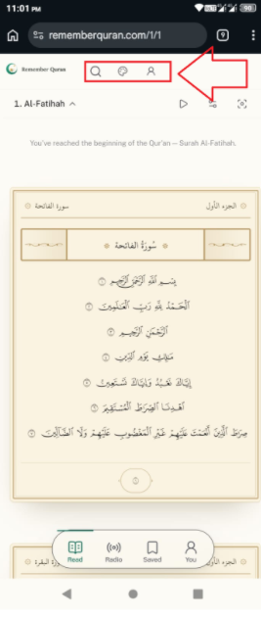

RQ-35
Issue Name | Mobile – Misplaced Header Options and Unwanted Green Line Indicator
Description | On mobile view, while on the surah reading page, some options that should be in the header instead appear at the bottom of the screen. Additionally, a green line (used on desktop to indicate the active page) also appears on mobile, which is unnecessary and should be removed.
Steps to Reproduce | 1. Open a surah reading page on a mobile device.  2. Observe the options shown at the bottom of the screen.  3. Check for a green line indicator near the top.
Severity | Low
Expected Result | Header-related options should be placed in the header (or an appropriate mobile menu), and the green active-page indicator line should not appear on mobile.
Actual Result | Some header options appear at the bottom of the mobile screen, and an unnecessary green line indicator is also visible.
Screenshot | 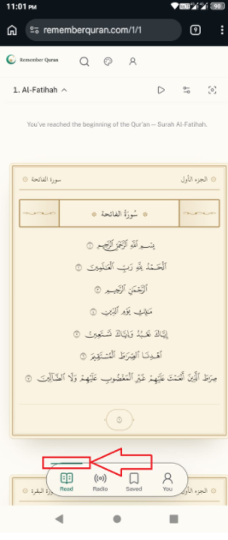

RQ-36
Issue Name | Mobile – Listen Page Label Confusion and Dropdown Hides Options
Description | On mobile view, on the Listen page, text that is shown normally on desktop appears as a "radio" name on mobile, which confuses users. Also, when the dropdown is opened on the Listen page, it hides all the available options, making them inaccessible while the dropdown remains open.
Steps to Reproduce | 1. Open the Listen page on a mobile device.  2. Observe how the label/text is displayed.  3. Open the dropdown and observe the visibility of the options.
Severity | Medium
Expected Result | The label should display consistently as it does on desktop, and opening the dropdown should show the available options clearly, not hide them.
Actual Result | The label appears as a "radio" name causing confusion, and opening the dropdown hides the options, making them inaccessible.
Screenshot | 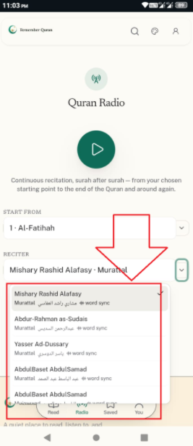

RQ-37
Issue Name | Mobile – "Create" Page Missing from Header
Description | On mobile view, the header does not list the "Create" page, which is available in the desktop header.
Steps to Reproduce | 1. Open the website on a mobile device.  2. Check the header menu items.  3. Compare with the desktop header, which includes "Create."
Severity | Medium
Expected Result | The "Create" page link should also be available in the mobile header menu.
Actual Result | The "Create" page link is missing from the mobile header menu.
Screenshot | 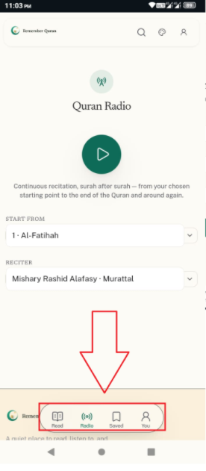

RQ-38
Issue Name | Mobile – Playback Controls Bar Too Small
Description | On mobile view, on the surah reading page, when a surah is played, the playback controls bar appears too small, and its options are also small and hard to see.
Steps to Reproduce | 1. Open a surah reading page on a mobile device.  2. Play the surah.  3. Observe the size of the playback controls bar and its options.
Severity | Medium
Expected Result | The playback controls bar and its options should be made larger and easily readable on mobile.
Actual Result | The playback controls bar and its options are too small and hard to see on mobile.
Screenshot | 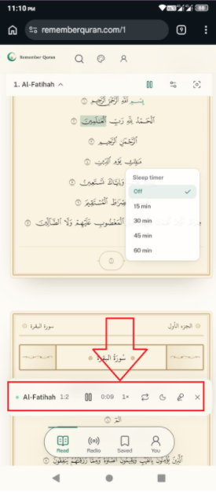

RQ-39
Issue Name | Mobile – Full Screen Option Missing on Surah Reading Page
Description | On mobile view, on the surah reading page, the full screen option that is available on desktop is missing.
Steps to Reproduce | 1. Open a surah reading page on a mobile device.  2. Look for a full screen option.
Severity | Low
Expected Result | The full screen option should also be available on the surah reading page in mobile view.
Actual Result | The full screen option is missing on mobile.
Screenshot | 