Mozhi: A Real-Time Indian Sign Language Terminal for the Hospital Counter with Bilingual Caption and Speech
[AUTHOR 1 NAME] [DEPARTMENT], [UNIVERSITY]
[AUTHOR 2 NAME] [DEPARTMENT], [UNIVERSITY]
[AUTHOR 3 NAME] [DEPARTMENT], [UNIVERSITY]
[Corresponding author e-mail address]
Abstract—A deaf or hard-of-hearing visitor at a hospital counter is usually left to pantomime, write a note, or bring a relative along to interpret. This paper presents Mozhi, a browser terminal that recognises isolated Indian Sign Language glosses from an ordinary webcam and replies in both text and speech, so the exchange can be read and heard by everyone at the counter. The recognition chain couples MediaPipe hand and pose landmarks with a 175,389-parameter bidirectional GRU and temporal-attention classifier over a fixed 30-frame window, exported to ONNX and executed in the browser so that no inference server sits in the path. The classifier is trained on 1,305 labelled clips covering a 29-word clinical reception vocabulary signed by three signers, and reaches 98.1% (256/261) on a stratified held-out split. Because a terminal that fires when nobody is signing is worse than one that stays silent, a ten-stage decision layer — confidence floor, hand onset, span gate, motion-based rest detection, stability agreement, smoothing and debouncing — rejects phantom predictions, and every gate is reported together with its measured cost to latency. The first accepted word appears 1.29 s after signing begins, against 1.42 s before onset buffering. Captions are bilingual English and Tamil, chosen by voice or by touch, and are spoken by the browser's offline synthesiser with the voice selected by script rather than by setting.
Keywords—Indian sign language, isolated sign recognition, MediaPipe, bidirectional GRU, temporal attention, human–computer interaction, speech synthesis

Introduction
Roughly 70 million deaf and hard-of-hearing people worldwide use a sign language as their primary means of communication ^{[2]}, and Indian Sign Language is the everyday language of a large deaf community in India. Most public counters nevertheless remain staffed by people who do not sign. A deaf visitor at a hospital reception is left with three poor options: pantomime, a written note, or a relative acting as an interpreter. The first two are unreliable and the third is a privacy problem that is not always available. The cost is not inconvenience. It is a wrong cup of water, a wrong room, or a missed emergency.
Sign-language recognition has improved sharply, but two very different failures are usually reported as one number. A miss costs the visitor a retry. A false accept — the counter acting on a word that was never signed — costs the visitor something wrong actually happening to them, and it is the failure that makes a deployed terminal unusable rather than merely irritating. Published accuracy figures almost always measure the first failure, on pre-segmented clips supplied by the evaluator, and say little about the second or about how the system knows a sign has begun.
This document describes Mozhi, a browser-based terminal for the reception counter. It recognises 29 ISL glosses, displays them as a caption that can be read in English and Tamil, speaks the transcript aloud, and drives an avatar named Meenu that signs the recognised glosses back. Everything runs client-side: landmarks come from MediaPipe, the classifier is an ONNX graph evaluated in WebAssembly, and speech is the browser's own synthesis. No video leaves the machine and no inference server is required.
The contributions are:
- A 29-gloss clinical reception vocabulary and a 1,305-clip ISL dataset from three signers, collected through a landmark-only pipeline that never writes a camera frame to disk.
- A 175,389-parameter bidirectional GRU with temporal attention, exported to ONNX at 707 kB and executed in the browser at well under one millisecond per classification window.
- A ten-stage decision layer that decides when a sign has begun and whether it may be trusted, with every threshold stated and its cost to latency measured rather than asserted.
- A bilingual English/Tamil caption and speech output whose voice is chosen by script rather than by setting, selected either by voice or by touch.
Section II reviews the related work this builds on. Section III sets out the method: the design architecture, the recognition algorithm in pseudocode, and then each stage in turn. Section IV describes the dataset and the experimental setup. Section V presents the results, their analysis and the limitations that bound them, and Section VI concludes.

Related Work

Isolated Sign Recognition and Its Datasets
Isolated sign recognition classifies a single sign from a short clip, as opposed to continuous recognition of running signing, and remains the tractable setting for a counter terminal. Sharma and Singh ^{[1]} developed a deep-learning ISL model over a 65-user corpus; earlier ISL systems relied on hand-crafted visual features. The largest recent progress has come from dataset scale rather than architecture. ASL Citizen ^{[2]} contains 83,399 crowdsourced videos covering 2,731 signs from 52 signers, and reports 63% accuracy evaluated entirely on signers absent from training and validation. PopSign ASL v1.0 ^{[3]} collects over 210,000 examples of 250 signs from 47 consenting Deaf adults, with an LSTM baseline reaching 84.2% on its held-out test signers.
Those numbers are not directly comparable to ours and the difference is structural rather than rhetorical. Both corpora are an order of magnitude larger, span two to three orders of magnitude more classes, and are scored per signer, which is the harder and more honest protocol. Our corpus is 1,305 clips across 29 classes and is split by clip, with all three signers present on both sides of the split. Our 98.1% therefore reflects a small, closed, in-domain vocabulary — appropriate for a reception counter and not a claim about signer-independent recognition. Section V-F returns to this explicitly.

Landmark Estimation Rather Than Raw Pixels
The alternative to learning from pixels is to learn from a skeleton. MediaPipe provides a cross-platform perception framework ^{[4]} and a real-time hand tracker ^{[5]} that recover 21 landmarks per hand together with handedness. Working from landmarks rather than RGB is what makes a 175,389-parameter CPU model possible: the input collapses from hundreds of thousands of pixels to 144 numbers per frame, the model becomes invariant to clothing, lighting and background, and — decisively for a hospital — no camera frame is ever persisted.

Sequence Classification
A sign is a trajectory, not a posture, so the classifier must operate over time. Recurrent networks are the classical choice: the long short-term memory unit ^{[6]} and the gated recurrent unit ^{[7]} are the two standard cells, and bidirectionality lets a timestep be scored with both its past and its future. Attention over time ^{[8]}, ^{[9]} generalises the idea by learning which timesteps deserve weight rather than committing to the last hidden state. Our model combines the two in the cheapest possible way: a two-layer bidirectional GRU followed by an additive attention pool. The motivation is specific — a 30-frame window necessarily contains preparatory and resting frames in which nothing is being signed, and a learned attention pool can discount them, which a last-hidden-state readout cannot do reliably.

Method

Design Architecture
Mozhi is a single-page application built with React and TypeScript and served as static files. Four stages sit between the camera and the counter's reply, and each is a separate module so that any one of them can be inspected or replaced independently. The stages are shown in Fig. 1 and walked through as pseudocode in Section III-B; the remainder of this section then describes them one at a time in the order data flows.
- Capture. A webcam frame is handed to MediaPipe, which returns hand and pose landmarks and nothing else.
- Windowing. The segmenter decides whether a sign is in progress, assembles the last 30 frames into a fixed window, and hands it to the classifier.
- Classification. The ONNX graph scores the window over 29 classes; the decision layer decides whether that score may be believed.
- Output. An accepted gloss is appended to the transcript, drawn as a caption in one or both languages, spoken aloud, and signed by the avatar Meenu.
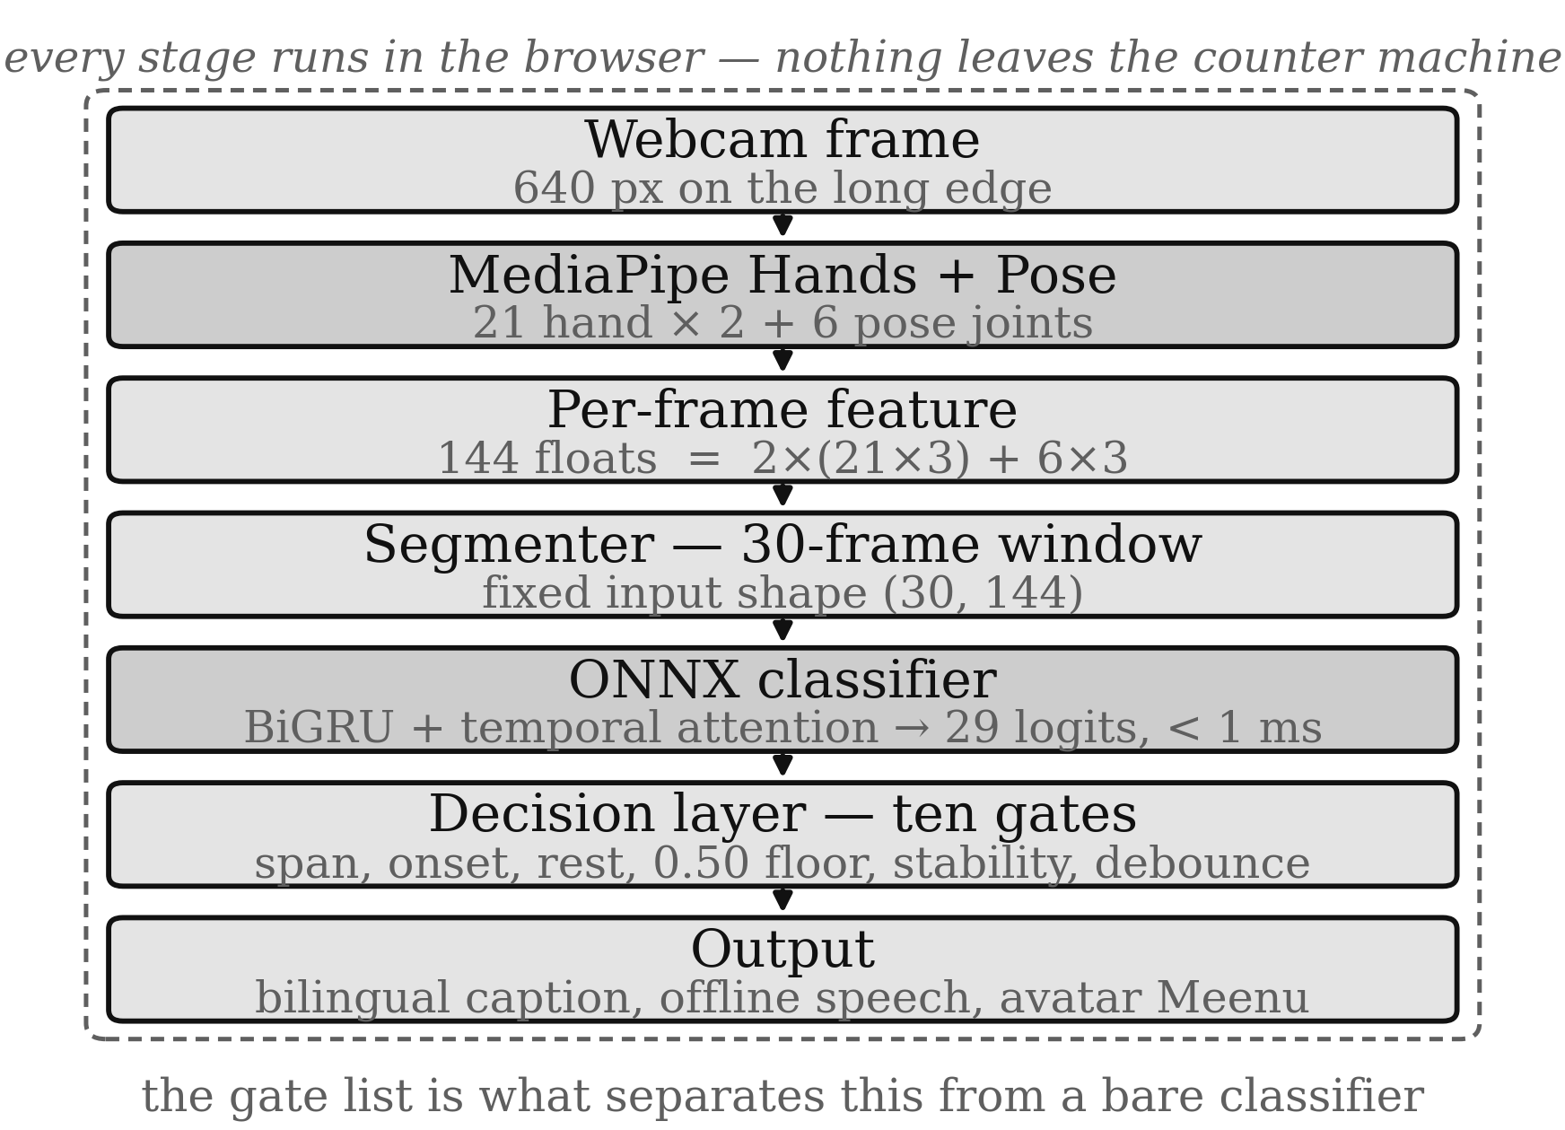
- End-to-end pipeline of the Mozhi counter terminal. Every stage runs in the browser; no frame and no inference request leaves the machine.
Five screens are exposed: the live counter, the vocabulary browser, a review screen for inspecting what was recognised, a settings screen that sets caption and speech language, and an archive of past sessions. The settings screen is where the visitor's language is chosen, either by voice or by touch; selecting a language moves the caption and the speech together so the two cannot disagree about which language the counter is running in. The deployed interface is shown in Fig. 2.
One distinction is worth stating here, because the interface shows both numbers. The twenty-nine glosses described in Section IV-A are the ones the classifier was trained on and the only ones it can read. The terminal's output side is deliberately wider: the avatar and the staff composer draw on a larger written glossary than the recogniser covers, which is why the vocabulary screen counts more signs than Table III. Recognition, not output, is the binding constraint.
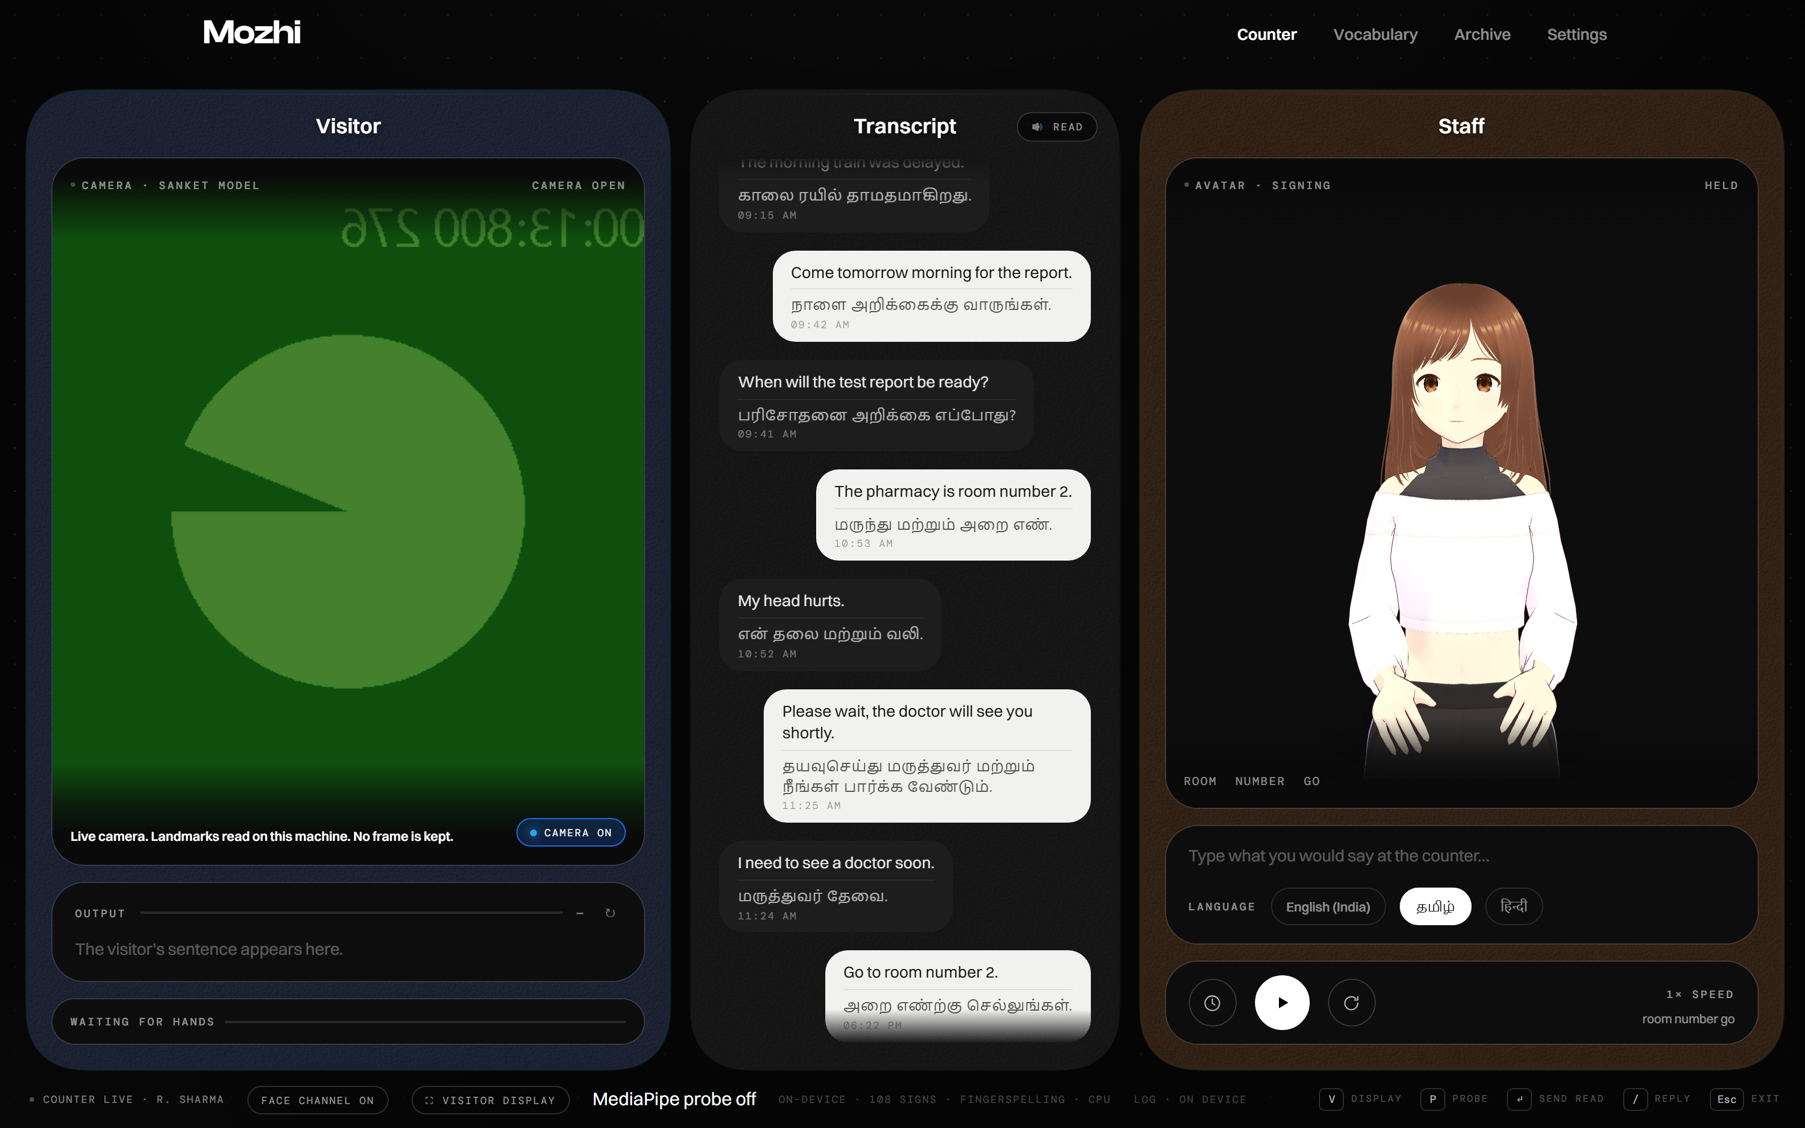
- The counter interface as deployed. Left: the visitor's live camera panel and the sentence under construction. Centre: the running transcript, captioned in English and Tamil. Right: the avatar Meenu and the language selector through which the visitor's language is chosen by touch. The image was captured without a signer present, so the camera panel shows the browser's synthetic test feed.

Recognition Algorithm
The algorithm below is the whole live path, from one webcam frame to one accepted word. It is given before the individual stages so that the stages can then be read as parts of something already seen whole. Constants are written as they are pinned in the engine; each is justified where it is introduced.
Algorithm 1 — Per-frame recognition and the decision layer
Require: one webcam frame f, a monotonic timestamp now,
and a window of the last 30 frames of 144 values
1 procedure ONFRAME(f, now)
2 v, hands, person ← MediaPipe(f)
3 if isHand(v) = false then hands ← false
4 if not person then
5 noPerson ← noPerson + 1
6 if noPerson ≥ 5 then window ← []
7 return
8 end if
9 noPerson ← 0
10 motion ← 1 if prev = null else norm(v − prev)
11 prev ← v
12 low ← low + 1 if motion < 0.015 else 0
13 if low ≥ 90 then window ← []; return
14 if not hands then
15 noHand ← noHand + 1 ; handsRun ← 0
16 if noHand ≥ 6 then window ← []
17 return
18 end if
19 noHand ← 0 ; handsRun ← handsRun + 1
20 window.push(v) ; trim(window, 30)
21 if handsRun < 5 then return # counted, not judged
22 if |window| < 30 then return # not yet classifiable
23 if inFlight then return # never queue results
24 top ← ONNX(flatten(window)) # < 1 ms on CPU
25 best ← top[0] ; fold(top)
26 if best.conf < 0.50 then recent ← []; return
27 recent.append(best) ; drop(recent, older than 600 ms)
28 s ← argmax smooth
29 if s = null or smooth[s] < 0.50 then return
30 if s ≠ best.label then return # self-agreement
31 if now − recent[0].at < 300 then return
32 if agree(recent, best.label) < 0.70 then return
33 if best.label = lastWord and now − lastAt < 1000
34 then return # debounce
35 lastWord ← best.label ; lastAt ← now ; recent ← []
36 EMIT(best.label) # caption, speech,
37 # avatar
38 end procedure
39 procedure FOLD(top) # line 25, detail
40 for k in smooth: smooth[k] ← smooth[k] × 0.70
41 drop k if smooth[k] < 1e-4
42 for p in top: smooth[p.label] ←
43 smooth[p.label] + p.conf × 0.30
44 end procedure
Gates are tested in the order that fails cheapest: presence and geometry before any inference, then confidence, then agreement, then depth of evidence, and finally debounce.
Three properties of that listing are worth naming. First, the onset frames of line 21 are pushed into the window but withheld from judgement: admitting them costs no gate, because the stability history stays closed and every check below still sees the frames it did before, and it shortens the wait for a full window. Second, the span test of line 3 runs before inference at all, so a detection that is a sliver never reaches a classifier that would happily name it. Third, the readings pushed in line 27 are recorded before the gates below them are applied; a share measured only over the readings that already passed would be 100% by construction and would prove nothing.

Landmark Extraction and Windowing
Landmarks are extracted by MediaPipe in video mode with a monotonic timestamp per frame. The delegate is fixed to CPU. This is a deliberate choice rather than a fallback: the offline extractor that produced the training data also forces CPU, and letting the live path run on a different delegate would make it compute landmarks the model has never seen. Requests are capped at 640 pixels on the long edge, which is the widest input at which the measured pipeline still holds a usable frame period.
The hand definition is shared by the detector and the engine so that the two cannot disagree about what a hand is and then disagree about what was signed. A candidate whose bounding box spans less than 0.05 of the frame is not a hand at all: it is the detector inventing one, and the geometry test is what removes that class of phantom before any classifier sees it. A frame that passes becomes one 144-value vector, normalised by re-centring on the shoulder midpoint and scaling by shoulder width, and is pushed onto a rolling window that holds exactly the last 30 such vectors.

Classifier Design
The classifier maps a (30, 144) window to 29 logits. It is a two-layer bidirectional GRU with hidden size 64 and dropout 0.35, whose output is pooled over time by a learned attention readout rather than by taking the final hidden state. Attention scores each timestep with an additive composition — a tanh projection followed by a linear head producing a scalar per frame — softmaxes those scores across the window, and returns the weighted sum of the recurrent states. A final dropout and linear projection produce the logits. The forward pass is given as Algorithm 2 and drawn in Fig. 3.
Algorithm 2 — Classifier forward pass
Require: X, the last 30 frames, each 144 landmark values
1 H ← BiGRU(X)
# 2 layers, hidden 64, both directions → 30 × 128
2 e_t ← v^T · tanh(W · h_t + b)
# W: 128 × 128, v: 1 × 128 → 16,512 params
3 α ← softmax(e) # one weight per frame, sum α = 1
4 z ← Σ_t α_t · h_t # resting frames get small α
5 z ← dropout(z, p = 0.35)
6 logits ← W_c · z + b_c
# W_c: 29 × 128 → 3,741 params
7 return softmax(logits) # 29 glosses
Step 4 is the point of the design: a window that is mostly rest is pooled toward the frames that moved, which a final hidden state cannot do.
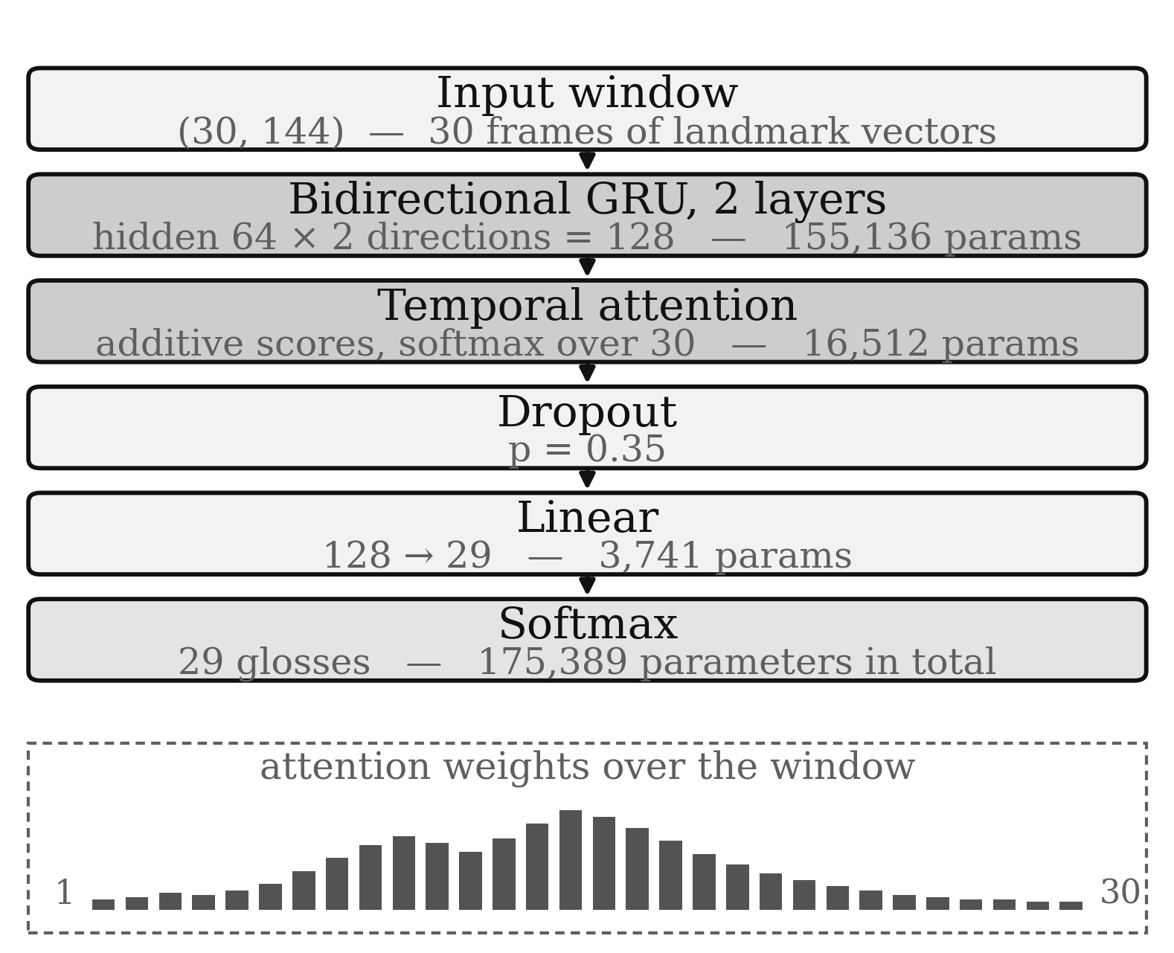
- Classifier architecture. The attention pool replaces a last-hidden-state readout so that resting frames inside the window can be discounted.
Parameter composition is given in Table I. The recurrent stack accounts for 88% of the model, which is the expected shape for this task: the temporal dynamics are what has to be learned, while the readout is cheap. At 707 kB the graph is small enough to ship with the page and to evaluate on a laptop CPU without a warm-up pause.
- Model composition
Component | Shape | Parameters | Share
BiGRU, 2 layers, bidirectional | input 144 → hidden 64 ×2 | 155,136 | 88.4%
Temporal attention | 128 → 128 → 1 | 16,512 | 9.4%
Classification head | 128 → 29 | 3,741 | 2.1%
Total | — | 175,389 | 100%
ONNX export is 707,250 bytes (691 KiB) with input [1, 30, 144] and output [1, 29].

Training Procedure
Training uses Adam at a learning rate of 1e-3 with weight decay 1e-4 and cross-entropy loss, batches of 32, for at most 120 epochs with early stopping after 12 epochs without validation improvement. The split is stratified over classes. Landmark-space augmentation is applied on the fly to the training subset only and never to validation: Gaussian jitter at 0.005, temporal warping between 0.8× and 1.2×, translation within ±0.02, and scaling between 0.95× and 1.05×. Each sample receives a random subset rather than the full chain, so the model sees single corruptions as well as compound ones.

Decision Layer
This is the part of the system that determines whether it is usable, and it is where isolated-clip accuracy stops being the relevant number. The classifier produces a distribution on demand, every frame, whether or not anyone is signing. Something has to decide when a sign has started, whether the evidence is stable, and whether it may be written to the transcript. The ten gates between a raw prediction and an accepted word are listed in Table II with the value each is pinned to; Algorithm 1 shows where each of them sits in the frame path.
- The ten decision gates, in order
# | Gate | Value | Purpose
1 | Person presence | 5 frames | No subject for 5 frames puts the engine idle.
2 | Hand span | 0.05 | Rejects a detection whose bounding box is a sliver — the classic phantom that produces a confident word from no hand.
3 | Hand onset | 5 frames | Five consecutive frames of a valid hand before anything is judged. Frames are buffered into the window during onset but not classified.
4 | Rest detection | 0.015 / 90 frames | Per-frame landmark motion below 0.015 for 90 consecutive frames ends the utterance — a signer who stops is finished, not hesitating.
5 | Hand loss | 6 frames | Six frames without a hand ends the utterance and clears state.
6 | Confidence floor | 0.50 | A softmax below 0.50 is discarded rather than shown.
7 | Stability window | 600 ms | Predictions are accumulated over 600 ms.
8 | Stability agreement | 0.70 / 300 ms | At least 70% of the window must agree, and stability reads are throttled to 300 ms apart.
9 | Score smoothing | 0.70 | Exponential smoothing damps single-frame spikes.
10 | Debounce | 1000 ms | The same gloss cannot be emitted twice within one second.
Gates 2, 3, 6 and 8 are the anti-false-positive gates and are the ones most likely to be weakened for a demo. Each is reported with its latency cost in Section V-D so that any such weakening can be priced rather than discovered later.

Caption and Speech Output
Everything the system produces is written: the caption, the transcript log, and the reply. Two people at a counter cannot both rely on reading it, so the log is spoken as well as shown, using the browser's own speech synthesis ^{[14]}. Nothing is fetched: the synthesiser and its voices are installed with the browser, and the interface says so rather than implying an offline synthesiser it does not have.
Two rules decide what comes out of the speaker, and both exist to stop the machine producing nonsense. First, the voice follows the script the line is written in, not the language setting: a line the counter could not translate stays English, and English read by a Tamil voice — or Tamil read by an English one — is noise rather than speech. The script is detected directly from the Unicode range of the text. Second, when this machine has no voice for that script, the English fallback is spoken instead of handing the original to a voice that cannot pronounce it. Tamil characters read as English letters is worse than an accented English answer at a window.
The caption language and the speech language are one setting rather than two: choosing English shows English captions in English speech, choosing Tamil shows a bilingual caption and speaks Tamil, and the choice can be made by voice or by touch. Selecting one moves both so they cannot end up disagreeing about which language the counter is running in.

Experimentation

Dataset Description
The dataset is deliberately small and deliberately closed. It covers the words a reception counter actually needs, recorded by three signers, and is stored as landmarks rather than video. This section states what is in it and how it was collected, so the results in Section V can be read against the data that produced them.

Vocabulary
The vocabulary is the 29 glosses listed in Table III. They were chosen against three constraints: each must be a word a hospital counter would plausibly say; each must be signable by a non-expert after one page of instruction; and the set must be visually separable, meaning that no two glosses should differ only in a detail that a webcam at a counter distance cannot resolve. Glosses are stored as written English, so multi-word entries such as "thank you" and "how much" are single classes, not compositions.
- The 29-gloss reception vocabulary
Function | Glosses
Greeting and leave-taking | hello, welcome, goodbye, thank you, please, sorry, yes, no, good, bad
Clinical | help, water, food, medicine, hospital, emergency, fever, pain
Query | name, where, when, how much, i dont understand
Direction | come, go, sit, stand, wait, stop
Every entry is one class. "thank you" is signed and stored as a single gloss.

Signers and Collection
Three signers contributed 1,305 clips in total, 45 per class. Composition is given in Table IV. Two acquisition paths feed the same store: a live prompt-and-countdown capture that records roughly 30 frames per attempt, and a batch extractor that decodes pre-recorded clips with OpenCV ^{[12]}. Both paths run the identical landmark pipeline, so a clip's provenance does not change its representation.
- Dataset composition
Signer | Clips | Share of corpus | Frames at 30 per clip
hritankar | 452 | 34.6% | 13,560
ayush | 417 | 32.0% | 12,510
pratham | 436 | 33.4% | 13,080
Total | 1,305 | 100% | 39,150
29 classes × 45 clips = 1,305. Clips per signer differ because the 45 clips of each class are split unevenly across signers.

Landmark Representation and Normalisation
Each frame becomes a single float vector of 144 values. Both hands contribute 21 landmarks × 3 coordinates = 63 each, and a six-joint pose subset — two shoulders, two elbows and two wrists — contributes 6 × 3 = 18, giving 63 + 63 + 18 = 144. The full torso and the face are excluded: they add dimension without adding evidence, and dropping the face keeps the stored data free of biometric imagery.
MediaPipe reports handedness in its own frame, so the label it emits is swapped when written: its "Left" lands in the signer's right-hand block. Without this the two hand blocks would be silently exchanged for one detector and consistent for the other.
Coordinates are then normalised per frame by re-centring on the midpoint of the two shoulders and scaling by the shoulder width. This makes the representation invariant to how far the signer stands from the camera and to where they sit horizontally in the frame — exactly the two degrees of freedom that vary between a lab recording and a hospital corridor. Frames in which neither shoulder is detected are left as zero rather than rescaled, so a missing pose cannot be amplified into a plausible-looking one. A window is the last 30 normalised frames, stored as a (30, 144) float32 array.

Labels, Split and Privacy
The store holds two things: one .npy array per clip, and a labels.csv of word, sample identifier and signer. The label file is the sole authority on what exists — a stray array on disk that labels.csv does not name is not part of the dataset and is not read. A stratified 80/20 split over labels.csv, made with scikit-learn ^{[11]}, yields 1,044 training and 261 validation clips, with every class represented on both sides.
The privacy property is architectural rather than procedural. No raw camera frame is ever written to disk by either acquisition path; only derived landmark vectors and label metadata persist. There is therefore no image store to secure, back up or purge, and a leaked dataset cannot be used to identify a signer.

Experimental Setup
Offline experiments used Python 3.13 with PyTorch ^{[10]} 2.10 on CPU, MediaPipe 1.0.1, ONNX Runtime ^{[13]} 1.27 and scikit-learn ^{[11]} for the stratified split. The trained checkpoint was exported to ONNX and served statically; in the browser it runs under ONNX Runtime Web in WebAssembly. Live measurement used an ordinary laptop webcam with no capture card or ring light.
Three quantities are reported. Top-1 accuracy is the usual argmax agreement. Emission rate is the fraction of clips the deployed decision layer would actually have displayed, requiring argmax agreement and a confidence at or above the 0.50 floor — the difference between the two is the price of the floor. Latency is wall-clock time from the first frame in which the signer begins to the moment the accepted word appears on screen, instrumented in the browser rather than estimated.

Results and Analysis

Held-Out Accuracy
On the 261-clip stratified validation split the model scores 256 correct, or 98.1%. Per-signer results are given in Table V. The spread between the best and worst signer is 1.3 percentage points, which is narrow enough to say the model is not leaning on one signer's mannerisms, though the absolute level must be read with Section V-F in mind.
- Accuracy, by signer, on the held-out split and over the full corpus
Signer | Val clips | Val correct | Val acc. | All clips | All correct | All acc.
ayush | 76 | 74 | 97.4% | 417 | 413 | 99.0%
hritankar | 106 | 104 | 98.1% | 452 | 445 | 98.5%
pratham | 79 | 78 | 98.7% | 436 | 435 | 99.8%
All | 261 | 256 | 98.1% | 1,305 | 1,293 | 99.1%
The validation split contains only clips the model was not trained on but does contain signers that were. "All clips" includes training clips and is therefore reported as an in-sample figure.

Emission Rate and the Cost of the Floor
Over the full corpus the argmax is correct on 1,293 of 1,305 clips (99.08%). Requiring the confidence floor as well — that is, asking what the deployed terminal would actually have shown — gives 1,291 (98.93%). The floor therefore costs 0.15 percentage points, on two clips: one go at 0.350 and one i dont understand at 0.444. Both were classified correctly and both were suppressed. That is the intended behaviour: a word the terminal declines to emit is a retry, whereas a word it emits wrongly is an incident. The floor is doing its job at a known and measured price.

Error Analysis
Twenty of the 29 classes are perfect over the corpus. The twelve errors are listed in Table VI, and they are not distributed at random: they form one dense neighbourhood plus two isolated pairs.
- All twelve corpus errors, as true → predicted
True gloss | Predicted gloss | Count | Mean conf. of true class
food | thank you | 2 | 0.916
food | medicine | 1 | 0.916
please | food | 1 | 0.907
please | medicine | 1 | 0.907
sorry | food | 1 | 0.926
medicine | sorry | 1 | 0.902
good | sorry | 1 | 0.949
hello | goodbye | 1 | 0.959
pain | goodbye | 1 | 0.959
name | please | 1 | 0.970
i dont understand | no | 1 | 0.846
food → thank you occurs twice, so eleven distinct clips carry twelve errors.
The dominant cluster is food, please, sorry and medicine, which exchange votes among themselves and account for seven of the twelve. These four are semantically related at a counter and, more importantly, share handshapes in the region of the torso the pose subset is coarsest about. The remaining five are scattered rather than clustered: hello → goodbye and pain → goodbye are both signs that move outward from the body, good → sorry and name → please each cost a single clip, and i dont understand → no is a single-head-shape confusion.
The practical consequence is that a sentence should not be built from two words that steal from each other. food and thank you appearing in one utterance is fine because thank you itself is never misread; food and medicine in the same utterance is not, because the first can be replaced by the second. Mean confidence is a poor guide to this — i dont understand has the lowest mean confidence at 0.846 but errs once in 45, while food at 0.916 errs three times. Confidence measures how sure the model is, not whether it is right.

Runtime and Latency
Landmark extraction dominates the budget and inference does not appear in it. Measured on CPU at 640 pixels wide, MediaPipe with both hands and pose costs 34.1 ms per frame, or 29 fps; on a loaded machine the same run degrades to 48.4 ms, or 21 fps. ONNX inference on the 30-frame window is below one millisecond. Extraction is also the stage that can fail: a hand is present in 92.7% of signing frames and pose in 100%, but both hands are present in only 69.3% of them — so roughly a third of signing frames reach the classifier with a hand missing, which is precisely what the hand-loss and hand-onset gates exist to absorb.
The latency budget is given in Table VII. The first word reaches the screen 1.29 s after the signer begins. About a second of that is structural: the classifier needs 30 frames before it has anything to classify, and 30 frames at 34–48 ms is 1.0–1.4 s. This is not a parameter that can be tuned, because 30 is baked into the ONNX input shape [1, 30, 144]; shrinking it would require retraining, and the model was not retrained for this work.
- Latency budget, first accepted word
Stage | Cost | Note
Camera frame period | 34–48 ms | Load-dependent; measured, not assumed.
Landmark extraction | 34.1 ms | MediaPipe, hands and pose, CPU, 640 px.
Hand onset gate | absorbed | Five frames of hand presence before anything is judged. Those frames are buffered into the window rather than discarded, which is what recovered 132 ms.
Window fill | ≈1,020–1,440 ms | 30 frames — the structural floor.
ONNX inference | <1 ms | 30-frame window, CPU.
Stability + debounce | ≈300–600 ms | 600 ms agreement window with reads throttled to 300 ms.
First word on screen | 1,287 ms | Was 1,419 ms before onset buffering; 132 ms recovered.

Suppression of Phantom Predictions
The anti-false-positive gates were treated as a first-class requirement rather than a tuning afterthought, and none of them has been relaxed. The span gate is the most consequential and the least obvious: a wrist-length bounding box returned for a background edge is a detection MediaPipe will happily label, and a two-layer GRU trained on real signing will still assign it a confident class. Rejecting on geometry — the box must span at least 0.05 of the frame — removes that class of phantom at negligible cost. The onset gate serves the complementary role: five frames of sustained hand presence before any classification is judged, so a hand passing through the frame cannot open an utterance.
The skeleton overlay visible to the operator is drawn from the same landmarks the classifier reads, with pose connections suppressed below a visibility of 0.5 and a connection drawn only when both endpoints pass. The overlay therefore reports what was actually classified rather than a best-guess anatomy, which matters when an operator is trying to work out why a sign was not recognised.

Limitations
Four limitations bound these results and should be read as part of them.
- The split is by clip, not by signer. All three signers appear on both sides of the validation split, so 98.1% measures new performances by known signers. Signer-independent accuracy would require leave-one-signer-out evaluation, which would require retraining the model and was not performed. The comparable figure in the literature for unseen signers is far lower — 63% on ASL Citizen ^{[2]} and 84.2% on PopSign ^{[3]} — across vastly more classes.
- The validation clips are clean. They are pre-segmented landmark sequences extracted offline, not frames from a live webcam chain. Live operation adds hand loss in 30.7% of signing frames, framing variation, and corridor lighting that no validation clip contains.
- Three signers, one vocabulary, one site. The vocabulary was designed for this counter, and no claim is made about signs, signers or settings outside it.
- Single-window latency is structural. At 1.0–1.4 s for window fill it cannot be reduced without retraining at a shorter sequence length, and the dataset/model were deliberately left un-retrained.

Conclusion
Mozhi is a reception terminal rather than a research benchmark, and it was built around the failure that matters there: saying something when nothing was signed. The recognition component — a 175,389-parameter bidirectional GRU with temporal attention over 30 frames of 144-dimensional landmark data — is deliberately small enough to run in the browser on a CPU, and scores 98.1% on a stratified held-out split of a 1,305-clip, 29-gloss corpus.
The contribution that took the work is the ten gates in front of it. Confidence floor, hand onset, span geometry, rest detection, stability agreement, smoothing and debouncing are all pinned to stated values, each is reported with its measured cost, and none has been relaxed to improve a demo number. The result is a terminal that suppresses phantom predictions at a known price — 0.15 percentage points of emission — and whose first word reaches the screen 1.29 s after the signer begins, of which about a second is the irreducible cost of having 30 frames to classify at all.
Speech follows the caption in both directions: the voice is chosen by the script a line is written in, so a Tamil line is spoken by a Tamil voice and an untranslated line stays English rather than being read aloud in a voice that cannot pronounce it. The language is selected by voice or by touch and moves caption and speech together. The most valuable next step is evaluating signer-independent performance, which needs a retrained model and would replace the principal caveat with a measurement.

References
- S. Sharma and S. Singh, “Recognition of Indian sign language (ISL) using deep learning model,” Wireless Pers. Commun., vol. 123, no. 1, pp. 671–692, 2022, doi: 10.1007/s11277-021-09152-1.
- A. Desai et al., “ASL Citizen: A community-sourced dataset for advancing isolated sign language recognition,” in Proc. Adv. Neural Inf. Process. Syst. (NeurIPS) Datasets Benchmarks Track, 2023, arXiv:2304.05934.
- T. Starner et al., “PopSign ASL v1.0: An isolated American sign language dataset collected via smartphones,” in Proc. Adv. Neural Inf. Process. Syst. (NeurIPS) Datasets Benchmarks Track, 2023, doi: 10.52202/075280-0011.
- C. Lugaresi et al., “MediaPipe: A framework for building perception pipelines,” 2019, arXiv:1906.08172.
- F. Zhang et al., “MediaPipe hands: On-device real-time hand tracking,” 2020, arXiv:2006.10214.
- S. Hochreiter and J. Schmidhuber, “Long short-term memory,” Neural Comput., vol. 9, no. 8, pp. 1735–1780, 1997, doi: 10.1162/neco.1997.9.8.1735.
- K. Cho et al., “Learning phrase representations using RNN encoder–decoder for statistical machine translation,” in Proc. Conf. Empirical Methods Natural Language Process. (EMNLP), 2014, pp. 1724–1734, doi: 10.3115/v1/D14-1179.
- D. Bahdanau, K. Cho, and Y. Bengio, “Neural machine translation by jointly learning to align and translate,” in Proc. Int. Conf. Learn. Represent. (ICLR), 2015.
- A. Vaswani et al., “Attention is all you need,” in Proc. Adv. Neural Inf. Process. Syst. (NeurIPS), 2017, pp. 5998–6008.
- A. Paszke et al., “PyTorch: An imperative style, high-performance deep learning library,” in Proc. Adv. Neural Inf. Process. Syst. (NeurIPS), 2019, pp. 8024–8035.
- F. Pedregosa et al., “Scikit-learn: Machine learning in Python,” J. Mach. Learn. Res., vol. 12, pp. 2825–2830, 2011.
- G. Bradski, “The OpenCV library,” Dr. Dobb's J. Softw. Tools, vol. 25, no. 11, pp. 120–125, 2000.
- ONNX Runtime. [Online]. Available: https://onnxruntime.ai
- W3C, “Web Speech API,” Draft Community Group Report. [Online]. Available: https://webaudio.github.io/web-speech-api/

