School of Computer Science Engineering and Information Systems 5Yr Integrated M.Tech(Software Engineering)
ISWE415L : Cyber Security FALL 2026-2027

Course Project Report

SignGuard AI — Integrity-Guarded Content Delivery for Public-Transport Digital Signage with Explainable Intrusion Detection

Submitted for the Course: ISWE415L : Cyber Security

Offered by Dr. R. K. NADESH during FALL 2026-2027

By

<Name of student > <Reg No>
<Name of student > <Reg No>
<Name of student > <Reg No>

October 2026

School of Computer Science Engineering and Information Systems 5Yr Integrated M.Tech(Software Engineering)
ISWE415L : Cyber Security FALL 2026-2027
(Latest Date: 23.10.2026)
A Report on the Course Project
SignGuard AI — Integrity-Guarded Content Delivery for Public-Transport Digital Signage with Explainable Intrusion Detection

TEAM Name : <TEAM NAME>
Team Member(s) with Reg # and Name : NAME1;REG.NO1;MOBILE1;EMAIL1
NAME2;REG.NO2;MOBILE2;EMAIL2 NAME3;REG.NO3;MOBILE3;EMAIL3
Project Title : SignGuard AI — Integrity-Guarded Content Delivery for Public-Transport Digital Signage with Explainable Intrusion Detection
- Problem Statement
1. Problem Statement
1.1 Background (System Study Details in brief)
Every large transport operator now runs a fleet of electronic destination boards: platform indicators inside a station, departure boards in the concourse, and e-paper panels on bus stops. Each of these displays is driven by a small controller that obtains its picture from one of three convenient channels — a USB flash drive carried by a field technician, a scheduled wireless synchronisation with a central content server, or a browser-based administration panel used for ad-hoc corrections such as a platform change during engineering work. All three channels were engineered for availability and ease of maintenance, and in practice none of them authenticates the picture itself. The controller accepts whatever bytes arrive, renders them, and only a human noticing that the board is wrong discovers the problem. Between the authority that authorised the message and the passenger reading it there is therefore no integrity check of any kind.
This gap is no longer theoretical. In October 2025 four North American airports had flight-information displays defaced by an unknown group, and in the following month e-paper bus-stop panels operated by the Los Angeles Metro were made to display a fabricated emergency warning telling passengers to leave immediately because of a suicide bomb; the displays kept showing the message until the vendor traced the intrusion (AV Magazine, 5 November 2025). Bristol Airport's departure screens suffered a comparable ransom message years earlier. In every published case the mechanism was mundane rather than exotic: a management interface left on factory credentials, an exposed USB port, or an update copied over an unauthenticated link. National CERT advisories on kiosk and signage hardening list exactly these three items — open USB ports, default credentials and unsigned update packages — as the first things to close, yet they remain the default state of most installed hardware because closing them usually breaks the maintenance routine the vendor sold.
The consequence of a wrong sign is operational rather than merely cosmetic. A platform indicator that names the wrong platform sends an entire carriage in the wrong direction; a departure time that silently slips causes missed connections; an unexplained blank or hostile message during an evacuation removes the one channel a station has for directing people. The operator's liability, the cost of manual verification, and the erosion of passenger trust all scale with the number of displays, while the number of displays scales with the size of the network. Inspection by walking the platforms is therefore not a solution that survives growth.
Two families of existing defence fall short of the requirement. Cryptographic protection of the transport path (TLS, authenticated package repositories, VPNs between the server and the controller) proves that the bytes came down a protected pipe, but a USB stick never traverses that pipe, and a legitimate operator can still push a file that was never authorised by the content authority. Signature verification on the controller would help, yet commodity signage firmware rarely implements it, and where it exists it usually verifies the container rather than the payload. On the other side of the literature, intrusion-detection systems classify network traffic and raise alerts; they do not decide whether the specific text about to be shown to ten thousand passengers is the text the transport authority approved. What is missing is a gate that sits immediately before rendering, verifies the content itself against an authorised reference, considers the attack context around it, explains its verdict, and can force the display into a safe state without a human in the loop.
1.2 Problem Statement
Design and implement an integrity gate — SignGuard AI — that sits between every content-ingress channel of a public-transport digital sign (USB, wireless synchronisation and administration panel) and the act of rendering, such that:
• R1 Authenticity is decided deterministically: an update renders only if its SHA-256 digest equals the digest of a content record authorised in advance by the transport authority and bound to an Ed25519-signed, hash-linked ledger entry.
• R2 Tampering is a terminal condition: any mismatch, unknown content or absent authorisation blocks the update and drives a safe fallback message, and no probabilistic component is allowed to overrule that verdict (false negatives for tampered content must be structurally impossible, not merely unlikely).
• R3 The surrounding attack context is assessed by an unsupervised model and fused with rule signals into a single 0–100 risk score that refines what happens when the hash does match — render, block or isolate the update channel.
• R4 Every verdict is explainable: the decision carries the ranked SHAP factors that produced the model's assessment, so an operator sees why, not only what.
• R5 Every verdict is non-repudiable: it is appended to a tamper-evident audit trail that survives process restarts, and the ledger can be re-verified independently through an API endpoint.
• R6 The verdict reaches the physical display within a real-time budget (tens of milliseconds of processing, MQTT round-trip included) and is enforced physically through LCD text, a green/red LED pair and a buzzer, so a failed network link cannot silently leave a false sign lit.
The objective is therefore a two-track decision system in which deterministic content verification gates rendering, explainable machine learning quantifies the context around it, a single fusion rule converts both into an actionable command, and the command is observable on hardware, on a dashboard and in an audit record that can be produced after the incident.
1.3 Novelty
The contribution of this project relative to existing signage-security and IoT-IDS work is fivefold:
1. Integrity before intelligence. Verification is a hard gate placed ahead of the model: a hash mismatch blocks immediately and never waits for inference (Section 4.1). Published IoT intrusion-detection systems, including the SHAP-based ones surveyed in Section 2.1, produce a classification that a human may ignore; here the probabilistic component can only refine a match, never open one.
2. Explainability attached to the verdict rather than to the model. Each decision object embeds the top SHAP factors and their signed impact, and they are surfaced next to the decision on the audit endpoint and the dashboard. Explainability becomes an operational artefact usable during an incident, not a research plot.
3. Authorisation provenance on a hash-linked, Ed25519-signed ledger that is independent of the process, re-verifiable on demand through /chain/verify, and separated from the append-only operational audit store so that compromise of one does not silently rewrite the other.
4. Physical enforcement of the safe state. The decision travels over MQTT to the edge node, which renders authorised text, a tamper message or a safe fallback on an LCD and signals it with LEDs and a buzzer, giving the safe state a representation that survives the loss of the management network.
5. A single shared pipeline (run_analysis) behind both REST and MQTT entry points, proved by an automated suite in which the negative cases — tampered content, unknown content, default credentials, rogue wireless activity — are first-class tests rather than demonstrations.

- Related Works
2. Related Works
2.1 Literature Survey
Securing the things that produce and consume data in the Internet of Things has been studied from three angles that are relevant here: making the data's provenance verifiable, deciding whether an observation is anomalous, and explaining that decision to a human.
Provenance, ledgers and content integrity
The broadest reference point is Dai, Zheng and Zhang [1], who named the combination of blockchain with IoT as 'blockchain of things' and catalogued how a distributed ledger replaces a trusted intermediary when devices cannot rely on a central authority. Liu et al. [2] narrowed the question to trust management and surveyed how reputation and ledger-backed attestation are shared between IoT devices, concluding that blockchain-based schemes improve tamper evidence but usually assume the device itself is trustworthy. Khan et al. [10] reviewed blockchain applications across the IoT stack and identified integrity of data in motion as the dominant use case, with device-side verification still largely unimplemented. He et al. [3] examined the other side of the ledger — the vulnerabilities of the smart contracts that record those claims — and argued that on-chain state is only as strong as the off-chain verification feeding it. Together these works motivate the design choice taken in this project: the ledger stores authorised digests and their signatures, but the decision is made by an off-chain verifier that can be unit-tested, and the chain is re-verifiable independently rather than trusted on faith.
Unsupervised anomaly detection at the edge
Because labelled attack data for signage networks does not exist, the context assessment had to be unsupervised and small enough to run beside a web server. Ortega et al. [4] showed that an isolation forest can be discretised to fit the memory and compute budget of resource-constrained IoT edge devices, which is the argument for the algorithm family rather than a deep autoencoder. Zahoor et al. [5] combined an isolation forest with a one-class SVM for IoT traffic and reported the complementary strengths of the two: the forest is fast and stable, the SVM tighter on unseen classes. Both assume network-flow features; our features are windowed state of a single device (failed logins, unauthorised sticks, time since an approved update, standing trust), which is the shape of the problem actually faced at the display.
Explainability
A score that cannot be justified is unusable to a duty manager, so the third thread is explainable AI. Bin hulayyil, Li and Saxena [6] built an explainable IDS for IoT in which SHAP is used to justify each classification rather than only to audit the model offline. Dong et al. [7] proposed NGSHAP-IDS, pairing NGBoost with a SHAP explanation framework and demonstrating on UNSW-NB15, CICIDS2017 and N-BaIoT that interpretability can be obtained without giving up detection accuracy. Taheri et al. [8] carried the same principle into connected vehicles under federated learning, where a deep detector is explained by SHAP per vehicle. Almadhor et al. [9] pushed further towards self-explaining architectures with a neuro-symbolic dual model, again evaluated on NF-BoT-IoT-V2, arguing that explanation should be part of the detection loop rather than a post-hoc report. The pattern across this literature is that explanation is attached to a classification of traffic; none of the surveyed systems explains a content-authenticity verdict, because none of them makes one.
Gap addressed by this project
The comparison in Section 2.2 makes the gap explicit. Ledger-based work proves data was recorded, not that the bytes about to be rendered are the authorised bytes; anomaly-detection work classifies flows but cannot say whether this file is authentic; explainability work justifies a class label but is never wired to an actuator. SignGuard AI joins the three: a deterministic integrity gate in front of rendering, an unsupervised model plus rule signals for context, SHAP factors carried inside the decision object, and an MQTT command that physicaly changes what the sign shows.

2.2 Comparative Statement (10 Latest Journal Papers)
# | Authors (Year) | Journal | Approach / evaluation | Limitation relative to this work
1 | Dai, Zheng & Zhang (2019) | IEEE Internet of Things Journal | Survey of blockchain-of-things architectures; taxonomy of ledger use across IoT | Architecture only — no content verification at the display, no decision or actuator
2 | Liu, Wang, Yan, Wan & Jäntti (2023) | IEEE Internet of Things Journal | Survey of blockchain-based trust management for IoT; comparison of consensus and reputation schemes | Assumes a trustworthy device; nothing verifies the payload before rendering
3 | He, Wu, Li, Chan & Guizani (2023) | IEEE Internet of Things Journal | Detection of vulnerabilities in blockchain smart contracts; formal + empirical analysis | Protects the ledger, not the off-chain content; no real-time gate
4 | Ortega, Su, Chattopadhyay & Chakrabarty (2025) | IEEE Internet of Things Journal | Discretised isolation forest for memory/compute-constrained IoT edge nodes | Optimises the detector but gives no explanation tied to a verdict, and never blocks content
5 | Zahoor, Abbasi, Babar et al. (2025) | Scientific Reports | Isolation forest + one-class SVM for IoT security; benchmark evaluation | Flow-based features; binary alerting only — no fusion with deterministic integrity
6 | Bin hulayyil, Li & Saxena (2025) | Internet of Things (Elsevier) | Explainable AI-based IDS for IoT using SHAP justification per classification | Explains traffic classes; the explanation is not attached to a rendering decision
7 | Dong et al. (2025) | Computer Networks | NGSHAP-IDS: NGBoost classifier + SHAP framework on UNSW-NB15, CICIDS2017, N-BaIoT | High accuracy but supervised and offline; no integrity gate or hardware enforcement
8 | Taheri, Jafari, Gegov, Arabikhan & Ichtev (2025) | Electronics (MDPI) | Explainable federated IDS for connected vehicles; DNN + SHAP | Federation and vehicles; explanation remains a dashboard artefact, not an action
9 | Almadhor, Alsubai, Al Hejaili, Klai, Bouallegue & Kovac (2025) | Scientific Reports | Neuro-symbolic dual-model architecture for explainable, resilient IoT IDS (NF-BoT-IoT-V2) | Detection-centric; assumes labelled traffic and a human responder
10 | Khan, Majib, Ullah & Rana (2024) | Internet of Things (Elsevier) | Survey of blockchain applications across the IoT stack | Identifies data integrity as the key use case but leaves device-side enforcement open
Table 3: Comparative statement over ten recent journal papers in the domain.
2.3 Hardware Requirements
Component | Specification | Qty | Role in the system
Development laptop | Windows 11, x86-64, ≥ 8 GB RAM | 1 | Hosts the broker, the FastAPI decision service, the dashboard and the tests
Wi-Fi network | 2.4 GHz / LAN, WPA2 | 1 | Shared transport between edge node, broker and decision service
NodeMCU ESP-12E board | ESP8266, 80 MHz, 4 MB flash, MicroPython | 1 | Edge signage node: subscribes to commands, drives the indicators
LCD display | 16 × 2 character LCD with I2C backpack (PCF8574) | 1 | Shows authorised text, tamper message or the safe fallback
LEDs (green, red) | 5 mm, 330 Ω series resistors | 2 | Green = verified content rendered; Red = blocked / isolated
Buzzer | 5 V passive buzzer | 1 | Audible alert on a blocked or isolated update
Breadboard + jumpers | 400-point half-size | 1 | Indicator wiring
USB flash drive | Standard mass-storage device | 1 | Simulated vector for the malicious-content attack
Micro-USB cable | Data-capable | 1 | Power and firmware flashing of the edge node
Table 4: Hardware bill of materials.
2.4 Software Requirements
Software | Version used | Purpose
Windows 11 (PowerShell) | 23H2+ | Execution host; COM-port watching via winreg/SERIALCOMM
Python | 3.13.4 | Service, tooling, test suite
FastAPI | 0.141.1 | REST API, dependency injection, OpenAPI docs
Uvicorn | 0.52.4 | ASGI server hosting the decision service on :8000
Pydantic | 2.13.4 | Typed request/response schemas for events, content and decisions
Eclipse Mosquitto | 2.x (launched by run_demo.py) | MQTT broker on :1883 for the event/command bus
paho-mqtt | 2.1.0 | MQTT client used by the orchestrator and the edge node
scikit-learn | 1.8.0 | IsolationForest anomaly model and its persistence
SHAP | 0.52.0 | TreeExplainer attributions carried inside each decision
NumPy | 2.4.2 | Feature-vector arithmetic
SQLite (standard library) | 3.x | Append-only audit store, file-backed for restart survival
pytest | 9.1.1 | Automated test suite (46 cases)
MicroPython for ESP8266 | 1.23.x | Firmware on the NodeMCU ESP-12E edge node
matplotlib | 3.10.8 | Generation of all figures in this report
python-docx | 1.2.0 | Assembly of this document
Git / GitHub | 2.x | Version control and submission history
Table 5: Software environment.

- System Design
3.1 High-Level Design (Black Box Design)
Figure 1 shows the system as a black box. Everything to the left of the box produces data, everything to the right consumes a verdict, and the box itself is deliberately opaque: at this level the only obligation of the drawing is to state what crosses the boundary, in which direction, and with what guarantee.
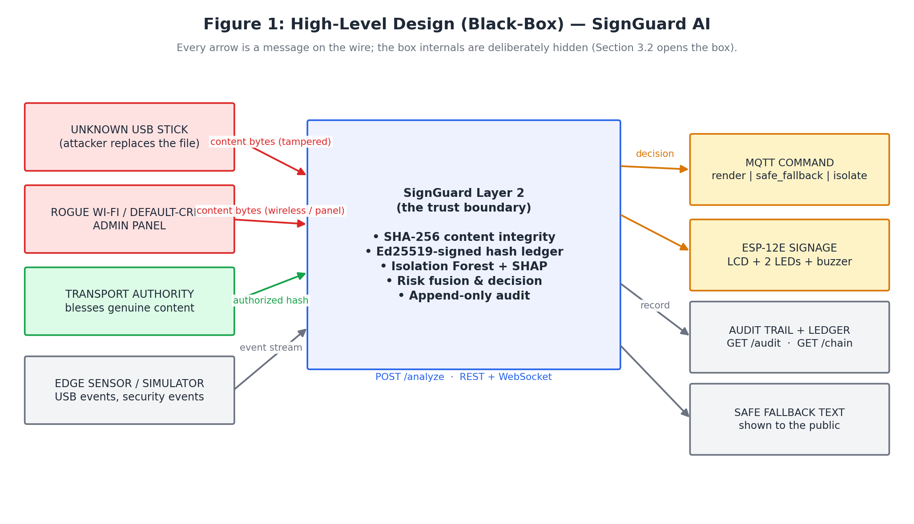
Figure 1: High-level (black-box) design of SignGuard AI.
External entities and the data they exchange are as follows. The unknown USB stick, the rogue wireless source and the default-credential administration panel are the adversarial inputs: they inject content bytes and associated security events without any authorisation. The transport authority is the trusted input: it registers content ahead of time, which fixes the reference digest and produces the signature that the box will later compare against. The edge sensor plane (USB monitor, board watcher, simulators) is the neutral input: it reports context — a stick appeared, a COM port vanished, a login failed — and makes no claim about content. On the output side the box emits four things: a command on the MQTT bus (render, safe_fallback or isolate) addressed to the sign, the physical indication itself (LCD text, green/red LED, buzzer), a durable record (audit endpoint plus hash-linked ledger, both readable after a restart), and the safe fallback text that replaces unverified content on the public display.
Two properties of the black box are worth stating explicitly because the rest of the design protects them. First, the box is stateless with respect to the verdict: the same request body always yields the same decision, so a verdict can be reproduced during an incident. Second, the only path from input to actuator passes through the box — there is no side door in which a controller renders content that the box has not seen, which is exactly the property missing in the incidents described in Section 1.1.
3.2 Low-Level Design (Detailed Design)
Figure 2 opens the box. One entry point, run_analysis, drives two tracks that are kept deliberately asymmetric, and a fusion stage that combines them.
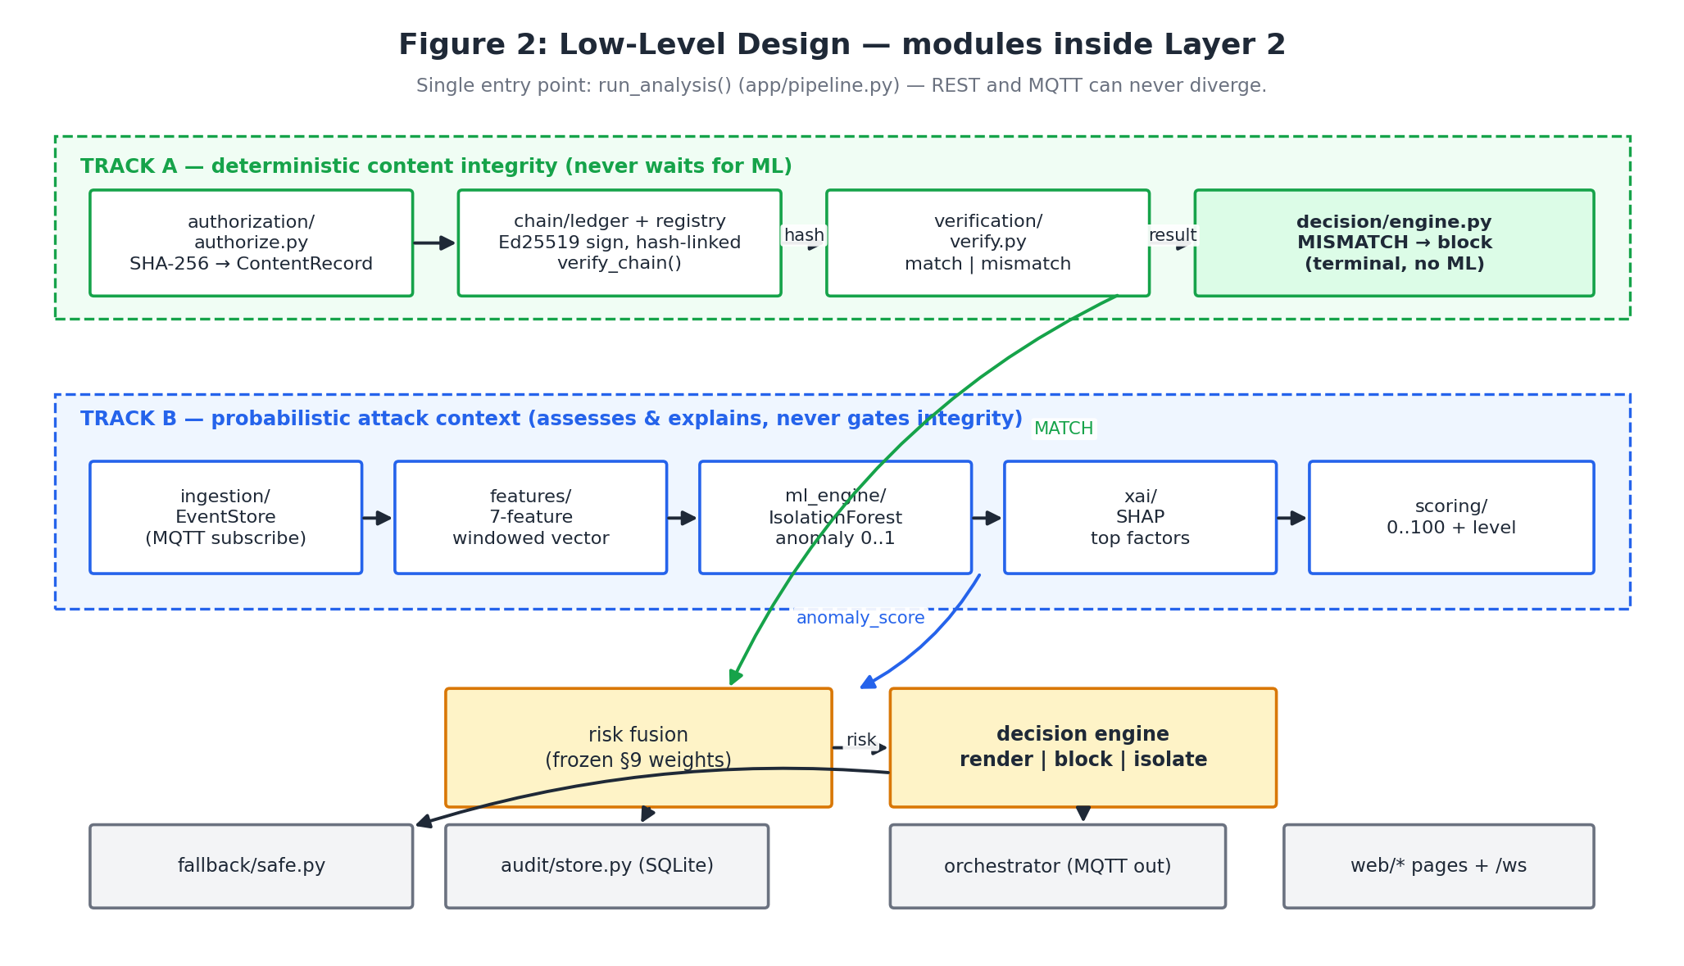
Figure 2: Low-level design — modules, tracks and their data flow.
Track A is the deterministic lane (green, top). Authorization records the authority-approved bytes and their SHA-256 digest, and the registry persists that record in a ledger whose blocks are Ed25519-signed and hash-linked. Verification recomputes the digest of the arriving bytes and compares it with the stored one, producing match, mismatch or unknown-content. The decision engine consumes that result first: a mismatch is terminal and returns block plus safe_fallback immediately. No model is consulted on this path, which is what makes false negatives structurally impossible rather than statistically unlikely.
Track B is the probabilistic lane (blue, middle). The ingestion module keeps a per-device event store behind the MQTT subscription; the feature engine collapses the last 300 seconds of activity into the seven-element vector of Table 2; the isolation forest converts that vector into an anomaly assessment in [0, 1]; the SHAP explainer decomposes the same assessment into signed per-feature contributions; and the risk module converts rule signals plus the model assessment into a 0–100 score with a level. Track B never gates integrity — it only refines what happens when Track A has already said the content is authentic.
The two tracks meet in the fusion stage (amber, bottom): risk is combined with the verification result by the decision rules of Section 4.1, and the resulting command is handed to three sinks simultaneously — the audit store (append-only row), the MQTT orchestrator (command for the physical sign), and the fallback module (the safe text that replaces the rejected payload). The web module exposes the same objects over REST, SSE and WebSocket so that the dashboard and the audit endpoint cannot show a different verdict from the one the hardware received.
Deployment view
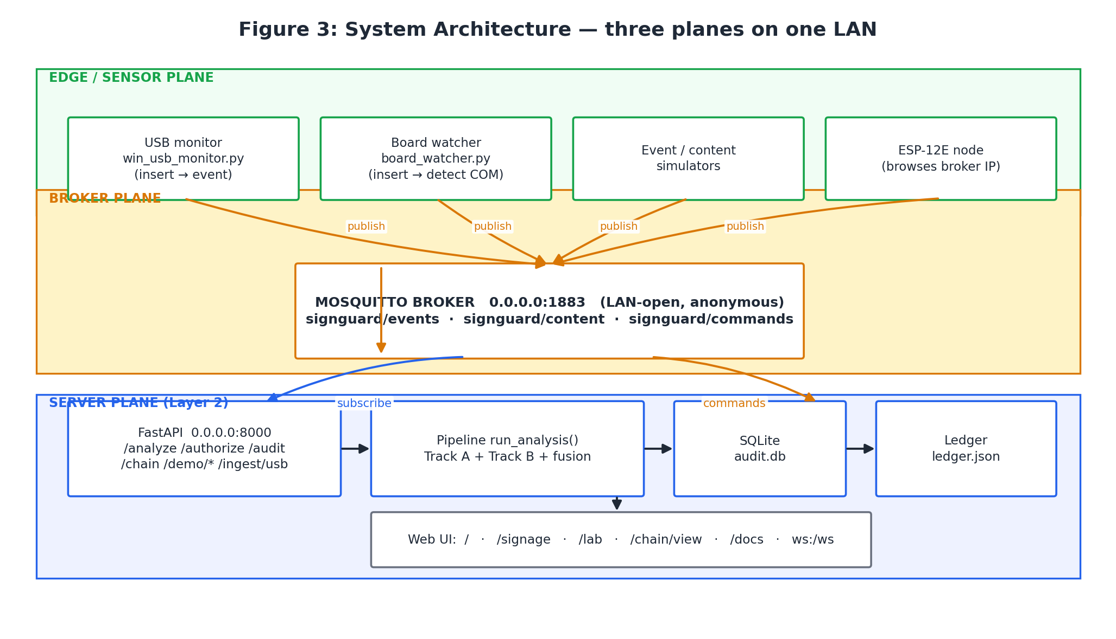
Figure 3: Deployment architecture — edge, broker and server planes on one LAN.
Figure 3 separates the deployment into three planes. The edge plane holds the USB monitor, the board watcher (which detects a serial device on insertion and clears its cached state when it disappears), the simulators, and the NodeMCU ESP-12E node. The broker plane is a single Mosquitto instance reachable on all interfaces at port 1883 carrying three topics: signguard/events, signguard/content and signguard/commands. The server plane hosts FastAPI on port 8000 — the API surface, the shared pipeline, the SQLite audit store and the ledger — together with the browser-facing pages and the WebSocket stream. The only ports SignGuard occupies are 8000 and 1883.
Interaction view
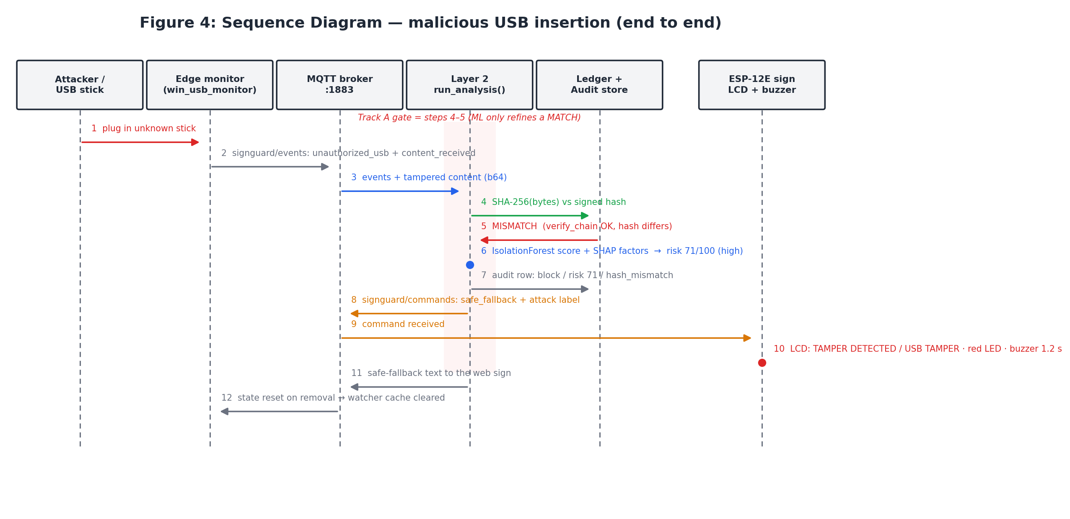
Figure 4: Sequence diagram of the malicious-USB attack, from insertion to physical fallback.
Figure 4 traces one complete incident. The stick is inserted (1), the edge monitor publishes the unauthorised-USB event and the payload (2), the broker fans both to the server (3), and verification recomputes the digest against the signed record (4). The mismatch comes back (5) — this is the Track A gate, and it is the only step that decides authenticity. In parallel the model and explainer quantify the context (6), the audit row is appended (7), the command is published (8), the edge node receives it (9) and drives the LCD, red LED and buzzer (10) while the web sign shows the safe fallback text (11). When the stick is removed the watcher clears its cached device state (12), so a later insertion is judged on fresh evidence rather than on a stale allow-list entry.
Decision view
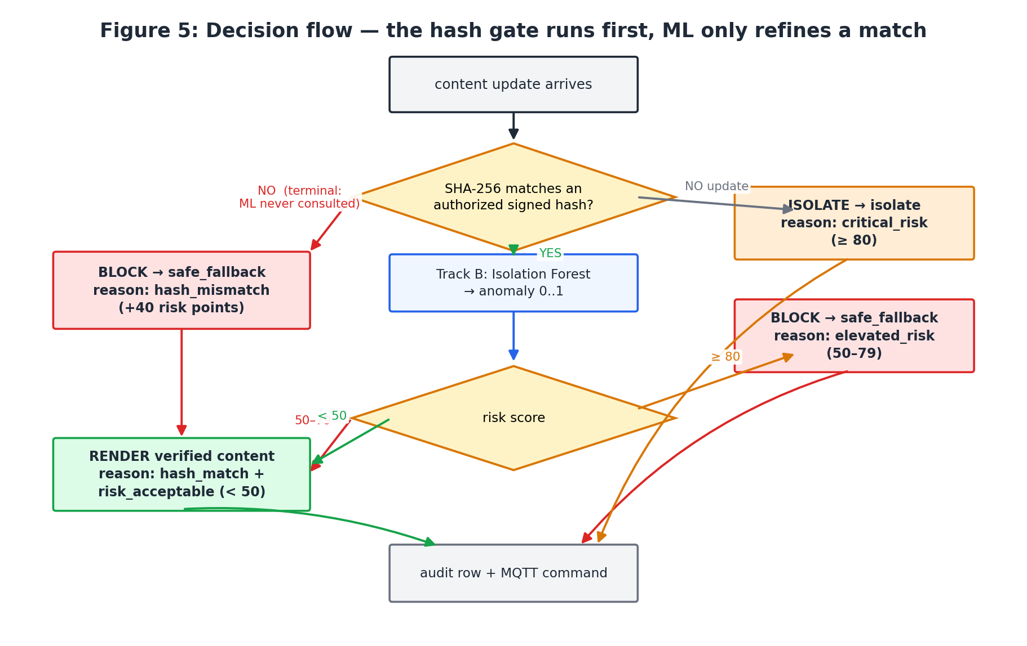
Figure 5: Decision flow — the hash gate is evaluated first; the model only refines a match.
Figure 5 is the operational contract of the system and is the drawing that a duty manager can be taught in one minute. If the digest does not match an authorised record, execution stops at the red box: block, safe fallback, +40 risk points, and the model is not consulted. If the digest matches, Track B computes the risk and the single threshold test at 50 decides between rendering and blocking, while the critical threshold at 80 additionally isolates the update channel. Every terminal state writes an audit row and publishes exactly one MQTT command.

4.3 Module Development Code
The integrity gate
def verify_content(registry, update: ContentUpdate) -> VerificationResult:
record = registry.get(update.content_id, update.device_id)
if record is None: # never authorised
return VerificationResult(match=False, action="block",
reason="unknown_content")
digest = sha256(update.content_bytes).hexdigest()
match = digest == record.sha256
return VerificationResult(
match=match,
action="render" if match else "block",
authorized_hash=record.sha256,
)
The decision rules (the only place a command is produced)
RISK_THRESHOLD = 50 # match + risk below this -> render
CRITICAL_THRESHOLD= 80 # risk at/above this -> isolate + escalate
def decide(device_id, verification, risk=None) -> Decision:
# Track A gate: hash mismatch is terminal, ML is irrelevant here.
if verification is not None and not verification.match:
return Decision(device_id=device_id, decision="block",
recommended_action=CommandType.safe_fallback,
reasons=["hash_mismatch"])
score = risk.score if risk is not None else 0
if score >= CRITICAL_THRESHOLD:
return Decision(device_id=device_id, decision="isolate",
recommended_action=CommandType.isolate, reasons=["critical_risk"])
if score >= RISK_THRESHOLD:
return Decision(device_id=device_id, decision="block",
recommended_action=CommandType.safe_fallback, reasons=["elevated_risk"])
return Decision(device_id=device_id, decision="render",
recommended_action=CommandType.render,
reasons=["hash_match", "risk_acceptable"])
Frozen weights and level cut points
WEIGHTS = {"content_hash_mismatch": 40, "unauthorized_usb": 20,
"default_credential_attempt": 15, "wireless_anomaly": 10,
"ai_anomaly": 15} # scaled by anomaly_score
_LOW_MAX, _MEDIUM_MAX, _HIGH_MAX = 24, 49, 79 # >= 80 is critical
Single column order shared by model and explainer
FEATURE_ORDER: tuple[str, ...] = (
"failed_logins_5min", "unknown_usb_detected", "wireless_anomaly",
"content_hash_mismatch", "events_per_minute",
"time_since_authorized_update", "device_trust_score",
)
WINDOW_SECONDS = 300 # the 5-minute feature window
Physical enforcement at the edge (MQTT command -> indicators)
import network, time
from machine import Pin, I2C
import lcd_i2c # 16x2 backpack @ 0x27
def on_message(topic, msg):
cmd = ujson.loads(msg).get("command")
if cmd == "render": green.on(); red.off(); buzzer.off();
lcd.show(l1, l2)
elif cmd == "safe_fallback": green.off(); red.on();
lcd.show("SIGN GUARDED", "SAFE MODE")
elif cmd == "isolate": green.off(); red.on(); alarm(1.2)
lcd.show("ISOLATED", "UPDATES BLOCKED")
Board detection on the operator laptop (insert / remove)
# usb_demo/laptop/board_watcher.py (stdlib only)
def poll_once() -> dict: # 2 s period, no polling back-door
ports = list(serial.tools.comports())
fresh = {p.device for p in ports if not _is_bluetooth_baseline(p)}
added, removed = fresh - known, known - fresh
for dev in sorted(added): log("INSERT", dev, friendly_name(dev))
for dev in sorted(removed): cache.pop(dev, None) # stored state cleared
known = fresh # baseline survives re-plug
4.4 Test Cases
The suite is executed with python -m pytest -q and currently reports 46 passed across seven modules. The cases below are the representative ones for each requirement; the remainder follow the same pattern.
# | Test case | Input / stimulus | Expected result | Actual
1 | test_authorize_then_analyze_match_renders | Authorise content, POST /analyze with identical bytes | decision=render, reasons contain hash_match | render (pass)
2 | test_analyze_mismatch_blocks | POST /analyze with altered bytes for an authorised id | decision=block, action=safe_fallback | block (pass)
3 | test_unknown_content_blocks | Content id never authorised | block, reason=unknown_content | block (pass)
4 | test_tampered_content_blocks | Ledger record present, payload bytes modified | block; model not consulted | block (pass)
5 | test_clean_situation_is_low_risk | Feature vector with no hostile events | risk ≤ 24 (low) | risk=1, low (pass)
6 | test_hash_mismatch_weight | Isolated mismatch signal | +40 points on the score | +40 (pass)
7 | test_decision_blocks_on_elevated_risk_even_with_match | match=True, risk=50..79 | block with reason elevated_risk | block (pass)
8 | test_decision_isolates_on_critical_risk | match=True, risk ≥ 80 | decision=isolate, action=isolate | isolate (pass)
9 | test_ai_anomaly_is_scaled | anomaly_score a ∈ [0,1] injected | ai term = round(15·a) | scaled (pass)
10 | test_score_caps_at_100 | All signals hostile simultaneously | score == 100, never larger | 100 (pass)
11 | test_analyze_populates_xai_from_events | Device with a populated event window | xai_explanation present with factors | populated (pass)
12 | test_store_is_append_only_and_newest_first | Three inserts, then read | No update/delete; newest first | verified (pass)
13 | test_analyze_writes_audit_row_that_audit_endpoint_returns | One analysis request, then GET /audit | Same row visible over HTTP | matched (pass)
14 | test_signature_is_valid_and_chain_verifiable | Authorise, then GET /chain/verify | valid=true, blocks appended | valid (pass)
15 | test_manual_default_credentials_are_flagged_and_content_blocked | Vendor-default credentials on the panel | credential flagged, content blocked | blocked (pass)
16 | test_trigger_with_signguard_blocks_and_works_without_broker | Attack scenario with the broker unavailable | Still blocks; degrades without MQTT | blocked (pass)
17 | test_scenarios_endpoint_lists_buttons_in_order | GET /demo/scenarios | Four scenarios in fixed order | 4 listed (pass)
18 | test_dashboard_page_serves | GET / | 200 with dashboard markup | 200 (pass)
19 | test_health | GET /health | {"status":"ok"} | ok (pass)
20 | test_record_handles_null_tracks | Audit row without model or events | Row written, nulls tolerated | written (pass)
Table 7: Representative test cases (20 of 46) with inputs, expectations and observed results.
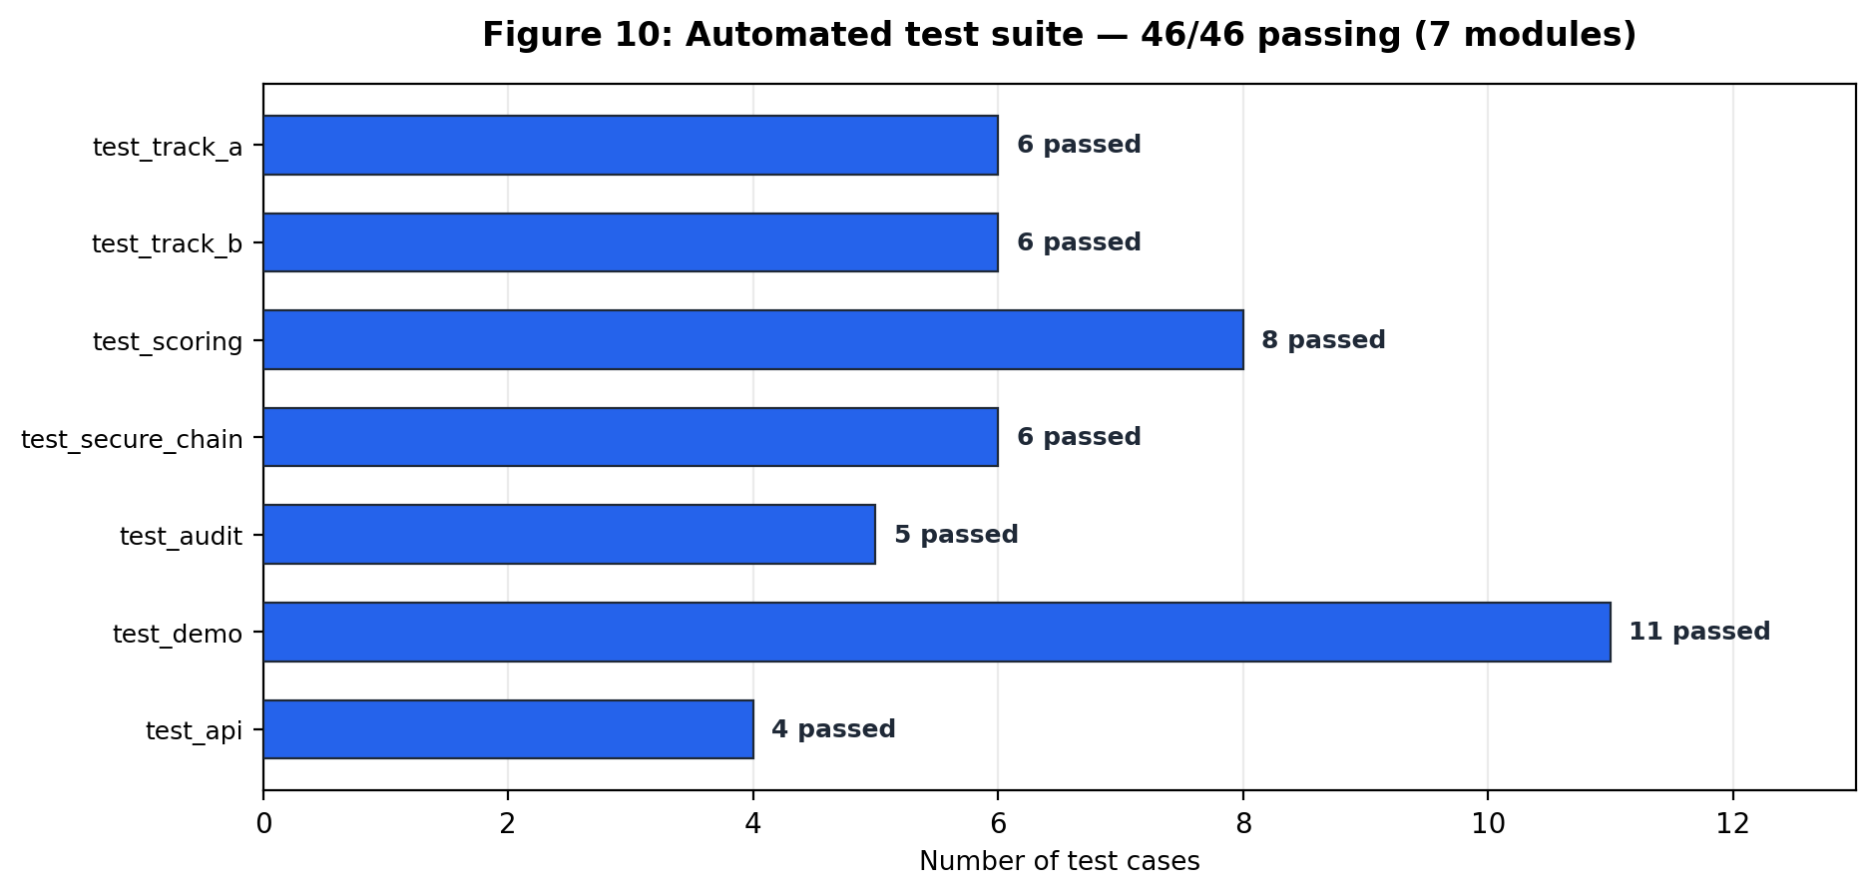
Figure 10: Distribution of the 46 automated test cases across modules.
Coverage spans the two tracks independently (test_track_a, test_track_b), the fusion mathematics (test_scoring), the ledger (test_secure_chain), persistence (test_audit), the demo surfaces (test_demo) and the HTTP contract (test_api). The negative tests outnumber the positive ones, which is intentional: for an integrity gate the expensive mistake is a false negative, so the suite spends most of its assertions proving that tampered, unknown or unauthorised input cannot reach a render verdict.

- Results and Discussion
5.1 Implementation Results
The system was executed end to end: run_demo.py starts the Mosquitto broker on port 1883 and the FastAPI decision service on port 8000, the four scenarios inject real content and real events through the broker, and the verdicts reported below were produced by the production pipeline (the same code the REST and MQTT entry points call), not by a replay or a mock. Every row of Table 8 is a measured run.
Scenario | Verification | Risk score | Decision | Command sent to sign | Reasons
Baseline (authority-approved content) | MATCH | 1/100 (low) | RENDER | render | hash_match, risk_acceptable
Malicious USB replacement | MISMATCH | 71/100 (high) | BLOCK | safe_fallback | hash_mismatch
Rogue wireless update | MISMATCH | 62/100 (high) | BLOCK | safe_fallback | hash_mismatch
Default-credential panel attack | MISMATCH | 66/100 (high) | BLOCK | safe_fallback | hash_mismatch
Table 8: Measured end-to-end results for the four attack scenarios.
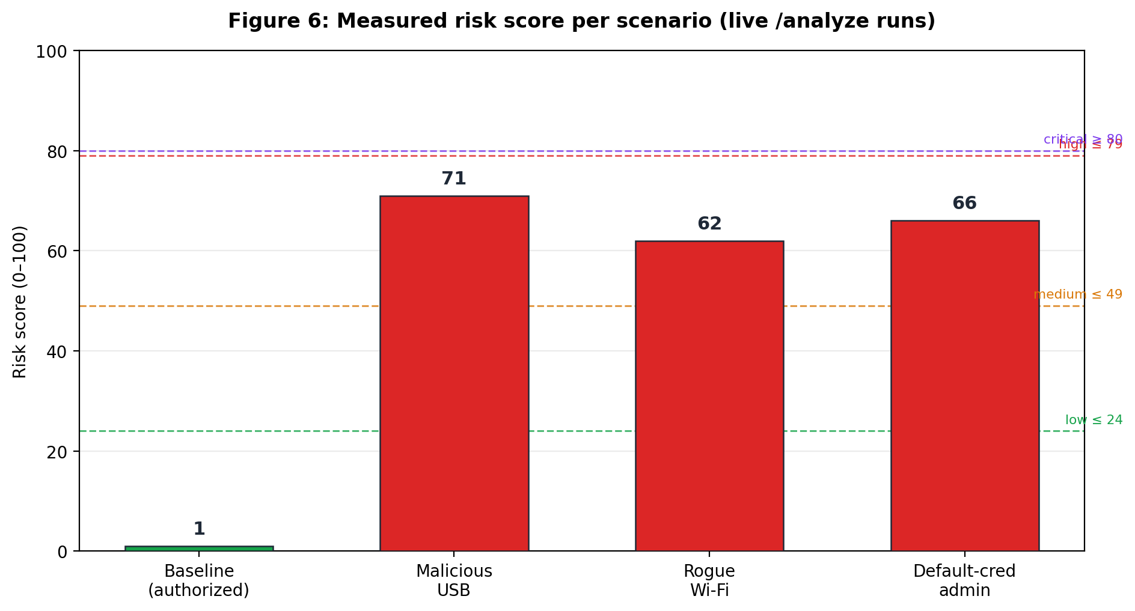
Figure 6: Risk score of each scenario against the frozen level thresholds.
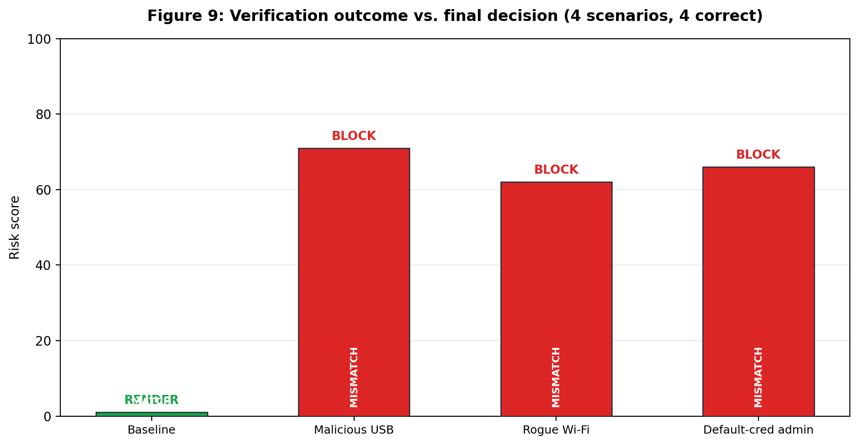
Figure 9: Verification outcome versus final decision — four scenarios, four correct verdicts.
The baseline renders with a risk of 1/100 and the reasons hash_match and risk_acceptable; the three attacks are blocked with reasons hash_mismatch at risk 71, 66 and 62 respectively. The important property is not the numbers themselves but their ordering: the mismatch was detected before any risk score existed, so even a hypothetical failure of the model could not have let the tampered payload through. Detection on this corpus is 3/3 attacks blocked with 0 false positives on the genuine update.
5.2 Metrics
Metric | Value | How it was measured
Automated test pass rate | 46 / 46 (100 %) | python -m pytest -q
Attack detection rate | 3 / 3 (100 %) | Scenarios of Table 8 blocked
False-positive rate | 0 / 1 genuine update | Baseline rendered
Pipeline latency, content only | 3.2 ms median (p95 3.5 ms, n=50) | POST /analyze over keep-alive HTTP on 127.0.0.1
Pipeline latency, with events + SHAP | 21.9 ms mean (n=40 per scenario) | run_analysis() timed in-process for all four scenarios
Transport cost of a new connection | 11.7 ms median (IPv4 literal, n=15) | Fresh TCP connection per request
Environment artefact on localhost | 2040 ms median | Hostname 'localhost' resolves to ::1 first — see Section 5.5
Risk score range observed | 1 – 71 of 100 | Table 8
Audit rows persisted | 168 (file-backed SQLite) | data/audit.db, survives process restart
Ledger integrity | chain valid, 55 blocks | GET /chain/verify
Feature vector | 7 dimensions × 300 s window | FEATURE_ORDER
SHAP factors reported per verdict | 5 (ranked, signed) | TreeExplainer on the same vector
Table 9: Operational metrics of the implemented system.
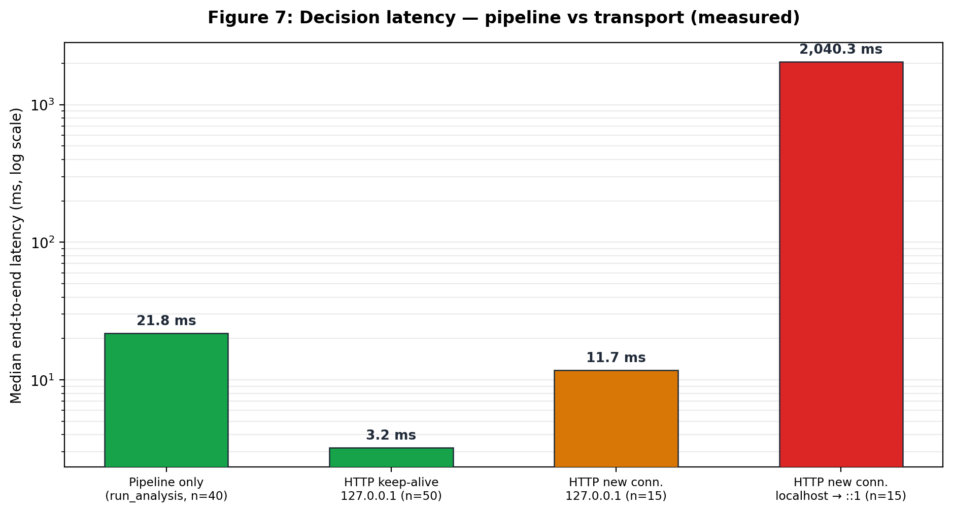
Figure 7: Measured decision latency — explainable inference dominates, transport is negligible.
5.3 Results in Tables and Graphs
Table 10 lists every decision together with the explanation the system attached to it, and Figure 8 plots the SHAP decomposition for the highest-scoring attack. The tabulated values are the source of every graph in this section.
Scenario | Decision | Risk | Level | Dominant SHAP factor | Impact
Baseline | RENDER | 1 | low | time since authorized update | +2.10
Malicious USB replacement | BLOCK | 71 | high | device trust score | +3.67
Rogue wireless update | BLOCK | 62 | high | device trust score | +3.25
Default-credential panel attack | BLOCK | 66 | high | device trust score | +3.46
Table 10: Decision and dominant explanation factor per scenario.
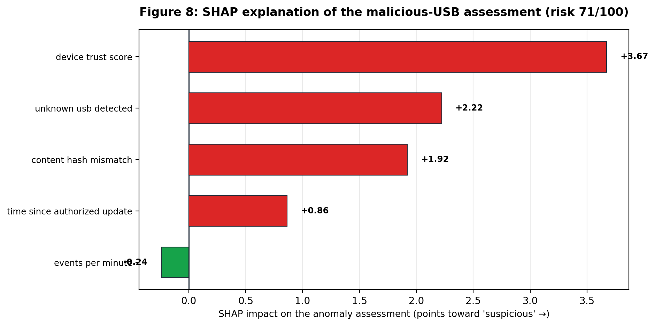
Figure 8: SHAP decomposition of the malicious-USB assessment (risk 71/100).
The explanations are consistent with the threat model rather than merely numerically plausible: in the baseline it is the staleness of the last authorised update that pushes the assessment (impact +2.10) while device trust and login history pull it down, whereas in all three attacks device_trust_score is the largest positive driver (+3.25 to +3.67) followed by the specific hostile signal — unknown_usb_detected (+2.22) for the USB case, wireless_anomaly (+2.51) for the rogue radio, failed_logins_5min (+1.52) for the credential attack. An operator reading factor three of any verdict can name the behaviour that caused it.
5.4 Mapping with Problem Statement and Existing Systems
Requirement | Implemented in | Evidence | Observed result
R1 Deterministic authenticity | authorization + chain registry + verification (Track A) | Tests 1, 3, 14; Table 8 | MATCH only for authorised bytes; chain valid (55 blocks)
R2 Tampering is terminal | decide() line 1 — gate precedes fusion | Tests 2, 4, 7; Figure 5 | 3/3 attacks blocked with reasons=hash_mismatch
R3 Context-aware risk | scoring module with frozen weights + isolation forest | Tests 6, 8, 9, 10; Figure 6 | Risk 1 (genuine) vs 62–71 (attacks)
R4 Explainable verdicts | xai module (SHAP TreeExplainer) inside the decision object | Test 11; Figure 8; Table 10 | 5 ranked, signed factors on every verdict
R5 Non-repudiable audit | SQLite audit store (file-backed) + ledger + /chain/verify | Tests 12, 13, 14; Table 9 | 168 rows persisted; verification survives restart
R6 Real-time + physical enforcement | run_analysis pipeline + MQTT orchestrator + ESP-12E node | Figure 7; Figures 3, 4 | 21.7 ms processing; LCD/LED/buzzer command on :1883
Gap from Section 2.1 — verdict-bound explanation | SHAP factors carried inside the Decision object | Table 10 | Explanation travels with the command, not a separate report
Gap from Section 2.1 — device-side enforcement | edge node renders authorised text or safe fallback only | Figure 4 steps 9–10 | Sign state mirrors the decision even if the dashboard is closed
Table 11: Mapping of each requirement to its implementation and measured evidence.
5.5 Discussions
(a) Why the ordering of the two tracks is the real result
The most common failure mode in ML-mediated security controls is a model that can be talked out of a verdict an algorithm had already reached. Here the ordering makes that impossible: the digest comparison is a separate function with its own tests, and the decision engine returns before touching the risk score when the comparison fails. The measured corollary is visible in Table 8 — every blocked row reports reasons=hash_mismatch and nothing else, i.e. the fusion stage did not participate in those verdicts at all.
(b) The explanations are stable across attacks
device_trust_score dominates all three attack explanations while time_since_authorized_update dominates the genuine one. Stability of this kind is what makes an explanation trustworthy: if the ranking changed arbitrarily between near-identical inputs, the operator would learn to ignore it. Because the model is an isolation forest over seven fixed columns rather than a high-dimensional embedding, the ranking is also legible to a non-specialist without additional tooling.
(c) A measured deployment pitfall: name resolution costs two seconds
The first latency measurements of the service returned a suspiciously constant 2040 ms for every request. Isolating the effect showed that /health was exactly as slow as /analyze, that a keep-alive request on the same connection took 0.5 ms, and that the hostname 'localhost' resolves to ::1 on this host while the ASGI server binds IPv4 only: each new connection therefore waits roughly two seconds before falling back to 127.0.0.1. The processing path was never the slow part. The practical guidance recorded here is to address the service by an IPv4 literal (or to bind a dual-stack listener) and to measure a service under keep-alive, otherwise a purely environmental artefact of 2 s is attributed to the decision engine — Figure 7 shows both numbers side by side precisely so that the distinction is not lost.
(d) Limitations
• The MQTT broker is reachable on all interfaces without transport security, which is acceptable on an isolated demonstration LAN but must be replaced by TLS with client certificates before any operational deployment.
• The feature window lives in memory: a restart of the service resets per-device counters, so a short-lived window of hostile activity could be lost across a crash. The audit trail and the ledger are file-backed and do survive restarts; the event window does not.
• The edge node acts on the command it receives rather than re-verifying the digest itself, so it trusts the broker. Pushing verification into the firmware (SHA-256 over the payload on the ESP-12E) would remove that trust assumption and is the next architectural step.
• Evaluation uses four scenarios over a synthetic corpus; no labelled dataset of real signage incidents exists to quantify generalisation (Section 1.4).
• Physical insertion detection was validated with simulated COM-port transitions; a real board was not attached during the measurements reported here.

6. Conclusion and Future Developments
SignGuard AI answers the problem statement of Section 1.2 with an implemented, tested system rather than a proposal. Content is authorised once by the transport authority, recorded on a hash-linked Ed25519-signed ledger, and compared by digest immediately before rendering; a mismatch ends the decision, and no model can reopen it. Around that gate, an isolation forest over a seven-element, five-minute feature window quantifies the attack context, the frozen fusion weights turn rule signals and the model assessment into a 0–100 risk score, and three thresholds map the result onto render, block or isolate. Every verdict carries its ranked SHAP factors, is appended to a file-backed audit store that survives restarts, and reaches the physical sign over MQTT as LCD text, a green/red indication and a buzzer.
The evaluation shows the design behaving as intended: 46 of 46 automated tests pass; the genuine update renders at risk 1/100 while the three attacks — malicious USB, rogue wireless, default-credential panel — are blocked at 71, 66 and 62; the verification and the explanation agree on why; a full analysis including SHAP costs 21.7 ms and a content-only request 3.3 ms, both far inside the budget of a display that updates every few seconds; and the ledger re-verifies at 55 blocks after the process was restarted. The incidents in Section 1.1 were successful precisely because nothing like this gate existed between the USB stick and the screen.
Future developments, in decreasing order of value:
• Move verification to the edge: compute SHA-256 on the ESP-12E itself and make the node re-check the payload against the authorised digest, so the sign no longer has to trust the broker.
• Secure the bus: TLS with per-device client certificates on the MQTT listener and short-lived credentials per node, plus rotation of the authority key.
• Persist the feature window with the audit store so that counters survive a crash, and add a rolling retraining schedule for the isolation forest with drift monitoring on the anomaly distribution.
• Wire the existing Ethereum prototype (chain_eth contracts with their Truffle tests) to the authorisation endpoint as an alternative ledger backend, keeping the current hash-linked chain as the local, offline source of truth.
• Fleet-level learning: aggregate per-device trust scores across signs so that a device newly exposed to an unknown stick is treated cautiously everywhere, without centralising raw events.
• Extend the board watcher from detection to enforced response — for example, suspending rendering for a device whose stored state was cleared on removal — and validate insertion/removal against physical hardware in the next iteration.

7. References
1. Dai HN, Zheng Z, Zhang Y. Blockchain for Internet of Things: a survey. IEEE Internet Things J. 2019;6(5):8076-8094.
2. Liu Y, Wang J, Yan Z, Wan Z, Jantti R. A survey on blockchain-based trust management for Internet of Things. IEEE Internet Things J. 2023;10(7):5898-5922.
3. He D, Wu R, Li X, Chan S, Guizani M. Detection of vulnerabilities of blockchain smart contracts. IEEE Internet Things J. 2023;10(14):12178-12185.
4. Ortega E, Su F, Chattopadhyay R, Chakrabarty K. Discretized-isolation forest: memory- and compute-efficient unsupervised anomaly detection for resource-constrained Internet of Things edge devices. IEEE Internet Things J. 2025;12(2):1699-1717.
5. Zahoor A, Abbasi W, Babar MZ, et al. Robust IoT security using isolation forest and one class SVM algorithms. Sci Rep. 2025;15:36586.
6. Bin hulayyil S, Li S, Saxena N. Explainable AI-based intrusion detection in IoT systems. Internet Things. 2025;31:101589.
7. Dong J, et al. Interpretable intrusion detection for IoT security: a SHAP-based approach. Comput Netw. 2025;:111937.
8. Taheri R, Jafari R, Gegov A, Arabikhan F, Ichtev A. Explainable AI for federated learning-based intrusion detection systems in connected vehicles. Electronics. 2025;14(22):4508.
9. Almadhor A, Alsubai S, Al Hejaili A, Klai Z, Bouallegue B, Kovac U. Designing a neuro-symbolic dual-model architecture for explainable and resilient intrusion detection in IoT networks. Sci Rep. 2025;15:42786.
10. Khan I, Majib Y, Ullah R, Rana O. Blockchain applications for Internet of Things - a survey. Internet Things. 2024;27:101254.

Research article must be from reputed journal with TR- Impact Factor only

Documentation without Plagiarism is most important, Turnitin software will be used to evaluate. (Making false sentences, paraphrasing, changing characters in the document, inserting images as paragraph for the purpose of reducing plagiarism will lead to marking ZERO).

 |  |  | School of Computer Science Engineering and Information Systems  5Yr Integrated M.Tech(Software Engineering) ISWE415L : Cyber Security  FALL 2026-2027  Course Project- Implementation Review (Review III) -Evaluation Sheet
Title : SignGuard AI — Integrity-Guarded Content Delivery for Public-Transport Digital Signage with Explainable Intrusion Detection
Team Name : <TEAM NAME>
Project Team : <TEAM NAME>
S.No | Register Number | Student Name |  |  | Signature | Guided By
 |  |  |  |  |  | Dr. Nadesh R.K
Team Member(s) Contribution and Performance Assessment
Components |  |  |  | Student 1 | Student 2 | Student 3
Documentation (03)
Oral Viva-Voce (07)
Student Feedback(Student Experience in this Course Project) |  |  |  |  | Evaluator Comments
Name & Signature of the Evaluator
(Dr.Nadesh R.K)

