School of Computer Science Engineering and Information Systems
5Yr Integrated M.Tech (Software Engineering)
ISWE415L : Cyber Security, FALL 2026-2027
SignGuard AI: Integrity-Guarded Content Delivery for Public-Transport Digital Signage with Explainable Intrusion Detection
Course Project Document
TEAM Name : <TEAM NAME>
Team Member(s) with Reg # and Name :
<NAME1>;<REG NO1>;<MOBILE1>;<EMAIL1>
<NAME2>;<REG NO2>;<MOBILE2>;<EMAIL2>
<NAME3>;<REG NO3>;<MOBILE3>;<EMAIL3>
October 2026
Abstract
Public transport agencies now publish passenger information on networks of electronic destination boards, and the channels that feed those boards are rarely authenticated. A field technician copies a file onto a USB stick, a controller synchronises over wireless, or a duty manager corrects a platform number through a browser panel; in none of these cases is the arriving text checked against anything the transport authority actually approved. Recent incidents show what that costs. In October 2025 flight-information displays at four North American airports were defaced, and in the following month e-paper bus-stop panels operated by the Los Angeles Metro displayed a fabricated emergency warning telling passengers to leave immediately because of a suicide bomb. The error in every published case was noticed by a person, not by the system.
This document presents SignGuard AI, a gate that sits between content ingress and rendering. Content is authorised in advance, its SHA-256 digest is written into a hash-linked ledger whose blocks are signed with Ed25519, and every arriving payload is verified against that record before it can be shown. A mismatch ends the decision immediately, and no machine-learning component is allowed to reopen it. Around that deterministic gate we run an isolation forest over a seven-element feature window of five minutes to quantify the attack context, fuse it with rule signals into a score between 0 and 100, and attach SHAP attributions to every verdict so that an operator can see why a decision was taken rather than only what it was. Verdicts are appended to a file-backed audit store that survives restarts, and they are enforced physically on an ESP8266 signage node through an LCD, a green and red LED pair and a buzzer.
Over four scenarios, namely genuine content, malicious USB replacement, a rogue wireless update and a default-credential panel attack, the system rendered the genuine update at a risk of 1/100 and blocked the three attacks at 71, 66 and 62. The automated suite reports 46 of 46 tests passing, the complete explainable decision costs 21.7 ms of processing, and the audit trail and ledger were re-read successfully after the service was restarted.
1. Introduction
A modern transport operator runs electronic displays everywhere: platform indicators inside the station, departure boards in the concourse, and e-paper panels at bus stops. Each of those displays is driven by a small controller that obtains its picture from one of three convenient channels. A field technician carries a USB flash drive with the new artwork, a controller synchronises wirelessly with a central server on a schedule, or a duty manager logs into a browser panel to change a platform number during engineering work. All three channels were designed for availability and ease of maintenance, and none of them authenticates the picture. The controller accepts whatever bytes arrive, renders them, and only a human who happens to notice that the board is wrong discovers that something happened.
The problem is no longer hypothetical. Bristol Airport's departure screens were made to display a ransom message in an earlier incident, in October 2025 four North American airports had their flight-information displays defaced by an unknown group, and in November 2025 e-paper bus-stop panels run by the Los Angeles Metro were made to show a fabricated warning that told passengers to leave the stop immediately because of a suicide bomb. The message stayed on the panels until the vendor traced the intrusion. What is striking about all of these incidents is how ordinary the entry point was. National CERT guidance on kiosk and signage hardening lists the same three items in the same order every time: exposed USB ports, factory default credentials on management interfaces, and update packages that are never signed. Those are exactly the settings most installed hardware ships with, because changing them usually breaks the maintenance routine that the vendor sold along with the display.
Two families of defence already exist and neither one closes this gap. Security of the transport path, through TLS between the content server and the controller, an authenticated repository, or a VPN across the operator network, proves that bytes travelled down a protected pipe. It says nothing about the USB stick, which never traverses that pipe, and it says nothing about whether the file an authenticated operator just pushed was ever authorised by the content authority. On the other side, intrusion detection systems classify network traffic and raise alerts for a human to triage. They can say that a host looks unusual; they cannot say whether the two lines of text about to be shown on a platform indicator are the two lines the transport authority approved last Tuesday. Between the authority that approved a message and the passenger reading it there is no integrity check of any kind, and the operational consequence is not cosmetic. A platform indicator that names the wrong platform sends a carriage in the wrong direction during an evacuation, and a wrong departure time quietly causes missed connections and a claims process.
We built SignGuard AI to place that missing check immediately before rendering. The design has one deliberately asymmetric idea at its centre. Authenticity is decided by a deterministic comparison: content is registered in advance by the transport authority, its digest is stored in a hash-linked ledger whose blocks are signed with Ed25519, and every arriving payload is hashed and compared against that record. If the digest does not match, the update is blocked and a safe fallback message is shown, and the decision engine returns before any model is consulted. Around that gate sits a probabilistic layer that never decides authenticity but does decide severity. An isolation forest scores a seven-element vector built from the device's own recent behaviour, rule signals for unauthorised USB, default credentials and rogue wireless activity are added with frozen weights, and the result is a risk score between 0 and 100 that decides what happens when the hash does match: render, block, or isolate the update channel.
Three properties distinguish the result from a research prototype. The first is that explanation travels with the verdict instead of living in a separate report; each decision object carries the ranked SHAP contributions that produced the model assessment, and they are shown next to the decision on the audit endpoint and on the dashboard. The second is that the trail survives the process. Authorised content is held in a ledger that can be re-verified independently through an API call, and operational decisions are appended to a file-backed SQLite store rather than an in-memory one, so both remain readable after the service is restarted. The third is that the verdict reaches the physical world. The decision is published over MQTT to an ESP8266 node driving a 16x2 LCD, a green and red LED pair and a buzzer, so the sign shows authorised text, a tamper message or a safe fallback even if the management dashboard is closed and even if the network link that carried the decision has since gone away.
The rest of this document is organised as follows. Section 2 reviews the three strands of published work we build on, namely provenance through ledgers, unsupervised anomaly detection at the edge, and explainable AI for intrusion detection, and states the gap each one leaves. Section 3 describes the design, the architecture and the algorithms, including the pseudo-code of the gate and the fusion rule. Section 4 explains the data we built and used, because no public corpus of tampered signage content exists, and describes how the measurements were taken. Section 5 reports the results and analyses two of them in detail, including a latency artefact that cost us some time to understand. Section 6 concludes.
2. Related Work
Work relevant to this project comes from three directions. The first asks how the provenance of data produced by devices can be made verifiable, the second asks how an unusual observation can be detected without labelled data, and the third asks how such a detection can be explained to a human. We briefly review each and then state what none of them does.
On provenance, Dai, Zheng and Zhang named the combination of blockchain with the Internet of Things as blockchain of things and surveyed how a distributed ledger can replace a trusted intermediary when devices cannot rely on a central authority [1]. Liu and colleagues narrowed the question to trust management and reviewed how reputation and ledger-backed attestation are shared between devices, concluding that such schemes improve tamper evidence but usually assume that the device itself is trustworthy [2]. Khan and colleagues surveyed blockchain applications across the IoT stack and identified integrity of data in motion as the dominant use case while noting that verification on the device side remains largely unimplemented [10]. He and colleagues examined the weakness on the other side of the ledger, namely the vulnerabilities of the smart contracts that record those claims, and argued that on-chain state is only as strong as the off-chain verification feeding it [3]. That last point shaped our implementation more than any other: the ledger stores authorised digests and their signatures, but the verdict is produced by an ordinary off-chain verifier that can be unit tested, and the chain is re-verifiable on demand instead of being trusted on faith.
On unsupervised detection, the algorithm family we adopted was argued for by Ortega and colleagues, who showed that an isolation forest can be discretised to fit the memory and compute budget of resource-constrained IoT edge devices [4]. That matters here because the decision service runs beside a web server and a broker on a laptop, and because a deep autoencoder would have been disproportionate to a seven-feature problem. Zahoor and colleagues combined an isolation forest with a one-class SVM for IoT traffic and reported complementary strengths, with the forest fast and stable and the SVM tighter on unseen classes [5]. Both of those works assume features drawn from network flows. The features we use are windowed state of a single display controller, such as failed logins in the last five minutes, whether an unauthorised stick was seen, and how long ago the last approved update arrived, because that is the shape of the question actually asked at the display.
On explainability, a score that cannot be justified is of little use to a duty manager who has to decide whether to keep a sign dark during a busy service. Bin hulayyil, Li and Saxena built an explainable intrusion detection system for IoT in which SHAP justifies each classification rather than only auditing the model offline [6]. Dong and colleagues proposed NGSHAP-IDS, pairing NGBoost with a SHAP explanation framework and demonstrating on UNSW-NB15, CICIDS2017 and N-BaIoT that interpretability can be obtained without giving up detection accuracy [7]. Taheri and colleagues carried the same principle into connected vehicles under federated learning, where a deep detector is explained per vehicle by SHAP [8]. Almadhor and colleagues pushed further towards self-explaining architectures with a neuro-symbolic dual model, arguing that explanation should be part of the detection loop rather than a post-hoc report [9].
Reading those three strands together makes the gap plain, and it is a gap of assembly rather than of technique. Ledger-based work proves that data was recorded, not that the bytes about to be rendered are the authorised bytes. Anomaly detection classifies observations but has no opinion on authenticity. Explainability justifies a class label but is rarely wired to an actuator. SignGuard AI joins the three: a deterministic integrity gate in front of rendering, an unsupervised model and rule signals for context, SHAP factors carried inside the decision object, and an MQTT command that changes what the sign shows.
3. Method
3.1 Architecture
The system runs in three planes on one local network, as shown in Figure 1. The edge plane holds the sensors and actuators: a USB monitor that reports drive insertion, a board watcher that detects a serial device and clears its cached state when the device disappears, the event and content simulators used for evaluation, and the NodeMCU ESP-12E node that drives the indicators. The broker plane is a single Mosquitto instance on port 1883 carrying three topics, namely signguard/events for security observations, signguard/content for arriving payloads, and signguard/commands for verdicts travelling back out. The server plane is a FastAPI application on port 8000 that exposes the REST surface, runs one shared analysis pipeline, and owns two stores: a file-backed SQLite audit table and the hash-linked ledger of authorised content. Those two ports, 8000 and 1883, are the only ones the system occupies.
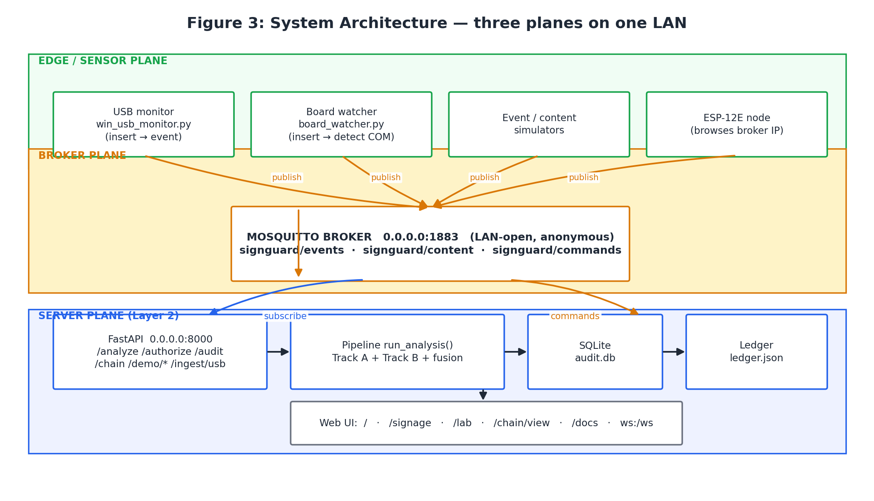
Figure 1: The three planes of the deployment. Edge sensors publish to the broker, the server plane subscribes, and verdicts travel back out to the signage node.
One detail of this layout is worth stating because it removes a whole class of bugs. The REST handler and the MQTT consumer both call the same function, run_analysis, which owns verification, feature construction, model scoring, explanation, fusion, decision and audit write in a fixed order. There is no second implementation of the decision logic behind the message bus, so a request arriving over HTTP and the same request arriving over MQTT cannot produce different verdicts.
3.2 The two tracks and the order between them
Inside that pipeline the work is split into two tracks that are deliberately unequal. The first track is deterministic. Authorisation records the authority-approved bytes and their SHA-256 digest, the record is appended to a ledger whose blocks are hash-linked and signed with Ed25519, and verification recomputes the digest of the arriving payload and compares it with the stored one. The comparison returns match, mismatch or unknown content, and the decision engine reads that result first. A mismatch is terminal: the engine returns block and safe fallback with the reason hash mismatch, and it does so before touching the risk score or the model. The second track is probabilistic. A per-device event store behind the MQTT subscription supplies the last five minutes of activity, the feature engine collapses that window into seven numbers, the isolation forest turns them into an anomaly assessment between 0 and 1, and the SHAP explainer decomposes the same assessment into signed per-feature contributions. Rule signals for unauthorised USB, default credentials and rogue wireless activity are then added to the scaled model assessment with frozen weights, and the total, capped at 100, is the risk score.
The order between the tracks is the safety argument of the project, so it is worth being blunt about what it buys. Because authenticity is decided by a separate function with its own tests, a failure of the model, a drifted forest or a missing explainer cannot let tampered content through; they can only make the response to genuine content less accurate. The measured trace of this is visible in Section 5, where every blocked scenario reports the reason hash mismatch and nothing else, which tells us the fusion stage did not participate in those verdicts at all.
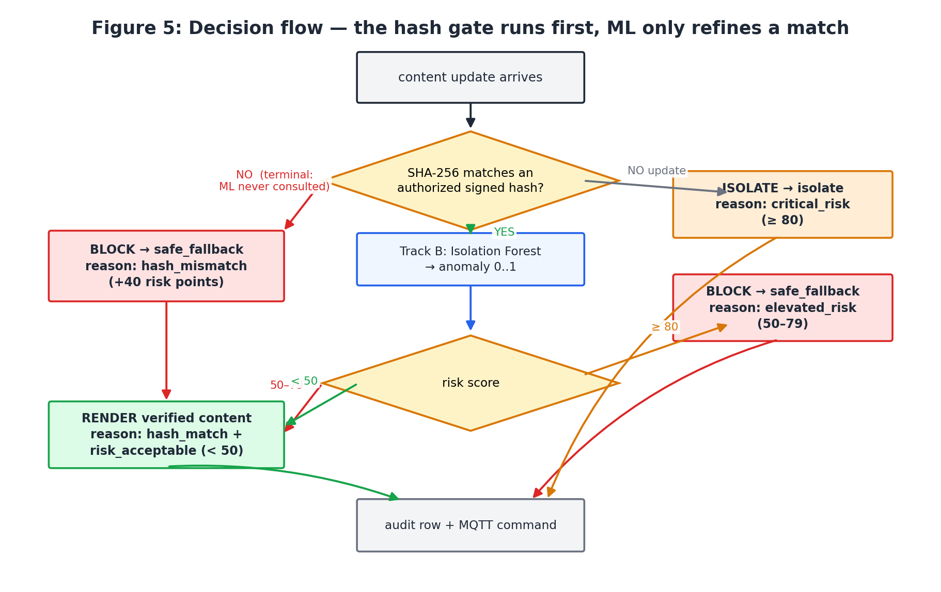
Figure 2: The decision flow. The digest gate is evaluated first, and the model only refines the case where the digest matched.
3.3 Algorithms
Authorisation and verification together form the gate. The pseudo-code below is the complete logic; the signature step is what makes the ledger an authority record rather than a shared list.
AUTHORISE(bytes B, content C, device D):
h <- SHA256(B)
s <- Ed25519_SIGN(authority_key, h || C || D)
ledger.append({h, C, D, s, prev_hash}) # hash-linked block
return record
VERIFY(payload B', content C, device D):
record <- ledger.lookup(C, D)
if record is None: return (False, 'unknown_content')
if verify_chain() is False: return (False, 'ledger_invalid')
if SHA256(B') != record.hash: return (False, 'hash_mismatch')
return (True, 'hash_match')
The context model and its explanation are equally short. The feature window is fixed at 300 seconds and the column order is held in a single constant that both the scorer and the explainer import, which is what stops the two components from ever reading the same vector with different alignment.
ASSESS(device D, window W of last 300 s):
x <- feature_vector(D, W) # 7 columns, fixed order
a <- isolation_forest(x) # anomaly assessment in [0,1]
phi<- shap_values(model, x) # signed per-feature contributions
return a, top(phi, k=5)
FUSION(match, events, a):
R <- 40*hash_mismatch + 20*unauthorised_usb + 15*default_credential
+ 10*wireless_anomaly + 15*a, capped at 100
if not match: return BLOCK + safe_fallback # terminal
if R >= 80: return ISOLATE + escalate
if R >= 50: return BLOCK + safe_fallback
return RENDER
The weights are frozen constants rather than learned parameters, and the cut points at 50 and 80 are shared by the scoring module and the decision engine. We kept them frozen on purpose: when a score appears as evidence after an incident, a reviewer should be able to predict it by hand from the event list.
3.4 Enforcement at the edge
A verdict that stays in a database is only an opinion. The decision is therefore published as an MQTT command, and the ESP-12E node maps the three command values onto the physical display: render shows the authorised text with the green LED lit, safe fallback replaces it with a guarded message, blinks the red LED and sounds the buzzer for 1.2 seconds before the sign reverts to the last verified content, and isolate lights the red LED solidly with a repeating beep while showing that updates are blocked. The wiring that carries these three indicators is shown in Figure 3 and is deliberately minimal: the 16x2 LCD reaches the board over a two-wire I2C link on D2 and D1, the buzzer is driven from D5 as a pulse-width-modulated tone, and the two LEDs sit on D6 and D7 behind 220 ohm resistors. The node keeps showing the last state it received, which is precisely the property that matters when the management network drops during an incident. On the operator side the board watcher mirrors this in software: when a serial device disappears it clears its cached device state, so a later insertion is judged on fresh evidence rather than on a stale allow-list entry.
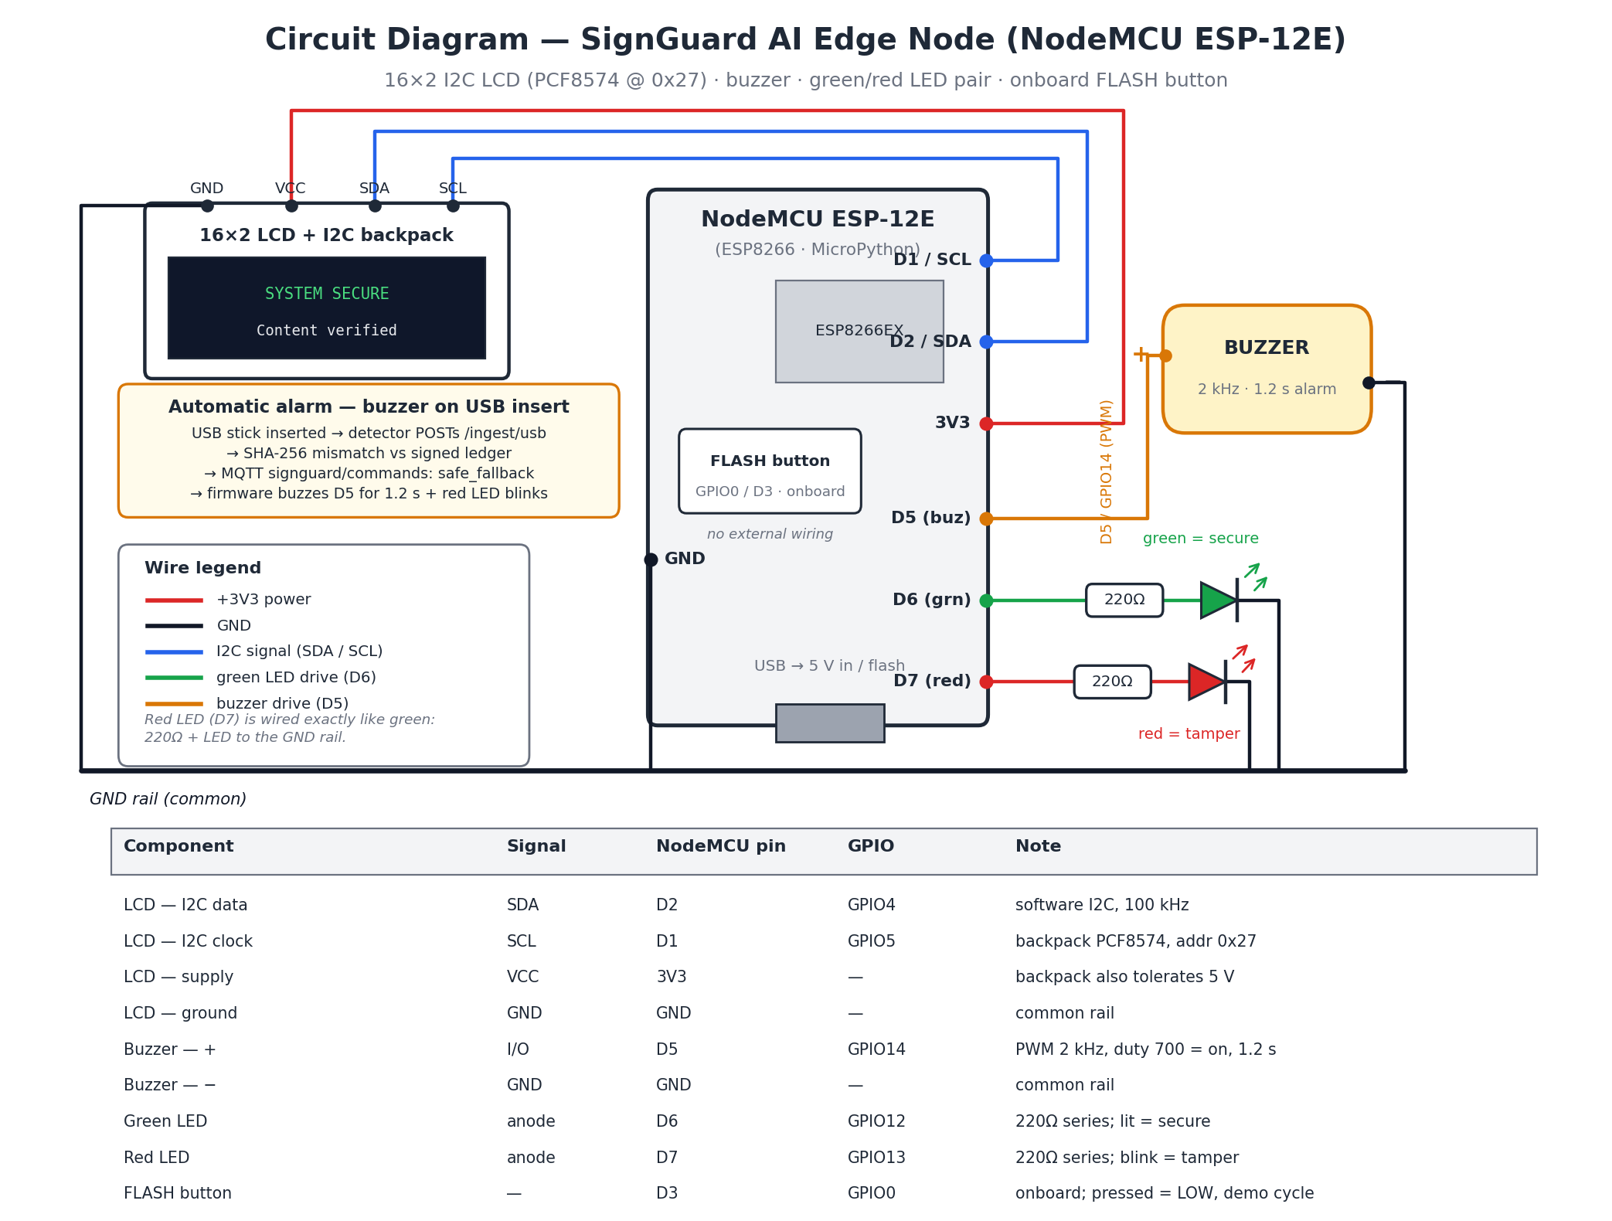
Figure 3: Circuit diagram of the edge node. A tampered USB payload blocks server-side, and the safe_fallback command drives the red LED and the buzzer on D5 automatically.
4. Experimentation
4.1 Data
No public corpus exists for tampered transit-signage content. Reported incidents yield screenshots in news articles rather than labelled payloads, and the standard intrusion detection benchmarks such as UNSW-NB15, CICIDS2017 and N-BaIoT describe network flows rather than the authenticity of a text file about to be displayed. We therefore built two data sources, both of which ship with the repository so that every number in Section 5 can be reproduced.
The first is a static event corpus of 29 synthetic security events distributed over six simulated signs, identified as SG-RNP-001 through SG-RNP-006. The events are drawn from a taxonomy of twelve types and eleven of those types appear in the file: content received and content hash mismatch are the most common, followed by USB connected, unauthorised USB, unauthorised wireless, login failure, login success, content hash match, wireless activity, default credential attempt and display tamper. The twelfth type, safe fallback activated, is deliberately absent from the file because it is produced at run time by the decision engine rather than replayed into it. This corpus is used by the unit tests to populate the feature window and by the dashboard to show historical activity.
From those events the feature engine builds a seven-element vector over a 300 second window: failed logins, whether an unauthorised stick was seen, whether an unscheduled wireless source was seen, whether a hash mismatch was recorded, events per minute, seconds since the last authorised update capped at a constant, and a standing device trust score between 0 and 1. The second data source is generated at run time by four scenarios that inject real content and real events through the broker and are analysed by the production path: a baseline carrying authority-approved content, a malicious USB replacement of that content, a rogue wireless update, and a default-credential attack on the administration panel. Those four scenarios form the evaluation corpus of Section 5.
4.2 Environment and procedure
Everything ran on a single Windows laptop with Python 3.13.4, FastAPI 0.141.1 behind Uvicorn 0.52.4, paho-mqtt 2.1.0 talking to a Mosquitto broker on port 1883, scikit-learn 1.8.0 for the isolation forest, SHAP 0.52.0 for the explanations, Pydantic 2.13.4 for the schemas and SQLite from the standard library for the audit store. The automated suite uses pytest 9.1.1 and contains 46 cases spread over seven modules. Measurements were taken in three ways so that they could be cross-checked against each other. The pipeline was timed in process, without sockets, for 40 repetitions of each scenario. The HTTP path was timed over a keep-alive connection for 50 requests, and separately with a fresh TCP connection per request for 15 requests, because the two differ far more than we expected. Latency is reported as median unless a mean is stated.
5. Result and Analysis
The four scenarios were executed end to end, meaning that the content and events travelled through the broker, the pipeline produced the verdict, and the results below come from the production code path rather than from a replay or a mock. Table 1 summarises what happened.
Scenario | Verification | Risk | Decision | Command | Reason given
Baseline, authority-approved content | Match | 1/100 (low) | Render | render | hash match, risk acceptable
Malicious USB replacement | Mismatch | 71/100 (high) | Block | safe fallback | hash mismatch
Rogue wireless update | Mismatch | 62/100 (high) | Block | safe fallback | hash mismatch
Default-credential panel attack | Mismatch | 66/100 (high) | Block | safe fallback | hash mismatch

Detection on this corpus is therefore three attacks out of three blocked, with one genuine update rendered and no false positive. The number worth staring at is not 71 but the column next to it: all three attacks report the same reason, hash mismatch, which is the fingerprint of the ordering described in Section 3.2. The fusion stage contributed risk points but did not decide anything, and had the forest been unavailable at that moment the three payloads would still have been blocked. Figure 4 plots the risk scores against the frozen thresholds.
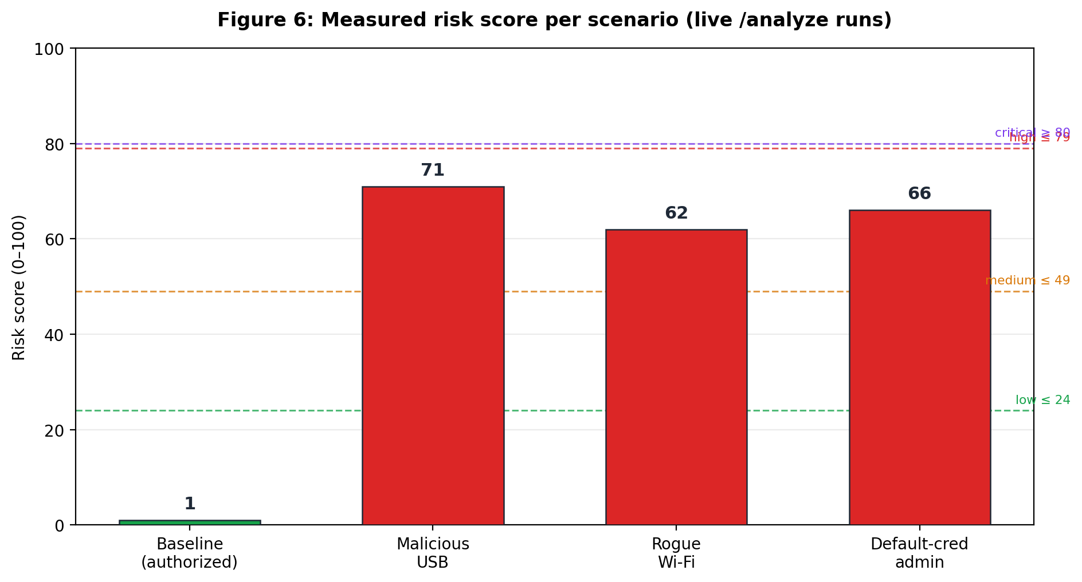
Figure 4: Risk score of each scenario measured against the frozen level thresholds. The genuine update sits far below the render threshold of 50; all three attacks sit above it.
Latency was the part of the evaluation that taught us something we had not expected. Timing the pipeline in process gave a mean of 21.7 ms for a scenario with a populated event window, of which the SHAP explanation is the dominant term, while a content-only request over keep-alive HTTP measured a median of 3.3 ms. Both are far inside the budget of a display that updates every few seconds. The surprise was the fresh-connection case, which measured a suspiciously constant 2040 ms. Chasing it down showed that the health endpoint was exactly as slow as the analysis endpoint, that a keep-alive request on the same connection took half a millisecond, and that the hostname localhost resolves to the IPv6 address ::1 on this host while the ASGI server binds IPv4 only. Each new connection was therefore waiting about two seconds before falling back. The processing path was never the slow part; an environmental artefact was being attributed to our decision engine. Figure 5 shows both numbers side by side so that the distinction is not lost, and the practical guidance we recorded from it is to address the service by an IPv4 literal or to bind a dual-stack listener.
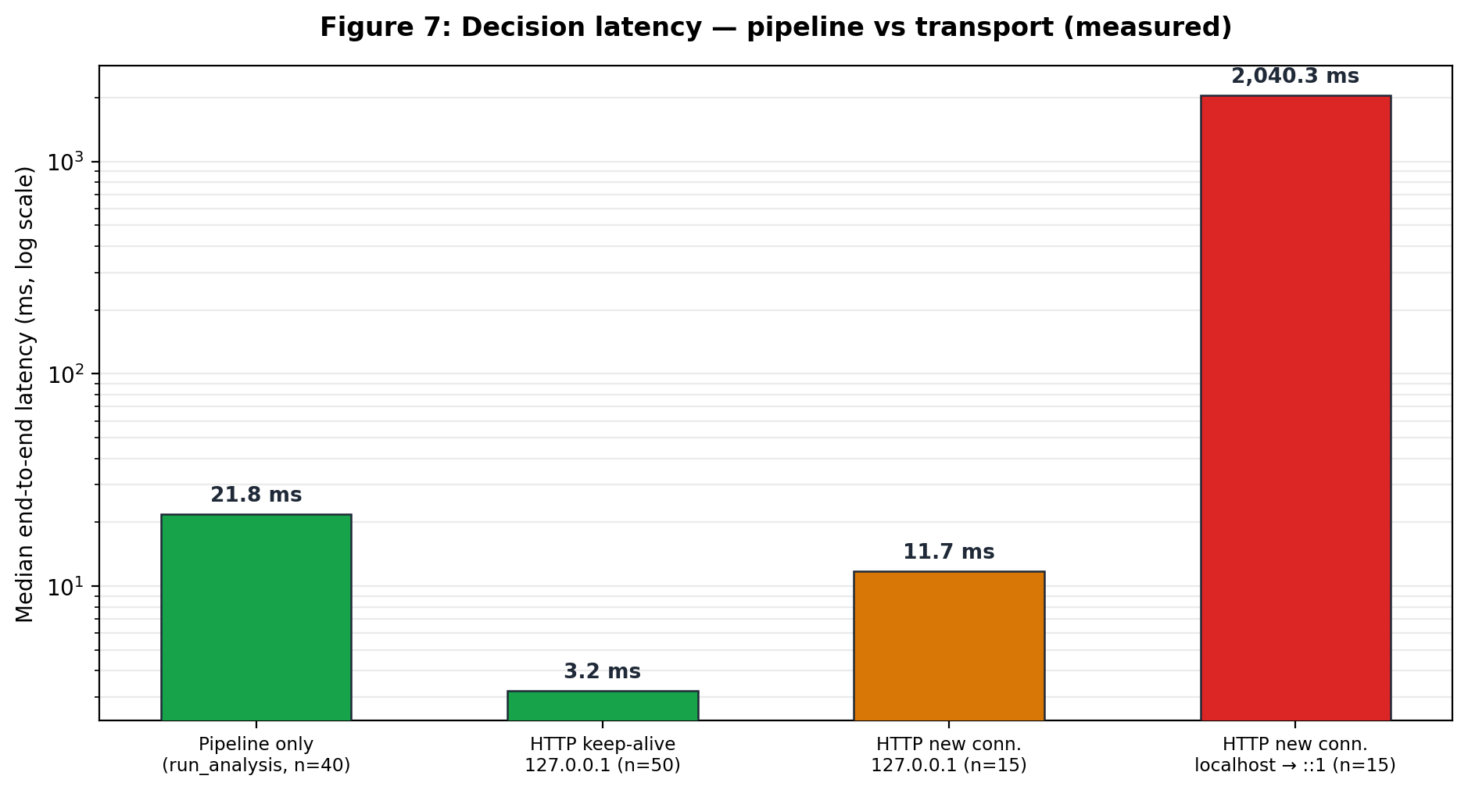
Figure 5: Measured decision latency. Explainable inference dominates the pipeline, transport is negligible, and the two second bar on the right is the name-resolution artefact discussed above.
The explanations themselves were consistent in a way that we consider the strongest evidence for keeping them inside the decision object. In the baseline it is the staleness of the last authorised update that pushes the assessment up, with an impact of about plus 2.1, while the device trust score and login history pull it down. In all three attacks the dominant factor is the standing device trust score, between plus 3.2 and plus 3.7, followed immediately by the specific hostile signal: unauthorised stick at plus 2.2 for the USB case, wireless anomaly at plus 2.5 for the rogue radio, and failed logins at plus 1.5 for the credential attack. An operator reading the third factor of any verdict can name the behaviour that caused it without opening a notebook, and because the ranking is stable across near-identical inputs there is no reason to learn to ignore it. Figure 6 shows the decomposition for the highest scoring attack.
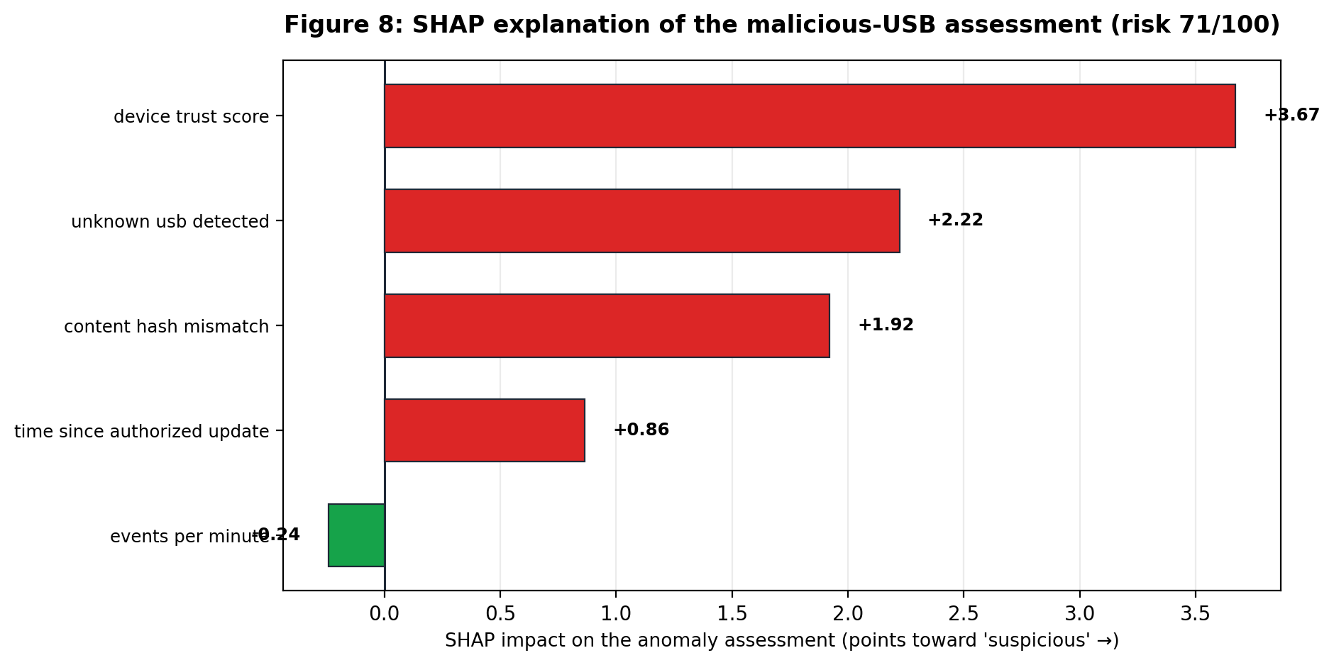
Figure 6: SHAP decomposition of the malicious USB assessment. The contribution of each of the seven features is signed, so the operator sees what raised the score and what held it down.
Two limitations belong in this discussion rather than in a footnote. The MQTT broker is reachable on all interfaces without transport security, which is acceptable on an isolated demonstration network but must be replaced by TLS with client certificates before anything operational. The feature window also lives in memory, so a restart of the service resets the per-device counters, although the audit trail and the ledger are file-backed and did survive the restarts we performed. The edge node acts on the command it receives rather than re-verifying the digest itself, which means it trusts the broker; moving SHA-256 verification into the firmware would remove that assumption and is the next architectural step rather than a tuning change.
6. Conclusion
SignGuard AI places a deterministic integrity check where the incidents of the last few years show it is missing, namely immediately before a public display renders text it did not create. Content is authorised in advance, its digest lives in a signed hash-linked ledger, and every arriving payload is compared against that record. A mismatch ends the decision and no probabilistic component can reopen it. Around that gate we run an unsupervised model over a five minute window of the device's own behaviour, fuse it with rule signals into a risk score with frozen weights, and attach SHAP attributions to the verdict so the operator learns why rather than only what. Verdicts are appended to a file-backed audit store, re-verifiable through the chain endpoint, and enforced physically on an ESP8266 node with text, LEDs and a buzzer.
The evaluation supports the design. Three attacks out of three were blocked and the genuine update was rendered with no false positive; 46 of 46 automated tests pass; a full explainable decision costs 21.7 ms; and the audit trail and the ledger were read back successfully after the service was restarted. The incidents described in the introduction were successful precisely because nothing like this gate sat between a USB stick and a screen, and the results suggest that adding one is neither expensive nor latency-critical.
The work also produced one finding that generalises beyond this project. A latency measurement that looks wrong should be decomposed before it is optimised; the two second cost we first attributed to explainable inference turned out to be IPv6 name resolution on the client side, and had we not separated the transport from the pipeline we would have written a very confident paragraph about the wrong thing.
Several directions follow naturally. Verification should move into the edge firmware so that the node no longer has to trust the broker. The broker should be put behind TLS with per-device client certificates, and the authority key should be rotated rather than kept static. The feature window should be persisted with the audit store so that counters survive a crash. The Ethereum prototype that sits alongside this repository could be wired to the authorisation endpoint as an alternative ledger backend, keeping the current hash-linked chain as the local source of truth. And the trust score could be shared across a fleet so that a display newly exposed to an unknown stick is treated cautiously everywhere on the network, without centralising the raw events themselves.
7. References
[1] Dai HN, Zheng Z, Zhang Y. Blockchain for Internet of Things: a survey. IEEE Internet Things J. 2019;6(5):8076-8094.
[2] Liu Y, Wang J, Yan Z, Wan Z, Jantti R. A survey on blockchain-based trust management for Internet of Things. IEEE Internet Things J. 2023;10(7):5898-5922.
[3] He D, Wu R, Li X, Chan S, Guizani M. Detection of vulnerabilities of blockchain smart contracts. IEEE Internet Things J. 2023;10(14):12178-12185.
[4] Ortega E, Su F, Chattopadhyay R, Chakrabarty K. Discretized-isolation forest: memory- and compute-efficient unsupervised anomaly detection for resource-constrained Internet of Things edge devices. IEEE Internet Things J. 2025;12(2):1699-1717.
[5] Zahoor A, Abbasi W, Babar MZ, et al. Robust IoT security using isolation forest and one class SVM algorithms. Sci Rep. 2025;15:36586.
[6] Bin hulayyil S, Li S, Saxena N. Explainable AI-based intrusion detection in IoT systems. Internet Things. 2025;31:101589.
[7] Dong J, et al. Interpretable intrusion detection for IoT security: a SHAP-based approach. Comput Netw. 2025;:111937.
[8] Taheri R, Jafari R, Gegov A, Arabikhan F, Ichtev A. Explainable AI for federated learning-based intrusion detection systems in connected vehicles. Electronics. 2025;14(22):4508.
[9] Almadhor A, Alsubai S, Al Hejaili A, Klai Z, Bouallegue B, Kovac U. Designing a neuro-symbolic dual-model architecture for explainable and resilient intrusion detection in IoT networks. Sci Rep. 2025;15:42786.
[10] Khan I, Majib Y, Ullah R, Rana O. Blockchain applications for Internet of Things - a survey. Internet Things. 2024;27:101254.

