Pre-Process

1. Arguments:
--input_txt: Path to the text file to be used for training. Default is the tiny-shakespeare.txt dataset.
- --output_h5: Path to the HDF5 file where preprocessed data should be written.
- --output_json: Path to the JSON file where preprocessed data should be written.
- --val_frac: What fraction of the data to use as a validation set; default is 0.1.
- --test_frac: What fraction of the data to use as a test set; default is 0.1.
- --quiet: If you pass this flag then no output will be printed to the console.

2. Encoding all the chars in the text file to utf-8.
3. Calculate vocabulary size and number of tokens in the text.
4. Choosing datatype based on the vocabulary size: 8bits or 32 bits.
5. Create h5py data sets for train , val and test.
6. Create JSON file and encode the data into it.

Train
1.Arguments:
Data options:
- -input_h5, -input_json: Paths to the HDF5 and JSON files output from the preprocessing script.
- -batch_size: Number of sequences to use in a minibatch; default is 50.
- -seq_length: Number of timesteps for which the recurrent network is unrolled for backpropagation through time.
Model options:
- -init_from: Path to a checkpoint file from a previous run of train.lua. Use this to continue training from an existing checkpoint; if this flag is passed then the other flags in this section will be ignored and the architecture from the existing checkpoint will be used instead.
- -reset_iterations: Set this to 0 to restore the iteration counter of a previous run. Default is 1 (do not restore iteration counter). Only applicable if -init_from option is used.
- -model_type: The type of recurrent network to use; either lstm (default) or rnn. lstm is slower but better.
- -wordvec_size: Dimension of learned word vector embeddings; default is 64. You probably won't need to change this.
- -rnn_size: The number of hidden units in the RNN; default is 128. Larger values (256 or 512) are commonly used to learn more powerful models and for bigger datasets, but this will significantly slow down computation.
- -dropout: Amount of dropout regularization to apply after each RNN layer; must be in the range 0 <= dropout < 1. Setting dropout to 0 disables dropout, and higher numbers give a stronger regularizing effect.
- -num_layers: The number of layers present in the RNN; default is 2.
Optimization options:
- -max_epochs: How many training epochs to use for optimization. Default is 50.
- -learning_rate: Learning rate for optimization. Default is 2e-3.
- -grad_clip: Maximum value for gradients; default is 5. Set to 0 to disable gradient clipping.
- -lr_decay_every: How often to decay the learning rate, in epochs; default is 5.
- -lr_decay_factor: How much to decay the learning rate. After every lr_decay_every epochs, the learning rate will be multiplied by the lr_decay_factor; default is 0.5.
Output options:
- -print_every: How often to print status message, in iterations. Default is 1.
- -checkpoint_name: Base filename for saving checkpoints; default is cv/checkpoint. This will create checkpoints named - cv/checkpoint_1000.t7, cv/checkpoint_1000.json, etc.
- -checkpoint_every: How often to save intermediate checkpoints. Default is 1000; set to 0 to disable intermediate checkpointing. Note that we always save a checkpoint on the final iteration of training.
Benchmark options:
- -speed_benchmark: Set this to 1 to test the speed of the model at every iteration. This is disabled by default because it requires synchronizing the GPU at every iteration, which incurs a performance overhead. Speed benchmarking results will be printed and also stored in saved checkpoints.
- -memory_benchmark: Set this to 1 to test the GPU memory usage at every iteration. This is disabled by default because like speed benchmarking it requires GPU synchronization. Memory benchmarking results will be printed and also stored in saved checkpoints. Only available when running in GPU mode.
Backend options:
- -gpu: The ID of the GPU to use (zero-indexed). Default is 0. Set this to -1 to run in CPU-only mode
- -gpu_backend: The GPU backend to use; either cuda or opencl. Default is cuda.
The Model:
1. The Model consists of Vocabulary size input neurons 128 hidden neurons and Vocabulary size output neurons all fully connected.

2. The Loss function is a Cross Entropy between the probability output char from the net to the next char class of the entire batch.
The Loss function uses mini batch size * sequence length data points (by default 2500)
https://en.wikipedia.org/wiki/Cross_entropy

3. The model can be manipulated between Vanilla RNN and LSTM, by default we use the LSTM model where each neuron activation function is:

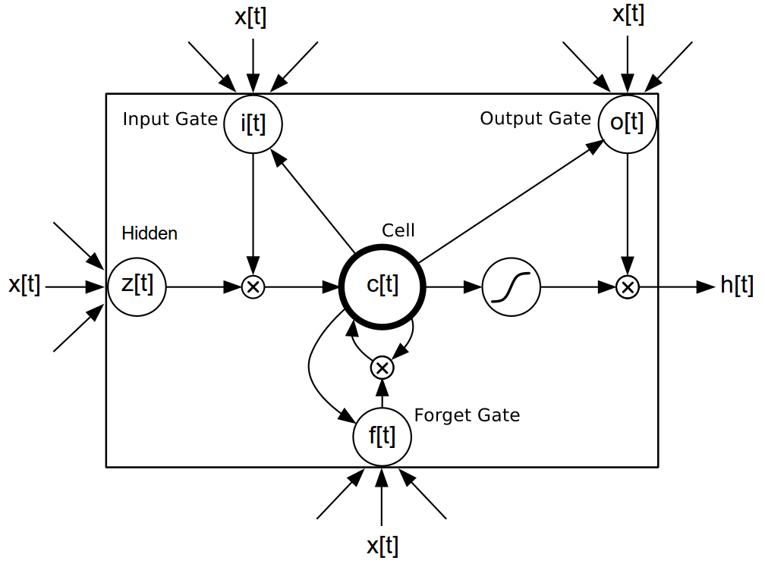

Sample
Arguments:
the sampling script sample.lua accepts the following command-line flags:
- -checkpoint: Path to a .t7 checkpoint file from train.lua
- -length: The length of the generated text, in characters.
- -start_text: You can optionally start off the generation process with a string; if this is provided the start text will be processed by the trained network before we start sampling. Without this flag, the first character is chosen randomly.
- -start_file: You can optionally start off the generation process with a file;if this is provided the start file text will be processed by the trained network before we start sampling.

- -sample: Set this to 1 to sample from the next-character distribution at each timestep; set to 0 to instead just pick the argmax at every timestep. Sampling tends to produce more interesting results.
- -temperature: Softmax temperature to use when sampling; default is 1. Higher temperatures give noiser samples. Not used when using argmax sampling (sample set to 0).
- -gpu: The ID of the GPU to use (zero-indexed). Default is 0. Set this to -1 to run in CPU-only mode.
- -gpu_backend: The GPU backend to use; either cuda or opencl. Default is cuda.
- -verbose: By default just the sampled text is printed to the console. Set this to 1 to also print some diagnostic information.

After all arguments selected the sample procedure is as follows:
- forward pass a char in the network
- receiving probabilities to the next char.
- Using multinomial distribution to select the next char.
- If Length variable has been reached – print else run again.

