Лабораторная работа №4
«Реализация распределенного приложения (dApp) для голосования.»

1 ХОД РАБОТЫ

1. Был создан каталог dapp, в котором был инициализирован шаблон приложения из фреймворка Truffle.
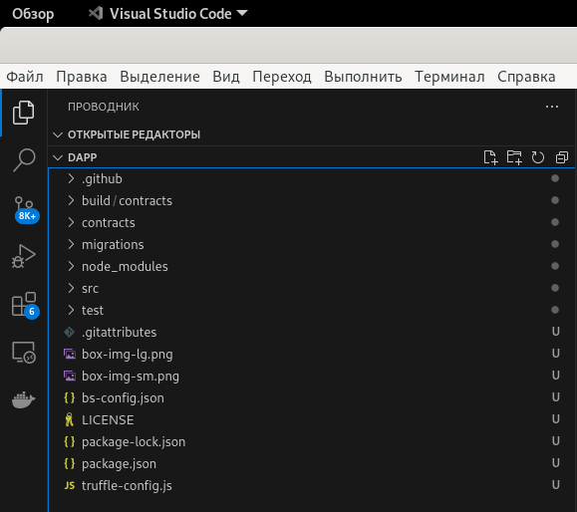
Рисунок 1 – Инициализированное приложение pet_shop

2. Был создан контракт Election.sol, а также скрипт миграции 2_deploy_contracts.js

Листинг 1 – Контракт Election.sol
pragma solidity >=0.4.2;

contract Election {
// Read/write candidate
string public candidate;

// Constructor
constructor() public {
candidate = "Candidate 1";
}
}

Листинг 2 – Скрипт миграции 2_deploy_contracts.js
var Election = artifacts.require("./Election.sol");

module.exports = function(deployer) {
deployer.deploy(Election);
};

3. Был установлен Ganache, а также изменена конфигурация проекта.

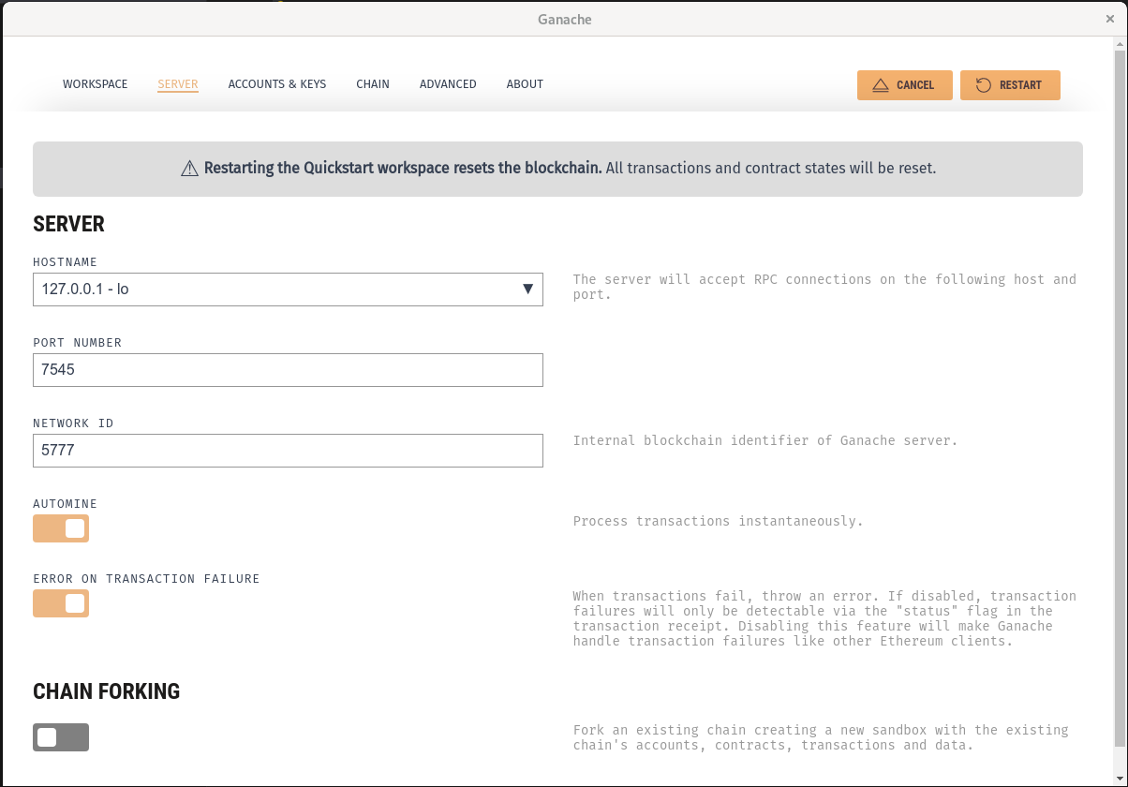
Рисунок 2 – Настройки сервера в Ganache
Листинг 3 – Файл truffle-config.js
module.exports = {
// See <http://truffleframework.com/docs/advanced/configuration>
// for more about customizing your Truffle configuration!
networks: {
development: {
host: "127.0.0.1",
port: 7545,
network_id: "5777" // Match any network id
},
develop: {
port: 8545
}
}
};

4. После чего, были запущены миграции (truffle migrate), а также инициализировано приложение.

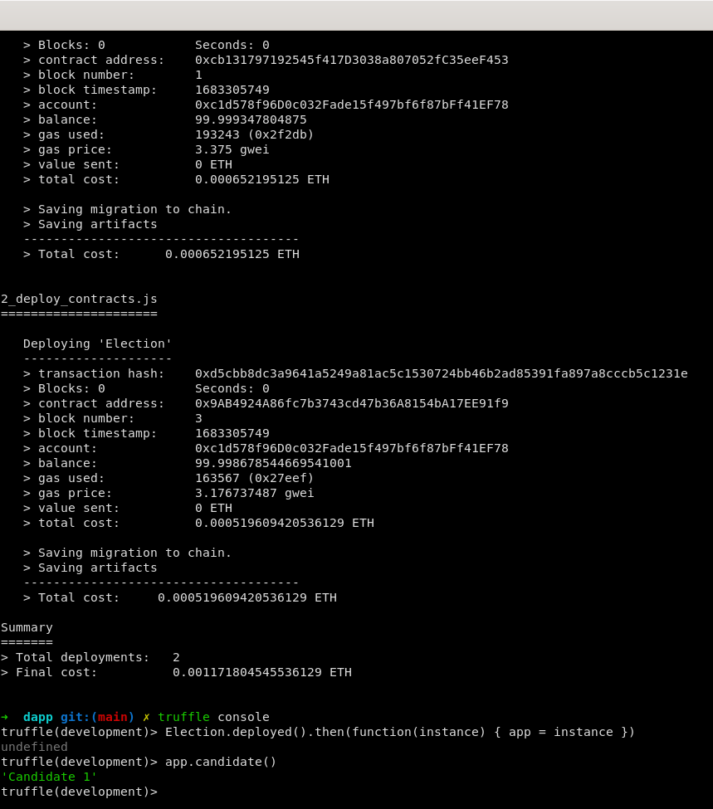
Рисунок 4 – Корректная работа окружения
5. Был изменён контракт Election.sol, а также был написан тест для него.

Листинг 4 – Контракт Election.sol
pragma solidity >=0.4.2;

contract Election {
// Модель данных кандидата
struct Candidate {
uint id;
string name;
uint voteCount;
}

// Хранилище конадидатов
// Получаем отсюда же, без геттеров
mapping(uint => Candidate) public candidates;

// Счетчик кандидатов
uint public candidatesCount;

constructor() public {
addCandidate("Candidate 1");
addCandidate("Candidate 2");
}

function addCandidate (string memory _name ) private {
candidatesCount ++;
candidates[candidatesCount] = Candidate(candidatesCount, _name, 0);
}
}

Листинг 5 – Тест election.js
var Election = artifacts.require("./Election.sol");

contract("Election", function(accounts) {
var electionInstance;

it("initializes with two candidates", function() {
return Election.deployed().then(function(instance) {
return instance.candidatesCount();
}).then(function(count) {
assert.equal(count, 2);
});
});
it("it initializes the candidates with the correct values", function() {
return Election.deployed().then(function(instance) {
electionInstance = instance;
return electionInstance.candidates(1);
}).then(function(candidate) {
assert.equal(candidate[0], 1, "contains the correct id");
assert.equal(candidate[1], "Candidate 1", "contains the correct name");
assert.equal(candidate[2], 0, "contains the correct votes count");
return electionInstance.candidates(2);
}).then(function(candidate) {
assert.equal(candidate[0], 2, "contains the correct id");
assert.equal(candidate[1], "Candidate 2", "contains the correct name");
assert.equal(candidate[2], 0, "contains the correct votes count");
});
});
});

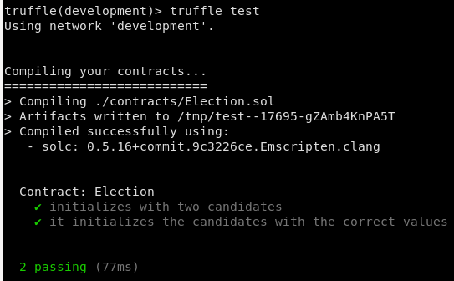
Рисунок 5 – Успешное прохождение теста
6. Была исправлена базовая разметка интерфейса приложения, а также js код для него.

Листинг 6 – Файл index.html
<!DOCTYPE html>
<html lang="en">

<head>
<meta charset="utf-8">
<meta http-equiv="X-UA-Compatible" content="IE=edge">
<meta name="viewport" content="width=device-width, initial-scale=1">
<title>Election Results</title>

<!-- Bootstrap -->
<link href="css/bootstrap.min.css" rel="stylesheet">
</head>

<body>
<div class="container" style="width: 650px;">
<div class="row">
<div class="col-lg-12">
<h1 class="text-center">Election Results</h1>
<hr />
<br />
<div id="loader">
<p class="text-center">Loading...</p>
</div>
<div id="content" style="display: none;">
<table class="table">
<thead>
<tr>
<th scope="col">#</th>
<th scope="col">Name</th>
<th scope="col">Votes</th>
</tr>
</thead>
<tbody id="candidatesResults">
</tbody>
</table>
<hr />
<p id="accountAddress" class="text-center"></p>
</div>
</div>
</div>
</div>

<!-- jQuery (necessary for Bootstrap's JavaScript plugins) -->
<script src="https://ajax.googleapis.com/ajax/libs/jquery/1.12.4/jquery.min.js"></script>
<!-- Include all compiled plugins (below), or include individual files as needed -->
<script src="js/bootstrap.min.js"></script>
<script src="js/web3.min.js"></script>
<script src="js/truffle-contract.js"></script>
<script src="js/app.js"></script>
</body>

</html>

Листинг 7 – Файл app.js
App = {
web3Provider: null,
contracts: {},
account: '0x0',

init: function() {
return App.initWeb3();
},

initWeb3: function() {
if (typeof web3 !== 'undefined') {
// If a web3 instance is already provided by Meta Mask.
App.web3Provider = web3.currentProvider;
web3 = new Web3(web3.currentProvider);
} else {
// Specify default instance if no web3 instance provided
App.web3Provider = new Web3.providers.HttpProvider('http://localhost:7545');
web3 = new Web3(App.web3Provider);
}
return App.initContract();
},

initContract: function() {
$.getJSON("Election.json", function(election) {
// Instantiate a new truffle contract from the artifact
App.contracts.Election = TruffleContract(election);
// Connect provider to interact with contract
App.contracts.Election.setProvider(App.web3Provider);

return App.render();
});
},

render: function() {
var electionInstance;
var loader = $("#loader");
var content = $("#content");

loader.show();
content.hide();

// Load account data
web3.eth.getCoinbase(function(err, account) {
if (err === null) {
App.account = account;
$("#accountAddress").html("Your Account: " + account);
}
});

// Load contract data
App.contracts.Election.deployed().then(function(instance) {
electionInstance = instance;
return electionInstance.candidatesCount();
}).then(function(candidatesCount) {
var candidatesResults = $("#candidatesResults");
candidatesResults.empty();

for (var i = 1; i <= candidatesCount; i++) {
electionInstance.candidates(i).then(function(candidate) {
var id = candidate[0];
var name = candidate[1];
var voteCount = candidate[2];

// Render candidate Result
var candidateTemplate = "<tr><th>" + id + "</th><td>" + name + "</td><td>" + voteCount + "</td></tr>"
candidatesResults.append(candidateTemplate);
});
}

loader.hide();
content.show();
}).catch(function(error) {
console.warn(error);
});
}
};

$(function() {
$(window).load(function() {
App.init();
});
});

7. Был создан аккаунт MetaMask и подключен к сайту.

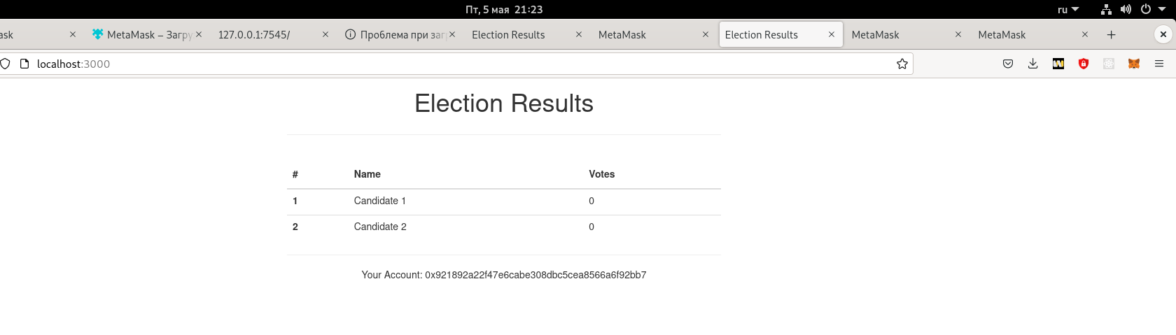
Рисунок 6 – Вход на сайт

8. Была добавлена возможность голосования, также она была покрыта тестами.

Листинг 8 – Файл Election.sol
pragma solidity >=0.4.2;

contract Election {
// Модель данных кандидата
struct Candidate {
uint id;
string name;
uint voteCount;
}

// Хранилище конадидатов
// Получаем отсюда же, без геттеров
mapping(uint => Candidate) public candidates;

// Store accounts that have voted
mapping(address => bool) public voters;

// Счетчик кандидатов
uint public candidatesCount;

constructor() public {
addCandidate("Candidate 1");
addCandidate("Candidate 2");
}

function addCandidate (string memory _name ) private {
candidatesCount ++;
candidates[candidatesCount] = Candidate(candidatesCount, _name, 0);
}

function vote (uint _candidateId) public {
// require that they haven't voted before
require(!voters[msg.sender]);

// require a valid candidate
require(_candidateId > 0 && _candidateId <= candidatesCount);

// record that voter has voted
voters[msg.sender] = true;

// update candidate vote Count
candidates[_candidateId].voteCount ++;
}

}

Листинг 9 – Файл election.js
var Election = artifacts.require("./Election.sol");

contract("Election", function(accounts) {
var electionInstance;

it("initializes with two candidates", function() {
return Election.deployed().then(function(instance) {
return instance.candidatesCount();
}).then(function(count) {
assert.equal(count, 2);
});
});

it("it initializes the candidates with the correct values", function() {
return Election.deployed().then(function(instance) {
electionInstance = instance;
return electionInstance.candidates(1);
}).then(function(candidate) {
assert.equal(candidate[0], 1, "contains the correct id");
assert.equal(candidate[1], "Candidate 1", "contains the correct name");
assert.equal(candidate[2], 0, "contains the correct votes count");
return electionInstance.candidates(2);
}).then(function(candidate) {
assert.equal(candidate[0], 2, "contains the correct id");
assert.equal(candidate[1], "Candidate 2", "contains the correct name");
assert.equal(candidate[2], 0, "contains the correct votes count");
});
});

it("allows a voter to cast a vote", function() {
return Election.deployed().then(function(instance) {
electionInstance = instance;
candidateId = 1;
return electionInstance.vote(candidateId, { from: accounts[0] });
}).then(function(receipt) {
return electionInstance.voters(accounts[0]);
}).then(function(voted) {
assert(voted, "the voter was marked as voted");
return electionInstance.candidates(candidateId);
}).then(function(candidate) {
var voteCount = candidate[2];
assert.equal(voteCount, 1, "increments the candidate's vote count");
})
});

it("throws an exception for invalid candidates", function() {
return Election.deployed().then(function(instance) {
electionInstance = instance;
return electionInstance.vote(99, { from: accounts[1] })
}).then(assert.fail).catch(function(error) {
assert(error.message.indexOf('revert') >= 0, "error message must contain revert");
return electionInstance.candidates(1);
}).then(function(candidate1) {
var voteCount = candidate1[2];
assert.equal(voteCount, 1, "candidate 1 did not receive any votes");
return electionInstance.candidates(2);
}).then(function(candidate2) {
var voteCount = candidate2[2];
assert.equal(voteCount, 0, "candidate 2 did not receive any votes");
});
});

});

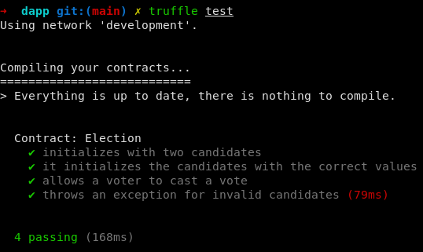
Рисунок 7 – Пройденные тесты
9. Была добавлена форма для выбора кандидатов во фронтовскую часть приложения, также был изменён файл app.js.

Листинг 10 – Файл index.html
<!DOCTYPE html>
<html lang="en">
<head>
<meta charset="utf-8">
<meta http-equiv="X-UA-Compatible" content="IE=edge">
<meta name="viewport" content="width=device-width, initial-scale=1">
<title>Election Results</title>

<!-- Bootstrap -->
<link href="css/bootstrap.min.css" rel="stylesheet">
</head>
<body>
<div class="container" style="width: 650px;">
<div class="row">
<div class="col-lg-12">
<h1 class="text-center">Election Results</h1>
<hr/>
<br/>
<div id="loader">
<p class="text-center">Loading...</p>
</div>
<div id="content" style="display: none;">
<table class="table">
<thead>
<tr>
<th scope="col">#</th>
<th scope="col">Name</th>
<th scope="col">Votes</th>
</tr>
</thead>
<tbody id="candidatesResults">
</tbody>
</table>
<hr/>
<form onSubmit="App.castVote(); return false;">
<div class="form-group">
<label for="candidatesSelect">Select Candidate</label>
<select class="form-control" id="candidatesSelect">
</select>
</div>
<button type="submit" class="btn btn-primary">Vote</button>
<hr />
</form>
<p id="accountAddress" class="text-center"></p>
</div>
</div>
</div>
</div>

<!-- jQuery (necessary for Bootstrap's JavaScript plugins) -->
<script src="https://ajax.googleapis.com/ajax/libs/jquery/1.12.4/jquery.min.js"></script>
<!-- Include all compiled plugins (below), or include individual files as needed -->
<script src="js/bootstrap.min.js"></script>
<script src="js/web3.min.js"></script>
<script src="js/truffle-contract.js"></script>
<script src="js/app.js"></script>
</body>
</html>

Листинг 11 – Файл app.js
App = {
web3Provider: null,
contracts: {},
account: '0x0',

init: function () {
return App.initWeb3();
},

initWeb3: function () {
if (typeof web3 !== 'undefined') {
// If a web3 instance is already provided by Meta Mask.
App.web3Provider = web3.currentProvider;
web3 = new Web3(web3.currentProvider);
} else {
// Specify default instance if no web3 instance provided
App.web3Provider = new Web3.providers.HttpProvider('http://localhost:7545');
web3 = new Web3(App.web3Provider);
}
return App.initContract();
},

initContract: function () {
$.getJSON("Election.json", function (election) {
// Instantiate a new truffle contract from the artifact
App.contracts.Election = TruffleContract(election);
// Connect provider to interact with contract
App.contracts.Election.setProvider(App.web3Provider);

return App.render();
});
},
render: function () {
var electionInstance;
var loader = $("#loader");
var content = $("#content");

loader.show();
content.hide();

// Load account data
web3.eth.getCoinbase(function (err, account) {
if (err === null) {
App.account = account;
$("#accountAddress").html("Your Account: " + account);
}
});

// Load contract data
App.contracts.Election.deployed().then(function (instance) {
electionInstance = instance;
return electionInstance.candidatesCount();
}).then(function (candidatesCount) {
var candidatesResults = $("#candidatesResults");
candidatesResults.empty();

var candidatesSelect = $('#candidatesSelect');
candidatesSelect.empty();

for (var i = 1; i <= candidatesCount; i++) {
electionInstance.candidates(i).then(function (candidate) {
var id = candidate[0];
var name = candidate[1];
var voteCount = candidate[2];

// Render candidate Result
var candidateTemplate = "<tr><th>" + id + "</th><td>" + name + "</td><td>" + voteCount + "</td></tr>"
candidatesResults.append(candidateTemplate);

// Render candidate ballot option
var candidateOption = "<option value='" + id + "' >" + name + "</ option>"
candidatesSelect.append(candidateOption);
});
}
return electionInstance.voters(App.account);
}).then(function (hasVoted) {
// Do not allow a user to vote
if (hasVoted) {
$('form').hide();
}
loader.hide();
content.show();
}).catch(function (error) {
console.warn(error);
});
},

castVote: function () {
var candidateId = $('#candidatesSelect').val();
App.contracts.Election.deployed().then(function (instance) {
return instance.vote(candidateId, { from: App.account });
}).then(function (result) {
// Wait for votes to update
$("#content").hide();
$("#loader").show();
}).catch(function (err) {
console.error(err);
});
}
};

$(function () {
$(window).load(function () {
App.init();
});
});
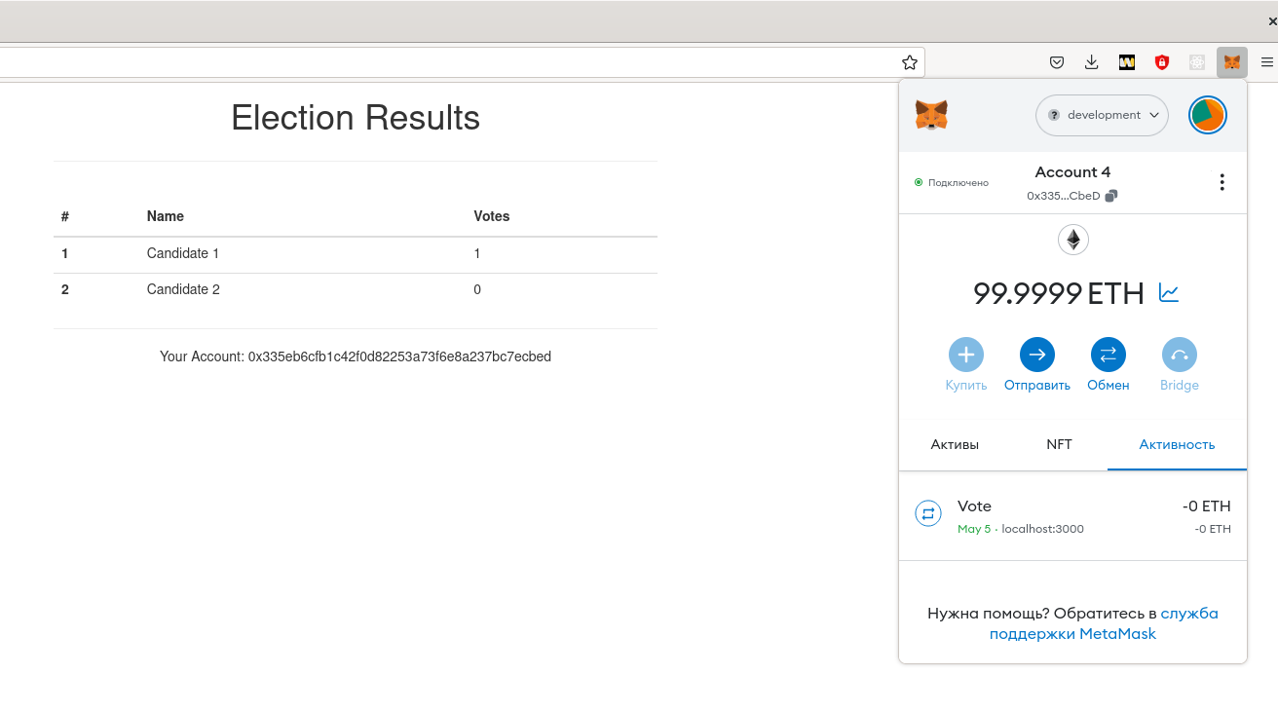
Рисунок 8 – Проведённая транзакция
10. Было добавлено событие о голосовании, параметром которого является кандидат, за которого проголосовали.

Листинг 12 – Файл Election.sol
pragma solidity >=0.4.2;

contract Election {
// Модель данных кандидата
struct Candidate {
uint id;
string name;
uint voteCount;
}

// Хранилище конадидатов
// Получаем отсюда же, без геттеров
mapping(uint => Candidate) public candidates;

// Store accounts that have voted
mapping(address => bool) public voters;

// Счетчик кандидатов
uint public candidatesCount;

constructor() public {
addCandidate("Candidate 1");
addCandidate("Candidate 2");
}

function addCandidate (string memory _name ) private {
candidatesCount ++;
candidates[candidatesCount] = Candidate(candidatesCount, _name, 0);
}

function vote (uint _candidateId) public {
require(!voters[msg.sender]);
require(_candidateId > 0 && _candidateId <= candidatesCount);
voters[msg.sender] = true;
candidates[_candidateId].voteCount ++;
// После завершения обработки транзакции – запустим событие.
emit votedEvent(_candidateId);
}

event votedEvent (
uint indexed _candidateId
);

}

Листинг 13 – Файл election.js
var Election = artifacts.require("./Election.sol");

contract("Election", function(accounts) {
var electionInstance;

it("initializes with two candidates", function() {
return Election.deployed().then(function(instance) {
return instance.candidatesCount();
}).then(function(count) {
assert.equal(count, 2);
});
});

it("it initializes the candidates with the correct values", function() {
return Election.deployed().then(function(instance) {
electionInstance = instance;
return electionInstance.candidates(1);
}).then(function(candidate) {
assert.equal(candidate[0], 1, "contains the correct id");
assert.equal(candidate[1], "Candidate 1", "contains the correct name");
assert.equal(candidate[2], 0, "contains the correct votes count");
return electionInstance.candidates(2);
}).then(function(candidate) {
assert.equal(candidate[0], 2, "contains the correct id");
assert.equal(candidate[1], "Candidate 2", "contains the correct name");
assert.equal(candidate[2], 0, "contains the correct votes count");
});
});

it("allows a voter to cast a vote", function() {
return Election.deployed().then(function(instance) {
electionInstance = instance;
candidateId = 1;
return electionInstance.vote(candidateId, { from: accounts[0] });
}).then(function(receipt) {
return electionInstance.voters(accounts[0]);
}).then(function(voted) {
assert(voted, "the voter was marked as voted");
return electionInstance.candidates(candidateId);
}).then(function(candidate) {
var voteCount = candidate[2];
assert.equal(voteCount, 1, "increments the candidate's vote count");
})
});

it("throws an exception for invalid candidates", function() {
return Election.deployed().then(function(instance) {
electionInstance = instance;
return electionInstance.vote(99, { from: accounts[1] })
}).then(assert.fail).catch(function(error) {
assert(error.message.indexOf('revert') >= 0, "error message must contain revert");
return electionInstance.candidates(1);
}).then(function(candidate1) {
var voteCount = candidate1[2];
assert.equal(voteCount, 1, "candidate 1 did not receive any votes");
return electionInstance.candidates(2);
}).then(function(candidate2) {
var voteCount = candidate2[2];
assert.equal(voteCount, 0, "candidate 2 did not receive any votes");
});
});

it("allows a voter to cast a vote", function() {
return Election.deployed().then(function(instance) {
electionInstance = instance;
candidateId = 1;
return electionInstance.vote(candidateId, { from: accounts[2] });
}).then(function(receipt) {
assert.equal(receipt.logs.length, 1, "an event was triggered");
assert.equal(receipt.logs[0].event, "votedEvent", "the event type is correct");
assert.equal(receipt.logs[0].args._candidateId.toNumber(), candidateId, "the candidate id is correct");
})
});

});

Листинг 14 – Файл app.js
App = {
web3Provider: null,
contracts: {},
account: '0x0',

init: function () {
return App.initWeb3();
},

initWeb3: function () {
if (typeof web3 !== 'undefined') {
// If a web3 instance is already provided by Meta Mask.
App.web3Provider = web3.currentProvider;
web3 = new Web3(web3.currentProvider);
} else {
// Specify default instance if no web3 instance provided
App.web3Provider = new Web3.providers.HttpProvider('http://localhost:7545');
web3 = new Web3(App.web3Provider);
}
return App.initContract();
},

initContract: function () {
$.getJSON("Election.json", function (election) {
// Instantiate a new truffle contract from the artifact
App.contracts.Election = TruffleContract(election);
// Connect provider to interact with contract
App.contracts.Election.setProvider(App.web3Provider);
App.listenForEvents();
return App.render();
});
},
render: function () {
var electionInstance;
var loader = $("#loader");
var content = $("#content");

loader.show();
content.hide();

// Load account data
web3.eth.getCoinbase(function (err, account) {
if (err === null) {
App.account = account;
$("#accountAddress").html("Your Account: " + account);
}
});

// Load contract data
App.contracts.Election.deployed().then(function (instance) {
electionInstance = instance;
return electionInstance.candidatesCount();
}).then(function (candidatesCount) {
var candidatesResults = $("#candidatesResults");
candidatesResults.empty();

var candidatesSelect = $('#candidatesSelect');
candidatesSelect.empty();

for (var i = 1; i <= candidatesCount; i++) {
electionInstance.candidates(i).then(function (candidate) {
var id = candidate[0];
var name = candidate[1];
var voteCount = candidate[2];

// Render candidate Result
var candidateTemplate = "<tr><th>" + id + "</th><td>" + name + "</td><td>" + voteCount + "</td></tr>"
candidatesResults.append(candidateTemplate);

// Render candidate ballot option
var candidateOption = "<option value='" + id + "' >" + name + "</ option>"
candidatesSelect.append(candidateOption);
});
}
return electionInstance.voters(App.account);
}).then(function (hasVoted) {
// Do not allow a user to vote
if (hasVoted) {
$('form').hide();
}
loader.hide();
content.show();
}).catch(function (error) {
console.warn(error);
});
},

castVote: function () {
var candidateId = $('#candidatesSelect').val();
App.contracts.Election.deployed().then(function (instance) {
return instance.vote(candidateId, { from: App.account });
}).then(function (result) {
// Wait for votes to update
$("#content").hide();
$("#loader").show();
}).catch(function (err) {
console.error(err);
});
},

listenForEvents: function() {
App.contracts.Election.deployed().then(function(instance) {
instance.votedEvent({}, {
fromBlock: 0,
toBlock: 'latest'
}).watch(function(error, event) {
console.log("event triggered", event)
// Перерисовываем UI по приходу сообщения
App.render();
});
});
}

};

$(function () {
$(window).load(function () {
App.init();
});
});

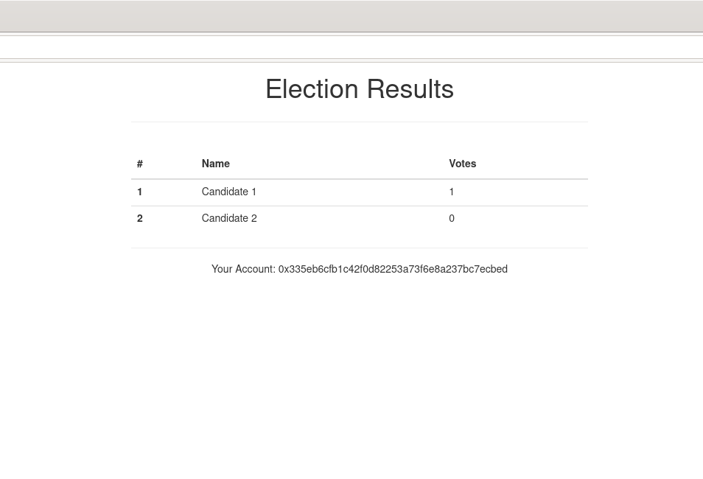
Рисунок 9 – Итоговое приложение

