State Capacity Ecosystem
Field Building Guide

1. What This Guide Is
How to build enough credibility and reach in a new city or vertical that your first event draws real practitioners and real government authority.

2. The Core Idea
Field building comes down to two things: credibility and reach. Build both before your event. Continue building it as you go.
- Credibility. Proof you understand the space. Proof you deserve to be a leader. Must be authentic to you. What that means is up to you.
- Reach. People who know you and will show up for you. Likes on a LinkedIn post help. Attendees at your event are the bottom line.
There is no fixed formula to generate either. Find the angle that is authentic to you and lean into it hard. Henry from the SCE team posted on LinkedIn about moving from private sector into government and ended up on dozens of calls with interested people. Each call built credibility and reach simultaneously.

3. The Toolkit
Tactics that build credibility, reach, or both. Entirely non-exhaustive and intentionally evergreen.
Tactic | Builds | What It Looks Like
Map your ecosystem | Credibility | A local or topic-specific version of the map. Horizontal is a city. Vertical is a deep dive on one segment.
Write and post | Credibility + Reach | Publish your own thinking in your own voice. Do not wait for a template.
Take the calls | Reach | Say yes to intro calls. Offer your time generously. Follow up.
Stand up Slack and Substack | Reach | Substack first, low lift and one-way. Slack once there is enough interest to sustain it. Assign an owner beyond yourself.
Court insiders, then decision-makers | Credibility to Reach | Find one or two respected insiders first. Let their credibility open the door to someone with real authority.

4. Suggested Timeline
Field building should build to a crescendo. Below is a rough band, not a formula.
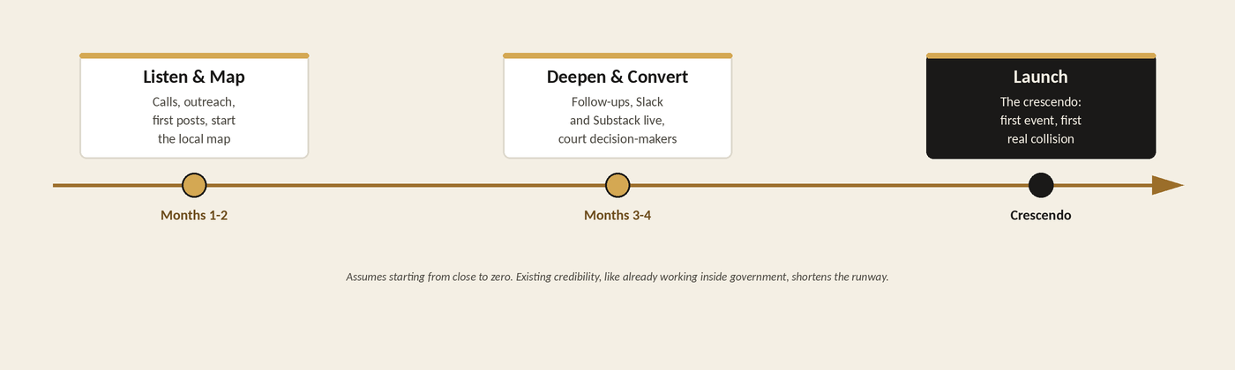
This assumes starting from close to zero. Existing credibility, like already working inside government, shortens the runway.

5. Feed the Central Directory
Everything you map locally should end up in the central Ecosystem directory and CRM. That keeps the national picture accurate. Work with the State Capacity Ecosystem to make that happen.

