

Bio-tech world

AMAZON TECKATHON 2020



# **Table of Contents**

**1. Introduction** **2**

Purpose 2

Assumptions and Constraints 2

Project Overview 3

**2. Oversight**11

**3. Major Tasks and Schedule**11

Task List 11

4. Security and Testing 11

Security 11

Development and Testing 12

**5. Resource Needs**13

Hardware 13

Software 13

Training 13

**6. What's next?** 14

# 

# **1**. Introduction

## Purpose

Educate kids and elementary students about the importance of biotechnology and science in general by using entertainment and fun activities. Delivering Information in a different way, other than school classes and educational institutes, to allow students enjoy science and have no more fears while dealing with such topics. Our “tech-world” website will accomplish this goal.

## Assumptions and Constraints

* Time
* Budget
* Resource availability and skill sets
* Software and other technology to be used or purchased
* Interoperability of existing websites with our website
* Clarity and easy presentation
* Usage of website

## Project Overview

* Main Page :  
    
  The “Home Page” is the 1st page to appear the moment a user opens the website. It has the main activities that the student can select and start learning. We made sure to create an interesting and catchy page in order to encourage the user continue exploring the website and continue learning.  
  (more details in demo video).
* 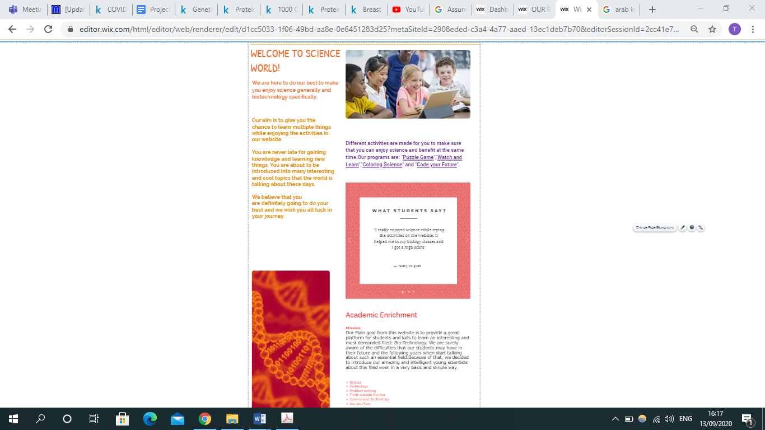Programs Page :  
    
  When the user is seeking for the type of programs we offer in the website, it would be very easy by clicking on the “PROGRAMS” tab and it will immediately open the Programs Page. It has multiple text boxes written in different colors explaining and welcoming the students. Some opinions and suggestions from previous users are added too to give a quick impression.  
  (more details in demo video).

* 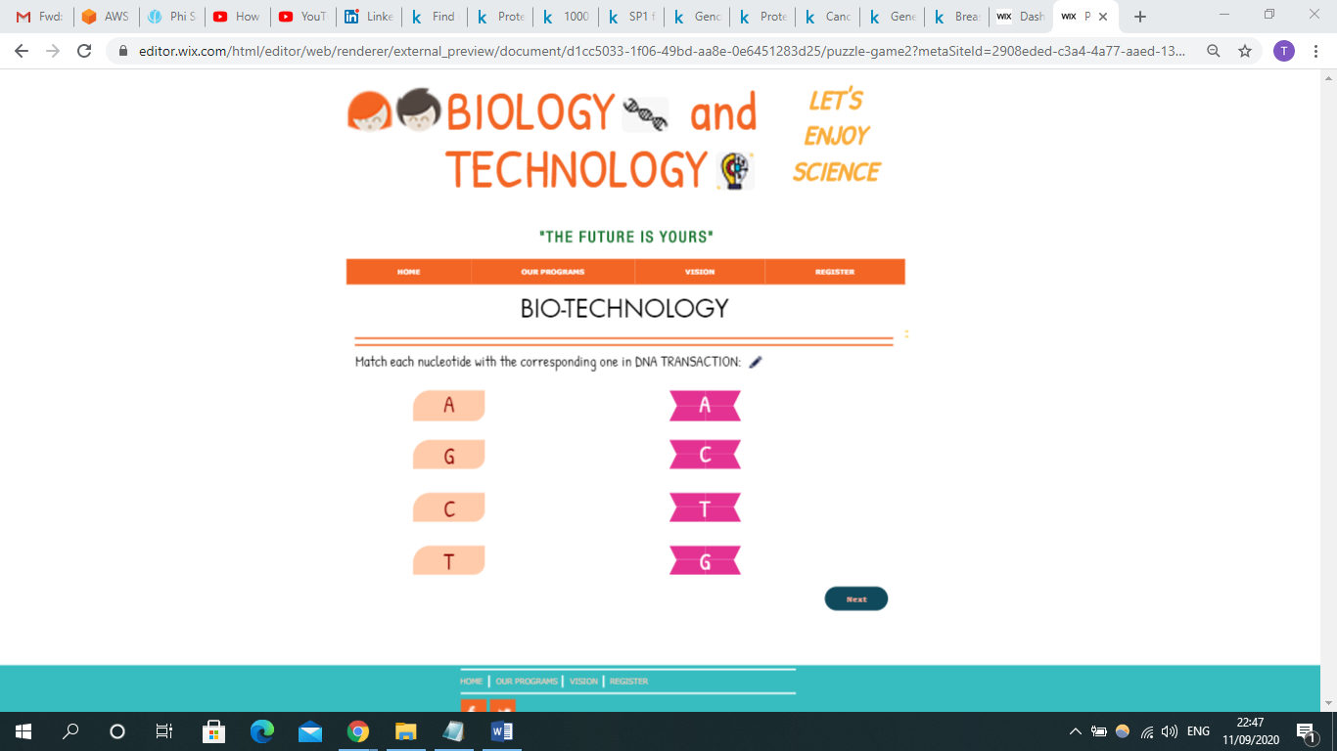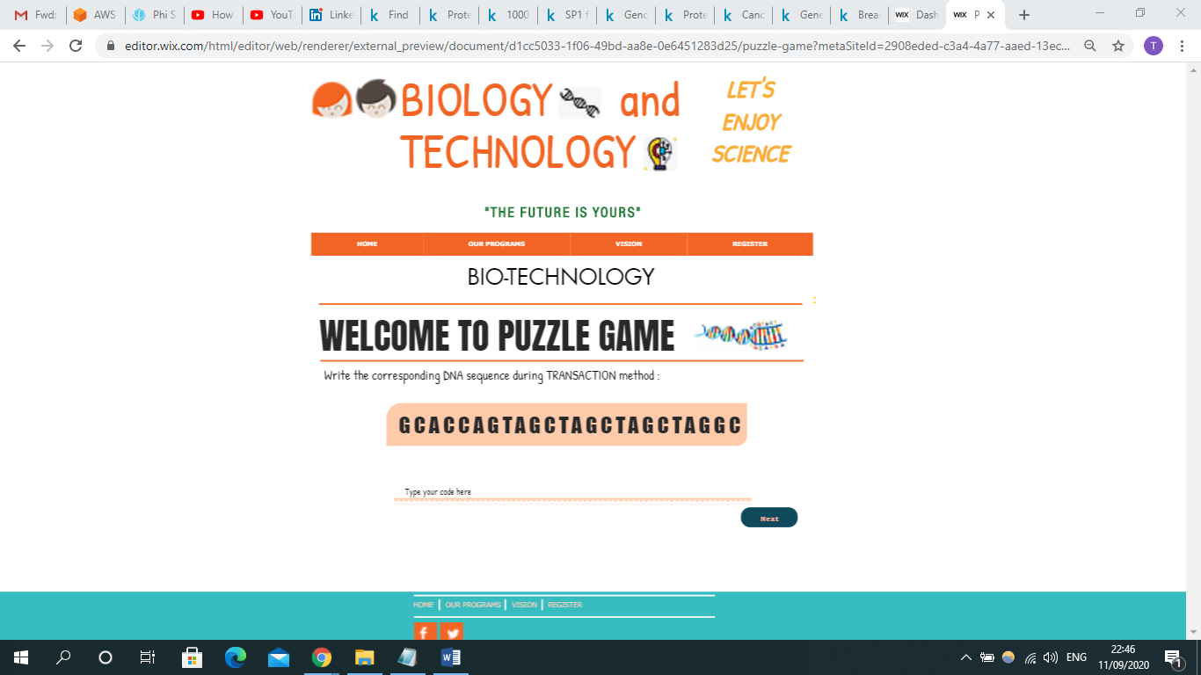Activity1 Page :  
    
  When the user picks the “PUZZLE GAME” activity, he/she are going to start writing and matching each letter which represents a “nucleotide” in the DNA with a corresponding letter. By clicking next , the user will be moved to the next puzzle game.Many more ideas are going to be added later. However, the idea is that we want students to play and have fun while at the same time they are learning biology and science in general . (more details in demo video).
* 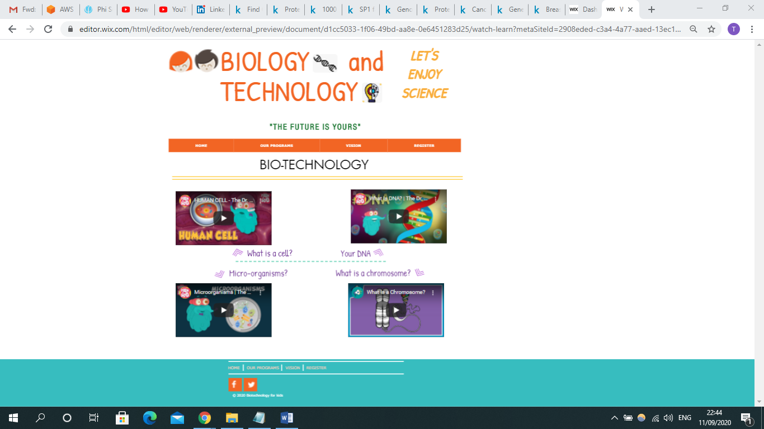Activity2 Page :  
    
  If the user couldn’t solve one of the activities that are related to Science and needed some help in learning/re-studying one of the topics ,we made sure to add a specific activity called “WATCH AND LEARN”. They are already downloaded on Youtube but we made it easier by uploading them on our page to let the students learn what matched the suggested topics.  
  (more details in demo video).
* 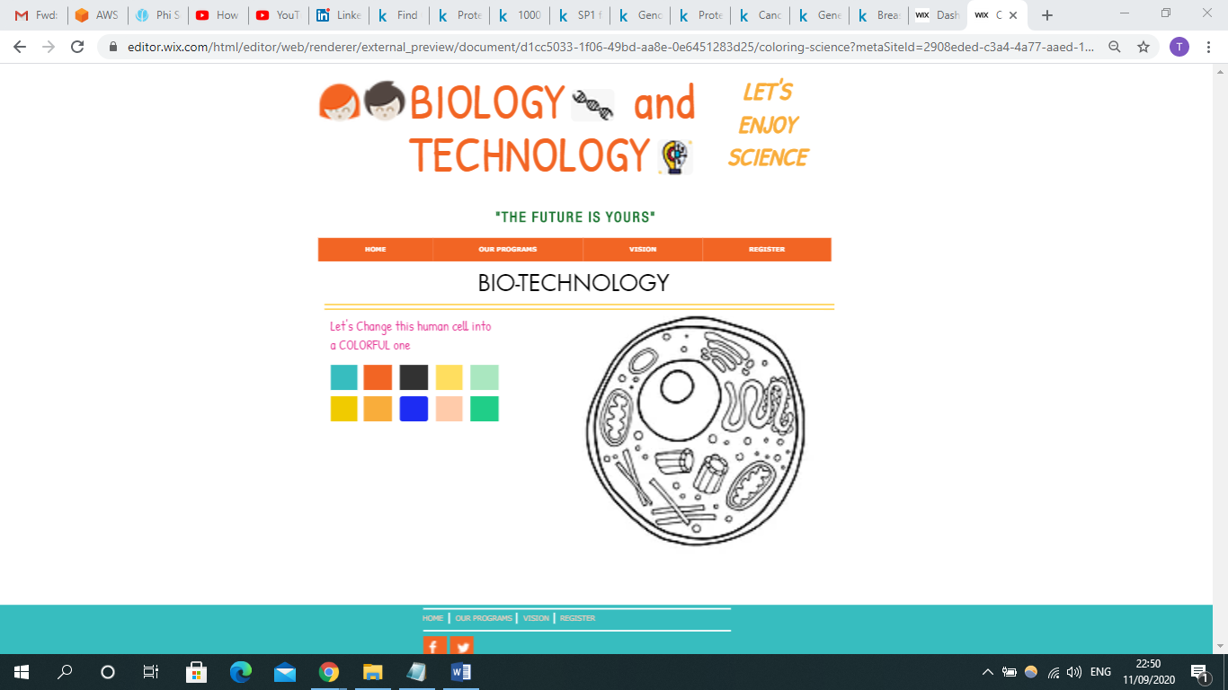Activity3 Page :  
    
  When the student chooses the “COLORING” in the main page or in programs page, he/she are going to be asked to color the required shape. This time , the shape isn’t about a flying bird or a big house , this time he/she are going to color CELLS. As Cells are the essential structures in our bodies and they occupy a very big role in biology in general. As a result, we wanted kids to be introduced into these structures at the time they are picking their favorite colors to show their art and design. (more details in demo video).

* Activity4 Page:

This page is about teaching students about Python, the most familiar coding language these days and most importantly in Biotechnology field. When picking the “CODE YOUR FUTURE” activity, the user is going to start learning the language step-by-step to get into the final level. As a beginning, the following pictures show a beginner level just to make the idea more clear. (more details in demo video).  
  
  
  
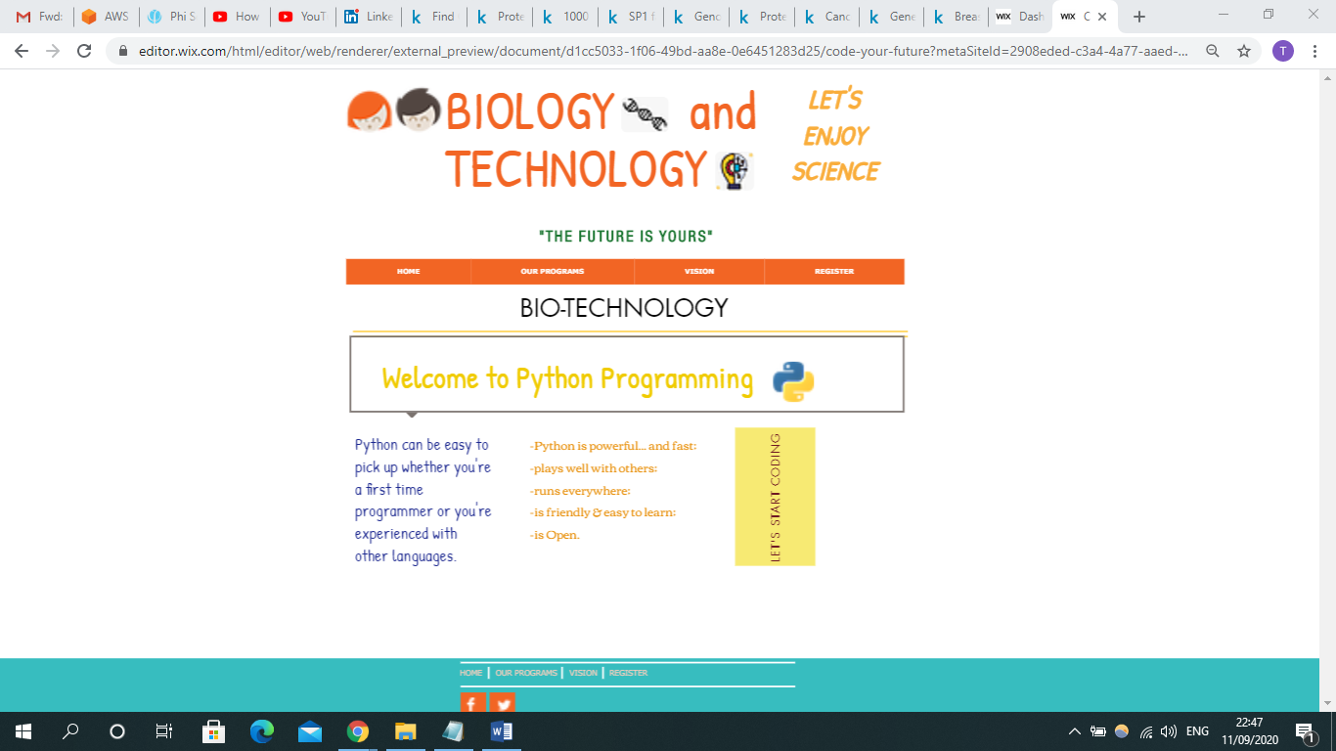  
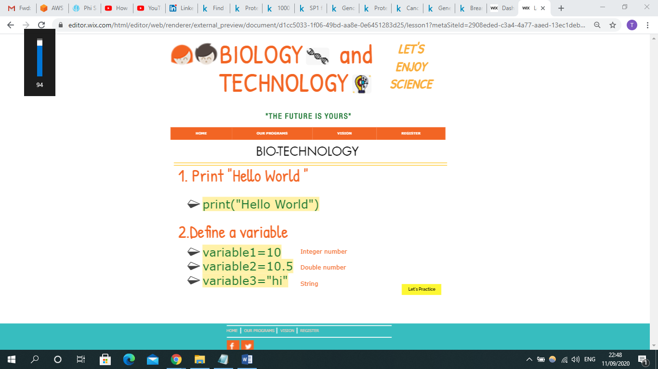

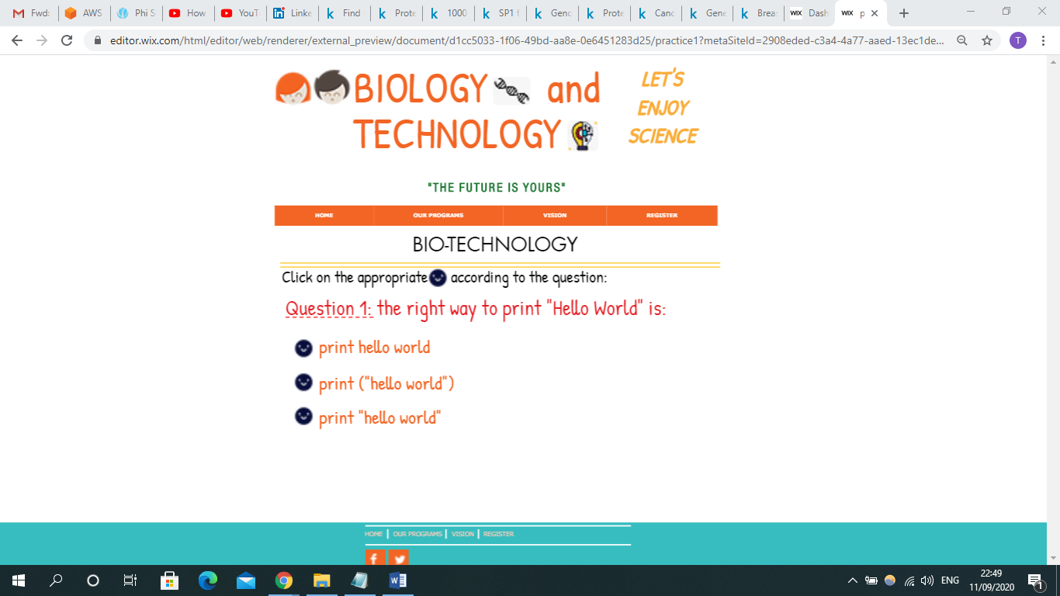and this is a simple practice to ensure the student is doing good while learning coding:

# 2. Oversight

|  |  |
| --- | --- |
| Member Name | Role |
| Tala Rabi | Design and Project management |
| Mohammed Madi | Coding and Software Development |
| Abdelfattah Yousef | Documentation and Implementation |

# 3. Major Tasks and Schedule Task List

* *Provide simplified videos which explain biology :*

This task ,for now,will be done by Youtube videos that are already uploaded and explain specific topics in a simple way. These topics on purpose are chosen to match the activities in website and due to its importance in Biotechnology fields.

* *Teaching students using games and activities :*

Kids, children or elementary school students are our focused category of people. Teaching them about Science and Technology is a little bit challenging .As a result , we decided to educate kids about this field no matter what using multiple techniques such as playing games and activities.

* *Creating a colorful website with less texts and more pictures:*Thinking about suitable design and style of the website isn’t the easiest thing to do. Young users won’t accept any type of websites nor continue using them if they don’t match their interests. So using colors, pictures, interactive activities and easy-to-use website is a definite aim.
* *Merging Biology and Technology in one Website :*

Due to our main goal : Teaching Biotechnology for children, the website offer classes and activities for both Biology such as (**Cells/DNA/Chromosomes/Genes** … etc) and Technology such as Programming language : **Python .** We believe that **the first step** to introduce students in a young age into this topic is to let them learn and deal with it under one activity and one website.

# 4. Security and Testing

# Security

In our website, one of the most important things that we will take care of it is the security system

Our security system will provide sufficient security for any new systems, servers or applications that will be added.

The safety of our users is what matters the most , especially when we are talking about young children , then safety and type of content must be safe and clean.

# Development and Testing

Our system will have a permanent development without suspended from use and without disturbance our users. Continuous maintenance to the website is a must and updating the user with what’s new is the main goal.

The testing strategy will be done by evaluation from clients.

# 5. Resource Needs

# Hardware needs

* 1.9 Gigahertz Processor.
* Memory 2-GB RAM.
* Display Super VGA with a resolution of 1024 x 768.
* Internet connection.

# Software needs

* A database to store all the information used.
* Operating system.
* Microsoft .Net ASP.NET Core Hosting Module.

# Training

* Our staff and end-users will be trained to offer full assistance to users.
* Other than Technological support , we will be providing general support for any kind of questions that is related to science itself.

# 6.What’s next?

The website is going to be more interactive with the user and include additional content. More games and different activities are going to be uploaded to catch the students’ attention.   
In order to make sure that the student understands the activity and to encourage him/her continue learning , the education will be done through a game: starting from level 1 and ending in level 100 for example. In each level , the student will learn specific topic in biology and technology together . After finishing each level, the student is then allowed to solve the questions/practices on the website related to the same topic.

Later on , We can connect this website with schools and create for each student a Score : the more the student watch , learn and do the homework , the more score he/she will get either on website either in real life by adding some bonus to the subject he/she takes in school.