Effat University — College of Engineering Department of Computer Science
CS3081 Artificial Intelligence
LAB 3: Propositional Logic & Model Checking
Group Challenge
Instructor | Dr. Naila Marir |  | Duration | 1 hour 30 minutes
Semester | Fall 2026 |  | Group size | 3–4 students
Submission | One GitHub link per group |  | Total marks | 100
Group No.
Member name |  | Student ID | Member name |  | Student ID

Objectives
- Represent facts as propositional logic sentences using Not, And, Or and Implication.
- Explain how model_check decides whether a knowledge base entails a query.
- Encode a new logic puzzle in Python and solve it with model checking.

Tools and Files
- Python 3 and the package termcolor (install with pip install termcolor).
- Lab files (on Blackboard): logic.py, harry.py, clue.py, puzzle.py, mastermind.py. Put all of them in one folder.
- A GitHub account for each group.

Lab Plan
Step | Activity | Time
0 | Setup: run harry.py and clue.py | 5 min
1 | Task 1 — Understand the code | 20 min
2 | Task 2 — Change the knowledge | 20 min
3 | Task 3 — Knights & Knaves challenge | 30 min
4 | Write the PDF and push to GitHub | 15 min

Task 1 — Understand the Code (30 marks, 20 min)
- harry.py: Write the truth table for rain, hagrid, dumbledore (8 rows). Mark the rows where the knowledge base is true. Use the table to explain why the program prints True.
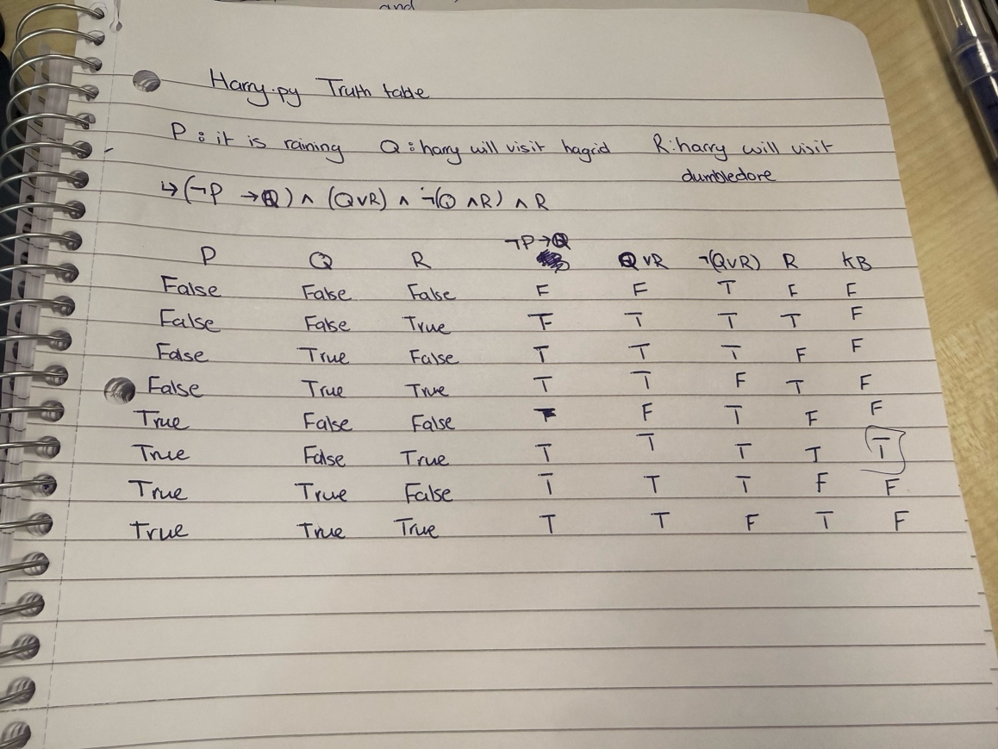
- clue.py: The program prints MsScarlet, library and knife. Explain in plain English why each one must be true.
The output of the code” Msscarlet, library and knife” is true, because with the knowledge of the initial cards being not mustard, not kitchen and not wrench, with the combined knowledge of the known cards being not plum and not ballroom, we are left with only ms scarlet as the person, the library as the room, as for the weapon, and because of the unknown cards we know that one of the cards is not the answer, and since its scarlet , and library then its not the wrench, but the knife.
CS3081 Artificial Intelligence — Lab 3: Propositional Logic Page 1

Task 2 — Change the Knowledge (30 marks, 20 min)
For each change: (a) predict the result, (b) run the code, (c) explain the result.
- harry.py: Delete the last fact dumbledore from the knowledge base. What does the program print now? Why?
Because we know it’s raining because of the knowledge that harry visited dumbledore, without that knowledge, it cannot guarantee that it was actually raining
- puzzle.py: Delete the clue MinervaGryffindor. Who can still be placed in a house? Then add one new clue of your own that makes the answer unique again.
no one can be placed for sure in any house because glideroy is either in grtffindor or ravenclae ane pomona is not in slytherin, it depends on MinervaGryiffendor clue.

Task 3 — Group Challenge: Knights & Knaves (30 marks, 30 min)
On an island, a knight always tells the truth and a knave always lies. Every person is one or the other, never both. Create a new file knights.py that imports logic.py and solves the puzzles below.
Hint — use this pattern for what a person says:
Implication(AKnight, statement) # a knight's statement is true
Implication(AKnave, Not(statement)) # a knave's statement is false
- Puzzle 0: A says “I am both a knight and a knave.”
- Puzzle 1: A says “We are both knaves.” B says nothing.
- Puzzle 2: A says “We are the same kind.” B says “We are of different kinds.”
Bonus (+10 marks) — Puzzle 3: A says either “I am a knight.” or “I am a knave.” (you don’t know which). B says “A said ‘I am a knave’.” B also says “C is a knave.” C says “A is a knight.”

Submission
Create one public GitHub repository named Lab3_GroupX and submit only its link on Blackboard. The repository must contain:
- Lab3_GroupX.pdf — group number, member names, and for each task: your answer, your code, and a screenshot of the output.
- All .py files — logic.py, your changed harry.py and puzzle.py, and your new knights.py.
- README.md — member names and one line on how to run knights.py.
Before you submit: open your link in a private (incognito) browser window to check that it works.

Grading Rubric
Task | What is checked | Marks
Task 1 | Correct truth table and clear explanations | 30
Task 2 | Predictions, results and explanations; a working new clue | 30
Task 3 | Puzzles 0–2 encoded correctly with output and explanation | 30
Submission | Clear PDF and complete GitHub repository | 10
Total |  | 100
Bonus | Puzzle 3 solved and explained | +10
CS3081 Artificial Intelligence — Lab 3: Propositional Logic Page 2

