**Initial Design Review (IDR)**

**Cause And Effect**

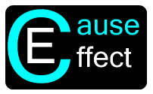

**By:**

**Keith Adler**

**Matthew Brannick**

**Tomin Kozhimala**

**William Vennes**

Table of Contents

Vision Statement 3

User Stories 4

High Priority User Stories 4

Medium Priority User Stories 4

Low Priority User Stories 5

Phone/Physical Rules 5

Account Sync Rules 5

Alternative Solutions and Designs 6

Rule View Activity 6

Drag and Drop View 7

Rule Creation Activity 8

My Rules Activity (Version 2) 9

Account Sync Activity 10

My Rules Activity 11

Help Activity 12

Android Screen Flow Diagram 13

Risk Management Plan 14

Proposed Budget 14

Source Code Repository 14

Appendix 15

Phone/Physical Rule User Stories 15

Account Sync Rule User Stories 17

# Vision Statement

# Cause And Effect: For people wanting to make their smart devices truly intelligent. Today, smart phones are overly complex and jammed pack with functionality. Despite having the power to do so many spectacular things, smart devices lack the ability for users to take control and put the phone to work for them. Cause and Effect is a software solution that let users easily program their smart devices to respond to a set of rules with a chosen effect. With Cause and Effect, smart devices will become more intelligent and make user’s lives easier by intuitively automating tasks, gathering information, displaying information, etc. Unlike other rule based software, Cause and Effect will provide more functionality and a better user interface to allow any type of user to take control of their phone.

# User Stories

We met with Samsung and outlined our requirements for the project. These requirements are organized into user stories, so that we can develop a project in a structured manner that abides by our agile development methodology. Some user stories can be considered "epic." Epic user stories are high level requirements and are intended to be broken into sub user stories and tasks when developed. For organizational purposes, the stories are organized into three categories. High Importance user stories are user stories that the client specifically asked for, are epic, or are "need to haves." Medium important stories are the "nice to haves" and complete "if extra time is available." Low importance user stories consist of our project backlog and end product ideas.

## High Priority User Stories

* As a client, I want a rules engine, so that users can automate phone actions.
* As a client, I want a fluid user interface, so that all users can use our application with ease.
* Extensible to Third Parties
* As a client, I want rules to work with Boolean algebra, so that users can create complex rules to tailor to their needs.
* As a client, I want rules to be sharable, so that users can easily distribute their rule frameworks to others
* As a client, I want the application to require a minimum of Android version 4.0 (Ice Cream Sandwich), so that we can utilize the next generation of Android devices.
* As a client, I want the application to run on all Android v4.0+ devices, so that we can have as much user compatibility as possible
* As a client, I want to include NFC based rules and sharing, so that the app can make use of Samsung's latest hardware sharing technology.
* As a client, I want rules that react to the user's location, so that users can create intricate rules using any given location.
* As a client, I want to include Wi-Fi based rules and sharing, so that the app can make use of local network capabilities.

## Medium Priority User Stories

* As a client, I want the application to be optimized for battery efficient, so that the application will not drain the phone's battery life.
* As a client, I want an additional drag and drop rule creation interface, so that the user can choose to have a fluid look and feel while creating rules.
* As a developer, I want to be able to also share using email, MMS, Facebook, and Dropbox, so that users can have options on the sharing medium.
* As a developer, I want to create user notifications, so that users are aware of the application's activity and progress.
* As a developer, I want to include a user preferences activity, so that users can tweak and enable settings for the application.
* As a developer, I want to have text message based rules, so that I can debug rules using the phone's mobile network.
* As a developer, I want to have time based rules, so that I can debug the application easily.
* As a developer, I want to have vibrate based rules, so that I can debug the application easily.
* As a developer, I want to have "Toast" based rules, so that I can debug the application easily.
* As a developer, I want to have Facebook based rules, so that I can test the account sync rules.
* As a developer, I want to have Google based rules, so that I can test the account sync rules.
* As a developer, I want to have Dropbox based rules, so that I can test the account sync rules.

## Low Priority User Stories

* As a developer, I want to have screen animations, so that the application is fluid and aesthetically pleasing.
* As a developer, I want a cool logo, so that our application is memorable and aesthetically pleasing.
* As a developer, I want a cool application icon, so that our application is easy to recognize on the Android home screen.

### Phone/Physical Rules

There are many phone features that will be included in the final product. Some of the rule types are considered more important, and there are listed above and are not included in this list. For the sake of space and organization, the list of phone based rules are listed as an appendix at the end of this document.

### Account Sync Rules

There are also numerous account types that will be integrated in the final product. The plethora of accounts and rule types even prompted the creation of a "Category View" that will be the default view for browsing rule options. For the sake of space and organization, the list of account types are listed as an appendix at the end of this document.

# Alternative Solutions and Designs

Each member of the team came up with their own designs for the application. The overall design was created using different ideas and functions from each individual design.

## Rule View Activity

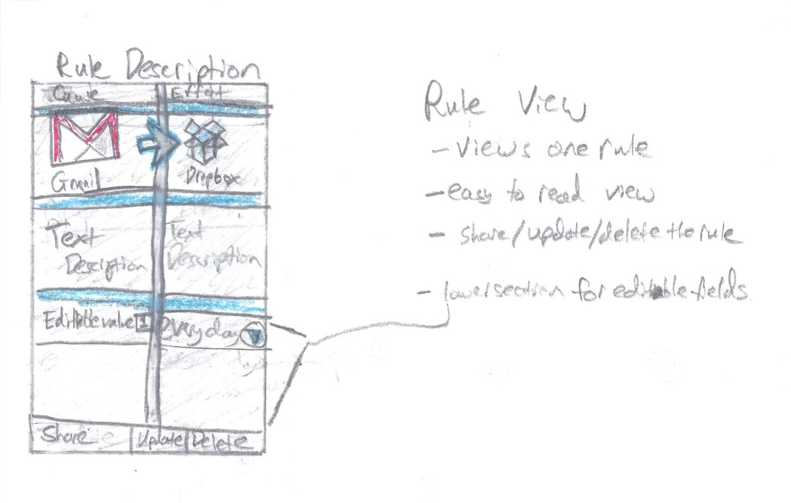

* Here, the user will follow the rule description page as they create the rule. They click on the cause size to choose a cause, and the effect page to choose an effect. As the user adds causes and effects, they will return to this page to see how their rule looks as they create it.

## Drag and Drop View

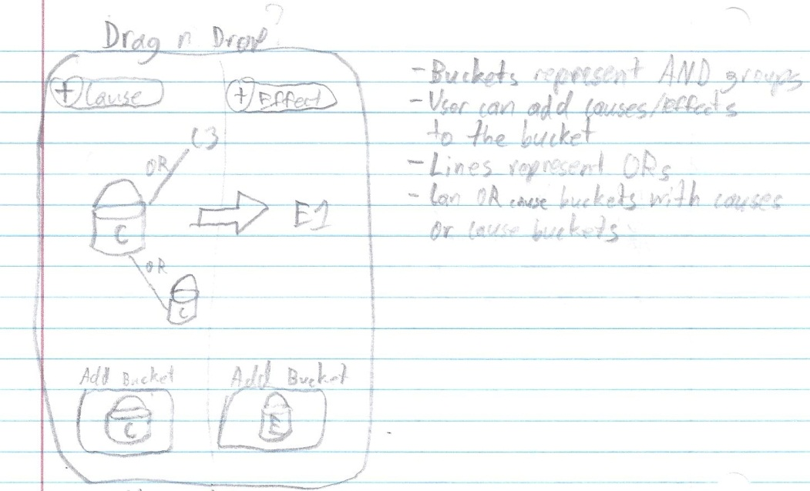

* Here is an idea for a drag and drop implementation of the rule creation page, in which users place selections in “buckets” to represent groups of causes or effects, and link them to other buckets or individual items by an OR line. This would create a more abstract view of how the user creates rules.

## Rule Creation Activity

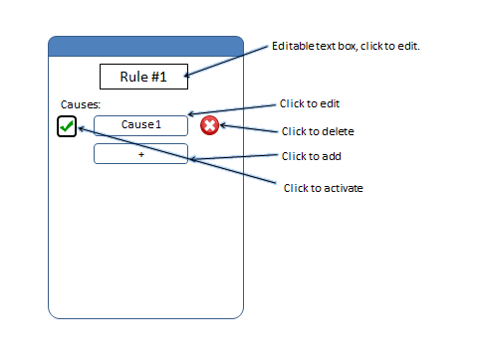

* Here is a rule creation page in which causes and effects are separated by different pages and takes a more list view approach.

## My Rules Activity (Version 2)

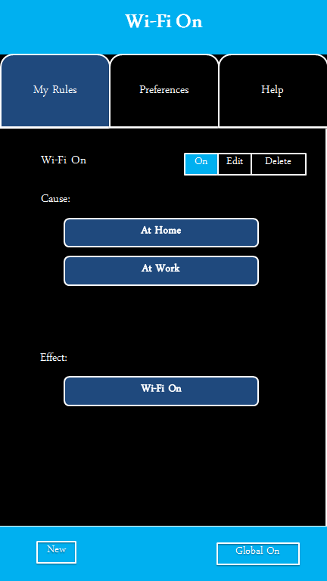

* Another rule view where causes and effects are listed sequentially in a list format.

## Account Sync Activity

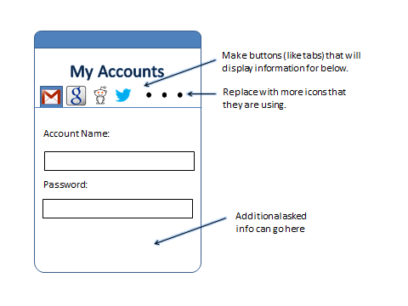

* This is an accounts page in which the user syncs their Google, Facebook, etc. accounts for use with rule creation. Another idea was moving the list of accounts to a separate page accessed from preferences, rather than a slide at the top.

## My Rules Activity

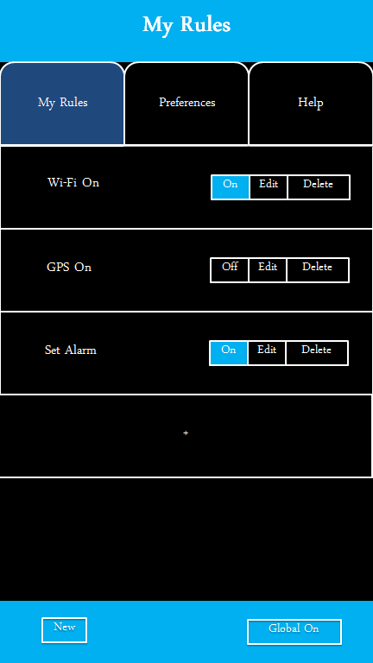

* This was an idea for viewing existing rules. It has options to turn each rule on or off, delete, and edit.

## Help Activity

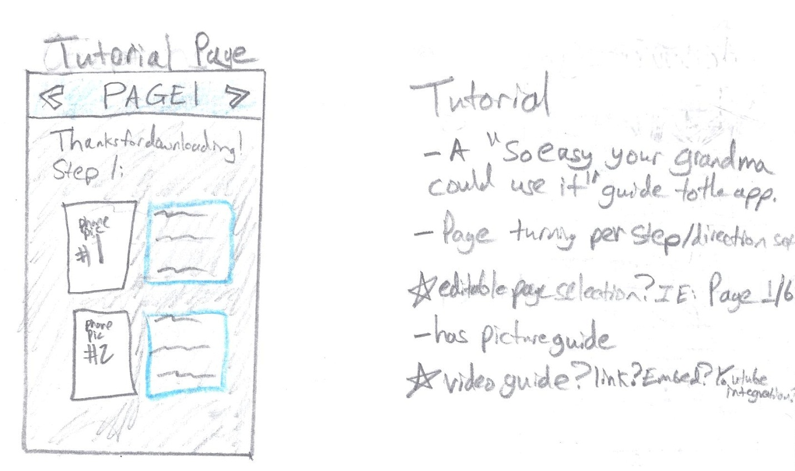

* One idea we had was for a tutorial page or overlay, where first time users can learn how to use the app.

## Image (8)Android Screen Flow Diagram

* This is the general flow diagram that is being used for the navigation and usage of the app.

# Risk Management Plan

We looked at all aspects of what could possibly affect the quality/security of the application. To start off, when developing any application for mobile devices, one must be aware that there are multiple different types of mobile devices (even just androids) that must deliver the same package to every user. And for most users of android, people tend to have off data encryption on their phone so any person that can get into the phone through our application (malware) will then have access to a lot of their information. Another way for them to lose a lot of their information is to simply lose their phone somewhere. There is no implemented password or anything to get into the app once you have unlocked the phone. And the last part is simply account security. I wanted to mention this specifically since it is such an important issue since people think, “what’s the worst they could do if they got into my phone?” Leaking of personal information is a large issue that we will try to tackle in our application development.

# Proposed Budget

Our current proposed budget is $0.00. One of the benefits of a pure computer science group is that most of our project costs only time. We were provided 4 mobile devices from Samsung Mobile in order to debug and test our application across a variety of devices. All of our software is free and open source. We are using the Eclipse IDE with the Android Development Plug-in. Our source control is hosted privately by Bitbucket for free as well. This was because we could use our smu.edu email accounts to register and create free private repositories. Due to the client's recommendation and our interest, we chose Mercurial as our source control type.

# Source Code Repository

Our Repository can be found at:

**https://Talador12@bitbucket.org/Talador12/ceandroid**

Feel free to request read privileges and/or follow our project.

# Appendix

Here is the list of all of the user stories that are included in the low priority list. This list is enormous but it includes all of the rule types implemented by our competitors and much more.

## Phone/Physical Rule User Stories

* As a developer, I want to be able to access location using the mobile service, mobile data, Wi-Fi, and GPS, so that I can regulate a relationship between battery use and accuracy.
* As a developer, I want to be able to open a given location in a maps application, so that the user may view location data on their phone.
* As a developer, I want to be able to open a given location in a navigation application, so that the user may access navigation features on their phone.
* As a developer, I want to be able to integrate Bluetooth functionality, so that users can use rules and sharing that utilizes the phone's Bluetooth capabilities.
* As a developer, I want phone call based rules, so that the user can take communicate effectively using our application.
* As a developer, I want sound based rules, so that the user can get clear notification of events, even when not looking at the device.
* As a developer, I want the app to feature media message based rules, so that the user can handle complex message types.
* As a developer, I want the application to access the display features, so that the display can be turned on or off as desired by the user.
* As a developer, I want the application to recognize when it is docked, so that the user can create rules based on docking status.
* As a developer, I want the application to be able to send fax messages, so that our users can use this functionality.
* As a developer, I want the application to recognize when headphones are plugged in, so that the user can create rules based on headphones.
* As a developer, I want the application to recognize when an external display is plugged in, so that the user can create rules that interact with the external display.
* As a developer, I want to include rules associated with the calendar, so that users can interact with their schedules using our application.
* As a developer, I want to take advantage of Android (and especially Android 4.1)'s voice commands, so that the user can interact with rules using their voice.
* As a developer, I want the application to be able to open or terminate other applications, so that the user can optimize application flow on their phone.
* As a developer, I want the application to be able to access the phone's memory and storage, so that the user can interact with the phone's data hardware.
* As a developer, I want the application to interact with the audio player, so that the user can create rules based on audio.
* As a developer, I want the user to be able to change phone preferences with our application, so that the operating system is editable by rules.
* As a developer, I want rules that effect the battery usage, so that the user can optimize battery life using our application.
* As a developer, I want to access the LEDs, because that would be a really cool feature that all users could enjoy.
* As a developer, I want to access the phone's alarm system, so that the user can edit their alarm settings using rules.
* As a developer, I want to be able to toggle airplane mode, so that the user can access this feature using rules.
* As a developer, I want to be able to change the wallpaper using our app, so that users can have dynamically changing or updating wallpapers.
* As a developer, I want to be able to manage files on the device use our app, so that users can manage their file structure using rules.
* As a developer, I want to access the camera, so that users can create rules that can utilize the camera's features (new photo, flash, etc).
* As a developer, I want rules that can access the current time zone, so that the user can utilize different time zones as they change.
* As a developer, I want rules that access email, so that the user can manage their email using our rules engine.
* As a developer, I want rules that can access the web, so that the user can access web content using our rule system.
* As a developer, I want the access the state of the USB tethering, so that the user can build rules from this.
* As a developer, I want to be able to build rules for a wireless hotspot, so that the user can utilize their over expensive data plan or rooted phone.
* As a developer, I want to be able to access the phone's Radio, so that there can be rules that use the radio.
* As a developer, I want the be able to access different profiles, so that the user can enable or disable sets of rules at any time (even with rules).
* As a developer, I want to integrate rule types for the lock screen, so that the user can create rules using the lock functionality.
* As a developer, I want rules that access the motion sensors/accelerometers, so that the user can create rules based on the motion of the phone.
* As a developer, I want rules that access the gyroscope, so that the user can create rules based on the device's orientation.
* As a developer, I want to access when the phone is shutdown or restarted, so that the user can create rules based on these actions/events.
* As a developer, I want to know when the first boots up, so the user can respond using a set of rules.
* As a developer, I want to access the phone's current state, so that the user can use that state in rules.
* As a developer, I want language based rules, so that the application can be used internationally and for translation.
* As a developer, I want debug based rules, so that the user can create sets of rules for debugging their applications (including this one).
* As a developer, I want to be able to interact with a printer, so that the user can create rules that interact with the printer.
* As a developer, I want to allow the user to directly input JavaScript, so that a technical user can use the rules engine to its fullest.
* As a developer, I want to access the weather status, so that the user can use rules based on this.
* As a developer, I want to access emergency messages, so that the user is quickly informed of hazards.
* As a developer, I want to access the news, so that the user can create rules based on this.
* As a developer, I want to create rules based on traffic, so that the user can create rules for this.
* As a developer, I want to access Stocks, so that the user can integrate with any stock service.
* As a developer, I want to access Banking, so that the user can manage their banking using rules.
* As a developer, I want to store VPN settings, so that the user can manage VPN connections.
* As a developer, I want to react to Data roaming, so the user can include this state in rules.
* As a developer, I want to access Voicemail, so that the user can manage voicemail using rules.
* As a developer, I want to know when something is downloaded and uploaded, so the user can create rules for this.
* As a developer, I want to be able to access movie times, so that the user can create rules for this.

## Account Sync Rule User Stories

* As a developer, I want to access Dropbox, so that the user can manage their files stored on the cloud.
* As a developer, I want to access Evernote, so that the user can manage their notes using this rules engine.
* As a developer, I want to access Flickr, so that the user can manage photos using this application.
* As a developer, I want to access Craigslist, so that the user can interact with this service using our application.
* As a developer, I want to access Blogger, so that the user can interact with blogs using rules.
* As a developer, I want to access RSS feeds, so that users can integrate their rules with the feeds.
* As a developer, I want to access Gmail, so that the user can use Google email as an email source for rules.
* As a developer, I want to access eBay, so that the user can interact with this service using our rules.
* As a developer, I want to access Instagram, so that the user can manage their sepia stained photos.
* As a developer, I want to access Twitter, so that the user can tweet using our rule system.
* As a developer, I want to access Steam, so that users can interact with their gaming communities using this application.
* As a developer, I want to access Foursquare, so that users can interact with this service and sync the user's location using this service.
* As a developer, I want to access Google+, so that users can interact with social media.
* As a developer, I want to access Pintrest, so users can manage their boards using our app.
* As a developer, I want to access Path, so users can stay connected with family & close friends.
* As a developer, I want to access last.fm, so users can manage music using our application.
* As a developer, I want to access LinkedIn, so users can manage their professional identities.
* As a developer, I want to access Google and Yahoo Finance, so users can manage their financial interests using our app.
* As a developer, I want to access YouTube, so they can manage their video accounts.
* As a developer, I want to access Word Press, so they can manage their blogs.
* As a developer, I want to access Tumblr, so that users can manage their Tumblr content.
* As a developer, I want to access StumbleUpon, so that users can stumble using our application.
* As a developer, I want to access Yahoo, so that users can manage their Yahoo accounts.
* As a developer, I want to access Windows live, so that users can integrate with their Window's live features.
* As a developer, I want to access ESPN, so that users can manage their sports.
* As a developer, I want to access GroupMe, so that users can manage group text messaging using our app.
* As a developer, I want to access Samsung Kies, so that users can update their hardware using this application.
* As a developer, I want to access Amazon, so that users access this service.
* As a developer, I want to access Newegg, so that users can interact with this online store.
* As a developer, I want to access Google play store, so that the user can create rules involving the Android marketplace.
* As a developer, I want to access Google voice, so that users can integrate with voice accounts.
* As a developer, I want to access AIM, so that users can interact with this messaging service.
* As a developer, I want to access Google Talk, so that users can interact with this service.
* As a developer, I want to access Skype, so that users can text/audio/video with other users.
* As a developer, I want to access Netflix, so that users can build rules for this type.
* As a developer, I want to access Hulu Plus, so that users can build rules for this type.
* As a developer, I want to access Kindles, so that users can interact with these accounts and devices.
* As a developer, I want to access Wikipedia, so that users can be well informed.
* As a developer, I want to access App.net, so that other developers can create rules based on this wonderful service.
* As a developer, I want to access Bit.ly, so that users can save, share, & discover links.
* As a developer, I want to access Buffer, so that users can have a smart way to share on social media.
* As a developer, I want to access Delicious.com, so that users can access cooking and recipe features.
* As a developer, I want to access Diigo, so that users can collect and organize using our app.
* As a developer, I want users to be able to ordering food (Example: Pizza Hut), so that users can automate this process.
* As a developer, I want to access Readability, so users can read comfortably if they prefer to.
* As a developer, I want to access Storify, so that users can create custom scenarios using social media.
* As a developer, I want to access Spotify, so that users can manage their media libraries.
* As a developer, I want to access Rdio, so that users can listen to music whenever they want.
* As a developer, I want to access Svpply, so that users can shop a wide variety of products.
* As a developer, I want to access Vimeo, so that users can have multiple options for viewing media.
* As a developer, I want to access ZooTool, so that users can bookmark and share content with ease.
* As a developer, I want to access Myspace, so that users can access music and video based social media.
* As a developer, I want to access Friendster, so that users can access this social media source.
* As a developer, I want to access 4chan, so that our application can address a wide user base.
* As a developer, I want to access Classmates.com, so that users can communicate with old classmates using our app.
* As a developer, I want to access Deviant art, so that users can manage their art portfolios using our application.
* As a developer, I want to access CrunchyRoll, so that users can be notified of new release dates.
* As a developer, I want to access Blogster, so that users can manage their blogs.
* As a developer, I want to access IGN, so that users can use this game database functionality.
* As a developer, I want to access GameFly, so that users can order games using our application.
* As a developer, I want to access IMDB, so that users can use this movie database functionality.
* As a developer, I want to access Grindr, so that our application is usable for many audiences.
* As a developer, I want to access Live journal, so that users can manage their personal publishing.
* As a developer, I want to access Xanga, so that users can manage their own blogs.
* As a developer, I want to access Yelp, so that users can access local reviews and information.
* As a developer, I want to access Bebo, so that users can use this social media outlet.
* As a developer, I want to access Badoo, so that users can communicate with local people.
* As a developer, I want to access stackoverflow, so that users can communicate on these developer forums.
* As a developer, I want to access XDA developers, so that developers can communicate on this medium.
* As a developer, I want to access the MSDN, so that developers can use this means of communication.
* As a developer, I want to access Digg, so that users can stay up to date on current events.
* As a developer, I want to access Orkut, so that users can social network and discuss using Google's engine.
* As a developer, I want to access Playstation Network, so that we can accompany Playstation users.
* As a developer, I want to access MSN, so that users can use access this functionality.
* As a developer, I want to access Bing, so that users can choose which search engine they wish to use.
* As a developer, I want to access AOL, so that we can address all user types.
* As a developer, I want to access Ask.com, so that users can have their questions answered.
* As a developer, I want to access Google's basic search, so that users can use this search engine.
* As a developer, I want to access CNN, so that users can receive updates about news.
* As a developer, I want to access FOX, so that users can receive updates about entertainment.
* As a developer, I want to access ABC, so that users can receive updates about news.
* As a developer, I want to access BBC, so that users can integrate with an international news source.
* As a developer, I want to access Wolfram Alpha, so that users can do complex math using our application.
* As a developer, I want to access Whitepages, so that users can quickly search this database.
* As a developer, I want to access Yellowpages, so that users can quickly search this database.
* As a developer, I want to access RememberTheMilk.com, so that users can update and receive reminder notifications.
* As a developer, I want to access iTunes, so that users can integrate their phone with this music application.
* As a developer, I want to access Apple accounts, so that users can integrate their Android device with Apple hardware.
* As a developer, I want to access PayPal, so that users can manage purchases using this application.
* As a developer, I want to access GoDaddy, so that users can manage website domains using our application.
* As a developer, I want to access 4shared, so that users can manage files on this service.
* As a developer, I want to access The Weather Channel, so that users can have more accurate weather on demand.
* As a developer, I want to access SourceForge, so that developers can manage their projects from their phone.
* As a developer, I want to access GitHub, so that developers can manage their code repositories.
* As a developer, I want to access Bitbucket, so that developers can manage their code repositories.
* As a developer, I want to access Walmart, so that users can be aware of updates and make purchases.
* As a developer, I want to access Target, so that users can utilize this department store's API.
* As a developer, I want to access Fedex, so that users can monitor shipping status.
* As a developer, I want to access UPS, so that users can monitor shipping status.
* As a developer, I want to access Dictionary.com, so that users can define words.
* As a developer, I want to access Urban dictionary, so that users can understand local colloquialisms.
* As a developer, I want to access Thesaurus.com, so that users can use this service.
* As a developer, I want to access Google Documents, so that users can manage their documents from our app.
* As a developer, I want to access Google Drive, so that users can manage their files on this service.
* As a developer, I want to access GroupOn, so that users can get deals from local businesses.
* As a developer, I want to access Living Social, so that users can receive deals on local services.
* As a developer, I want to access Urban Spoon, so that users can have information on cooking at hand.
* As a developer, I want to access Rhapsody, so that users can use this music player.
* As a developer, I want to access Imugr, so that users can manage their image files.
* As a developer, I want to access Heroku, so that users can manage their projects using this service.
* As a developer, I want to access Speedtest.net, so that users can check their current connection status with detail.
* As a developer, I want to access Photobucket, so that users can manage their image and video files.
* As a developer, I want to access Pandora, so that users can use this music service.
* As a developer, I want to access CNet, so that users can view technical reviews on products.
* As a developer, I want to access Battle.net, so that these users can manage their accounts.
* As a developer, I want to access Grooveshark, so that users can use this music service.
* As a developer, I want to access Monster, so that users can find the job that's right for them.
* As a developer, I want to access the NFL, so that users can receive updates from this feed.
* As a developer, I want to access Expedia, so that users can manage travel details.
* As a developer, I want to access Hotels.com, so that users can manage travel details.
* As a developer, I want to access Kayak, so that users can manage travel details.
* As a developer, I want to access Travelpedia, so that users can manage travel details.
* As a developer, I want to access Engadget, so that users can be up to date on technology news.
* As a developer, I want to access Slashdot, so that users can be up to date on technology news.
* As a developer, I want to access Fandango, so that users can manage movie tickets.
* As a developer, I want to access Ticketmaster, so that users can book and manage tickets.
* As a developer, I want to access StubHub, so that users can book and manage tickets.
* As a developer, I want to access Match.com, so that users can communicate with local individuals.
* As a developer, I want to access Rotten Tomatoes, so that users can use this movie review service.
* As a developer, I want to access Twilio, so that users can manage VoIP, Voice, and Text applications over the web.
* As a developer, I want to access Metro Lyrics, so that users can search for song lyrics.
* As a developer, I want to access Shazam, so that users can recognize songs using this service.
* As a developer, I want to access the NBA, so that users can receive updates from this service.
* As a developer, I want to access Dailymotion, so that users can upload, share, and embed their own videos.
* As a developer, I want to access Chacha, so that they can have their questions answered.
* As a developer, I want to access Best Buy, so that users can access this API service.
* As a developer, I want to access Quora, so that users can connect and share content using this service.
* As a developer, I want to access Voxeo, so that users can manage their cloud computing profiles.
* As a developer, I want to access "Let me Google that for you," so that users can share knowledge with peers.
* As a developer, I want to access About.com, so that users can solve their needs.
* As a developer, I want to access eHow, so they can use this service for information.
* As a developer, I want to access Mustang TRAK, so that users can manage their SMU job profiles.
* As a developer, I want to access to Access.smu.edu, so that users can manage their student accounts using our application.
* As a developer, I want to access Blackboard, so that users can manage their classes using this rules engine.