**References**

**[Glassdoor]**

<http://www.glassdoor.com/Salary/Samsung-Group-Software-Engineer-Salaries-E3363_D_KO14,31.htm>

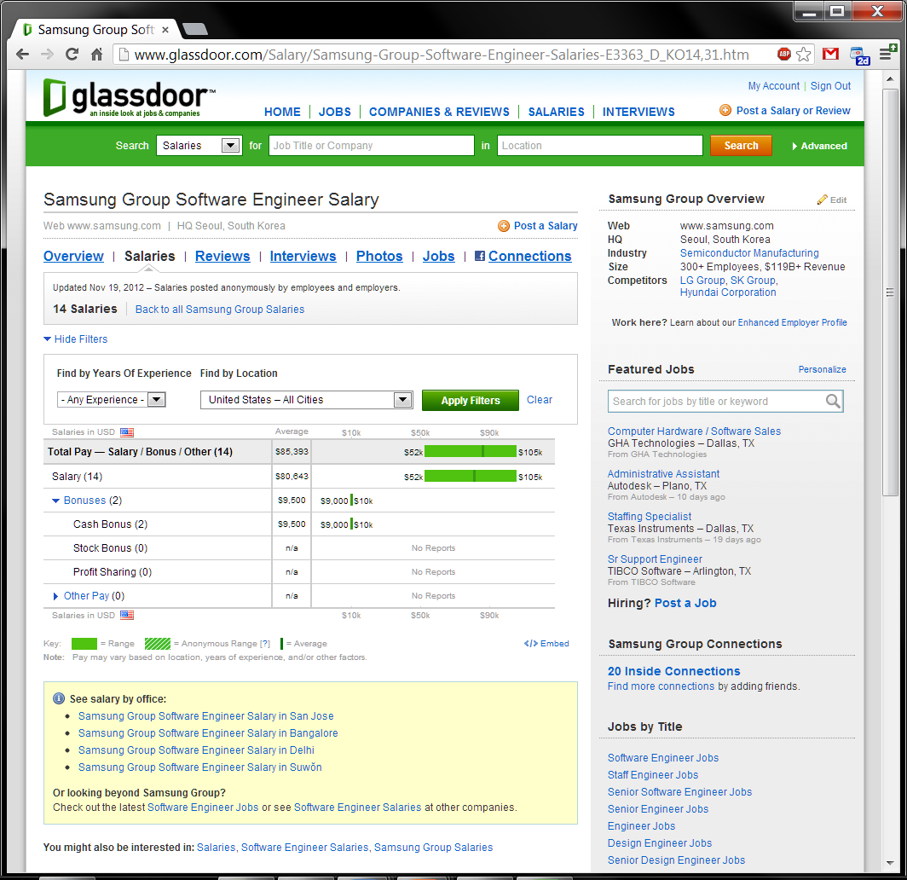

**[Bureau of Labor Statistics]**

<http://www.bls.gov/news.release/ecec.nr0.htm>

