# Project Report

# Project Title:

**Labour4U**

# Group Members:

* Syed Ahmed Hashir (18k-1100)
* Abeer Fatima (18k-0304)
* Ruba Waqar (18k-1099)

# Introduction:

The main idea of the project is that a user can easily book a worker for a specified date while at home; on the other hand, the worker can accept incoming jobs from bookings.

# Description:

This project would be a platform to connect the local area labors and the people who need their help. The user would be able to have a worker at their home through this online portal, just by contacting them through this application. On the other hand, the labor or the workers would be able to get more customers through this user-friendly platform.

# Function:

The main function of this website is booking; i.e booking a worker for a specified date. The worker can choose to accept this booking and accept the job, but if the job was of an old date, then the booking will have been expired.

# Technologies:

Languages used for front-end: Html, Css, Javascript, Jquery

Languages used for Back-end: Php, Ajax.

Database Language: MySql.

Software used: Xampp, DataModeler, SqlYog.

# Normalization:

(Done on paper and images attached)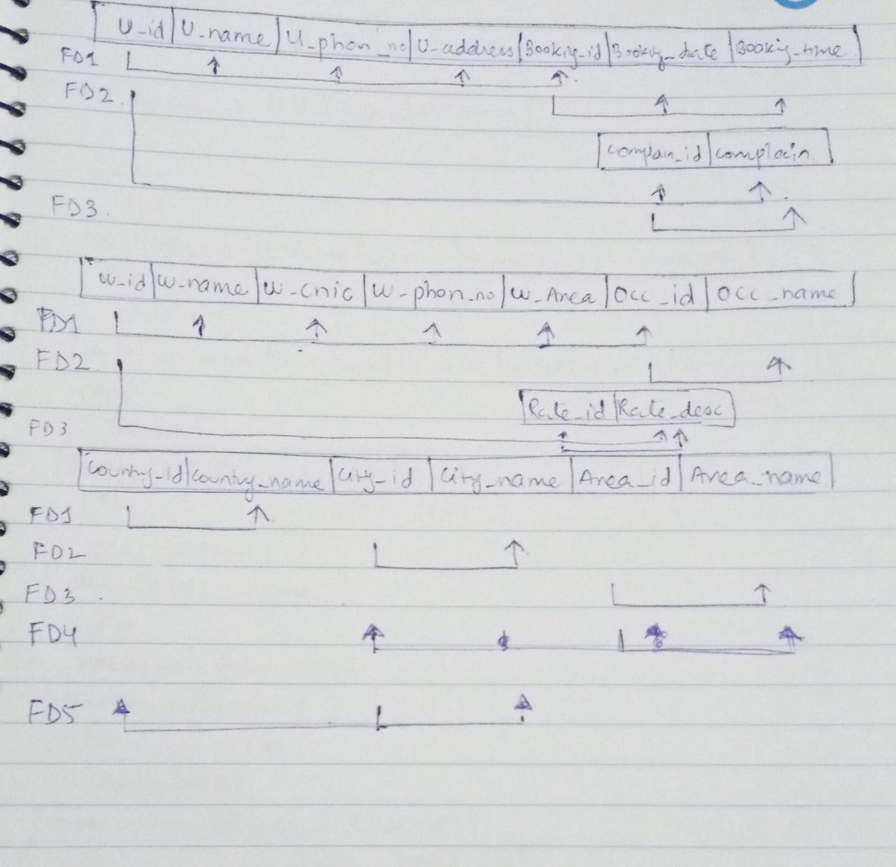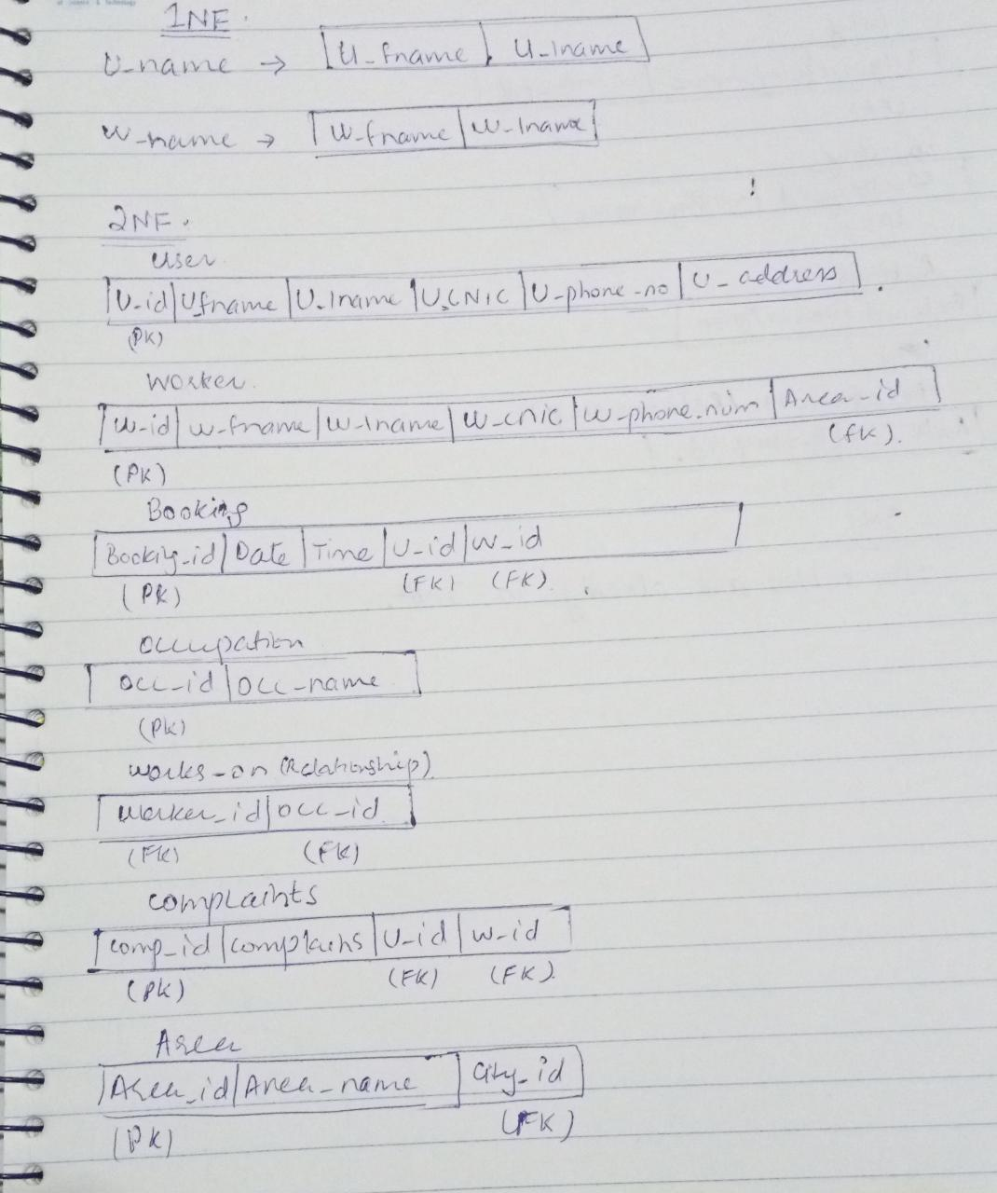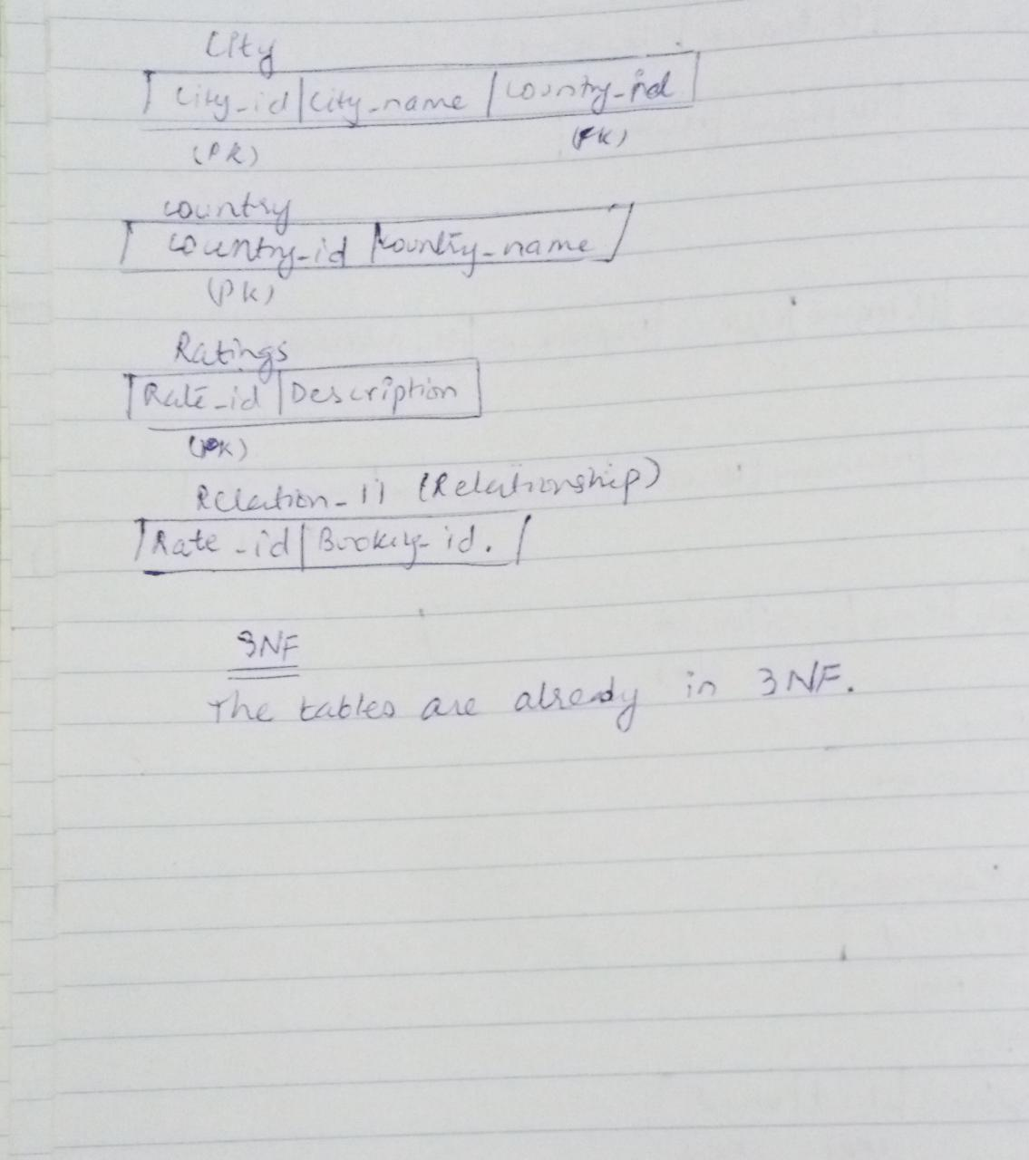

In the booking table, we used User_user_id, Worker_worker_id and Date as a composite key, since date will be different for same user and worker ids, and then we changed the primary key it to a system generated primary key i.e. booking_id, to make it easier to handle the data in other tables.

# Entity Relation Diagram:

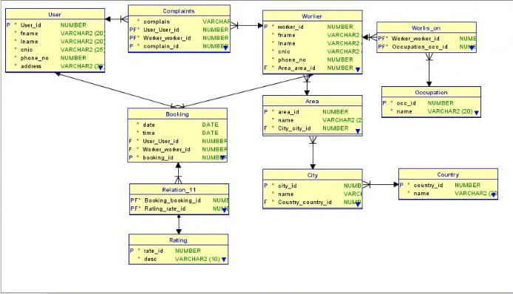

## Entities:

* User: This table holds all the data of the user, along with their login information.
* Worker: This table includes all the data of the worker, along with the area they operate in.
* Area: These are the areas that have workers operating from, a worker can add a new area at the time of registration, with city id as foreign key.
* City: Same as area, with Country id as a foreign key.
* Country: Same as area
* Booking: This table holds the booking information made by the user, which includes date and time of the booking, as well as the booking status.
  + *Done=0; the user has made a booking but the worker has not yet accepted.*
  + *Done=1: the user has made a booking and the worker has accepted the job.*
  + *Done=2: the worker has completed the job and the booking is now finished.*
* Complain: Complains registered by the user are stored here, and use booking id to specify the complaint.
* Occupation: All the occupations that have at least one worker registered for. A worker can add a new occupation if need be.
* Rating: The values of ratings for a worker.

## Relationship Tables:

* Works_on: Relationship for worker and occupation, to specify which worker is registered in which occupation.
* Relation_11: This relation is between rating and booking, meaning it will tell which booking is given what rating.