The Assessment of Obesity through predictive models

Christopher Ge Yong, Lim
School of Computing and Aritificial Intelligence
Sunway University
Petaling Jaya, Malaysia
22049472@imail.sunway.edu.my

Muhammad Talal Naveed
School of Engineering and Technology
Sunway University
Petaling Jaya, Malaysia
22062186@imail.sunway.edu.my
Zhong Qing, Tan
School of Computing and Aritificial Intelligence
Sunway University
Petaling Jaya, Malaysia
22031892@imail.sunway.edu.my
Jia Heng, Goh
School of Computing and Aritificial Intelligence
Sunway University
Petaling Jaya, Malaysia
22094551imail.sunway.edu.my

In this digital age, social and web analytics has become ever more crucial in navigating user behavior while supplementing business decisions. The rise of social media usage in the daily lives of consumers has led to analytics being crucial to identify trends to gain an insight into the market. Despite the many ways of analyzing data, many struggle to identify the best way to analyze data for specific fields, in this case healthcare data in regard to obesity. This study aims to assess the performance of various predictive models towards an obesity centric healthcare dataset, and to find the best performing model among them. The dataset is obtained from an online repository provided, which the models will then be used towards the dataset to assess each model’s performance. These results will allow companies to identify the best performing model to predict obesity related data.
Keywords—obesity, comparison, algorithm, predictive modelling, healthcare

Introduction (Heading 1)
The issue regarding obesity has become an increasing concern since the 1980s [1]. Obesity has become widespread, which leads to concern towards it by various parties. The World Health Organization defines obesity as an excessive and abnormal accumulation of adipose tissue within the body, which could potentially signify health issues. Obesity is primarily indicated by the BMI score ranging between 25 and 30, which is calculated through the height and weight of an individual [2]. Obesity inevitably affects various aspects of life, which ranges from personal health to societal roles.
While there are a myriad of ways for obese individuals to lose weight, the obesity rate has somehow risen in the past few years [3]. The objective of this report is to perform predictive analysis on medical information about the estimation of obesity in contrast to eating habits and medical conditions of individuals recorded. This report focuses on assessing eating habits and medical conditions, and the effects the following variables would have on potentially obesity predictions.
Through this report, we aim to visualize potential variables that might significantly impact the potential obesity predictions, and to visualize potential areas of impact that can help public understanding towards the effective treatment of obesity, which aims to create alternative options for treating obesity in efficient and effective ways.

Literature Review

Introduction to Literature Review
This section reviews research done previously on the comparisons of predictive models towards healthcare data focused on obesity statistics. By understanding and analyzing existing works, it will help identify research gaps and assist the development process of this research. The articles reviewed were selected based on their relevance in terms of the models used, its relevance towards prediction models, which are published in high-quality peer-reviewed journals and sources.

Review of Articles
Gozukara Bag et al. [4] conducted a comprehensive estimation of obesity levels through predictive based models, which revolves around physical activity and nutritional habits. They compared three different predictive models, which the Logistic Regression model came as the most accurate. Self-reported data, regional bias, synthetic sampling limits are some of the limitations that might skew the final results presented within the paper.
Alharbi and Ikram [5] studied the Obesity Risk Level (ORL) based on the combination of K-Means and XGBoost prediction models to predict childhood obesity. Their study excluded important factors and lacked dataset diversity, which might limit the model accuracy and generalization integrity.
Buani and Nuraeni [6] applied an XGB classifier for obesity rate prediction in terms of seven models to compare to accuracy between the models used. The dataset used is obesity data which has healthcare details of individuals with obesity. The study ignored key factors assumed to be important factors influencing obesity, which might affect its ability to test in real-world situations.
Maulana et al. [7] used a hybrid model called the CatBoost machine learning model built from a range of models such as Logistic Regression, K-nearest neighbors (KNN), random forest and naïve Bayes algorithm towards predicting obesity levels. The dataset used primarily focuses on healthcare data focusing on obesity centric data. The model used in this study performed poorly towards certain classes, which is attributed to the limited number of instances based on the findings within the paper.
Kabongo et al. [8] pitted utilized five machine learning supervised algorithms to analyze and predict obesity data. The models used were Random Forest Classifier, K-nearest Neighbors Classifier, Support Vector Machine, Logistic Regression and Ridge Classifier. The data used was centered around obesity related health data. Limited application and sample for each class identified.
Helforoush and Sayyad [9] utilizes prediction models to improve obesity rate prediction. The models used are Logistic Regression, Support Vector machine, Random Forest, XGBoost and LGBM and CatBoost. The dataset used primarily focuses on obesity related data. By removing the height class, the research found that it diminishes performance, which could affect broader applications.
Garg and Pundir [10] conducted a study to create a framework to reduce obesity. The models used are Random Forest, k-NN, Extra Trees, XGBoost and Decision Tree. The study used an obesity focused dataset. A drawback indicated within the study is that the dataset used only covers the South American region, which could be biased in different views.
Solomon et al. [11] utilized seven distinct models to predict and classify obesity data. The models used are SVM, Multilayer perceptron neural network, Ensemble machine learning, Decision tree(ID3), k-NN, Decision trees (DT) and Logistic Regression (LR) and Random Forest. The dataset used focuses on obesity centric healthcare data. The hybrid model highlighted within the research would need more testing for a more stable narrative.
Ayub et al. [12] utilizes a hybrid model designed to enhance interpretability and performance in terms of obesity data prediction. The study used the Abi-LSTM hybrid model. The hybrid model introduced within the study would need further testing towards a variety of datasets to explore its potential.

Made and Supriana [13] focuses on using Case Based Reasoning (CBR) to estimate obesity levels. The models used are the Means Algorithm and the CBR system with K-Means indexing. The data is used in centers around healthcare. The system used lacks a true demonstration, which would need further study with more complex data.
Choudhuri [14] proposes a hybrid machine learning model by utilizing models such as Extremely Randomized Trees, Multilayer Perceptron and XGboost through Python. The dataset used centers around obesity focused data based in South America. The hybrid model would need more testing for concrete feasibility.
Dirik [15] engaged in research to build a robust predictive model for identifying overweight and obese people. The models used are Multilayer Perceptron, Support Vector Machine, Fuzzy K-Nearest Neighbors, Fuzzy Unordered Rule Induction Algorithm, Rough Sets, Random Tree, Random Forest, Naïve Bayes, Logistic Regression and Decision Table. The dataset used primarily focuses on healthcare data critical on obesity statistics. The number of models used could be considered overwhelming for reviewers, which will need renaming to create a more impressionable read.

Comparison Table
- Table of 10 reviewed articles

Reference | Title | Problem Statement | Technique | Findings | Limitations
Gozukara Bag et al. (2023) | Estimation of Obesity Levels through the Proposed Predictive Approach Based on Physical Activity and Nutritional Habits | Obesity is a global epidemic, and effective and robust models are essential to predict obesity using lifestyle data, even when working with imbalanced datasets. | Logistic Regression (LR)  Random Forest (RF)  XGBoost (Extreme Gradient Boosting) | Logistic Regression performed best; RFE improved LR and RF; lifestyle factors showed significant obesity links. | Self-reported data, regional bias, synthetic sampling limits, feature selection affected XGBoost, no longitudinal analysis.
Alharbi and Ikram (2025) | An Obesity Risk Level (ORL) Based on Combination of K-Means and XGboost Algorithms to Predict Childhood Obesity | Traditional methods miss complex factors in childhood obesity; machine learning better predicts risk and patterns. | K-Mean  XGBoost | XGBoost achieved 88.04% accuracy; socioeconomic factors and K-means clustering helped identify childhood obesity risk levels. | Excluded important factors and lacked dataset diversity, limiting model accuracy and broader generalizability.
Buani and Nuraeni (2023) | Application of XGB Classifier for Obesity Rate Prediction | Early detection is critical to addressing obesity in children and in Indonesia and globally. This study, therefore, assessed a range of machine learning models based upon lifestyle and physical activity data. | Logistic Regression (LR)  XGB Classifier (XGB)  Naive Bayes (NB)  Random Forest (RF)  Decision Tree Classifier (DTC)  SVM  K - NN | XGBoost performed the best with an accuracy of 96.69%; ensemble learning models such as Random Forest and Decision Tree were also found to be quite effective; while SVM and Naive Bayes underperformed. | Limited sample size, ignoring key components assumed to be important factors influencing obesity, the inability to test in real-world situations, and a lack of focus on applicability in clinical settings.
Maulana et al. (2024) | Predicting Obesity Levels with High Accuracy: Insights from a CatBoost Machine Learning Model | Rising obesity in Indonesia lacks ML literature, the study used CatBoost algorithm to predict risk and better target health intervention. | Logistic Regression (LR)  K-nearest neighbors (KNN)  random forest  naive Bayes algorithms  CatBoost model | CatBoost provided the best prediction accuracy at 95.98%. Key contributing features include demographics, diet, activity or inactivity, and family history. While the best classification was Obesity Type I. | Limited generalizability and a limited sample for each of the obesity classes, no analysis was conducted, missing key covariates.
Kabongo et al. (2023) | Five Machine Learning Supervised Algorithms for The Analysis and the Prediction of Obesity | Obesity has serious global health problems; this study optimizes prediction capabilities in machine learning for prevention and management. | Random Forest (RF)  Support Vector Machine (SVM)  Logistic Regression (LR)  K-nearest Neighbor  Ridge Classifier | Optimized SVM model resulted in 97% accuracy, high F1-scores across all classes with minimal misclassification rates, which reflects good fit of the model. | Limited in its dataset, population-specific, and sensitive to feature selection and tuning of parameters, struggling with unbalanced real data.
Helforoush and Sayyad (2024) | Prediction and classification of obesity risk based on a hybrid metaheuristic machine learning approach | Predicting obesity requires intelligent models; this study compared multiple machine learning (ML) approaches, including ANN-PSO, to enhance accuracy for clinical decision making. | Logistic Regression (LR)  Support Vector Machine (SVM)  Random Forest (RF)  XGBoost  LGBM  CATBoost | The ANN-PSO had an accuracy of 91.79%; had balanced metrics and high AUC; shap values revealed weight, gender, FAVC, and age as the most significant features. | Limit a Single dataset, SMOTE limitations, tuning dependency, and no validation in clinical or real-time settings.
Garg and Pundir (2021) | MOFit: A Framework to reduce Obesity using Machine learning and IoT | Sedentary lifestyles increase youth obesity; study aims to predict obesity using ML, hyperparameter tuning, and IoT integration. | Random Forest (RF)  K-nearest neighbors (KNN)  XGBoost  Decision Tree  Extra Tree | Random Forest optimized with Grid Search predicted obesity best; Extra Trees and XGBoost with Optuna excelled in regression; Optuna was the most effective tuner. | TModel and HPO may not generalize; unclear dataset specifics; real-world use limited by user compliance and IoT accuracy.
Solomon et al. (2023) | Hybrid Majority Voting: Prediction and Classification Model for Obesity | The complexity of obesity means there is a need for better predictive measures; this study produced a hybrid machine learning (ML) model that improved upon algorithmic measures of classification accuracy. | Gradient boosting classifier  XGB classifier  Multilayer perceptron  K-nearest-neighbour classifier  Logistic Regression  Naive Bayes classifier | The hybrid majority voting method achieved 97.16% accuracy, outperforming all models; smoking, gender, and diet were the key reasons for obesity. | Limited to three countries, self-reporting data, and actual results may vary, plus the single-stage ensemble approach created a limited performance outcome.
Ayub et al. (2024) | Unraveling the Potential of Attentive Bi-LSTM for Accurate Obesity Prognosis: Advancing Public Health towards Sustainable Cities | Obesity presents a health challenge on a global scale that requires precise, interpretable prediction models; enhanced machine learning methodologies aid obesity prevention and urban planning for improved healthier environments. | ABi-LSTM (Attention-based Bidirectional Long Short-Term Memory)  CNN (Convolutional Neural Network)  RNN (Recurrent Neural Network)  LSTM (Long Short-Term Memory)  Bi-LSTM (Bidirectional LSTM without attention)  TabNet  Adam optimizer | Bi-LSTM achieved highest accuracy (96.5%) and metrics, outperforming CNN, RNN, and others; confusion matrix showed minimal misclassifications and robust performance. | Dataset differences limit generalizability; limited hyperparameter tuning; real-world use affected by demographics and environment; larger datasets needed.
Made and Supriana (2023) | CASE BASED REASONING (CBR) FOR OBESITY LEVEL ESTIMATION USING K-MEANS INDEXING METHOD | Obesity leads to serious disease; this study aims to improve obesity estimation using CBR with K-Means for faster predictions. | K - Means Algorithm  CBR System with  K - Means indexing | CBR without K-Means is slightly more accurate; K-Means indexing had a faster retrieval but slightly reduced accuracy due to tied case handling. | Limited by simple test data, tied similarity cases, and only two clusters restricting pattern capture.

Review of Articles
Several studies [4] [6] [8] [9] [11] [15] focus on comparing the performance of predictive models for healthcare data centering around obesity, which mostly lacks in comprehensive analysis towards the results.
A few studies [5] [7] [12] [14] engaged in creating a hybrid model amalgamated from a variety of different predictive models. The utilization of a unique predictive model will need further testing towards more complex datasets to impose a concrete narrative.
A study [10] conducted focuses on creating a framework to train models in terms of obesity data. The study attributes the findings towards real-world situations with clarity.
Research [13] done focuses on utilizing case-based reasoning towards predicting obesity centric data through two predictive models. This approach should be applied towards a wider range of datasets for more insightful results.
Despite numerous studies involving predicting and comparing model performance, few highlight the potential

Research Methodology

Introduction to Methodology
This section outlines the methodology used to develop and evaluate predictive models for obesity statistics, detailing the steps taken to preprocess health data of patience, the selection of suitable models, and the assessment of model performance to identify the most accurate model within the models used.

Research Framework
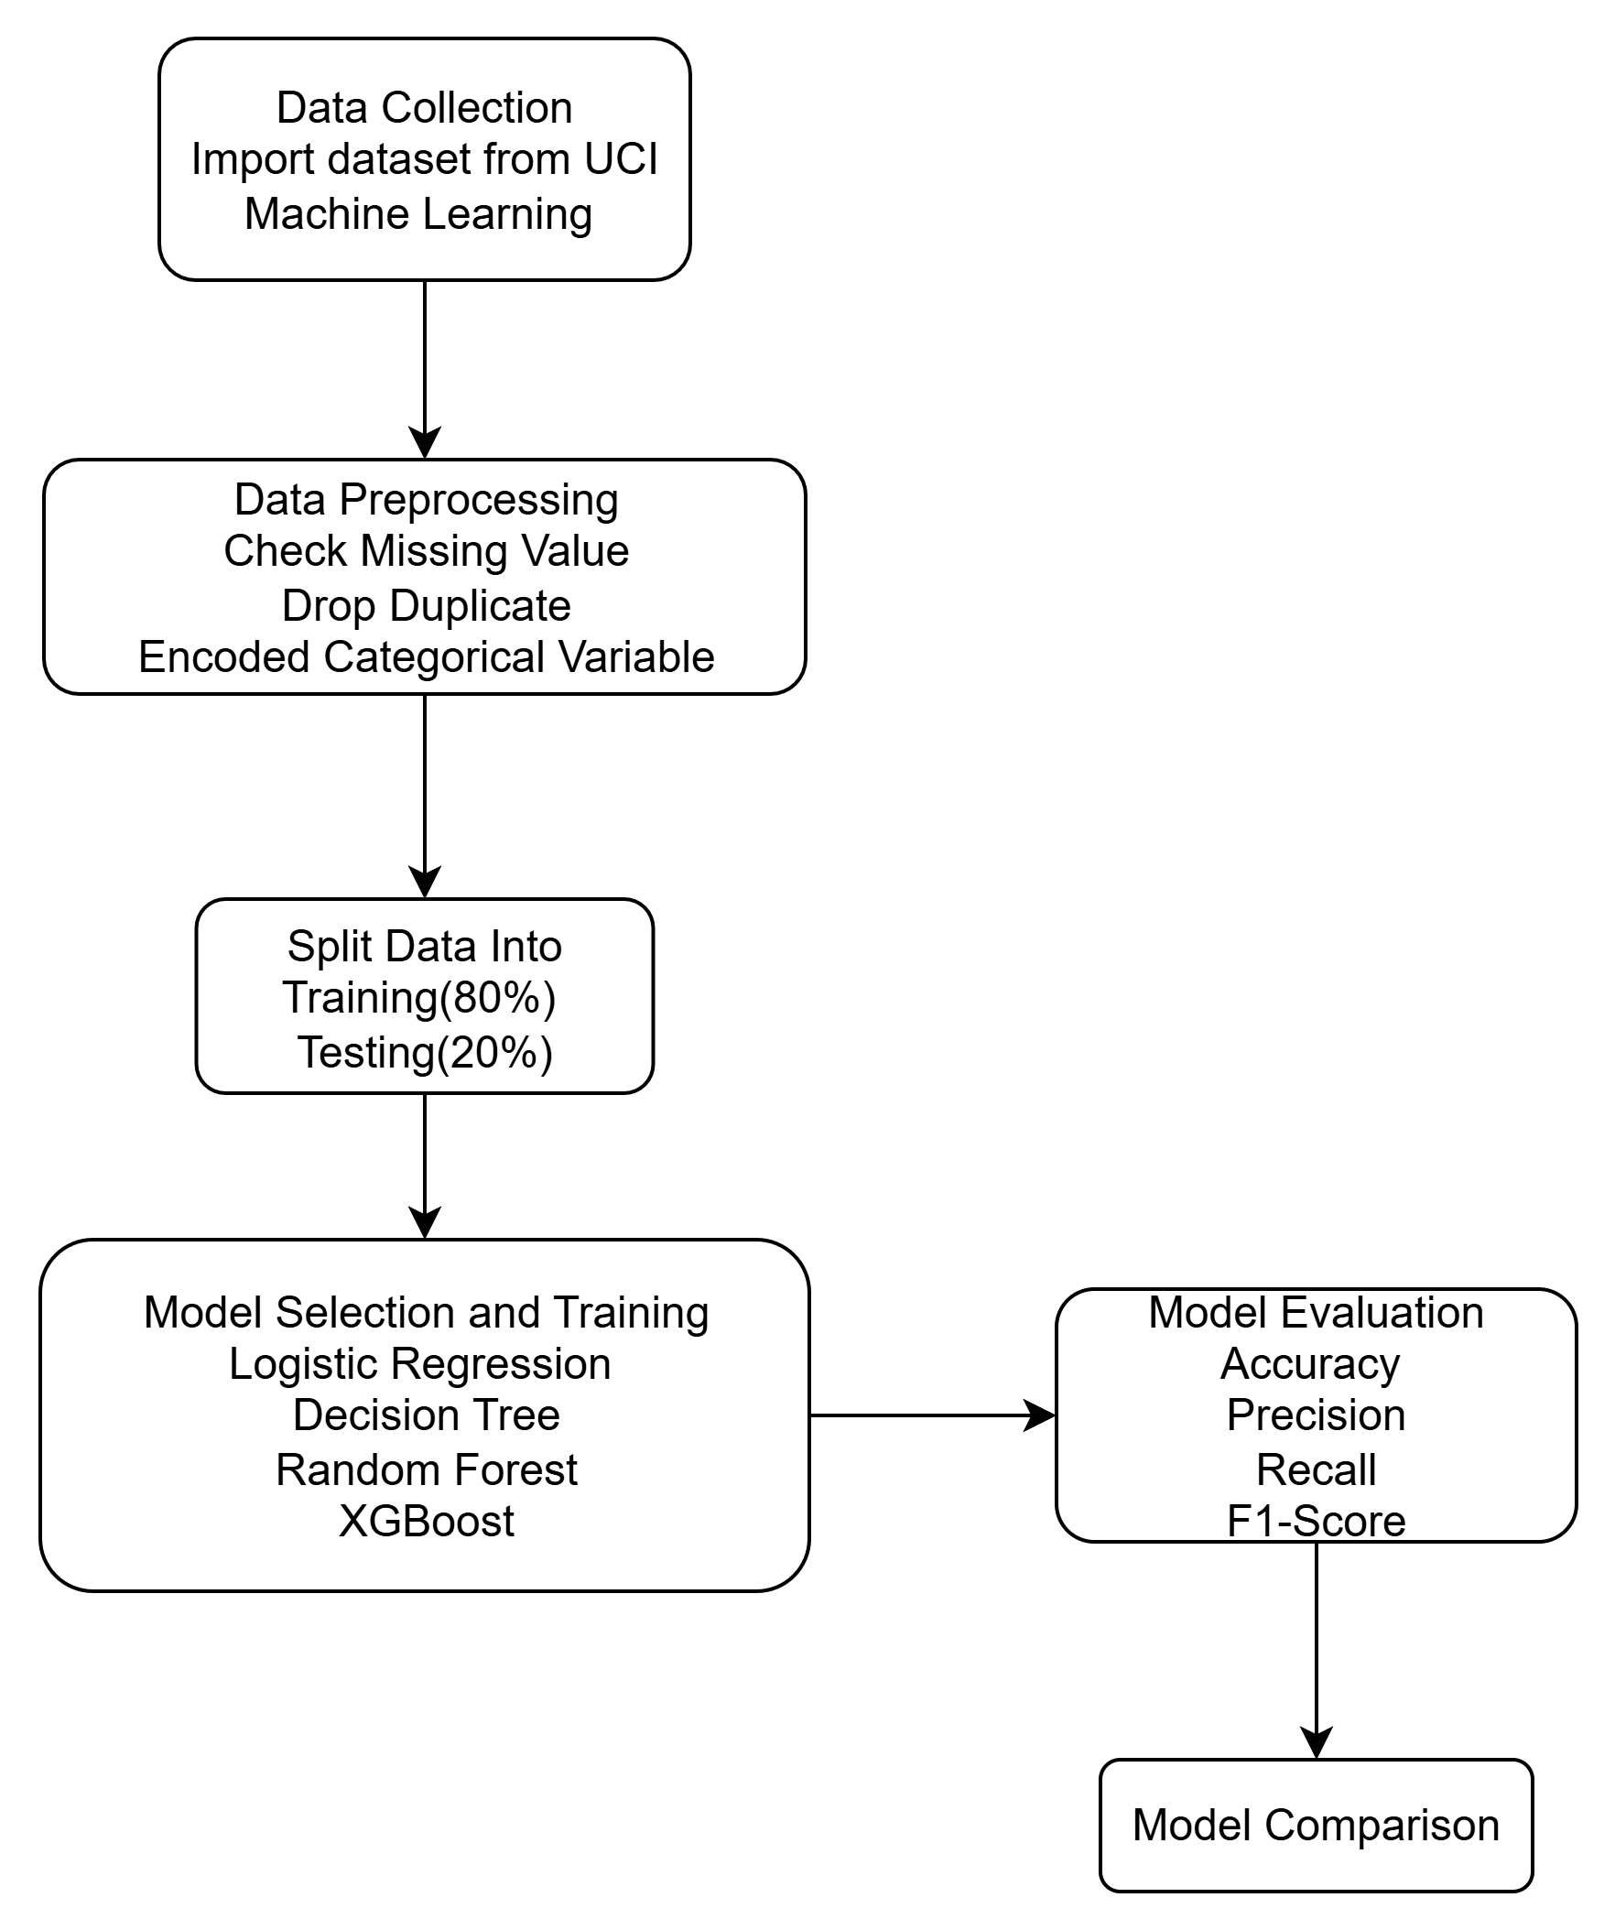
Figure 1: Flow Diagram

Research Design
This study uses a quantitative study design as the dataset includes measurable and structured variables, including numerical features such as age, height and weight as well as categorical labels that indicate various levels of obesity. A comparative study is used to assess the performance of different machine learning classification models in predicting obesity levels. The study uses statistical and computational methods which are fundamental to quantitative research due to the dataset is specifically designed for classification tasks. The goal is to identify which model performs best and to analyze how different features contribute to the classification of individuals into various obesity categories.

Steps Involved in Methodology
The core aim of the research is to determine the level of obesity with regards to the demographic, lifestyle and heath related factors of the individuals. To do that four-machine learning classification algorithms were applied and evaluated to compare with each other: Logistic Regression, Decision Tree, Random Forest and XGBoost. The objective is to compare the conditions under which the most appropriate model can be used to identify accurately the individuals into one of the seven obesity levels as a part of early detection and public health intervention.
The dataset that was utilized in the current study was derived of an open dataset that was meant to compute the level of obesity among persons in Mexico, Peru, and Colombia. The respondents ranged between 14 and 61 years and included information as part of an anonymous online survey. The survey captured data about eating habits, physical activity, and personal characteristics, 17 attributes, 2111 records were obtained.
Eating habit features include:
- Frequent consumption of high caloric food (FAVC)
- Frequent of vegetable consumption (FCVC)
- Number of main meals per day (NCP)
- Consumption of food between meals (CAEC)
- Daily water intake (CH2O)
- Alcohol consumption (CALC)
Physical condition features include:
- Monitoring of calorie consumptions (SCC)
- Frequency of physical activity (FAF)
- Daily technology usage time (TUE)
- Transportation method used (MTRANS)
Other attributes:
- Gender, Age, Height and Weight
The target variable NObeyesdad which classifies individuals into seven categories based on WHO and Mexican health norms:
- Insufficient Weight
- Normal Weight
- Overweight level I, II
- Obesity Type I, II, III
Four machine learning algorithms were implemented to predict obesity levels. These include:
- Logistic Regression
- Decision Tree
- Random Forest
- XGBoost
Four machine learning models were used to predict the level of obesity which are Logistic Regression, Decision Tree, Random Forest and XGBoost. Before running the model, we used tools such as Pandas and Numpy to do data preprocessing steps which consists of checking missing value and dropping duplicate row. All the categorical variables were applying labels encoding and splitting the dataset into training and testing through 80% training, 20% testing split with random state. The input feature was all the rest of the attribute variables whereas the target variable was the NObesyesdad. The models were implemented using scikit learn which provides built in functions for model training evaluation and prediction. As part of the model comparison the performance of each classification model is accessed using essential evaluation metrics such as Accuracy, Precision, Recall and F1-Score. These metrics offer a comprehensive view of the model effectiveness in predicting obesity levels.
- Tools and Libraries used

Step | Description | Tool/Library Used
Check missing values and duplicate rows | Check for rows with missing/null values and check duplicate rows | Pandas
Encode categorical variables | Labels encode other categorical columns | Scikit-Learn (Label Encoder)
Splitting the dataset | Stratified random sampling split into 80% training and 20% testing sets based on target variable (NObeyesdad) | Scikit-Learn (train_test_split)

The use of predictive models for obesity prediction faces several challenges even though the dataset was structured. One major challenge is the use of self-reported data that will have the possibility of bias. Bias can result in discriminatory outcomes, such as the unjust classification or stigmatization of particular groupings due to their demographic traits. Furthermore, the lack of longitudinal data and the study's limited demographic focus limited the methodological framework, which will affect the external validity of the study's findings.
In summary, this research used a structured methodology to determine the best machine learning model for estimating obesity levels based on lifestyle, health, and demographic variables. The research began with well-defined objectives, followed by the selection and comprehension of a pertinent open-source dataset. To ensure data quality, data preprocessing techniques such as remove missing values, remove duplicates, and encoding categorical variables were used to ensure data quality. In this research, there are four classification algorithms which are Logistic Regression, Decision Tree, Random Forest, and XGBoost. These classification algorithms were implemented using Scikit-learn. The important metrics used to assess each algorithm's performance are Accuracy, Precision, Recall, and F1-Score were among the important metrics used to assess each algorithm's performance.
By comparing these 4 models under consistent experimental conditions, we manage to achieve the objectives of this research which is to determine the level of obesity regards to the demographic, lifestyle, and health related factors of the individuals. These methodological steps help us to support the research objective to improve public health interventions by using predictive modeling.

Results and Discussion

Introduction to Results and Discussion
This section will cover the results of the testing done through the methodology proposed, which will then be followed up by a comparative analysis of the results based on the evaluation parameters.

Results
Through initiating the models towards the dataset, here are the results we found. The first of the results being a table illustrating the quantitative results of the performance of all four models.
- Quantitative Results of all four models
Model | Accuracy | Precision | Recall | F1-Score
Logistic Regression (LR) | 0.80 | 0.79 | 0.80 | 0.79
Decision Tree | 0.77 | 0.79 | 0.77 | 0.77
Random Forest | 0.97 | 0.97 | 0.97 | 0.97
XGBoost | 0.99 | 0.99 | 0.99 | 0.99

The results illustrated in table 3 are not arranged in any particular order. The results shown by the table showcased the Decision tree with the lowest accuracy with a 0.77, followed by Logistic Regression (LR) with 0.80, Random Forest at 0.97 and the highest being XGBoost at 0.99. According to the results shown, XGBoost performs the best in every quantitative parameter compared to the other models involved. The following are the results illustrated through figures generated through the results of our research.
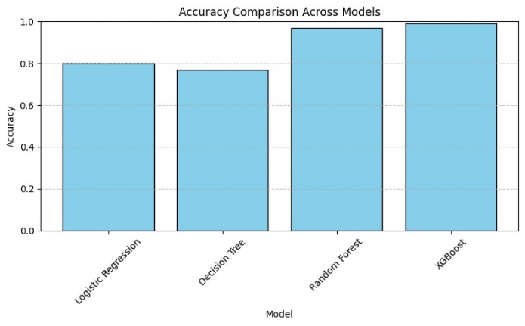
Fig 1: Bar Chart of Accuracy across all 4 models
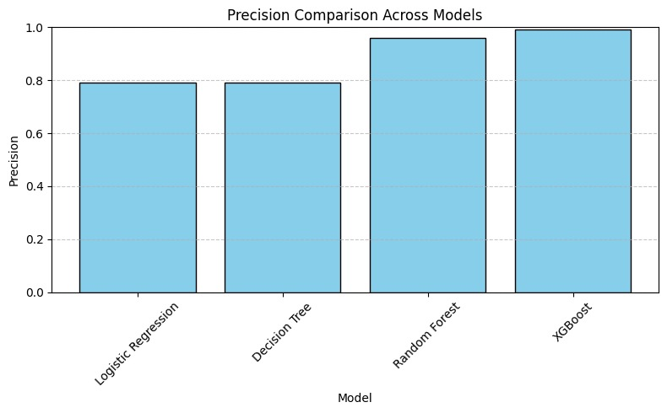
Fig 2: Bar Chart of Precision across all 4 models
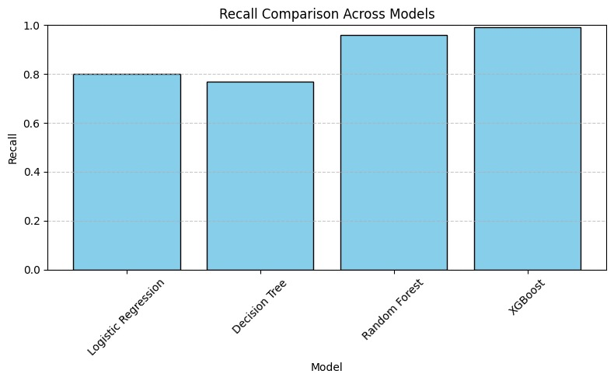
Fig 3: Bar Chart of Recall across all 4 models
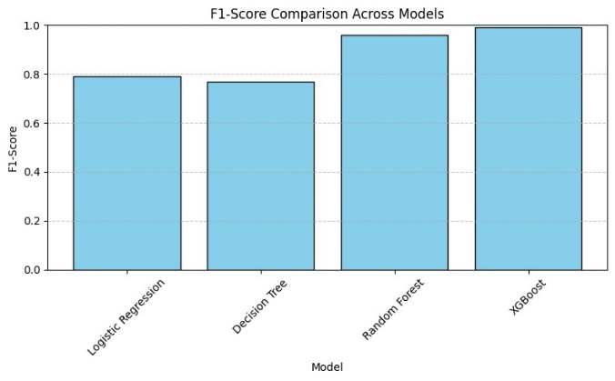
Fig 4: Bar Chart of F1-Score across all 4 models
From the results illustrated through the bar charts of the quantitative results, we can observe that XGBoost performs the best across all four models, which cements itself as the best performing predictive model in terms of obesity centric healthcare data. The following confusion matrix shows the best performing predictive model within our study.

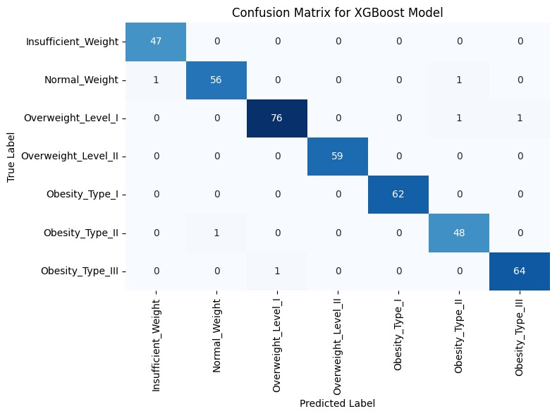
- Confusion Matrix of XGBoost model
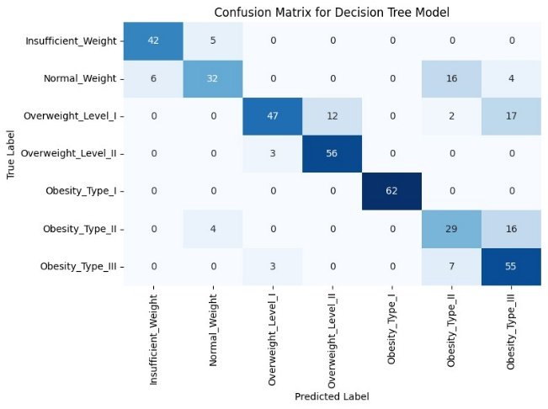
- Confusion Matrix of Decision Tree model
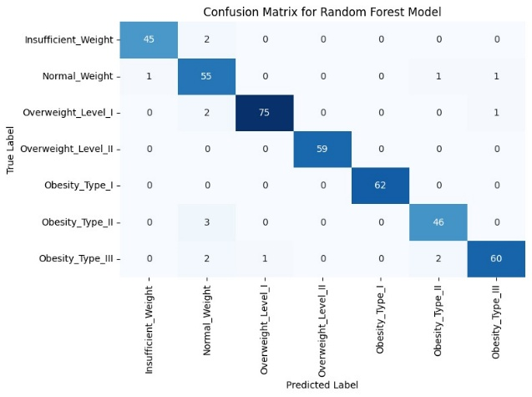
- Confusion Matrix of Random Forest model
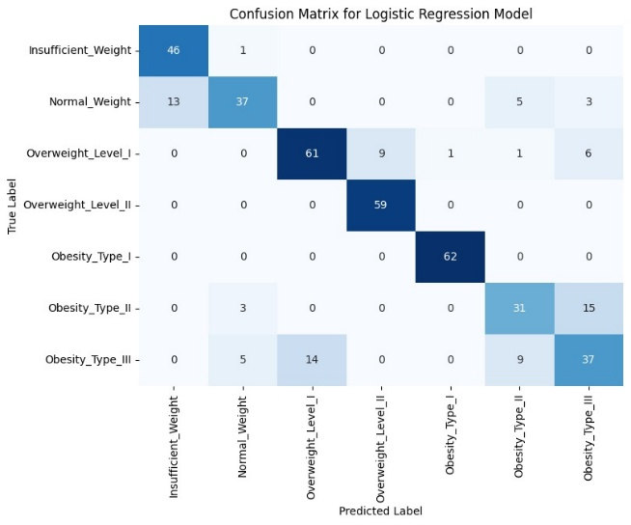
- Confusion Matrix of Logistic Regression (LR) model
Through utilizing the confusion matrix towards the models used within the study, the confusion matrix can visualize the performance of the respective models. At a glance, we can see that the Confusion matrix of the XGBoost model has minimal errors as seen with most squares being 1’s and 0’s, which the other models in comparison perform poorly, which are the Decision Tree model and the Logistic Regression model. However, the Random Forest model Confusion matrix indicates a similar performance as compared to the XGBoost model. The X and Y axis in the matrixes shown are both the predicted label and the true label.
The initial objective of our study was to assess the best performing predictive model of the four models, which the findings confirm the best performing predictive model being XGBoost.
The findings of our study did not directly coincide with studies [4] [6] [8] [9] [11] [15] referenced even though similar models were used. The conclusion and breakdown of results were taken in a different direction, which prohibits us from comparing the similarities due to the drastically different breakdown in concept.
The results from the comparisons cements XGBoost as the best possible prediction model for predicting healthcare data in terms of obesity. The 0.99 performance across all four quantitative criteria shows its effectiveness as compared to the other models involved in the study. The confusion matrix which illustrates the performance of each model further supports the performance of the XGBoost model.

Conclusion and Future work

Summary of Key Findings
The XGBoost model performed better than any other models that were tested, with significant performance on accuracy, precision, recall, and F1-score equal to 0.99. The confusion matrix demonstrated few errors, representing it as the best model for obesity prediction.

Practical Implications
The results produced can allow readers to identify the capabilities of the models used, which the XGBoost model performed best in terms of healthcare data related to obesity. In terms of practical implications, readers will be able to know immediately that XGBoost is a reliable model to predict healthcare data.

Limitations
A gap within the research is towards the potential of XGBoost, which will need further testing towards more complex datasets and situations to truly highlight its capabilities.

Recommendations for Future Research
The research suggests that more testing of XGBoost and other models on larger, more representative, real-world datasets will help assess how successful these models can become in many areas of healthcare.

Concluding Remarks
The results establish XGBoost as the top predicting model of obesity and provide strong encouragement to move on to other early detection and public health initiatives.

References
- Chooi, Y. C., Ding, C., & Magkos, F. (2019). The epidemiology of obesity. Metabolism, 92, 6-10..
- Apovian, C. M. (2016). Obesity: definition, comorbidities, causes, and burden. Am J Manag Care, 22(7 Suppl), s176-85.
- Koliaki, C., Dalamaga, M., & Liatis, S. (2023). Update on the obesity epidemic: after the sudden rise, is the upward trajectory beginning to flatten?. Current Obesity Reports, 12(4), 514-527.
- Gozukara Bag, H.G., Yağın, F.H., Gormez, Y., González, P.P., Çolak, C., Gülü, M., Badicu, G., & Ardigò, L.P. (2023). Estimation of Obesity Levels through the Proposed Predictive Approach Based on Physical Activity and Nutritional Habits. Diagnostics, 13.R. Nicole, “Title of paper with only first word capitalized,” J. Name Stand. Abbrev., in press.
- Alharbi, G. H., & Ikram, M. A. (2025). An Obesity Risk Level (ORL) based on combination of K-Means and XGBoost algorithms to predict childhood obesity. International Journal of Advanced Computer Science and Applications, 16(4), Article 40. https://doi.org/10.14569/IJACSA.2025.0160440
- Buani, D. C. P., & Nuraeni, N. (2023). Application of XGB classifier for obesity rate prediction. Jurnal Riset Informatika, 6(1), 1–6. https://doi.org/10.34288/jri.v6i1.260
- Maulana, A., Razief Perucha Fauzie, A., Maulydia, N. B., Idroes Mauer, G., & Rahimah, S. (2024). Predicting obesity levels with high accuracy: Insights from a CatBoost machine learning model. Infolitika Journal of Data Science, 2(1).
- Kabongo, J.M., Luzolo, M., CLEM’S, & Congo, D.R. Five Machine Learning Supervised Algorithms for The Analysis and the Prediction of Obesity.
- Helforoush, Z., & Sayyad, H. (2024). Prediction and classification of obesity risk based on a hybrid metaheuristic machine learning approach. Frontiers in Big Data, 7.
- Garg, S., & Pundir, P. (2021). MOFit: A Framework to reduce Obesity using Machine learning and IoT. 2021 44th International Convention on Information, Communication and Electronic Technology (MIPRO), 1733-1740.
- Solomon, D.D., Khan, S., Garg, S., Gupta, G., Almjally, A., Alabduallah, B.I., Alsagri, H.S., Ibrahim, M.M., & Abdallah, A.M. (2023). Hybrid Majority Voting: Prediction and Classification Model for Obesity. Diagnostics, 13.
- Ayub, H., Khan, M.A., Shehryar Ali Naqvi, S., Faseeh, M., Kim, J., Mehmood, A., & Kim, Y. (2024). Unraveling the Potential of Attentive Bi-LSTM for Accurate Obesity Prognosis: Advancing Public Health towards Sustainable Cities. Bioengineering, 11.
- Made, I., Bimantara, S., & Supriana, W. (2023). CASE BASED REASONING (CBR) FOR OBESITY LEVEL ESTIMATION USING K-MEANS INDEXING METHOD. Jurnal Ilmiah Kursor.
- Choudhuri, A.R. (2022). A Hybrid Machine Learning Model for Estimation of Obesity Levels. medRxiv.
- Dirik, M. (2023). Application of machine learning techniques for obesity prediction: a comparative study. Journal of Complexity in Health Sciences.

