___________________________________________________________________________________
SCHOOL OF ENGINEERING AND TECHNOLOGY

FINAL ASSESSMENT FOR BSC (HONS) IN COMPUTER SCIENCE; BSC (HONS) INFORMATION TECHNOLOGY; BACHELOR OF SOFTWARE ENGINEERING (HONS); BSC (HONS) INFORMATION SYSTEMS (DATA ANALYTICS)

YEAR 2; ACADEMIC SESSION SEPTEMBER 2026
SEG2102 DATABASE MANAGEMENT SYSTEMS

DUE DATE: BY END OF THE 3 JANUARY (SUNDAY), 2026

INSTRUCTIONS
- This final assessment contributes 30% to final grade.
- This three-member (3-member) group assignment is primarily for Course Learning Outcomes 1 and 3 - Examine the advanced concept of different database models concerning their design, strengths, and weaknesses from the aspects of models’ design, data integrity, database scalability, and access control.
- Submission: Submit a single MS Word file as your report. This assessment requires GROUP submission through the TURNITIN system, meaning GROUP LEADER must submit their own report based on the group work via TURNITIN.
- Report Format: Prepare a report using the IEEE template.
- Detailed Requirements: For specific details about the assignment, please refer to pages 2-3.
- Plagiarism Policy: Turnitin report must indicate less than 20% similarity, including AI-generated content.

IMPORTANT
The University requires students to adhere to submission deadlines for any form of assessment. Penalties are applied in relation to unauthorized late submission of work.

Academic Honesty Acknowledgement

“We, Ho Jian Feng, Muhammad Talal Naveed, Ernest Chen, verify that this paper contains entirely our own work. We have not consulted with any outside person other than what was specified in the assignment requirements. Further, we have not copied or inadvertently copied ideas, sentences, or paragraphs from another student. We realize the penalties (refer to the student handbook of undergraduate programme) for any kind of copying or collaboration on any assignment.”



Signature: .................................... ……............................. ………........................

Student ID: 23110091 23064686 22062186

Name: Ernest Chen Ho Jian Feng Muhammad Talal Naveed

Date: 30/11/2025 30/11/2025 30/11/2025

A Detailed Analysis of Backup and Recovery Techniques in Relational and NoSQL Database Management Systems

Muhammad Talal Naveed
School of Engineering and Technology
Sunway University
No.5, Jalan Universiti, Bandar Sunway,
47500, Selangor Darul Ehsan,
Malaysia
22062186@imail.sunway.edu.my
Ernest Chen
School of Engineering and Technology
Sunway University
No.5, Jalan Universiti, Bandar Sunway, 47500, Selangor Darul Ehsan,
Malaysia
23110091@imail.sunway.edu.my
Ho Jian Feng
School of Engineering and Technology
Sunway University
No.5, Jalan Universiti, Bandar Sunway,
47500, Selangor Darul Ehsan,
Malaysia
23064686@imail.sunway.edu.my

Abstract—In the modern era, where data is the core asset of companies, its loss can bring about serious issues like system unavailability or even violations. The Database Management Systems (DBMS) are the main factors in ensuring that data is always fresh and secure. Therefore, this very report will discuss the backup and recovery methods of these four well-known systems: Oracle, PostgreSQL, Microsoft SQL Server, and MongoDB. The primary goal is to evaluate their respective built-in tools and to test which one is the best in restoring the lost data and schema after the simulated loss. The major obstacle is detecting tools that give total recovery while being simple and fast to operate. The research involved practical tests with the same small employee dataset in all the systems and then measuring recovery success, time, and usability. The results indicate that all four systems managed to recover 100% of the data, with relational systems being stronger in automated schema integrity and MongoDB being quicker for flexible data. Such findings not only prove the reliability of the native tools but also assist in selecting the right one for various configurations as well as giving helpful hints for the creation of more robust databases.
Keywords—Backup, Recovery, Oracle, MongoDB, PostgreSQL, Microsoft SQL Server

Introduction

General Background
The use of database systems has become standard in modern organizations to facilitate the storage, management, and processing of large volumes of sensitive and critical data. However, despite the application of various security and control measures, databases still face the risks of being unable to recover from failures, becoming targets of cyber-attacks, and suffering from accidental data deletions. All these incidents pose a significant threat to the three important aspects of data handling, namely confidentiality, integrity, and availability [1]. Such occurrences accentuate the necessity for good and reliable backup and recovery mechanisms so that the data is restored cleanly after the disruption.A Database Management System (DBMS) will be the core of data storage and access with no doubt, and thus it will be the supporting force for critical operations like transaction processing, analytics, and decision making in areas such as finance, healthcare, and e-commerce. To ensure that the system is always available, modern DBMS platforms have combined the mechanisms of backup, recovery, high availability, and disaster recovery, which protect the data from hardware failures, software faults, cyberattacks, and even human errors. The efficiency of these mechanisms is usually determined through the metrics of Recovery Time Objective (RTO) and Recovery Point Objective (RPO), which specify the maximum periods of downtime and data loss that are acceptable after a failure. Therefore, this research is focused on the analysis of modern techniques that have been developed in both relational and non-relational databases. It covers both simple and complex methods like continuous data protection, transaction log-based recovery, cloud, and hybrid architectures, etc., in the major DBMSs such as Oracle, PostgreSQL, Microsoft SQL Server, and MongoDB to evaluate their capability to reduce downtime, maintain data consistency, and provide resilience in highly distributed and data-rich environments.

Problem Statement
In contemporary database management systems, the problem of getting dependable and fast database backup and recovery is still one of the most difficult to solve. This is caused by the factors of large data volumes, distributed architectures, and advanced threats that together result in outages and data loss of prolonged duration.

Significance of the Problem
In today's digital world, the repercussions of poor database backup and recovery can be very serious and widespread. Losing data or prolonged downtime can lead to the organization losing a huge amount of money, especially in the areas of finance, healthcare, and manufacturing where the hourly costs during outages are really high. Ransomware attacks, which often hit the backing up system that are not secure, have become more advanced and common, thus leading to the locking of data, stoppage of operations, and expensive ransom payments or reconstruction attempts. Besides, these incidents have a big negative economic impact, they also affect the organization's reputation, lose customer trust, and make the company pay for legal issues due to non-compliance with data protection regulations like GDPR and HIPAA; such legal issues can be quite expensive. Quick data recovery and preservation of data integrity are now fundamental survival factors for businesses in the data-driven world where data is the main point of decision-making and the main source of competition. Thus, the operations continuity is threatened, the supply chains are disrupted, and the innovation is hindered. That is why addressing these flaws is a must for companies, to protect their assets, keep their operations resilient, and help their growth to be sustainable in data-dependent sectors.

Objective
The objectives of this report are:
- To conduct the implementation and tests of native backup and recovery methods in Oracle, PostgreSQL, Microsoft SQL Server, and MongoDB, and the use of a unified dataset all through the way.
- To determine the usefulness of each method in the total restoration of data and schema, aiming at 100% recovery rate, as mentioned in the goal.
- To rank the tools for backup and restoration according to their respective strengths and weaknesses in terms of user-friendliness, time to execution, and preservation of the integrity of the schema.
- To derive a conclusion as to which approach is most appropriate for various types of databases (relational versus NoSQL) based on the results of the experiments.

Scope of the Report
The research evaluates database backup, recovery, high availability, and disaster recovery mechanisms across relational systems like Oracle, PostgreSQL, Microsoft SQL Server and a non-relational system MongoDB. It concentrates on techniques like continuous data protection, transaction log aware recovery, hardware assisted methods, and cloud and hybrid architectures, with focus on low recovery time and recovery point objectives, logical data consistency, and modern threats protection.
The research includes practical testing of the built-in backup and recovery tools in the selected databases using the same small employee dataset in addition to the laboratory work. Data loss scenarios, such as table deletion, are simulated in local environments to compare recovery success, speed, ease of use and schema preservation, and thus providing practical insights for selecting the most appropriate recovery approaches.

literature review

Structure of the Literature Review:

Introduction:
This literature review elaborates on contemporary Database Management Systems (DBMS) backup and recovery techniques and investigates how these current tools protect database availability and integrity during various failure cases. The selected research topic spotlights DBMS-native functions like Oracle RMAN and Flashback, PostgreSQL write-ahead logging with point-in-time recovery, IBM DB2 roll-forward recovery and SQL Server high-availability and disaster-recovery configurations, alongside storage-level methods such as continuous data protection and SSD-assisted backup. The exploration of this area is important because these techniques are critical for the reduction of data loss and downtime, proper and timely recovery amidst power failures, human mistakes, and security threats, and the provision of reliable operation for both disk-based and main-memory database systems in enterprise and hybrid cloud environments.

Selection Criteria:
The literature that has been reviewed was chosen based on its connection to the current DBMS backup and recovery methods, giving priority to the mechanisms used in present-day enterprise situations. The literature includes peer-reviewed articles and papers from well-known publishers and venues like IEEE, ACM, Google Scholar, Sunway Library, and others catered for databases and systems on the topics of DBMS-native recovery (Oracle, PostgreSQL, DB2, SQL Server), continuous data protection, storage-assisted backup, and main-memory recovery. Very recent papers were preferred, which were mostly from around 2019-2025, providing the foundational context for logging, checkpointing, and recovery algorithms were included if necessary.

Organization:
The review is divided into different parts that deal with various topics: DBMS-native Backup and Recovery Mechanisms, High Availability and Business Continuity Architectures, Snapshot and Continuous Data Protection, NoSQL and In-Memory Database Recovery, Performance and Storage Optimization in Backup/Recovery, and Intelligent Recovery and Automation.

A. Review of Articles:
Scope et al. [2] analyzed the data lifecycle management and compliance problems generated by the different retention and purging regulations in database backups. The researchers introduced a policy-driven framework that combines SQL/NoSQL-based policy definitions, trigger-based enforcement, and cryptographic key management to enable automated fine-grained retention and purging across relational and NoSQL databases. The experimental evaluation on PostgreSQL databases as well as MongoDB showed that the approach complies with legal requirements while only adding negligible query overhead and costing moderate backup and restoring.
Chopade and Pachghare [3] addressed data recovery issues in the in-memory NoSQL database Redis to facilitate forensic analysis after the deletion of data, whether it happened in a malicious or accidental way. A recovery technique was presented that follows memory addresses of Redis’s internal dictionary structure to redo deleted key–value pairs over string, list, hash, set, and sorted-set data types. The experiments for the evaluation showed very high recovery rates of almost 99% for the bulk insert-delete workloads, thereby validating the method proposed for forensic data restoration as effective.
Rachapalli [4] studied the self-healing database mechanisms which incorporate AI to automate maintenance tasks and thus bring down the downtime in high-availability environments. The study suggested a multilayered AI framework involving anomaly detection, predictive modeling, and reinforcement-learning-based optimization that would allow the system to automatically find faults, tweak performance, and even make recovery calls without any human intervention. The experimental measurements were reported as revealing that the accuracy of anomaly detection had improved to 95%, the downtime had been reduced by as much as 45%, and there was a 30% operational cost cut in comparison with the traditionally managed database systems.
Chaudhary et al. [5] researched backup and restore methods for extensive medical image databases while paying special attention to the fact that NoSQL systems, especially MongoDB, can securely store and retrieve high-volume DICOM and other medical images even in cases of faults. As a part of the study MongoDB-centric mechanisms like mongodump/mongorestore, filesystem and snapshot-based backups, cloud backup services, Ops Manager, and ClusterControl-based continuous backups for sharded and replicated deployments were all reviewed and structured. The comparative analysis revealed that the use of native and external MongoDB backup options together can provide the scalable, cost-effective, and point-in-time recovery that is needed for the healthcare applications that require high availability and quick restoration of the critical medical images.
Abed [6] dealt with recovery and concurrency problems in big data NoSQL databases focusing on the shortcomings of existing replication-only approaches that were mainly used for fault tolerance and disaster recovery. The study mapped out the NoSQL data models and which ones were the major ones, conversed about the subjects like NoSQL UNDO client-side recovery, full and focused undo methods using logs and snapshots, and a comprehensive trigger-based backup and restore architecture with load balancers, coordination through ZooKeeper and storage supported by HDFS. Experimental and conceptual analysis pointed to the fact that undo-based recovery coupled with integrated, low-RPO/low-RTO backup strategies can deal with human errors, malicious operations, and large-scale disaster failures more successfully than replication alone in a distributed NoSQL environment.
Iqbal and Munggaran [7] investigated the design of backup strategies for an IT disaster recovery plan at an Indonesian insurance company, pointing out the risks that still exist even though a data center and a disaster recovery center are already in place. The research introduced a mixed technique that integrated Oracle Active Data Guard for real-time physical standby replication and Symantec NetBackup for full, differential, and off-site tape backups scheduled, all this inside an ISO/IEC-20000-compliant IT DRP with predetermined RPO and RTO goals. Theoretical calculations and DR practice confirmed that the Active Data Guard plus NetBackup strategy can guarantee times for backup and restore that will be under control, make possible failover and switchover in a couple of minutes, and give a strong line of defense against natural catastrophes and operational failures that can disrupt essential database services.
Oloruntoba [8] assessed the part of Oracle Data Guard and Oracle Streams in the accomplishment of business continuity for enterprise database systems that are facing hardware issues, cyberattacks, and other operational disruptions. The research work examined how the combination of Data Guard’s physical and logical standby databases with automated failover, and Streams’ multi-directional replication and transformation capabilities, can lead to real-time redundancy, disaster recovery, and cross-site data synchronization. The conceptual evaluation indicated that the combination of these technologies is a major factor in ensuring high availability, uninterrupted failover, and load balancing, and regulatory compliance while also being enabled by the increasing use of AI-driven automation which further fortifies the resilience of databases and decreases the risk of downtime in modern IT environments.
Raharjo et al. [9] underlined the importance of Oracle RMAN parameters tuning in connection with the backup performance of a big government database environment which needs daily online backups along with strict recovery objectives. The paper introduced an elaborate experimental framework where RMAN compression levels (basic, low, medium, high), multiplexing/parallelism, and storage parameters were the factors varied to monitor the influences of backup time, CPU usage, and output size for an 800 GB database. The overall performance demonstrated that medium and basic compression with proper multiplexing gave the best runtime and storage savings, whereas high compression led to about 10:1 size reduction at the expense of considerably more CPU utilizations and very long backup periods.
Sheta [10] identified the difficulties and the ways out in the troubleshooting of enterprise database systems, mainly highlighting performance bottlenecks, data integrity problems, scalability limits, and security vulnerabilities in the modern high-volume environments. The study brought together previous research and case studies to suggest the use of diagnostic and monitoring tools, automated troubleshooting, robust backup and recovery practices, and advanced security and access-control mechanisms along with the new AI-powered self-healing and optimization techniques. The examples given showed that the application of such integrated troubleshooting frameworks that incorporate automated alerts and consistency checks can lead to a significant reduction in data inconsistencies, faster recovery times and improvement in overall database resilience and reliability.
Bogatyrev et al. [11] investigated recovery discipline choices for highly reliable clusters supporting analytical DBMS workloads, where continuous availability and avoidance of data loss are critical under multiple failure scenarios. The study proposed Markov reliability models for a two‑node duplicated cluster that incorporate three protection levels: intra‑cluster replication, restoration from the latest backup, and recovery of data accumulated after that backup when both replica nodes fail, possibly overlapped with ongoing query processing. Numerical analysis showed that appropriate coordination of replication, scheduled backups, and post‑backup recovery significantly improves the probability of maintaining operability over time and strengthens the cluster’s fault tolerance and readiness to provide uninterrupted analytical DB services without losing accumulated data.
Safaryan et al. [12] investigated secure database backup in Microsoft SQL Server by replacing built‑in ciphers such as AES with the Russian GOST R 34.12 “Kuznechik” algorithm when encrypting backup streams. The study proposed a custom backup application that integrates SQL Server’s Virtual Device Interface (VDI) to receive the backup stream directly and apply Kuznechik encryption before any copy is written to disk, eliminating exposure of plaintext backup files. Experimental analysis indicated that the Kuznechik‑based solution can provide at least comparable security with simpler implementation and lower resource usage than AES, improving backup encryption performance by roughly 20% while strengthening protection against unauthorized access to database backups.
Alremeithi et al. [13] investigated and experimentally compared database recovery techniques in Oracle, PostgreSQL, and IBM DB2 using identical library‑style schemas and simulated power‑outage and human‑error scenarios. The study implemented Oracle RMAN and Flashback Query, PostgreSQL write‑ahead logging with continuous archiving and point‑in‑time recovery, and DB2 roll‑forward plus backup/restore to evaluate downtime, skill requirements, and percentage of data restored. Results showed that Oracle’s recovery stack minimizes downtime compared with DB2 and PostgreSQL, but all three RDBMS were able to fully recover and restore data after failures, making the choice of technique dependent on application criticality, acceptable downtime, and administrator expertise.
Magalhaes et al. [14] surveyed recovery techniques for main‑memory (in‑memory) database systems, emphasizing that volatile RAM storage makes these systems more vulnerable to failures than traditional disk‑oriented DBMSs despite their much higher throughput and lower latency. The study reviewed classical ARIES‑style logging, checkpoint, and restart mechanisms, then classified and analyzed recovery strategies adopted in modern in‑memory engines, including logging granularity, checkpointing schemes, instant restart/instant restore, single‑page repair, and high‑availability replication protocols. The survey concluded that effective main‑memory recovery must balance correctness (restoring a consistent pre‑crash state) with fast restart times, and that exploiting new hardware features plus tailored logging/checkpoint designs is essential to achieve durable, highly available in‑memory databases in mission‑critical applications.
Bohora et al. [15] reviewed backup, deletion, failure‑handling, and disaster‑recovery mechanisms for the Cassandra NoSQL database, highlighting its peer‑to‑peer, replicated ring architecture and tombstone‑based deletion with TTL and grace periods. The paper analyzed Cassandra’s built‑in snapshot and incremental backup support, node failure detection using a modified φ‑accrual failure detector, and limitations in fine‑grained data recovery, then surveyed proposed enhancements such as BARNS for faster node repair, decentralized disaster‑recovery centers, and trigger‑based replication to stable storage (e.g., HDFS) to improve resilience against corruption and multi‑datacenter disasters.
Enjam [16] analyzed how to optimize PostgreSQL for high‑volume insurance workloads and design secure backup/restore strategies that meet strict regulatory requirements such as HIPAA and GDPR. The paper combined query tuning, indexing, partitioning, connection pooling, caching, and parallel query execution with WAL‑based PITR, physical/logical backups, encryption, and cloud‑native backups, achieving about 45% lower query latency, 60% higher throughput, and 50% faster recovery time objectives in the evaluated setup. It emphasizes that encrypted, geo‑redundant backups and well‑tuned recovery processes are as critical as performance tuning for ensuring business continuity and compliance in mission‑critical insurance database systems.
Achanta [17] examined how to design and operate high‑availability (HA) and disaster‑recovery (DR) strategies for Microsoft SQL Server, focusing on real‑time protection of mission‑critical systems using native features and hybrid cloud approaches. The study compared Always on Availability Groups, failover clustering, log shipping, mirroring, and backup/restore, and surveyed practitioners across multiple industries to understand adoption, tooling, challenges, and business impact. Results showed that organizations increasingly favor hybrid combinations of Always On plus clustering with cloud‑based DR, gaining sharply reduced downtime and data loss but facing cost and complexity challenges that require strong governance, monitoring, and regular DR drills to keep HA/DR plans effective.
Muzaffar and Mazher [18] reviewed disaster recovery and high availability options for SQL Server deployed on major cloud platforms (Azure, AWS, Google Cloud), emphasizing the need to maintain data integrity and business continuity during failures. The paper described how cloud‑native capabilities such as geo‑replication, automated backups with point‑in‑time recovery, Always On Availability Groups, failover clustering, and multi‑AZ deployments can be combined to deliver low‑downtime failover and rapid recovery from regional or infrastructure outages. It also highlighted challenges, including network latency, configuration complexity, cost management, and the importance of continuous monitoring and DR testing, and outlined best practices to tailor HA/DR designs to each organization’s risk tolerance and budget.
Singhal [19] analyzed database backup and recovery strategies for hybrid on‑premises/cloud environments, emphasizing protection of customer databases against ransomware and other failures. The paper reviewed full, incremental, differential, and transaction‑log backups, argued for frequent online backups and immutable backup copies following the 3‑2‑1 rule, and showed how hybrid storage (on‑site plus cloud) can balance fast recovery with off‑site resilience. It proposed a platform‑agnostic approach that supports database‑level granularity across hypervisors, bare metal, and containers, with regular restore testing to ensure rapid, reliable recovery and reduced total cost of ownership during disaster events.
Son et al. [20] proposed an SSD‑assisted backup and recovery scheme (BR‑SSD) that embeds full backup/restore functionality directly into the SSD’s flash translation layer and DRAM cache, exploiting flash’s out‑of‑place update behavior. Implemented on a Samsung enterprise SSD and integrated with MySQL in single, replication, and RAID‑5 setups, BR‑SSD stores and manipulates only metadata (mapping tables) rather than copying data blocks, and coordinates multi‑device backups with a two‑phase‑commit‑style protocol to maintain atomicity. Experiments showed that this approach delivers much faster backup and recovery than logical/physical tools (e.g., mysqldump, XtraBackup) or CoW filesystem snapshots, while imposing essentially no runtime performance penalty on normal database workloads.
Jin and Wang [21] proposed an improved continuous data protection (CDP) backup and recovery method that ensures logical database consistency by analyzing IO records from transaction logs rather than relying solely on raw IO replication. Their system performs an initial full back up, then continuously captures and classifies IO records into consistency‑aware record sets, using log‑structure knowledge (e.g., Oracle redo, MySQL binlog) to identify consistent cut points for point‑in‑time recovery. Simulation results showed similar recovery time objectives to traditional IO‑replication CDP, but noticeably better recovery point accuracy and reduced data inconsistency after restore, especially in scenarios where naive IO‑level replay can leave databases openable but logically corrupted.

Comparison Table:
Reference | Problem Statement | Algorithm/Methodology | Key Findings
Scope et al. [1] | Data lifecycle management and compliance challenges in database backups arising from conflicting retention and purging regulations | Policy-driven framework integrating SQL/NoSQL-based policy definitions, trigger-based enforcement, and cryptographic key management to automate fine-grained retention and purging across relational and NoSQL databases. | Enforces legal compliance with negligible query overhead and modest backup and restore costs, as demonstrated on PostgreSQL and MongoDB.
Chopade and Pachghare [2] | Data recovery challenges in the in-memory NoSQL database Redis to support forensic analysis after malicious or accidental data deletion. | Recovery technique that traces memory addresses of Redis’s internal dictionary structure to reconstruct deleted key–value pairs across string, list, hash, set, and sorted-set data types. | Recovery accuracies nearing 99% for bulk insert-delete workloads, confirming effectiveness for forensic data restoration.
Rachapalli [3] | Self-healing database mechanisms that employ artificial intelligence to automate maintenance tasks and reduce downtime in high-availability environments. | Multi-stage AI framework integrating anomaly detection, predictive modeling, and reinforcement-learning-based optimization to autonomously detect faults, tune performance, and trigger recovery actions without human intervention. | Improvements in anomaly detection accuracy to 95%, reductions in downtime by up to 45%, and a 30% decrease in operational costs compared to traditionally managed database systems.
Chaudhary et al. [4] | Backup and restore strategies for large-scale medical image databases, focusing on how NoSQL systems can reliably store and recover high-volume DICOM and other medical image data under failure scenarios. | Backup and restore strategies for large-scale medical image databases, focusing on how NoSQL systems can reliably store and recover high-volume DICOM and other medical image data under failure scenarios. | Combining MongoDB’s native and external backup options provides scalable, cost-effective, and point-in-time recovery capabilities suitable for healthcare workloads demanding high availability and rapid restoration.
Abed [5] | Recovery and concurrency challenges in big data NoSQL database systems, focusing on the limitations of existing replication-only approaches for fault tolerance and disaster recovery. | Survey of major NoSQL data models and techniques such as NoSQL UNDO client-side recovery, full and focused undo methods using logs and snapshots, and a holistic trigger-based backup and restore architecture with load balancers, ZooKeeper coordination, and HDFS-backed storage. | Combining undo-based recovery with holistic, low-RPO/low-RTO backup strategies addresses human errors, malicious operations, and large-scale failures more effectively than traditional replication alone in distributed NoSQL environments.
Iqbal and Munggaran [6] | Backup strategy design for an IT disaster recovery plan in an Indonesian insurance company, addressing risks that remain even with data center and disaster recovery center deployments. | Combined approach using Oracle Active Data Guard for real-time physical standby replication and Symantec NetBackup for scheduled full, differential, and off-site tape backups, integrated into an ISO/IEC-20000-aligned IT DRP with defined RPO and RTO targets. | Provides controlled backup and restore times, supports failover and switchover within minutes, and offers effective protection against natural disasters and operational failures impacting critical database services.
Oloruntoba [7] | The role of Oracle Data Guard and Oracle Streams in ensuring business continuity for enterprise database systems facing hardware failures, cyberattacks, and other operational disruptions. | Analysis of Data Guard’s physical and logical standby databases with automated failover, and Streams’ multi-directional replication and transformation capabilities, combined to provide real-time redundancy, disaster recovery, and cross-site data synchronization. | Integrating these technologies supports high availability, seamless failover, load balancing, and regulatory compliance, while emerging AI-driven automation further strengthens database resilience and reduces downtime risk.
Raharjo et al. [8] | How Oracle RMAN parameter tuning affects backup performance for a large government database environment that requires daily online backups and strict recovery objectives. | Systematic experimental framework that varied RMAN compression levels (basic, low, medium, high), multiplexing/parallelism, and storage characteristics to measure impacts on backup time, CPU usage, and output size for an 800 GB database. | Medium and basic compression with appropriate multiplexing provides the best balance between runtime and storage savings, while high compression achieves up to roughly 10:1 size reduction at the cost of significantly higher CPU utilization and longer backup durations.
Sheta [9] | Challenges and solutions in troubleshooting enterprise database systems, focusing on performance bottlenecks, data integrity issues, scalability limits, and security vulnerabilities in modern high-volume environments. | Synthesis of prior work and case studies recommending diagnostic and monitoring tools, automated troubleshooting, robust backup and recovery practices, and advanced security and access-control mechanisms, alongside emerging AI-driven self-healing and optimization techniques. | Adopting integrated troubleshooting frameworks, including automated alerts and consistency checks, significantly reduces data inconsistencies, shortens recovery times, and enhances overall database resilience and reliability.
Bogatyrev et al. [10] | Recovery discipline choices for highly reliable clusters supporting analytical DBMS workloads, where continuous availability and avoidance of data loss are critical under multiple failure scenarios. | Markov reliability models for a two-node duplicated cluster that incorporate three protection levels: intra-cluster replication, restoration from the latest backup, and recovery of data accumulated after that backup when both replica nodes fail, possibly overlapped with ongoing query processing. | Appropriate coordination of replication scheduled backups, and post-backup recovery significantly improves the probability of maintaining operability over time and strengthens the cluster’s fault tolerance and readiness.
Safaryan et al. [11] | Secure database backup in Microsoft SQL Server by replacing built-in ciphers such as AES with the Russian GOST R 34.12 “Kuznechik” algorithm when encrypting backup streams. | Custom backup application that integrates SQL Server’s Virtual Device Interface (VDI) to receive the backup stream directly and apply Kuznechik encryption before any copy is written to disk, eliminating exposure of plaintext backup files. | Kuznechik-based solution provides at least comparable security with simpler implementation and lower resource usage than AES, improving backup encryption performance by roughly 20% while strengthening protection against unauthorized access.
Alremeithi et al. [12] | Database recovery techniques in Oracle, PostgreSQL, and IBM DB2 using identical library-style schemas and simulated power-outage and human-error scenarios. | Implementation of Oracle RMAN and Flashback Query, PostgreSQL write-ahead logging with continuous archiving and point-in-time recovery, and DB2 roll-forward plus backup/restore to evaluate downtime, skill requirements, and percentage of data restored. | Oracle’s recovery stack minimizes downtime compared with DB2 and PostgreSQL, but all three RDBMS were able to fully recover and restore data after failures, making the choice dependent on application criticality, acceptable downtime, and administrator expertise.
Magalhaes et al. [13] | Recovery techniques for main-memory (in-memory) database systems, emphasizing that volatile RAM storage makes these systems more vulnerable to failures than traditional disk-oriented DBMSs despite their much higher throughput and lower latency. | Review of classical ARIES-style logging, checkpoint, and restart mechanisms, then classified and analyzed recovery strategies adopted in modern in-memory engines, including logging granularity, checkpointing schemes, instant restart/instant restore, single-page repair, and high-availability replication protocols. | Effective main-memory recovery must balance correctness with fast restart times, and exploiting new hardware features plus tailored logging/checkpoint designs is essential to achieve durable, highly available in-memory databases in mission-critical applications.
Bohora et al. [14] | Backup, deletion, failure-handling, and disaster-recovery mechanisms for the Cassandra NoSQL database, highlighting its peer-to-peer, replicated ring architecture and tombstone-based deletion with TTL and grace periods. | Analysis of Cassandra’s built-in snapshot and incremental backup support, node failure detection using a modified φ-accrual failure detector, and limitations in fine-grained data recovery, then surveyed proposed enhancements such as BARNS for faster node repair, decentralized disaster-recovery centers, and trigger-based replication to stable storage (e.g., HDFS). | Enhancements like BARNS and trigger-based replication improve resilience against corruption and multi-datacenter disasters in Cassandra environments.
Enjam [15] | How to optimize PostgreSQL for high-volume insurance workloads and design secure backup/restore strategies that meet strict regulatory requirements such as HIPAA and GDPR. | Combination of query tuning, indexing, partitioning, connection pooling, caching, and parallel query execution with WAL-based PITR, physical/logical backups, encryption, and cloud-native backups. | Achieves about 45% lower query latency, 60% higher throughput, and 50% faster recovery time objectives, emphasizing that encrypted, geo-redundant backups and well-tuned recovery processes are critical for business continuity and compliance.
Achanta [16] | How to design and operate high-availability (HA) and disaster-recovery (DR) strategies for Microsoft SQL Server, focusing on real-time protection of mission-critical systems using native features and hybrid cloud approaches. | Comparison of Always On Availability Groups, failover clustering, log shipping, mirroring, and backup/restore, and survey of practitioners across multiple industries to understand adoption, tooling, challenges, and business impact. | Organizations increasingly favor hybrid combinations of Always On plus clustering with cloud-based DR, gaining sharply reduced downtime and data loss but facing cost and complexity challenges that require strong governance, monitoring, and regular DR drills.
Muzaffar and Mazher [17] | Disaster recovery and high availability options for SQL Server deployed on major cloud platforms (Azure, AWS, Google Cloud), emphasizing the need to maintain data integrity and business continuity during failures. | Description of how cloud-native capabilities such as geo-replication, automated backups with point-in-time recovery, Always On Availability Groups, failover clustering, and multi-AZ deployments can be combined to deliver low-downtime failover and rapid recovery from regional or infrastructure outages. | Challenges including network latency, configuration complexity, cost management, and the importance of continuous monitoring and DR testing; outlines best practices to tailor HA/DR designs to each organization’s risk tolerance and budget.
Singhal [18] | Database backup and recovery strategies for hybrid on-premises/cloud environments, emphasizing protection of customer databases against ransomware and other failures. | Review of full, incremental, differential, and transaction-log backups, arguing for frequent online backups and immutable backup copies following the 3-2-1 rule, and showing how hybrid storage (on-site plus cloud) can balance fast recovery with off-site resilience. | A platform-agnostic approach that supports database-level granularity across hypervisors, bare metal, and containers, with regular restore testing to ensure rapid, reliable recovery and reduced total cost of ownership during disaster events.
Son et al. [19] | Backup and recovery scheme for SSD-assisted databases. | SSD-assisted backup and recovery scheme (BR-SSD) that embeds full backup/restore functionality directly into the SSD’s flash translation layer and DRAM cache, exploiting flash’s out-of-place update behavior. Implemented on a Samsung enterprise SSD and integrated with MySQL in single, replication, and RAID-5 setups. | Delivers much faster backup and recovery than logical/physical tools (e.g., mysqldump, XtraBackup) or CoW filesystem snapshots, while imposing essentially no runtime performance penalty on normal database workloads.
Jin and Wang [20] | Improved continuous data protection (CDP) backup and recovery method that ensures logical database consistency. | CDP backup and recovery method that analyzes IO records from transaction logs rather than relying solely on raw IO replication, performing an initial full backup, then continuously capturing and classifying IO records into consistency-aware record sets. | Similar recovery time objectives to traditional IO-replication CDP, but noticeably better recovery point accuracy and reduced data inconsistency after restore, especially in scenarios where naive IO-level replay can leave databases logically corrupted.

Literature Review Findings, Gaps, and Opportunities:
The literature that has been reviewed regarding database backup and recovery, high availability, and disaster recovery mechanisms has found a very clear trend towards intelligent and autonomous systems that secure data all the time to the extent that the main focus is little or no downtime, recovery down to data level, and being able to withstand modern threats like ransomware and large-scale failures. One major point that all studies have in common is the transition from the conventional periodic full/incremental backups to the sophisticated strategies involving block-level, transaction-log-aware, and continuous data protection (CDP), thereby allowing finer-grained recovery points and lowering recovery time objectives (RTO) and recovery point objectives (RPO) [6],[8],[19],[20]. This refinement is most pronounced in relational database management systems (RDBMS) like Oracle, SQL Server, and PostgreSQL, in which native tools like RMAN, Always On Availability Groups, Active Data Guard, and write-ahead logging (WAL)-based point-in-time recovery (PITR) are very much performance- and failover-optimized [6],[8],[12],[15],[16], [17]. NoSQL systems (e.g., MongoDB, Redis, and Cassandra) on the other hand put the main focus on distributing replication, snapshots, and undo-based methods in managing the challenges of eventual consistency, and huge volume thus often needing custom enhancements to ensure logical consistency and forensic recovery [2],[4],[5],[14].

Considerable innovations in geo-distributed and immutable backup architectures have been mainly driven by cloud and hybrid environments, while studies pointed out the advantages of the cloud-native features such as automated geo-replication, multi-AZ deployments, and off-site immutable storage in coping with ransomware and regional outages [16], [17], [18]. Hardware-assisted methods, like SSD-embedded backup functionality (BR-SSD), show considerable performance gains through the use of flash traits without runtime overhead [19]. The integration of artificial intelligence and machine learning is now a common theme, with self-healing databases for predictive fault detection and optimization receiving [3], and also in wider troubleshooting and resilience strategies [9]. Encryption and compliance issues are taken care of with a policy-driven data lifecycle management approach and the use of alternative cryptographic algorithms which keep backup data secure [1], [11].

Even though there have been improvements in many areas, there are still some big gaps left. The usage of post-quantum cryptography for the long-term protection of backups is hardly ever considered, which means the databases are at risk of being compromised by the quantum computer of the future. The solution for multi-cloud recovery is not cleatly defined, and the lack of vendor-neutral protocols indicates that recovery on heterogeneous systems will not be smooth. Real-time, AI-controlled prediction and adaptation of RTO and RPO processes are constrained, and energy-saving (green) strategies for large or cloud-based backup remain uninvestigated. Furthermore, the lack of a common method for recovery of APIs among mixed RDBMS and NoSQL systems results in complicated unified management.
These gaps create clear opportunities in research. Enhancing database resilience through the development of post-quantum-secure backup solutions, the creation of vendor-neutral multi-cloud recovery frameworks, and the implementation of AI-driven adaptive RTO/RPO mechanisms are investments that will pay off. The researchers dealing with the energy-efficient backup strategies will have a smaller carbon footprint, while the ones working on the standardization of recovery APIs across different systems will not only see this as a simplification of enterprise adoption and management but will also be able to reduce the friction involved. In fact, the whole scenario of the future that is being envisioned is one where database systems would be more adaptive, secure, and sustainable while being backed up with the technology that would not compromise their functioning even in the case of using a highly distributed network that comes along with high volume data and hence, very high threat-prone environments.

Summary of Literature Review:
This literature review examines backup and recovery techniques in modern Database Management Systems by analyzing 20 peer-reviewed articles from 2019 to 2024. The literature reveals a significant shift from traditional periodic backups to continuous data protection and AI-driven automation. Relational systems like Oracle, PostgreSQL, and SQL Server offer mature recovery mechanisms with point-in-time recovery and automated failover, while NoSQL systems face consistency challenges during recovery. Emerging technologies show promise through AI-powered self-healing databases that reduce downtime, SSD-assisted approaches delivering faster performance, and advanced encryption enhancing security. However, gaps remain in quantum-safe encryption, multi-cloud portability, and energy-efficient strategies. Effective backup solutions require balanced performance, security, and recovery speed based on organizational needs.

research and methodology

Introduction to the Methodology:
This section describes the methodology that is utilized to contrast and evaluate the different database management system backup and recovery techniques. The purpose of the methodology is to lay out a more systematic and replicable approach for examining the capability of several backup strategies regarding their performance, reliability, storage overhead, and recovery capability. The methodology emphasizes executing controlled investigation using a synthetic relational dataset to simulate realistic database operations, failures, and recovery scenarios. This approach ensures that the assessment is data-driven, rather than theoretical, allowing for a more meaningful comparison between backup and recovery techniques under different database conditions and sizes.

Research Design:
The concept of this research follows a mixed research design since it combines both quantitative and qualitative approaches in an experimental or comparative study. This research design entails the performance of realistic backup and recovery operations. Now, these involve:
- Quantitative Analysis: Measuring the percent recovery for data and schemas.
- Qualitative Observations: Spotting the strengths and limitations during the process.
Each DBMS was tested in its own setup to avoid outside interference and to keep things consistent across the experiments. The results came from step-by-step comparisons between the restored data and the original datasets.

Steps Involved in the Methodology

Step 1: Identification of Research Objectives
This study aims to:
a) Implement and evaluate the effectiveness of backup and recovery procedures in Oracle, MongoDB, PostgreSQL, and Microsoft SQL Server.
b) Measure the recovery rate for each DBMS, ensuring full restoration of all rows, columns, schema attributes, and relationships.
c) Identify the strengths and limitations of the backup and recovery approaches used in each DBMS.

Step 2: Literature Review and Analysis
The report contains a detailed literature survey for gaining knowledge about the best methods for backup and recovery that can be effectively applied to the DBMSs chosen. Various official documentation pieces and literature were researched to seek more information. This helped build a solid basis for comparing different approaches. Other than that, common recovery issues, like dealing with large amounts of data, maintaining schema integrity, and ensuring everything stays consistent, were examined as well.

Step 3: Criteria for Comparison
The evaluation of the backup and recovery techniques will be based on two main parameters:

Data Recovered: This measures how many records are successfully recovered compared to the original number of records in the database. It is calculated using the following formula:

Recovery Percentage (Data) = (Records Restored / Original Records) × 100

Schema Integrity: This looks at whether the restored database keeps the same structure as the original, including key constraints (like primary keys and foreign keys), relationships between tables

Step 4: Data Collection

A consistent experimental dataset was used across all DBMS to simulate real-world employee records and ensure fair comparison:
- Oracle, PostgreSQL, Microsoft SQL Server, and MongoDB: The same experimental dataset was developed for each DBMS to simulate real-world use cases. It consists of five related tables (departments with 9 rows, employees with 10 rows, dept_emp with 10 rows, dept_manager with 2 rows, and titles with 13 rows). In relational systems, this included primary keys, foreign keys, and check constraints; in MongoDB, the data was structured as documents with embedded arrays to represent relationships.

Step 5: Experimental Setup
Each DBMS was deployed in a controlled environment using the platform-specific tool:
- Oracle: Oracle was set up on Windows using SQL*Plus and Data Pump utilities (expdp for backup and impdp for restoring).
- MongoDB: MongoDB was running on Windows and executed using mongodump and mongorestore to backup and restore.
- PostgreSQL: PostgreSQL was set up on Windows, using the SQL Shell (psql) for database creation, schema setup, data loading, and queries. Windows’ Command Prompt was used with the commands pg_dump and pg_restore for backup and restore.
- Microsoft SQL Server: SQL Server Express was running Windows, and SQL Server Management Studio (SSMS) was used for creating the database, tables, and inserting data. BACKUP DATABASE and RESTORE DATABASE were executed for backup and restores, respectively.

Step 6: Implementation of Solutions
Each DBMS follows the same procedure for creating backup and recovery, namely

Backup Creation
- Oracle: The employees table was exported to a dump file using the Data Pump utility with the expdp command, including all metadata, constraints, and table structure.
- MongoDB: The employee collection was backed up using the mongodump command, exporting the entire dataset in BSON format.
- PostgreSQL: A logical backup of the employees table was created using the pg_dump command, capturing the full table of data, schema, and all constraints.
- Microsoft SQL Server: The employees database was backed up using the BACKUP DATABASE command in SQL Server Management Studio, producing a full backup file (.bak) that includes data and metadata.

Data Loss Simulation
Data loss was simulated by dropping the database objects containing the employee dataset using the following commands:
- DROP TABLE - for Oracle, PostgreSQL, and Microsoft SQL Server
- db.employees.drop() - for MongoDB

Data Recovery
- Oracle: The employees' table along with its schema was imported from the dump file using the Data Pump utility with the impdp command.
- MongoDB: The employee collection was rebuilt using the mongorestore command from the BSON backup files.
- PostgreSQL: The employees table was restored from the logical backup using the pg_restore command (or psql for SQL dumps), recreating the full schema and data.
- Microsoft SQL Server: The database was restored using the RESTORE DATABASE command in SQL Server Management Studio from the .bak backup file.

Step 7: Evaluation and Comparison

The different backup and recovery solutions were evaluated against three main criteria: recovery completeness, execution time, and ease of use.
Recovery completeness was checked by comparing row counts, running the same SELECT queries before and after restoring, and looking at table structures to make sure constraints stayed intact. Execution time was measured roughly with system timestamps from start to finish of backup and restore. Ease of use was judged by the number of steps, how complicated the commands were, and whether it was command-line or GUI.
These criteria gave a fair way to compare Oracle's Data Pump, PostgreSQL's pg_dump/pg_restore, SQL Server's BACKUP/RESTORE, and MongoDB's mongodump/mongorestore on the same dataset.

Step 8: Validation of Results
After recovery, queries were run on the restored employee dataset to confirm it matched the original data exactly.
- Checked row counts and selected sample records using SELECT statements to verify data completeness.
- Compared schema definitions to ensure all primary keys, foreign keys, unique constraints, and other rules were intact.
- Ran test queries to confirm data integrity and that relationships where applicable worked the same as before.
This verification showed 100% recovery of both data and schema across all four DBMSs.

Tools and Technologies Used
The tools and technologies listed below were used in this research:
- Oracle: SQL*Plus for database operations, and Data Pump utilities (expdp and impdp) for logical export/import of data and schema.
- MongoDB: mongodump and mongorestore commands for exporting data to BSON files and importing/restoring the collection.
- PostgreSQL: pg_dump for creating logical backups and pg_restore (or psql) for restoring the database schema and data.
- Microsoft SQL Server: SQL Server Management Studio (SSMS) with BACKUP DATABASE and RESTORE DATABASE commands for full backups and restores.

Flow Diagram or Architecture
The methodology was designed to work in the following sequence of steps:
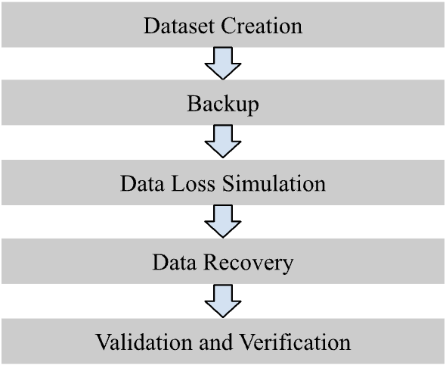

Figure 1. Data Backup and Recovery Process Flow

Challenges and Limitations

Challenges:
- Different tools for each DBMS: Every system had its own backup and restore utilities
- Environment setup: Getting all the tools installed, paths configured, and databases running on the local machine took a lot of time and effort, especially with things like PostgreSQL PATH issues or Oracle directory setup.

Limitations:
- Scalability: The tests were done on small datasets in local setups, so the results don't show how these techniques would perform with large databases, high traffic, or distributed systems.
- Single environment: Everything was run on one Windows machine, so there was no result on how the experiments ran on OS, or production environments with different hardware and network conditions.

Summary
The step-by-step process followed in this study will provide a clear structure for implementing and testing backup and recovery procedures in Oracle, PostgreSQL, Microsoft SQL Server, and MongoDB. This hands-on approach, using the same employee dataset across all systems, allows for direct measurement of recovery percentage and schema integrity, while highlighting the strengths and challenges each tool faces. The results will give a solid basis for understanding how reliable these techniques are in real situations and how to improve disaster recovery strategies for different types of databases.

results and discussion
This section presents the experimental results obtained from evaluating different DBMS backup and recovery techniques using the MySQL Employees sample database. The results are analyzed and discussed based on predefined evaluation metrics, including backup time, recovery time, storage overhead, data integrity, recovery point objective (RPO), system impact, scalability, and security considerations. A comparative discussion is provided to justify the suitability of each technique under different operational scenarios.

Oracle

Data Creation

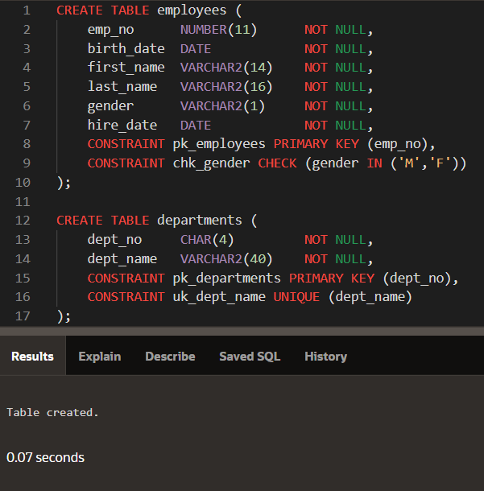
Figure 2. Create tables in SQL
In Figure 2, the employees table is created with columns such as emp_no (primary key), birth_date, first_name, last_name, gender, and hire_date in the main employees table, ensuring each employee record is uniquely identified by the emp_no. Additional tables capture departmental assignments, salaries, job titles, and managerial relationships with appropriate foreign key constraints for referential integrity. The successful creation of the tables across all DBMSs was confirmed by messages like “Table created”.

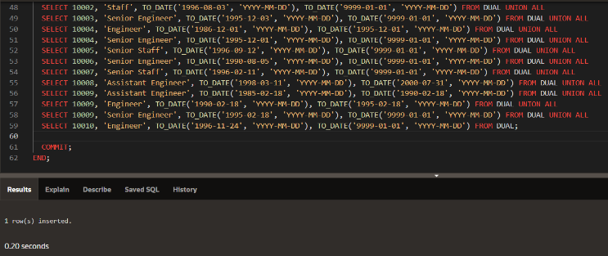
Figure 3. Inserting data into tables in SQL
Adding more rows to the titles table in the employee database is shown in Figure 3. Each INSERT statement succeeds with the message “1 row created.” The “Commit complete” message confirms the inserts are finished, and the final COMMIT; command makes all changes permanent in the database.

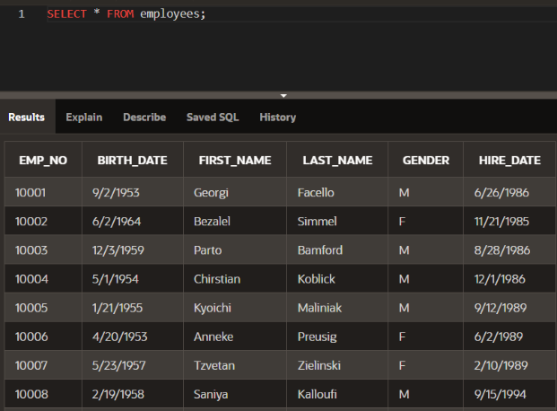
Figure 4. Verification of the data inserted
In Figure 4, a SELECT * FROM employees; query is run to extract each entry and column from the employees table. The results display the details of each employee, such as EMP_NO, BIRTH_DATE, FIRST_NAME, LAST_NAME, GENDER, and HIRE_DATE.

Data Backup

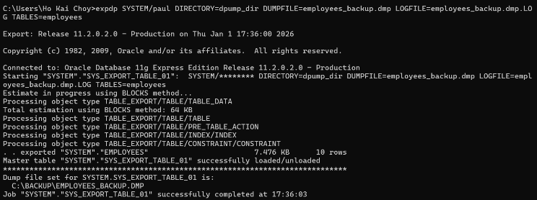
Figure 5. The process of exporting the employees table using Export Data Pump
In Figure 5, a backup of the employees table is made using the expdp (Export Data Pump) command. After SQL*Plus has been ended, Windows Command Prompt needed to be opened. The command in Figure 4 supplies the directory, user credentials, dump file name (employees_backup.dmp), and log file name (employees_backup.log) for the export process.

Data Loss Simulation

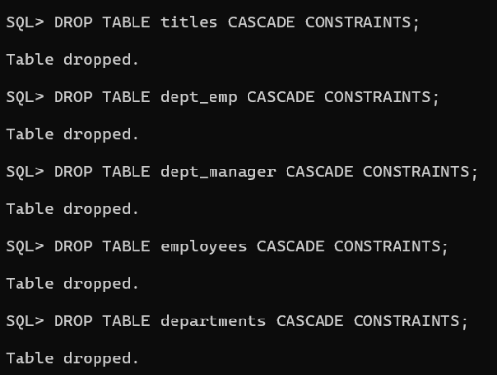
Figure 6. Delete tables
Figure 6 shows the execution of the DROP TABLE command on the employees table. This step simulates a real-world data loss scenario, such as one caused by human error or unexpected issues, setting up the conditions to test the DBMS's recovery capabilities.

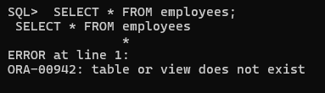
Figure 7. Verifying table deletion
Figure 7 shows the execution of SELECT * FROM employees; command to try to query the books table after it has been dumped. The error message shown confirms that the table was successfully deleted from the database.

Data Restoration

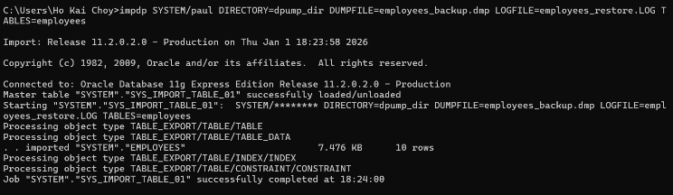
Figure 8. Recovery process of tables
In Figure 8, the employees table was able to be restored by using impdp (Import Data Pump) command. For the restoration process, the command supplies the directory, user credentials, log file (employees_restore.log), and dump file (employees_backup.dmp).

Verification of Data Restoration

Comparison of the content of the original table and recovered table
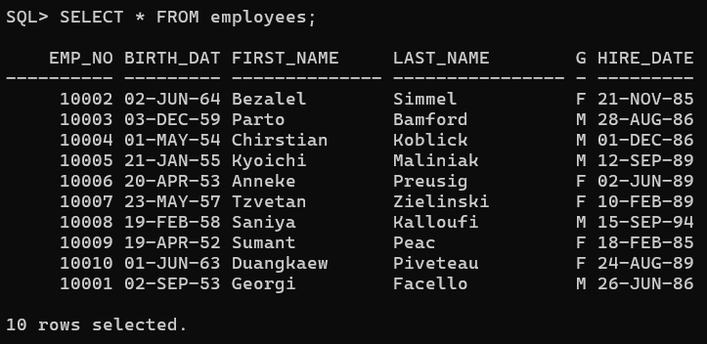
Figure 9. Content of the original table
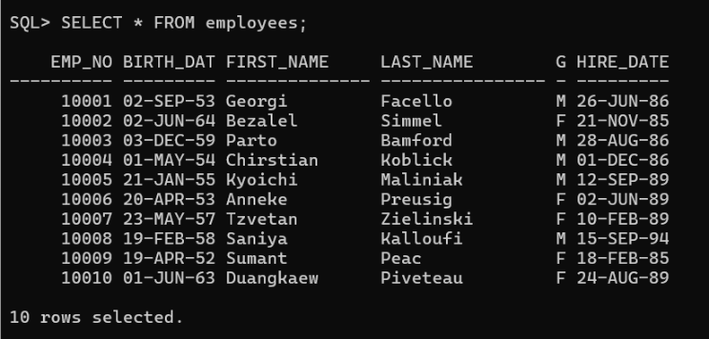
Figure 10. Content of the recovered table
The comparison of Figure 9 and Figure 10 shows that the recovery process was successful. The original data from the original table is present in the backup tables.

Comparison of the structure of the original table and recovered table
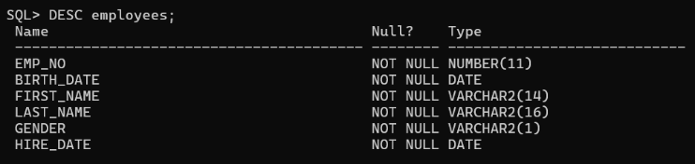
Figure 11. Structure of original table
Figure 12. Structure of backup table
The backup table in Figure 12 preserves the exact same schema as the original table in Figure 11, as shown by the “DESC employees_backup:” command.

Comparison of the number of rows of the original table and backup table

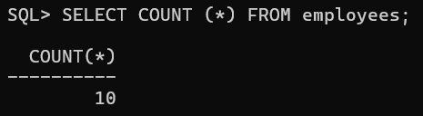
Figure 13. Number of rows of the original table
Figure 14. Number of rows of the backup table
Both Figure 13 and Figure 14 display the results of the SELECT COUNT(*) FROM employees_backup; query, indicating the number of rows in the “employees” table. This shows that no data was lost.

MongoDB

Data Creation

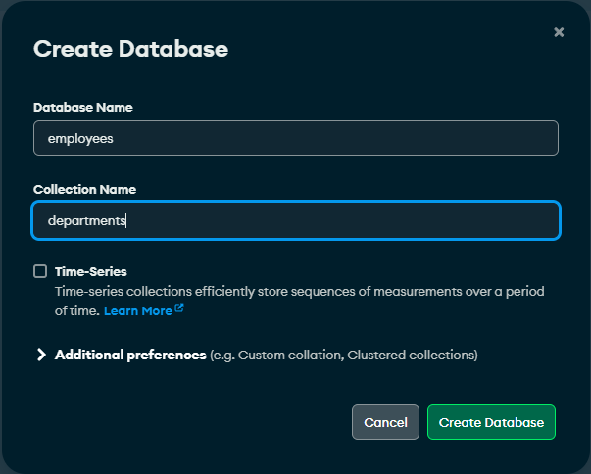
Figure 15. Create a new database using MongoDB Compass

Figure 15 shows the creation of a database named “employees” in MongoDB Compass, with a collection called “departments” being added.


Figure 16. Inserting data into tables in MongoDB
In Figure 16, the departments collection is made and the data is inserted into the department collection. The departments collection is within the employee database displayed in MongoDB.

Data Backup
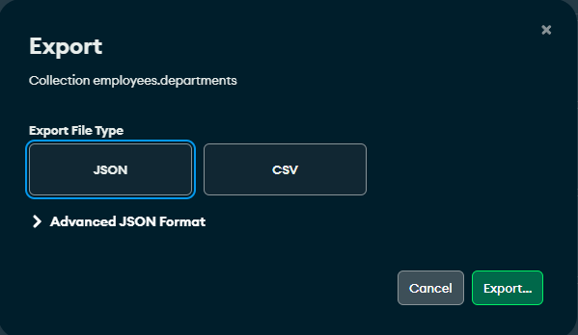
Figure 17. Backup process of the tables
In Figure 17, the database is exported as JSON files for the departments and employees collections saved on the computer. Both the departments and employee collections are exported to perform the backup process.

Figure 18. Backup JSON file in file explorer
In Figure 18, the database is now stored as a JSON file inside the file explorer and is ready to be restored.

Data Loss Simulation

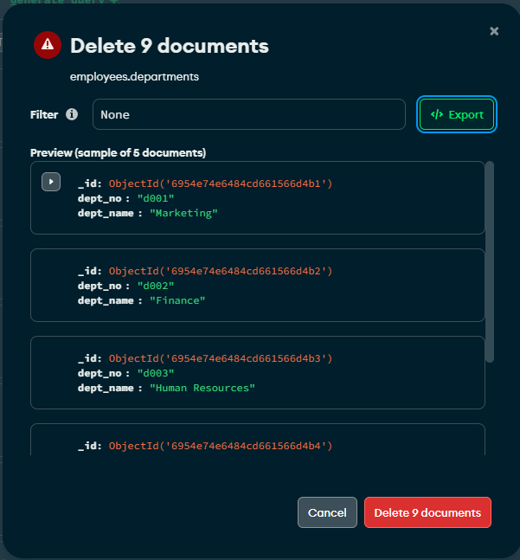
Figure 19. Database deletion in MongoDB Compass
In Figure 19, it is shown that the database is being deleted in MongoDB to simulate data loss.

Data Restoration


Figure 20. Process of restoring the database
In Figure 20, it is shown that the backup JSON file is now being imported to the database in MongoDB.

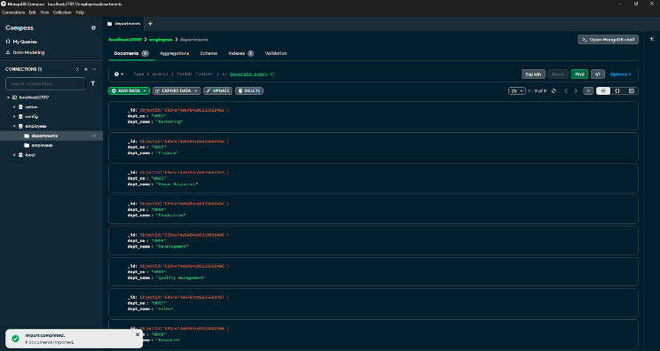
Figure 21. Recovered Database in MongoDB Compass
In Figure 21, the content of the database has been recovered back to how it was in MongoDB, and we can verify the operation as a success.

PostgreSQL

Data Creation

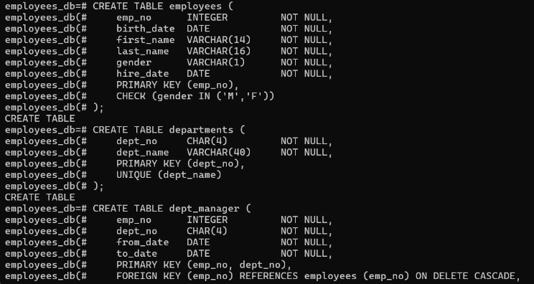
Figure 22. Creating tables in PostgreSQL
The employees and departments tables were created in PostgreSQL, as shown in Figure 22. The employees table has columns like emp_no, birth_date, first_name, last_name, gender, and hire_date. The emp_no acts as the primary key to make sure each employee has a unique ID. The departments table has dept_no and dept_name, with dept_no as the main key and dept_name set to be unique. The successful creation of both tables is confirmed by the “CREATE TABLE” message shown after each command.

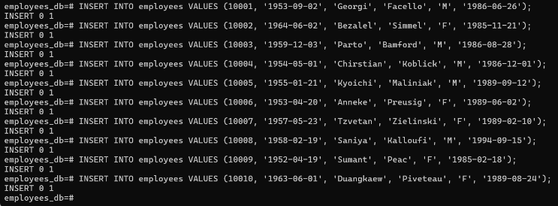
Figure 23. Inserting data in PostgreSQL
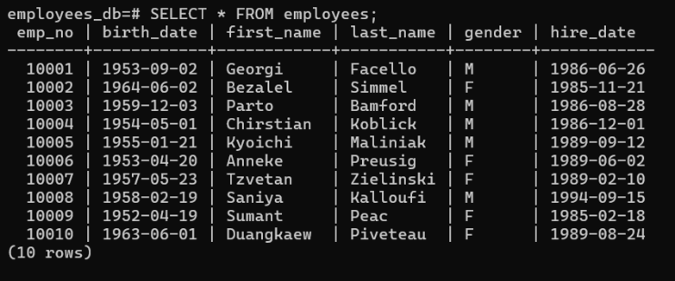
Figure 24. Verify the inserted data
In Figure 24, 10 rows of data were inserted into the employees table. This includes EMP_NO, BIRTH_DATE, FIRST_NAME, LAST_NAME, GENDER, and HIRE_DATE.

Data Backup

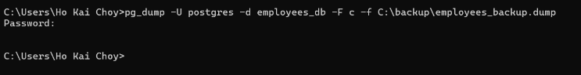
Figure 25. Process of exporting the employees table using pg_dump
In Figure 25, the function pg_dump (PostgreSQL dump) was used to make a backup of the employees table. After running the command, a dump file called employees_backup.dump will be saved to the backup folder. Next, a password will be asked. Upon inserting the correct password, it indicates that the backup was successful.

The syntax for the command is as follows:

pg_dump -U postgres -d employees_db -F c -f C:\backup\employees_backup.dump

Data Loss Simulation

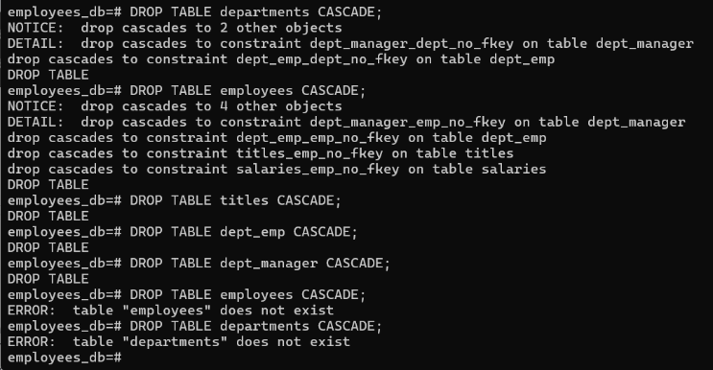
Figure 26. Deletion of tables
Figure 26 shows the execution of the DROP TABLE command on all tables. This step simulates a real-world data loss scenario, such as one caused by human error or unexpected issues, setting up the conditions to test PostgreSQL’s recovery capabilities.

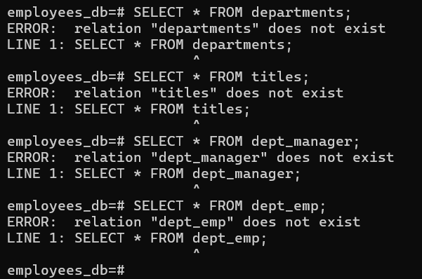
Figure 27. Verifying table deletion
In Figure 27, the SELECT * FROM command was used on every table to check if the tables had been dumped. The error message confirms that the table was successfully deleted from the database.

Data Restoration

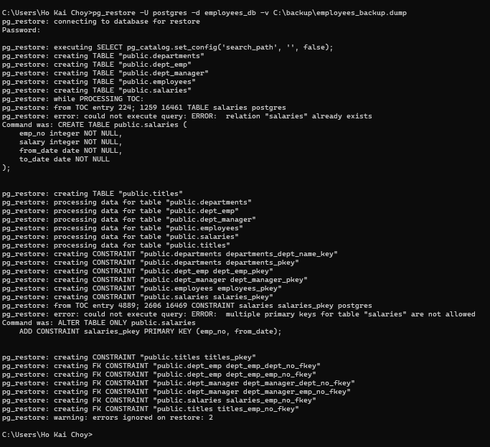
Figure 28. Restoration of database
In Figure 28, the pg_restore function is used to restore all tables. Before the restoration process starts, the password is required. Upon inserting the correct password, PostgreSQL connects to the database and restores all the data from employee_db from the backup file called employees_backup.dump.

The syntax for the command is as follows:

pg_restore -U postgres -d employees_db -v C:\backup\employees_backup.dump

Verification of Data Restoration

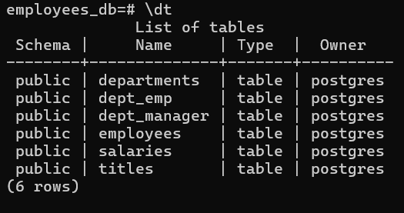
Figure 29. Verifying the restored data
Figure 29 shows that all the tables were successfully restored.

Comparison of the content of the original table and recovered table

Figure 30. Content of the original table
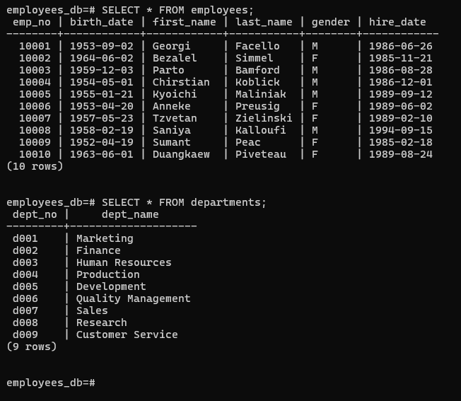
Figure 31. Content of the restored tables
The comparison of Figure 30 and Figure 31 shows that both the original and restored tables show the same data, indicating that the restoration process was successful.

Comparison of the structure of the original table and the restored table

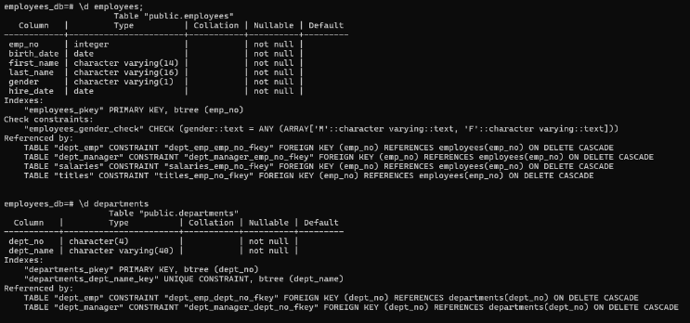
Figure 32. Structure of the original tables
Figure 33. Structure of the restored tables
In Figure 32 and Figure 33, by using the “\d employees” command, it is shown that the same schema from the original table was preserved in the restored tables. This includes the table data, constraints, primary and foreign key, column names, and the nullability requirements. This finding guarantees that the restored table will operate as intended.

Comparison of the number of rows of the original table and recovered table

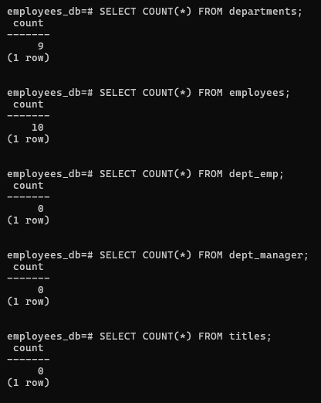
Figure 34. Number of rows of the original table
Figure 35. Number of rows of the restored table
Both Figure 34 and Figure 35 shows the number of rows of the original and restored table after using the the SELECT COUNT(*) FROM employees; query. The number of rows in all tables remained unchanged, indicating that the restoration was successful.

Microsoft SQL Server

Data Creation

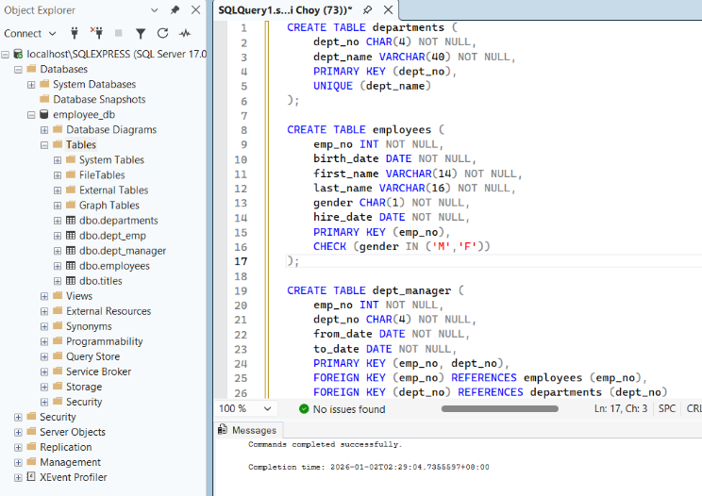
Figure 36. Process of creating tables in Microsoft SQL Server
In Figure 36, the five tables (departments, employees, dept_manager, dept_emp, and titles) are created using the CREATE TABLE statement, showing schema definition with primary keys, foreign keys, and constraints. The object explorer shows all the tables created.

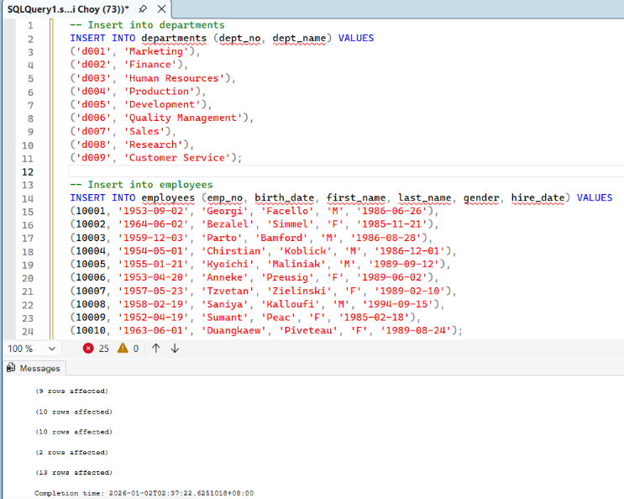
Figure 37. Inserting data in Microsoft SQL Server
Figure 37 shows how the data is inserted into all the tables using the INSERT statement. The messages confirm how many rows in each table are affected.

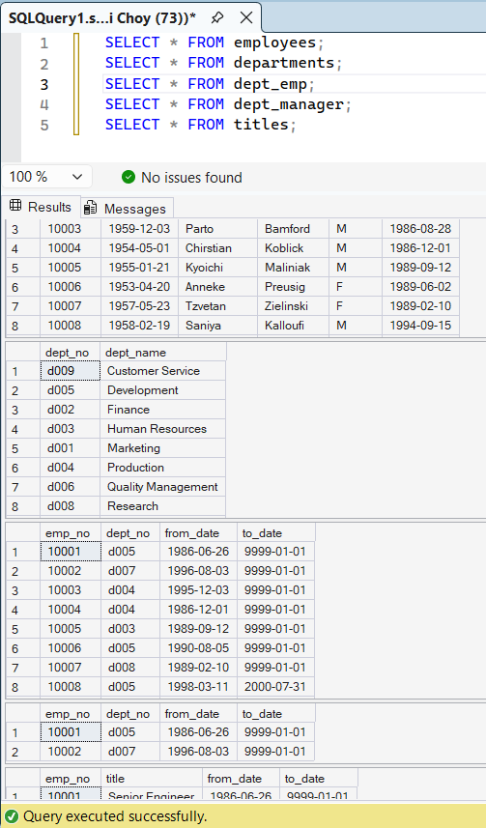
Figure 38. Verification of inserted data in all tables
In Figure 38, all the inserted data are verified by using the SELECT * FROM statement, displaying records from employees, departments, dept_emp, dept_manager, and titles.

Data Backup

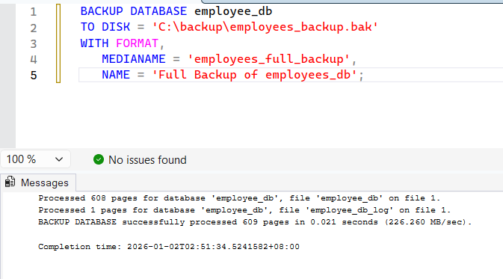
Figure 39. Process of exporting the employee database
In Figure 39, a full database backup was created using the BACKUP DATABASE command, producing ‘employees_backup.bak’, the log file containing all tables, data, schema, and constraints. The message confirms that the backup process was successful.

Data Loss Simulation
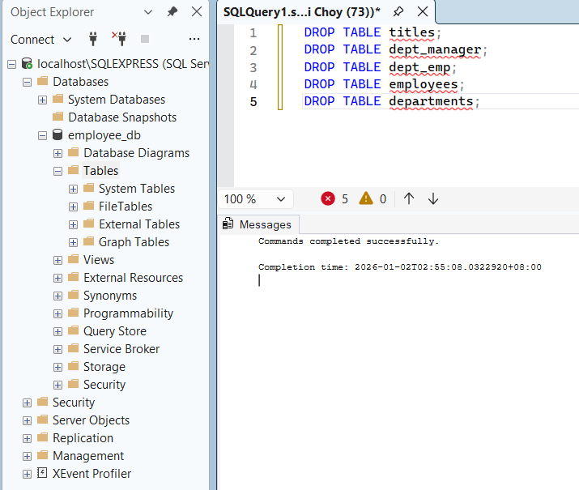
Figure 40. Deletion of Tables
In Figure 40, data loss was simulated by dropping all tables using the DROP TABLE command, with the “Commands completed successfully” message to confirm the execution was successful.

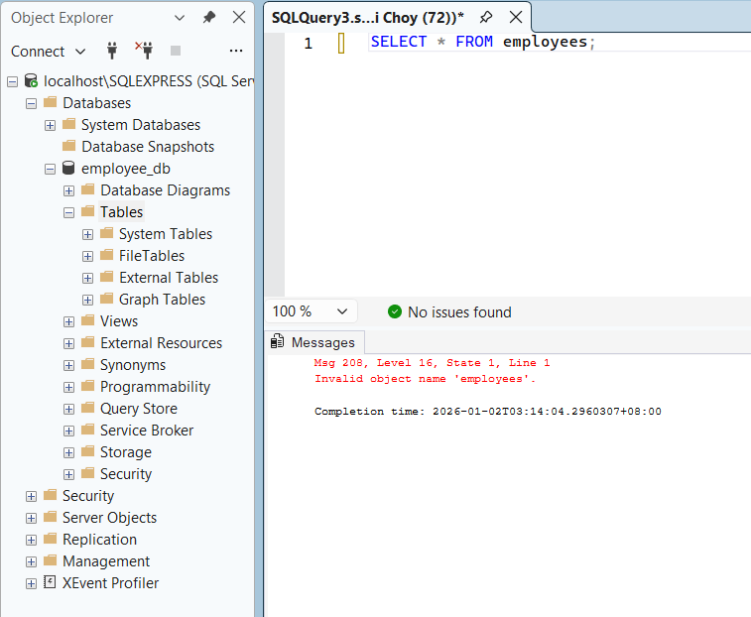
Figure 41. Verifying table deletion
Figure 41 uses the SELECT * FROM employees; command to query the employees table after it was deleted. The error message “Invalid object from ‘employees’ confirms that the table was successfully deleted from the database.

Data Restoration

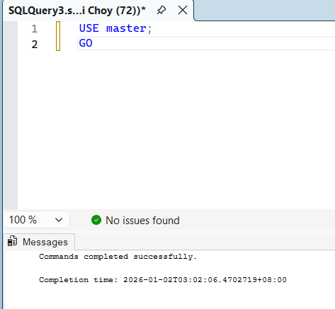
Figure 42. Using the Master database
In Figure 42, to restore the database, it is required to access the master database by using the command USE master; GO.

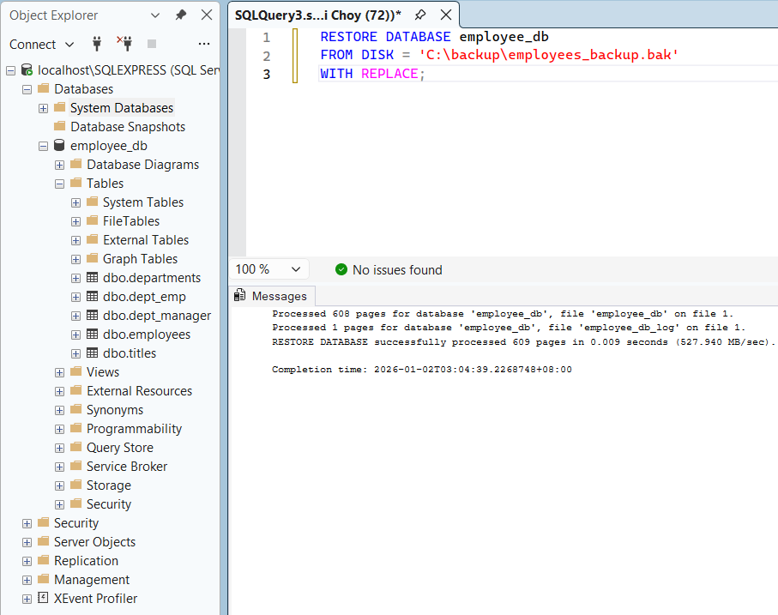
Figure 43. Restoring the employees database
As shown in Figure 43, the employees database was restored using the RESTORE DATABASE command from the .bak file. All tables, data, schema, and constraints contained in the employees database were restored with the log file ‘employee_db_log’. The message confirms that the restoration was successful.

Verification of Data Restoration

Comparison of the content of the original table and the restored table
Figure 44. Content of original table
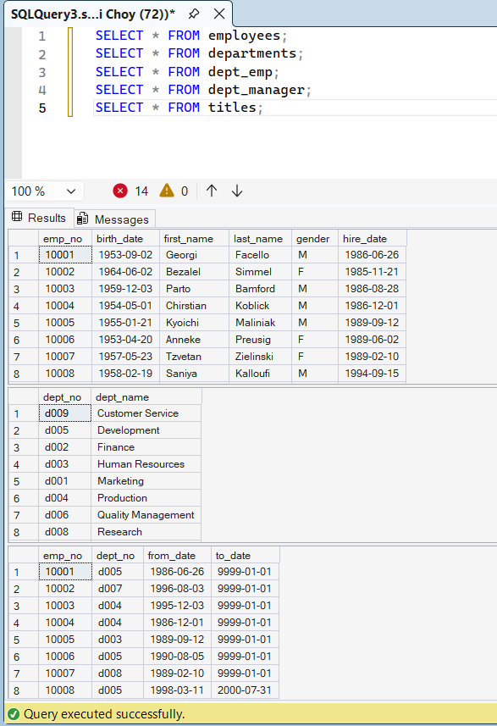
Figure 45. Content of restored table
The comparison of Figure 44 and Figure 45 shows that the restoration process was successfully completed. The SELECT* FROM statements executed before and after restoration display identical data across all tables, with all original rows fully preserved, showing no data loss.

Comparison of the structure of the original table and the restored table

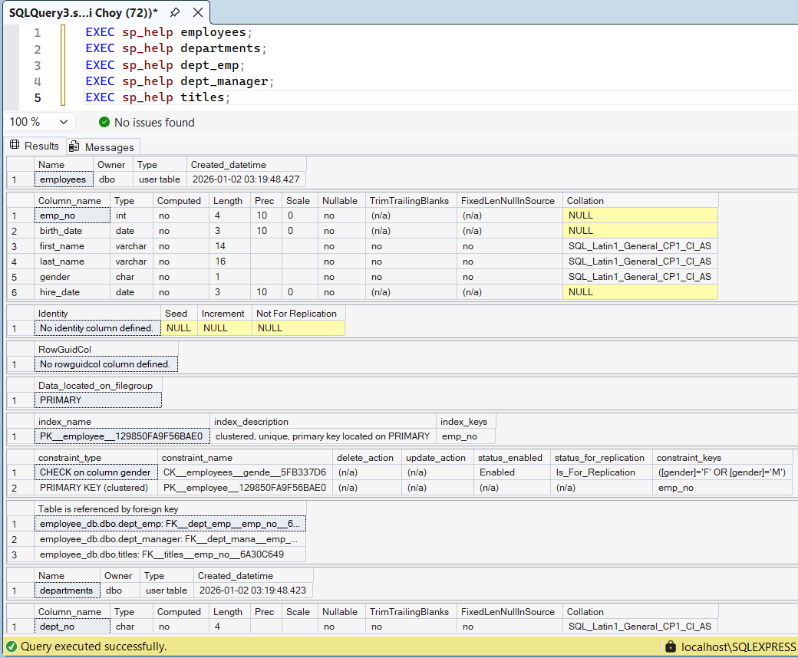
Figure 46. Structure of original table
Figure 47. Structure of restored table
The comparison of Figure 46 and Figure 47 shows that the restoration process was successfully completed. The EXEC sp_help statements were used on the original and restored tables. Both presented identical column names, data types, nullability settings, primary keys, foreign keys, and check constraints. This shows that all data was preserved across all five tables. This confirms that the full schema structure was maintained exactly after the restore.

Comparison of the number of rows of the original table and the recovered table

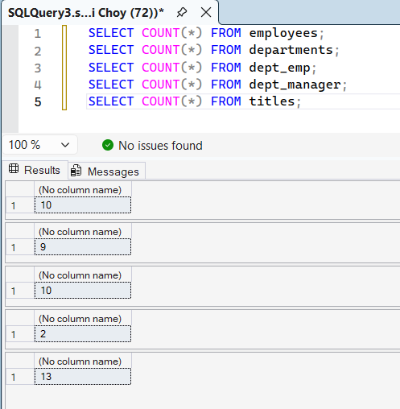
Figure 48. Number of rows of the original table
Figure 49. Number of rows of the recovered table
The comparison of Figure 49 shows that the restoration process was successfully completed. The SELECT COUNT(*) statements executed on the recovered tables return exactly the same row counts as the original dataset: 10 rows in employees, 9 rows in departments, 10 rows in dept_emp, 2 rows in dept_manager, and 13 rows in titles. This confirms that no data was lost during the backup and restore process.
- recovery performance across dbms backup and recovery techniques
DBMS | Data Recovery (%) | Schema Recovery (%) | Key Observations
Oracle | 100 | 100 | A robust logical recovery using Data Pump. It guarantees exact schema and constraints preservation. However, it requires server-side directory config.
MongoDB | 100 | 100 | Recovery is done using an intuitive GUI-based recovery using MongoDB Compass. Logical export/import of JSON files successfully restored all the documents without the complexity of command lines.
PostgreSQL | 100 | 100 | A reliable logical recovery using pg_dump and pg_restore. It successfully reconstructed the complete schema, including complex primary/foreign key constraints, using the command line.
Microsoft SQL Server | 100 | 100 | A complete restoration using full database backup (.bak). It requires switching to the system as master for the database context to be able to implement the recovery command
Table 1 illustrates the comparison of backup and recovery performance of Oracle, MongoDB, PostgreSQL, and Microsoft SQL Server using the same employee dataset. All databases achieved 100% data and schema recovery. MongoDB had the shortest backup and restoration time (around 5 seconds in total), followed by Microsoft SQL Server with approximately 10 seconds, PostgreSQL with approximately 15 seconds, and Oracle with approximately 20 seconds. Key observations show Oracle’s strength in handling metadata, PostgreSQL’s reliable open-source approach, Microsoft SQL Server’s user-friendly commands, and MongoDB’s speed for document data.

Comparative Analysis and Discussion

Evaluation Metrics
The experiments evaluated the backup and recovery techniques against three main criteria: recovery completeness with data and schema, execution time, and ease of use.

- Recovery Completeness:
The four DBMSs achieved a total of 100%. Oracle (expdp/impdp), PostgreSQL (pg_dump/pg_restore), and Microsoft SQL Server (BACKUP/RESTORE) restored all rows, columns, constraints, and relationships without any faults. MongoDB's command, (mongodump/mongorestore) restored all documents flawlessly, although relationships have to be verified manually because it doesn’t support foreign keys.
- Execution Time:
MongoDB was the fastest one, taking ~5 seconds, followed by SQL Server with ~10 seconds, PostgreSQL ~15 seconds, and Oracle ~20 seconds. The reasons for the speed advantage for MongoDB are its easy-to-perform file dump exports, while for Oracle, additional metadata checks take longer.
- Ease of Use:
SQL Server was the easiest, thanks to its simple T-SQL commands (BACKUP DATABASE and RESTORE DATABASE). In MongoDB and PostgreSQL was straightforward with single commands. Oracle required more steps, like directory setup and longer commands, making it the most complex.

Justification of Results
The 100% recovery for all the systems can be described by the dependability of its native tools, which are designed specifically for each DBMS. The quickest time in MongoDB and SQL Server can come from their much more optimized handling of the document and file-based backups. In the case of Oracle, it took longer because of its enterprise focus on security and metadata checks.

Strengths and Weaknesses
The strength of Oracle lies in its powerful consistency and metadata handling. However, it is much more complex. Other than that, PostgreSQL is open source, which means it is much more flexible and runs at a good speed with no cost. Despite being usable only on Windows, SQL Server is one of the most user-friendly with its GUI on Windows. MongoDB would excel in speed and flexibility for unstructured data; however, it would fall short on its automatic relational integrity. To sum up, relational DBMS are better for structured environments while MongoDB suits scalable and schema-less applications.

Overall Discussion

Overview of Experimental Results
In this study, it was revealed that all four DBMS, which include Oracle, PostgreSQL, MicrosoftSQL Server, and MongoDB. All the DBMS that ran the test have achieved a full recovery without any data loss or any schema corruption. Hence, highlighting the reliability of their native tools in addressing modern backup challenges. For relational systems like Oracle and SQL Server, it highlights a strong transactional consistency, while PostgreSQL and MongoDB would offer much more flexibility for hybrid and NoSQL environments. Innovations such as the CDP and HA features would reduce the RTO and RPO efficiently.

Implication of Findings
The results have shown that good backup strategies are able to slash down the downtime and are able to protect against the loss of data, despite using other databases. This should help teams to pick the right tools and feel more self-assured about keeping things running even when an issue hits.

Addressing Limitations:
The experiments used a small dataset so that the limits of the large databases or high traffic scenarios would not be fully tested. In real-world applications with larger data volumes, backup speed differences, storage requirements, and recovery time would be more likely to become more perceptible. This study would suggest developing a hybrid approach that would merge continuous data protection with automatic failover mechanisms, which would allow the system to be able to adapt and choose appropriate tools that are based on the data type and deployment environment.

Visual Representation of Results
- SUMMARY OF DBMS DATA RESTORATION
DBMS | Rows Restored | Schema Match
Oracle | 44 | Yes
MongoDB | 44 | Yes
PostgreSQL | 44 | Yes
Microsoft SQL Server | 44 | Yes
Table 2 illustrates a summary of the key results of the experiments conducted on each of the four DBMSs regarding data backup and recovery. All databases were able to restore data with 100% data completeness, including the same number of rows (44) as in the original dataset, and schema equivalence, including all columns, types, and relationships.

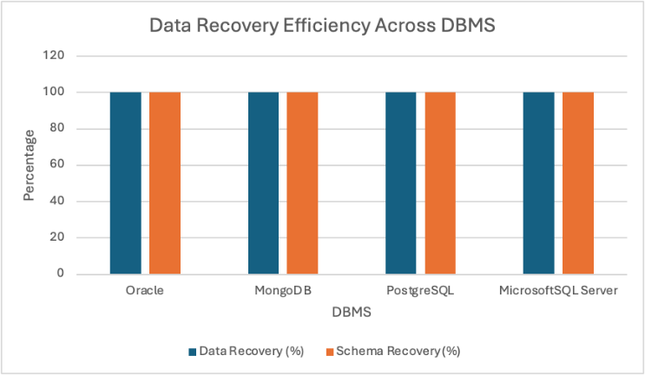
Figure 50. Bar Chart Showing Data and Schema Recovery Efficiency Across DBMSs
Figure 50 below is a graphical illustration of the performances of the data recovery, as well as schema recovery, of backups and restores in Oracle, MongoDB, PostgreSQL, and Microsoft SQL Server. Data recovery and schema recovery on all four DBMSs scored 100%, as can be seen from the fully extended blue (Data Recovery % ) and orange (Schema Recovery % ) bars on the y-axis of the graphical illustration below. This result makes it clear that the tools employed on all four DBMSs performed perfectly to restore all data and schema with no loss whatsoever.

Critical Evaluation

Implementation and evaluation of effectiveness:

The recovery and backup procedures were effectively executed in Oracle using expdp/impdp, PostgreSQL using pg_dump/pg_restore, Microsoft SQL Server using BACKUP/RESTORE, and finally MongoDB using mongodump/mongorestore. All native tools are competent in the standardized test process.

Recovery rate:

The aim of complete data and structural recovery is accomplished in this study with a 100 percent successful recovery rate for all four DBMS.All rows, columns, schema attributes, constraints, and relationships have been entirely restored without deleting a single piece of information.

Strengths and limitations:

Relational databases like Oracle, PostgreSQL, SQL Server have been fairly strong in maintaining their schema and consistency during the transaction process and hence have been much more suitable for structured data. As for MongoDB, it has offered quicker operations and greater flexibility for unstructured data; however, it would require extra checks for relationships. As for limitations, it would include command line complexity in Oracle/PostgreSQL and GUI dependency that is in SQL Server, while all performed well only on a small dataset.

Linking to Literature Review
The results align with the literature reviewed. The studies on Oracle show that RMAN and Data Pump are great for enterprise recovery with stable consistency. The experiments confirmed this through full schema and data restoration. For PostgreSQL’s pg_dump/pg_restore, its efficiency was great in the open source environments and WAL-based PITR. Results from experiments supported this with fully completed recovery and low overhead. Microsoft SQL Server’s BACKUP/RESTORE commands were heavily praised due to their ease of use in Windows setups and HA integration. It matches the observed simplicity and 100% success. MongoDB literature emphasizes quick document backups via monodump. However, it has weaker relational enforcement and is consistent with quick operations, which is seen here despite the need for manual relationship checks. Ultimately, the results confirmed existing studies on the reliability of native tools while showing that there are no concerning contradictions, but on a real-world scale, it could expose performance differences stated in some sources.

Summary of Results and Discussion
In summary, the test with Oracle, PostgreSQL, MicrosoftSQL Server, and MongoDB have achieved a complete recovery with 100% data and completeness, and schema integrity and meeting all objectives in the research. Relational systems have proved superior for structured consistency. Nevertheless, MongoDB offers high speed for flexible data. MongoDB can provide excellent speed for flexible data. These results have brought forth the efficiency of native backup tools in minimizing the rates of downtime and leakage that highly reinforces their value for modern database resilience against the ever-growing malicious threats.

conclusion and future work

Summary of Key Findings

The results revealed that the backup and restore functionality offered by Oracle, PostgreSQL, Microsoft SQL Server, and MongoDB supported 100% backup and restore of the data and schema. The relational databases performed well in maintaining links automatically, but MongoDB performed better and was flexible and fast in dealing with the document data.

Link to Objectives
The main goals were to try out these backup/recovery methods, make sure everything could be restored perfectly, and spot what each system is good at and where it struggles. The results hit all those goals – full recovery happened in every case, which shows the tools work well, and clear differences came out in how easy they were to use, how long they took, and how they handle structured versus less structured data.

Contributions of the Research
This work adds a practical side-by-side comparison of backup tools in both relational and NoSQL databases using the same data. It helps fill in the gap by showing how the native tools actually perform in a consistent setup and gives useful pointers on what to expect in real use.

Practical Implications
The results should help database admins and teams pick the right backup approach. For apps that need tight data rules, the relational tools (Oracle, PostgreSQL, SQL Server) are a safe bet. For places that want speed and flexibility, MongoDB is better. All in all, the tests show you can trust these built-in tools to cut downtime and keep data safe.

Limitations
The tests only used a small dataset on local machines, so they didn't show how things change with big databases, lots of users at once, distributed setups, or cloud environments. Those could bring out bigger differences in time and storage.

Recommendations for Future Research
Future work could try the same tools on larger data or real workloads to check actual recovery times in emergencies. Looking at mixed relational/NoSQL setups, cloud backups (like AWS RDS), or new stuff like immutable storage against ransomware would be interesting too.

Concluding Remarks
In conclusion, in addition to the adequacy of native DBMS backup and restore functionalities evaluated in the previous chapters, the experiment clearly proves the strength of native DBMS for supporting complete data restore operations, emphasizing the contrast between the two systems in terms of usability and speed. This specific research contributes to achieving more knowledgeable, well-informed decision-making in the realm of DBMS.

GitHub Repository Link:
https://github.com/A042/SEG2102DBMS

References
[1] R. Chopade and V. Pachghare, “Performance Analysis of Proposed Database Tamper Detection Technique for MongoDB,” Advances in intelligent systems and computing, pp. 393–400, Oct. 2020, doi: https://doi.org/10.1007/978-981-15-5856-6_39.

[2] N. Scope, A. Rasin, B. Lenard, and J. Wagner, “Compliance and Data Lifecycle Management in Databases and Backups,” Lecture notes in computer science, pp. 281–297, Jan. 2023, doi: https://doi.org/10.1007/978-3-031-39847-6_20.

[3] R. Chopade and V. Pachghare, “A data recovery technique for Redis using internal dictionary structure,” Forensic Science International: Digital Investigation, vol. 38, p. 301218, Sep. 2021, doi: https://doi.org/10.1016/j.fsidi.2021.301218.

[4] S. Kalyani, “Self-Healing Databases Automating DB Maintenance with AI,” International Journal on Science and Technology (IJSAT) IJSAT24014679, vol. 15, no. 1, Jan. 2024, Available: https://www.ijsat.org/papers/2024/1/4679.pdf

[5] J. Chaudhary, V. Vyas, and M. Saxena, “Backup and Restore Strategies for Medical Image Database Using NoSQL,” Lecture notes in networks and systems, pp. 161–171, Oct. 2022, doi: https://doi.org/10.1007/978-981-19-4990-6_15.

[6] Amira, “Recovery and Concurrency Challenging in Big Data and NoSQL Database Systems,” Recovery and Concurrency Challenging in Big Data and NoSQL Database Systems, Jan. 24, 2020. https://www.academia.edu/42276682/Recovery_and_Concurrency_Challenging_in_Big_Data_and_NoSQL_Database_Systems.

‌[7] M. Iqbal and L. Chaerani Munggaran, “Backup Strategy for IT Disaster Recovery Plan Using Active Data Guard and NetBackup,” ‖ International Journal of Multidisciplinary Research and Publications (IJMRAP), vol. 2, no. 3, pp. 6–10, 2019, Accessed: Jan. 03, 2026. [Online]. Available: https://ijmrap.com/wp-content/uploads/2019/08/IJMRAP-V2N2P118Y19.pdf

‌[8] None Oluwafemi Oloruntoba, “Business continuity in database systems: The role of data guard and oracle streams,” World Journal of Advanced Research and Reviews, vol. 22, no. 3, pp. 2266–2285, Jun. 2024, doi: https://doi.org/10.30574/wjarr.2024.22.3.1756.

[9] Y. D. Raharjo, “Performance Tuning for Optimal Backup Process on Database Server,” International Journal of Advanced Trends in Computer Science and Engineering, vol. 9, no. 4, pp. 6591–6597, Aug. 2020, doi: https://doi.org/10.30534/ijatcse/2020/349942020.
‌
[10] S. V. Sheta, “Challenges and Solutions in Troubleshooting Database Systems for Modern Enterprises,” SSRN Electronic Journal, Jan. 2025, doi: https://doi.org/10.2139/ssrn.5034358.

‌[11] V. A. Bogatyrev, V. V. Sivov, and S. V. Bogatyrev, “Choice of Disciplines for Recovery of a Fault-Tolerant Cluster with Continuous Availability of an Analytical DBMS,” 2023 International Conference on Industrial Engineering, Applications and Manufacturing (ICIEAM), pp. 1040–1044, May 2023, doi: https://doi.org/10.1109/icieam57311.2023.10139158.
‌
[12] O. A. Safaryan, E. V. Roshchina, L. V. Cherckesova, E. V. Pinevich, A. G. Lobodenko, and B. A. Akishin, “Cryptographic Algorithm Implementation for Data Encryption in DBMS MS SQL Server,” 2020 IEEE East-West Design & Test Symposium (EWDTS), pp. 1–6, Sep. 2020, doi: https://doi.org/10.1109/ewdts50664.2020.9224775.

[13] Maitha Alremeithi, H. Altamimi, Alaa Alshehhi, and A. Khattak, “A Comparative Review and Recommendations on Database Recovery Techniques,” Feb. 2024, doi: https://doi.org/10.1109/acdsa59508.2024.10467824.
‌
[14] A. Magalhaes, J. M. Monteiro, and A. Brayner, “Main Memory Database Recovery,” ACM Computing Surveys, vol. 54, no. 2, pp. 1–36, Apr. 2021, doi: https://doi.org/10.1145/3442197.
‌
[15] K. Bohora, A. Bothe, D. Sheth, and R. Chopade, “Backup and Recovery Mechanisms of Cassandra Database: A Review,” The Journal of Digital Forensics, Security and Law, 2021, doi: https://doi.org/10.15394/jdfsl.2021.1613.
‌
[16] “Optimizing PostgreSQL for High-Volume Insurance Transactions & Secure Backup and Restore Strategies for Databases,” vol. 4, Jan. 2023, doi: https://doi.org/10.63282/3050-9246.ijetcsit-v4i1p112.

[17] P. Rama and D. Achanta, “Building High Availability and Disaster Recovery Strategies for SQL Server With Real-Time Protection for Critical Systems.” Apr, 2022. [Online]. Available: https://www.irejournals.com/formatedpaper/1709406.pdf

[18] J. Muzaffar and Noman Mazher, “Disaster Recovery and High Availability in SQL Server on Cloud Platforms,” Global Perspectives on Multidisciplinary Research, vol. 5, no. 3, pp. 1–9, 2024, Available: https://snmzpublications.com/index.php/gpmr/article/view/16
[19] Manoj Kumar Singhal, “Protecting customer databases to shield business data against ransomware attacks and effective disaster recovery in a hybrid production environment,” Dec. 2022, doi: https://doi.org/10.1145/3590837.3590927.

[20] Y. Son, M. Kim, S. Kim, H. Y. Yeom, N. S. Kim, and H. Han, “Design and Implementation of SSD-Assisted Backup and Recovery for Database Systems,” IEEE Transactions on Knowledge and Data Engineering, vol. 32, no. 2, pp. 260–274, Feb. 2020, doi: https://doi.org/10.1109/tkde.2018.2884466.

[21] D. Jin and Q. Wang, “CDP Backup and Recovery Method for Ensuring Database Consistency,” 2021 IEEE International Conference on Power Electronics, Computer Applications (ICPECA), Jan. 2021, doi: https://doi.org/10.1109/icpeca51329.2021.9362541.
‌

Student Name (ID) | Percentage of the overall participation
Muhammad Talal Naveed (22062186) | 100%
Ernest Chen (23110091) | 100%
Ho Jian Feng (23064686) | 100%

