CEN454/Intelligent systems
Sep 2024

Project:
UCMerced Land use Classification

Talal Aloushan
441102306

Introduction:
In this project im going to train a CNN model(both Pytorch&Tensorflow frameworks) on the UCMerced dataset which consists of 21 class each with 100 images with a total of 2100 , to get hands-on experience of Deep learning and computer vision, first of all i have splitted the data into training set(60%) and validation set(40%), then i applied data augmentation on the training set,i choose the EffecientnetB0 (imagenet) model which has 4 Million parameters to train it on my data, at first i froze the whole model weights and added an output dense layer with 21 neurons, so im training the last layers weights only, i got 96% accuracy, then i unfroze some of the deep layers, 20% of the model only, and started training, i got 97%, then i switched to the Yolov11n-cls model which has 1.5 Million parameters and got 98% accuracy.

Dataset explore:
This is a 21 class land use image dataset meant for research purposes.
There are 100 images for each of the following classes:
- agricultural
- airplane
- baseballdiamond
- beach
- buildings
- chaparral
- denseresidential
- forest
- freeway
- golfcourse
- harbor
- intersection
- mediumresidential
- mobilehomepark
- overpass
- parkinglot
- river
- runway
- sparseresidential
- storagetanks
- tenniscourt
Each image measures 256x256 pixels.
The images were manually extracted from large images from the USGS National Map Urban Area Imagery collection for various urban areas around the country. The pixel resolution of this public domain imagery is 1 foot.
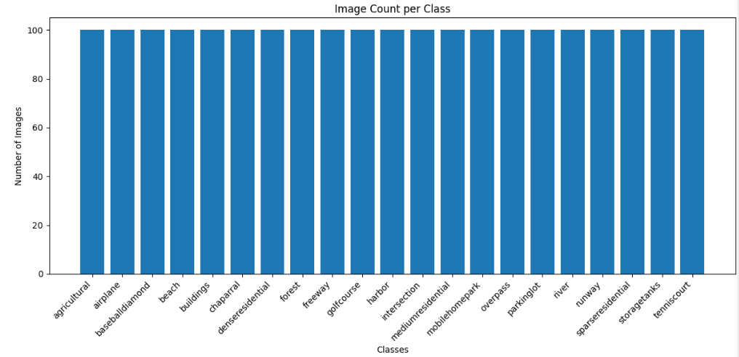

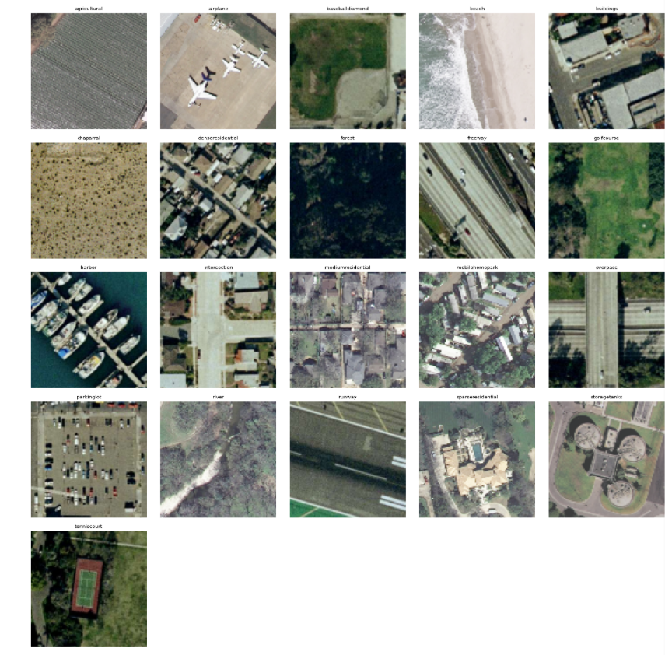

Data split and augmentation:
I splitted the data into 60% 40%, did 7 augmentation which is :
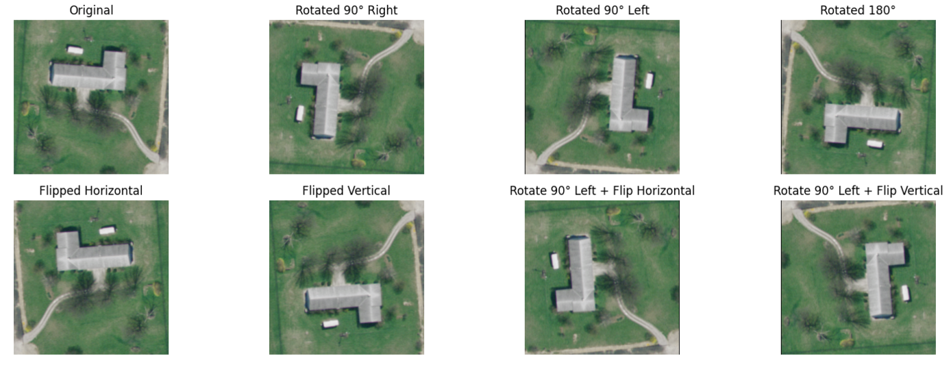

New label count chart:

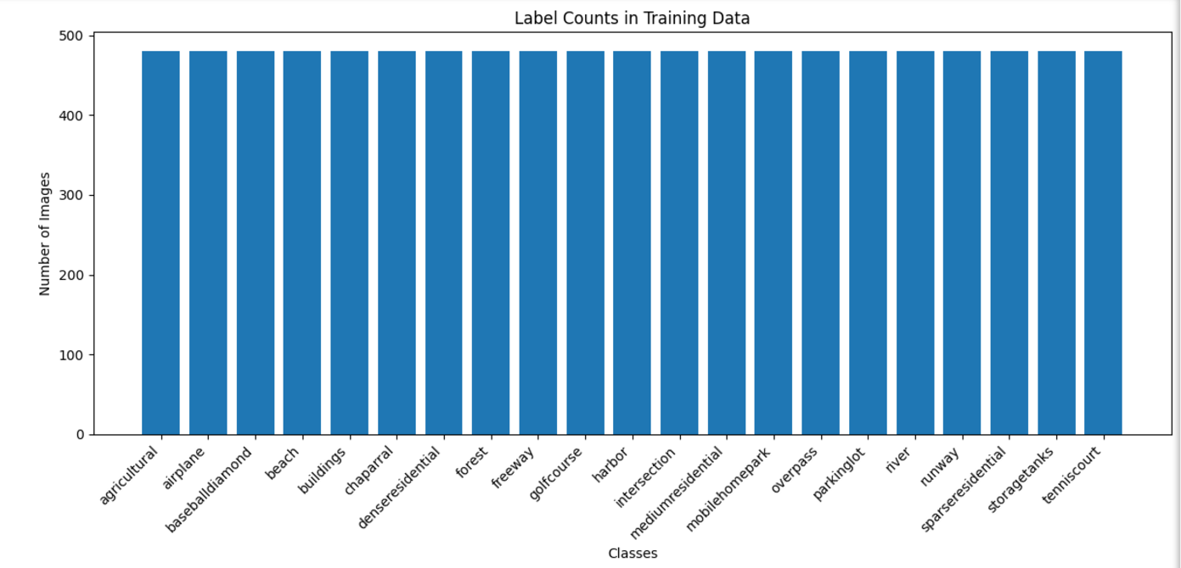
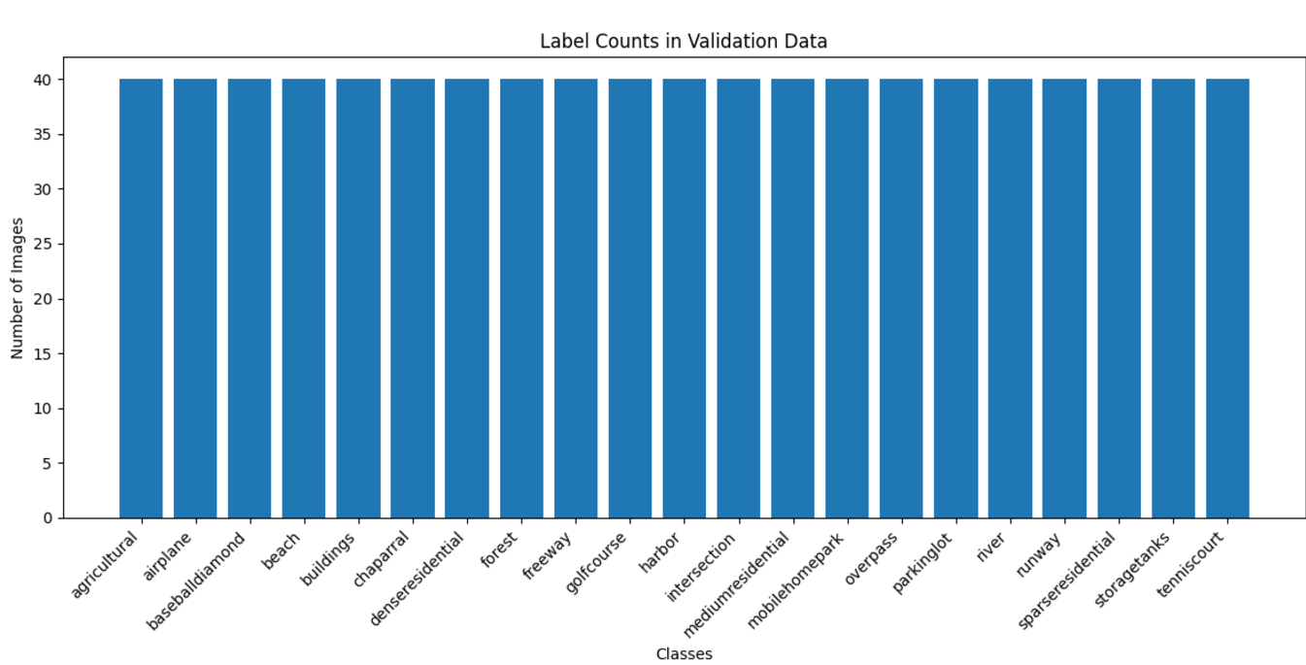

480 x 21 = 10080 training images.
40 x 21 = 840 validation images.

CNN Model ( EfficentnetB0)imagenet based:

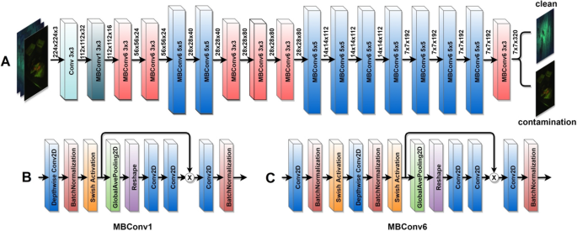

Approach#1(Tensorflow) (frozen model)(96%acc):

Data preprocessing:
Batched data into 16 batches
Scaled pixel values in the range (0,1)
Resized to 224x224

So i froze the entire model and added a dropout layer to prevent overfitting and a dense output layer with 21 nodes:

┏━━━━━━━━━━━━━━━━━━━━━━━━━━━━━━━━━┳━━━━━━━━━━━━━━━━━━━━━━━━┳━━━━━━━━━━━━━━━┓
┃ Layer (type) ┃ Output Shape ┃ Param # ┃
┡━━━━━━━━━━━━━━━━━━━━━━━━━━━━━━━━━╇━━━━━━━━━━━━━━━━━━━━━━━━╇━━━━━━━━━━━━━━━┩
│ efficientnetb0 (Functional) │ (None, 8, 8, 1280) │ 4,049,571 │
├─────────────────────────────────┼────────────────────────┼───────────────┤
│ global_average_pooling2d │ (None, 1280) │ 0 │
│ (GlobalAveragePooling2D) │ │ │
├─────────────────────────────────┼────────────────────────┼───────────────┤
│ dropout (Dropout) │ (None, 1280) │ 0 │
├─────────────────────────────────┼────────────────────────┼───────────────┤
│ dense (Dense) │ (None, 21) │ 26,901 │
└─────────────────────────────────┴────────────────────────┴───────────────┘

Total params: 4,076,472 (15.55 MB)

Trainable params: 26,901 (105.08 KB)

Hyperparameters:

model.compile(
loss='categorical_crossentropy',
optimizer=Adam(learning_rate=0.001),
metrics=['accuracy']
)
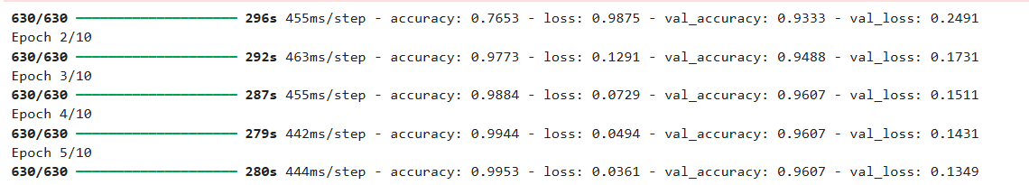

Approach#2(Tensorflow) (unfroze block6 and upper layers)(97%acc):
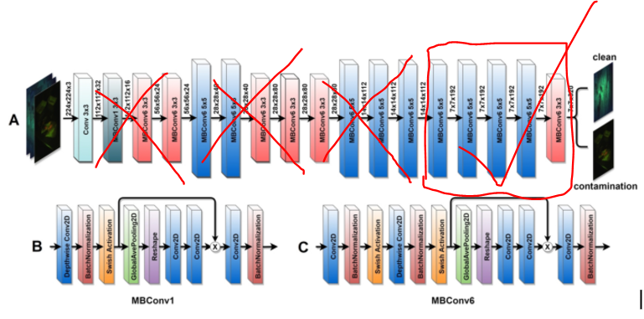

Actually not all the block6, i unfroze from block6d_se_excite layers exactly, which is 20% of block6 .
Layer 217: block6d_se_excite
Trainable params: 1,369,669 (5.22 MB)
Changed learning rate from 0.001 to 0.0001
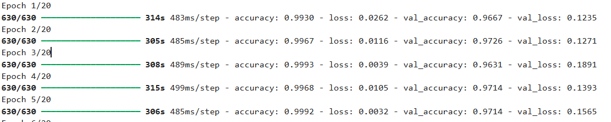

Next I tried to unfreeze until block 4 but my cpu and memory can't handle it. Anyway i think freezing the model with approach#1 was the best as it has only 26k trainable parameters and it performs nearly as the semi-unfrozen model that has 1.3Million trainable parameters. I will need to increase the epochs to get higher accuracy.

Approach#3(Pytorch)(Yolo11n-cls)imagenetbased(98%acc):
In this approach im fine-tuning all the weights of the model

from n params module arguments 0 -1 1 464 ultralytics.nn.modules.conv.Conv [3, 16, 3, 2] 1 -1 1 4672 ultralytics.nn.modules.conv.Conv [16, 32, 3, 2] 2 -1 1 6640 ultralytics.nn.modules.block.C3k2 [32, 64, 1, False, 0.25] 3 -1 1 36992 ultralytics.nn.modules.conv.Conv [64, 64, 3, 2] 4 -1 1 26080 ultralytics.nn.modules.block.C3k2 [64, 128, 1, False, 0.25] 5 -1 1 147712 ultralytics.nn.modules.conv.Conv [128, 128, 3, 2] 6 -1 1 87040 ultralytics.nn.modules.block.C3k2 [128, 128, 1, True] 7 -1 1 295424 ultralytics.nn.modules.conv.Conv [128, 256, 3, 2] 8 -1 1 346112 ultralytics.nn.modules.block.C3k2 [256, 256, 1, True] 9 -1 1 249728 ultralytics.nn.modules.block.C2PSA [256, 256, 1] 10 -1 1 357141 ultralytics.nn.modules.head.Classify [256, 21] YOLO11n-cls summary: 151 layers, 1,558,005 parameters, 1,558,005 gradients, 3.3 GFLOPs

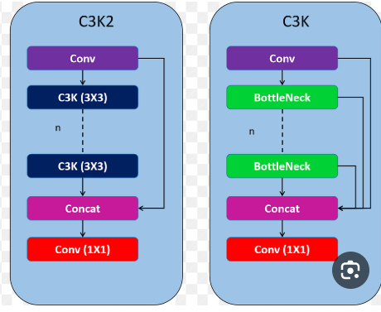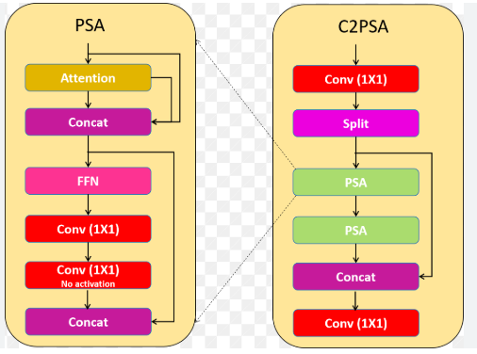

Data preprocessing:
Batched data into 16 batches
Scaled pixel values in the range (0,1)
Resized to 224x224

optimizer: AdamW(lr=0.000714, momentum=0.9) with parameter groups 39 weight(decay=0.0), 40 weight(decay=0.0005), 40 bias(decay=0.0)
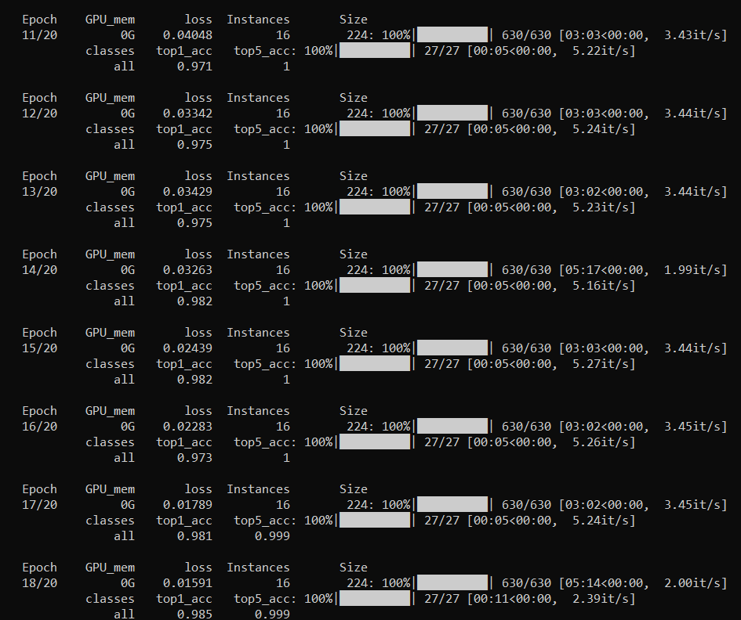
yolo11n-cls default random augmentations during training:


