CS462
Machine Learning
Nov 2024

Project: Date Fruit Classification

Talal Aloushan - 441102306

Problem description and its importance:
In today's fast-paced agricultural industry, telling different types of dates apart quickly and accurately is a real challenge. Imagine having to sort through thousands of dates by hand - it's time-consuming and prone to mistakes, even for experienced workers. That's where modern technology comes in handy, specifically computer vision. By teaching computers to "see" and categorize dates automatically, we can transform this tedious task into a streamlined process.
Think about it - each variety of date has its own special characteristics, commanding different prices in the market and being preferred for different uses. Some dates are perfect for luxury gift boxes, while others are ideal for processing into date syrup or paste. By using artificial intelligence to classify these dates automatically, we're not just saving time - we're ensuring consistent quality control, accurate pricing, and proper sorting. This means farmers get fair prices for their premium varieties, processors get the right types for their products, and consumers can trust what they're buying.

Platform:
Jupyter Notebook

Dataset:
Training set: 1156 samples
Validation set: 502 samples
Size: 600x400

Augmentation for training set:
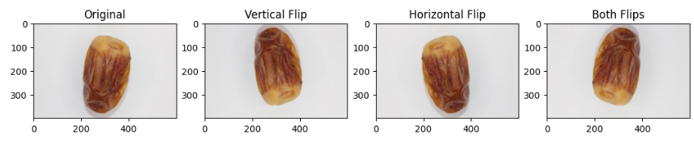
New training set samples: 4624

Count per label charts:

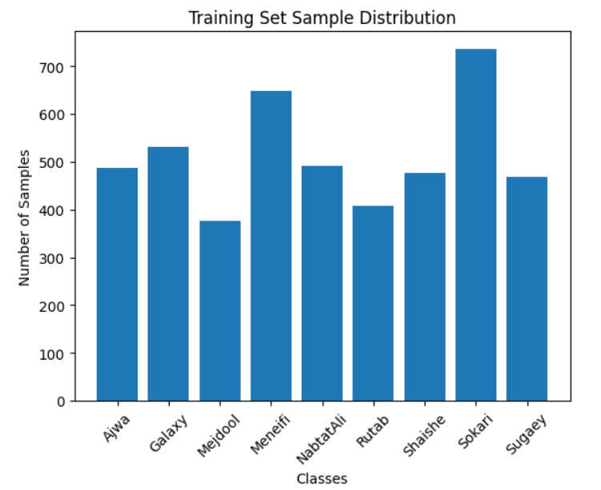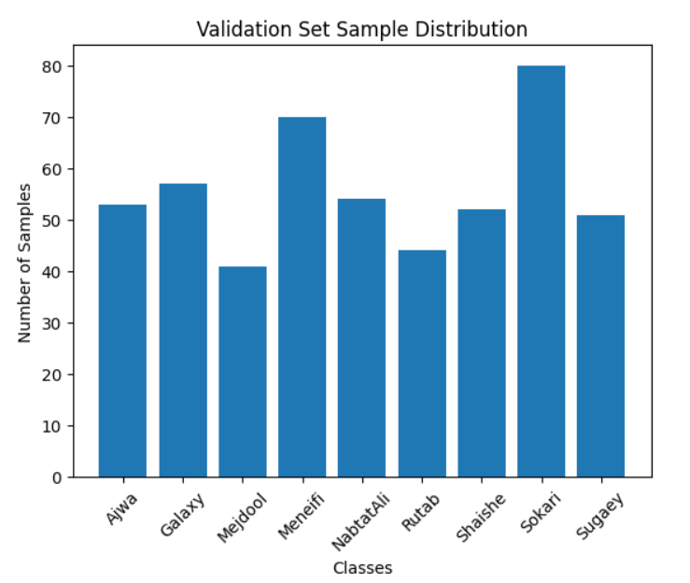

CNN Approaches:
I took 3 approaches to train a CNN model:
1: built a custom CNN using tensorflow framework and trained it. (94% acc)
2: applied the transfer learning concept on tf effecientnetb0 in 2 ways.
2.1:froze all the layers and weights, added an output layer and trained it. (96%)
2.2:unfroze the layers and fine-tuned the model. (97%)
3: fine-tuned yolov11n-cls pytorch model. (99%)

Approach #1 (Custom CNN model)

Data preprocessing:
Batched data into 32 batches.
Scaled pixel values to [0,1].
Resized images into 200x200.

CNN Architecture:

┏━━━━━━━━━━━━━━━━━━━━━━━━━━━━━━━━━┳━━━━━━━━━━━━━━━━━━━━━━━━┳━━━━━━━━━━━━━━━┓
┃ Layer (type) ┃ Output Shape ┃ Param # ┃
┡━━━━━━━━━━━━━━━━━━━━━━━━━━━━━━━━━╇━━━━━━━━━━━━━━━━━━━━━━━━╇━━━━━━━━━━━━━━━┩
│ conv2d_9 (Conv2D) │ (None, 196, 196, 32) │ 2,432 │
├─────────────────────────────────┼────────────────────────┼───────────────┤
│ max_pooling2d_9 (MaxPooling2D) │ (None, 98, 98, 32) │ 0 │
├─────────────────────────────────┼────────────────────────┼───────────────┤
│ conv2d_10 (Conv2D) │ (None, 96, 96, 32) │ 9,248 │
├─────────────────────────────────┼────────────────────────┼───────────────┤
│ max_pooling2d_10 (MaxPooling2D) │ (None, 48, 48, 32) │ 0 │
├─────────────────────────────────┼────────────────────────┼───────────────┤
│ conv2d_11 (Conv2D) │ (None, 46, 46, 32) │ 9,248 │
├─────────────────────────────────┼────────────────────────┼───────────────┤
│ max_pooling2d_11 (MaxPooling2D) │ (None, 23, 23, 32) │ 0 │
├─────────────────────────────────┼────────────────────────┼───────────────┤
│ flatten_3 (Flatten) │ (None, 16928) │ 0 │
├─────────────────────────────────┼────────────────────────┼───────────────┤
│ dense_6 (Dense) │ (None, 256) │ 4,333,824 │
├─────────────────────────────────┼────────────────────────┼───────────────┤
│ dropout_3 (Dropout) │ (None, 256) │ 0 │
├─────────────────────────────────┼────────────────────────┼───────────────┤
│ dense_7 (Dense) │ (None, 9) │ 2,313 │
└─────────────────────────────────┴────────────────────────┴───────────────┘

Total params: 4,357,065 (16.62 MB)

Optimizer and Epochs:
Adam, learning rate: 0.00001.
Loss Function: Categorical Crossentropy.
Metrics: Accuracy.
Epochs: 300.

Loss and accuracy plots:
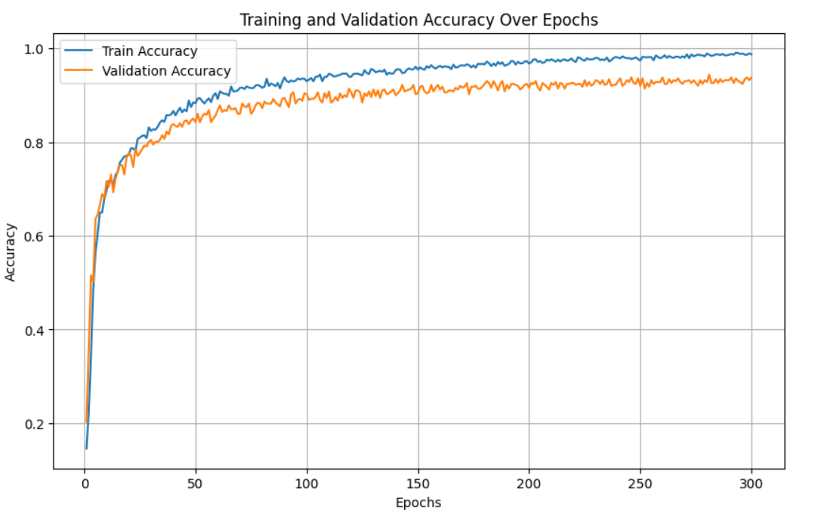
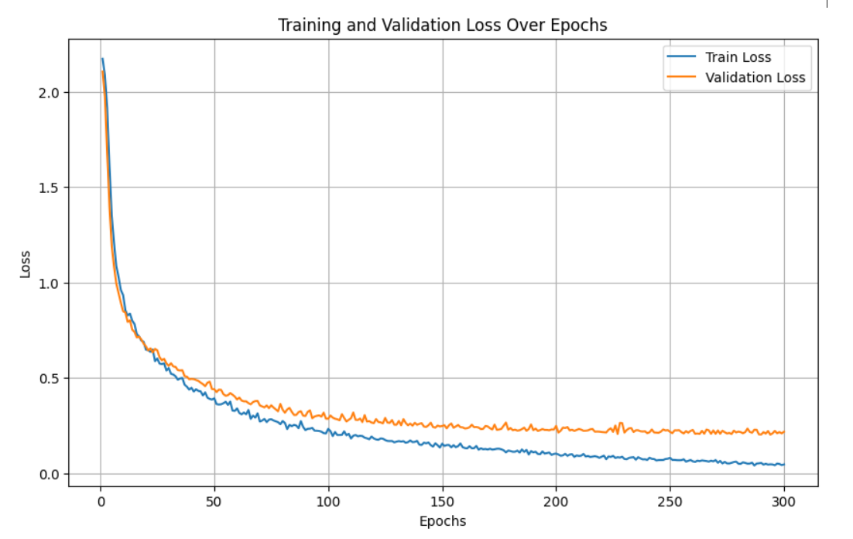

Evaluation results:
classification report:
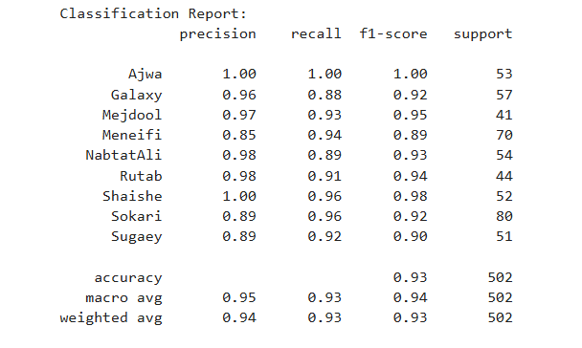
confusion matrix:
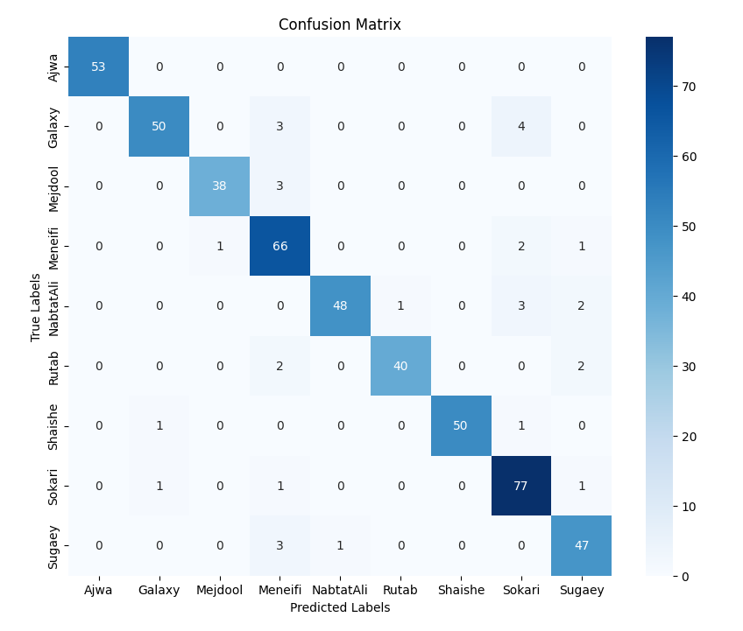

Screenshots:

Source code:
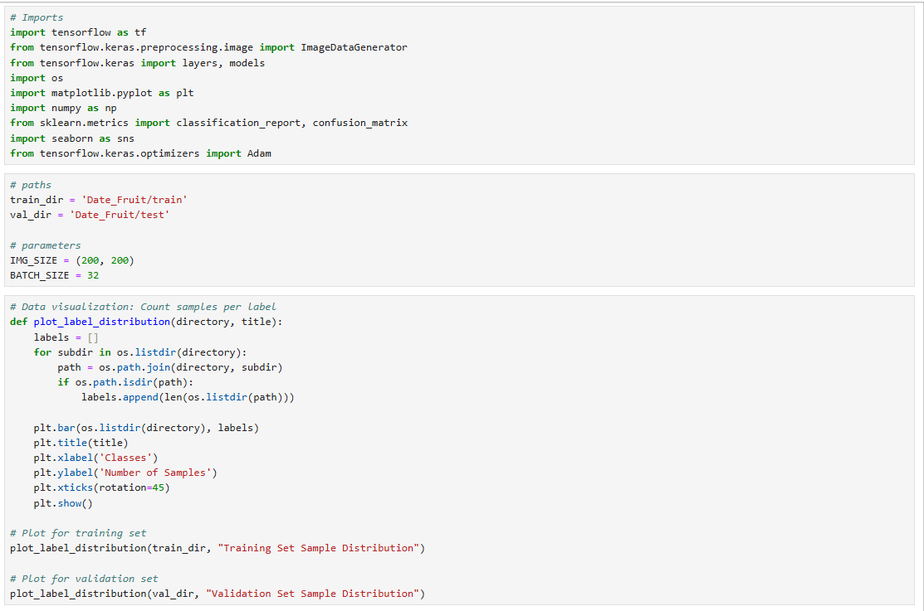

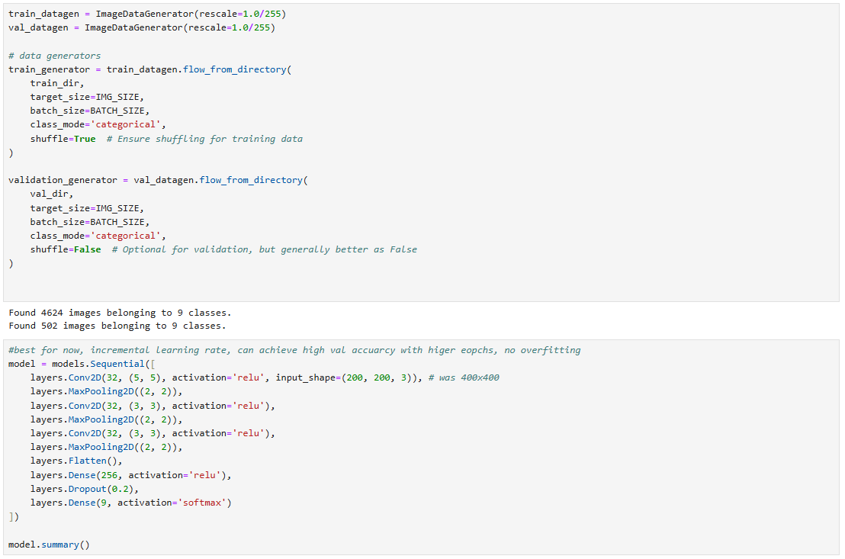

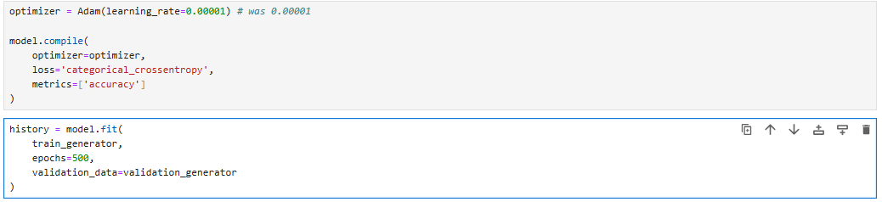

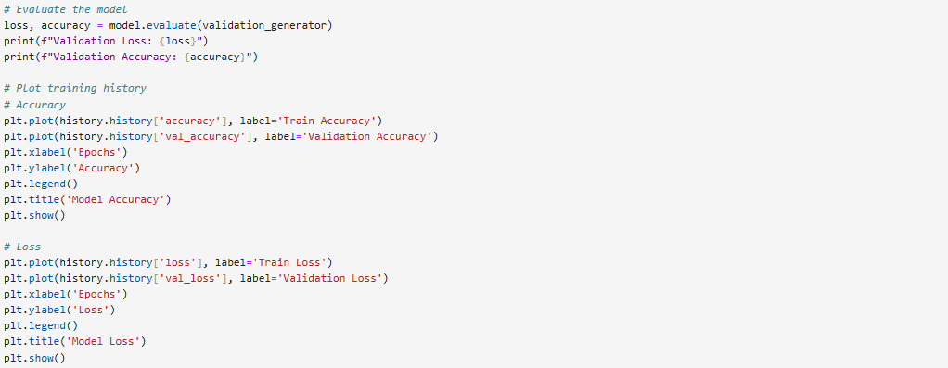

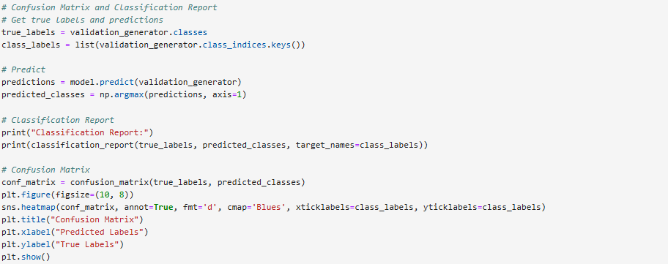

Evaluation results:

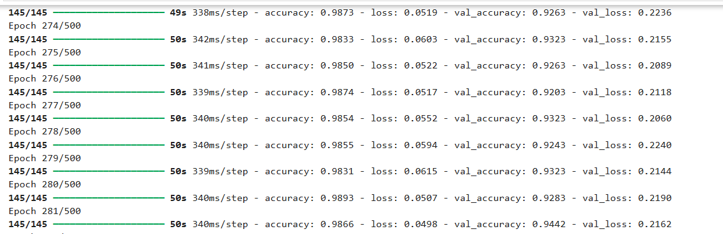

Approach #2 (EffecientnetB0)

Data preprocessing:
Batched data into 32 batches.
Scaled pixel values to [0,1].
Resized images into 224x224.

EffecientnetB0 Architecture:

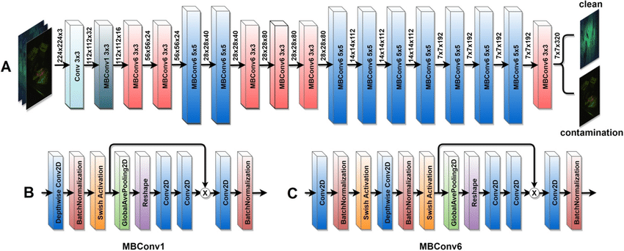

Frozen layers + a pooling, a drop out and my output dense layer :

Layer (type) ┃ Output Shape ┃ Param # ┃
┡━━━━━━━━━━━━━━━━━━━━━━━━━━━━━━━━━╇━━━━━━━━━━━━━━━━━━━━━━━━╇━━━━━━━━━━━━━━━┩
│ efficientnetb0 (Functional) │ (None, 7, 7, 1280) │ 4,049,571 │
├─────────────────────────────────┼────────────────────────┼───────────────┤
│ global_average_pooling2d │ (None, 1280) │ 0 │
│ (GlobalAveragePooling2D) │ │ │
├─────────────────────────────────┼────────────────────────┼───────────────┤
│ dropout (Dropout) │ (None, 1280) │ 0 │
├─────────────────────────────────┼────────────────────────┼───────────────┤
│ dense (Dense) │ (None, 9) │ 11,529 │
└─────────────────────────────────┴────────────────────────┴───────────────┘

Total params: 4,061,100 (15.49 MB)

Trainable params: 11,529 (45.04 KB)
Optimizer and Epochs(frozen model):
Adam, learning rate: 0.01.
Loss Function: Categorical Crossentropy.
Metrics: Accuracy.
Epochs: 20.

Optimizer and Epochs(unfrozen model):
Adam, learning rate: 0.0001.
Loss Function: Categorical Crossentropy.
Metrics: Accuracy.
Epochs: 20.

Screenshots:

Source code:
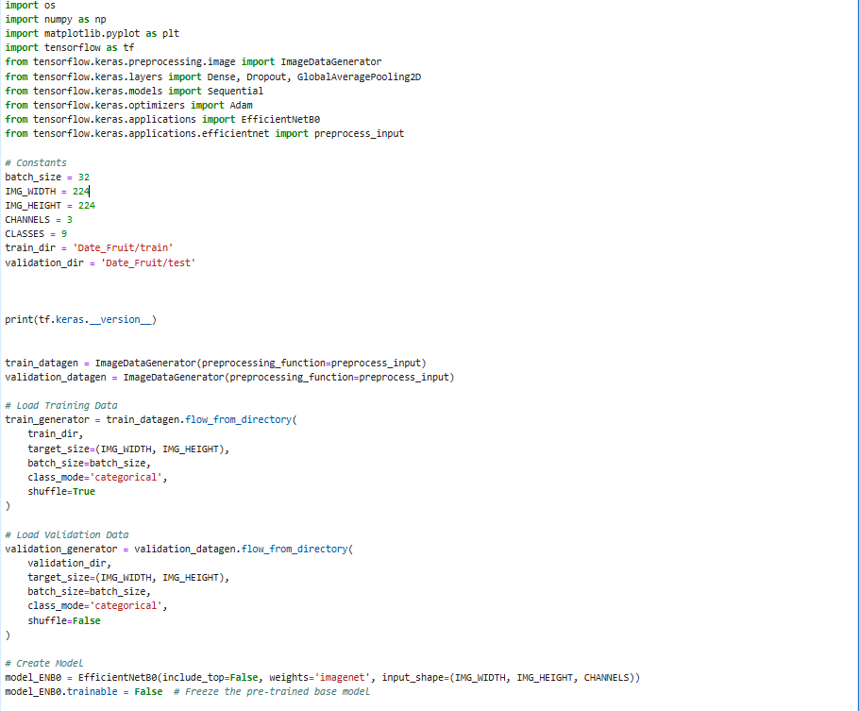

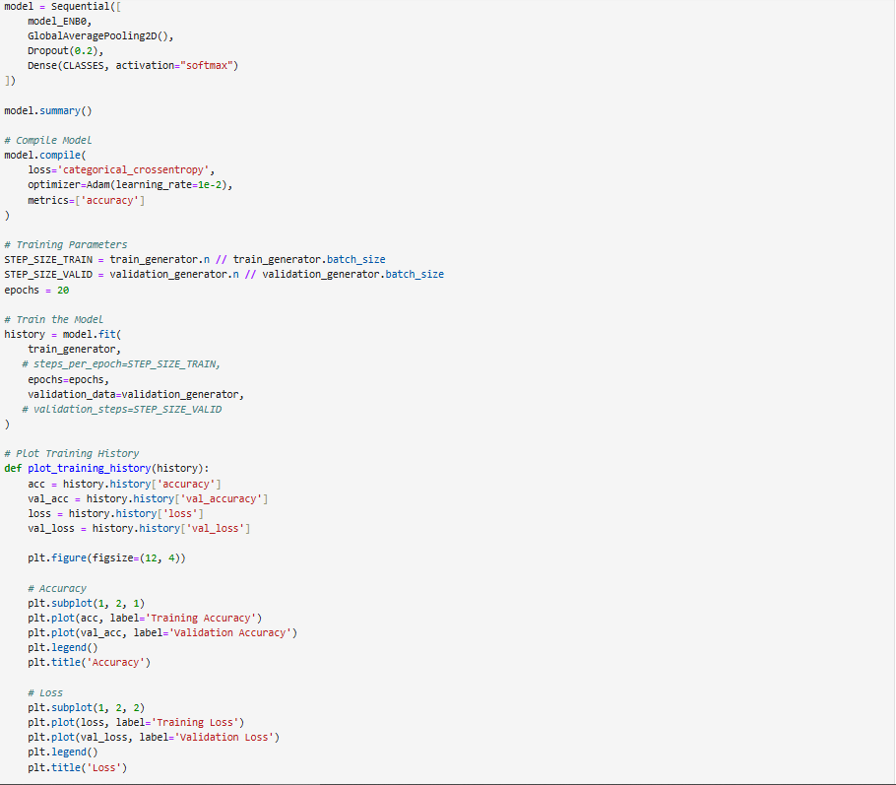
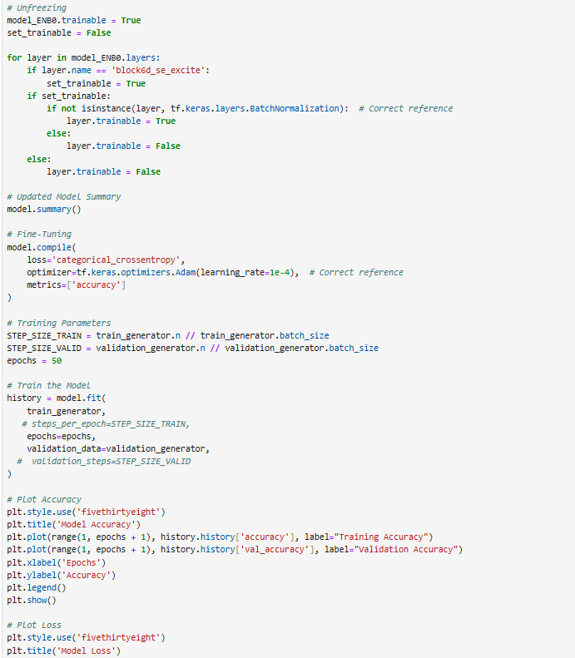

Evaluation results for frozen model:

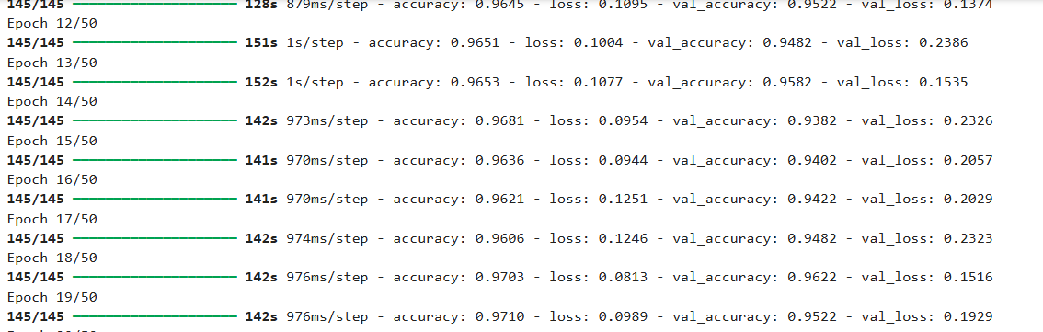

Evaluation results for unfrozen model:

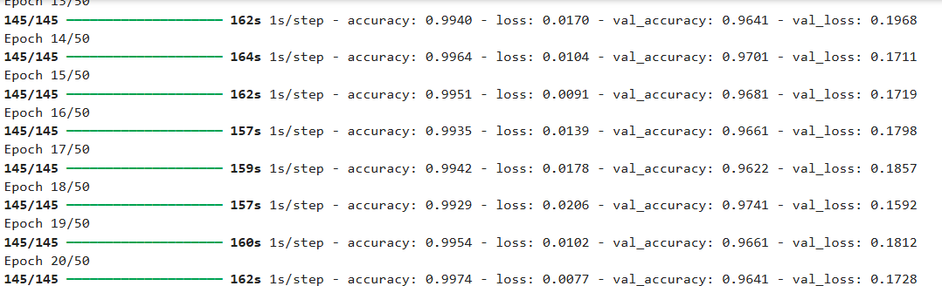

Approach #3 (Yolo11n-cls)

Data preprocessing:
Batched data into 16 batches.
Scaled pixel values to [0,1].
Resized images into 224x224.

Yolov11n-cls Architecture:

from n params module arguments 0 -1 1 464 ultralytics.nn.modules.conv.Conv [3, 16, 3, 2] 1 -1 1 4672 ultralytics.nn.modules.conv.Conv [16, 32, 3, 2] 2 -1 1 6640 ultralytics.nn.modules.block.C3k2 [32, 64, 1, False, 0.25] 3 -1 1 36992 ultralytics.nn.modules.conv.Conv [64, 64, 3, 2] 4 -1 1 26080 ultralytics.nn.modules.block.C3k2 [64, 128, 1, False, 0.25] 5 -1 1 147712 ultralytics.nn.modules.conv.Conv [128, 128, 3, 2] 6 -1 1 87040 ultralytics.nn.modules.block.C3k2 [128, 128, 1, True] 7 -1 1 295424 ultralytics.nn.modules.conv.Conv [128, 256, 3, 2] 8 -1 1 346112 ultralytics.nn.modules.block.C3k2 [256, 256, 1, True] 9 -1 1 249728 ultralytics.nn.modules.block.C2PSA [256, 256, 1] 10 -1 1 341769 ultralytics.nn.modules.head.Classify [256, 9] YOLO11n-cls summary: 151 layers, 1,542,633 parameters, 1,542,633 gradients, 3.3 GFLOPs

Optimizer and Epochs:
Adam, learning rate: 0.01.
Loss Function: Categorical Crossentropy.
Metrics: Accuracy.
Epochs: 20.

Loss and accuracy plots:
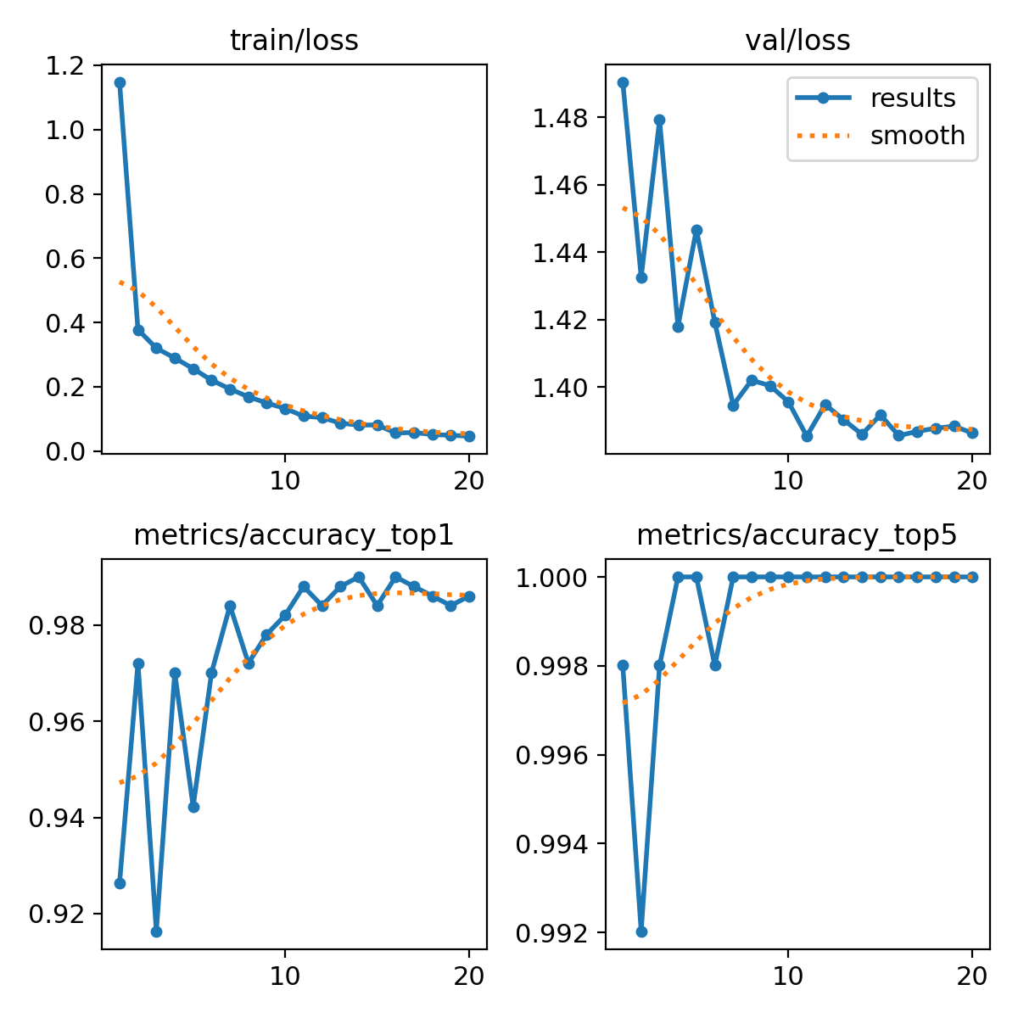

Evaluation results:
confusion matrix:

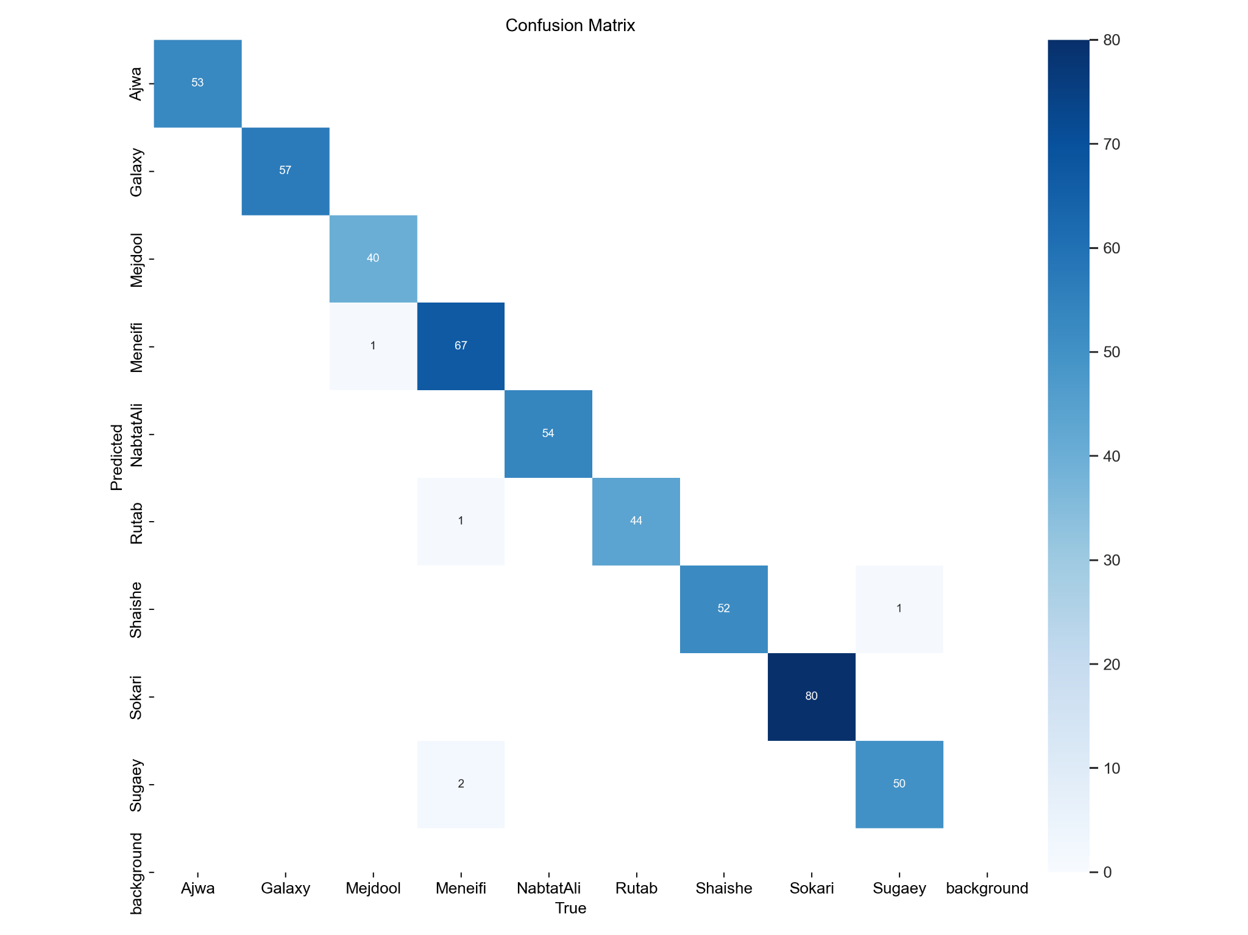

Screenshots:
Evaluation results:
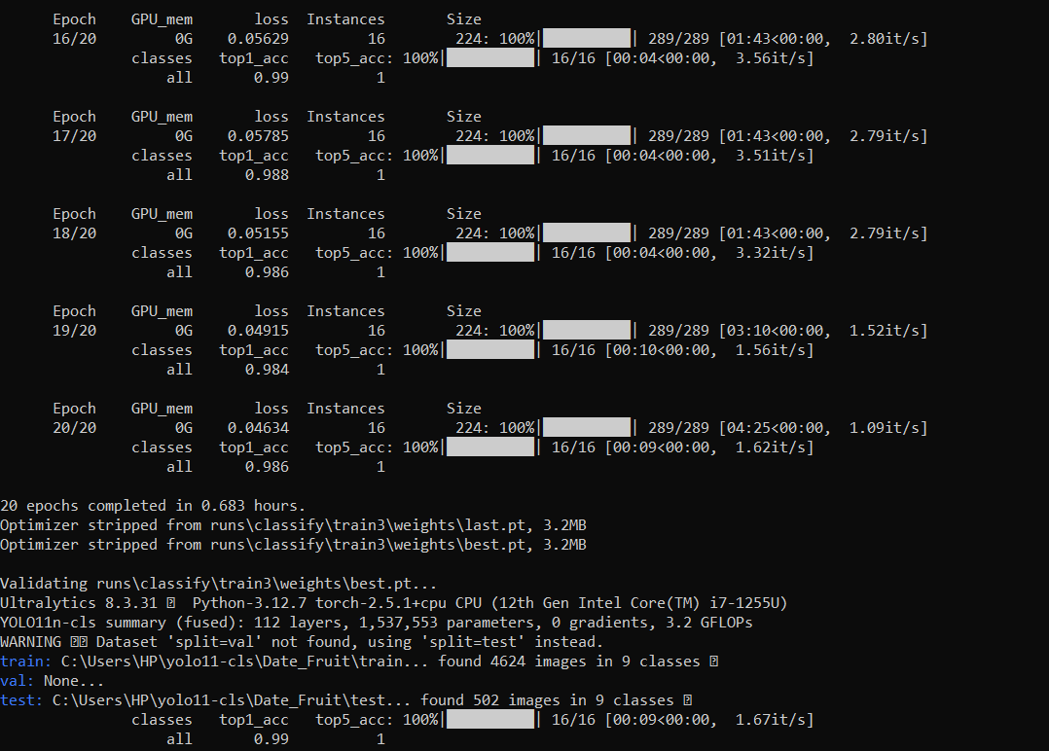
Feature extraction examples of the model:



