
King Saud University
College of Computer and Information Sciences
Computer Engineering Department
CEN415: Introduction to VLSI Design

8-bit input ALU
by
Talal Aloushan 441102306
Abdulrahman Almalek 441102392
Fahad Aljabr 441101585
Bader Alsabti 441103280

Supervised by: Dr. Ayed Al-Qahtani
1 Introduction

A combinational circuit which makes a specific arithmetic operations.

2 Problem Statement and Specifications

It’s required to design a system which is capable of doing the operations shown in table below:
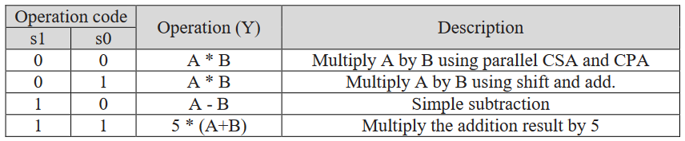
The system must have (at least): two different 8-bit inputs, 2-bit selectors, Common V_{DD} & GND, 16-bit output, Carry out signal.
Table 1. Operations of ALU

3 Motivation

The motivation is to apply most of the CMOS VLSI design fundamental concepts, such as using a layout tool to make layout of real circuit and gates.

4 Digital Logic Design
This section shows the digital logic design of the 8-bit system using Logisim, which is a tool for designing and simulating logic circuits.

4.1 Complete Design
Figure below shows the complete design of the circuit.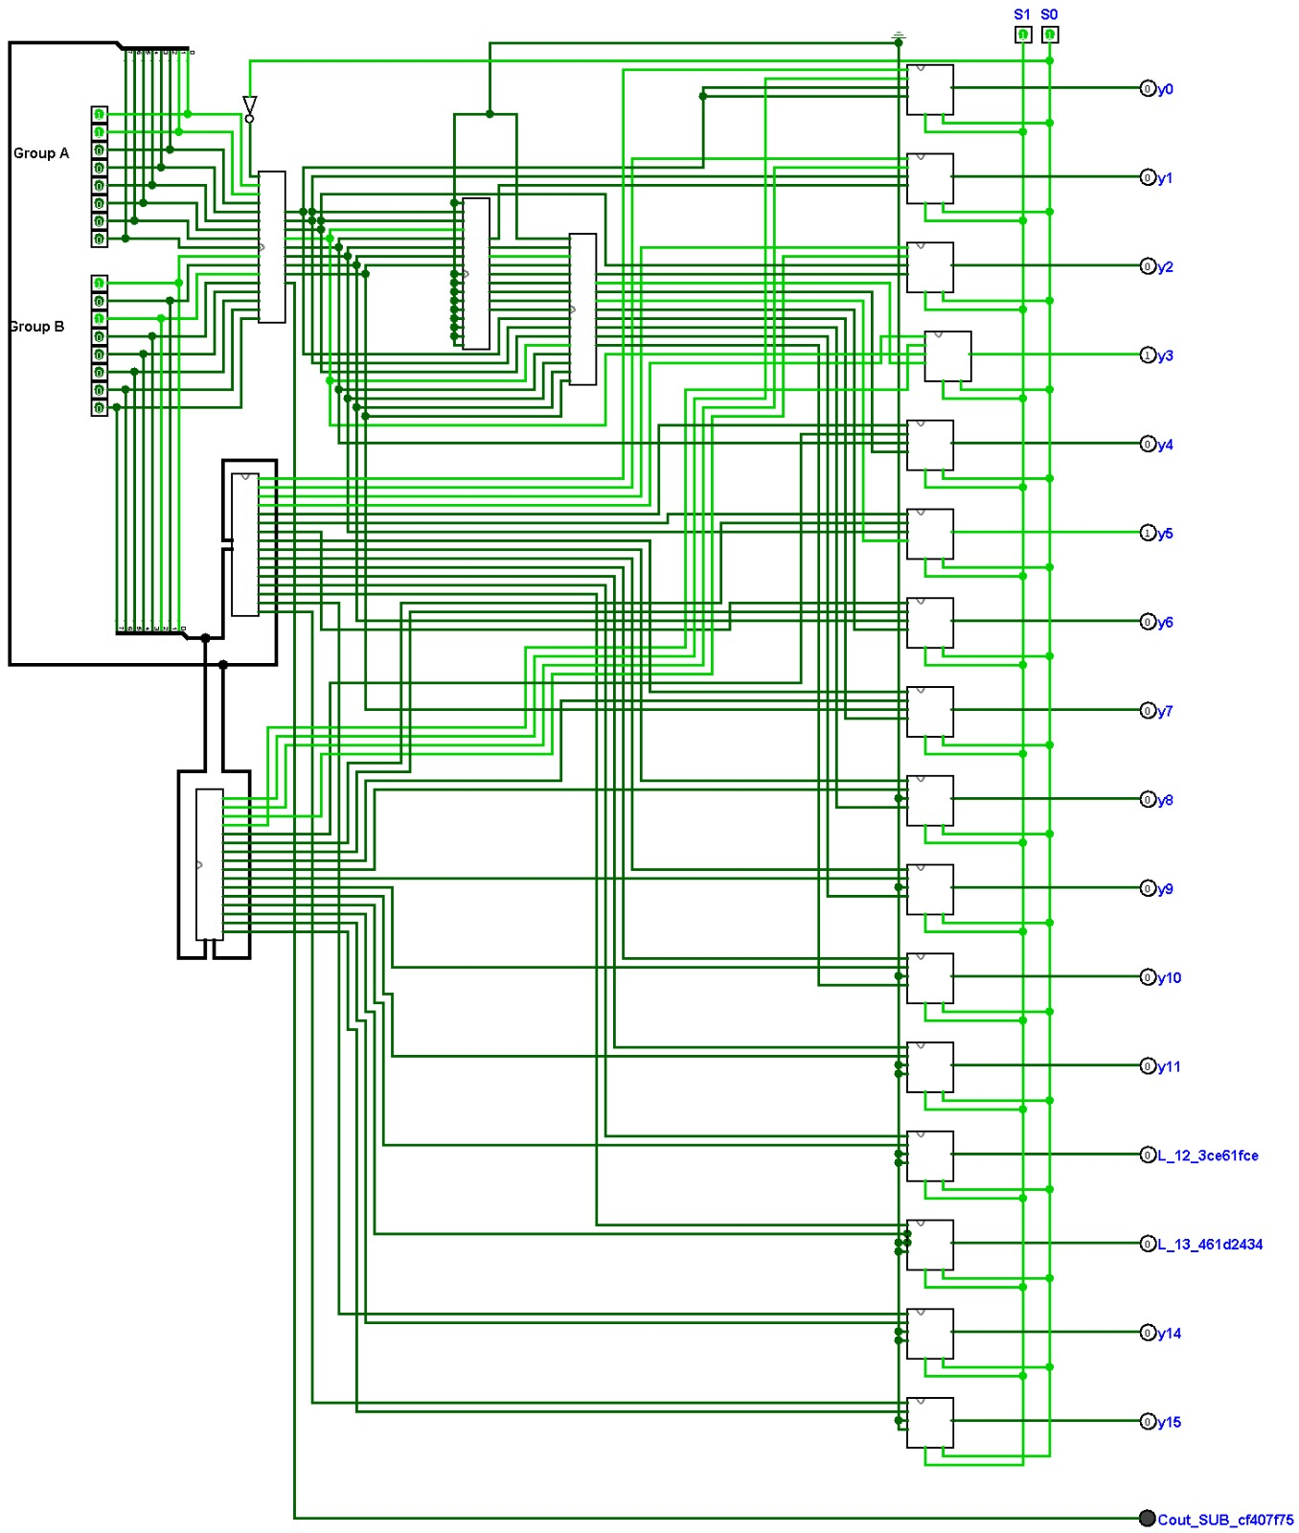
Figure 1. Complete Design

4.2 Multiply A by B using parallel CSA and CPA Unit

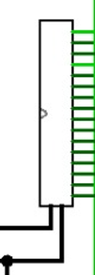
Figures below show the design of the Multiply A by B using parallel CSA and CPA unit.

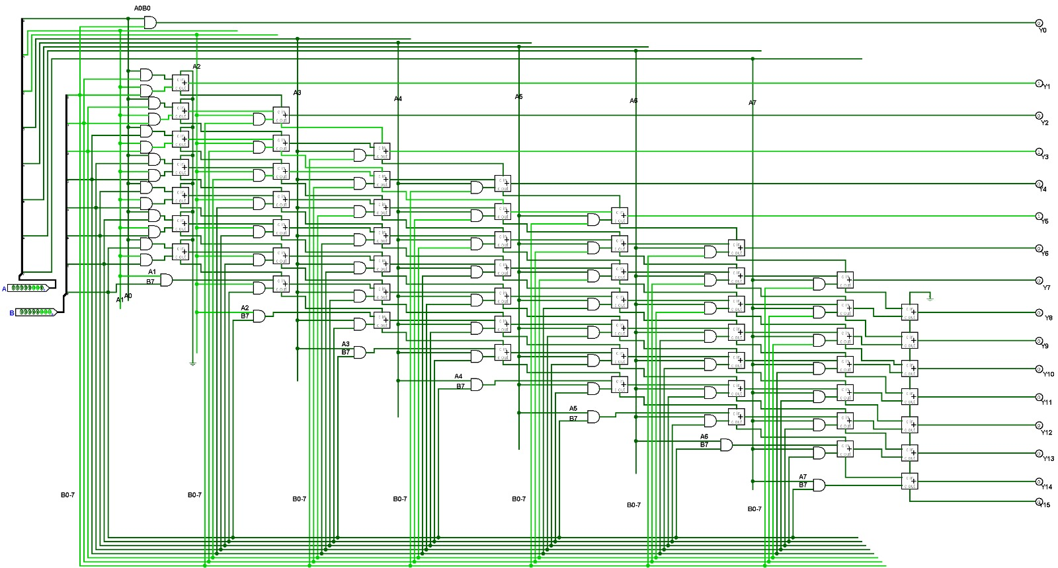
Figure 2. A*B Unit (Lvl 0)

Figure 3. A*B Unit (Lvl 1)

4.3 Multiply A by B using shift and add.
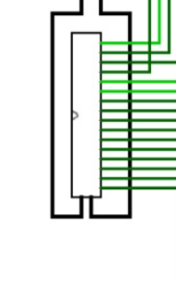Figure 5. A*B (Lvl 0)
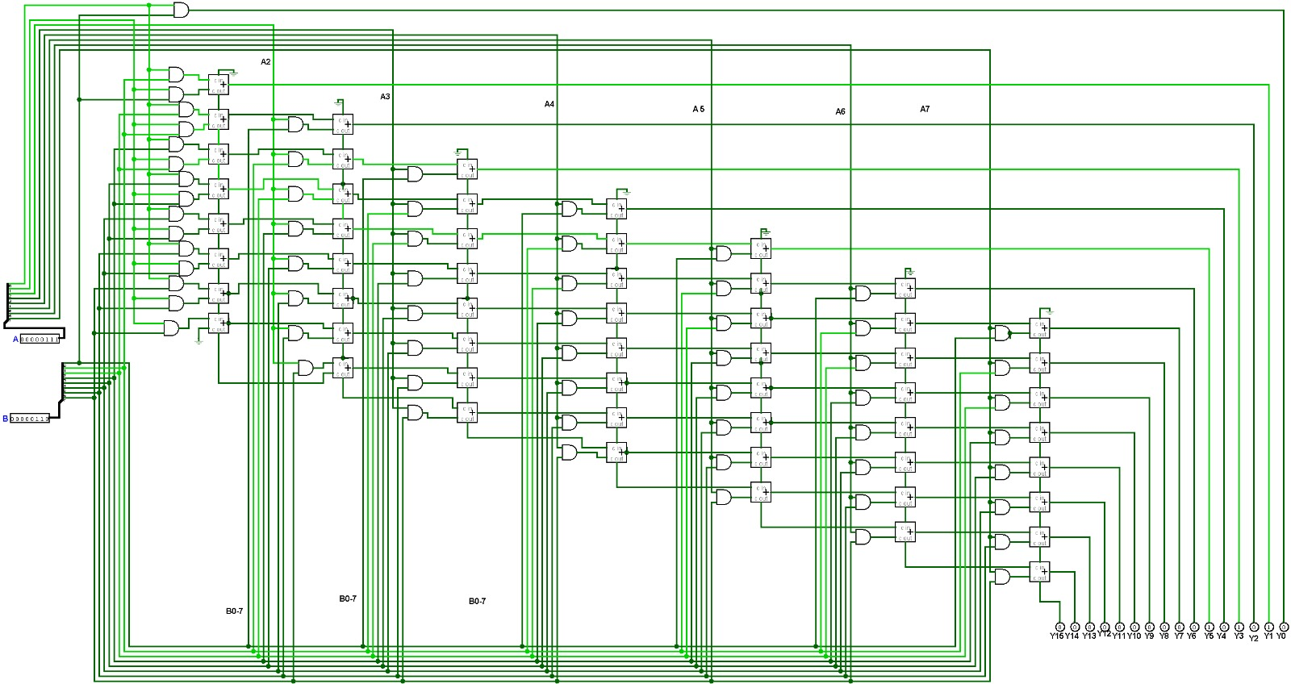

Figure 6. A*B (Lvl1)

4.4 Subtractor

In logic design we know that A – B = A + (~B) + 1, this technique is used in this subtractor by inverting the inputs of B and then adding them to A, which can be accomplished by inverting the S0 to choose between subtracting or adding, figures below show the subtraction unit.
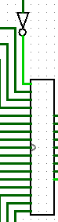

Figure 8. Subtraction Unit (Lvl 0)
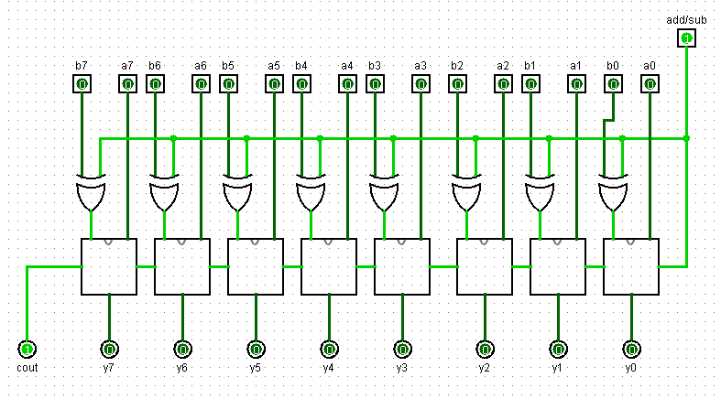

Figure 9. Subtraction Unit (Lvl 1)

4.5 Multiply the addition result by 5
The adder used is of type (Carry Ripple Adder), which is a two 8-bit inputs adder composed of 8 full adders having each carry out signal connected to the next adders as a carry in, then multiply it by constant number 5 by using two full adders and hardly connecting the multiplication. figures below present the design of the adder used.
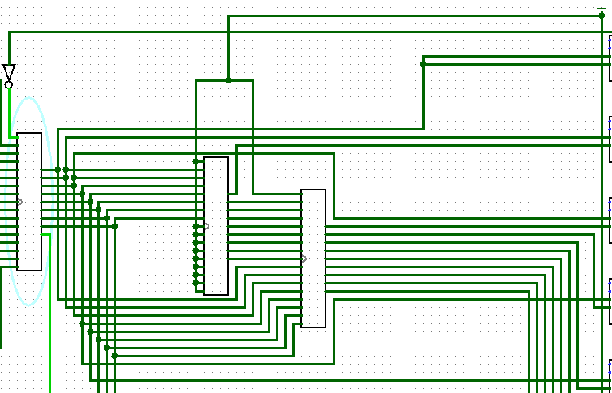
Figure 10. Multiply the addition result by 5 Unit (Lvl 0)
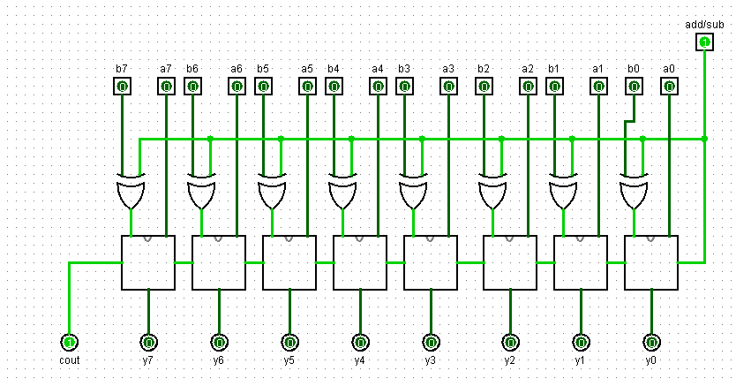
Figure 11. FULL adder (Lvl 1)

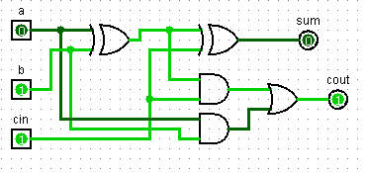

Figure 11. FULL adder (Lvl 2)

4.6 Multiplexer

The final design component of this section is the multiplexer, the multiplexer used Is a 4:1 multiplexer made out of 3 smaller 2:1 multiplexers, figures below present both levels of design for this unit.
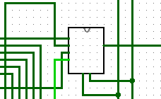

Figure 12. Multiplexer (Lvl 0)
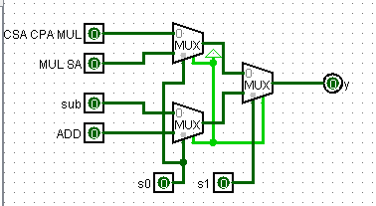

Figure 13. Multiplexer (Lvl 1)

Sample inputs verification
7*7 using CSA CPA
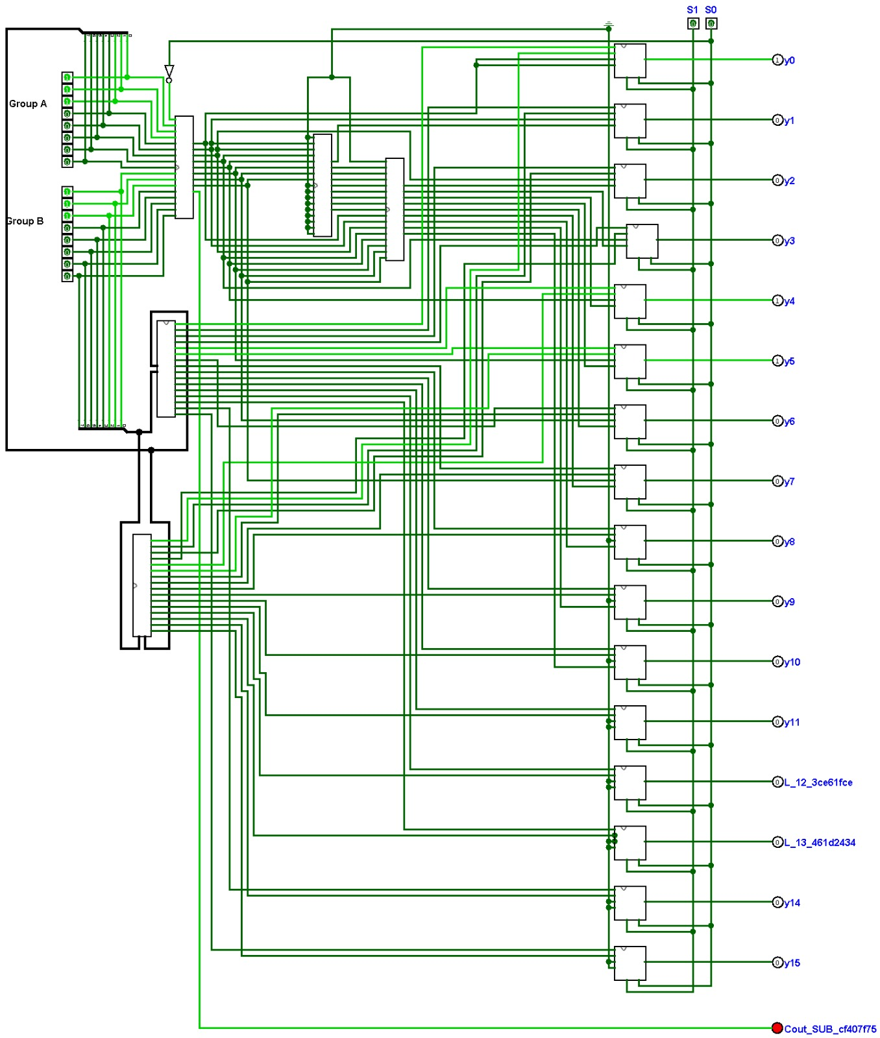

7*7 using shiftandadd
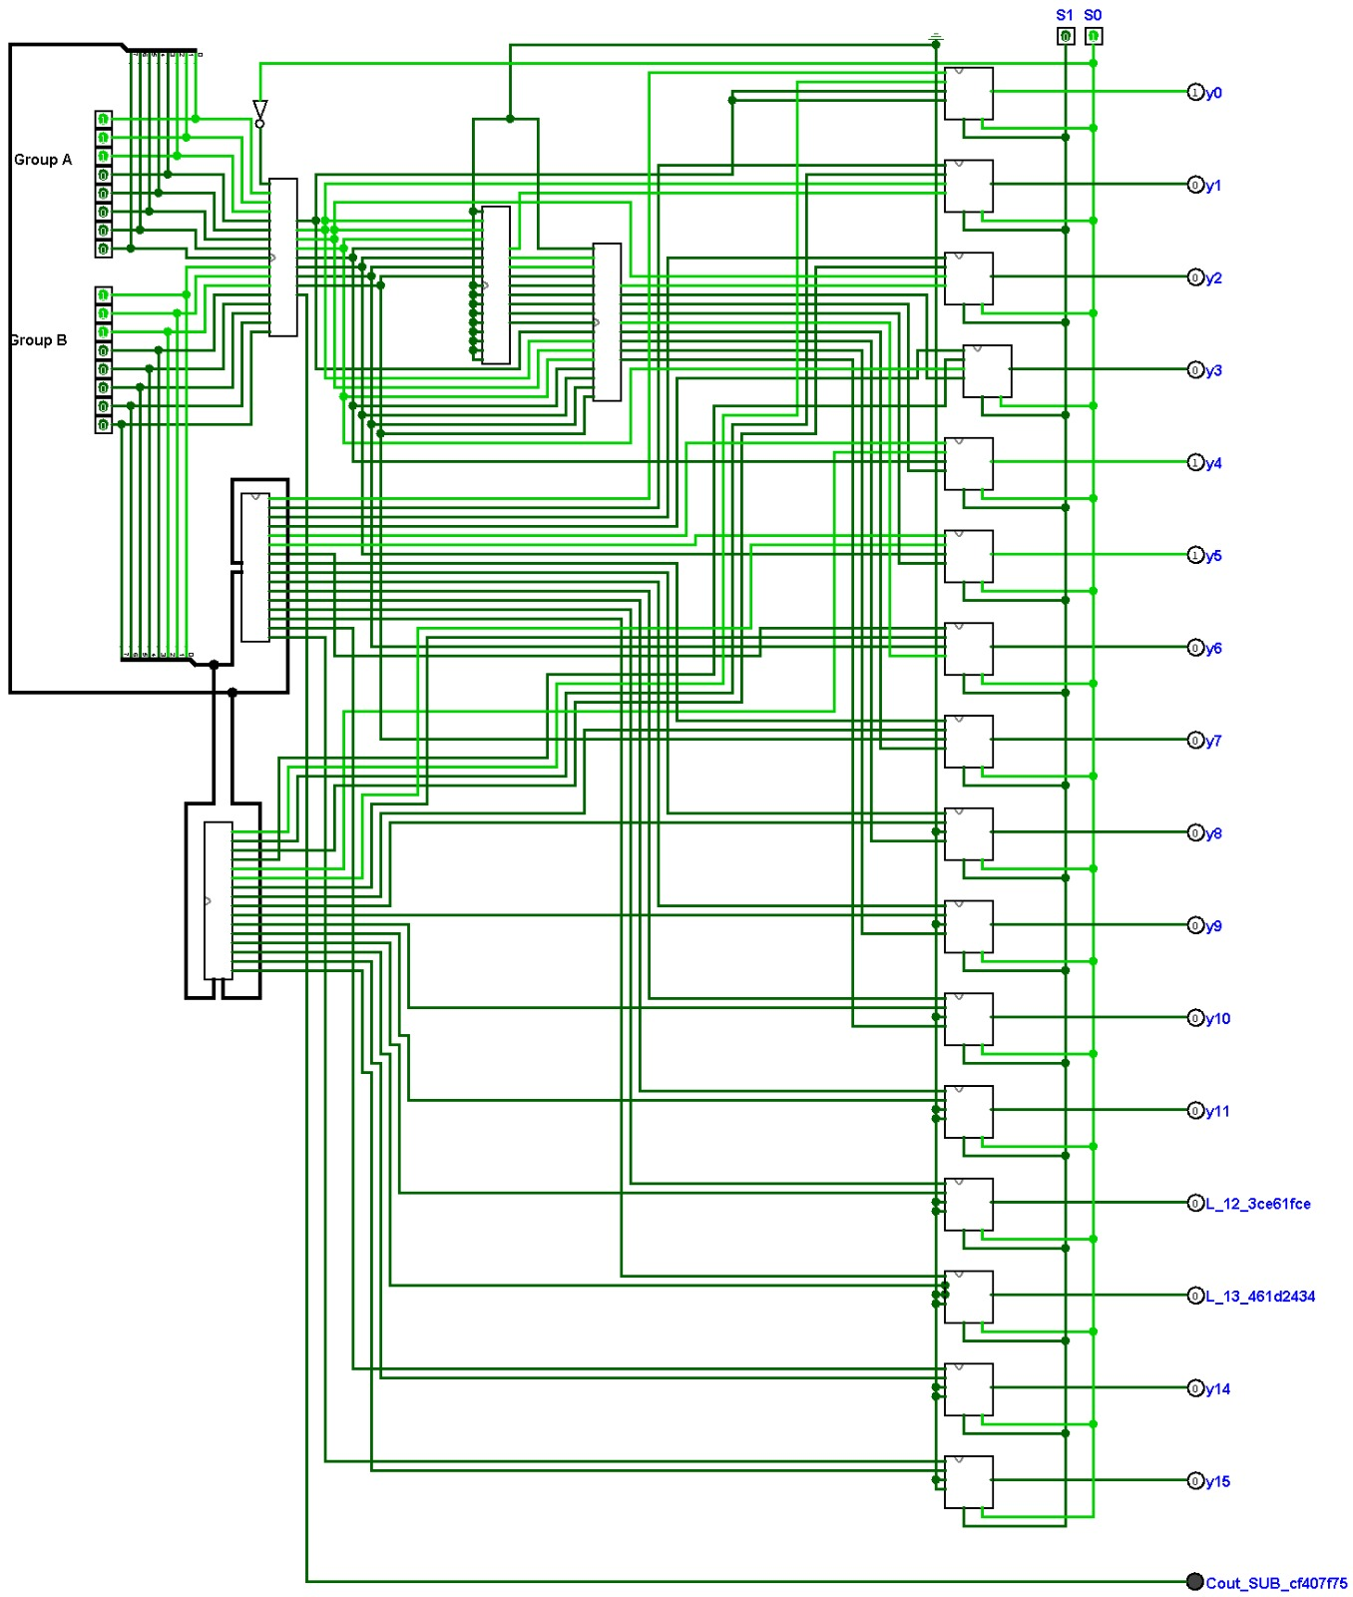

Sub 7-7
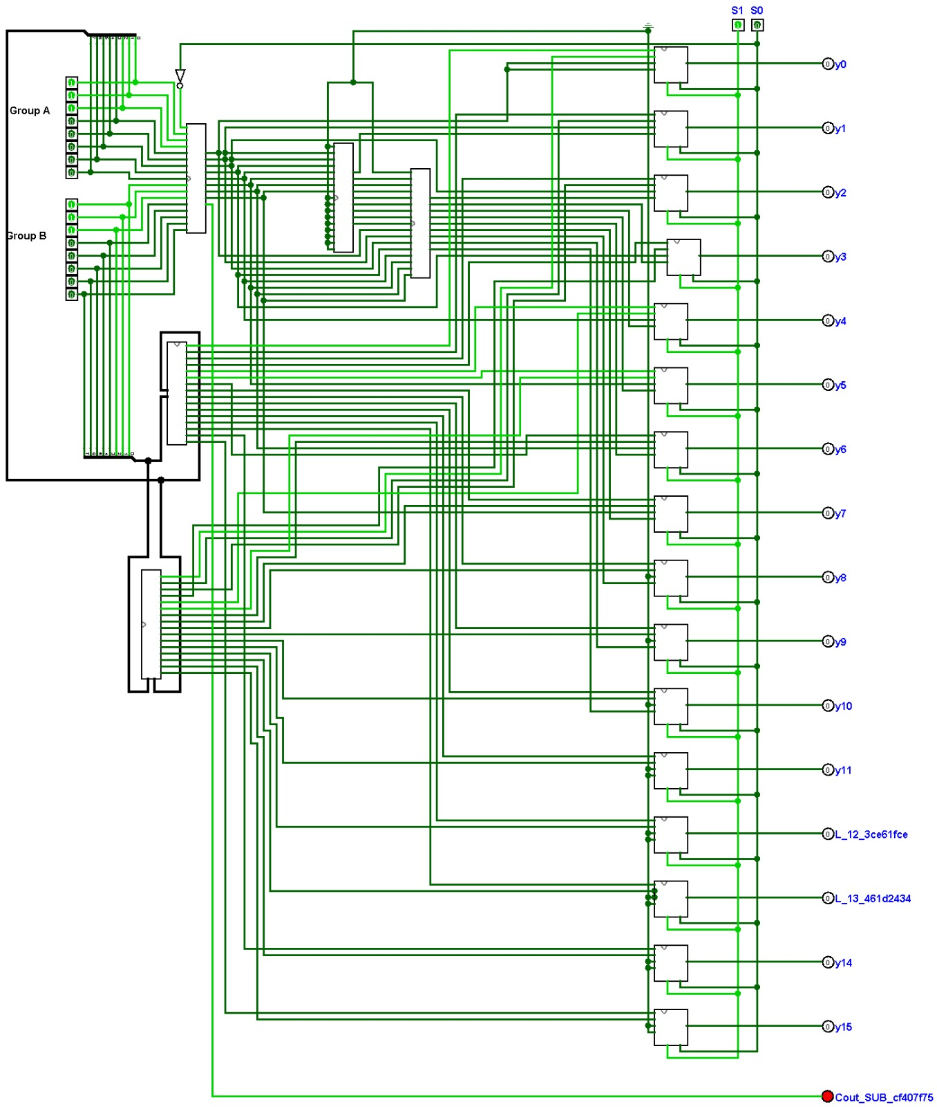

Add 3+5 and multiply by 5

5. Stick diagram:

AND:
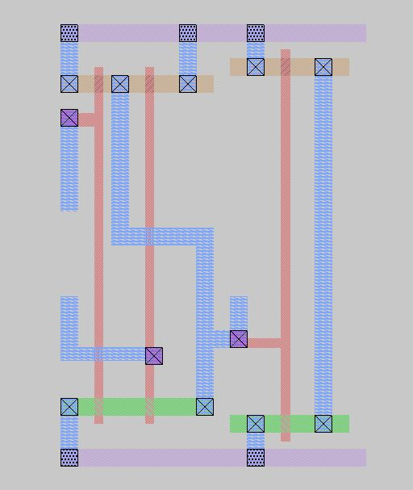

NAND:
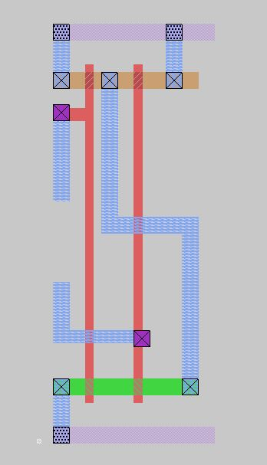
NOR:
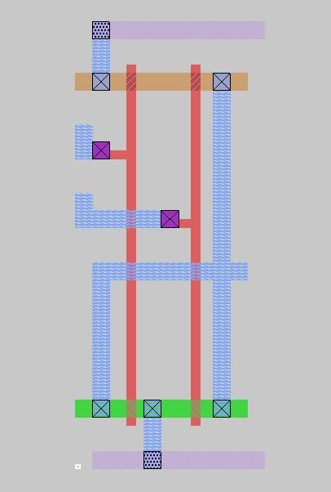

NOT:
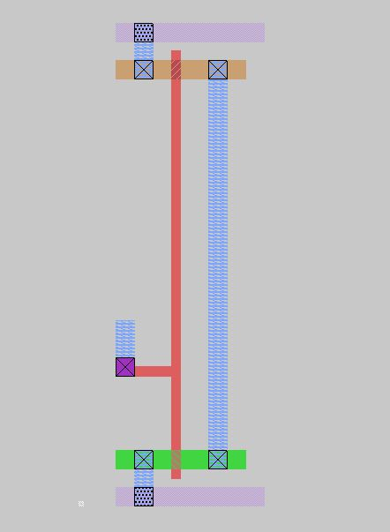
OR:
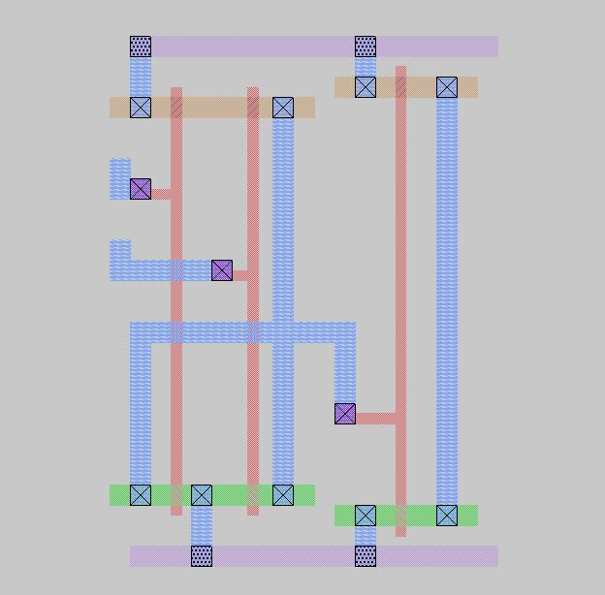

XOR:
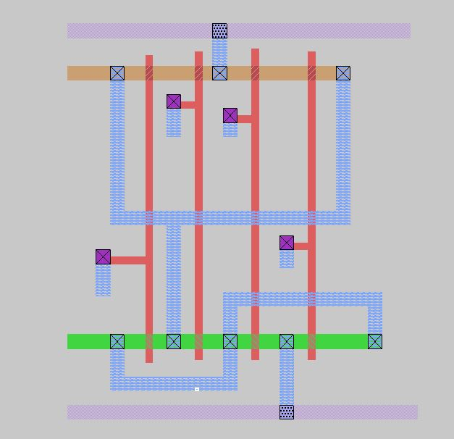
- Testing

System Consist of :
16 4-1 Mux
8bitSubsracter
8bitAdder-Multiplierb5
8bitCsaCpaMultiplier
8bitShiftAndAddMultiplier

4-1 Mux :
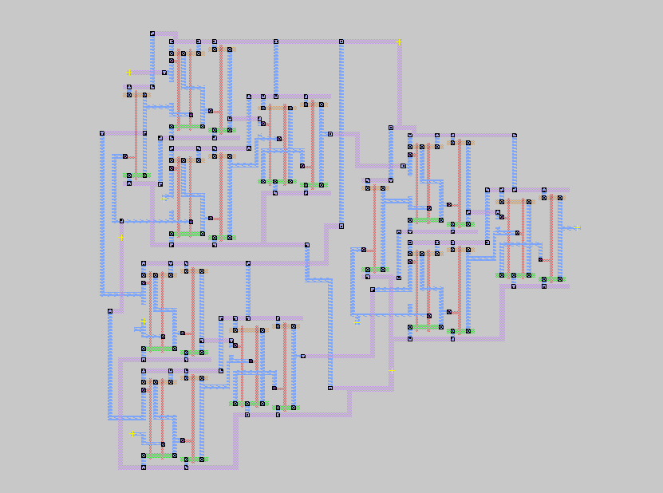

Test :

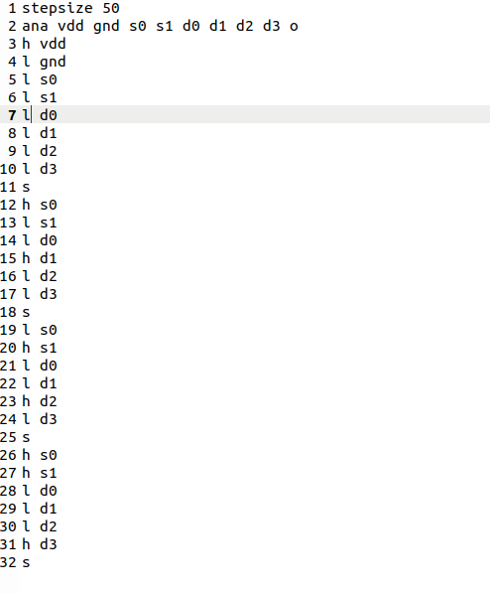

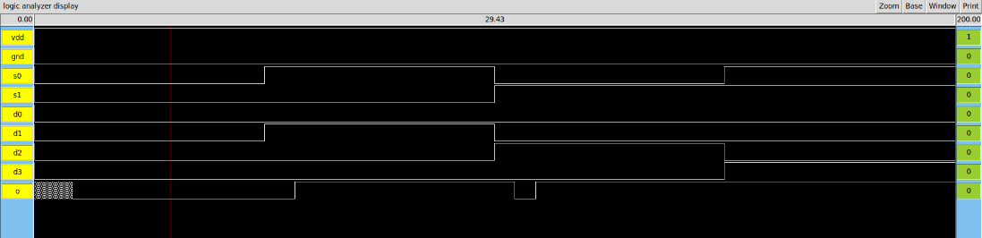

8bitSubsracter :
Test :
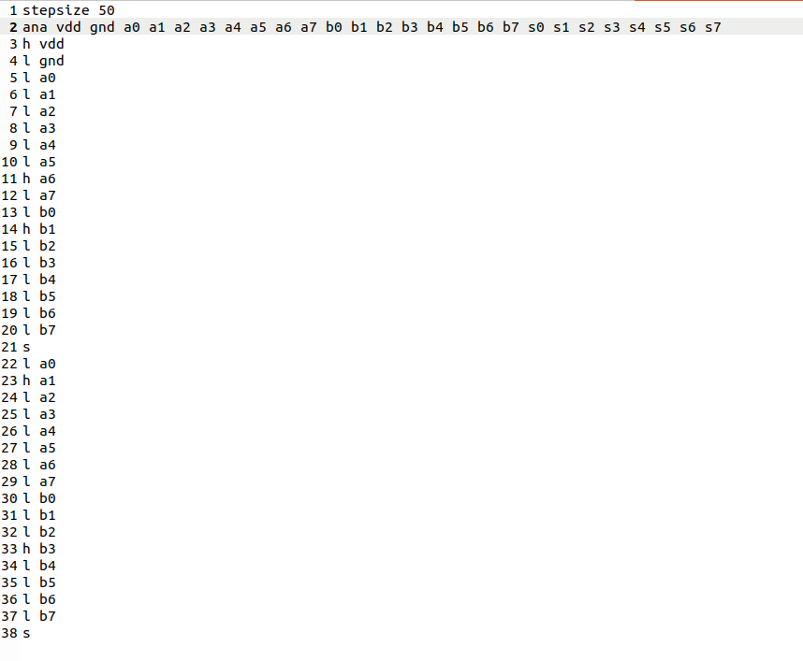
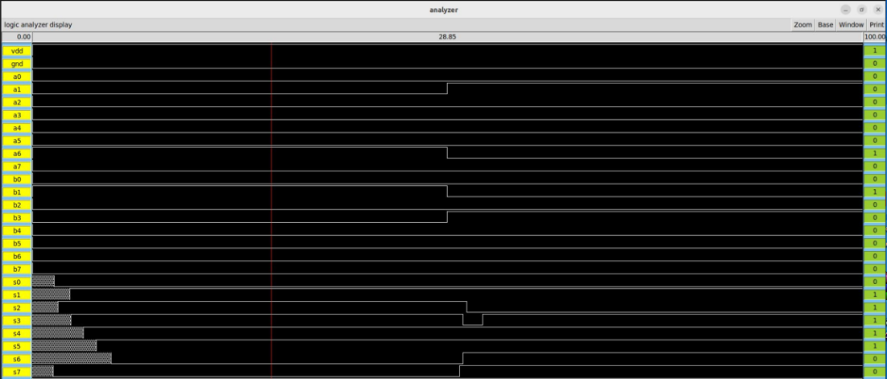

8bitAdderMultiplier5 :
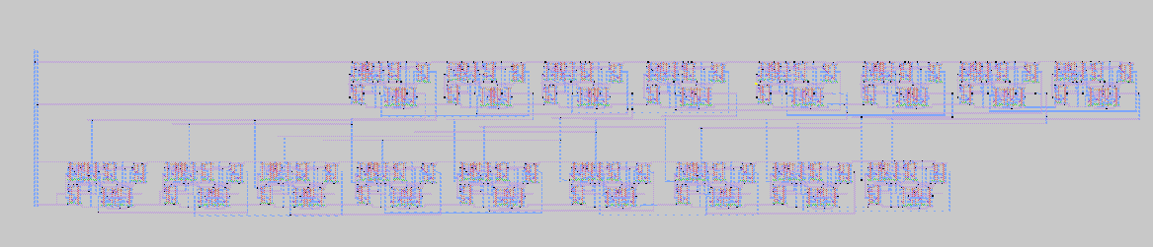

Test :
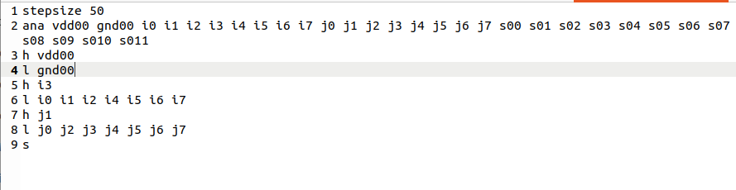
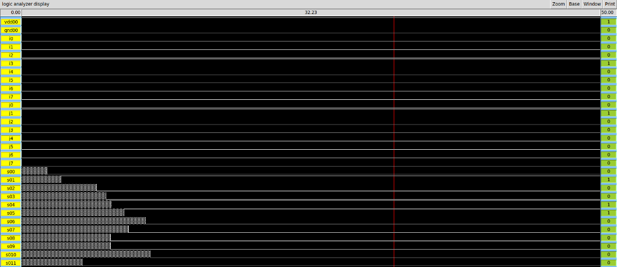

8bitCsaCpaMultiplier :
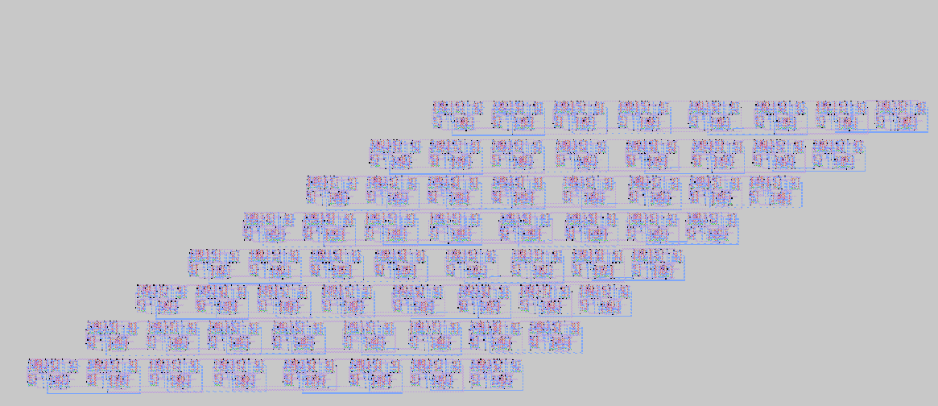

8bitShiftAndAddMultiplier :

Final Design :
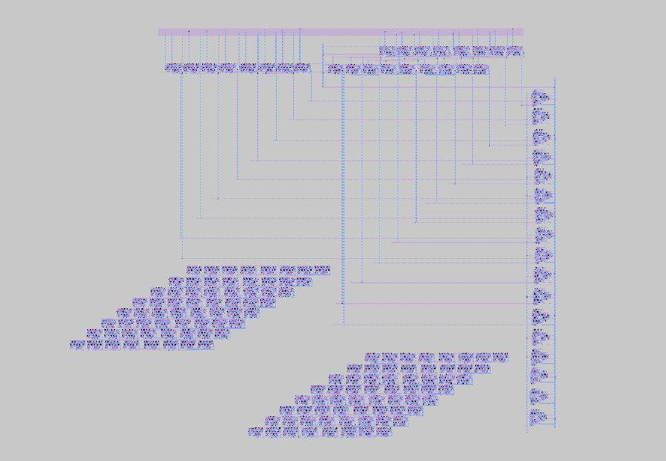

Test :

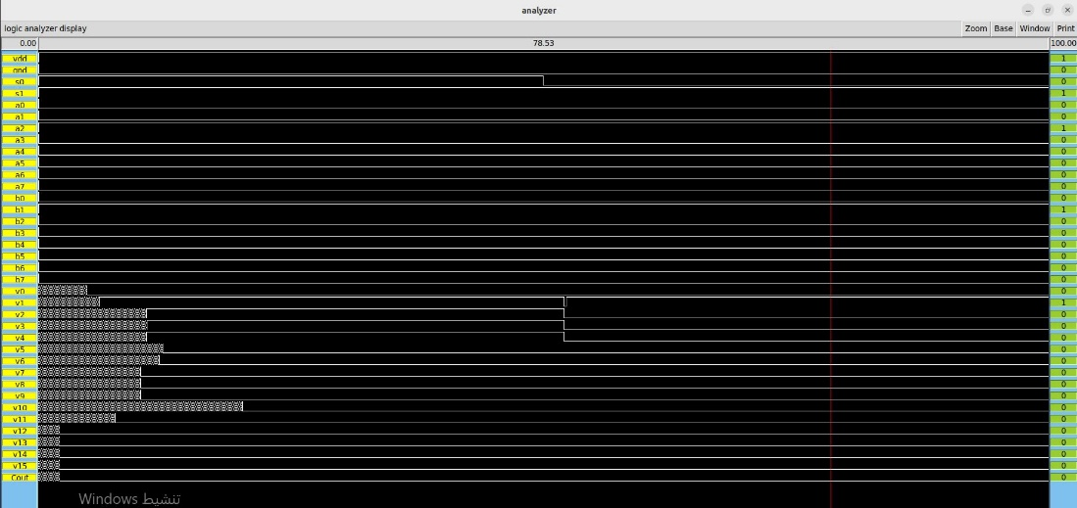

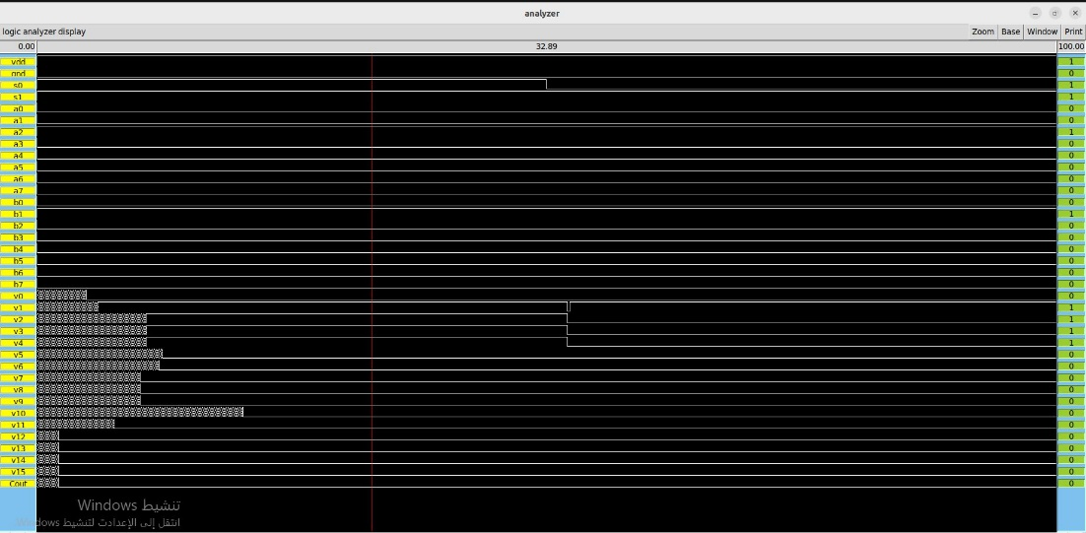

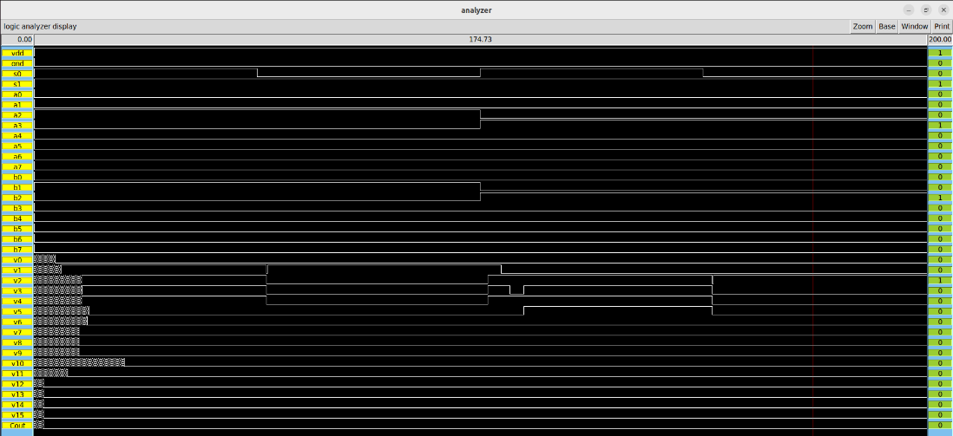

To see the design :
Go to the directory of the project file
Type: magic Final

To test the design :
Go to the directory of the project file
Type: irsim scmos100.prm Final.sim -Final.cmd

