EX1

1-https://portal.kfupm.edu.sa/

2- 198.11.1.39:443

3- 85 request

4- Types HTML, CSS, JavaScript, images (JPEG, PNG, etc.)

5- the largest file is open-sans-v34-latin-ext_latin-500.woff

6- 291ms

EX2

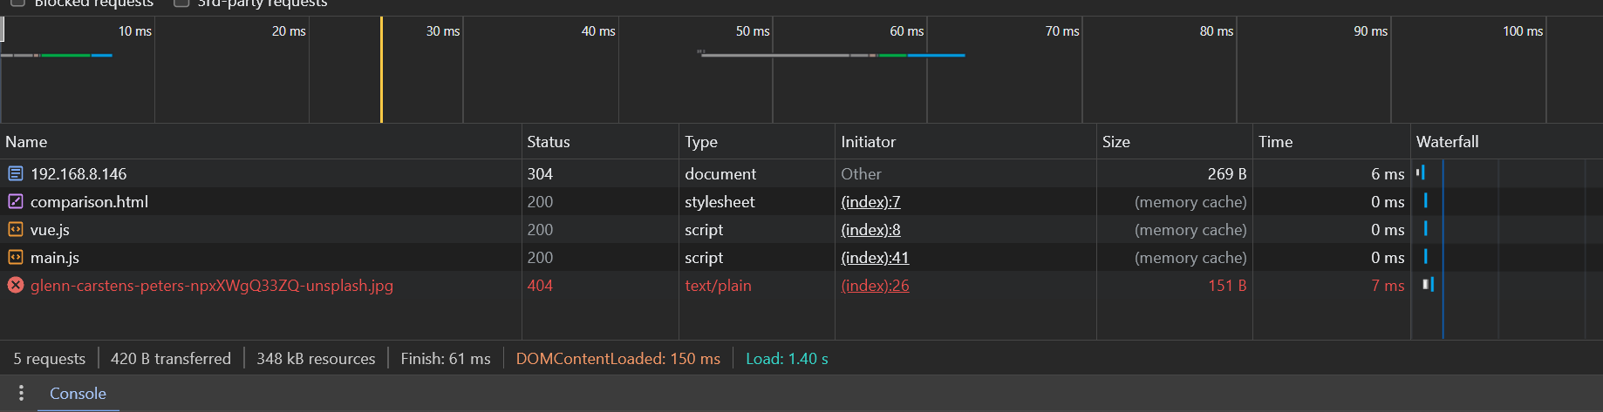

EX3

Talal Blog