PhishAware: A Bilingual Cybersecurity Awareness Platform
for Saudi Arabian Organizations
Senior Project Report
Abdulrahman Alharthi
Department of Computer Science
King Abdulaziz University
Jeddah, Saudi Arabia
Supervisor: Dr. [Supervisor Name]
March 2026

ABSTRACT
Abstract— This report presents PhishAware, a comprehensive bilingual (English/Arabic) cybersecurity awareness platform designed specifically for Saudi Arabian organizations. The platform addresses the growing need for effective security awareness training in the Kingdom's rapidly digitizing economy by providing an integrated suite of tools including realistic phishing simulation campaigns, adaptive risk scoring, gamified training modules, and multi-level analytics dashboards. The backend is built with Django REST Framework using a modular multi-app architecture encompassing eleven specialized applications: accounts, companies, campaigns, simulations, assessments, training, gamification, analytics, community, notifications, and core utilities. The frontend is developed using React 19 with Vite, featuring role-based access control (RBAC) for three user tiers (Super Admin, Company Admin, Employee), complete RTL support for Arabic, and responsive design using Tailwind CSS. Key features include JWT-based authentication with email verification, employee invitation workflows, a four-step simulation creation wizard, automated risk score calculation with remediation training assignment, a gamification engine with badges and leaderboards, and a public community portal for cybersecurity awareness. The platform uses SendGrid SMTP relay for transactional emails, SQLite for development storage, and implements comprehensive tracking for phishing simulations including pixel tracking, link click monitoring, and credential submission detection. Testing demonstrates the platform's effectiveness in raising security awareness through measurable risk score improvements after training interventions.
Index Terms— Cybersecurity awareness, phishing simulation, Django REST Framework, React.js, bilingual platform, Saudi Arabia, gamification, RBAC, risk scoring, training remediation, SendGrid, JWT authentication.

CONTENTS
I. PHASE 1: BACKEND FOUNDATION 1
A. Environment Setup & Access Management (Weeks 1-2) 2
1) Django & SQLite Initialization 3
2) Identity & Access Management 6
B. Simulation Engine & Campaign Logic (Week 3) 12
1) Core Database Models 13
2) Campaign, Email & Quiz APIs 20
C. Threat Tracking & Risk Remediation (Weeks 4-5) 28
1) Tracking Pixels, Lure Links & Landing Pages 29
2) Risk Scoring & LMS Integration 34
D. Analytics, Gamification, & System Finalization (Week 5) 41
1) Gamification Engine 42
2) Dashboards, Public APIs & Comprehensive Testing 48
II. PHASE 2: FRONTEND DEVELOPMENT 55
A. Application Setup & Secure Routing (Week 9) 56
1) React Core & Bilingual (i18next) Configuration 57
2) Authentication & Protected Routes 62
B. Administrator Management Interfaces (Week 10) 69
1) Admin Layout, Employee & Campaign Management 70
2) Content Libraries & Analytics Dashboards 78
C. Employee Training & Gamification UI (Week 11) 86
1) Employee Dashboard & Training Modules 87
2) Quiz Interfaces & Gamification Display 93
D. Public Awareness Portal & Final Polish (Week 11) 100
1) Community Portal & Awareness Content 101
2) Public Quizzes & Final UI/UX Polish 107
REFERENCES 113
APPENDICES 115

LIST OF FIGURES
Right-click and select 'Update Field' to populate this list.

LIST OF TABLES
Right-click and select 'Update Field' to populate this list.

I. PHASE 1: BACKEND FOUNDATION
Phase 1 encompasses the complete backend development of the PhishAware platform, built using Django 5.x and Django REST Framework. This phase establishes the server-side architecture, database models, API endpoints, authentication system, simulation engine, risk scoring algorithms, gamification mechanics, and analytics infrastructure. The backend follows a modular multi-app architecture with eleven specialized Django applications, each handling a distinct domain of the platform's functionality. All APIs follow RESTful conventions with JWT-based authentication, role-based access control, and comprehensive serialization for data validation and transformation.

A. Environment Setup & Access Management (Weeks 1-2)
The initial two weeks focused on establishing the development environment, configuring the Django project structure, implementing the custom user model with role-based access control, and building the authentication system with JWT tokens and email verification. This foundational work ensures secure identity management across all three user tiers: Super Admin, Company Admin, and Employee.

1) Django & SQLite Initialization
The PhishAware backend is initialized as a Django 5.x project with a modular multi-app architecture. The project uses SQLite as its development database, leveraging Django's built-in ORM for all data access patterns. The choice of SQLite provides zero-configuration persistence during development while maintaining full compatibility with production-grade databases like PostgreSQL through Django's database abstraction layer.
Project Structure and Application Organization
The backend follows Django's recommended project layout with a central configuration package (phishaware_backend/) and a dedicated apps/ directory containing eleven specialized Django applications. Each application encapsulates a distinct domain of the platform's business logic, following the Single Responsibility Principle:
TABLE 0: Django Application Architecture
Application | Purpose | Key Models
accounts | User authentication, registration, invitation | User
companies | Company management and subscription | Company
campaigns | Quiz campaign creation and execution | Campaign, Quiz, QuizResult
assessments | Email templates and quiz questions | EmailTemplate, QuizQuestion
simulations | Live phishing simulation engine | SimulationTemplate, SimulationCampaign, EmailSimulation, TrackingEvent
training | Risk scoring and remediation training | RiskScore, TrainingModule, RemediationTraining
gamification | Badges, points, and leaderboards | Badge, EmployeeBadge, EmployeePoints, PointsTransaction
analytics | Dashboard statistics and data export | (No models – queryset-based)
community | Public portal content | Article, PublicQuiz, Resource
notifications | In-app notification system | Notification
core | Shared utilities, permissions, emails | (Utility module)

Django Settings Configuration
The settings.py file configures Django with the following key parameters. Environment variables are managed through python-decouple for secure configuration management, separating sensitive credentials from the codebase:
# phishaware_backend/settings.py (key excerpts)
AUTH_USER_MODEL = 'accounts.User'
INSTALLED_APPS = [
'django.contrib.admin',
'rest_framework',
'rest_framework_simplejwt',
'rest_framework_simplejwt.token_blacklist',
'corsheaders',
'drf_yasg',
'apps.core', 'apps.accounts', 'apps.companies',
'apps.campaigns', 'apps.simulations', 'apps.assessments',
'apps.training', 'apps.gamification', 'apps.analytics',
'apps.community', 'apps.notifications',
]
DATABASES = {'default': {'ENGINE': 'django.db.backends.sqlite3',
'NAME': BASE_DIR / 'db.sqlite3'}}
REST Framework and JWT Configuration
Django REST Framework is configured with JWT authentication as the primary authentication backend. Access tokens have a lifetime of 1 hour while refresh tokens persist for 7 days with rotation enabled. Token blacklisting is implemented to support secure logout by invalidating refresh tokens on the server side:
REST_FRAMEWORK = {
'DEFAULT_AUTHENTICATION_CLASSES': [
'rest_framework_simplejwt.authentication.JWTAuthentication',
],
'DEFAULT_PAGINATION_CLASS':
'rest_framework.pagination.PageNumberPagination',
'PAGE_SIZE': 20,
}
SIMPLE_JWT = {
'ACCESS_TOKEN_LIFETIME': timedelta(hours=1),
'REFRESH_TOKEN_LIFETIME': timedelta(days=7),
'ROTATE_REFRESH_TOKENS': True,
'BLACKLIST_AFTER_ROTATION': True,
}
CORS and Middleware Stack
Cross-Origin Resource Sharing (CORS) is handled through django-cors-headers middleware, allowing the React frontend (running on localhost:5173 during development) to communicate with the Django API server. The middleware stack includes Django's security middleware, session middleware, CSRF protection, and authentication middleware in the standard order.
Email System Configuration
The platform uses SendGrid's SMTP relay for transactional email delivery. Configuration is managed through environment variables to keep API keys secure. The system supports four email types: verification, invitation, password reset, and simulation phishing emails. HTML email templates are stored in apps/core/templates/emails/ and rendered using Django's template engine:
TABLE 0: Django Settings Configuration
Setting | Value | Purpose
EMAIL_HOST | smtp.sendgrid.net | SendGrid SMTP relay server
EMAIL_PORT | 587 | TLS-encrypted SMTP port
EMAIL_HOST_USER | apikey | SendGrid authentication username
EMAIL_HOST_PASSWORD | (env var) | SendGrid API key
DEFAULT_FROM_EMAIL | PhishAware <noreply@phishaware.com> | Sender address for all emails
FRONTEND_URL | http://localhost:5173 | Base URL for email links (verification, invitation)
SITE_URL | http://localhost:8000 | Base URL for tracking pixels and API links

URL Routing Architecture
The main urls.py file defines the top-level URL routing, mounting each application's URL configuration under the /api/v1/ namespace. This versioned API structure supports future API evolution while maintaining backward compatibility. Swagger UI and ReDoc documentation are automatically generated via drf-yasg:
# phishaware_backend/urls.py
urlpatterns = [
path('api/docs/', schema_view.with_ui('swagger')),
path('api/v1/auth/', include('apps.accounts.urls')),
path('api/v1/employees/', include('apps.accounts.urls_employees')),
path('api/v1/companies/', include('apps.companies.urls')),
path('api/v1/campaigns/', include('apps.campaigns.urls')),
path('api/v1/simulations/', include('apps.simulations.urls')),
path('api/v1/training/', include('apps.training.urls')),
path('api/v1/gamification/', include('apps.gamification.urls')),
path('api/v1/analytics/', include('apps.analytics.urls')),
path('api/v1/community/', include('apps.community.urls')),
path('api/v1/notifications/', include('apps.notifications.urls')),
]
Dependency Management
The project's dependencies are managed through requirements.txt, listing all Python packages required for the backend. Core dependencies include Django 5.x, Django REST Framework 3.14+, djangorestframework-simplejwt for JWT token management, django-cors-headers for CORS handling, drf-yasg for API documentation generation, python-decouple for environment variable management, and python-dateutil for date manipulation. The SendGrid SDK is available but the platform primarily uses SMTP relay for email delivery.

2) Identity & Access Management
The identity and access management system is built around a custom User model extending Django's AbstractBaseUser. This provides full control over user fields, authentication logic, and role-based permissions. The system supports four user roles with hierarchical access control, email verification for new registrations, employee invitation workflows with token-based acceptance, and password reset functionality.
Custom User Model
The User model in apps/accounts/models.py replaces Django's default user model with email-based authentication (no username field). It includes comprehensive fields for user profile, role assignment, company association, email verification, invitation management, and password reset:
TABLE 0: Custom User Model Fields
Field | Type | Description
email | EmailField (unique) | Primary login identifier
first_name | CharField(100) | User's first name
last_name | CharField(100) | User's last name
phone_number | CharField(20, optional) | Contact phone number
role | CharField(choices) | SUPER_ADMIN, COMPANY_ADMIN, EMPLOYEE, PUBLIC_USER
company | ForeignKey(Company, nullable) | Associated company
preferred_language | CharField(choices) | en or ar
is_verified | BooleanField | Email verification status
verification_token | UUIDField(unique) | Email verification token
verification_token_created | DateTimeField | Token creation timestamp
invitation_token | UUIDField(unique, nullable) | Employee invitation token
invitation_sent_at | DateTimeField | Invitation send timestamp
invitation_accepted_at | DateTimeField | Invitation acceptance timestamp
invitation_status | CharField(choices) | PENDING, ACCEPTED, EXPIRED
password_reset_token | UUIDField(unique) | Password reset token
password_reset_token_created | DateTimeField | Reset token creation timestamp

Role-Based Access Control (RBAC)
The platform implements four user roles with distinct access levels. Custom permission classes in apps/core/permissions.py enforce access control at the view level:
TABLE 0: Role-Based Access Control Summary
Role | Access Level | Key Permissions
SUPER_ADMIN | Platform-wide | Manage all companies, view all data, create/delete companies, platform analytics
COMPANY_ADMIN | Company-scoped | Manage employees, create campaigns/simulations/training, company analytics, invite employees
EMPLOYEE | Personal + Company | Take quizzes, view training, view own risk score, company leaderboard, receive simulations
PUBLIC_USER | Public only | Access community portal, take public quizzes, view awareness content

# apps/core/permissions.py
class IsSuperAdmin(BasePermission):
def has_permission(self, request, view):
return request.user.is_authenticated and request.user.is_super_admin
class IsCompanyAdmin(BasePermission):
def has_permission(self, request, view):
return request.user.is_authenticated and request.user.is_company_admin
class IsSameCompany(BasePermission):
def has_object_permission(self, request, view, obj):
return obj.company == request.user.company
Authentication API Endpoints
The authentication system provides comprehensive endpoints for user registration, login, logout, email verification, password management, and profile operations. JWT tokens are issued on successful login, with access tokens for API authentication and refresh tokens for session renewal:
TABLE 0: Authentication API Endpoints
Endpoint | Method | Auth | Description
/api/v1/auth/register/ | POST | None | User registration with email verification
/api/v1/auth/login/ | POST | None | Login with JWT token issuance
/api/v1/auth/logout/ | POST | JWT | Logout with refresh token blacklisting
/api/v1/auth/token/refresh/ | POST | None | Refresh access token using refresh token
/api/v1/auth/verify-email/<token>/ | POST | None | Verify email with UUID token
/api/v1/auth/resend-verification/ | POST | None | Resend verification email
/api/v1/auth/password-reset/ | POST | None | Request password reset email
/api/v1/auth/password-reset/<token>/ | POST | None | Reset password with token
/api/v1/auth/profile/ | GET/PATCH | JWT | View or update user profile
/api/v1/auth/change-password/ | POST | JWT | Change password (requires current password)

Email Verification Flow
When a new user registers, the system generates a UUID verification token and sends a verification email containing a link to the frontend verification page. The link format is {FRONTEND_URL}/verify-email/{token}. Unverified users cannot log in—the CustomTokenObtainPairSerializer checks is_verified and returns a 400 error with an email_not_verified flag if the user has not verified their email. Staff users (is_staff=True) bypass this check.
Employee Invitation System
Company administrators can invite employees to join the platform. The invitation workflow creates a User record with is_active=False and invitation_status='PENDING', then sends an invitation email with a link to accept. Invited users set their password during acceptance and are automatically marked as verified (is_verified=True). Invitations expire after 7 days:
TABLE 0: Employee Invitation API Endpoints
Endpoint | Method | Auth | Description
/api/v1/employees/invite/ | POST | Admin | Send employee invitation
/api/v1/employees/invite/<token>/ | GET | None | Get invitation details
/api/v1/employees/invite/<token>/accept/ | POST | None | Accept invitation and set password
/api/v1/employees/pending-invitations/ | GET | Admin | List pending invitations
/api/v1/employees/users/<id>/resend-invitation/ | POST | Admin | Resend invitation email
/api/v1/employees/users/<id>/cancel-invitation/ | DELETE | Admin | Cancel pending invitation

Company Management
The companies app handles organization-level management including company registration, subscription tracking, and user management within companies. The Company model stores organizational details including bilingual name/description, industry classification, company size, and subscription dates:
TABLE 0: Company Model Fields
Field | Type | Description
name / name_ar | CharField | Company name (English and Arabic)
description / description_ar | TextField | Company description (bilingual)
industry | CharField(choices) | 10 industry categories
company_size | CharField(choices) | 6 size ranges (1-10 to 10000+)
email / phone / website | Various | Contact information
country / city / address | CharField | Location details
subscription_start_date / end_date | DateField | Subscription period
is_active | BooleanField | Company activation status

B. Simulation Engine & Campaign Logic (Week 3)
Week 3 focused on building the core simulation and campaign infrastructure. This includes the database models for phishing simulations, quiz campaigns, email templates, and the API endpoints for creating, managing, and executing campaigns. The simulation engine supports both quiz-based campaigns (where employees classify emails) and live phishing simulations (where real emails are sent to test employee responses).

1) Core Database Models
The PhishAware platform's data layer spans multiple Django applications, each containing domain-specific models. The core models establish the foundation for campaign execution, quiz management, phishing simulation tracking, and email template storage. All models follow Django's ORM patterns with proper foreign key relationships, unique constraints, and denormalized statistics for performance optimization.
Campaign Models (campaigns app)
The Campaign model represents a quiz-based assessment where employees classify emails as phishing or legitimate. Each campaign is associated with a company, has configurable parameters for the number of emails and phishing ratio, and tracks participant statistics through denormalized counters:
TABLE 0: Campaign Models Overview
Model | Key Fields | Relationships | Purpose
Campaign | name, status (DRAFT/ACTIVE/SCHEDULED/COMPLETED/ARCHIVED), num_emails (5-50), phishing_ratio (0.2-0.8), english_ratio | FK: company, created_by | Quiz campaign container
Quiz | status, current_question_index, started_at, completed_at | FK: campaign, employee (unique together) | Per-employee quiz instance
QuizResult | total_questions, correct_answers, score (%), phishing_detection_rate, risk_level | FK: quiz, campaign, employee | Final quiz scoring

Assessment Models (assessments app)
The assessments app stores email templates and quiz questions used in campaigns. EmailTemplate supports both phishing and legitimate email types with bilingual content, AI generation metadata, and educational red flags for post-quiz learning:
TABLE 0: Assessment Models Overview
Model | Key Fields | Purpose
EmailTemplate | email_type (PHISHING/LEGITIMATE), category (10 types), subject, body, sender_name/email, difficulty, red_flags (JSON), is_ai_generated | Email content for quiz questions
QuizQuestion | quiz (FK), email_template (FK), question_number, answer (PHISHING/LEGITIMATE), is_correct, confidence_level, time_spent_seconds | Individual question response in a quiz

Simulation Models (simulations app)
The simulation engine uses a three-tier model hierarchy: templates define reusable phishing email content, campaigns orchestrate sending to target employees, and email simulations track individual delivery and interaction status. TrackingEvent provides an immutable event log for all simulation interactions:
TABLE 0: Simulation Models Overview
Model | Key Fields | Purpose
SimulationTemplate | sender_name/email, subject, body_html, attack_vector (7 types), difficulty, red_flags (JSON), landing_page_title/message, is_public, language | Reusable phishing email template
SimulationCampaign | name, template (FK), company (FK), status, target_employees (M2M), track_email_opens/link_clicks/credentials, total_sent/clicked/reported (denormalized) | Campaign execution instance
EmailSimulation | campaign (FK), employee (FK), tracking_token (UUID), link_token (unique 64-char), status, was_opened/clicked/reported, timestamps | Per-employee email tracking
TrackingEvent | email_simulation (FK), event_type (8 types), event_data (JSON), ip_address, user_agent, geolocation (JSON) | Immutable interaction event log

The TrackingEvent model's save() method implements a critical side-effect chain: after persisting the event, it updates the corresponding EmailSimulation flags (was_opened, was_clicked, etc.), then propagates changes to the parent SimulationCampaign's denormalized statistics (total_opened, total_clicked, etc.). A Django post_save signal also triggers risk score recalculation in the training app.
Training and Risk Score Models (training app)
The training app contains models for risk scoring, training modules, remediation assignments, and interactive lesson progress. The RiskScore model maintains a per-employee security risk assessment based on quiz performance, simulation responses, and training completion:
TABLE 0: Training and Risk Score Models Overview
Model | Key Fields | Purpose
RiskScore | score (0-100), risk_level, quiz stats, simulation stats, training stats, requires_remediation | Per-employee risk assessment
RiskScoreHistory | previous_score, new_score, score_change, event_type (12 types), source_type/id | Risk score change audit trail
TrainingModule | title, content_type (5 types), category (10 types), difficulty, passing_score (80%), score_reduction_on_pass (15 points) | Training content library
TrainingQuestion | module (FK), question_text, options/options_ar (JSON), correct_answer_index, explanation | Training quiz questions
RemediationTraining | employee (FK), module (FK), status, reason (6 types), quiz_score, content_viewed, time_spent_seconds | Training assignment and tracking
InteractiveLessonProgress | user (FK), lesson_type, portal_type, current_scene, total_scenes, quiz_score, is_completed | Interactive lesson state tracking

2) Campaign, Email & Quiz APIs
The API layer exposes comprehensive endpoints for campaign management, email template CRUD operations, quiz execution, and simulation control. All endpoints follow RESTful conventions with proper HTTP method semantics, nested resource routing, and role-based access control through DRF permission classes.
Campaign Management API
The CampaignViewSet provides full CRUD operations for quiz campaigns with additional custom actions for campaign lifecycle management. Company administrators can create campaigns with configurable parameters, publish them to make quizzes available to employees, and track completion statistics:
TABLE 0: Campaign Management API Endpoints
Endpoint | Method | Description
/api/v1/campaigns/campaigns/ | GET | List campaigns (filtered by company)
/api/v1/campaigns/campaigns/ | POST | Create new campaign
/api/v1/campaigns/campaigns/{id}/ | GET | Campaign details with statistics
/api/v1/campaigns/campaigns/{id}/ | PUT/PATCH | Update campaign
/api/v1/campaigns/campaigns/{id}/ | DELETE | Delete campaign
/api/v1/campaigns/campaigns/{id}/publish/ | POST | Publish campaign (DRAFT → ACTIVE)

Quiz Execution API
The QuizViewSet manages employee quiz instances, providing endpoints for starting quizzes, answering individual questions, and submitting completed quizzes. Each quiz presents email templates that employees must classify as phishing or legitimate:
TABLE 0: Quiz Execution API Endpoints
Endpoint | Method | Description
/api/v1/campaigns/quizzes/ | GET | List employee's quizzes
/api/v1/campaigns/quizzes/{id}/ | GET | Quiz details with progress
/api/v1/campaigns/quizzes/{id}/start/ | POST | Start a quiz attempt
/api/v1/campaigns/quizzes/{id}/answer/ | POST | Answer current question
/api/v1/campaigns/quizzes/{id}/submit/ | POST | Submit completed quiz for scoring

Simulation Campaign API
The SimulationCampaignViewSet manages live phishing simulation campaigns. The send action triggers actual email delivery to target employees via SendGrid SMTP, creating EmailSimulation records with unique tracking tokens for each recipient:
TABLE 0: Simulation Campaign API Endpoints
Endpoint | Method | Description
/api/v1/simulations/campaigns/ | GET/POST | List or create simulation campaigns
/api/v1/simulations/campaigns/{id}/ | GET/PUT/DELETE | CRUD for individual campaign
/api/v1/simulations/campaigns/{id}/send/ | POST | Send simulation emails to targets
/api/v1/simulations/campaigns/{id}/cancel/ | POST | Cancel active campaign
/api/v1/simulations/campaigns/{id}/analytics/ | GET | Campaign analytics and statistics
/api/v1/simulations/templates/ | GET/POST | List or create simulation templates
/api/v1/simulations/templates/{id}/ | GET/PUT/DELETE | CRUD for individual template

Email Template System
Email templates support two types: PHISHING and LEGITIMATE, with 10 category subcategories each. Templates include bilingual content (English/Arabic), difficulty levels, red flags for educational purposes, and AI generation metadata. The simulation engine replaces template placeholders ({TRACKING_PIXEL}, {LURE_LINK}, {EMPLOYEE_NAME}, {EMPLOYEE_EMAIL}) with actual tracking URLs and employee details during email composition.
Serializer Architecture
The API uses a layered serializer pattern with separate serializers for list views (lightweight, fewer fields), detail views (comprehensive with nested data), and create views (validation-focused with write-only fields). This pattern optimizes payload sizes for list operations while providing complete data for detail views. Serializers include computed fields such as completion_rate, click_rate, and risk_level that are calculated from the underlying model properties.

C. Threat Tracking & Risk Remediation (Weeks 4-5)
Weeks 4-5 focused on implementing the threat tracking infrastructure for phishing simulations and the risk scoring algorithm with automatic training remediation. This includes tracking pixels for email opens, lure link click monitoring, credential submission detection, and a comprehensive risk scoring system that automatically assigns remediation training to high-risk employees.

1) Tracking Pixels, Lure Links & Landing Pages
The simulation tracking system implements three primary detection mechanisms: tracking pixels embedded in email HTML for open detection, lure links that redirect through the API for click tracking, and credential submission forms that capture (but do not store) login attempts. All tracking endpoints are public (AllowAny) since they must be accessible from email clients without authentication.
Tracking Pixel Implementation
When a simulation email is composed, the {TRACKING_PIXEL} placeholder is replaced with an <img> tag pointing to the tracking API. When the email client loads this invisible 1x1 pixel image, the server records an EMAIL_OPENED tracking event and returns a transparent GIF. The tracking pixel URL includes the EmailSimulation's tracking_token for identification.
Lure Link Click Tracking
Phishing simulation emails contain lure links that route through the API endpoint /api/v1/simulations/link/{token}/. When an employee clicks the link, the server creates a LINK_CLICKED tracking event with IP address, user agent, and geolocation data, then redirects the user to the React frontend's "You've been caught" page at {FRONTEND_URL}/simulation/caught/{link_token}. This provides immediate educational feedback to the employee.
# apps/simulations/views.py - Link click tracking
@api_view(['GET'])
@permission_classes([AllowAny])
def track_link_click_view(request, token):
email_sim = get_object_or_404(EmailSimulation, link_token=token)
TrackingEvent.objects.create(
email_simulation=email_sim,
campaign=email_sim.campaign,
employee=email_sim.employee,
event_type='LINK_CLICKED',
ip_address=get_client_ip(request),
user_agent=request.META.get('HTTP_USER_AGENT', ''),
)
redirect_url = f'{FRONTEND_URL}/simulation/caught/{token}'
return redirect(redirect_url)
Landing Page and Feedback System
After clicking a phishing link, the employee is redirected to a React-based educational landing page (SimulationCaught.jsx). This page fetches feedback data from the API endpoint /api/v1/simulations/feedback/{token}/, which returns the template's red flags, difficulty level, attack vector, and educational explanation in the appropriate language. The feedback system supports both English and Arabic, automatically selecting the language based on the simulation template's language setting.
Tracking Event Types
TABLE 0: Tracking Event Types
Event Type | Trigger | Data Captured
EMAIL_SENT | Email dispatched via SMTP | Timestamp, recipient details
EMAIL_DELIVERED | Delivery confirmation | Delivery timestamp
EMAIL_BOUNCED | Delivery failure | Bounce reason, error details
EMAIL_OPENED | Tracking pixel loaded | IP address, user agent, timestamp
LINK_CLICKED | Lure link accessed | IP address, user agent, geolocation
CREDENTIALS_ENTERED | Fake login form submitted | IP address, user agent (credentials not stored)
EMAIL_REPORTED | Employee reports phishing | Report timestamp, reporter details
LANDING_PAGE_VIEWED | Educational page accessed | IP address, view duration

Event Propagation Chain
When a TrackingEvent is saved, a cascade of updates occurs: (1) The Django post_save signal fires, triggering risk score recalculation in the training app. (2) The _update_simulation_stats() method updates the parent EmailSimulation's boolean flags (was_opened, was_clicked, etc.) and timestamps. (3) The _update_campaign_stats() method recalculates the SimulationCampaign's denormalized counters (total_opened, total_clicked, etc.) from the current EmailSimulation queryset. This ensures real-time statistics without expensive aggregate queries.

2) Risk Scoring & LMS Integration
The risk scoring system is the platform's core intelligence engine, calculating a comprehensive security risk score (0-100) for each employee based on their quiz performance, simulation responses, and training completion. The system automatically assigns remediation training when risk scores exceed thresholds, creating a closed-loop security awareness improvement cycle.
Risk Score Calculation Algorithm
The recalculate_score() method implements a multi-factor scoring algorithm that considers three primary dimensions: quiz accuracy, simulation response behavior, and training completion. The base score starts at 50 (neutral) and is adjusted by weighted factors:
# apps/training/models.py - RiskScore.recalculate_score()
def recalculate_score(self):
base_score = 50
# Quiz factor: -20 to +20 based on accuracy
quiz_adj = 0
if self.total_quizzes_taken > 0:
accuracy = self.correct_quiz_answers / self.total_quiz_questions
quiz_adj = (accuracy - 0.5) * -40 # inverted: high accuracy = low risk
# Simulation factor: +20 for clicks, -10 for reports
sim_adj = 0
if self.total_simulations_received > 0:
click_rate = self.simulations_clicked / self.total_simulations_received
sim_adj = click_rate * 40 # high click rate = high risk
report_rate = self.simulations_reported / self.total_simulations_received
sim_adj -= report_rate * 20 # reporting reduces risk
# Training factor: -15 for completion
training_adj = 0
if self.trainings_assigned > 0:
completion = self.trainings_completed / self.trainings_assigned
training_adj = (1 - completion) * 30 - 15
self.score = max(0, min(100, base_score + quiz_adj + sim_adj + training_adj))
self.risk_level = self.calculate_risk_level()
Risk Level Classification
TABLE 0: Risk Level Classification
Risk Level | Score Range | Description | Action
LOW | 0-25 | Employee demonstrates strong security awareness | No intervention required
MEDIUM | 26-50 | Moderate awareness with room for improvement | Optional training recommended
HIGH | 51-75 | Significant risk indicators present | Remediation training auto-assigned
CRITICAL | 76-100 | Severe vulnerability to phishing attacks | Immediate training + admin alert

Risk Score History and Audit Trail
Every risk score change is recorded in the RiskScoreHistory model with 12 event types including QUIZ_COMPLETED, SIMULATION_CLICKED, CREDENTIALS_ENTERED, PHISHING_REPORTED, TRAINING_COMPLETED, and MANUAL_ADJUSTMENT. Each history entry records the previous score, new score, change delta, and the source object (quiz result, tracking event, or training assignment) that triggered the change. This provides a complete audit trail for compliance and analytics purposes.
Automatic Remediation Training Assignment
When an employee's risk score exceeds 70 (requires_remediation threshold), the system automatically creates RemediationTraining assignments. The assignment reason is set based on the trigger: AUTO_HIGH_RISK for score threshold, AUTO_SIMULATION_FAIL for phishing link clicks, AUTO_QUIZ_FAIL for poor quiz performance. Assignments include a due date, training module reference, and track completion through a multi-stage workflow: ASSIGNED → IN_PROGRESS → COMPLETED/PASSED/FAILED.
Training Module System (LMS)
The Learning Management System provides five content types: VIDEO, TEXT, INTERACTIVE, PDF, and SLIDES, across ten security categories. Each module includes bilingual content, a passing score threshold (default 80%), and a score reduction value (default 15 points) that is applied to the employee's risk score upon successful completion. The training quiz system allows multiple-choice questions with bilingual options and explanations:
TABLE 0: Training API Endpoints
Endpoint | Method | Description
/api/v1/training/modules/ | GET | List training modules
/api/v1/training/modules/{id}/ | GET | Module details with questions
/api/v1/training/assignments/my_trainings/ | GET | Employee's training assignments
/api/v1/training/assignments/{id}/start/ | POST | Start training assignment
/api/v1/training/assignments/{id}/view_content/ | POST | Mark content as viewed
/api/v1/training/assignments/{id}/quiz/ | GET | Get training quiz questions
/api/v1/training/assignments/{id}/submit_quiz/ | POST | Submit quiz answers
/api/v1/training/assignments/bulk_assign/ | POST | Bulk assign training to employees
/api/v1/training/risk-scores/my_score/ | GET | Employee's current risk score
/api/v1/training/risk-scores/{id}/history/ | GET | Risk score change history

Seed Data Commands
The platform includes Django management commands for seeding initial data: seed_simulation_templates creates 15 phishing email templates (8 English, 7 Arabic) with company=None for global availability, and seed_training creates 3 training modules (EMAIL_SECURITY, MOBILE_SECURITY, SOCIAL_ENGINEERING) each with 5 bilingual quiz questions. These seed templates provide immediate usable content after platform deployment.

D. Analytics, Gamification, & System Finalization (Week 5)
The final backend week focused on implementing the gamification engine for employee engagement, analytics dashboards for data-driven decision making, public community portal APIs, notification system, and comprehensive testing. These systems complete the backend feature set and provide the data visualization layer for administrators.

1) Gamification Engine
The gamification system incentivizes security-conscious behavior through a badge and points economy with company leaderboards. The system awards points for completing quizzes, passing training, reporting phishing emails, and maintaining activity streaks. Badges provide visual recognition across five rarity tiers, while leaderboards create friendly competition within organizations.
Badge System
The Badge model defines nine achievement types that employees can earn through various security awareness activities. Each badge has a rarity level that determines its visual prominence and the points awarded upon earning it:
TABLE 0: Badge Types and Criteria
Badge Type | Rarity | Criteria | Points
FIRST_QUIZ_COMPLETED | COMMON | Complete first quiz | 10
PERFECT_QUIZ_SCORE | RARE | Score 100% on any quiz | 50
PHISH_SLAYER | EPIC | Identify all phishing emails in a campaign | 100
TRAINING_CHAMPION | UNCOMMON | Complete all assigned training | 30
SECURITY_AWARE | RARE | Maintain LOW risk score for 30 days | 75
QUICK_LEARNER | UNCOMMON | Complete training within 24 hours of assignment | 25
SIMULATION_SURVIVOR | EPIC | Report 5 consecutive phishing simulations | 100
STREAK_MASTER | LEGENDARY | Maintain 30-day activity streak | 200
TOP_REPORTER | RARE | Report 10+ phishing emails | 75

Points Economy
Every gamification-relevant action generates a PointsTransaction record with the transaction type, points value, running balance, and source reference. Points can be positive (awards) or negative (admin adjustments). The EmployeePoints model maintains denormalized aggregates including total_points, weekly_points, monthly_points, badge_count, and streak tracking for efficient leaderboard queries:
TABLE 0: Points Transaction Types
Transaction Type | Typical Points | Trigger
QUIZ_COMPLETED | +10-20 | Completing any quiz
QUIZ_PERFECT_SCORE | +50 | 100% quiz accuracy
PHISHING_REPORTED | +15 | Reporting a simulation as phishing
TRAINING_COMPLETED | +10 | Completing training content
TRAINING_PASSED | +25 | Passing training quiz
BADGE_EARNED | Variable | Earning a new badge
FIRST_ATTEMPT_PASS | +15 | Passing on first attempt
STREAK_BONUS | +5-20 | Maintaining activity streak

Leaderboard System
The LeaderboardViewSet provides ranked lists of employees by points with three time periods: weekly, monthly, and all-time. The leaderboard is company-scoped (employees only see colleagues) and includes the requesting user's current position, rank percentile, and comparison to top performers. The my_position endpoint returns the authenticated user's current ranking, total points, and the number of employees in their company.
TABLE 0: Gamification API Endpoints
Endpoint | Method | Description
/api/v1/gamification/badges/ | GET | List all available badges
/api/v1/gamification/badges/my_badges/ | GET | User's earned badges
/api/v1/gamification/badges/recent/ | GET | Recently awarded badges
/api/v1/gamification/points/my_summary/ | GET | User's points summary
/api/v1/gamification/points/my_transactions/ | GET | Points transaction history
/api/v1/gamification/leaderboard/ | GET | Company leaderboard (period filter)
/api/v1/gamification/leaderboard/my_position/ | GET | User's current rank

2) Dashboards, Public APIs & Comprehensive Testing
The analytics system provides multi-level dashboard APIs serving three user tiers: Super Admin (platform-wide metrics), Company Admin (organization-level insights), and Employee (personal performance tracking). The community portal APIs provide public access to awareness content, quizzes, and resources without authentication. The notification system enables real-time communication of platform events to users.
Analytics Dashboard APIs
The analytics app aggregates data from campaigns, simulations, training, and risk scores to provide comprehensive dashboard statistics. No separate models are needed—all analytics are computed from existing querysets in real-time:
TABLE 0: Analytics Dashboard API Endpoints
Endpoint | Method | Data Provided
/api/v1/analytics/dashboard/overview/ | GET | Total users, campaigns, simulations, training stats
/api/v1/analytics/dashboard/trends/ | GET | Time-series data with customizable period
/api/v1/analytics/campaigns/ | GET | Campaign performance analytics
/api/v1/analytics/simulations/ | GET | Simulation stats with template comparisons
/api/v1/analytics/risk/distribution/ | GET | Risk level distribution (pie chart data)
/api/v1/analytics/risk/trends/ | GET | Risk score trends over time (line chart data)
/api/v1/analytics/risk/high_risk_employees/ | GET | At-risk employee identification list
/api/v1/analytics/training/ | GET | Training completion and pass rate summary
/api/v1/analytics/training/effectiveness/ | GET | Risk reduction impact analysis
/api/v1/analytics/export/csv/ | POST | CSV data export with optional PII

Community Portal APIs (Public Access)
The community app provides public-facing APIs for cybersecurity awareness content. All endpoints use AllowAny permissions, making them accessible without authentication. The portal supports articles, quizzes, and downloadable resources with bilingual content, view tracking, and anonymous quiz attempt recording:
TABLE 0: Community Portal API Resources
Resource | Endpoints | Features
Articles | /api/v1/community/articles/ | Published articles, featured, recent, popular, by tag, share tracking
Categories | /api/v1/community/categories/ | Content categorization with article/quiz/resource counts
Public Quizzes | /api/v1/community/quizzes/ | Anonymous quiz taking with session tracking, scoring, difficulty filtering
Resources | /api/v1/community/resources/ | Downloadable PDFs, videos, guides, infographics with download tracking
Portal | /api/v1/community/portal/ | Homepage featured content, global search, portal statistics

Notification System
The notification system supports 30+ notification types across training, simulation, account, campaign, and admin categories. Notifications include priority levels (LOW, MEDIUM, HIGH, URGENT) and optional links to related platform objects. The API provides endpoints for listing notifications, filtering unread, marking as read (individual or bulk), and retrieving notification counts for the header badge display:
TABLE 0: Notification API Endpoints
Endpoint | Method | Description
/api/v1/notifications/ | GET | List user's notifications
/api/v1/notifications/unread/ | GET | Unread notifications only
/api/v1/notifications/{id}/mark_as_read/ | POST | Mark single notification as read
/api/v1/notifications/mark_all_as_read/ | POST | Mark all notifications as read

API Documentation
The backend includes auto-generated API documentation using drf-yasg, which produces both Swagger UI (at /api/docs/) and ReDoc (at /api/redoc/) interfaces. These interactive documentation pages allow developers and administrators to explore all API endpoints, view request/response schemas, and test endpoints directly from the browser.

II. PHASE 2: FRONTEND DEVELOPMENT
Phase 2 covers the complete frontend development of the PhishAware platform using React 19 with Vite as the build tool. The frontend implements a responsive, bilingual (English/Arabic) single-page application with role-based routing, JWT token management, and Tailwind CSS for styling. The application comprises 43 page components organized across five sections: authentication (7 pages), company admin (10 pages), employee (8 pages), super admin (5 pages), and public portal (10 pages). The frontend communicates with the Django REST API through an Axios-based service layer with automatic token refresh and error handling.

A. Application Setup & Secure Routing (Week 9)
Week 9 established the React application foundation, including project initialization, bilingual support with RTL layout capabilities, the Axios API service layer with JWT token management, authentication pages, and the protected routing system. This foundational work ensures all subsequent frontend development inherits proper internationalization, authentication, and access control capabilities.

1) React Core & Bilingual (i18next) Configuration
The PhishAware frontend is built with React 19.2 and Vite 7.2, using a modern component architecture with functional components, hooks, and context-based state management. The application supports complete bilingual functionality with English and Arabic translations, including automatic RTL (right-to-left) layout transformation for Arabic content.
Project Dependencies
TABLE 0: Frontend Project Dependencies
Package | Version | Purpose
React | 19.2 | UI component framework
React Router DOM | 6.28 | Client-side routing
Axios | 1.7.7 | HTTP client for API communication
i18next | 23.16.4 | Internationalization framework
react-i18next | 15.1.0 | React bindings for i18next
Tailwind CSS | 3.4.14 | Utility-first CSS framework
Lucide React | 0.460.0 | Icon library
Recharts | 3.7.0 | Chart/visualization library
react-hot-toast | 2.4.1 | Toast notification system
date-fns | 4.1.0 | Date formatting utilities
Vite | 7.2.4 | Build tool and dev server

Application Entry Point
The application bootstraps from main.jsx which mounts the root App component to the DOM. App.jsx wraps the application in Suspense (for lazy loading), AuthProvider (for authentication state), RouterProvider (for routing), and Toaster (for notifications). The file structure follows a domain-driven organization as shown in Fig. 3.
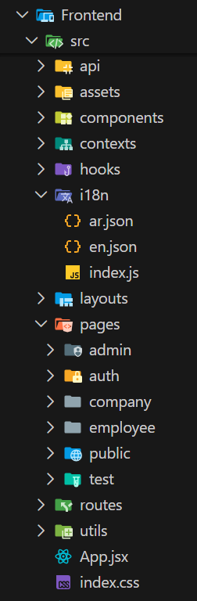
Fig. 0. VS Code file explorer showing Frontend/src/ folder structure with organized component directories.
// Frontend/src/App.jsx
function App() {
return (
<Suspense fallback={<LoadingFallback />}>
<AuthProvider>
<RouterProvider router={router} />
<Toaster position='top-right' toastOptions={{duration: 4000}} />
</AuthProvider>
</Suspense>
);
}
Internationalization (i18n) Configuration
The i18n system uses i18next with browser language detection, supporting English (en) and Arabic (ar) with 755 translation keys each. The changeLanguage() function updates the i18n instance, DOM direction attribute, and localStorage in a single operation. The language switcher is accessible from both the public navigation bar and the authenticated dashboard header, as shown in Fig. 4.
Fig. 0. AR/EN language switcher toggle button in the navigation bar for bilingual interface control.
// Frontend/src/i18n/index.js
i18n.use(LanguageDetector).use(initReactI18next).init({
resources: { en: { translation: en }, ar: { translation: ar } },
fallbackLng: 'en',
detection: { order: ['localStorage', 'navigator', 'htmlTag'],
lookupLocalStorage: 'phishaware-language' },
});
export const changeLanguage = (lang) => {
i18n.changeLanguage(lang);
document.documentElement.dir = lang === 'ar' ? 'rtl' : 'ltr';
document.documentElement.lang = lang;
localStorage.setItem('phishaware-language', lang);
};
RTL Support Implementation
The platform implements complete RTL support for Arabic content. When the language is switched to Arabic, the document direction is set to 'rtl', causing Tailwind CSS logical properties (ps-, pe-, ms-, me- for start/end padding and margins) to automatically mirror the layout. Fig. 5 and Fig. 6 demonstrate the LTR and RTL layout transformation.
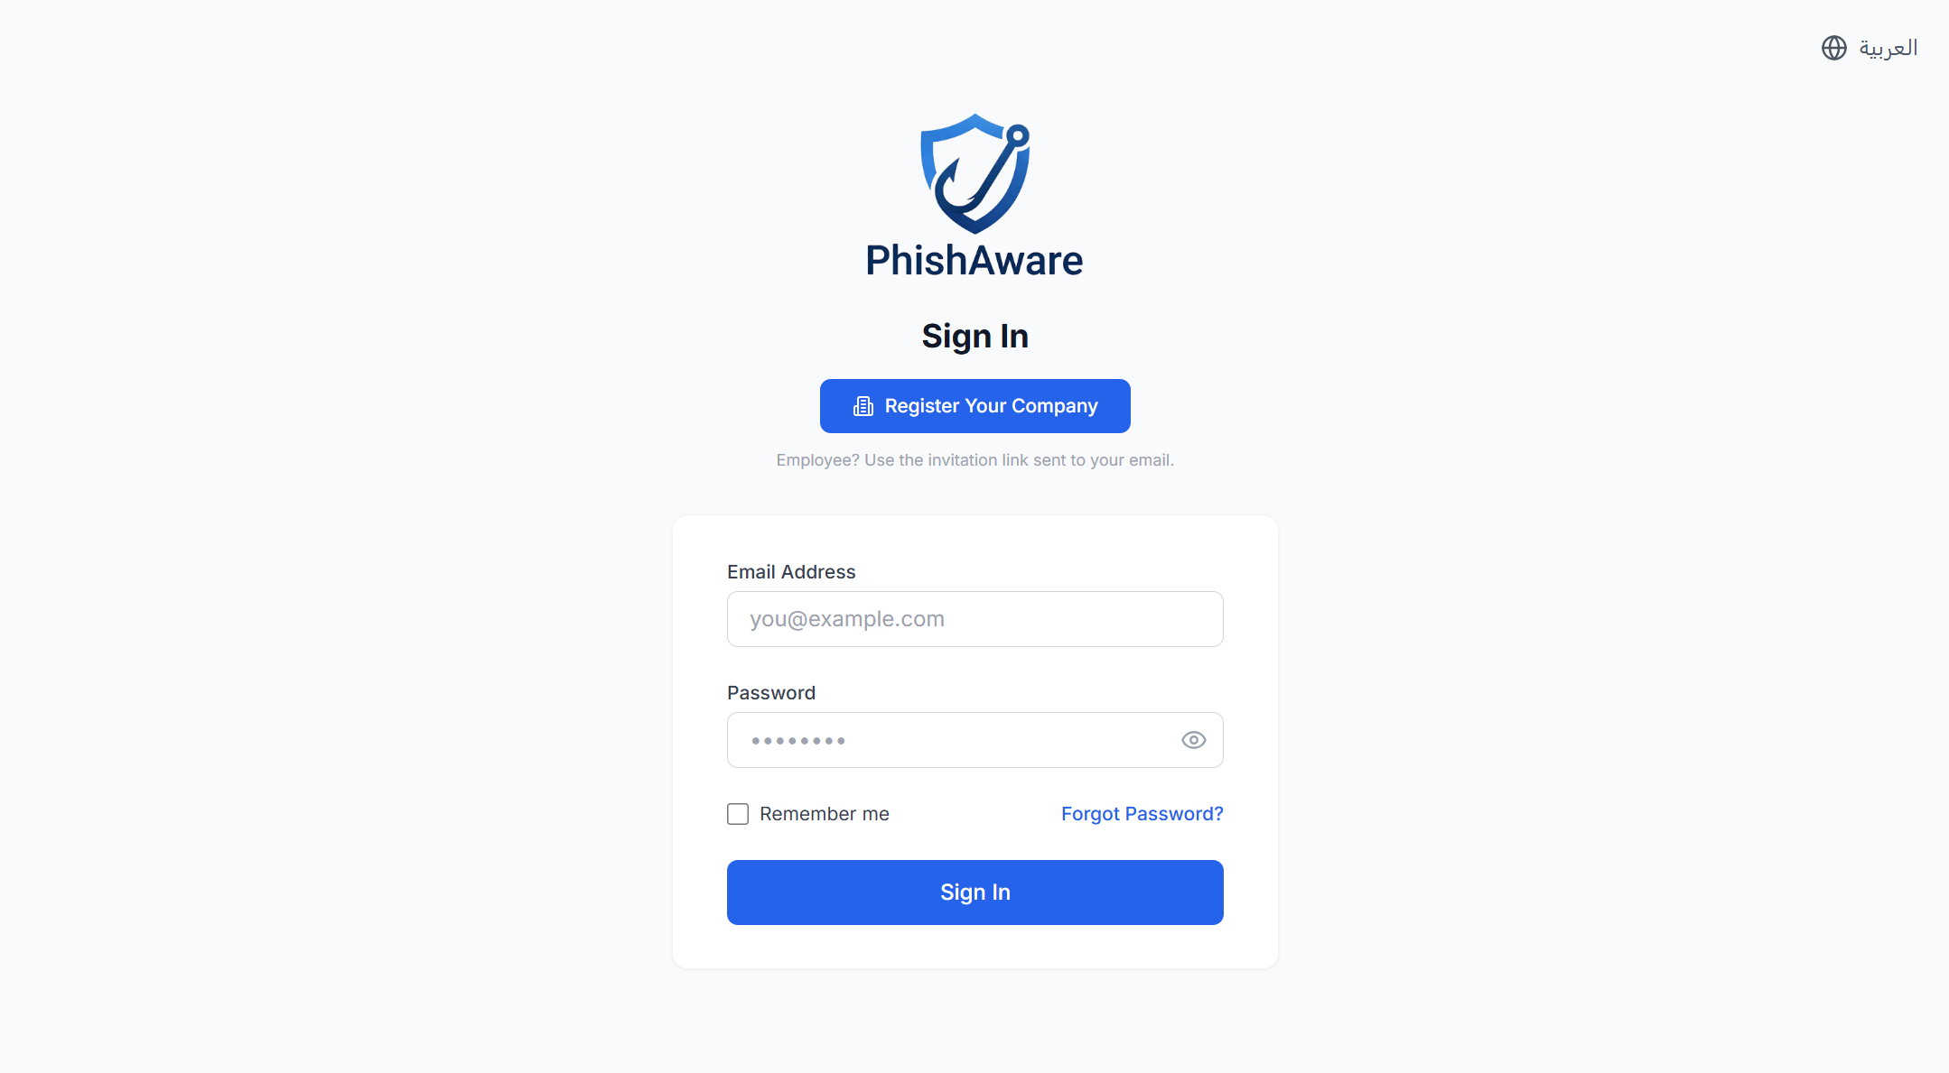
Fig. 0. Application page in English demonstrating left-to-right (LTR) layout orientation.
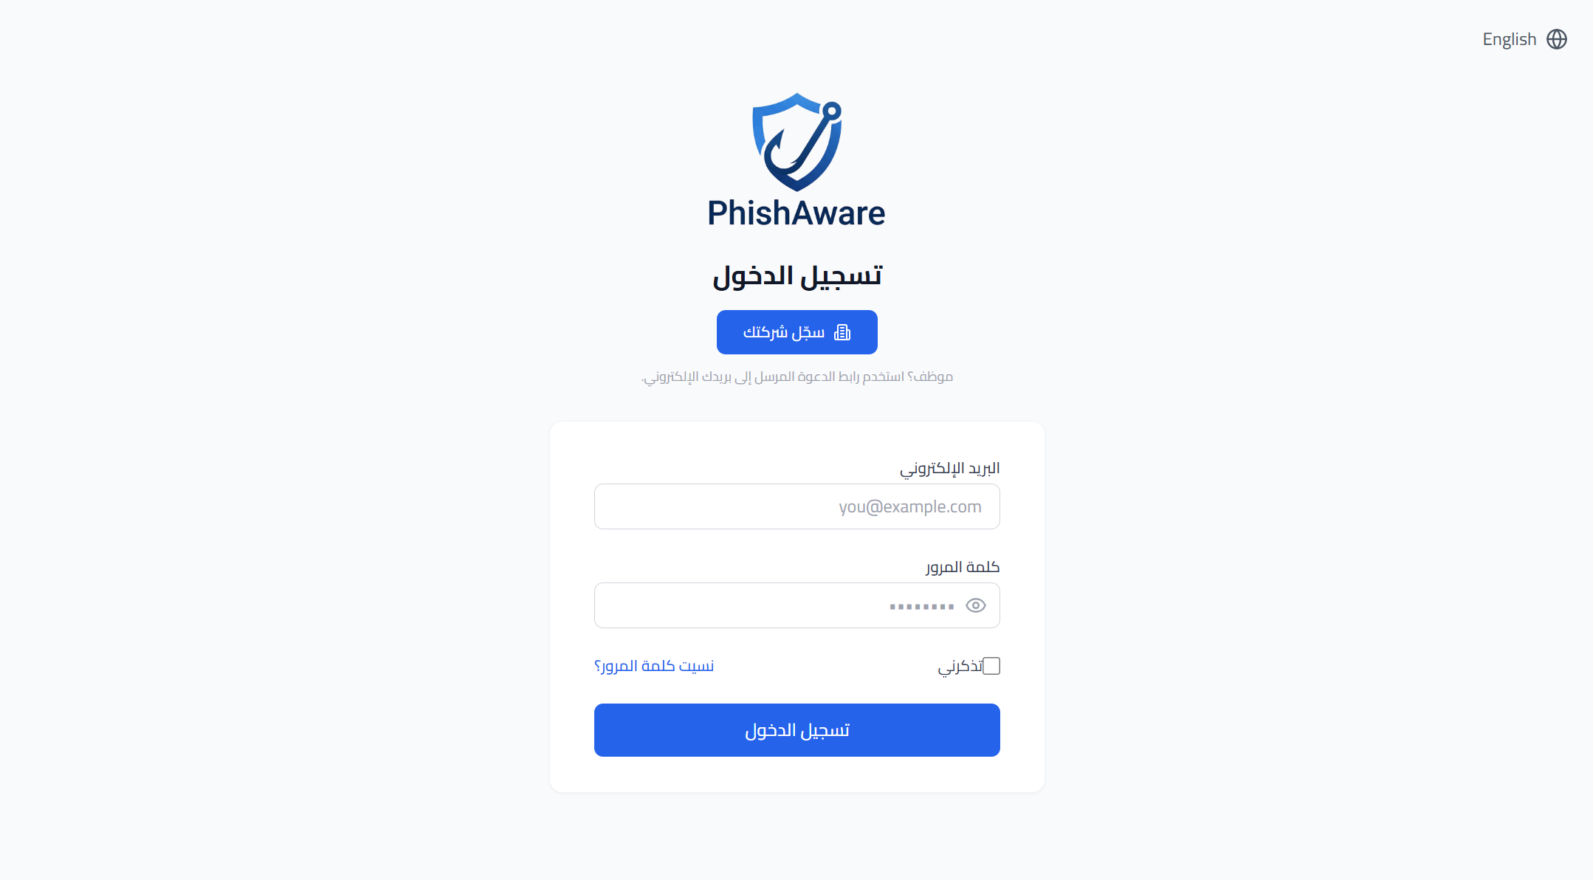
Fig. 0. Same application page in Arabic demonstrating right-to-left (RTL) mirrored layout.

2) Authentication & Protected Routes
The authentication system provides a complete login/registration flow with JWT token management, automatic token refresh, email verification, password recovery, and role-based route protection. The Axios service layer handles all API communication with interceptors for automatic token attachment and 401 error handling.
Axios Service Layer
The API client (api/axios.js) creates an Axios instance with the base URL configured from environment variables (VITE_API_URL, defaulting to http://localhost:8000/api/v1). Request interceptors automatically attach the JWT access token from localStorage. Response interceptors handle 401 errors by attempting token refresh, queuing failed requests during the refresh process, and replaying them with the new token. Failed refresh attempts clear all tokens and redirect to the login page.
API Endpoint Organization
The endpoints.js file organizes all API calls into 10 module objects: authAPI, companiesAPI, employeesAPI, campaignsAPI, simulationsAPI, quizzesAPI, trainingAPI, analyticsAPI, gamificationAPI, and communityAPI. Each module exports methods that correspond to backend API endpoints, providing a clean separation between UI logic and HTTP communication.
Authentication Context (AuthContext)
The AuthContext provides centralized authentication state management through React Context. It exposes the current user object, authentication status, and methods for login, register, logout, profile update, password change, and role checking. On initialization, it checks localStorage for existing tokens and verifies them against the API's profile endpoint:
// Frontend/src/contexts/AuthContext.jsx
const USER_ROLES = {
SUPER_ADMIN: 'SUPER_ADMIN',
COMPANY_ADMIN: 'COMPANY_ADMIN',
EMPLOYEE: 'EMPLOYEE',
PUBLIC_USER: 'PUBLIC_USER',
};
const getDashboardPath = () => {
switch (user?.role) {
case 'SUPER_ADMIN': return '/admin/dashboard';
case 'COMPANY_ADMIN': return '/company/dashboard';
case 'EMPLOYEE': return '/employee/dashboard';
default: return '/';
}
};
Login Page
The LoginPage (Fig. 7) presents a clean form with email and password fields, a "Remember me" checkbox, and a "Forgot password?" link. Form validation provides inline error messages with red borders (Fig. 9). The page includes a company registration call-to-action and an employee invitation hint. For unverified users, an amber banner appears with a "Resend verification email" button. The login page supports full RTL transformation for Arabic (Fig. 8).

Fig. 0. Login page in English showing PhishAware logo, email input, password field, and Sign In button.

Fig. 0. Login page in Arabic displaying full RTL transformation with mirrored layout elements.
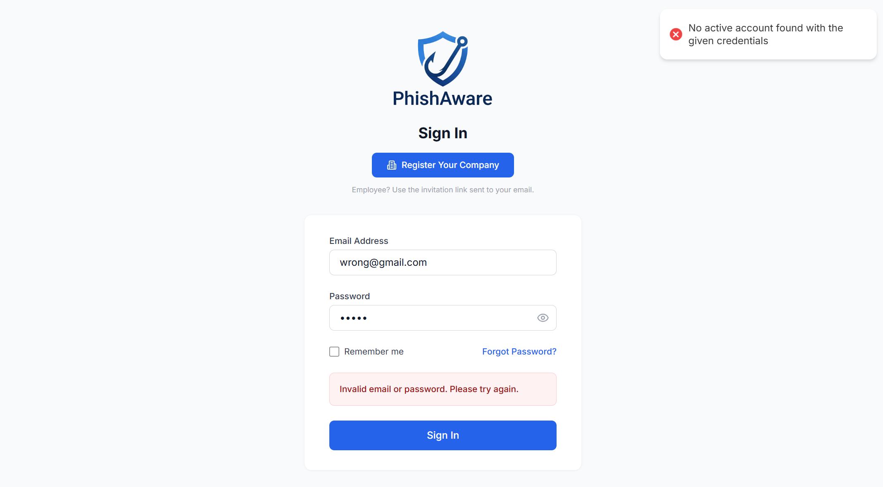
Fig. 0. Login page showing validation errors with red borders and descriptive error messages below fields.
Registration and Verification Flow
The RegisterPage (Fig. 10) collects company name, website URL, and administrator account details. Password validation enforces minimum 8-character length (Fig. 11). After successful registration, the page transitions to an inline success state showing a "Check your inbox!" message with the registered email and a resend verification button. The VerifyEmailPage handles token verification and displays a success page with a Login button (Fig. 12).
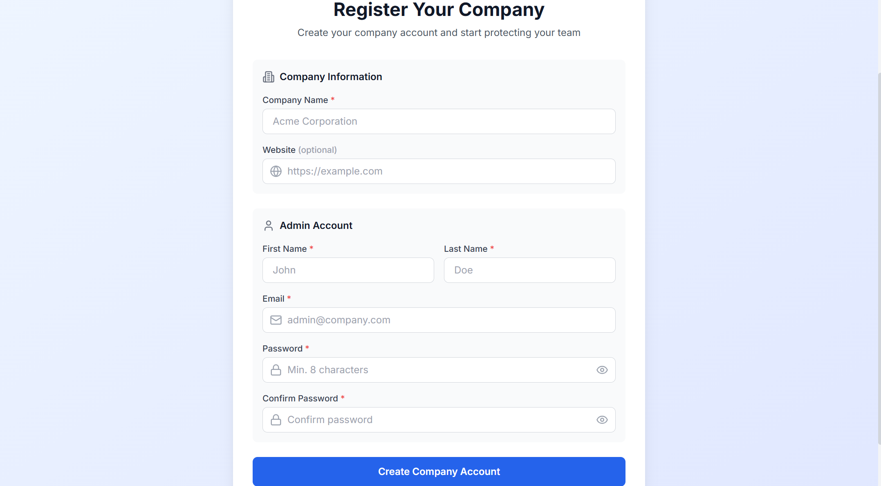
Fig. 0. Company registration form displaying Company Name, Website URL, and admin account creation fields.
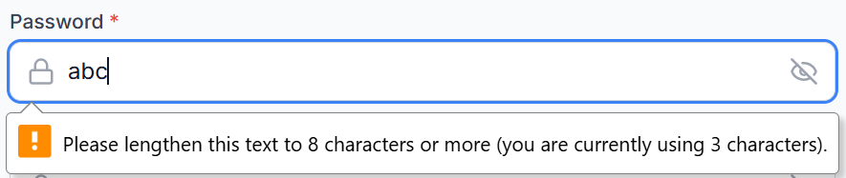
Fig. 0. Password field validation showing browser message "lengthen to 8 characters" for security requirements.
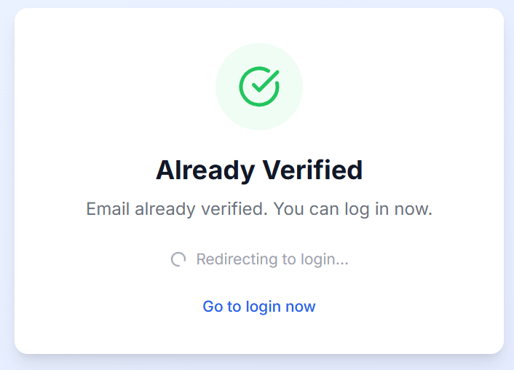
Fig. 0. Email verification success page with green checkmark icon and Login button for account access.
Protected Route System
The routing system implements three route guard components in ProtectedRoute.jsx: ProtectedRoute (requires authentication + optional role check, redirects to /login), PublicRoute (blocks authenticated users, redirects to dashboard), and GuestRoute (accessible to all). Routes are organized by user role with DashboardLayout as the parent for all authenticated routes:
TABLE 0: Route Guard Configuration
Route Group | Guard | Layout | Example Routes
Public | GuestRoute | PublicLayout | /, /training, /quiz, /community
Auth | PublicRoute | (none) | /login, /register, /verify-email/:token
Employee | ProtectedRoute (EMPLOYEE) | DashboardLayout | /employee/dashboard, /employee/quizzes
Company Admin | ProtectedRoute (COMPANY_ADMIN) | DashboardLayout | /company/dashboard, /company/campaigns
Super Admin | ProtectedRoute (SUPER_ADMIN) | DashboardLayout | /admin/dashboard, /admin/companies
Simulation | (none) | (none) | /simulation/caught/:token

B. Administrator Management Interfaces (Week 10)
Week 10 focused on building the company administrator interfaces, including the main dashboard layout with sidebar navigation and header, employee management with invitation workflows, campaign creation and management, simulation template libraries, and analytics dashboards. These interfaces provide comprehensive administrative control over the organization's cybersecurity awareness program.

1) Admin Layout, Employee & Campaign Management
The administrator interface uses a DashboardLayout component that provides a consistent structure across all authenticated pages. The layout features a collapsible sidebar for navigation, a fixed header with notifications and user menu, and a main content area. The layout adapts to mobile viewports with a hamburger menu and overlay-based sidebar.
Dashboard Layout Structure
The DashboardLayout (Fig. 13) implements a two-column design with a 256px fixed sidebar on desktop and an overlay sidebar on mobile. The sidebar displays the PhishAware logo, role-specific navigation items with icons, and a logout button. The header (Fig. 15) includes a language switcher (Globe icon with AR/EN text), notification dropdown with unread count badge, and a user profile menu with dropdown options.
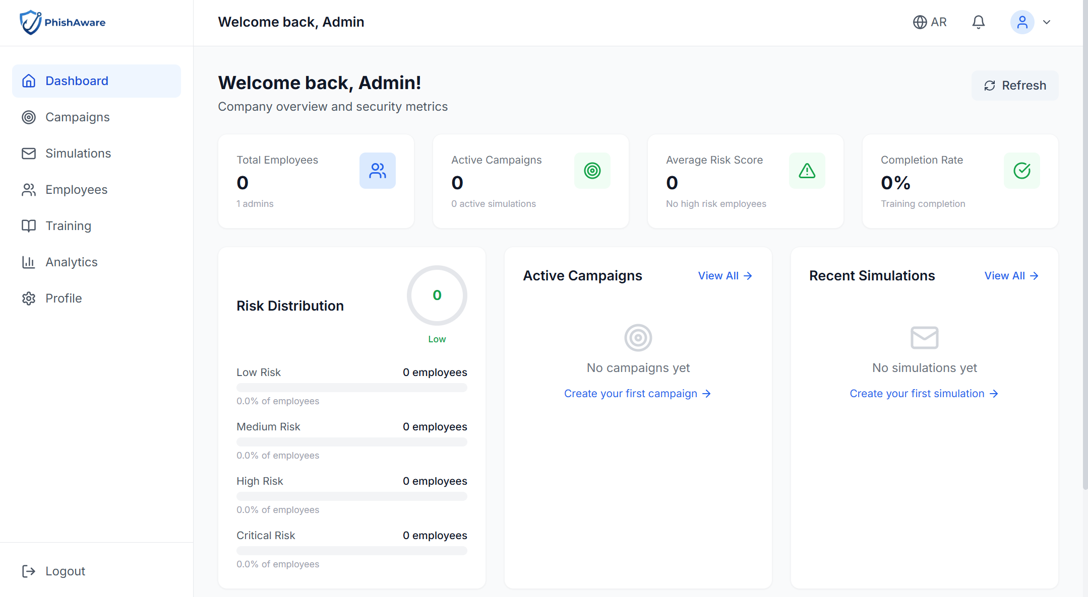
Fig. 0. Admin portal full layout showing collapsible sidebar, header with notifications, and main dashboard content area.
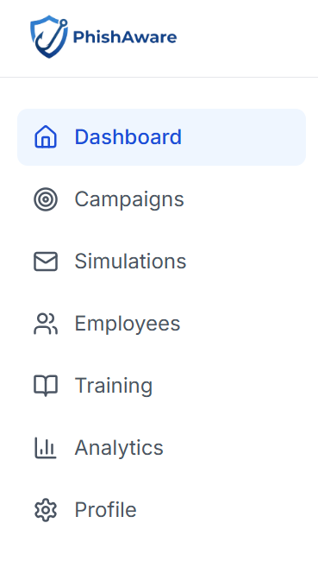
Fig. 0. Admin sidebar in expanded state displaying all menu items with icons, active item highlighted in blue.
Fig. 0. Admin header components including notification bell with badge count, AR/EN language toggle, and profile dropdown menu.
Campaign Management Interface
The CampaignList page (Fig. 16) displays all campaigns in a table with status badges (Draft, Active, Paused, Completed), start dates, participant counts, and action dropdowns. The CampaignCreate page (Fig. 17) provides a form for creating new quiz campaigns with configurable parameters including the English/Arabic language ratio slider and phishing scenario difficulty ratio controls. The employee assignment interface (Fig. 18) allows selecting specific employees with department filtering and displays the selected count.
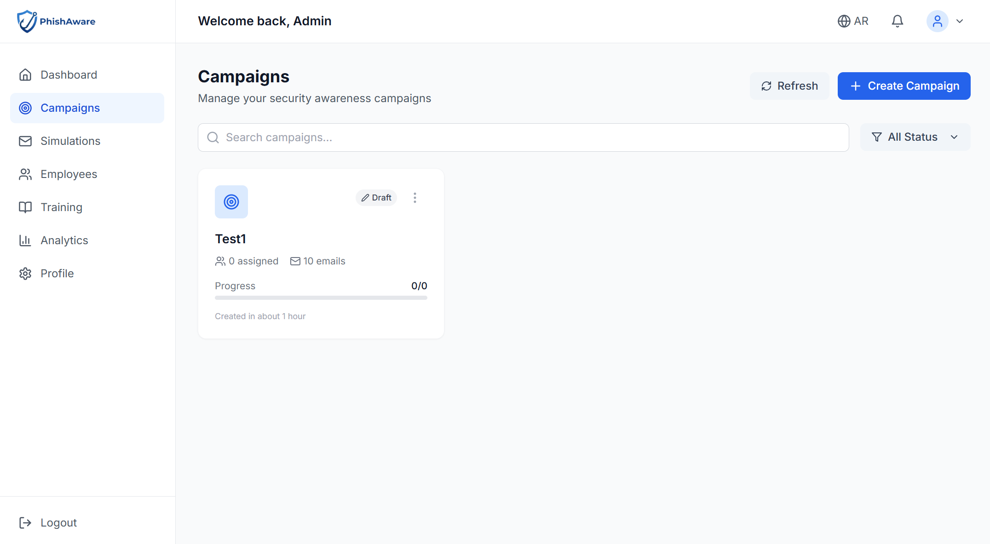
Fig. 0. Campaigns management page showing one campaign entry in Draft status with action buttons.
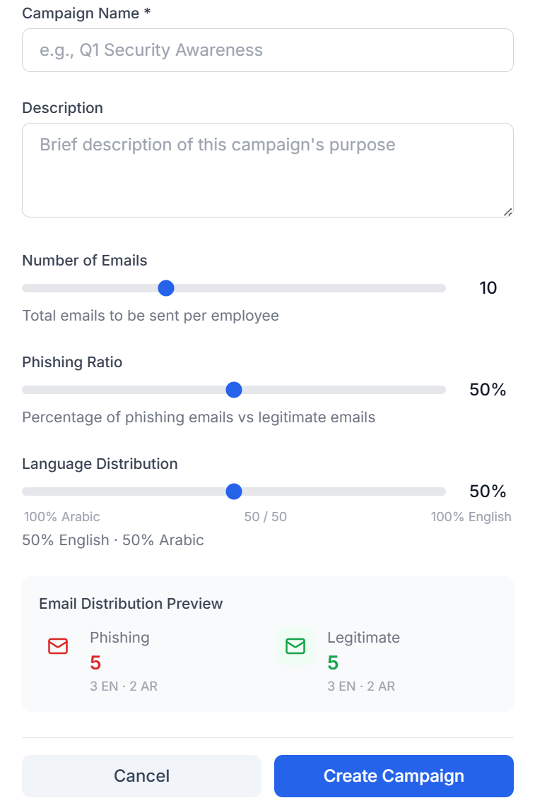
Fig. 0. Campaign creation interface with AR/EN language ratio slider and phishing scenario difficulty ratio controls.
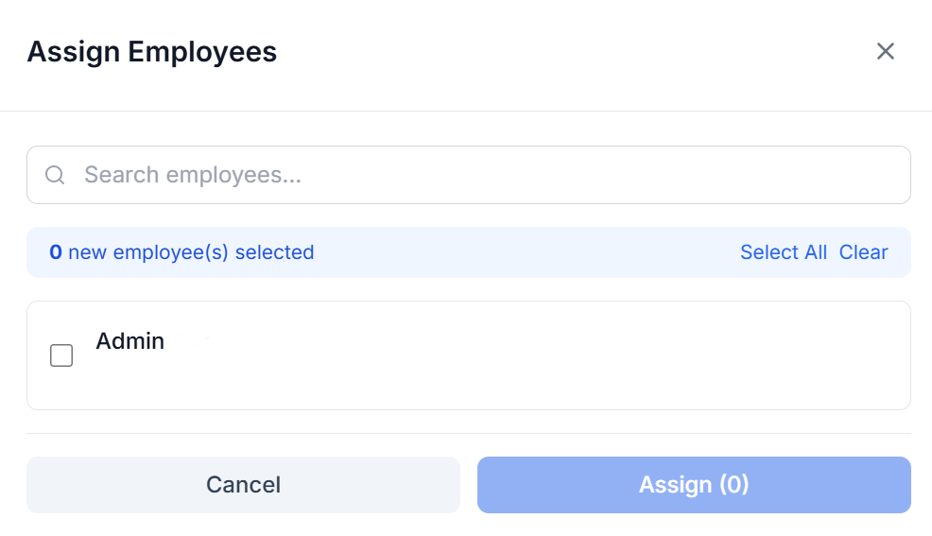
Fig. 0. Employee assignment interface with selection checkboxes, department filter dropdown, and selected employee count display.
Employee Management Interface
The CompanyEmployees page (Fig. 26) presents a comprehensive employee management table with columns for name, email, department, risk score badge (color-coded by level), campaign count, and action buttons. The invite modal (Fig. 27) accepts first name, last name, email address, and department selection for single employee invitations. The employee detail view (Fig. 28) shows the employee's profile information, current risk score visualization, and tabbed sections for training history and campaign results.
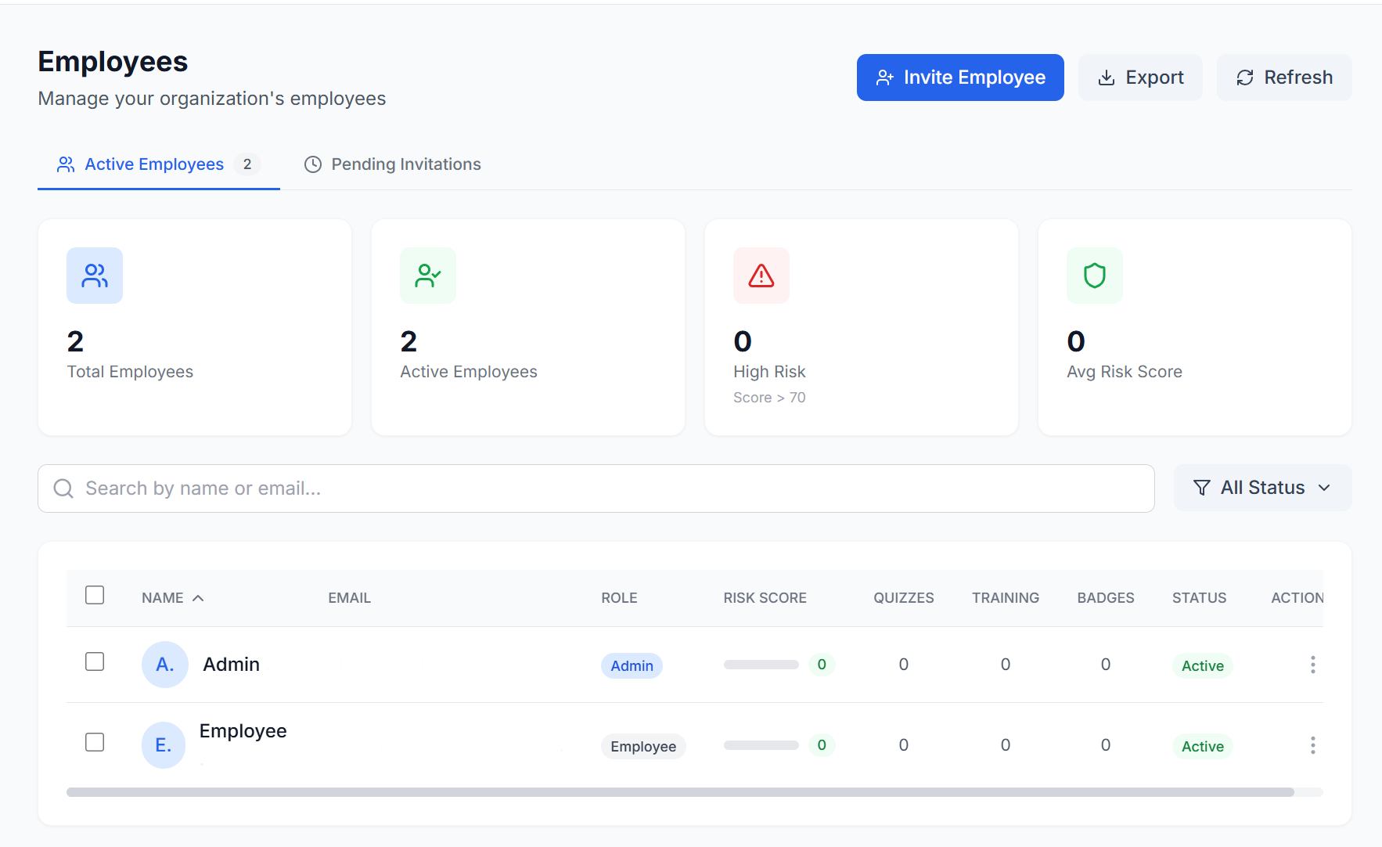
Fig. 0. Employee management table displaying name, email, department, risk badge, campaign count, and action buttons.
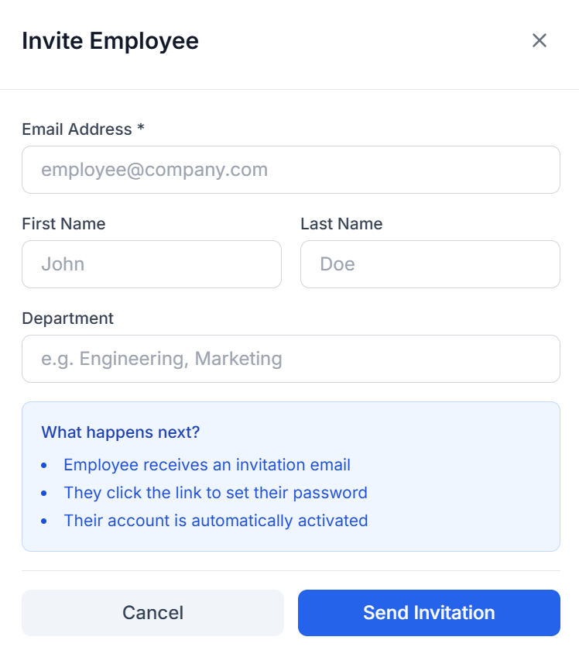
Fig. 0. Invite employee modal with input fields for first name, last name, email address, and department selection.
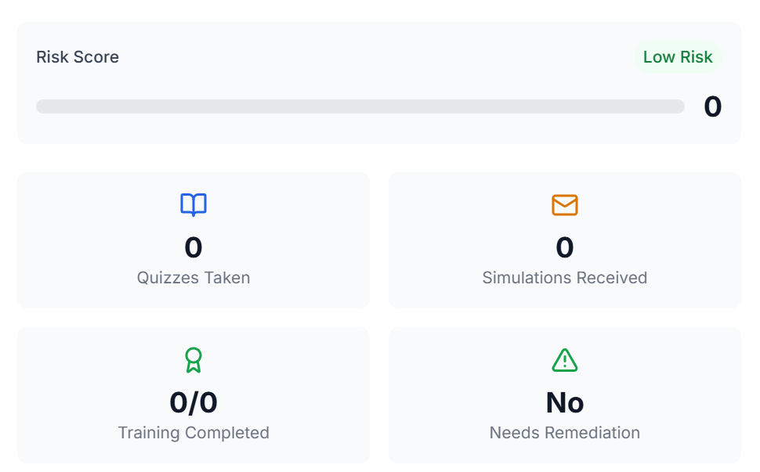
Fig. 0. Employee detail view showing profile information, current risk score, and tabbed sections for training history and campaign results.
Training Management Interface
The TrainingManagement page (Fig. 29) displays available training modules with card-based layouts showing module title, description, category badge, and action buttons. The View Details modal (Fig. 30) provides comprehensive module information including description, learning objectives, and quiz details. The assignment interface (Fig. 31) allows selecting target employees with department and risk level filters for bulk training assignment.
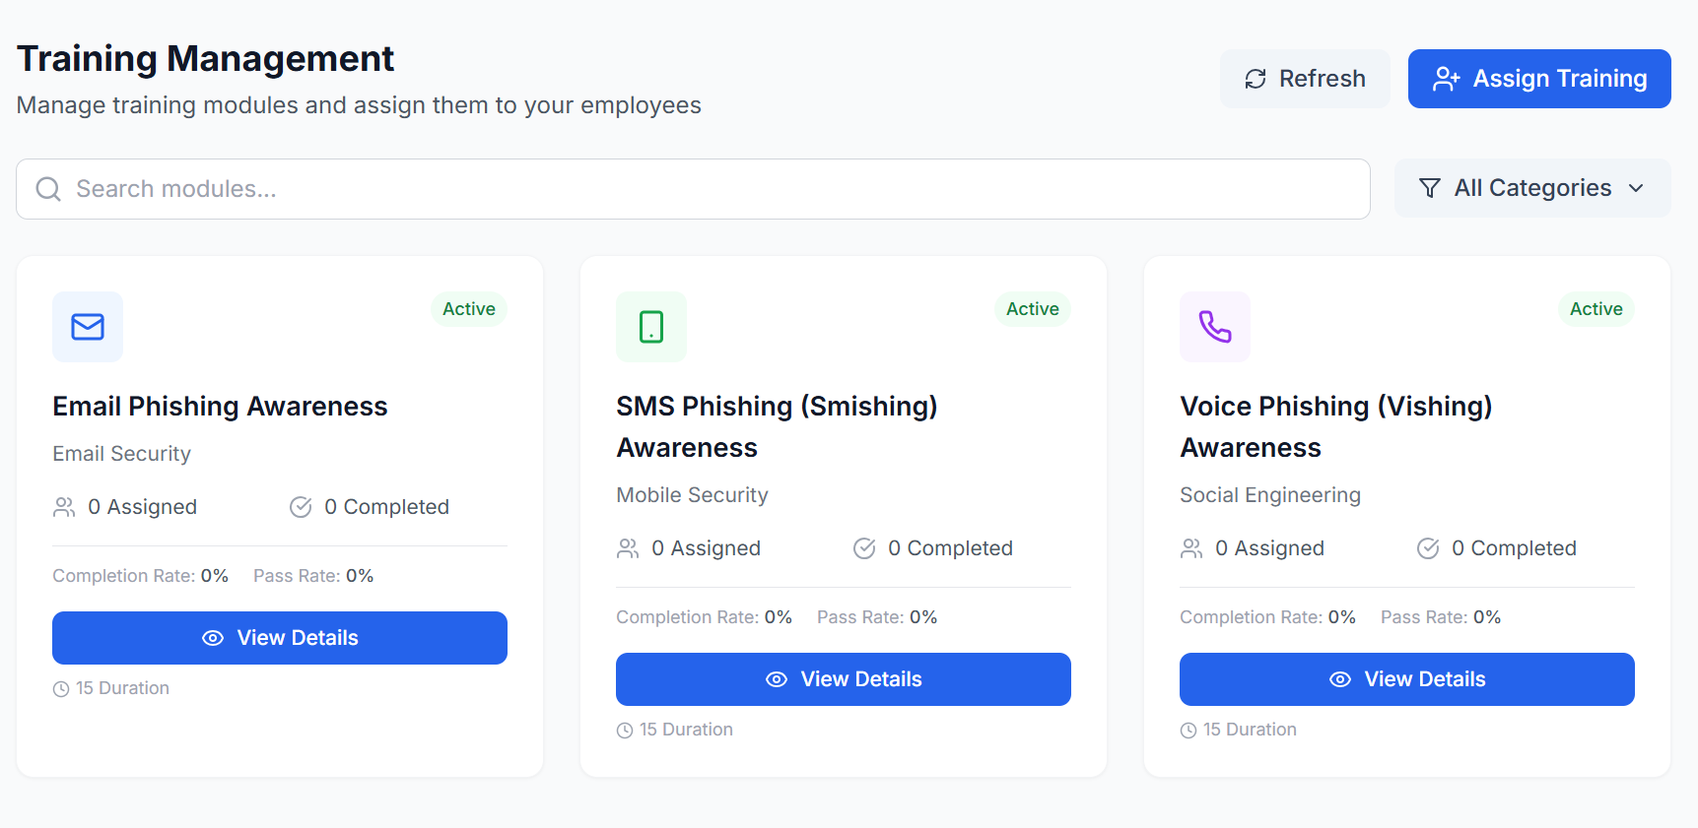
Fig. 0. Admin training page displaying 3 training modules: Email Phishing Awareness, SMS Scams Prevention, and Voice Call Scams Detection.
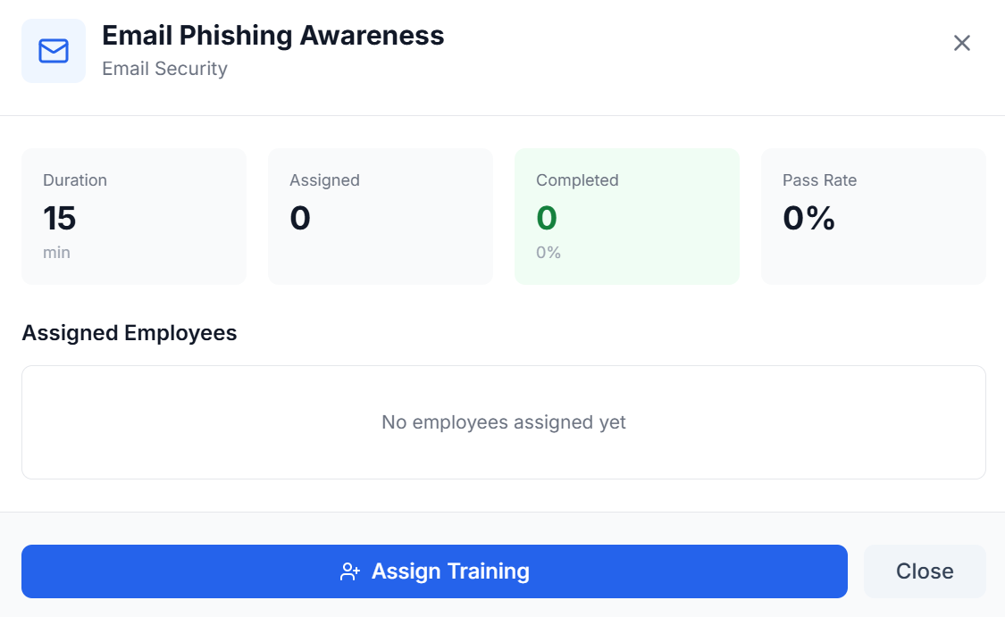
Fig. 0. Training module View Details modal showing module description, learning objectives, and quiz information.
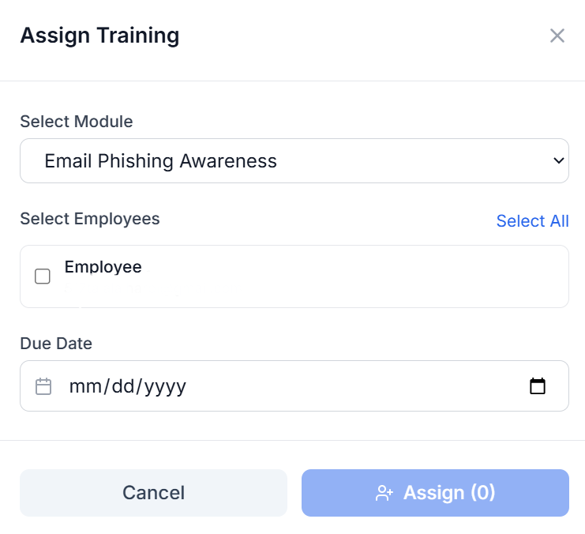
Fig. 0. Training module assignment interface for selecting target employees with department and risk level filters.
Admin Profile
The CompanyProfile page (Fig. 32) displays the administrator's personal information fields and account settings options, allowing profile updates and password changes.
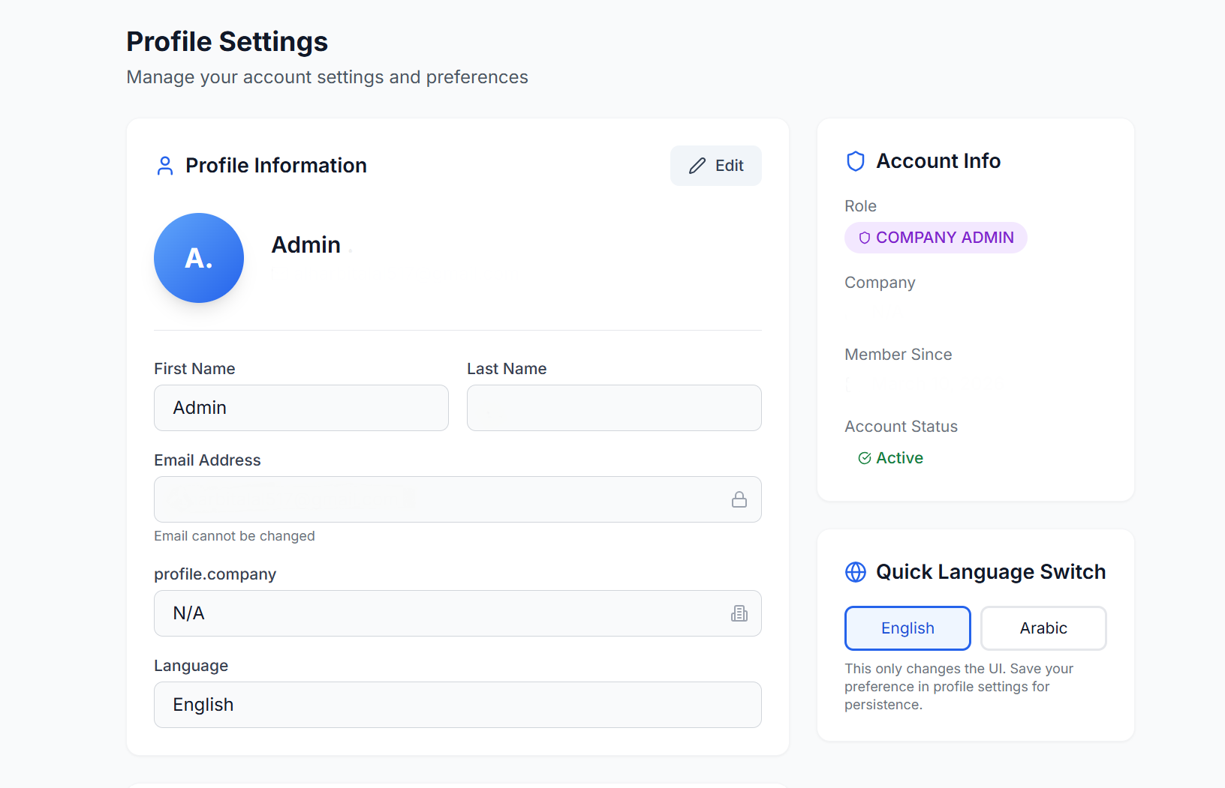
Fig. 0. Admin profile page displaying personal information fields and account settings options.

2) Content Libraries & Analytics Dashboards
The content libraries provide template management for phishing simulations, and the analytics dashboards deliver data-driven insights through interactive charts and KPI cards. The simulation creation wizard guides administrators through a four-step process from template selection to email delivery.
Simulation Template Library
The CompanySimulations page (Fig. 19) displays available pre-built phishing email templates in a list format with template name, attack vector, difficulty level, and language. Templates marked as public (company=None) are globally available, while company-specific templates are scoped to the organization.
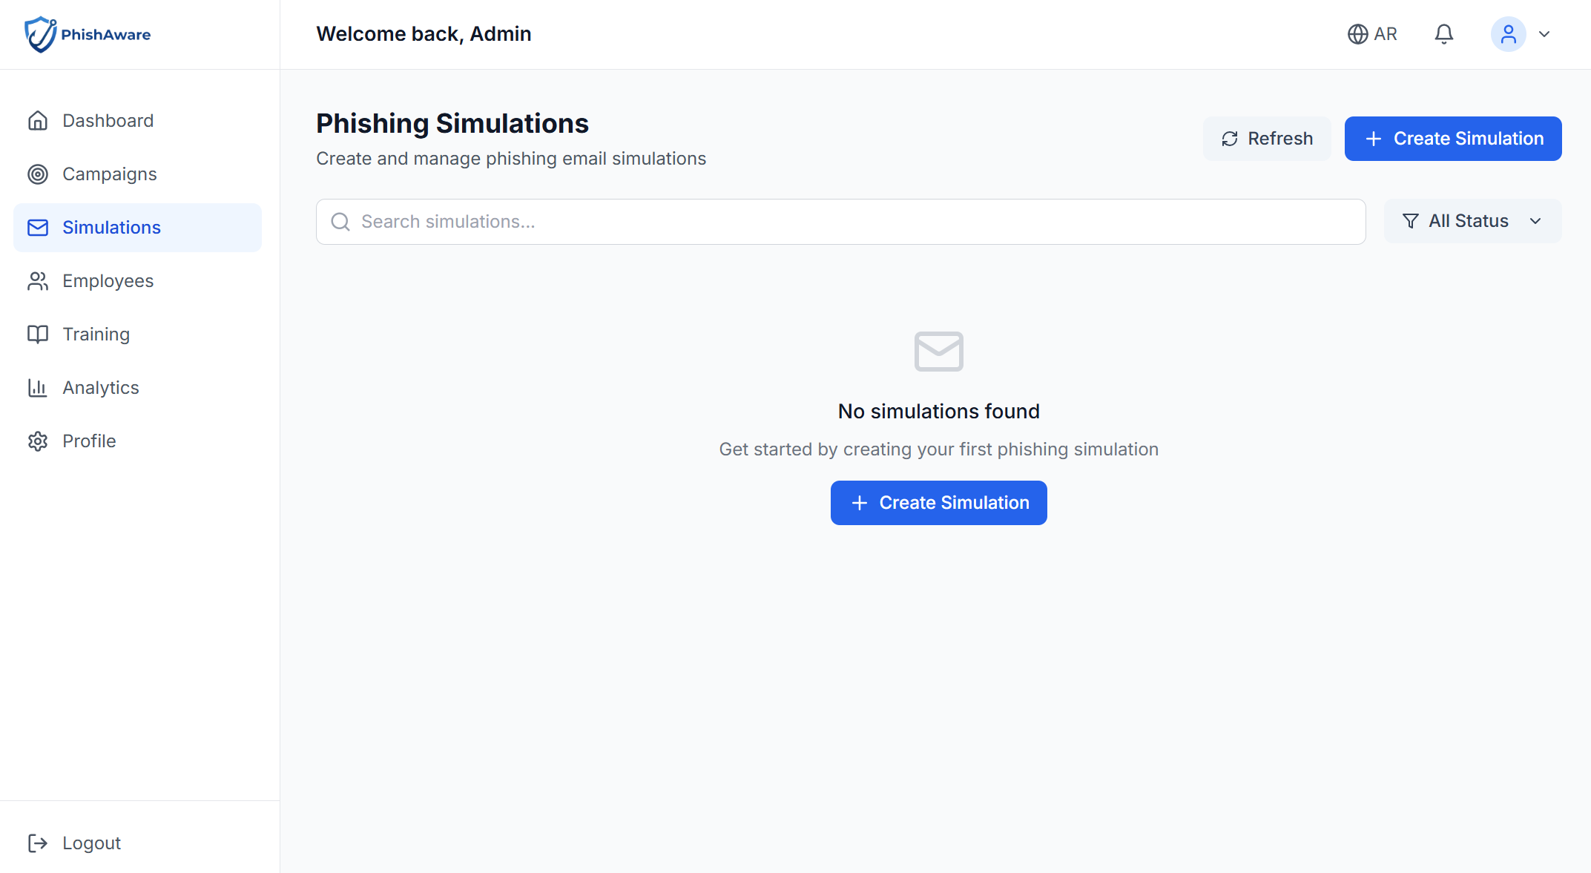
Fig. 0. Simulations tab displaying list of available pre-built phishing email templates.
Four-Step Simulation Creation Wizard
The SimulationCreate component implements a guided four-step wizard for creating and sending phishing simulations. Each step validates input before allowing progression to the next:
Step 1 - Template Selection (Fig. 20): Administrators enter a simulation name and description, then select from pre-built phishing email templates. Each template preview shows the subject line, sender, and difficulty level.
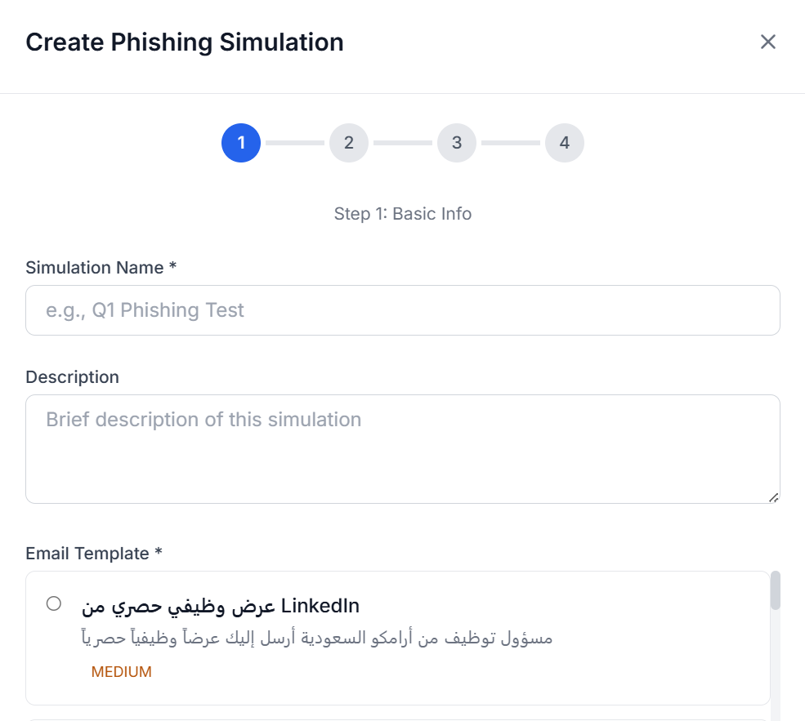
Fig. 0. Simulation creation Step 1 showing name input, description field, and pre-built template selection.
Step 2 - Employee Selection (Fig. 21): The employee selection interface provides department-based filtering, individual checkboxes, and a "select all" option. The selected employee count is displayed prominently.
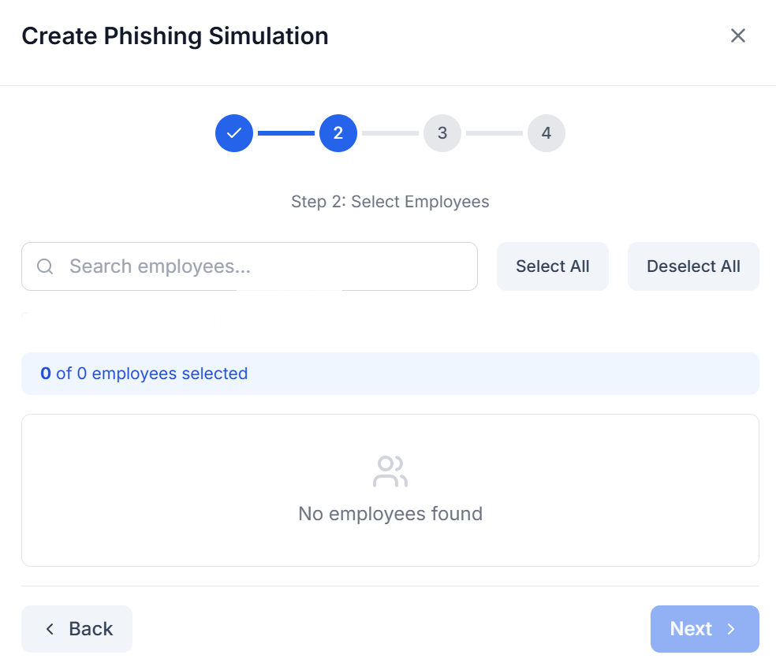
Fig. 0. Simulation creation Step 2 displaying employee selection interface with department filtering options.
Step 3 - Review and Confirm (Fig. 22): A summary view displays the simulation name, selected template, target employee count, and tracking options before final confirmation.
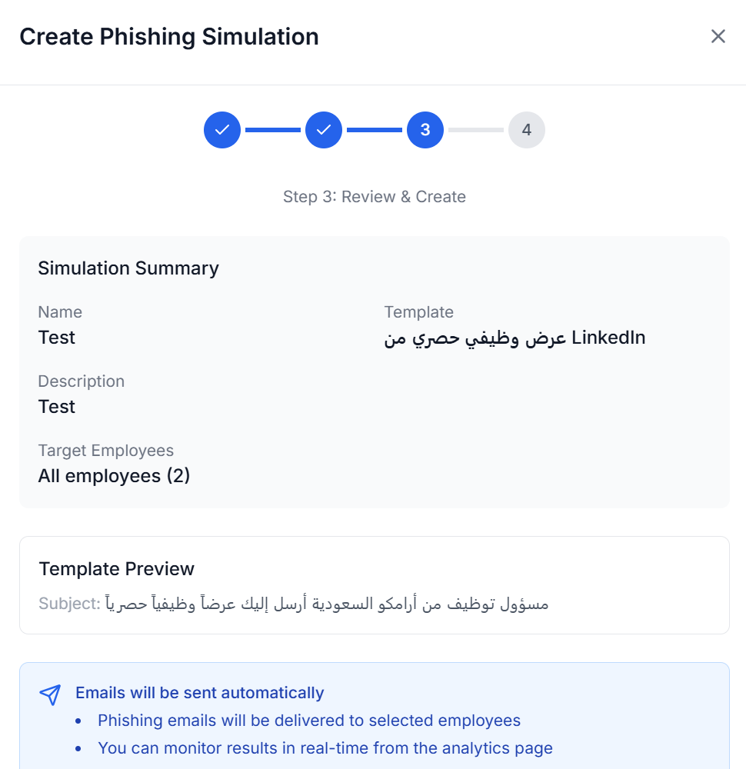
Fig. 0. Simulation creation Step 3 showing campaign summary review and confirm sending interface.
Step 4 - Sending (Fig. 23): A loading screen with a progress indicator displays while simulation emails are being sent via the API's send endpoint. Upon completion, the user is redirected to the simulation analytics page.
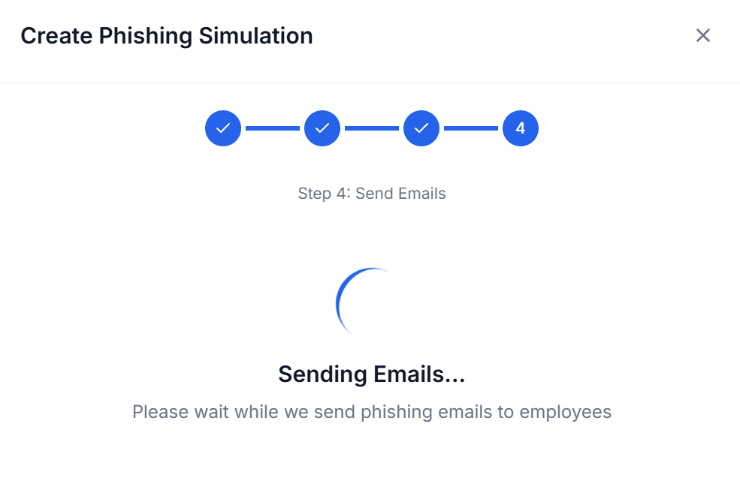
Fig. 0. Simulation creation Step 4 displaying loading screen with progress indicator while sending simulation emails.
Analytics Dashboard
The CompanyAnalytics page provides a comprehensive data visualization dashboard with two main sections. The upper section (Fig. 24) displays four KPI cards (total employees, active campaigns, average risk score, training completion rate), an Average Risk Score Over Time line chart (built with Recharts), and a Risk Level Distribution pie chart. The lower section (Fig. 25) shows Security Training Activity counters and Training Completion Rates breakdown by training module type.
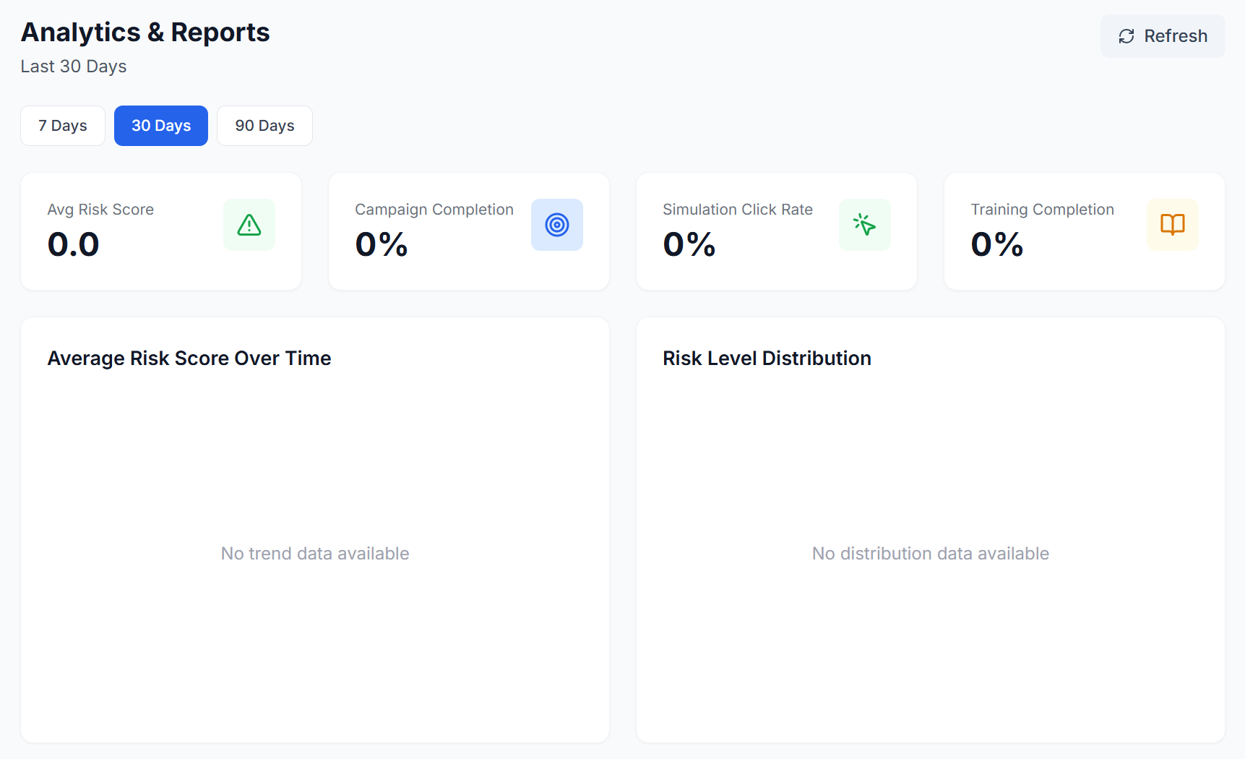
Fig. 0. Analytics dashboard upper section with 4 KPI cards, Average Risk Score Over Time line chart, and Risk Level Distribution pie chart (empty state shown).
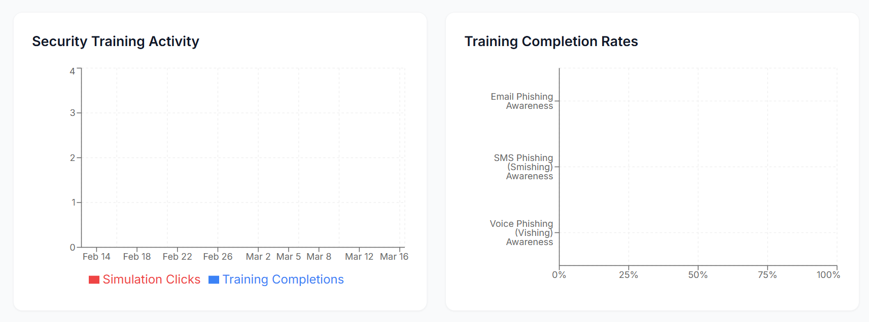
Fig. 0. Analytics dashboard lower section showing Security Training Activity counters and Training Completion Rates breakdown by training type.

C. Employee Training & Gamification UI (Week 11)
Week 11 developed the employee-facing interfaces including the personal dashboard, training module interactions, quiz-taking interfaces, and gamification displays. These interfaces provide employees with an engaging, gamified experience for improving their cybersecurity awareness while tracking their progress and achievements.

1) Employee Dashboard & Training Modules
The employee dashboard serves as the central hub for each employee's security awareness journey. It presents personalized risk assessment, pending tasks, earned achievements, and quick action links. The dashboard adapts to mobile viewports with a stacked layout design, ensuring accessibility on all devices.
Employee Dashboard
The EmployeeDashboard (Fig. 33) features a prominent risk score gauge implemented as an SVG circular progress indicator with color coding: green for LOW (0-25), yellow for MEDIUM (26-50), orange for HIGH (51-75), and red for CRITICAL (76-100). The gauge shows the numeric score, risk level badge, and breakdown of quiz accuracy and simulation click rate. For new employees without established scores, a gray gauge with an encouraging message prompts them to complete their first quiz.
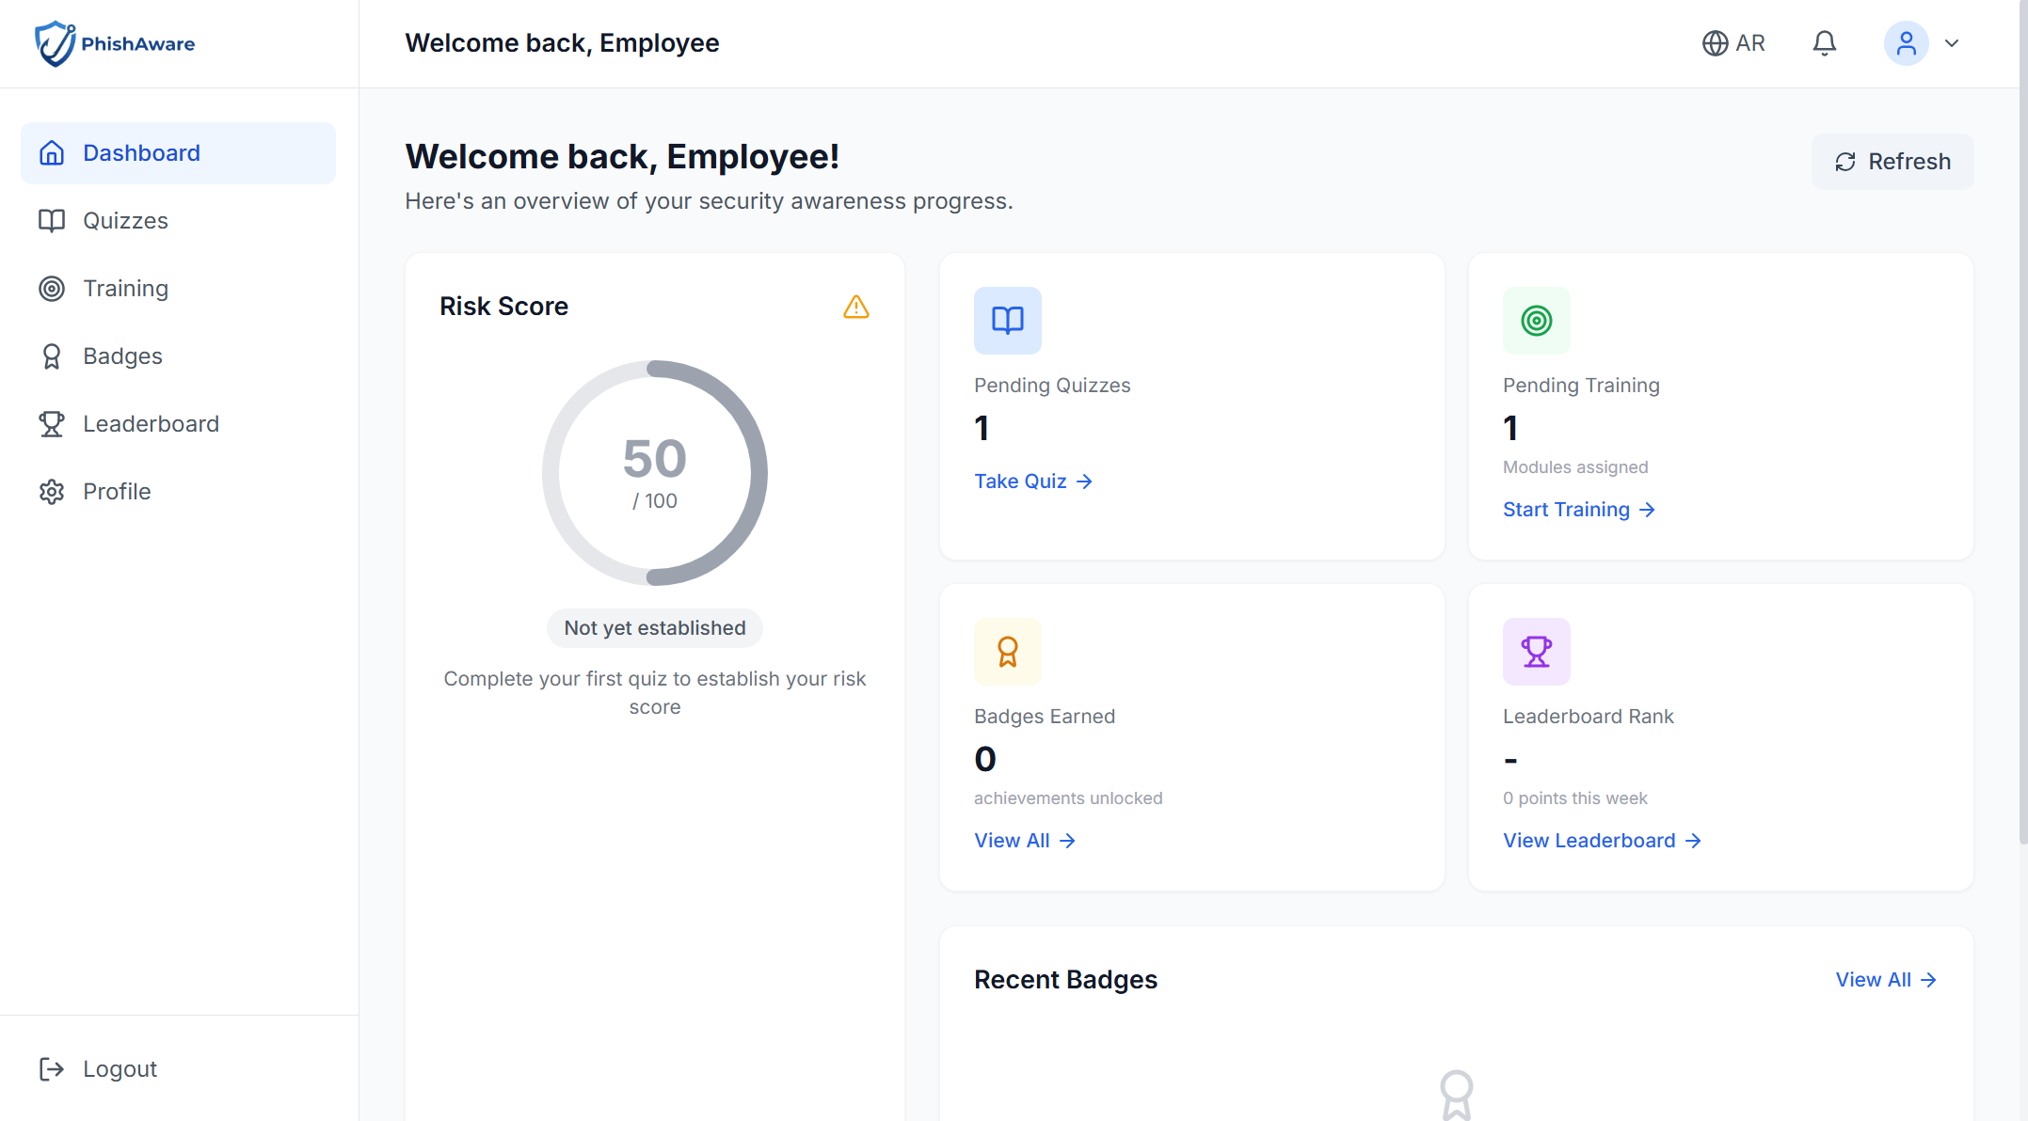
Fig. 0. Employee dashboard showing personalized welcome message, risk score gauge, training progress indicators, and earned badges display.
The dashboard also includes a 2x2 quick stats grid showing pending quizzes, pending training, badges earned, and leaderboard rank, each linking to the respective page. A recent badges section displays the three most recently earned badges with emoji, name, and earned date. Quick action cards at the bottom provide direct links to Take Quiz, Continue Training, and View Leaderboard. The mobile responsive view (Fig. 34) demonstrates the stacked vertical layout with hamburger menu navigation at 375px width.
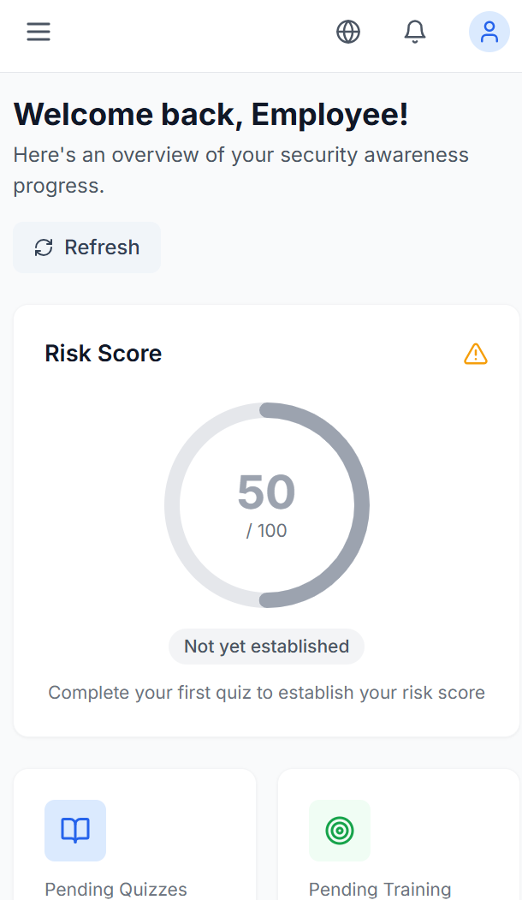
Fig. 0. Employee dashboard mobile view (375px width) with stacked vertical layout and hamburger menu navigation.
Training Module Interface
The EmployeeTraining page lists all assigned training modules with status badges (Assigned, In Progress, Completed, Passed, Failed), due dates, and progress bars. Clicking a training module navigates to TakeTraining, which presents the module detail page (Fig. 38) with title, description, learning objectives, and a training mode selection interface.
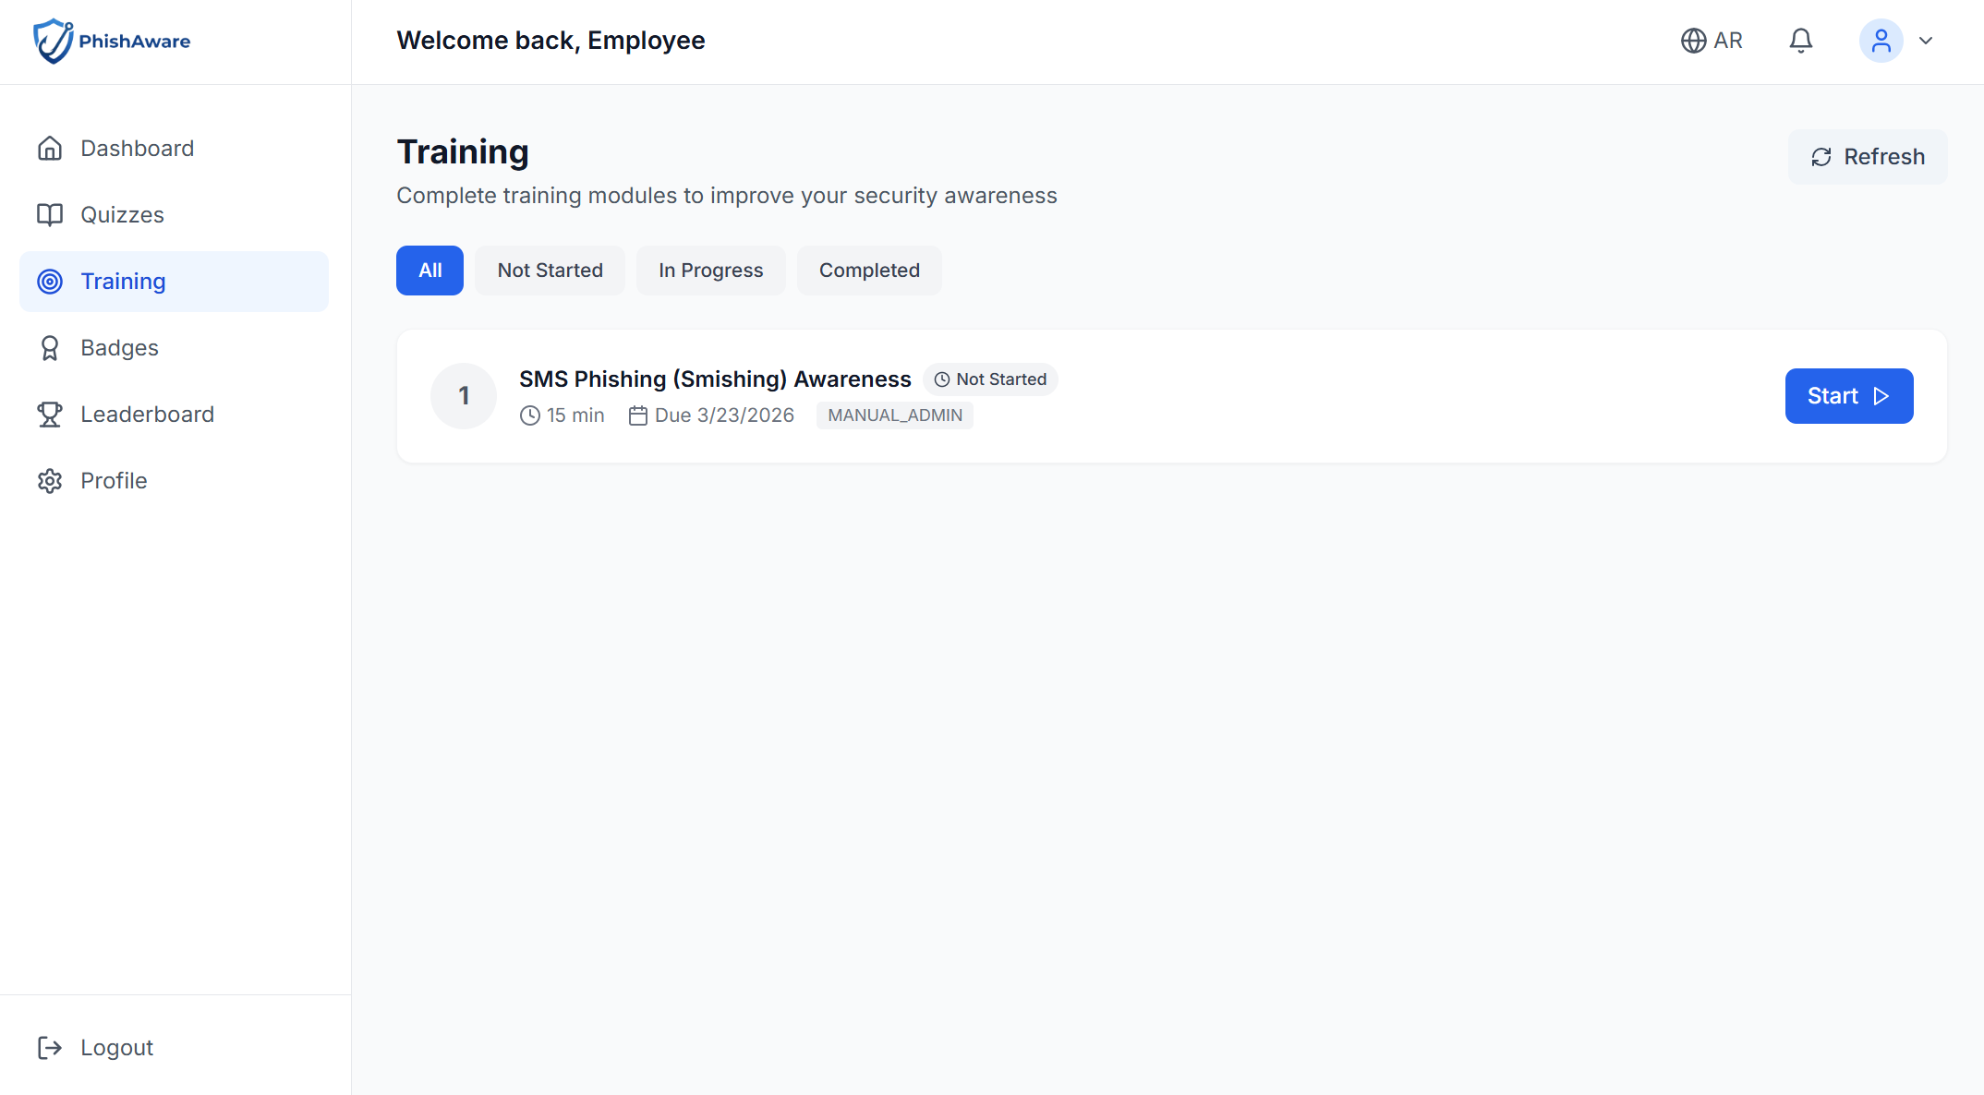
Fig. 0. Training module detail page showing module title, description, learning objectives, and training mode selection.
The training mode selection (Fig. 39) offers two cards: Video Training (traditional video content followed by a quiz) and Interactive Learning (scenario-based interactive modules). The interactive mode maps training categories to specific lesson modules: EMAIL_SECURITY maps to phishing lessons (V4/V5/V6), SOCIAL_ENGINEERING to vishing, and MOBILE_SECURITY to smishing. Each interactive lesson has both English and Arabic versions, providing 12 total interactive modules.
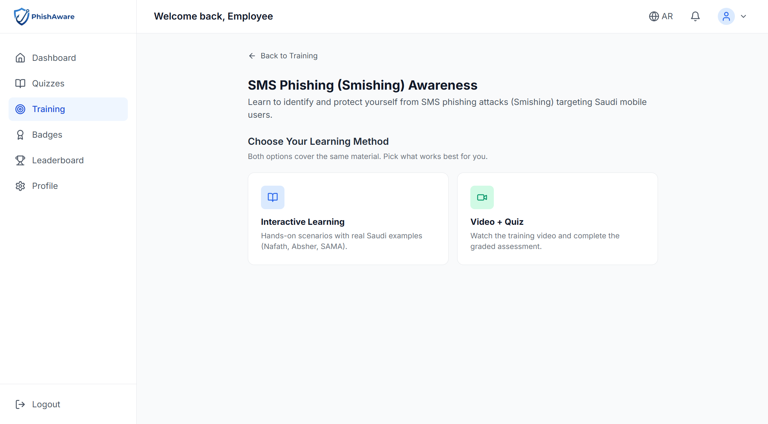
Fig. 0. Training mode selection interface with two cards: Video Training and Interactive Learning, each listing key features.

2) Quiz Interfaces & Gamification Display
The quiz and gamification interfaces provide engaging interaction patterns for employee assessment and recognition. The quiz system supports both campaign quizzes (where employees classify emails as phishing or legitimate) and training quizzes (module-specific knowledge assessments). The gamification display showcases earned badges, points, and leaderboard rankings.
Quiz Taking Interface
The TakeQuiz component implements a multi-stage quiz experience. The start screen (Fig. 35) displays the quiz title, description, difficulty level indicator, and a Start Quiz button. Once started, the quiz question interface (Fig. 36) presents phishing email scenarios with Safe and Phishing answer buttons and a progress indicator showing dots for each question. Navigation buttons allow moving between questions.
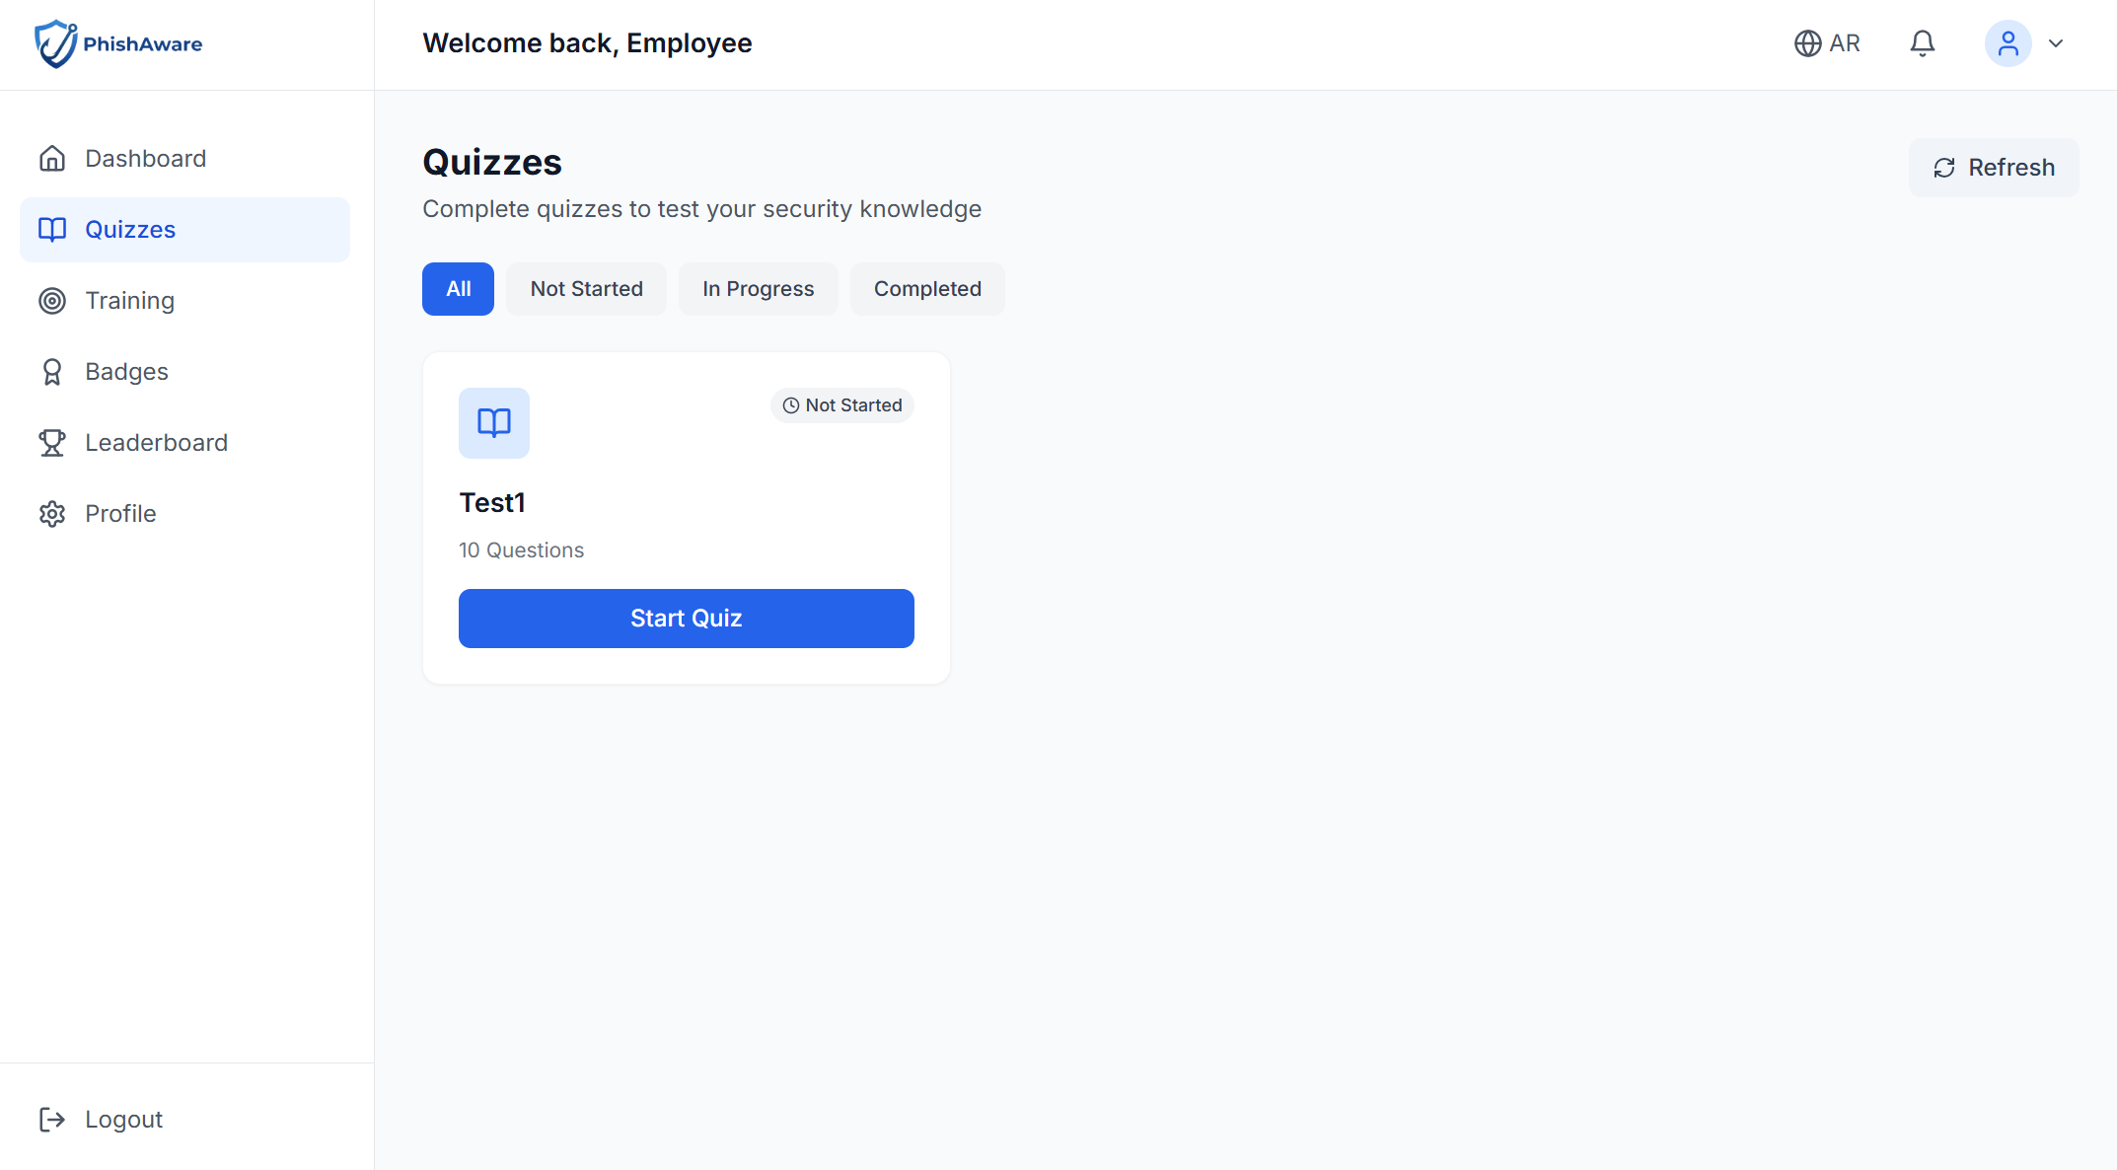
Fig. 0. Quiz start screen displaying quiz title, description text, difficulty level indicator, and Start Quiz button.
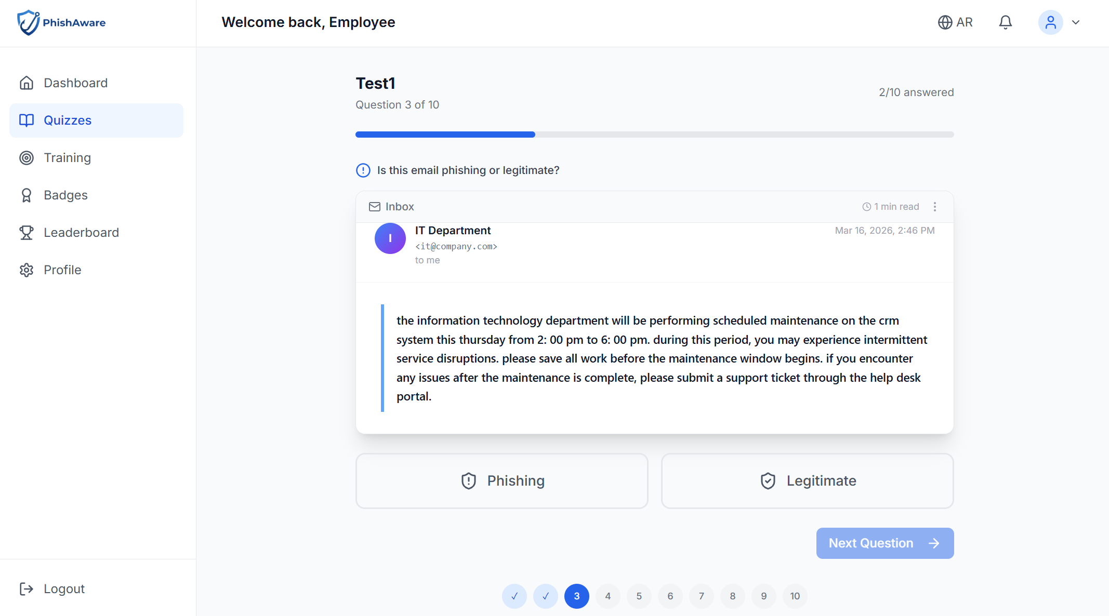
Fig. 0. Quiz question interface showing phishing email scenario with Safe and Phishing answer buttons and progress indicator dots.
Upon completion, the results page (Fig. 37) displays the final score, performance breakdown by category, and personalized recommendations based on the employee's strengths and weaknesses. The results interface provides actionable feedback to guide further learning.
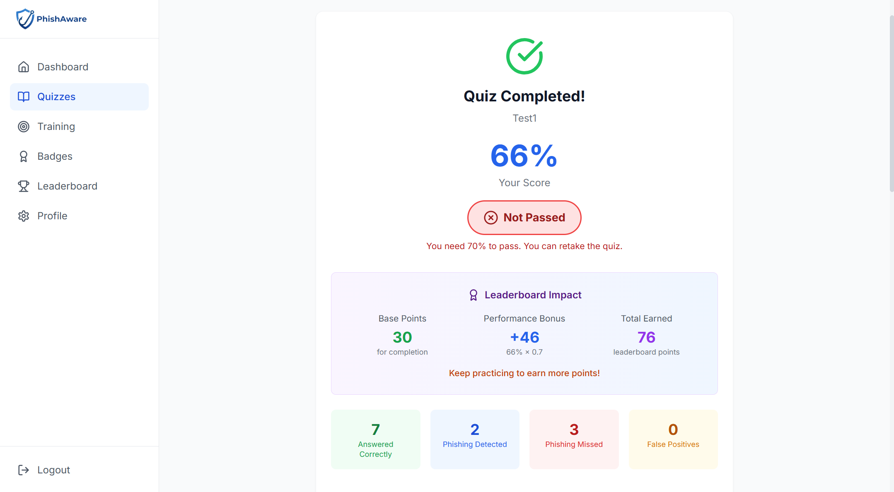
Fig. 0. Quiz results page displaying final score, performance breakdown by category, and personalized recommendations.
Badge Showcase
The EmployeeBadges page (Fig. 40) presents all available badges in a grid layout. Earned badges appear in full color with their emoji, name, and rarity badge (COMMON in gray, UNCOMMON in green, RARE in blue, EPIC in purple, LEGENDARY in yellow). Locked badges are displayed in greyscale with a lock icon overlay. Clicking a badge opens a modal with full details including description, criteria, and earning date. The page supports filtering between All, Earned, and Locked badges.
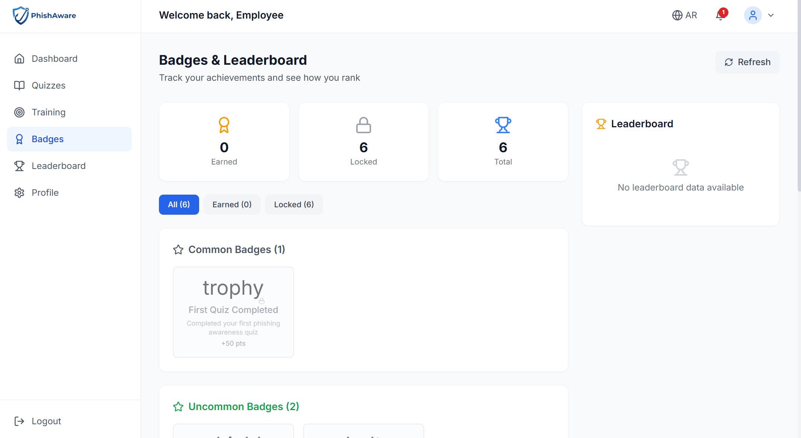
Fig. 0. Badges showcase page displaying earned badges in full color and locked badges in greyscale grid layout.
Leaderboard Interface
The EmployeeLeaderboard page (Fig. 41) features a "Your Position" section with the employee's current rank, total points, and percentile. Three period tabs (Weekly, Monthly, All Time) filter the leaderboard data. The top 3 positions receive special styling with Trophy (gold), Medal (silver), and Award (bronze) icons. Each leaderboard entry shows an avatar (generated from initials in a colored circle), rank number, name, and points badge. A "How Points Work" section explains the scoring formula, providing transparency to employees about how their rank is calculated.
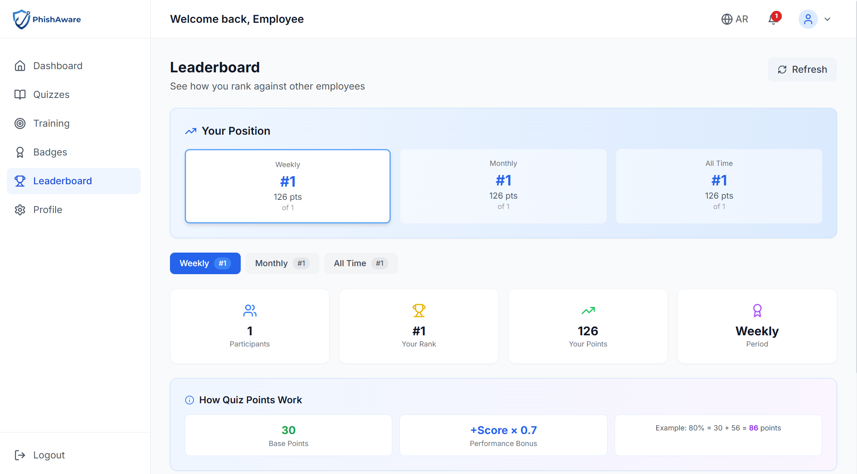
Fig. 0. Leaderboard interface showing "Your Position" section with Weekly/Monthly/All Time tabs, statistics cards, and "How Points Work" scoring formula.
Employee Profile
The EmployeeProfile page (Fig. 42) displays personal information fields (first name, last name, email, phone, department) and account configuration options including password change. The profile page uses the same form component pattern as the admin profile.
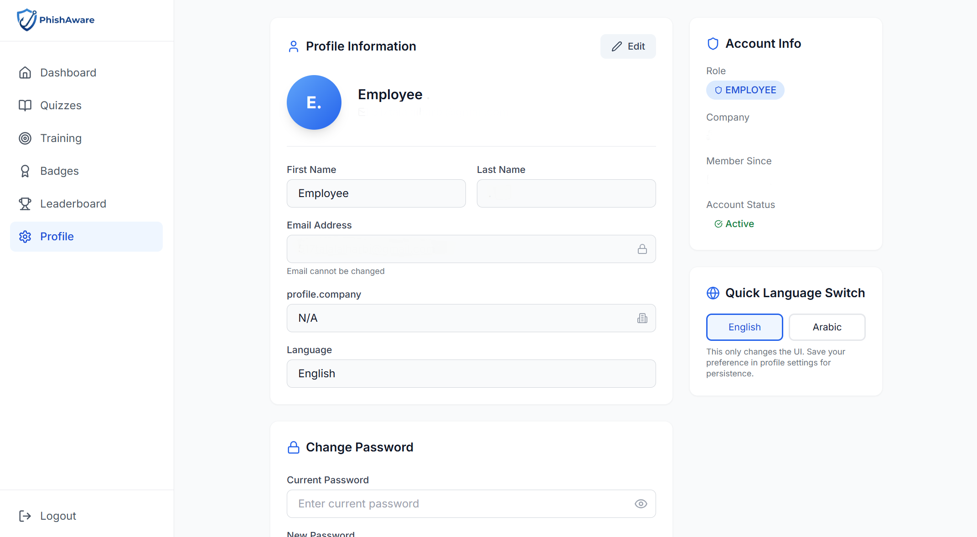
Fig. 0. Employee profile and settings page displaying personal information and account configuration options.

D. Public Awareness Portal & Final Polish (Week 11)
The final frontend development phase created the public-facing community portal for cybersecurity awareness, including the landing page, awareness content pages, public quizzes, and the platform's design system. These interfaces are accessible without authentication, serving as both an awareness resource and a funnel for platform adoption.

1) Community Portal & Awareness Content
The public portal provides free cybersecurity awareness content targeting Saudi Arabian users and organizations. The portal features bilingual content, Saudi-specific examples (SAMA, NCA, CERT references), and interactive elements designed to educate visitors about common cyber threats including email phishing, SMS scams, and voice call fraud.
Landing Page Design
The LandingPage (Fig. 43) opens with a hero section featuring a gradient background (primary-600 to primary-800) with the headline "Protect Yourself from Cyber Threats", a descriptive tagline, and dual call-to-action buttons: "Start Learning" (solid white) and "Take Free Quiz" (bordered). Below the hero, a features section displays four platform capabilities in a grid: Training, Simulations, Analytics, and Compliance.
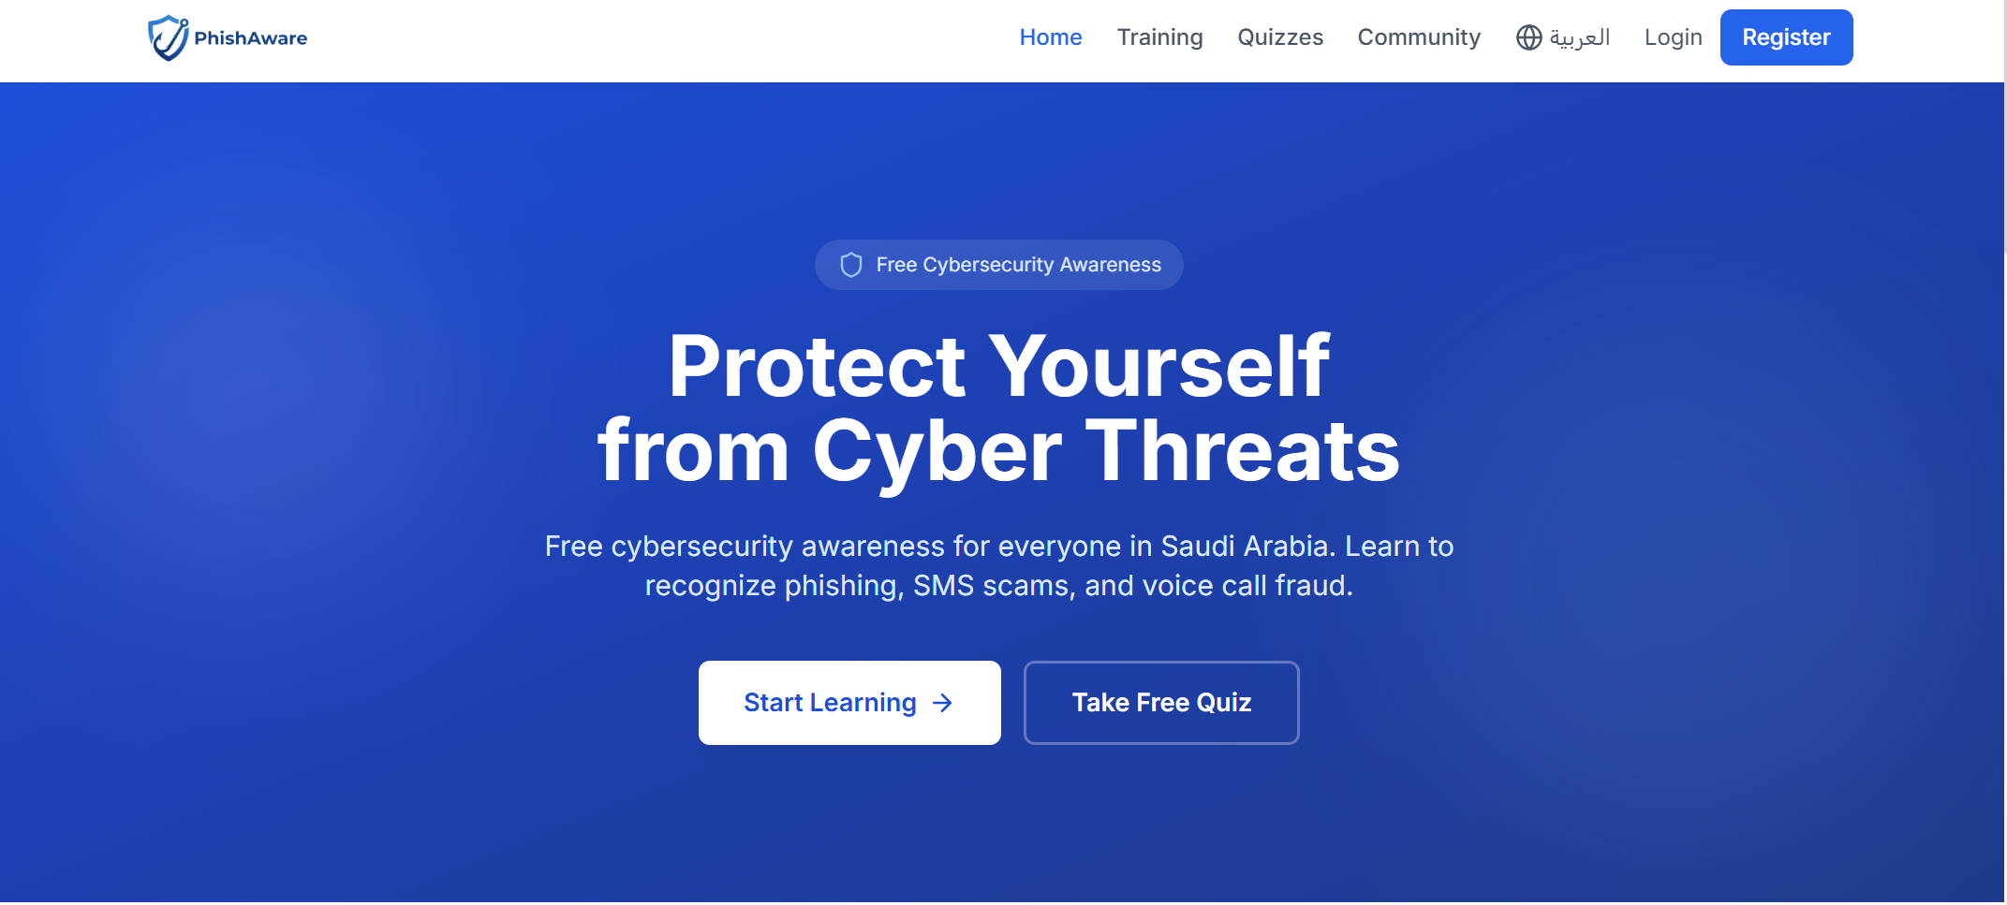
Fig. 0. Public homepage hero section with headline "Protect Yourself from Cyber Threats", tagline, and dual CTA buttons (Start Learning, Take Free Quiz).
The "Learn About Cyber Threats" section (Fig. 44) presents three topic cards—Email (blue), SMS (green), and Voice (purple)—each with Saudi-specific examples and descriptions. These cards link to detailed topic training pages. A statistics banner (Fig. 45) displays platform adoption metrics: 500+ Companies Protected, 50K+ Employees Trained, 95% Threat Detection rate, and 60% Risk Reduction.
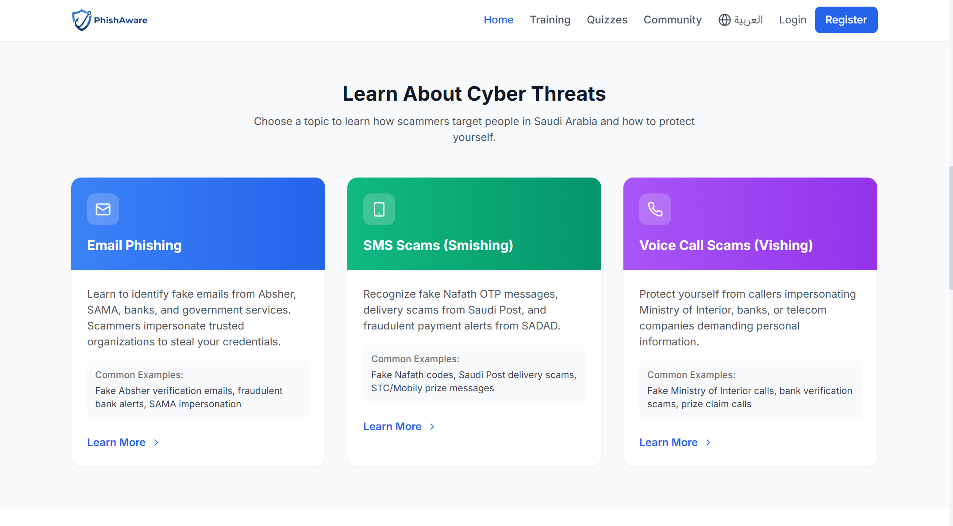
Fig. 0. Public homepage "Learn About Cyber Threats" section featuring 3 topic cards (Email in blue, SMS in green, Voice in purple) with Saudi-specific examples.
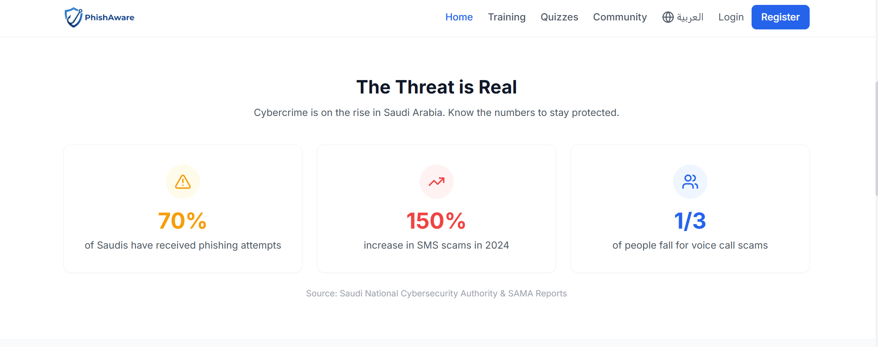
Fig. 0. Public homepage statistics banner displaying platform adoption metrics and success indicators.
Public Training Content
The TrainingTopics page (Fig. 46) displays three training module cards with descriptions and "Learn More" action buttons. The page supports complete RTL transformation for Arabic (Fig. 47), demonstrating the platform's bilingual commitment with identical content structure and mirrored layout. Each topic links to a detailed TopicTraining page with expanded educational content.
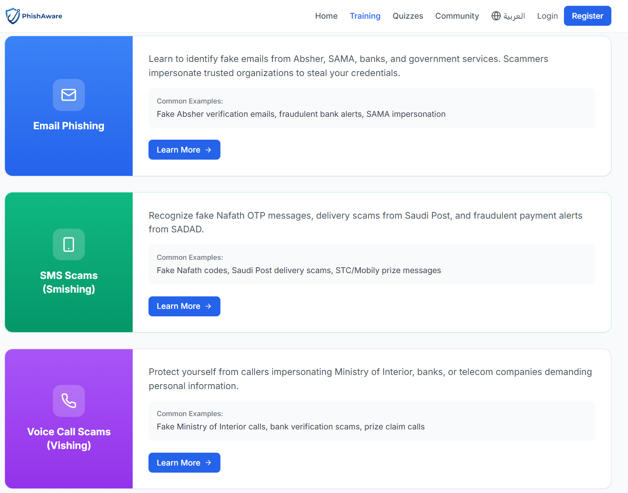
Fig. 0. Public training page in English showing 3 training module cards with descriptions and "Learn More" action buttons.
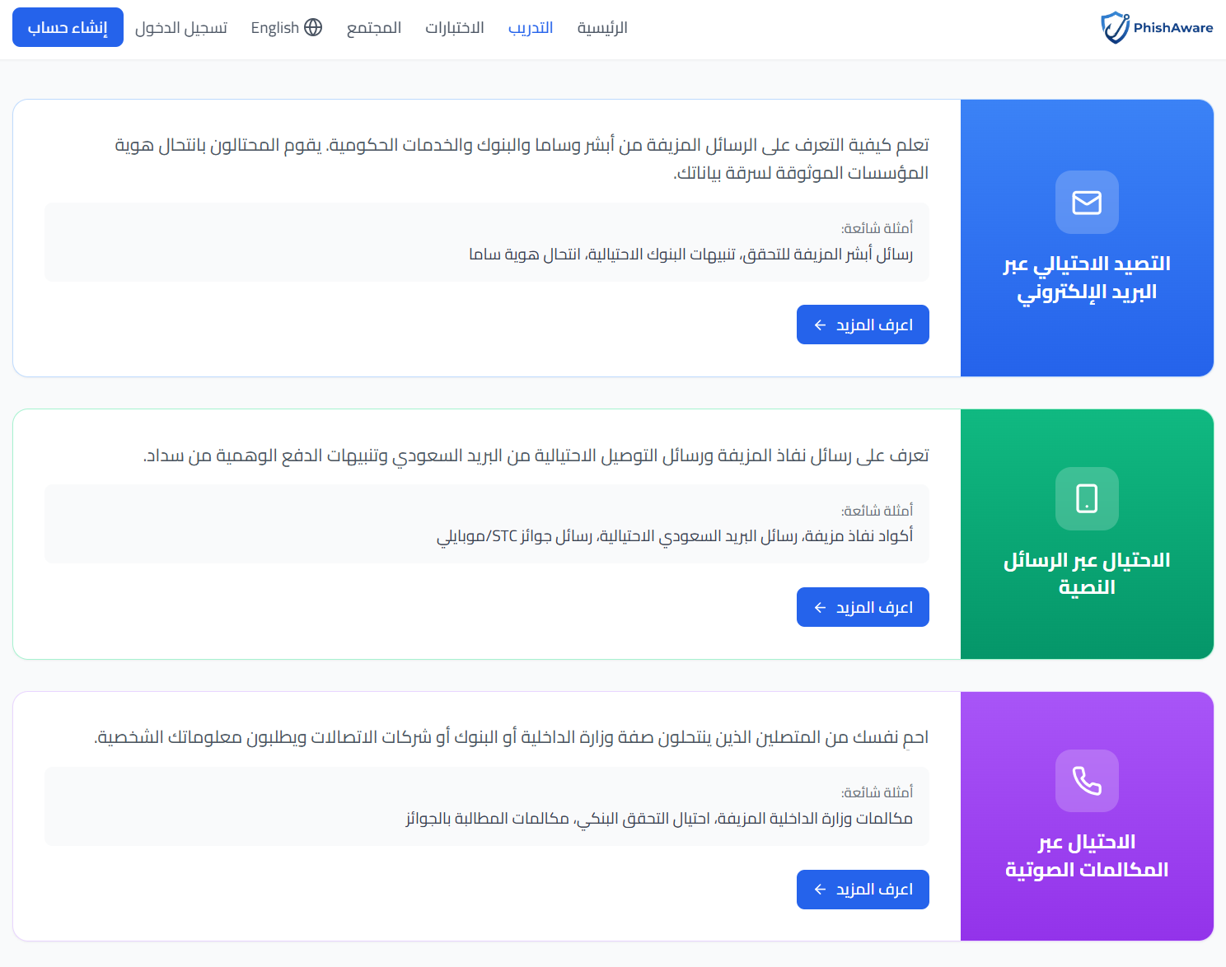
Fig. 0. Public training page in Arabic displaying identical content with complete RTL layout and Arabic text.

2) Public Quizzes & Final UI/UX Polish
The public quiz system provides free, anonymous cybersecurity knowledge assessments that serve dual purposes: educating visitors about common threats and demonstrating the platform's value proposition to potential customers. The design system establishes visual consistency across all platform interfaces through a defined color palette, typography standards, and responsive design patterns.
Public Quiz Interface
The PublicQuiz page (Fig. 48) presents a "Test Your Knowledge" section with three quiz options: Email Phishing (10 questions), SMS Scams (10 questions), and Voice Scams (10 questions), all marked as Beginner difficulty. The quiz question interface (Fig. 49) displays multiple choice options with a progress bar indicator and "Submit Answer" button. Quiz attempts are tracked anonymously using session IDs, and the results page (Fig. 50) shows the achieved score, category performance breakdown, and a registration call-to-action encouraging visitors to sign up for full platform access.
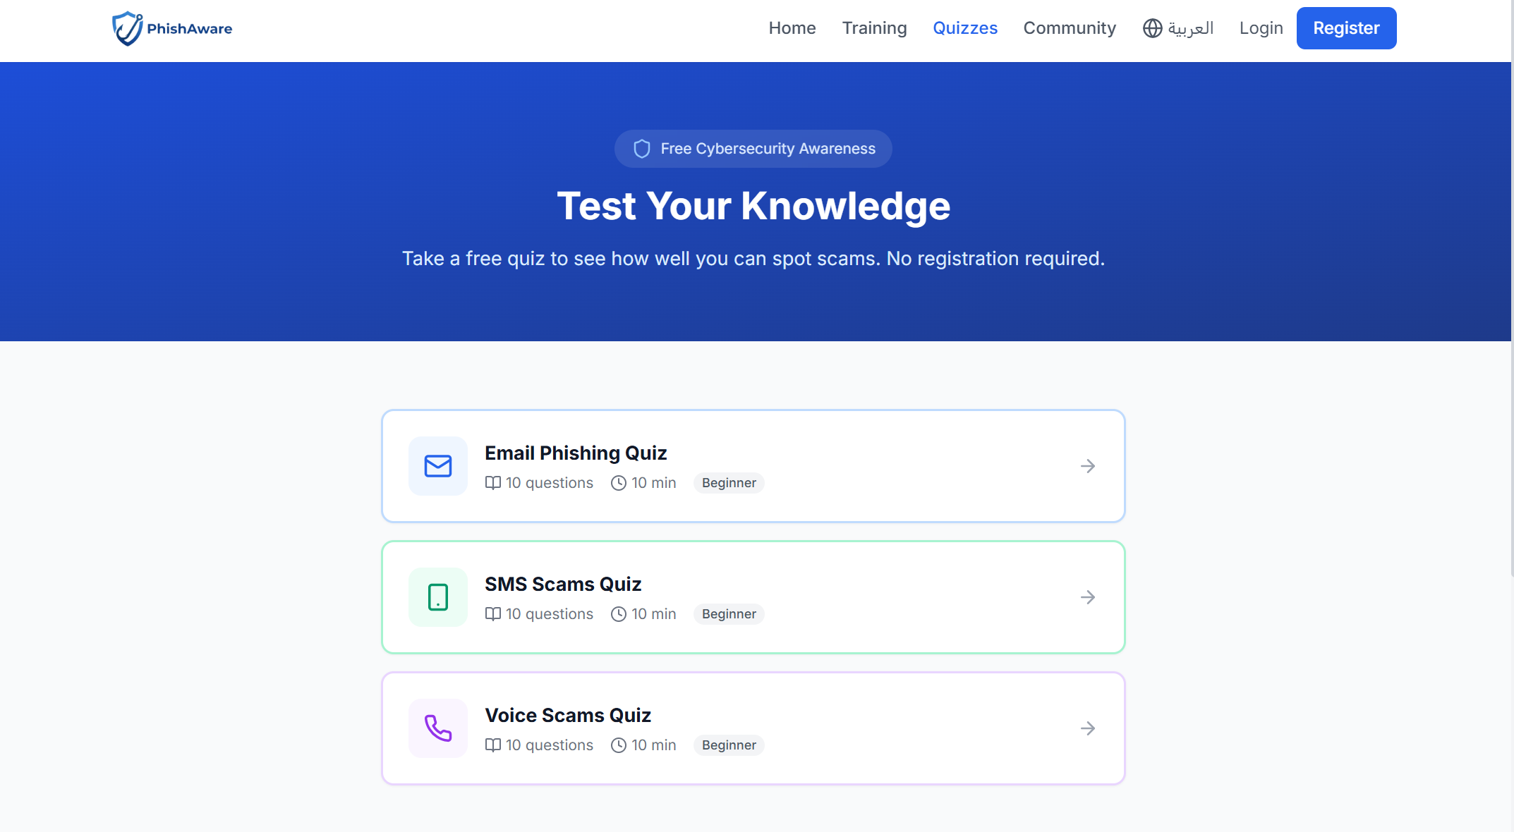
Fig. 0. Public quiz landing page "Test Your Knowledge" section with 3 quiz options: Email Phishing (10 questions), SMS Scams (10 questions), and Voice Scams (10 questions), all marked as Beginner difficulty.
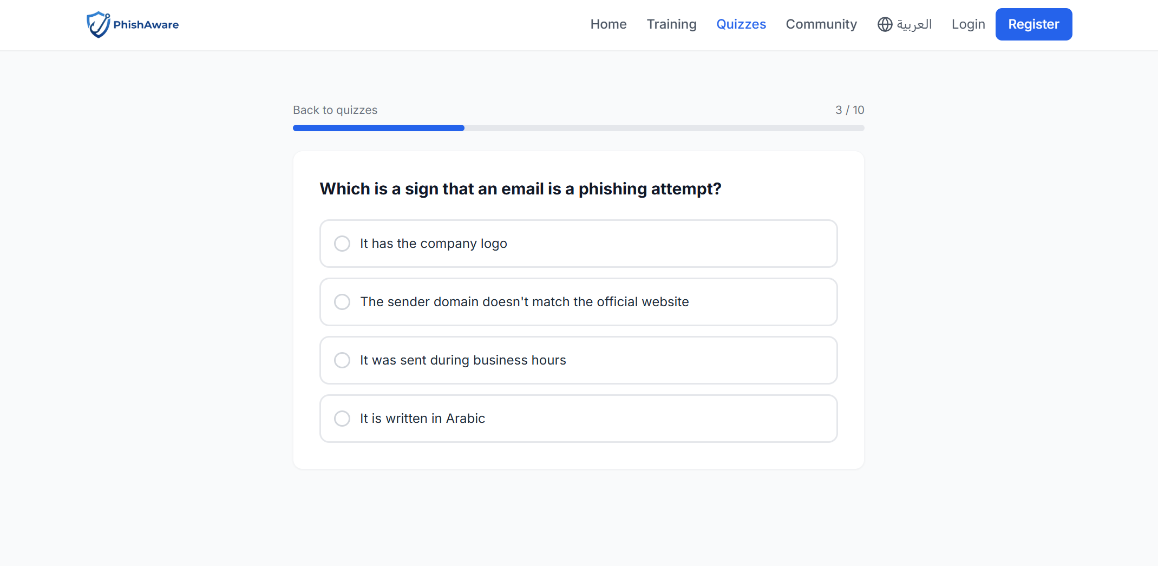
Fig. 0. Public quiz question interface with multiple choice options, progress bar indicator, and Submit Answer button.
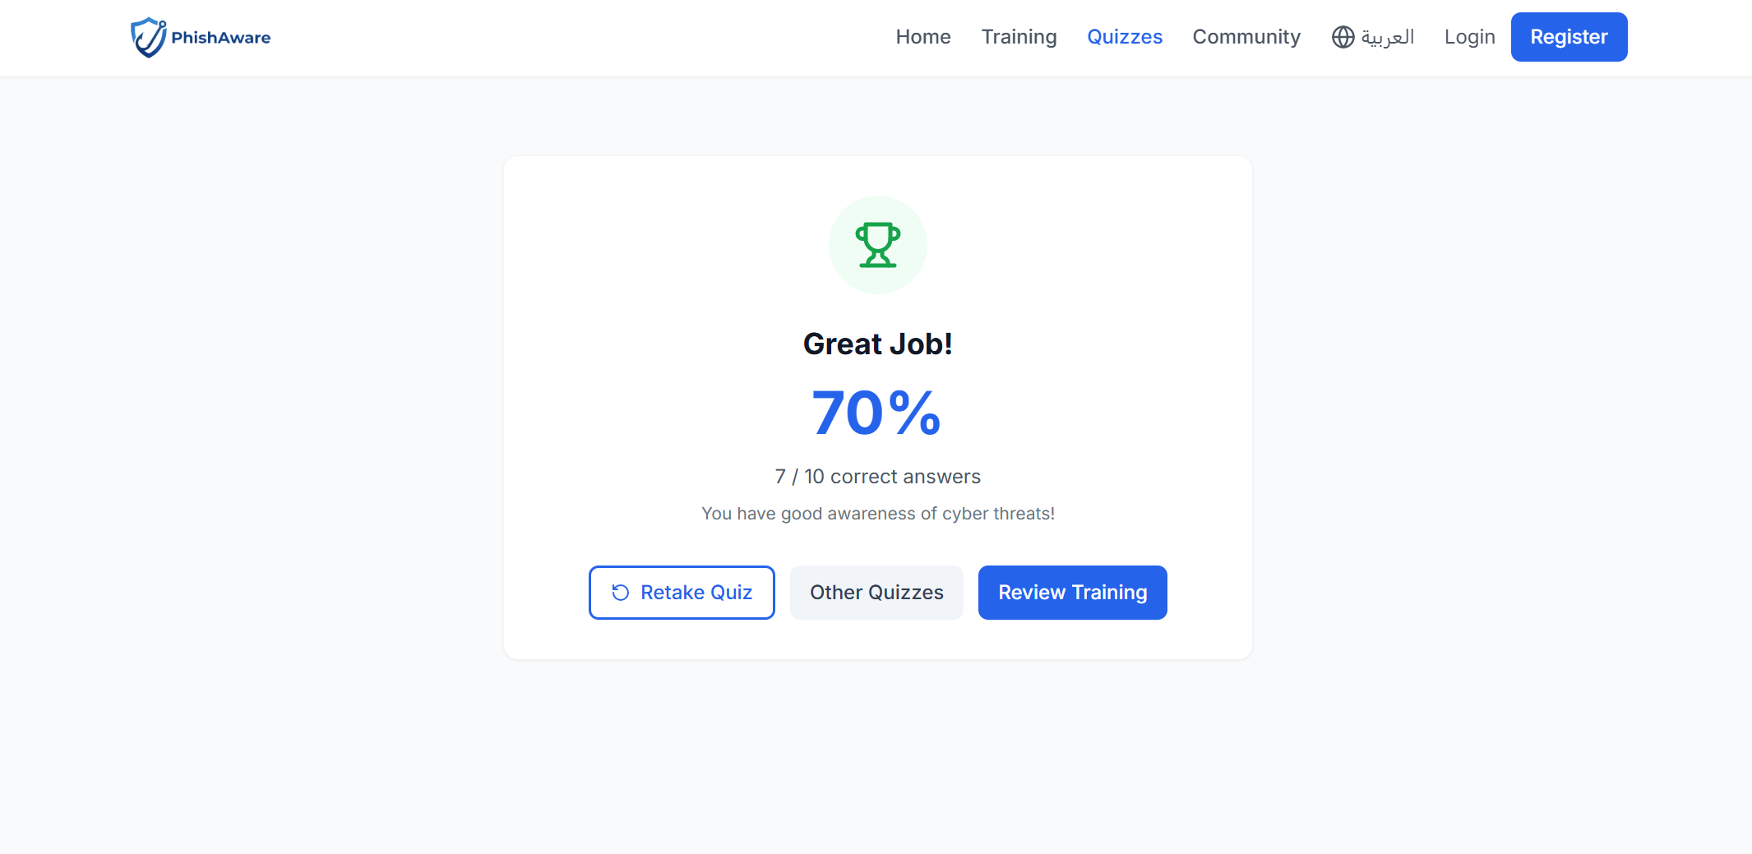
Fig. 0. Public quiz results page showing achieved score, category performance breakdown, and registration call-to-action for full platform access.
Design System
The PhishAware design system (Fig. 1) establishes a consistent visual language across the platform through a defined color palette with 10 color swatches including primary blues, success greens, warning ambers, and danger reds, each with hex codes and usage labels. The PhishAware logo (Fig. 2) features a shield icon symbolizing security protection, paired with the wordmark in the navigation bar.
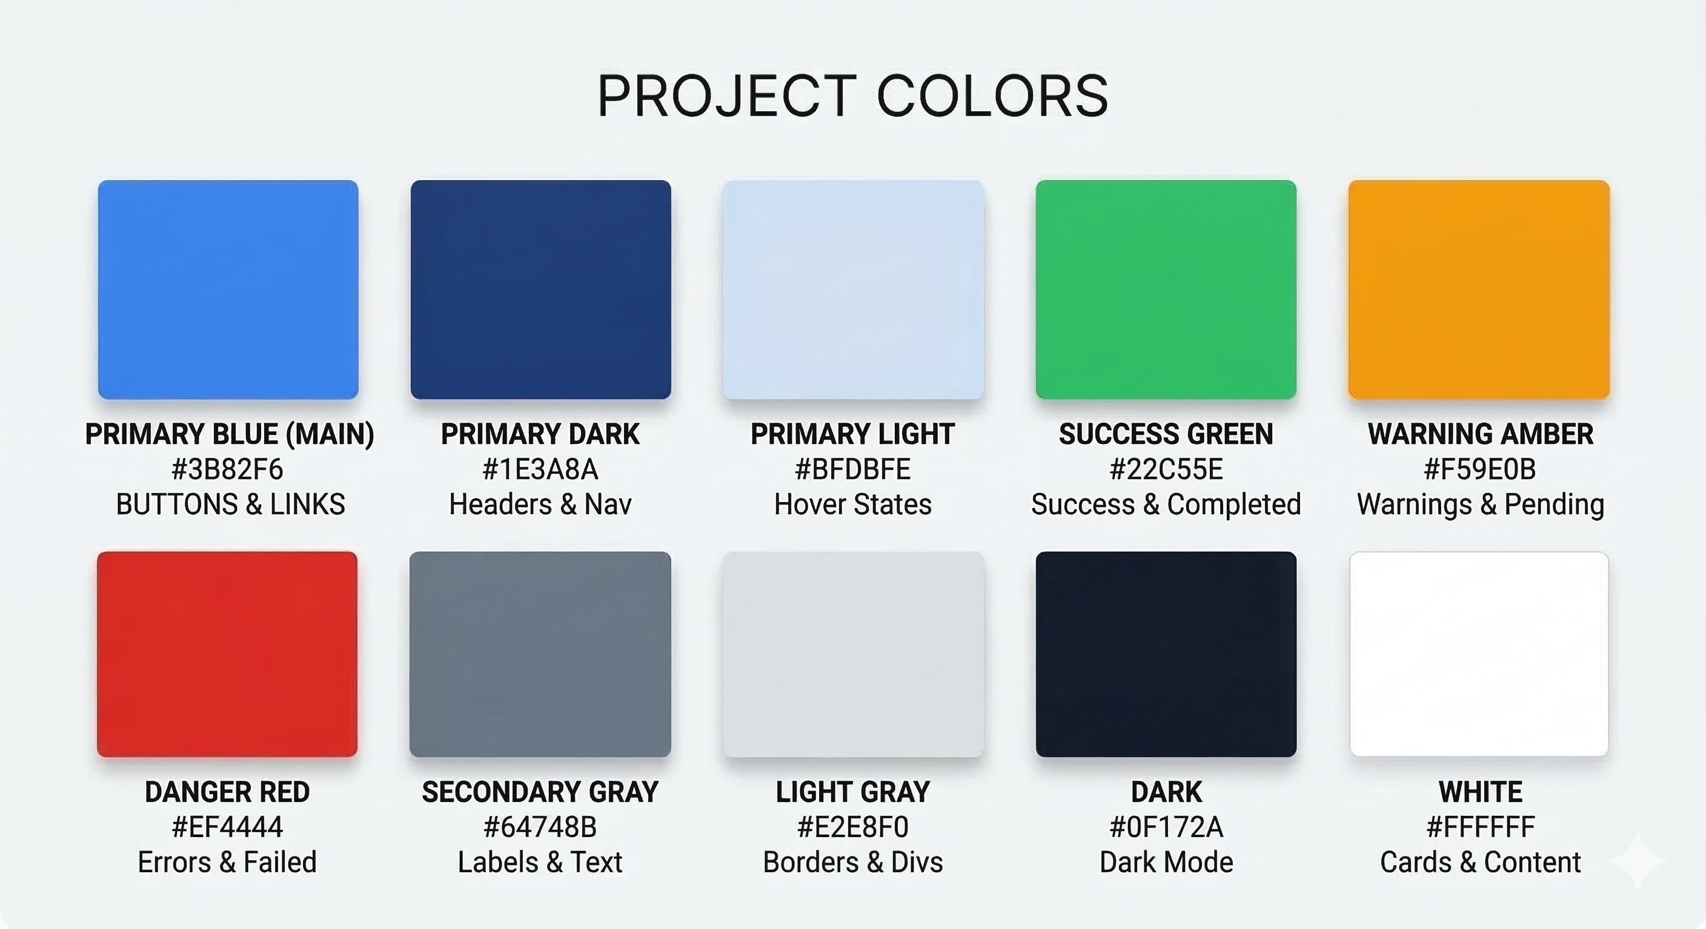
Fig. 0. Color palette showing 10 color swatches with hex codes and usage labels for PhishAware platform design system.

Fig. 0. PhishAware logo featuring shield icon with wordmark displayed in the navigation bar.
Responsive Design
The application implements responsive design using Tailwind CSS breakpoints (sm: 640px, md: 768px, lg: 1024px, xl: 1280px). Mobile layouts use stacked vertical arrangements with hamburger menu navigation, while desktop layouts utilize multi-column grids. The DashboardLayout switches from a fixed sidebar (desktop) to an overlay sidebar (mobile). All tables convert to card-based layouts on small screens, ensuring data readability. The public landing page adjusts hero text sizing, feature grids collapse from 4 columns to 1, and statistics reflow from horizontal to vertical alignment.
Accessibility and UX Patterns
The platform implements several UX best practices: toast notifications for immediate feedback on actions (react-hot-toast with top-right positioning and 4-second duration), loading spinners during async operations, empty states with descriptive text and action suggestions, confirmation dialogs for destructive operations (delete, cancel), form validation with inline error messages, and optimistic UI updates where appropriate. Charts use the Recharts library with responsive containers that adapt to available width.

REFERENCES
[1] Django Software Foundation, "Django documentation," 2024. [Online]. Available: https://docs.djangoproject.com/
[2] T. Christie, "Django REST framework," 2024. [Online]. Available: https://www.django-rest-framework.org/
[3] Meta Platforms, "React documentation," 2024. [Online]. Available: https://react.dev/
[4] E. You, "Vite: Next generation frontend tooling," 2024. [Online]. Available: https://vitejs.dev/
[5] J. Müller, "i18next internationalization framework," 2024. [Online]. Available: https://www.i18next.com/
[6] Tailwind Labs, "Tailwind CSS documentation," 2024. [Online]. Available: https://tailwindcss.com/
[7] S. Canny, "python-docx library documentation," 2024. [Online]. Available: https://python-docx.readthedocs.io/
[8] D. Arias, "djangorestframework-simplejwt," 2024. [Online]. Available: https://django-rest-framework-simplejwt.readthedocs.io/
[9] SendGrid, "SendGrid SMTP relay documentation," 2024. [Online]. Available: https://docs.sendgrid.com/
[10] Anti-Phishing Working Group, "Phishing activity trends report," APWG, 2024.
[11] Saudi National Cybersecurity Authority, "National Cybersecurity Strategy," NCA, 2023.
[12] SANS Institute, "Security awareness training best practices," SANS, 2024.
[13] Recharts Contributors, "Recharts composable chart library," 2024. [Online]. Available: https://recharts.org/
[14] Lucide Contributors, "Lucide icon library," 2024. [Online]. Available: https://lucide.dev/
[15] OWASP Foundation, "OWASP Top Ten," 2021. [Online]. Available: https://owasp.org/www-project-top-ten/

APPENDICES

A. Complete API Endpoint Reference
The following table lists all API endpoints available in the PhishAware platform organized by application module:
TABLE 0: Complete API Endpoint Reference
Endpoint | Auth | Description
POST /api/v1/auth/register/ | None | User registration
POST /api/v1/auth/login/ | None | JWT login
POST /api/v1/auth/logout/ | JWT | Token blacklisting
POST /api/v1/auth/token/refresh/ | None | Refresh access token
POST /api/v1/auth/verify-email/<token>/ | None | Email verification
POST /api/v1/auth/resend-verification/ | None | Resend verification
POST /api/v1/auth/password-reset/ | None | Request password reset
POST /api/v1/auth/password-reset/<token>/ | None | Reset password
GET/PATCH /api/v1/auth/profile/ | JWT | User profile
POST /api/v1/auth/change-password/ | JWT | Change password
POST /api/v1/employees/invite/ | Admin | Invite employee
GET /api/v1/employees/invite/<token>/ | None | Invitation details
POST /api/v1/employees/invite/<token>/accept/ | None | Accept invitation
GET /api/v1/companies/ | JWT | List companies
POST /api/v1/companies/ | SuperAdmin | Create company
GET /api/v1/companies/{id}/stats/ | JWT | Company statistics
GET /api/v1/campaigns/campaigns/ | JWT | List campaigns
POST /api/v1/campaigns/campaigns/ | Admin | Create campaign
POST /api/v1/campaigns/quizzes/{id}/start/ | JWT | Start quiz
POST /api/v1/campaigns/quizzes/{id}/submit/ | JWT | Submit quiz
GET /api/v1/simulations/templates/ | JWT | List templates
POST /api/v1/simulations/campaigns/{id}/send/ | Admin | Send simulation
GET /api/v1/simulations/link/{token}/ | None | Track link click
GET /api/v1/simulations/feedback/{token}/ | None | Simulation feedback
GET /api/v1/training/modules/ | JWT | List training modules
POST /api/v1/training/assignments/bulk_assign/ | Admin | Bulk assign training
GET /api/v1/training/risk-scores/my_score/ | JWT | My risk score
GET /api/v1/gamification/badges/my_badges/ | JWT | My badges
GET /api/v1/gamification/leaderboard/ | JWT | Leaderboard
GET /api/v1/analytics/dashboard/overview/ | Admin | Dashboard stats
POST /api/v1/analytics/export/csv/ | Admin | Export CSV
GET /api/v1/community/articles/ | None | Public articles
GET /api/v1/community/quizzes/ | None | Public quizzes
GET /api/v1/notifications/ | JWT | User notifications

B. Database Model Summary
Total models across all applications:
TABLE 0: Database Model Summary by Application
Application | Model Count | Models
accounts | 1 | User
companies | 1 | Company
campaigns | 3 | Campaign, Quiz, QuizResult
assessments | 2 | EmailTemplate, QuizQuestion
simulations | 4 | SimulationTemplate, SimulationCampaign, EmailSimulation, TrackingEvent
training | 6 | RiskScore, RiskScoreHistory, TrainingModule, TrainingQuestion, RemediationTraining, InteractiveLessonProgress
gamification | 4 | Badge, EmployeeBadge, PointsTransaction, EmployeePoints
community | 6 | ArticleCategory, Article, PublicQuiz, PublicQuizQuestion, PublicQuizAttempt, Resource
notifications | 1 | Notification
Total | 28

C. Frontend Component Summary
TABLE 0: Frontend Component Summary
Section | Page Count | Key Components
Authentication | 7 | Login, Register, Verify Email, Accept Invitation, Forgot/Reset Password
Employee Portal | 8 | Dashboard, Quizzes, Training, Badges, Leaderboard, Profile, TakeQuiz, TakeTraining
Company Admin | 10 | Dashboard, Campaigns, Simulations, Employees, Analytics, Training, Profile
Super Admin | 5 | Dashboard, Companies, Analytics, Users, Profile
Public Portal | 10 | Landing, Training Topics, Quiz, Community, SimulationCaught, Error Pages
Total | 43 pages | Plus layouts, common components, and 12 interactive modules

