CS4033 DATA WAREHOUSING PROJECT

Building and Analyzing Data Warehouse Prototype for METRO Shopping Store

TALAL ZAFAR 18I-0497 (A)

Project Overview

The aim of the project was to design, implement, and analyze a Data Warehouse (DW) prototype for METRO shopping store in Pakistan so that we make analysis of shopping behavior, optimize selling techniques etc. We had to build the warehouse with the data source which we were given. For this we implemented a real time ETL (Extraction, Transformation, and Loading) because the warehouse schema is different from database. We implemented the Mesh Join algorithm for integrating the transactional data with master data before loading into warehouse. After building the warehouse I analyzed the DW by applying OLAP queries.

Schema for Data Warehouse

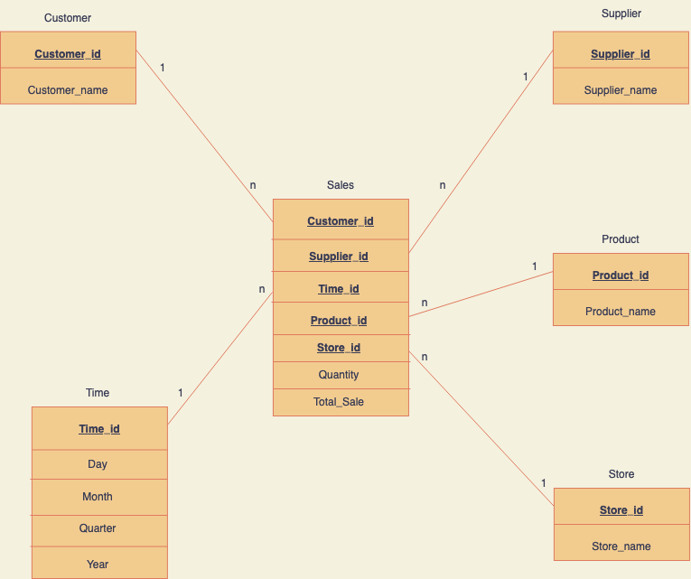

Mesh join Algorithm:

Start

While (reading_data or Queue_not_empty)

stream_buffer = load partition from Transactional table

Queue = insert(50) , hash_table = insert (key,tuple)

disk_buffer = load next partition from Master table

for i in disk_buffer

if (hash_table contains)

DW_tuple = join(i,hash_table(key))

load_into_DW(DW_tuple)

if (Queue.size == partition.size)

Queue.poll()

hash_table.remove()

end

OLAP QUERIES:

**-- 1ST QUERY**

SELECT SUPPLIER_ID, QUARTER, MONTH, ROUND(SUM(TOTAL_SALE),2) AS TOTAL_SALES

FROM SALES

INNER JOIN TIME

USING (TIME_ID)

GROUP BY SUPPLIER_ID, QUARTER, MONTH

ORDER BY SUPPLIER_ID;

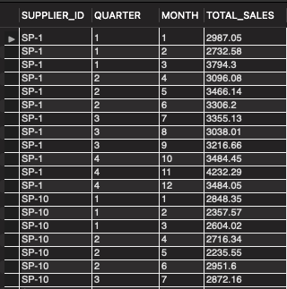

**-- 2ND QUERY**

SELECT STORE_ID, PRODUCT_ID, ROUND(SUM(TOTAL_SALE),2) AS TOTAL_SALES

FROM SALES

GROUP BY STORE_ID, PRODUCT_ID

ORDER BY STORE_ID;

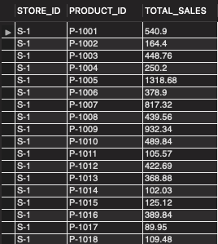

**-- 3RD QUERY**

SELECT PRODUCT_ID, SUM(QUANTITY) AS QUANTITY

FROM SALES

INNER JOIN TIME

USING (TIME_ID)

WHERE dayname(TIME_ID) like 'Saturday' or dayname(TIME_ID) like 'Sunday'

GROUP BY PRODUCT_ID

ORDER BY QUANTITY DESC

LIMIT 5;

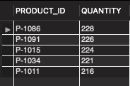

**-- 4TH QUERY**

SELECT PRODUCT_ID,

ROUND (SUM (CASE WHEN QUARTER =1 THEN TOTAL_SALE END),2) AS 1st_QUARTER,

ROUND (SUM (CASE WHEN QUARTER =2 THEN TOTAL_SALE END),2) AS 2nd_QUARTER,

ROUND (SUM (CASE WHEN QUARTER =3 THEN TOTAL_SALE END),2) AS 3rd_QUARTER,

ROUND (SUM (CASE WHEN QUARTER =4 THEN TOTAL_SALE END),2) AS 4th_QUARTER,

ROUND (SUM (CASE WHEN QUARTER <=4 THEN TOTAL_SALE END),2) AS TOTAL_SALES

FROM SALES

INNER JOIN TIME

USING (TIME_ID)

WHERE YEAR =2016

GROUP BY PRODUCT_ID

ORDER BY PRODUCT_ID;

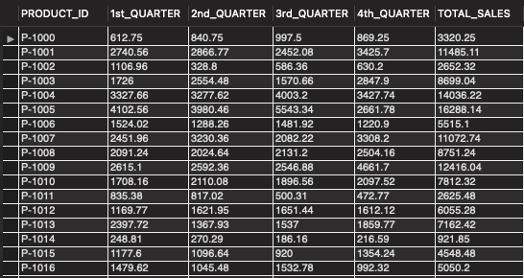

**-- 5TH QUERY**

SELECT PRODUCT_ID, ROUND (SUM (CASE WHEN QUARTER <=2 THEN TOTAL_SALE END),2) AS FIRST_HALF_SALE,

ROUND (SUM (CASE WHEN QUARTER >2 THEN TOTAL_SALE END),2) AS SECOND_HALF_SALE,

ROUND (SUM (CASE WHEN QUARTER <=4 THEN TOTAL_SALE END),2) AS YEARLY_SALE

FROM SALES

INNER JOIN TIME

USING (TIME_ID)

WHERE YEAR =2016

GROUP BY PRODUCT_ID

ORDER BY PRODUCT_ID;

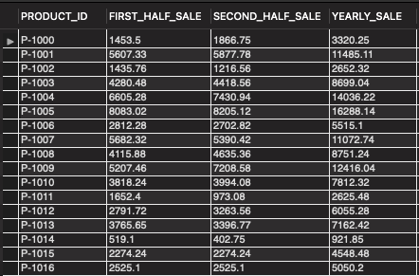

**-- 6TH QUERY**

SELECT DISTINCT(PRODUCT_ID), PRODUCT_NAME, PRICE, SUPPLIER_ID

FROM TRANSACTIONS

inner join MASTERDATA

using (PRODUCT_ID)

where PRODUCT_NAME= 'Tomatoes';

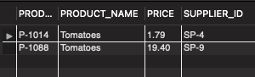

Anomaly:

The product “Tomatoes” has two different suppliers with different price so we have two different product ids for the same product which makes “Tomatoes” difficult to analyze.

**-- 7TH QUERY**

CREATE OR REPLACE VIEW STOREANALYSIS_MV AS

SELECT STORE_ID, PRODUCT_ID, ROUND(SUM(TOTAL_SALE),2) AS STORE_TOTAL

FROM SALES

GROUP BY STORE_ID, PRODUCT_ID

ORDER BY STORE_ID;

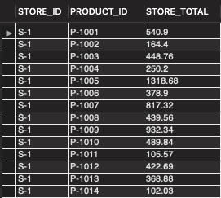

Shortcomings in Mesh Join:

1. Stream buffer can create a bottleneck as its size is fixed. It can overflow if we consider a stream of data coming.
2. When multiple partition of queue has same join id in hash table it becomes a challenge to differentiate between there tuples in the hash table when we are removing the tuple.
3. The no of partitions of master data should be equal to the partitions of the queue which has to be predefined which creates an overhead.
4. The time for one partition of transactional data to join with all of the master data is large.

What I learned:

I learned the following things through this project:

1. How to perform ETL process
2. Understanding and implementing Mesh Join algorithm
3. Building warehouse schema and loading data into warehouse
4. Analyzing data warehouse through OLAP queries