Talal Kerbag

9/24/2018

Web Apps Homework 4

For each type of errors, write what its type, copy and paste the exact error message you got and describe how or where you would normally expect to fix the problem

**The type of error: Missing database Driver**

**Image:**

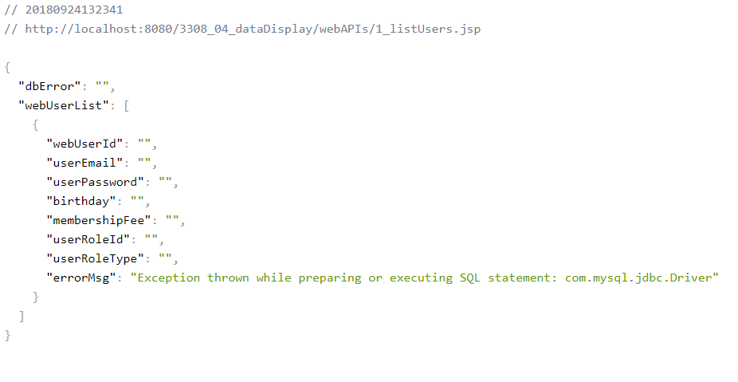

**Describe how you would fix this error**

* You will need to download and add my-sql jar file to the project library.

**The type of error: Database unreachable**

**Image**

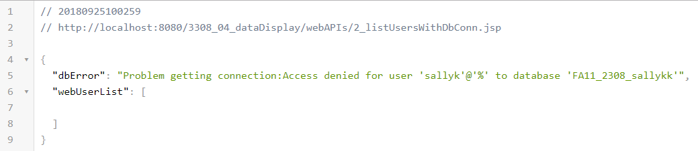

**Describe how you would fix this error**

* Check your database connect file and make sure that the database credentials string is correct. (Correct Database name and Password)

**The type of error: Database Not Authorized**

**Image:** 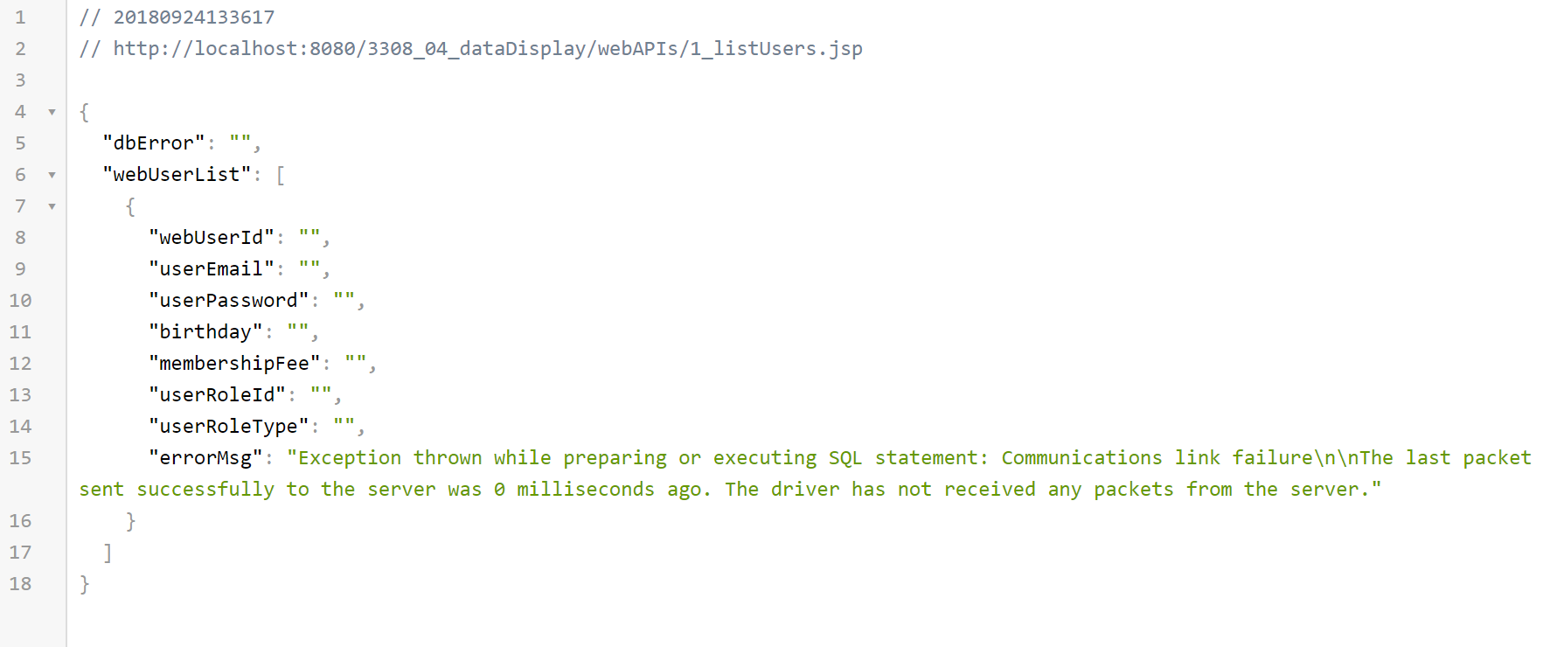

**Describe how you would fix this error**

* Trying to access a database with private permissions or server is not accessible. Try tunneling into the temple server.

**The type of error: Syntax error in Sql statment**

**Image:**



**Describe how you would fix this error**

* In your sql string where you try to formulate a sql command, check for misspelled tables or commands. If no word is misspelled then check your database tables and make sure they have correct names.

**The type of error: Error Extracting Data from Result set (bad column name)**

**Image:**

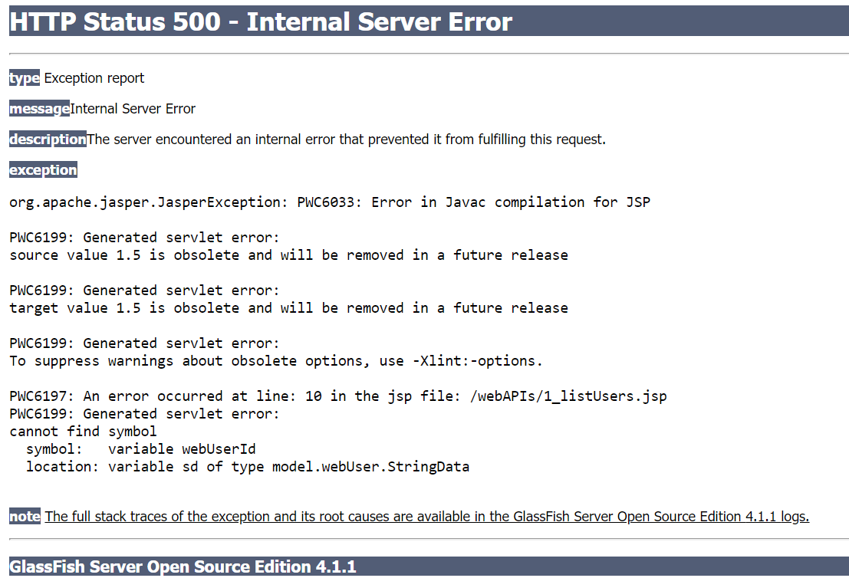

**Describe how you would fix this error**

* Data is extracted from the SQL result set in one of the constructors of your string data class. In this constructor, you could misspell a column name. Which will result in this server error.

**The type of error: Error Extracting Data from result set (wrong data type)**

**Image:**

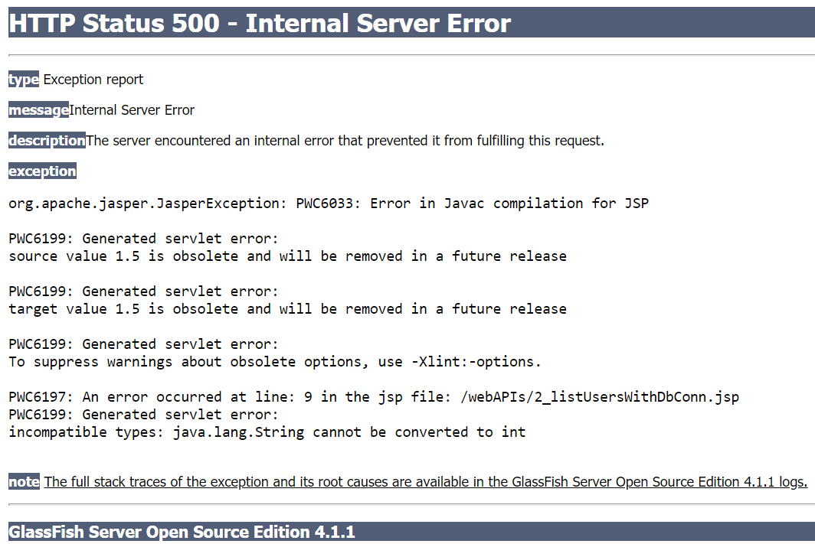

**Describe how you would fix this error**

* Data is extracted from the SQL result set in one of the constructors of your string data class. In this constructor, check to see if the data type is the same as you data model in the database.