Talal Kerbag

8/31/2018

Homework 1

ITIL Known Error Database

|  |  |  |  |  |  |
| --- | --- | --- | --- | --- | --- |
| What is the topic of the web app? | Who are the users that contribute content | What “other table” do your users interact with | What do users contribute to the database? | What can viewers of the site do? | Why is this a many-to-many relationship |
| ITIL Known Error Database | IT professionals | Problem table | Solutions | Viewers can search for problems and see their solutions | An IT professional can create many Problems. A Problem can be solved by many IT professionals |

1. **What is the title of your web application?**

ITIL Known Error Database

1. **Who will be the users of your web application?**
   * **What attribute will you store for each of the users?**

* Users are IT professionals. Their attributes will be:
  + Web User Id (AI)
  + First name
  + Last name
  + Email
  + Password
  + Problem Id
  + User role id
  + Date created
  + company

1. **What “other” table will be part of your database?**
   * **What attribute will be stored for each record of this table?**

* The other table will be the problem table. Its attributes will be:
  + problem Id
  + Date discovered
  + Title
  + Description
  + Solution

1. **What information will be stored in your associative table (the table that implements a “many-to-many” relationship between your “other table” and your user table)?**

* The associative table will be the solution. The table will store:
  + Solution Id
  + Web User Id
  + Problem id
  + Image URL
  + Viewer rating

1. **Explain how there is a many-to-many relationship between your user table and your “other” table.**

An IT professional can create many Problems. A Problem can be solved by many IT professionals.

1. **What functionality will your web application provide? Your application will provide the following at a very “mechanical” level, but functionally, how will users benefit from your web app?**
   * IT professional will be able to register, log on, and log off.
   * IT professional will be able to create problems or solve existing ones.
   * IT professional will be able to edit or delete problems that they have created.
   * Admin will be able to insert (edit/delete) associative records.
   * Guest will be able to view problems.
2. **Write 1-2 paragraphs of “Marketing material” that attempts to entice people to become registered users and/or viewers of your website. This will become the basis of the content area of your home page. In your paragraphs, do not explain to me what your web site will be able to do, write text that will entice users to visit your site.**

In the information technology infrastructure library there is a volume that speaks very highly of the importance of having a known Error Database in any IT department. One of the main and most important reason for having a KEDB implemented into your business is its downtime reduction capability; if an incident is already reported, a user does not have to wait long for a response from the help desk because a workaround likely already exists.

Furthermore, when a workaround already exists, visiting users will not have to troubleshoot on their own. When user is troubleshooting without the help of IT, the user’s productive worktime decreases significantly. This also helps the user use their own skills for their own work.

**Data Model**

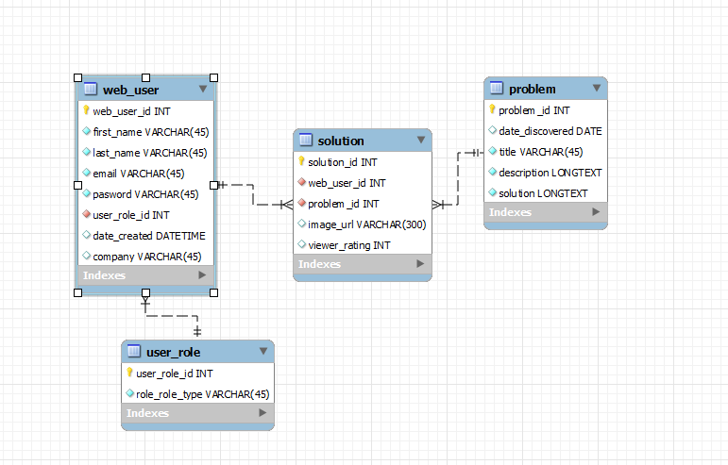

**Web User Table**

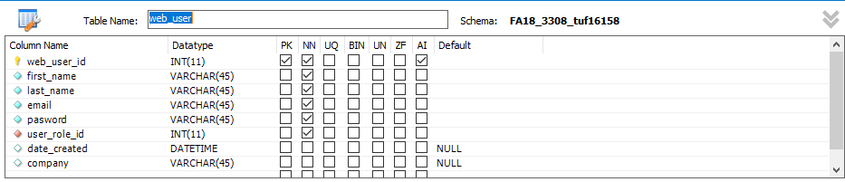

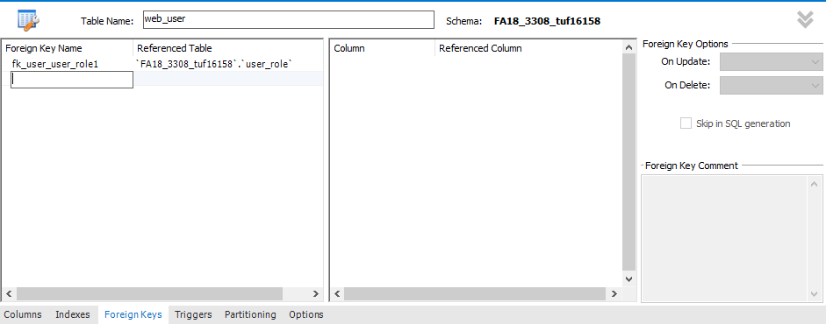

**Solution Table**

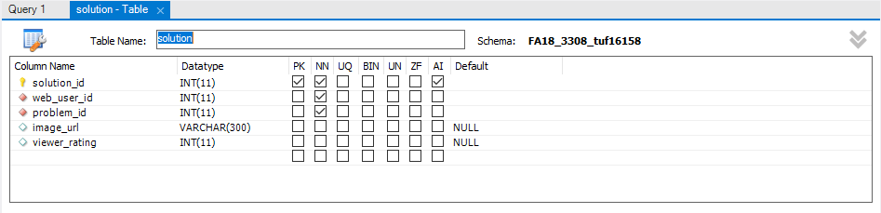

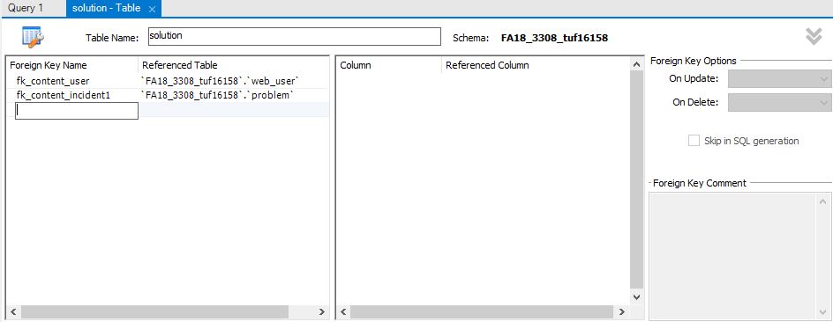

**Problem Table**

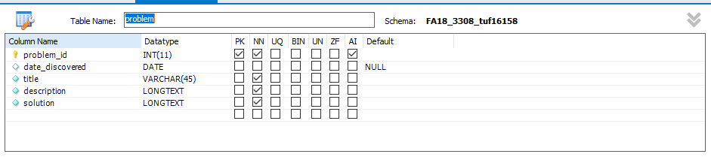

**User Role Table**

