TALAL MAHMUD

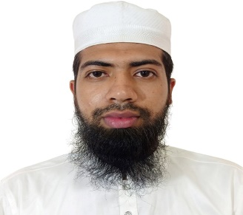

**PROFILE**

**EDUCATIONS**

2017-2022 Bachelor of Computer Science and Engineering

Bachelor of Computer Science & Engineering, Gazipur

CGPA-out of

2012-2016 Diploma in Electronics Technology

Dhaka Ploytechnic Institute

CGPA: out of

2011 Secondary School Certificate

Kohinur Boys High School

GPA: out of

**PROJECTS**

Project-1 Portfolio

HTML, CSS, JavaScript, Bootstrap, Django

Project-2 Student Management System

HTML, CSS, JavaScript, Bootstrap, Django

Project-3 Customer Relational Model(CRM)

HTML, CSS, JavaScript, Bootstrap, Django

**REFERENCES**

Dr. Rafiqul Islam

Professor

Department of Computer Science and Engineering

Bachelor of Computer Science & Engineering, Gazipur

**CONTACTS**

Chandona, Chowrasta, Gazipur

Phone: +88 01795257742

E-mail: [mahmudtalal2@gmail.com](mailto:mahmudtalal2@gmail.com)

**LANGUAGES**

* Bangali – Mother Tongue
* English – Good Command over reading, writing, listening and speaking

**SKILLS**

* C++
* C#
* Python
* Django
* HTML
* CSS
* JavaScript
* Bootstrap
* MySql
* PostgreSql

**PERSONAL DETAILS**

Father: Taz Uddin

Mother: Aklima

Religion: Islam

Date of birth: 08-04