**Babanov Ilhom Baxtiyor o’g’li**

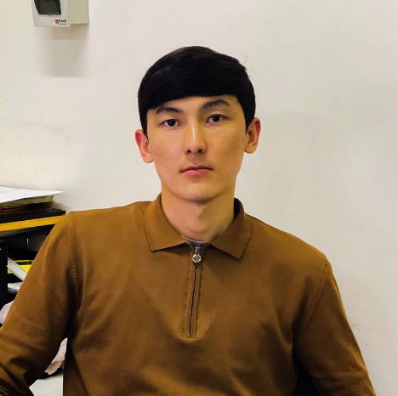Summary

2022 yil TATU dasturiy injeniring fakultetini bitirdim PDP da web frontend kursini yakunladim dasturlashga qiziqishim yaxshi bilmaganlarimni tez urgana olaman internetdan kerakli malumotlarni topa olaman hozirda Everestda English kursiga borayapman darajam elementary

Contact

**Address:**

Uzbekistan, Toshkent Shahar chilonzor , katta olmazor MCG 16/1 dom 15-xonadon

**Mobile:**

+998 99 3046599

**Telegram:**

+998 99 3046599 @ilhombabanov

**Email:** [ilhombabanov20@gmail.com](mailto:ilhombabanov20@gmail.com)

Languages

Key Skills

**HTML,**

**CSS, SASS,**

**Bootstrap, JavaScript, ReactJS,**

**Git,**

**Java,**

**PostgreSQL,**

**Mysql,**

**C++,**

Education

**Universitet**

Toshkent Axborot Texnologiyalari universiteti,

**Frontend web**

PDP Academy,

**English**

EVEREST,

**Finish, 2022**

**2021**

**Tashkent**

**Begin, 2022.11**

**Tashken**

Uzbek

English level Elementary