ShopEZ: E-commerce Application

INTRODUCTION
ShopEZ is your one-stop destination for effortless online shopping. With a user-friendly interface and a comprehensive product catalog, finding the perfect items has never been easier. Seamlessly navigate through detailed product descriptions, customer reviews, and available discounts to make informed decisions. Enjoy a secure checkout process and receive instant order confirmation. For sellers, our robust dashboard provides efficient order management and insightful analytics to drive business growth. Experience the future of online shopping with ShopEZ today.
Seamless Checkout Process Effortless Product Discovery Personalized Shopping Experience
Efficient Order Management for Sellers Insightful Analytics for Business Growth

Scenario: Sarah's Birthday Gift

Sarah, a busy professional, is scrambling to find the perfect birthday gift for her best friend, Emily. She knows Emily loves fashion accessories, but with her hectic schedule, she hasn't had time to browse through multiple websites to find the ideal present.
Feeling overwhelmed, Sarah turns to ShopEZ to simplify her search.
- Effortless Product Discovery: Sarah opens ShopEZ and navigates to the fashion accessories category. She's greeted with a diverse range of options, from chic handbags to elegant jewelry. Using the filtering options, Sarah selects "bracelets" and refines her search based on Emily's preferred style and budget.

- Personalized Recommendations: As Sarah scrolls through the curated selection of bracelets, she notices a section labeled "Recommended for You." Intrigued, she clicks on it and discovers a stunning gold bangle that perfectly matches Emily's taste. Impressed by the personalized recommendation, Sarah adds it to her cart.

- Seamless Checkout Process: With the bracelet in her cart, Sarah proceeds to checkout. She enters Emily's address as the shipping destination and selects her preferred payment method. Thanks to ShopEZ's secure and efficient checkout process, Sarah completes the transaction in just a few clicks.

- Order Confirmation: Moments after placing her order, Sarah receives a confirmation email from ShopEZ. Relieved to have found the perfect gift for Emily, she eagerly awaits its arrival.

- Efficient Order Management for Sellers: Meanwhile, on the other end, the seller of the gold bangle receives a notification of Sarah's purchase through ShopEZ's seller dashboard. They quickly process the order and prepare it for shipment, confident in ShopEZ's streamlined order management system.

- Celebrating with Confidence: On Emily's birthday, Sarah presents her with the beautifully packaged bracelet, knowing it was chosen with care and thoughtfulness. Emily's eyes light up with joy as she adorns the bracelet, grateful for Sarah's thoughtful gesture.

In this scenario, ShopEZ proves to be the perfect solution for Sarah's busy lifestyle, offering a seamless and personalized shopping experience. From effortless product discovery to secure checkout and efficient order management, ShopEZ simplifies the entire process, allowing Sarah to celebrate Emily's birthday with confidence and ease.

TECHNICAL ARCHITECTURE:

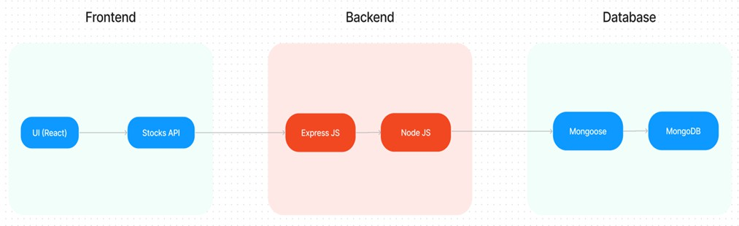
In this architecture diagram:
  - The frontend is represented by the "Frontend" section, including user interface components such as User Authentication, Cart, Products, Profile, Admin dashboard, etc.,
  - The backend is represented by the "Backend" section, consisting of API endpoints for Users, Orders, Products, etc.,It also includes Admin Authentication and an Admin Dashboard.
  - The Database section represents the database that stores collections for

Users, cart, Orders and Product.

ER DIAGRAM:
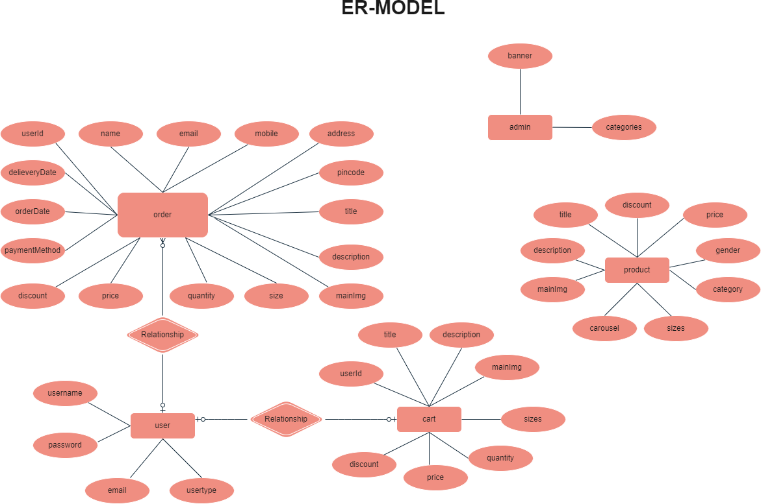

  - The Database section represents the database that stores collections for Users, Admin, Cart, Orders and products

USER: Represents the individuals or entities who are registered in the platform. Admin: Represents a collection with important details such as Banner image and Categories. Products: Represents a collection of all the products available in the platform.
Cart: This collection stores all the products that are added to the cart by users. Here, the elements in the cart are differentiated by the user Id.
Orders: This collection stores all the orders that are made by the users in the platform.

Features:
- Comprehensive Product Catalog: ShopEZ boasts an extensive catalog of products, offering a diverse range of items and options for shoppers. You can effortlessly explore and discover various products, complete with detailed descriptions, customer reviews, pricing, and available discounts, to find the perfect items for your needs.
- Shop Now Button: Each product listing features a convenient "Shop Now" button. When you find a product that aligns with your preferences, simply click on the button to initiate the purchasing process.
- Order Details Page: Upon clicking the "Shop Now" button, you will be directed to an order details page. Here, you can provide relevant information such as your shipping address, preferred payment method, and any specific product requirements.
- Secure and Efficient Checkout Process: ShopEZ guarantees a secure and efficient checkout process. Your personal information will be handled with the utmost security, and we strive to make the purchasing process as swift and trouble-free as

possible.
- Order Confirmation and Details: After successfully placing an order, you will receive a confirmation notification. Subsequently, you will be directed to an order details page, where you can review all pertinent information about your order, including shipping details, payment method, and any specific product requests you specified.

PREREQUISITES:
To develop a full-stack e-commerce app using React JS, Node.js, and MongoDB, there are several prerequisites you should consider. Here are the key prerequisites for developing such an application:

Node.js and npm: Install Node.js, which includes npm (Node Package Manager), on your development machine. Node.js is required to run JavaScript on the server side. • Download: https://nodejs.org/en/download/
  - Installation instructions: https://nodejs.org/en/download/package-manager/

MongoDB: Set up a MongoDB database to store hotel and booking information. Install MongoDB locally or use a cloud-based MongoDB service.
    - Download: https://www.mongodb.com/try/download/community
    - Installation instructions: https://docs.mongodb.com/manual/installation/

Express.js: Express.js is a web application framework for Node.js. Install Express.js to handle server-side routing,middleware, and API development.
    - Installation: Open your command prompt or terminal and run the following command: npm install express

React.js: React.js is a popular JavaScript library for building user interfaces. It enables developers to create interactive and reusable UI components, making it easier to build dynamic and responsive web applications. To install React.js, a JavaScript library for building user interfaces, follow the installation guide:

https://reactjs.org/docs/create-a-new-react-app.html

HTML, CSS, and JavaScript: Basic knowledge of HTML for creating the structure of your app, CSS for styling,and JavaScript for client-side interactivity is essential.

Database Connectivity: Use a MongoDB driver or an Object-Document Mapping (ODM) library like Mongoose to connect your Node.js server with the MongoDB database and perform CRUD (Create, Read, Update, Delete) operations.

Front-end Framework: Utilize Angular to build the user-facing part of the application, including product listings, booking forms, and user interfaces for the admin dashboard.

Version Control: Use Git for version control, enabling collaboration and tracking changes throughout the development process. Platforms like GitHub or Bitbucket can host your repository.
    - Git: Download and installation instructions can be found at: https://git scm.com/downloads

Development Environment: Choose a code editor or Integrated Development Environment (IDE) that suits your preferences, such as Visual Studio Code, Sublime Text, or WebStorm.

- Visual Studio Code: Download from https://code.visualstudio.com/download

- Sublime Text: Download from https://www.sublimetext.com/download

- WebStorm: Download from https://www.jetbrains.com/webstorm/download

PROJECT STRUCTURE:

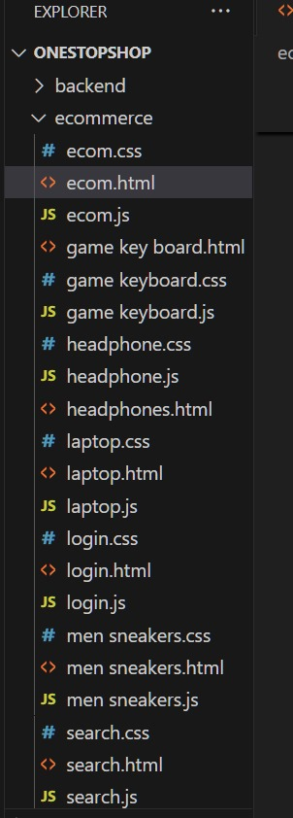

This structure assumes a React app and follows a modular approach. Here's a brief explanation of the main directories and files:
- src/components: Contains components related to the application such as, register, login, home, etc.,
- src/pages has the files for all the pages in the application.

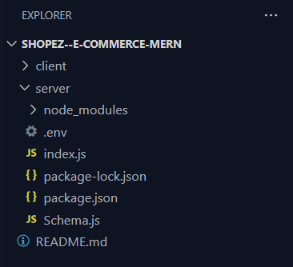

Project Flow:

Milestone 1: Project Setup and Configuration:

Create project folders and files:
- Client folders.
  - Server folders

Referral Image:

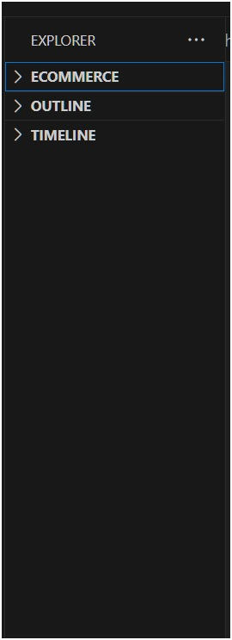

Milestone 2: Backend Development:
- Setup express server:

Reference Image:

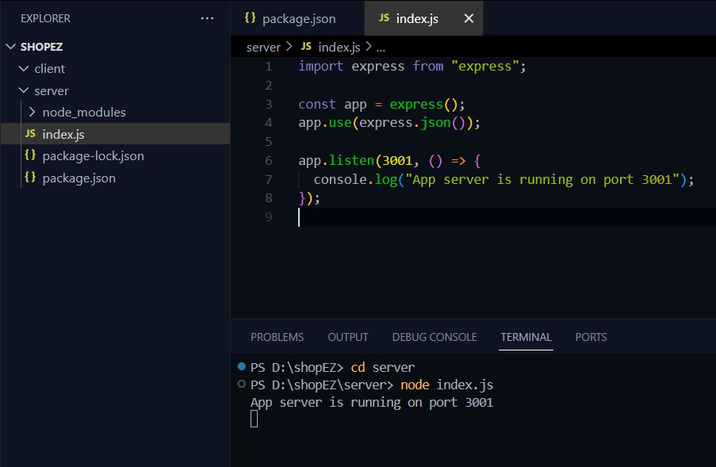
Now your express is successfully created.

Reference Image:

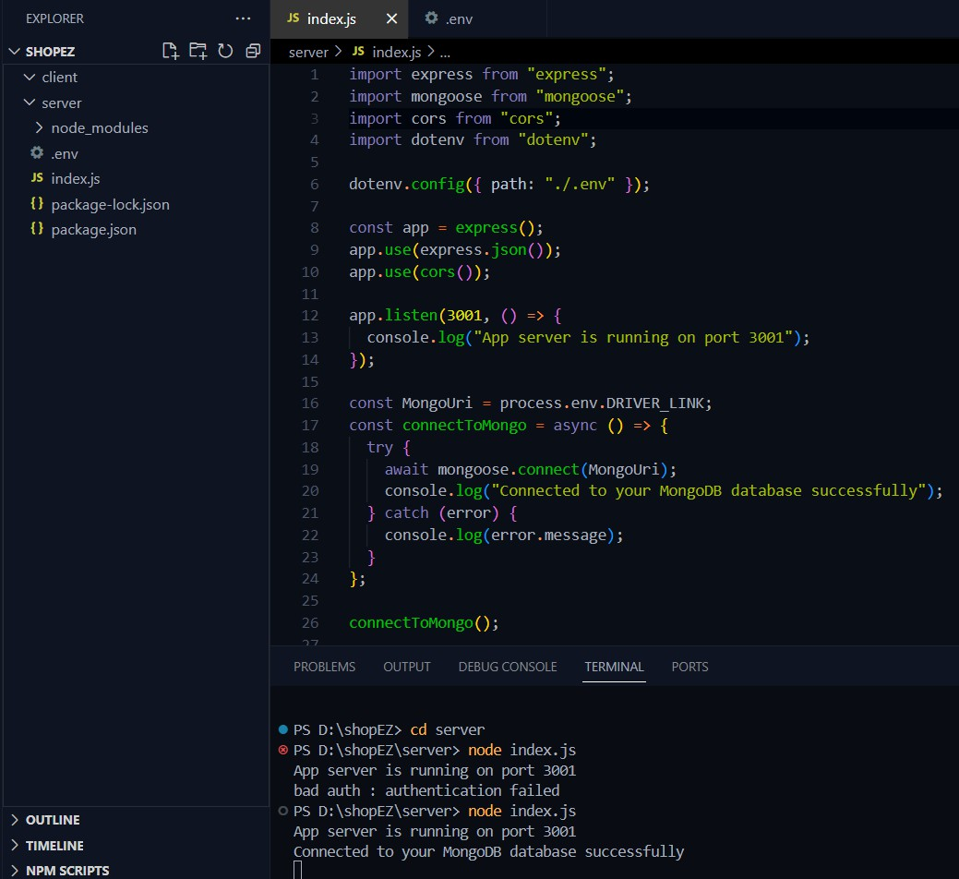

Backend:

Set Up Project Structure:
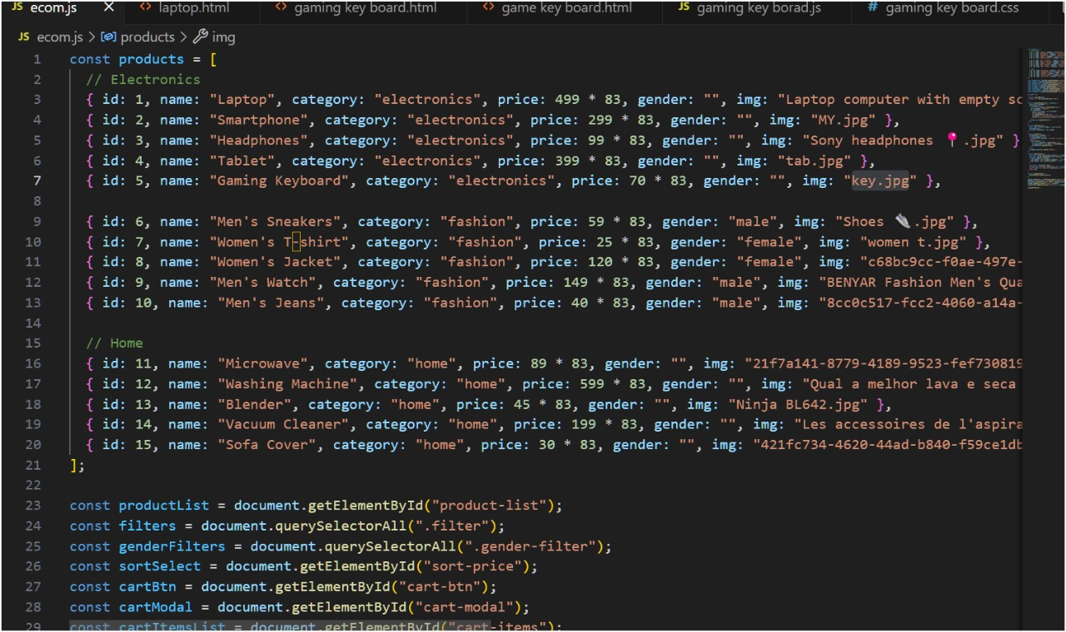

Code Explanation:

Schemas:
Now let us define the required schemas

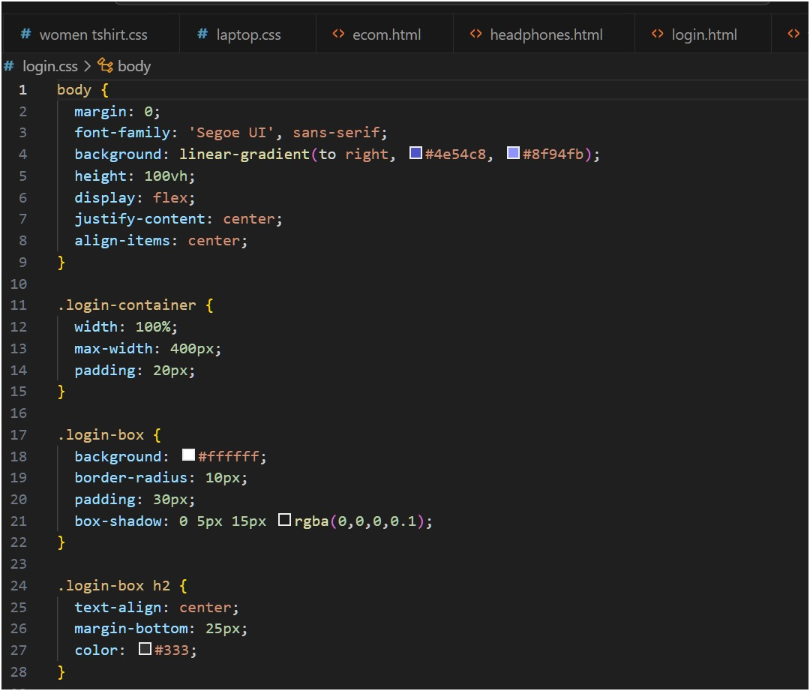

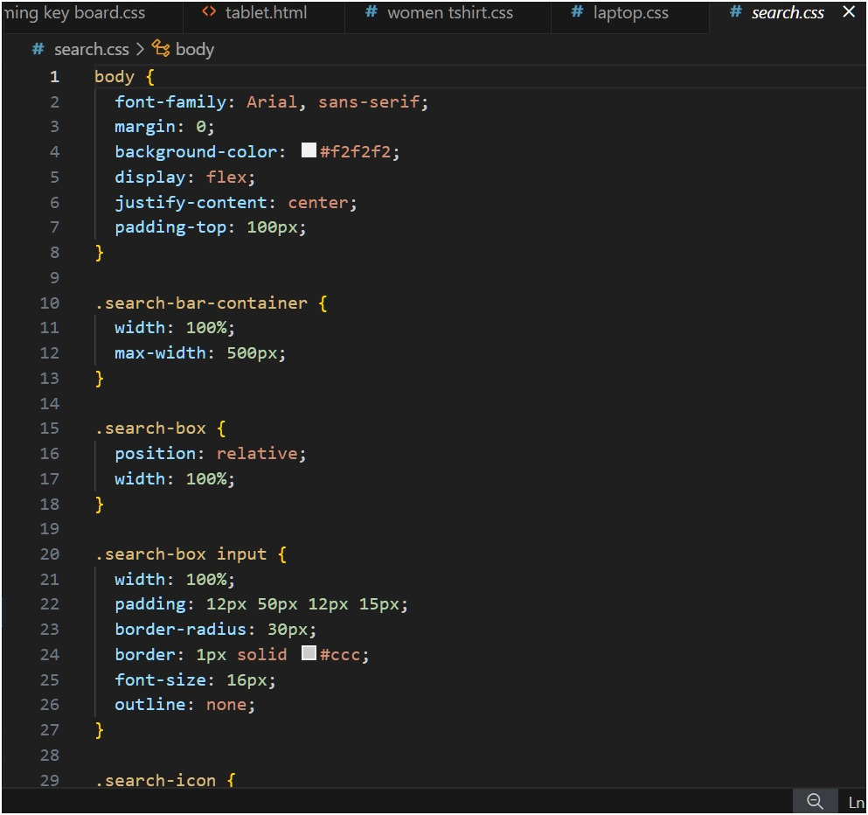

User Authentication:
· Backend
Now, here we define the functions to handle http requests from the client for authentication.

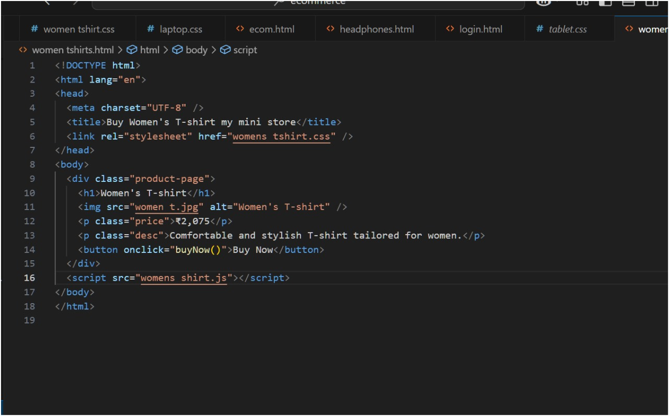

In the backend, we fetch all the products and then filter them on the client side.
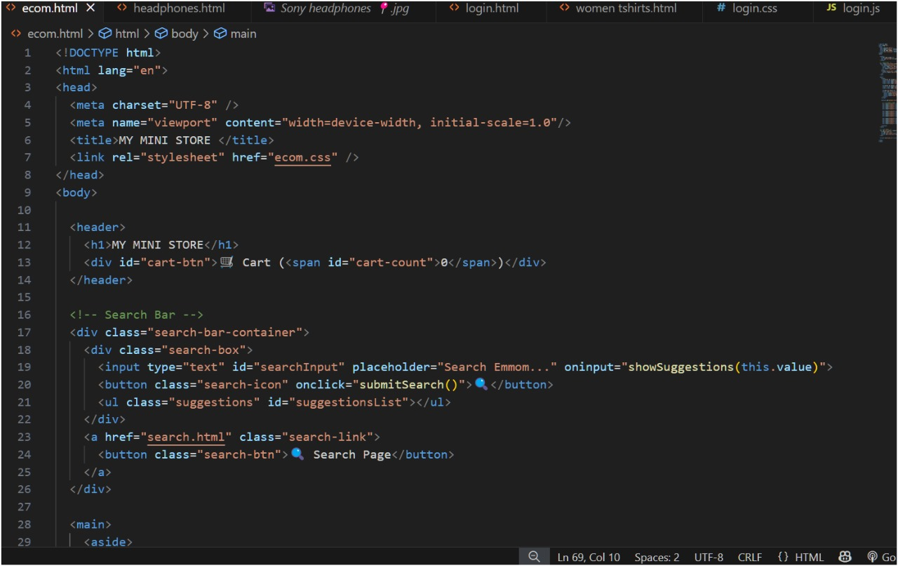

Milestone 3: Web Development:
- Setup React Application:
  - Create a React app in the client folder.
  - Install required libraries
  - Create required pages and components and add routes.

Design UI components:
  - Create Components.
  - Implement layout and styling.
  - Add navigation.

Implement frontend logic:
  - Integration with API endpoints.
  - Implement data binding.

Reference Image:
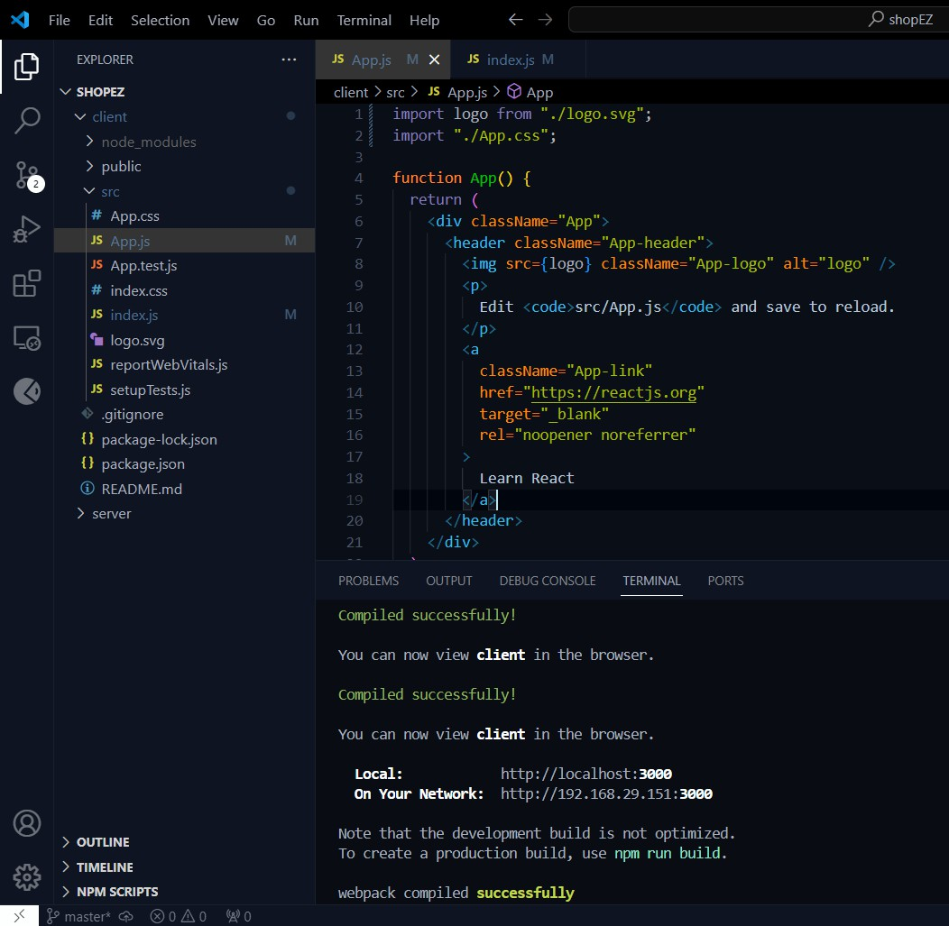

Code Explanation:
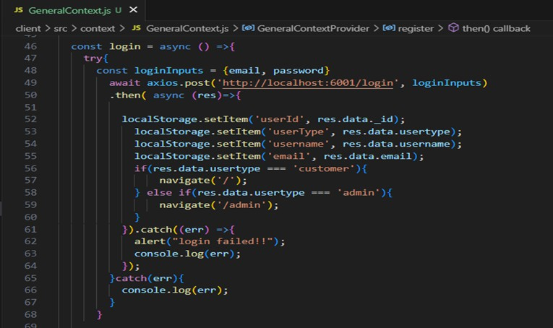
· Frontend Login:

Register:
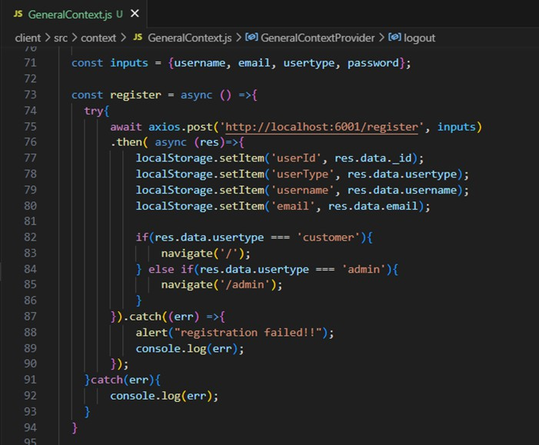

logout:
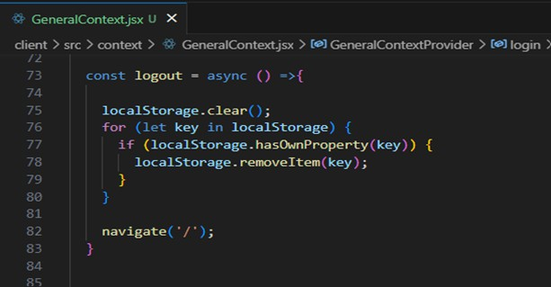

All Products (User):

In the home page, we’ll fetch all the products available in the platform along with the filters.

Fetching products:
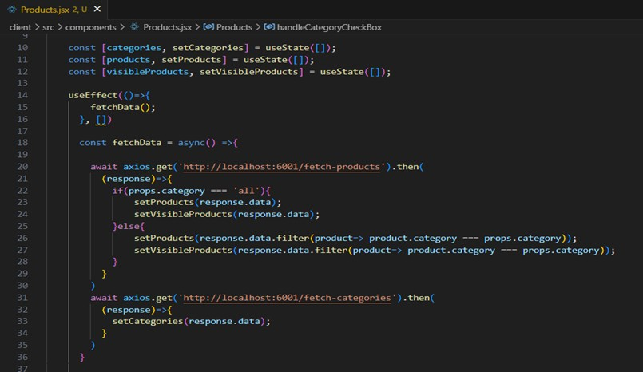

Filtering products:
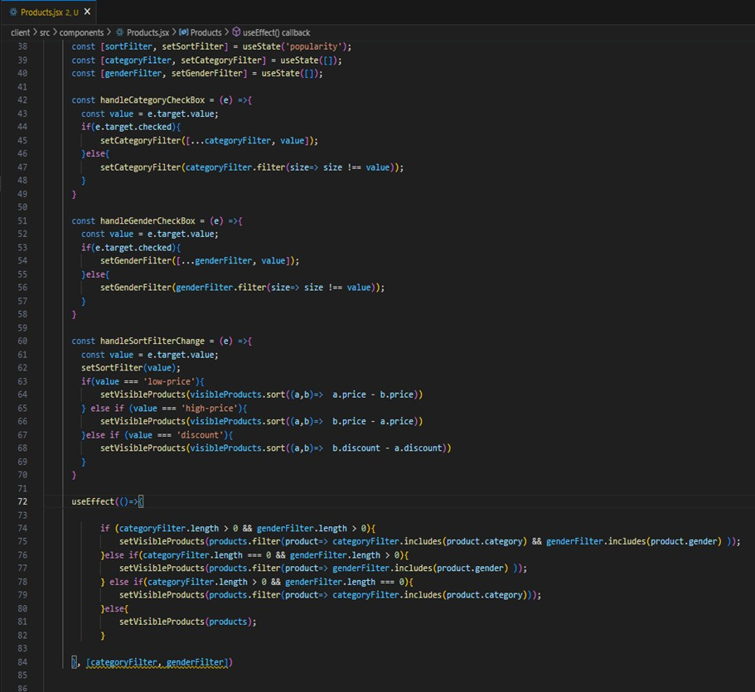
Add product to cart:
Here, we can add the product to the cart or can buy directly.

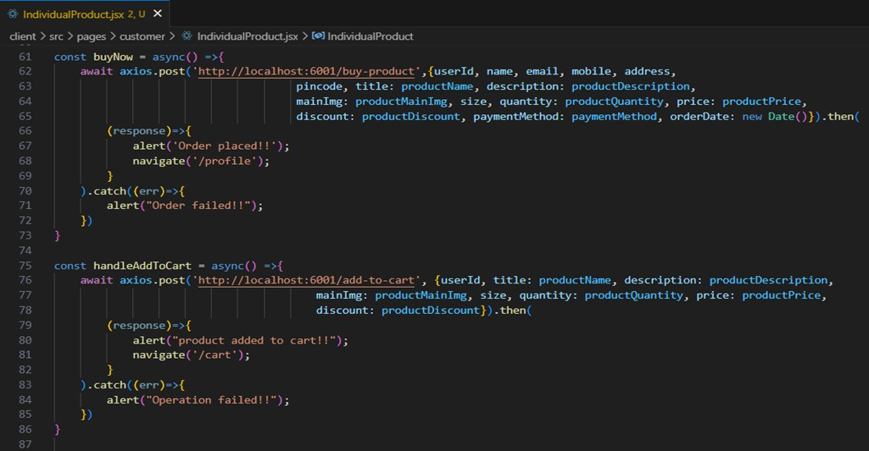
· Backend:
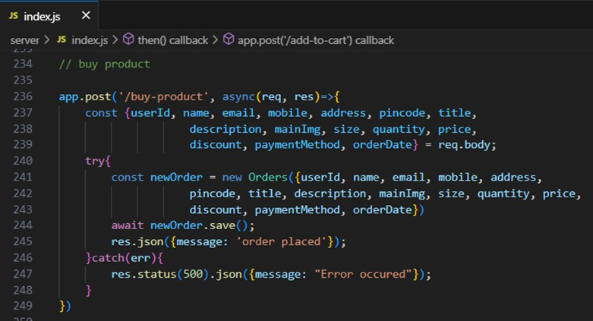

Add product to cart:

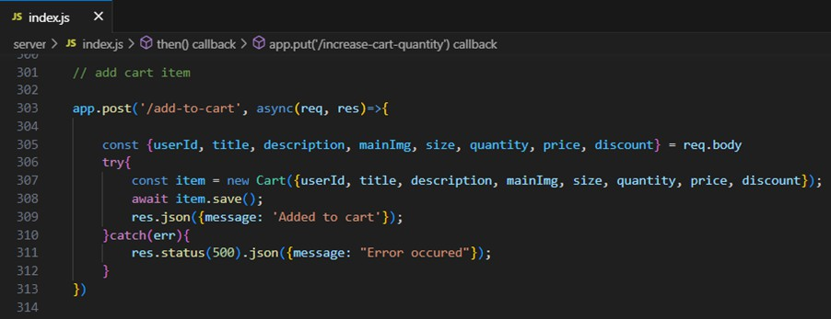

Order products:
Now, from the cart, let’s place the order
· Frontend

· Backend
In the backend, on receiving the request from the client, we then place the order for the products in the cart with the specific user Id.

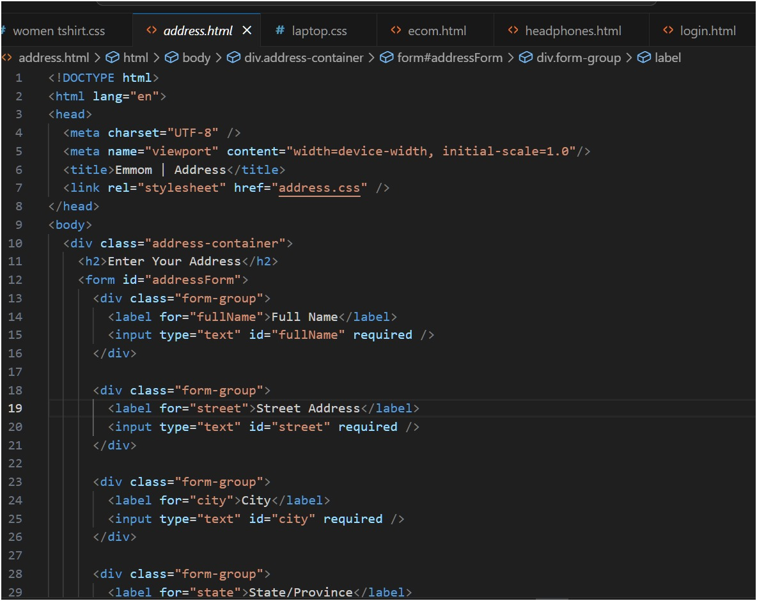

Add new product:
Here, in the admin dashboard, we will add a new product. o Frontend:

o Backend:

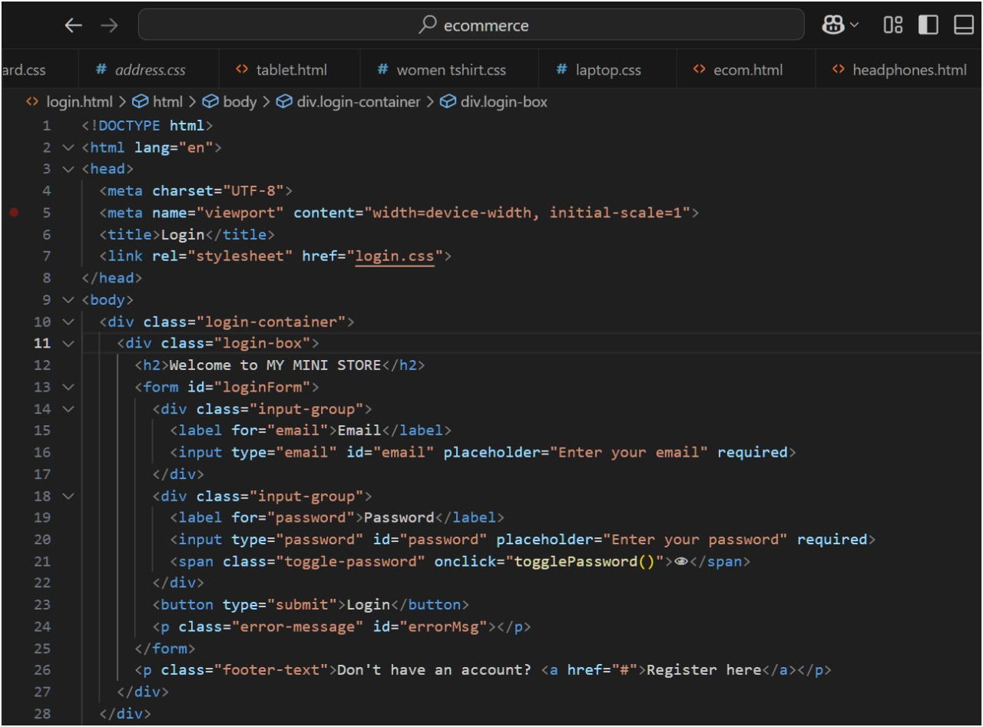

Demo UI images:
- Landing page

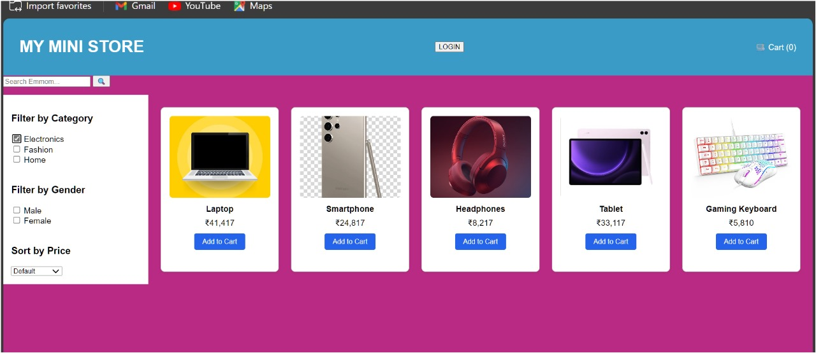
- Products

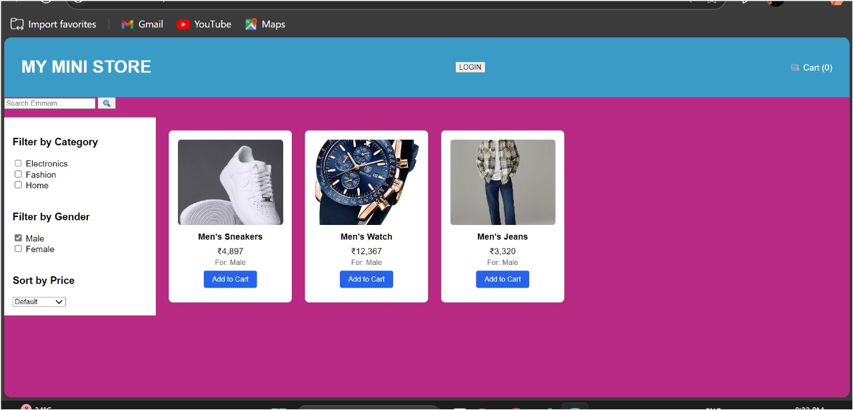

- Authentication

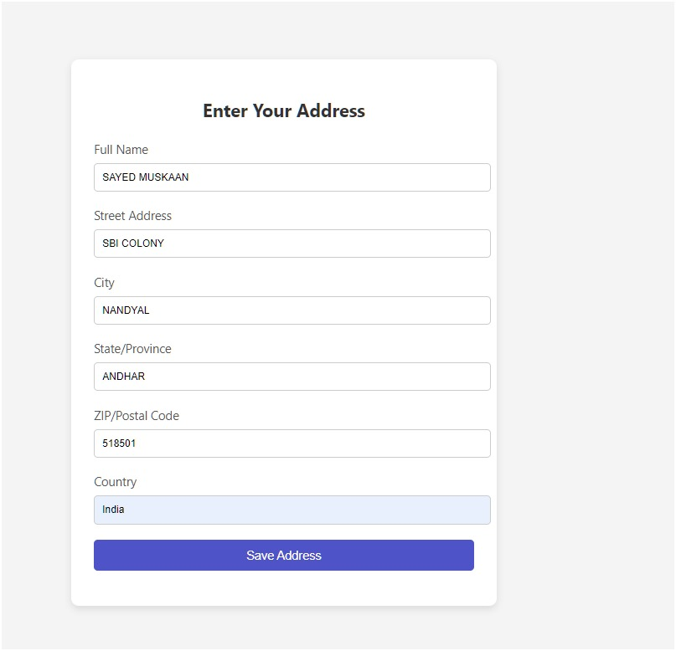

- User Profile

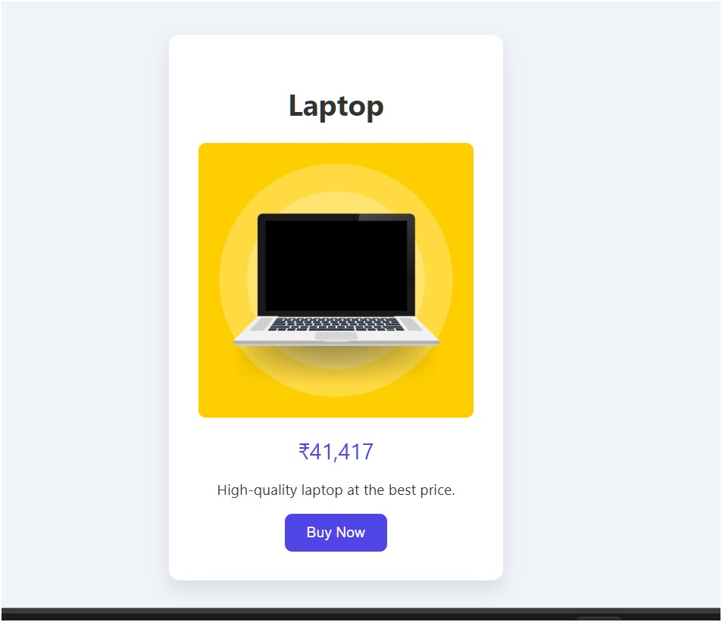

- Cart

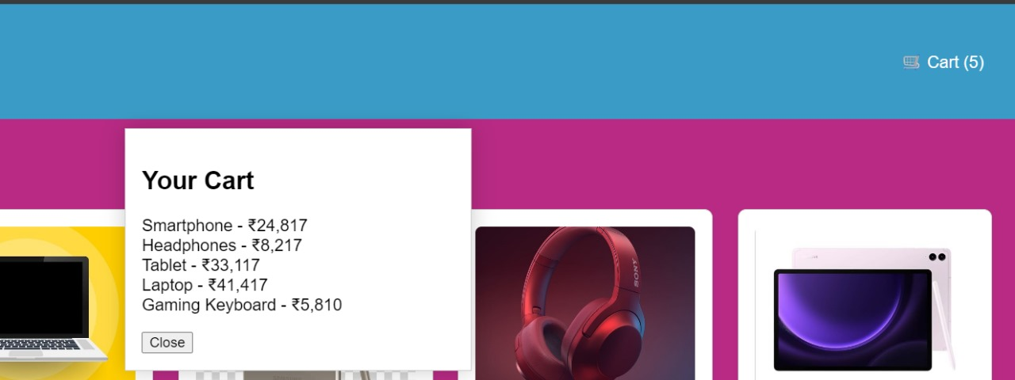

- Admin login

- All Orders
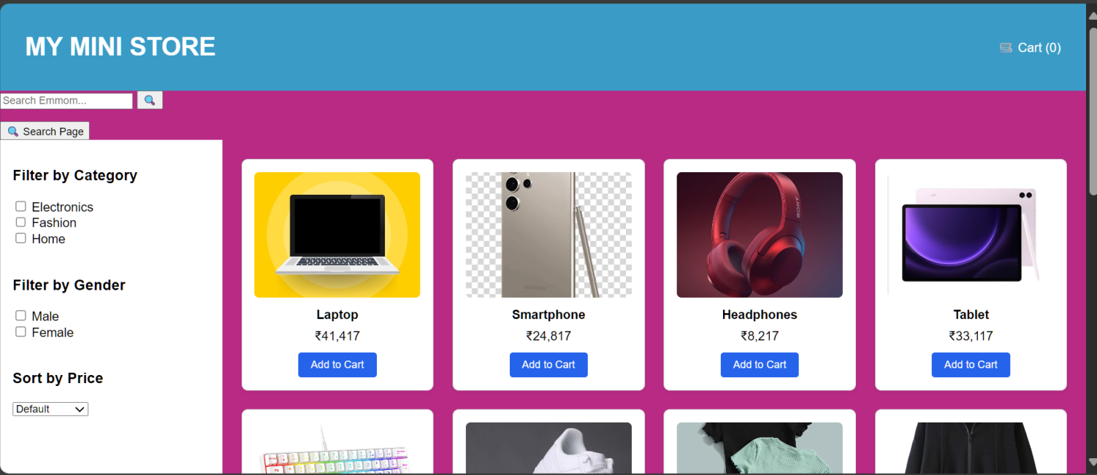

- All Products
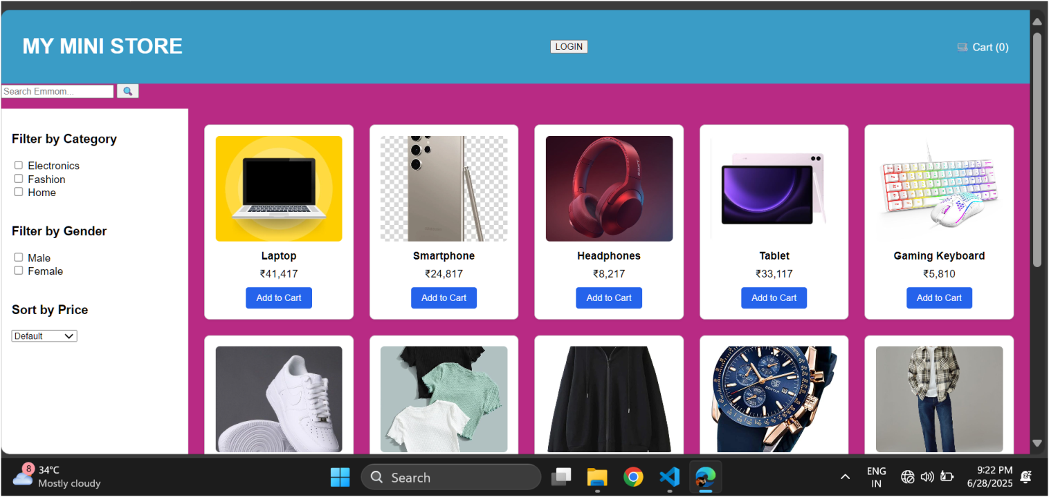

Final page
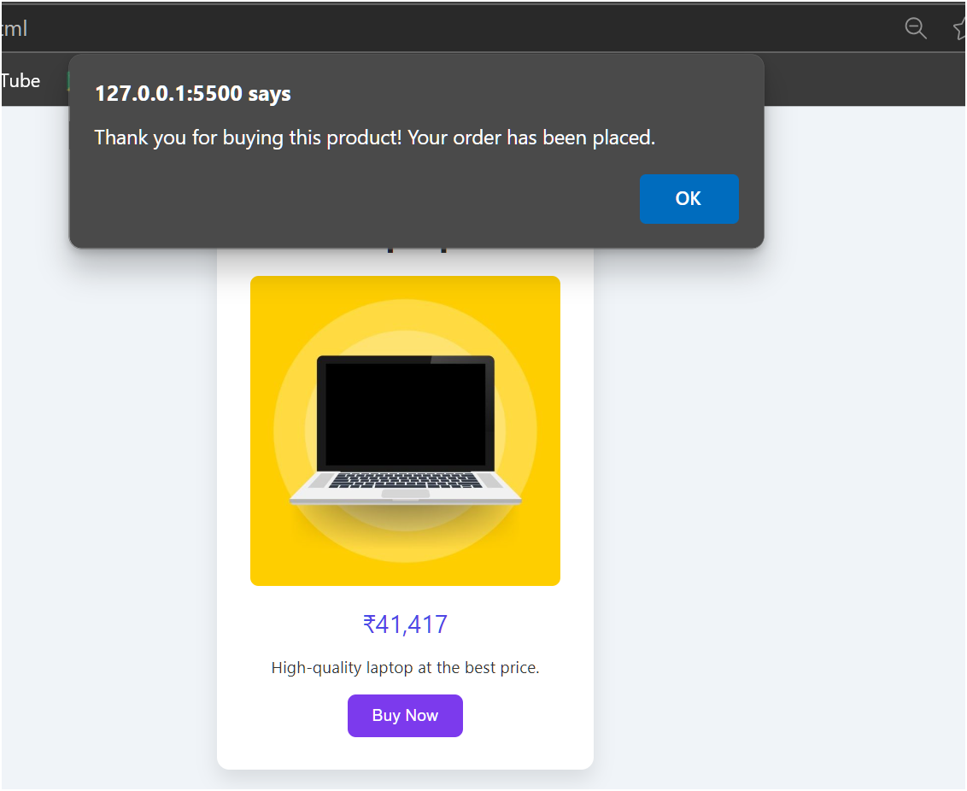

*** THANK YOU***

