## FedAvg vs FedAdam

FedAvg is updating its local model using the gradient descents and then average it whem aggregating. FedAdam is similar but before any update, the result of the training will go through an optimisation function.

FedAvg is the same as FedAdam if, both the server and client optimisation are SGD(gradient descent) and the lerniing rate is set to 1

IDD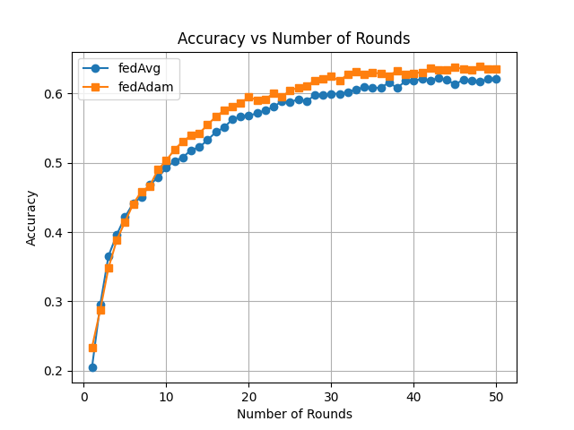

NON IDD