ChimpTool

Version 2.2.0

## Main Form:

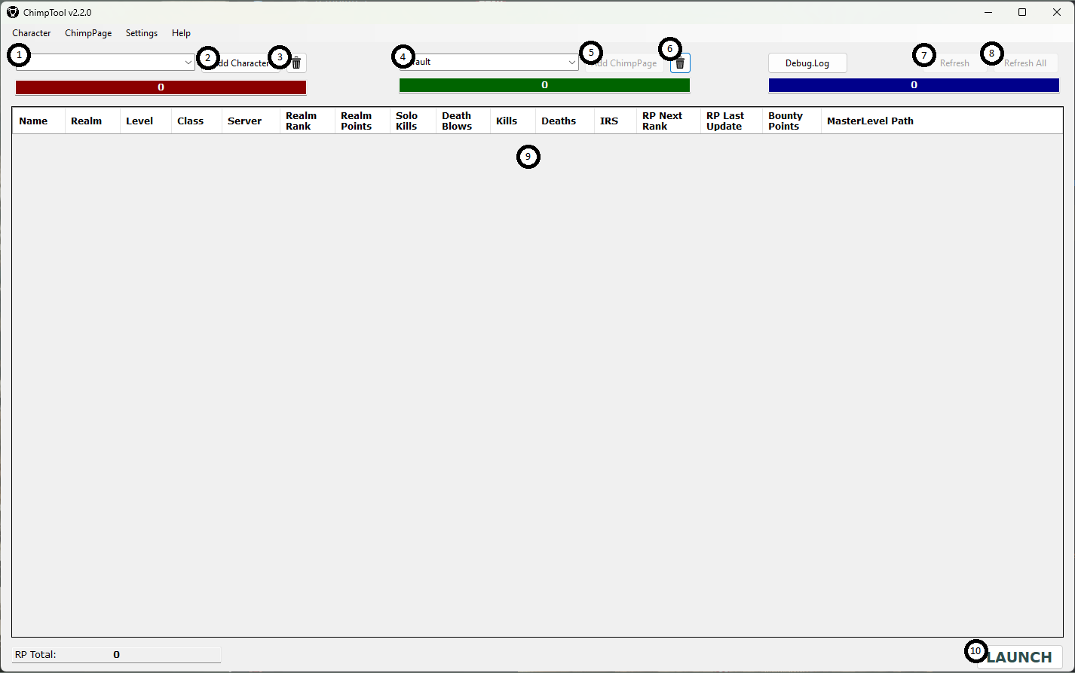

1. Character search text box. Enter the name of the character you wish to add to the current ChimpPage.
2. Add Character button. By default, left click will search Ywain server and shift + left click will search Gaheris. This is configurable under Settings > Configuration
3. Remove character button. This button will delete all selected characters on the current chimp page.
4. ChimpPage combobox. This is the name of the current chimp page. This can be changed under ChimpPage > Manage pages. You can type a new chimp page name in this combo box and press the Add ChimpPage button to create a new chimp page.
5. Add ChimpPage button. This button will only enable when a new unique name has been added for a new ChimpPage.
6. Delete ChimpPage will delete the currently selected ChimpPage.
7. Refresh button. This button will refresh the currently selected characters information. You may only use this button once per 10 seconds to avoid abuse of the Camelot Herald.
8. Refresh All button. This button will refresh all characters in the current ChimpPage. You may only use this button once per 60 seconds to avoid abuse of the Camelot Herald.
9. ChimpPage table. This is where character information added to the ChimpPage will be added.
10. Launch button. This button will directly launch the selected character into the game without use of the patcher. It is recommended that you use the patcher every time there is an update prior to using this feature as it may result in abnormal game behavior. Up to two characters can be launched from separate accounts. Each ChimpPage can be associated with a DAoC account.

## Character Menu:

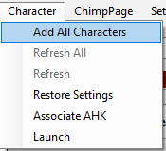

1. Add All Characters – Will scan your DAoC LOTM appdata folder for character INI files and auto add them into the currently selected ChimpPage. This can only be done to an empty ChimpPage and only once per 24 hours to avoid abuse of the Camelot Herald.
2. Refresh All – This performs the same action as the Refresh All button on the Main Form.
3. Refresh – This performs the same action as the Refresh button on the Main form.
4. Restore Settings – This grants you access to any saved settings made in the character tool for the selected character.
5. Associate AHK – this will allow you to select an auto hot key script that will be executed when you launch a character. Only the first character launched by ChimpTool will have an active AHK associated with it. ChimpTool has an integrated AHK implementation and you do not require AHK to be installed on your system in order to utilize AHK scripts. In fact, it is recommended to not have AHK running if you plan on using the ChimpTool to execute your scripts. Some things to consider if you wish to use the built in AHK:
   1. Remove all #Warn entries from your script. They throw false positives and stop the script prematurely.
   2. If you perform a reset it actually kills the built in AHK instance. You will need to quit out of the game and log back in via ChimpTool in order to restart it.
   3. You can not swap scripts during gameplay. If you log out to the character select screen and select another character without quitting the game, you will still be using the same scrip. You will need to quit completely out and select a new character in order to swap scripts.
   4. The working directory for the scripts in the same directory as where you installed DAoC Tool Suite (same folder as the ChimpTool.exe file).
6. Launch – This performs the same action as the Launch button on the Main form.

## ChimpPage Menu:

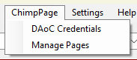

1. DAoC Credentials – Form to enter your DAoC credentials and provide the location of your game.dll file in order for the launch functionality to work. These credentials can be different for each ChimpPage.
2. Manage Pages – Form to rename, delete, or add new ChimpPages.

## Settings Menu:

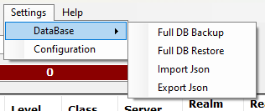

1. DataBase – This allows you to backup your database file, either by creating a clone of the database or by exporting the data to a json file. The json file does not contain your DAoC Credential information, so if you import a json file , you will need to reenter those per ChimpPage in order to use the Launch Functionality. This is not the case with a Full DB Backup, but in the future, if later versions of ChimpTool modify the table format, the json will be the only means to import data into the new database without starting from scratch.
2. Configuration – Form to configure the behavior of the Add Character button and set the location of your DAoC INI files and game.dll location.

## Right Click (Context Menu):

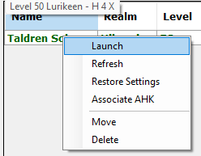

1. Launch – This performs the same action as the Launch button on the Main form.
2. Refresh – This performs the same action as the Refresh button on the Main form.
3. Restore Settings – This performs the same action as the Restore Settings menu item in the Character Menu.
4. Associate AHK -- This performs the same action as the Associate AHK menu item in the Character Menu.
5. Move – This will allow you to move a character from one ChimpPage to another.
6. Delete – This performs the same action as the Remove Character button on the Main Form.

CharacterTool

Version 1.0.0

## Main Form:

### Copy Settings Tab:

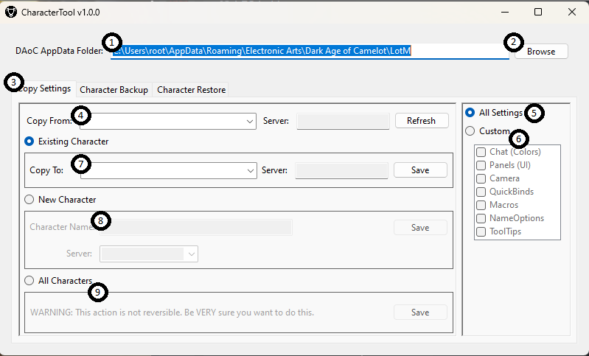

1. Location of your INI Files.
2. Browse Button – This will allow you to set the location of your INI Files should you have a custom installation.
3. Copy Settings Tab – This area allows you to copy your settings between characters.
4. Copy From Textbox – This is the source character for the copy.
5. All Settings – This will set the copy to duplicate all settings from one character to another. NOTE: All quickbar settings are removed other than those linked to macros.
6. Custom – This will allow you to select which settings are copied.
7. Existing Character – The name of the existing character to copy too.
8. New Character – This will allow you to copy to a character file for a character you have not logged in yet. Useful for Caledonia characters.
9. All Characters – This will copy the selected settings from the source character to every character file on your hard drive.

### Character Backup Tab:

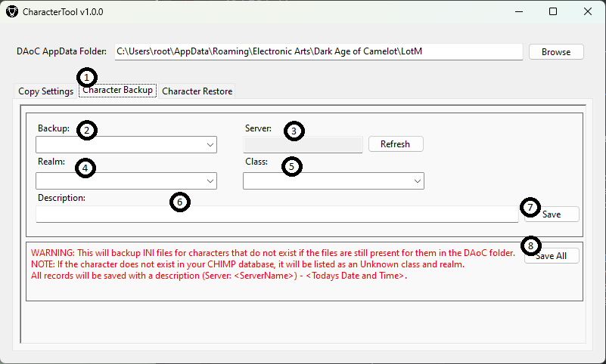

1. Character Backup tab – This tab allows you to save copies of your character INI and IGN data with a description so that you may quickly swap between specs/bar sets.
2. Name of the character to backup.
3. Server the selected character is tied too. This is auto populated.
4. Realm the character is on. This is auto populated if you have already added this character to chimptool.
5. Class the character is. This is auto populated if you have already added this character to chimptool.
6. A description that describes the characters build/spec.
7. Save button – will add the character and its description to the database.
8. Save All button – this will create a backup of every character ini and ign on your hard drive in the DAoC AppData Folder with a generic description.

### Character Restore tab:

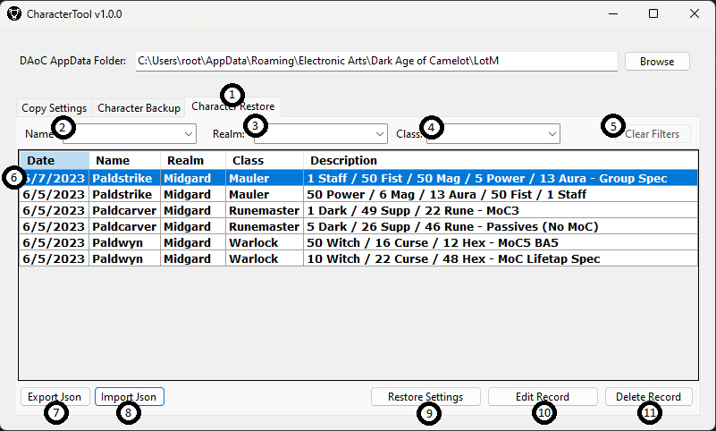

1. Character Restore tab – Restore character settings.
2. Name filter – Filter table by character name.
3. Realm filter – Filter table by realm.
4. Class filter – Filter table by class.
5. Clear filter button – Removes all applied filters.
6. Character table.
7. Export Json button – Allows the exporting of the character settings db data to a json.
8. Import Json button – Allows the importing of exported character setting data into the db.
9. Restore Settings button – This will restore the data of the selected records in the Character table.
10. Edit Record button – Allows you to modify the description of the saved record.
11. Delete Record button – This will delete the selected records from the character table.

LogTool

Version 1.1.0

## Main Form:

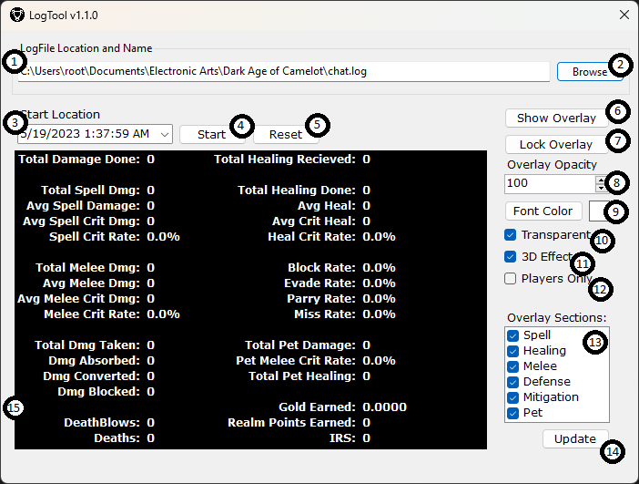

1. Location and file to be parsed.
2. Browse button – Allows you to load a log file.
3. Start location within the log file in which to begin parsing. This parses from the selected time stamp to the end of file.
4. Start/Stop button – The starts the parsing from the selected Start location. Once started it will parse all data in the file and then wait for the file to update before parsing further. Once parsing has started this will become the Pause button which will stop the parse and no longer auto update when the file updates.
5. Reset button – This resets all the collected statistics and allows you to change your time stamp location or choose a different file to parse.
6. Show Overlay button – Toggles the overlay.
7. Lock Overlay button – Locks the overlay such that it can no longer be moved.
8. Overlay Opacity – How transparent the overlay is.
9. Font Color – Font color of the text contained within the overlay window.
10. Transparent checkbox – True = no background to the text in the overlay, False provides a black bar behind the text.
11. 3D Effect – Provides a shadow/outline effect to the text in the overlay.
12. Players Only – Will attempt to filter all the data to be from actual players only. IE: Mobs, training dummies, doors, ect will be removed.
13. Sections of the overlay to be displayed.
14. When you change the overlay section selection , you will need to press the Update button to see the changes.
15. Player statistics.

## Overlay:

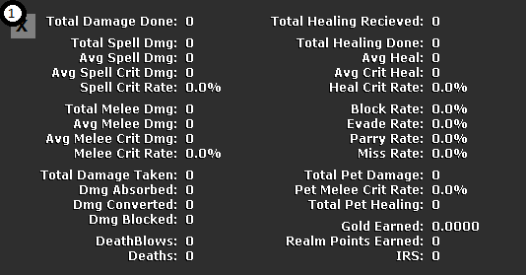

1. This is where you move the overlay. This will be hidden when locked.