TaleTime Features

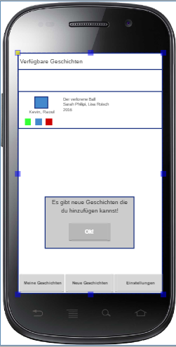
If new stories are available a window should Popup
and inform the client about the new stories.
The User can click on „OK“ that he/ she is informed
about the new stories that he/she can download and listen it.

This window should be shown after a new stories is updated.
So the user can be informed about it, when he/she starts
the app.

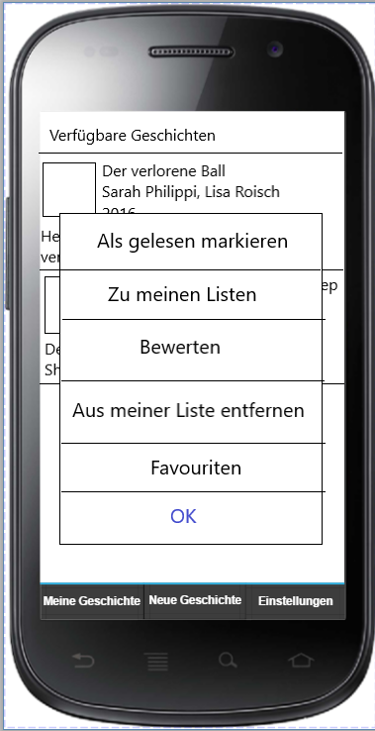
If the user click on the button „Meine Geschichten“ than he/she can see the storieswhich are downloaded for the user by himself/herself.

We can implement a Button on top of the right corner to open a window with some features. The first feature is that the user can mark the story as read. The second one ist to add to users lists.
The next buttons are for rate, to remove from the list and add to favourites.

With the „OK“ button the user can close the window.

