TaleTime Improvement

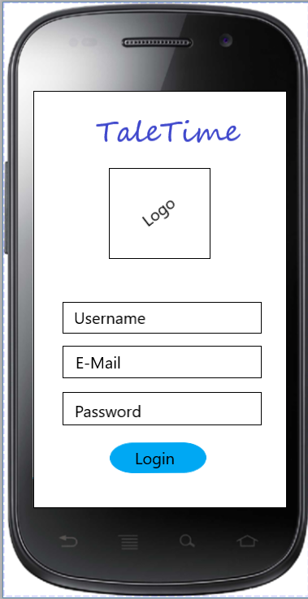

When the user start the Application the Logo and the Name
of the Application should be given.

If the user didn‘t registered yet, he/she can register with
the username, E-Mail and password.
Else the user can Login directly and just write his initials
to run the application.

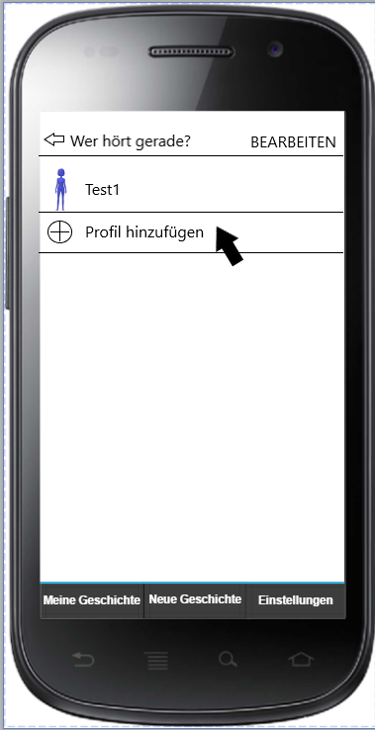

When the user login than he has already an account
with his initials, why do we need to still add an new account within a account? This should be taken out.

And especially if this Application is for kids, than why do
the client needs to register beforehand.
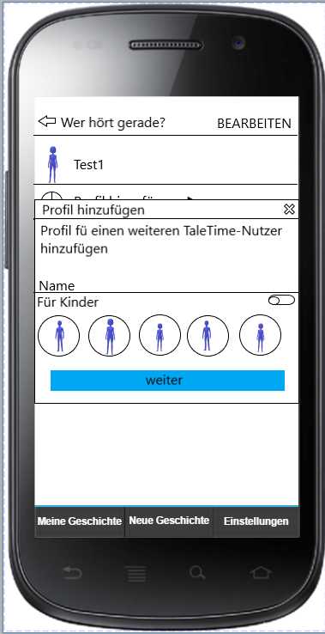

This must be changed definitly, cause if the user has logged in than he/ she wants to start to read or listen the stories. They don‘t wantt to create a new profile within a profile.

