Web Application Tutorial: Talented Europe for Companies

Companies

This document explains the use of the web application [talentedeurope.eu](https://talentedeurope.eu/) from the point of view of companies.

Registration

The first step to register a company in the Talented Europe application is to click on the Sign up button.

**Click**

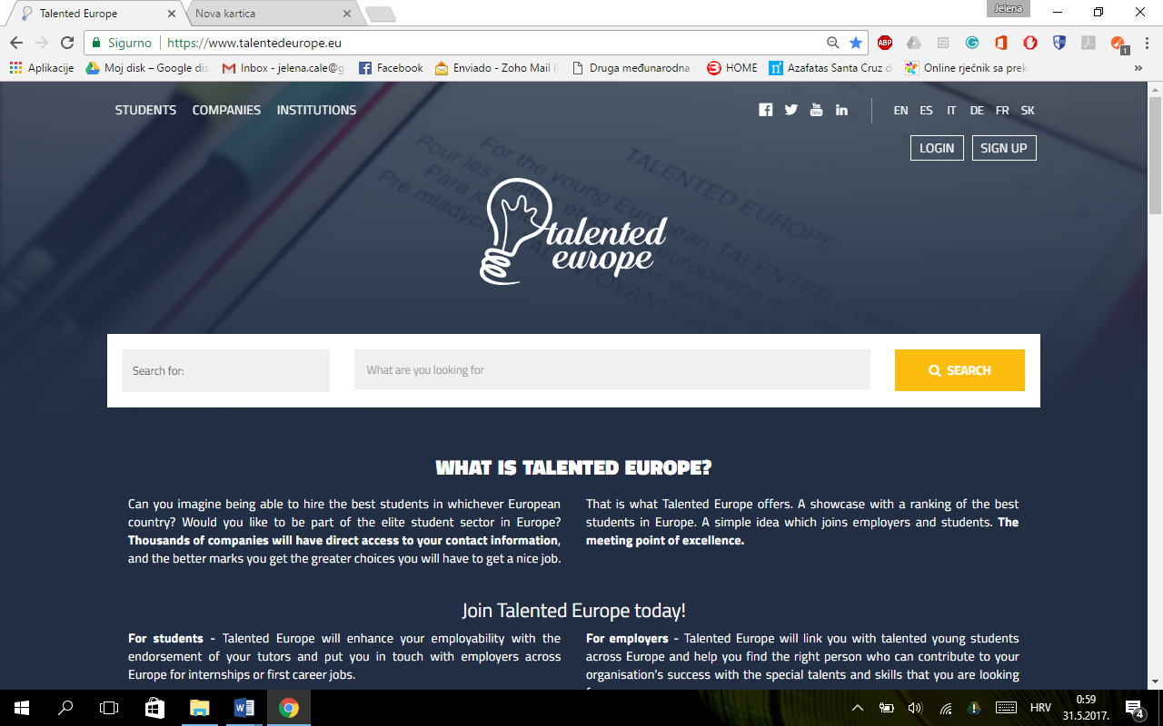

Afterwards, you need to select an icon corresponding to companies.

**Click**

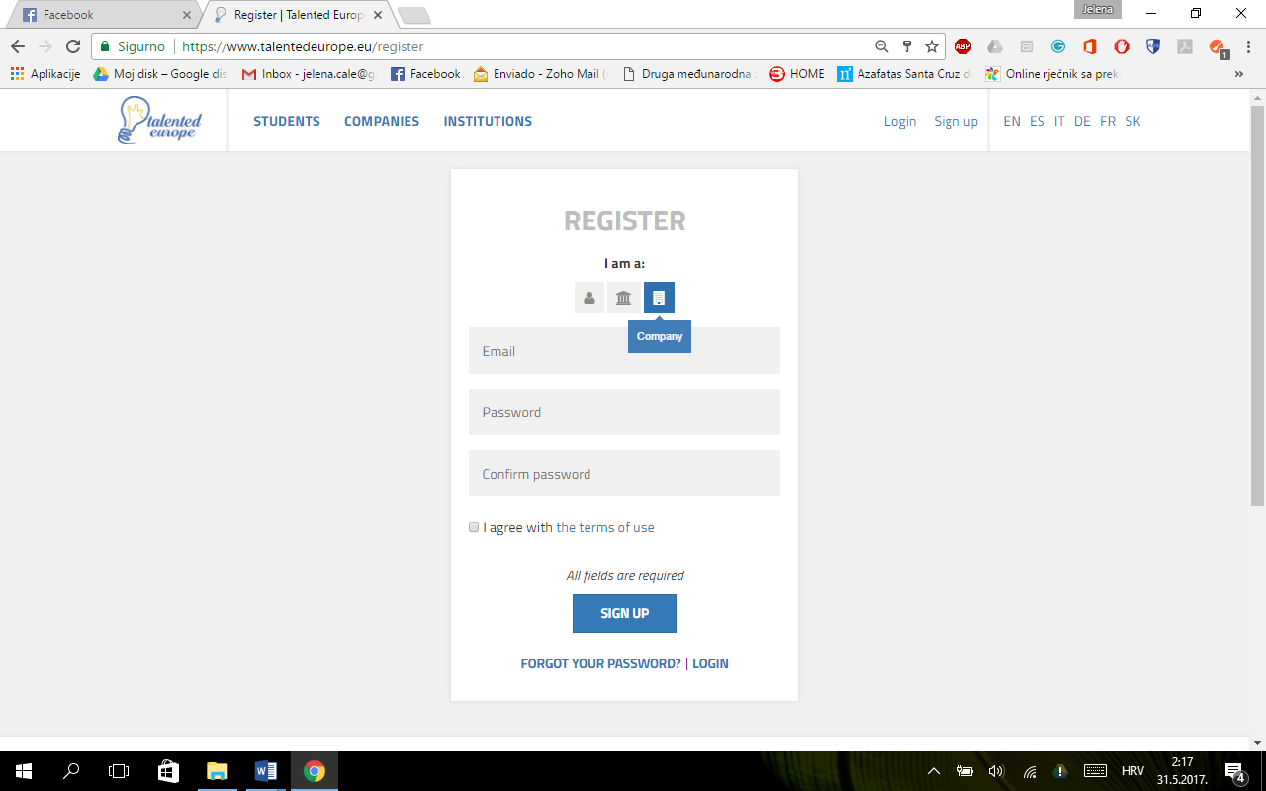

**Click**

Next, you have to provide an email and a password (with its subsequent confirmation). Terms of use have to be accepted.

Pressing the Sign up button, the initial registration process ends.

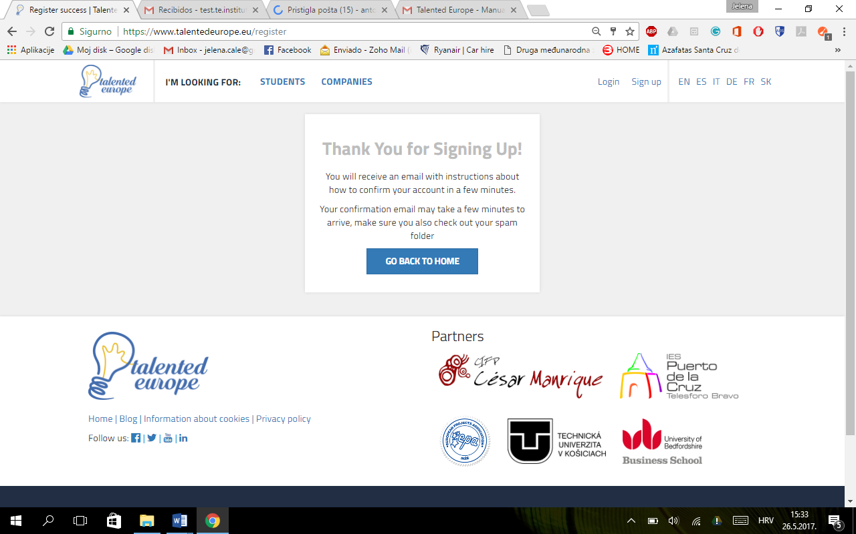

In a short time you will receive an email.

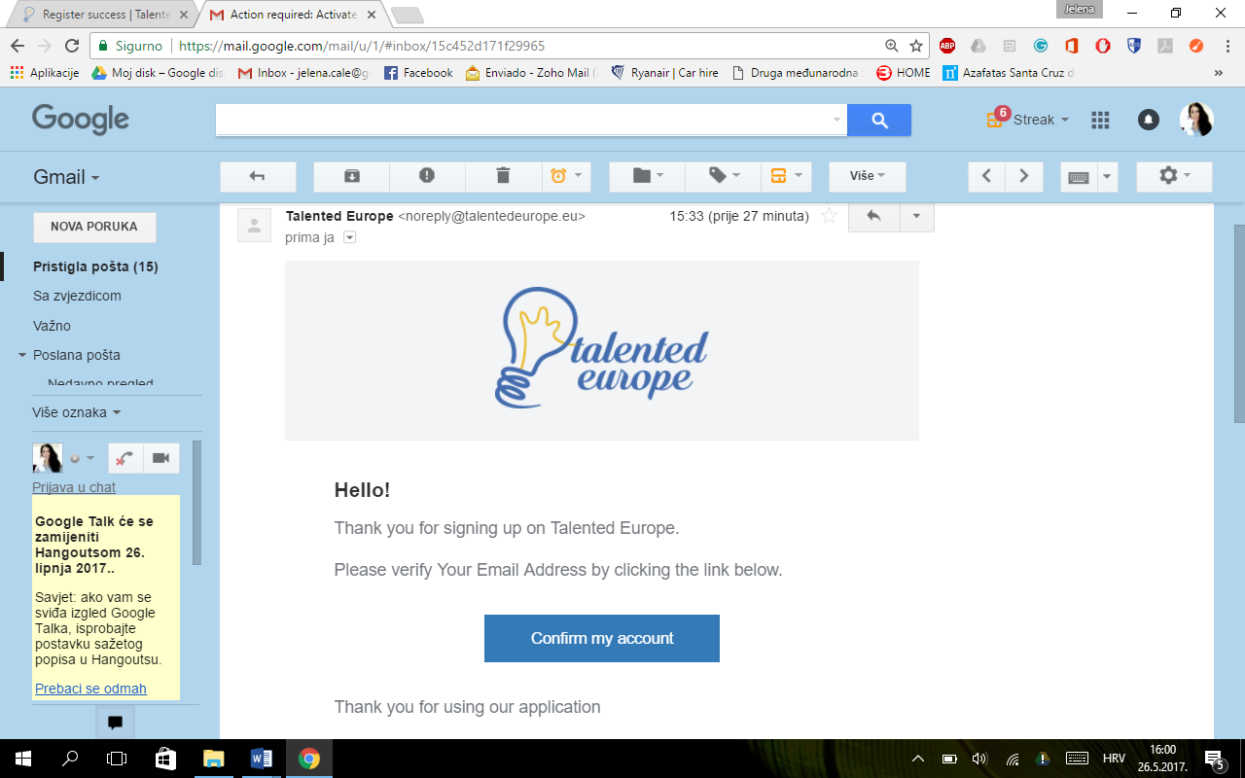

**Click**

When you click on the Confirm my account button, **a screen will be displayed where you have to confirm that the activation of the account was correct** and that it is possible to log in to the Talented Europe.

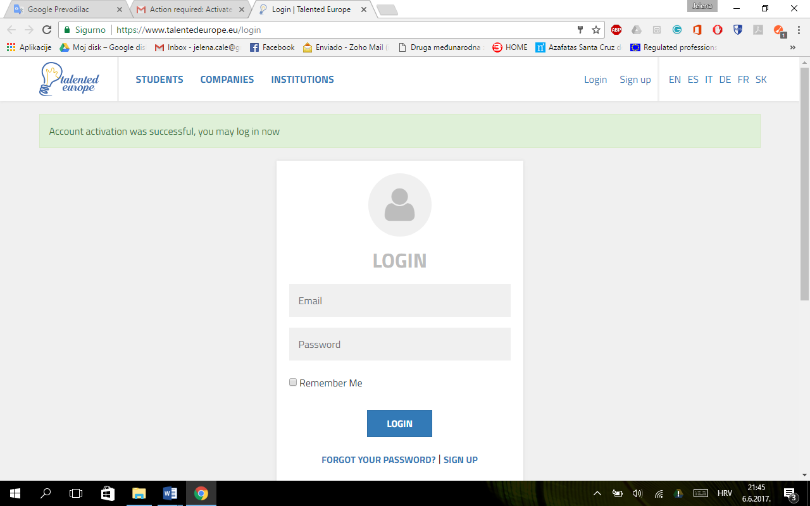

**Click**

In order to log in you have to enter email and password used during the registration. Upon the first login the following screen will appear in which it is stated that you have to complete your profile filling in the mandatory fields, and thus providing information about your company to your potential employees.To do this, press the Set up my profile button.

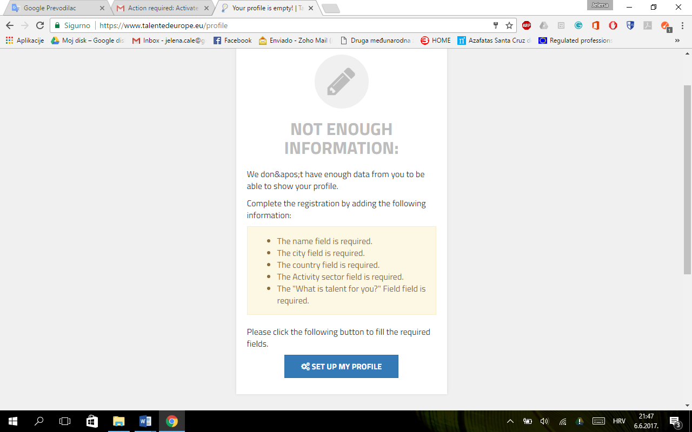

**Click**

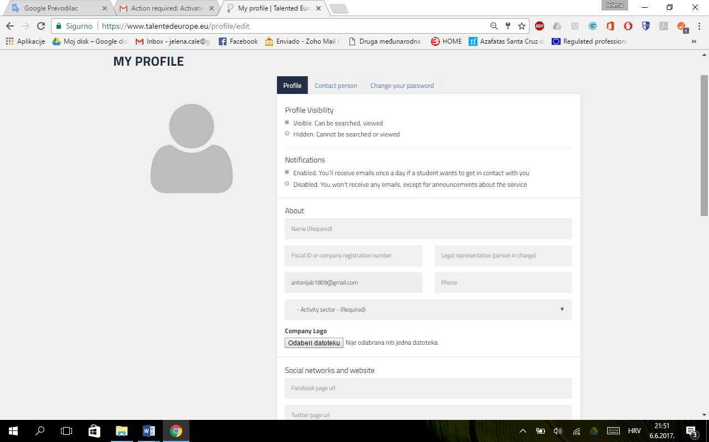

No file has been chosen

Choose File

@

* You will see the data corresponding to the **Profile** tab. First, you have to choose whether you wish your profile to be visible or hidden and enable or disable notifications.
* Your email is already filled out as it has been entered during the registration. The following information has to be completed:
* Name
* Fiscal ID or company registration number
* Legal representative (person in charge)
* Telephone number
* Activity sector

-> The **logo** of the company should be uploaded in the jpg or png format. Doing this is important because it will allow the company to be visible on the platform.

Continuing with the completion of the profile, the following fields appear:

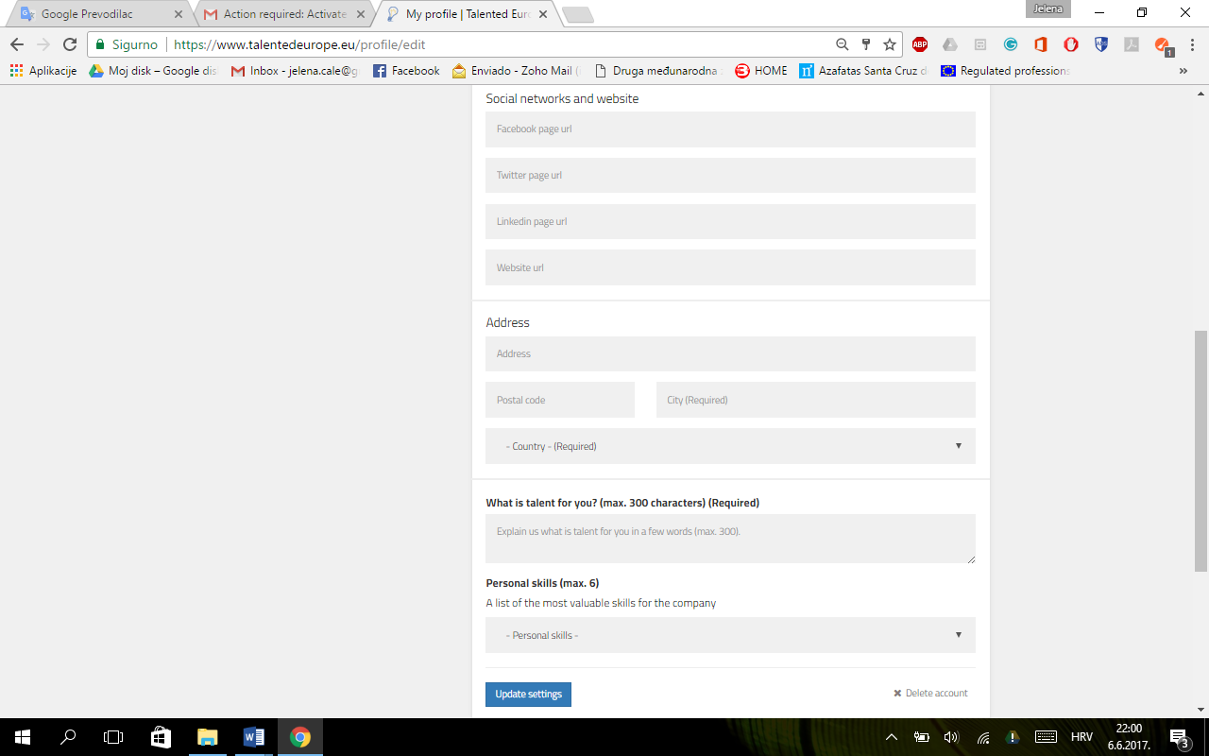

**Click**

-> You are free to add URLs of your social networks to give more details to your potential employees.

-> Fill in your address, postal code and city, and select your country.

-> Briefly, with a maxmixmum of 300 characters, describe what is a talent for you and list the most valuable personal skills for the company, with a maximun of six.

Whenever a modification is made to the profile, you have to click on the Update settings button. Otherwise, the changes will not be saved.

You can also delete the company's account by clicking on Delete account.

If you click on the Contact Person tab, you can enter a name and an email of the user responsible for receiving notifications from the Talented Europe platform.

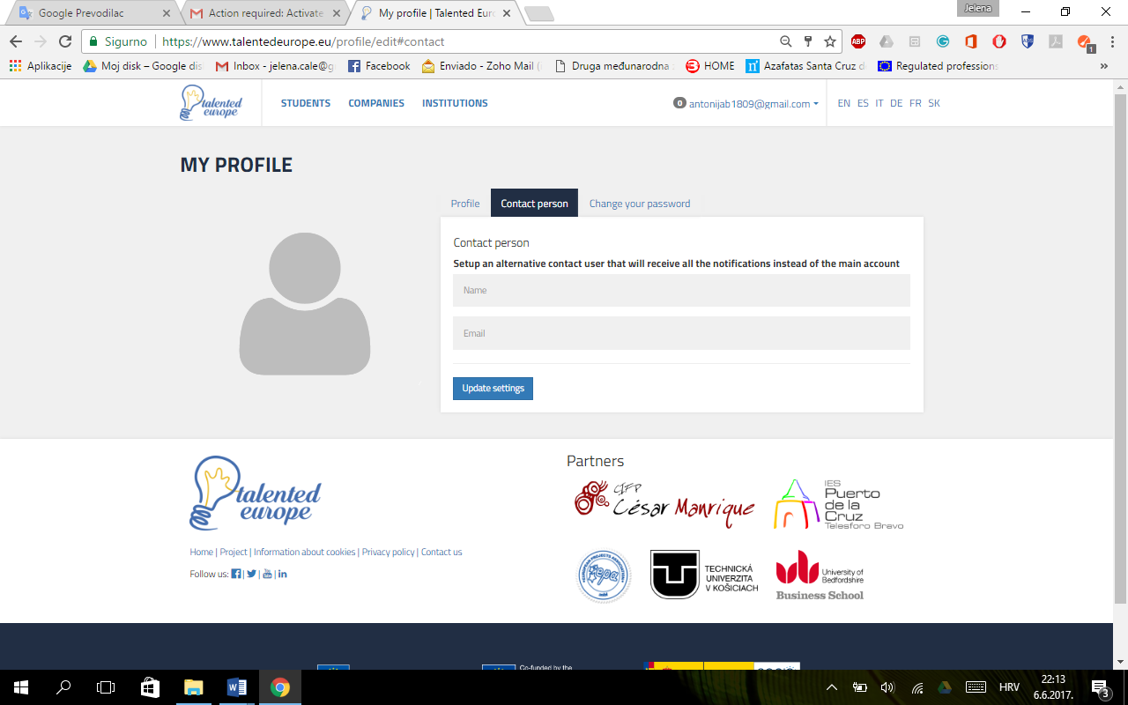

**Click**

Again, it is important to press the Update settings button. Otherwise, the changes will not be saved.

Finally, in the Change your password tab, you can change the password of the account associated with the company.

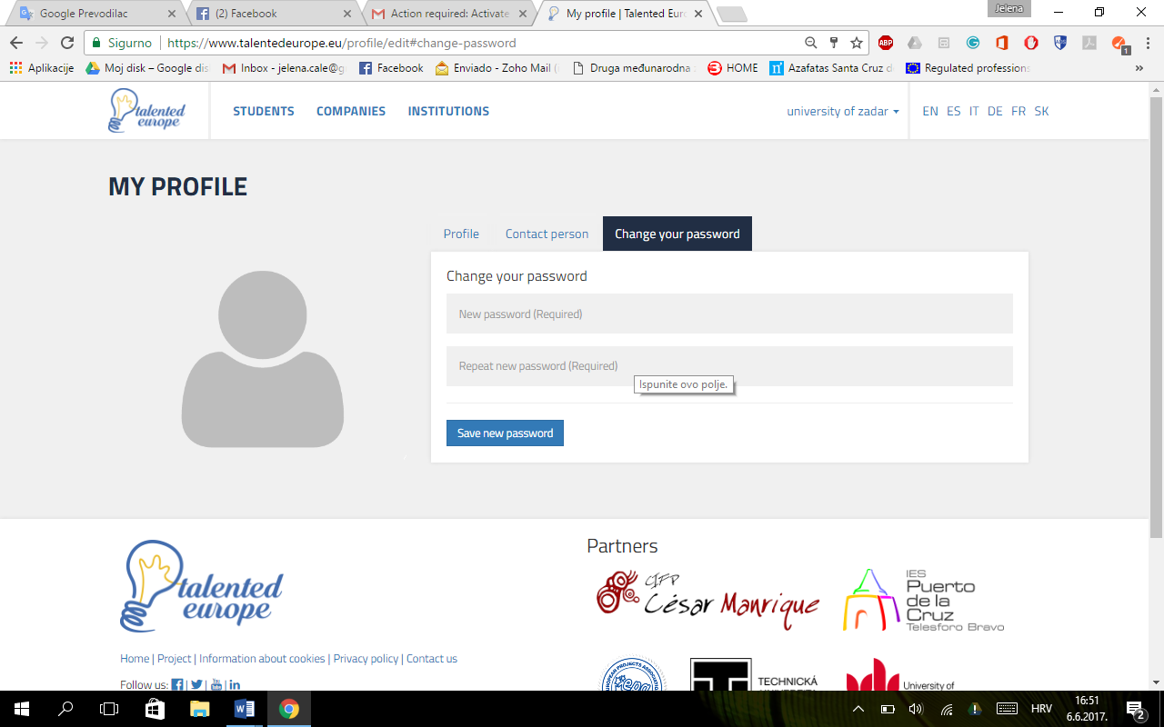

**Click**

It is important to press the Save new password button for the changes to take effect.

At any time you can change the profile of your company by clicking on the upper right area, where it says the name of your company and select the settings option.

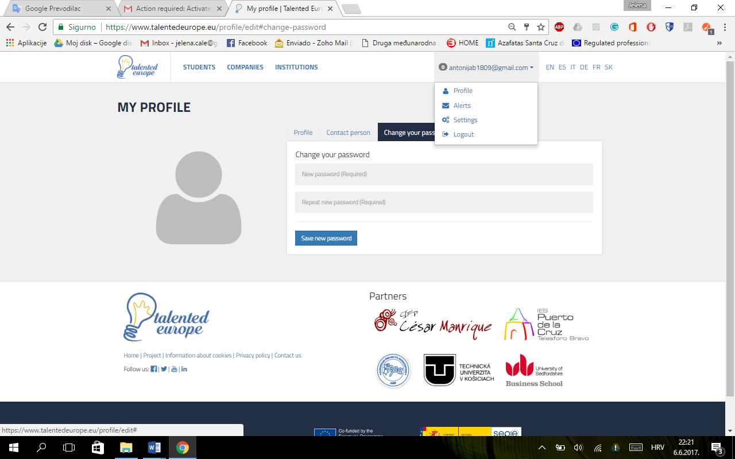

**Click**

*Name of the Company*

Login

To log in to the Talented Europe platform, access the <https://www.talentedeurope.eu/> and click on Login:

**Click**

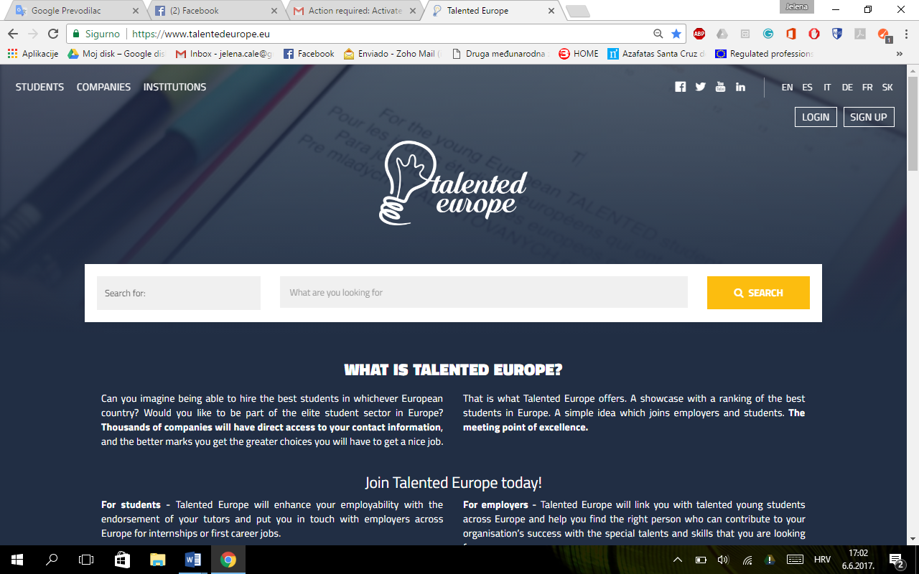

The following form will appear, where you have to enter email and password used upon your (company's) registration.

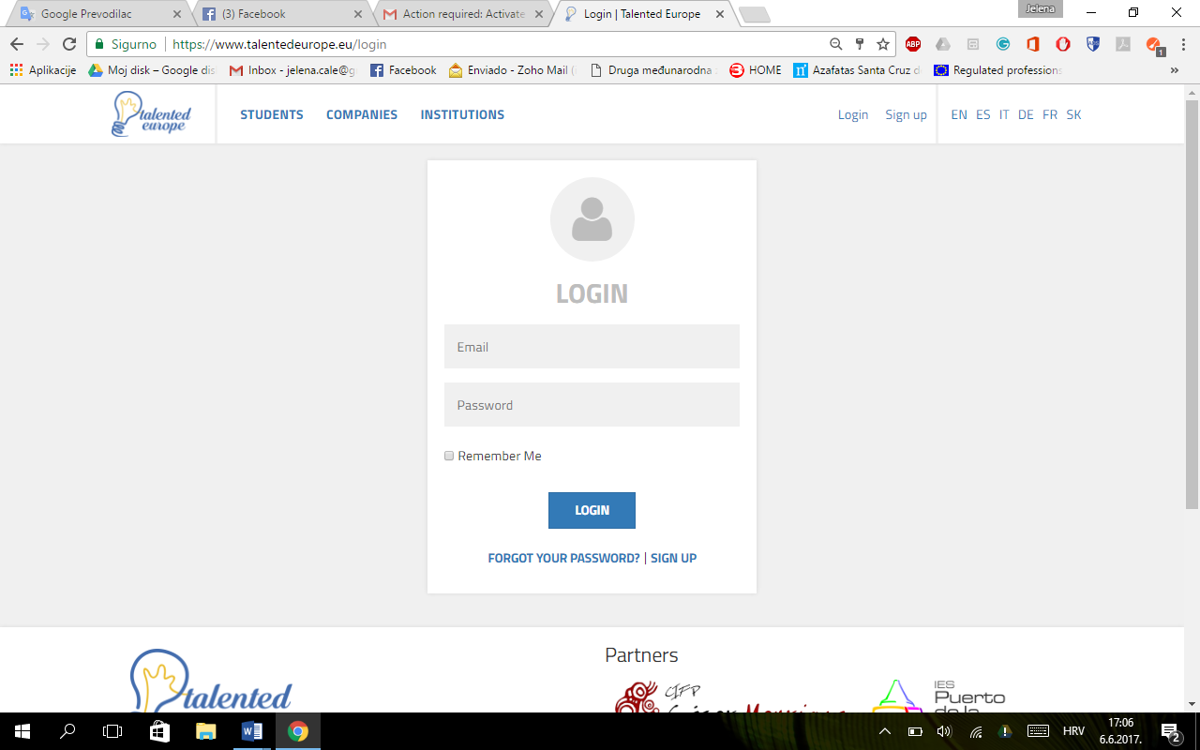

**Click**