Web Application Tutorial: Talented Europe

Referees

This document explains the use of the web application [talentedeurope.eu](https://talentedeurope.eu/) from the point of view of referees.

A referee is an academic figure in charge of assessing whether or not a certain student, who is registered on the Talented Europe platform, is talented.

Registration

Referees cannot sign up by themselves - they have to do so through an invitation, which comes from their educational institution in which they work.

Inviting a referee

To show you how it functions, during this tutorial educational institution called "Institution test" will be used as an example. Once logged in as an institution, we can go to the Referees section:

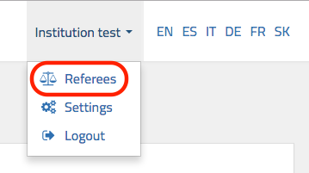

Once there, we go to Add a new referee, enter your (referee’s) email address and press the Send invitation to referee button:

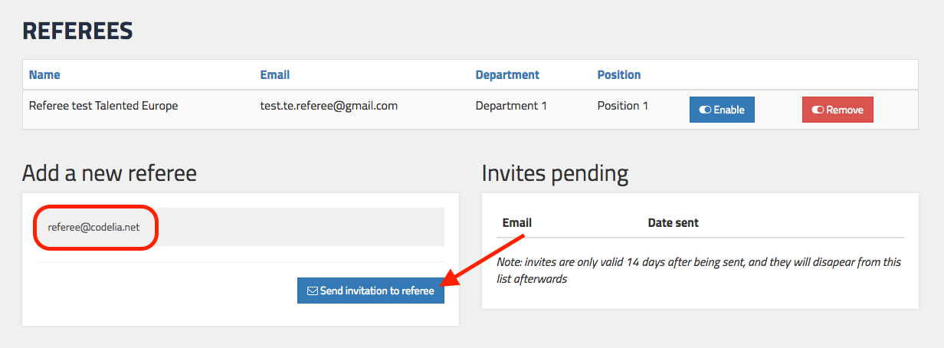

What follows is the message, at the bottom right corner, which was sent as an invitation to the referee:

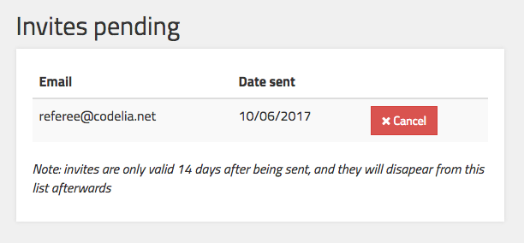

If you check your mail, you will see that you have received the invitation. Click on the Create my account button:



This will take you to the screen, where you have to complete your profile as a referee. Fill in all the required fields and press the Register button:

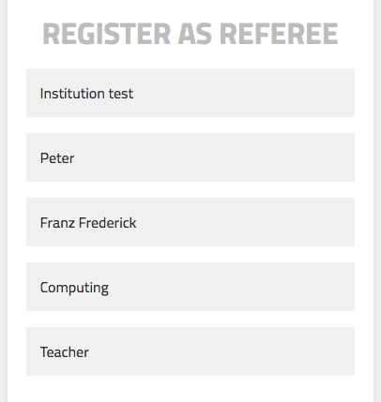 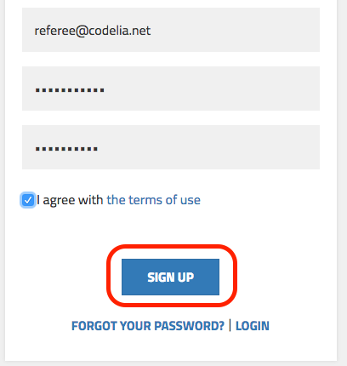

With this, the registration of the referee is concluded. As the final screen appears, click on the Return to the main page button:

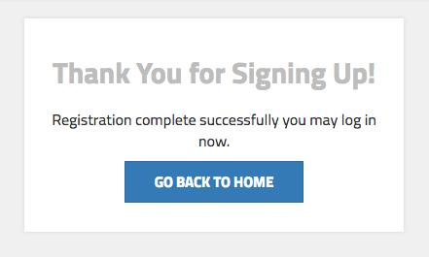

From now on you will have an access the application by clicking on the Login button in the upper right corner:

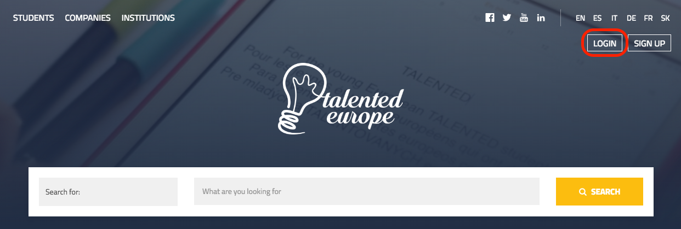

The login screen appears and you enter your email and password chosen during the registration, and press the Login button:

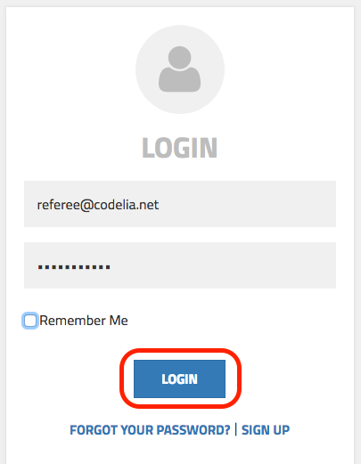

Validation

The first time you enter the platform as a referee, you can see that you do not have any students assigned yet:

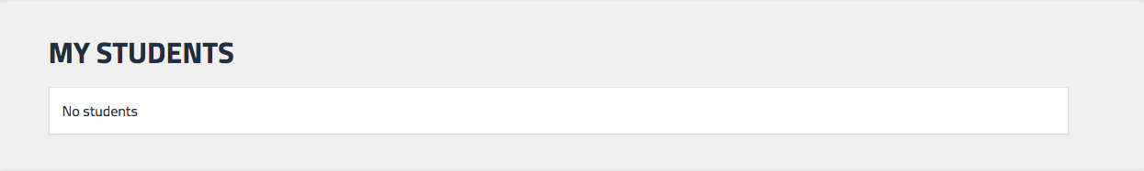

Thus, you wait for some validation requests.

For illustrative purposes, we are going to get a validation request from a fictitious student. The student in question will be "Student 2 Test Example". At some point in your configuration, the student will have to request a validation of his/her profile through the following screen:

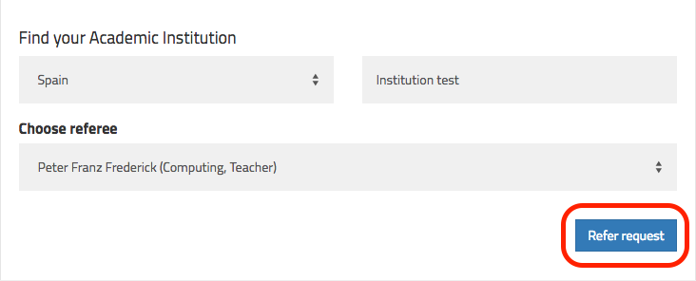

Once the student presses the Request a referee button, you will receive a notification via email (once a day) and also, you will have the pending application in your profile. If you enter with your referee credentials, you will be able to see the student’s request and click on the name:

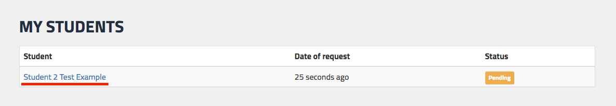

Now you can see the student’s whole profile and you have to check his/her personal skills, professional skills, studies, etc. At the end of the screen you will have an option to mark the student as Refereed or Not Refereed, or in other words as talented or not talented:

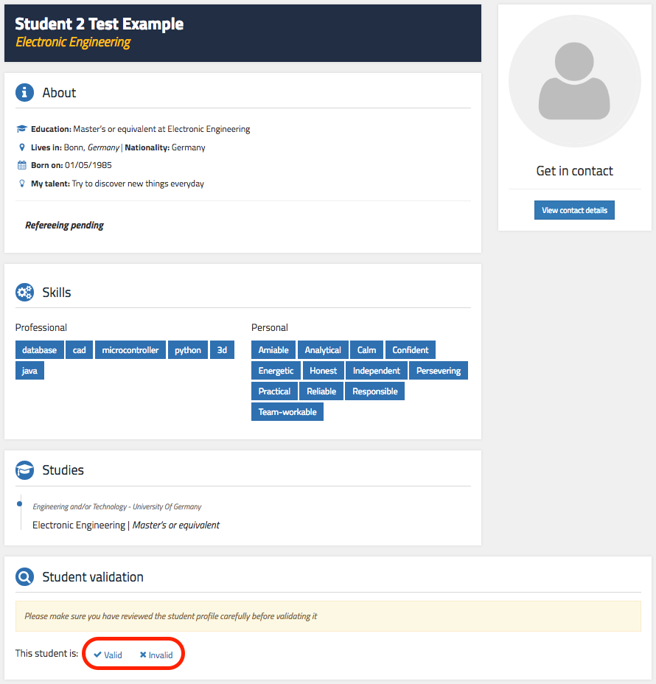

Assuming that you click on Refer, there is a section where you can specify personal skills (up to 6) that you consider that the student has, and add comments about the student. See an example on the following screen:

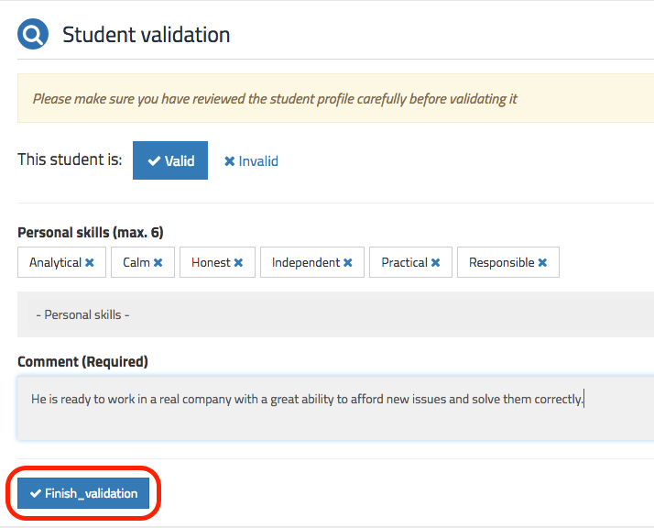

Once this is done, click on the Referral Completed button and then click Yes in the dialog box that appears to confirm the status:

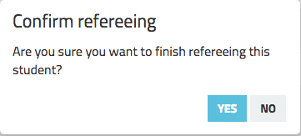

When returning to the page of your students, you can see the status of the student whom you have validated:

