Web Application Tutorial: Talented Europe for Students

Students

This document explains the use of the web application [talentedeurope.eu](https://talentedeurope.eu/) from the point of view of students.

Registration

The first step to register yourself as a student in the Talented Europe application is to click on the Sign up button.

**Click**

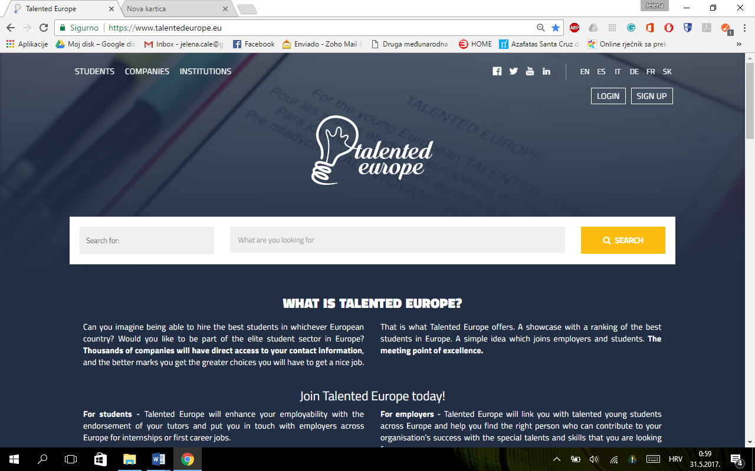

Afterwards, you need to select an icon corresponding to students.

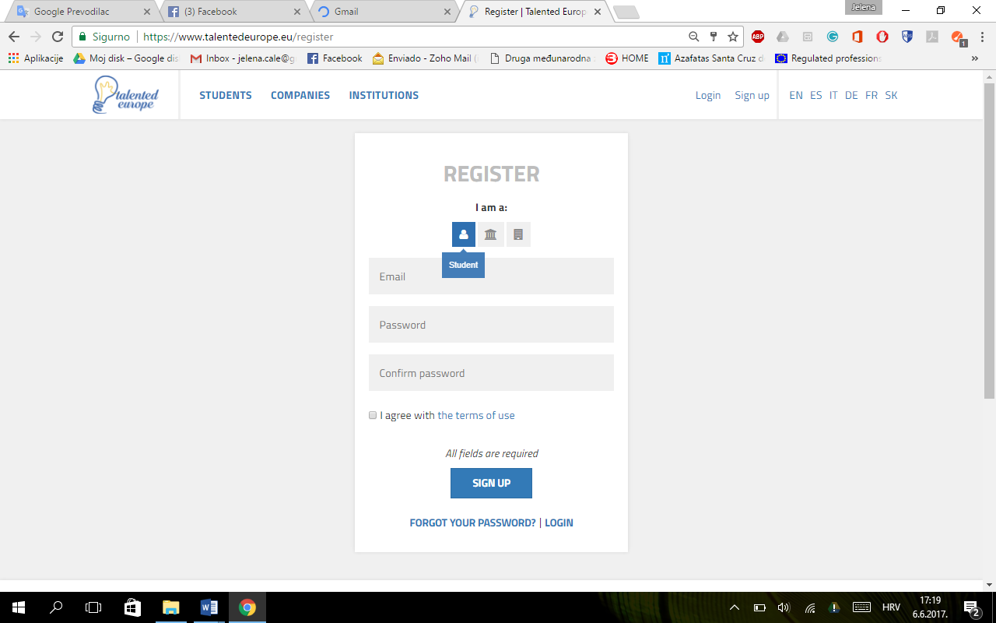

**Click**

**Click**

Next, you have to provide an email and a password (with its subsequent confirmation). Terms of use have to be accepted.

Pressing the Sign up button, the initial registration process ends.

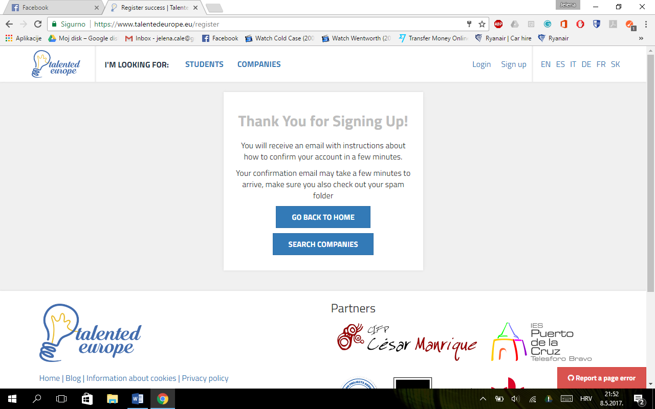

In a short time you will receive an email.

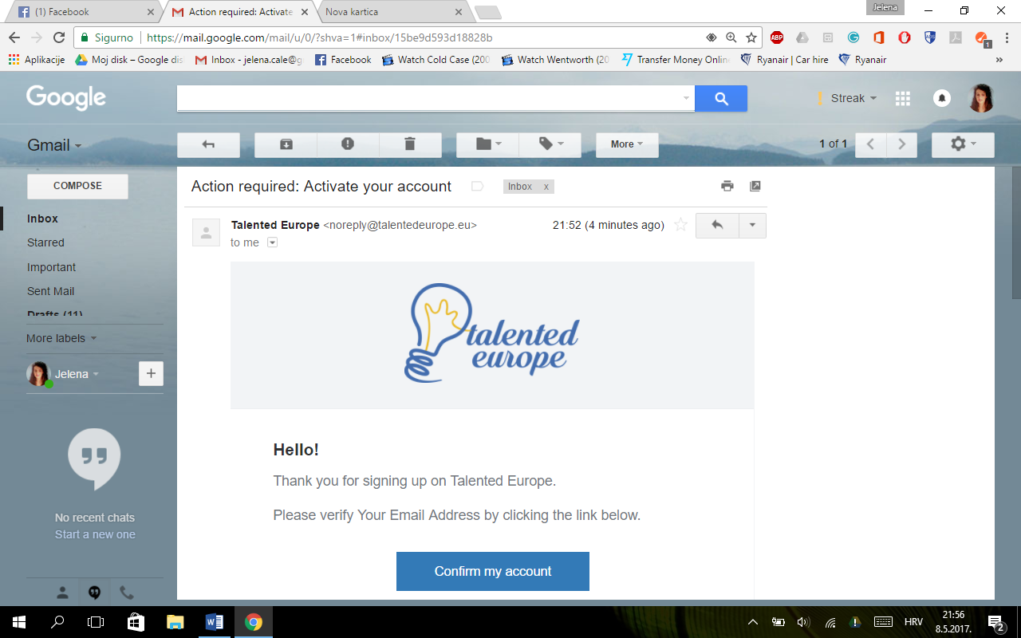

**Click**

When you click on the Confirm my account button, **a screen will be displayed where you have to confirm that the activation of the account was correct** and that it is possible to log in to the Talented Europe.

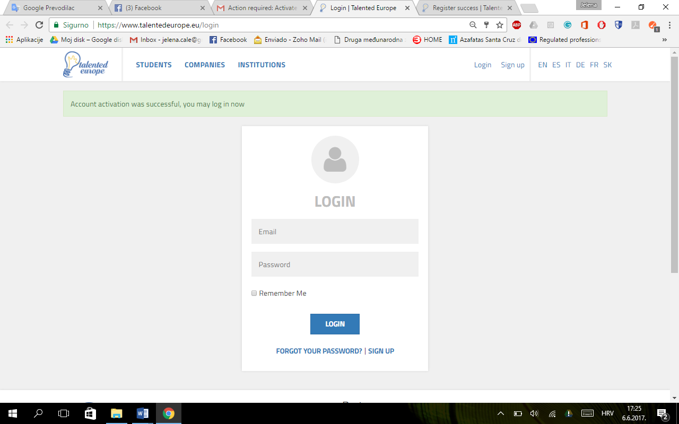

**Click**

In order to log in, you have to enter email and password used during the registration. Upon the first login the following screen will appear in which it is stated that you have to complete your profile filling in the mandatory fields so that you can have a full access to the Talented Europe platform.To do this, press the Set up my profile button.

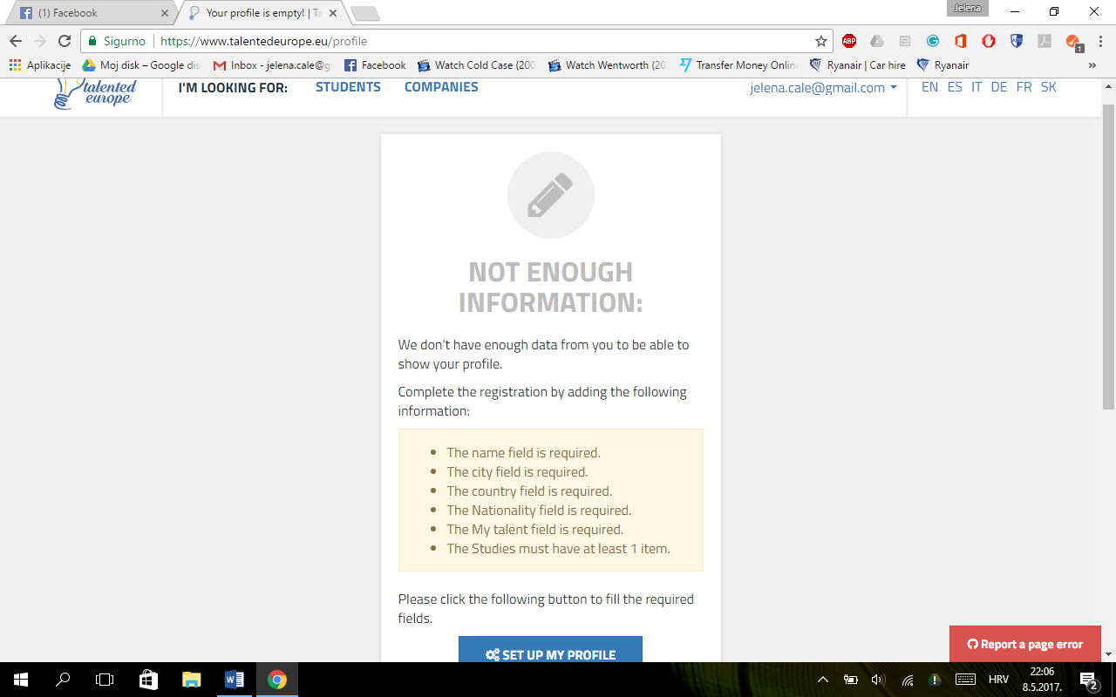

**Click**

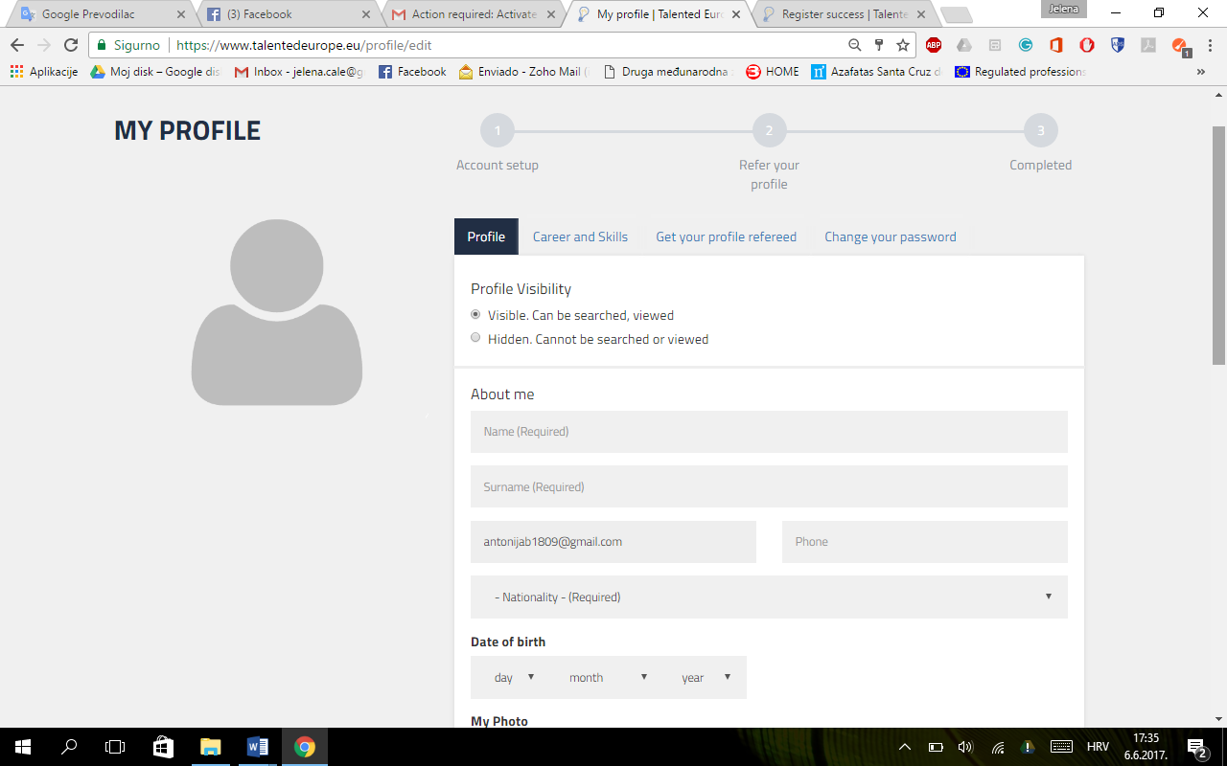

@

* You will see the data corresponding to the **Profile** tab. First, you have to choose whether you wish your profile to be visible or hidden.
* Your email is already filled out as it has been entered during the registration. The following information has to be completed:
* Name
* Surname
* Telephone number
* Nationality
* Date of birth

Continuing with the completion of the profile, the following fields appear:

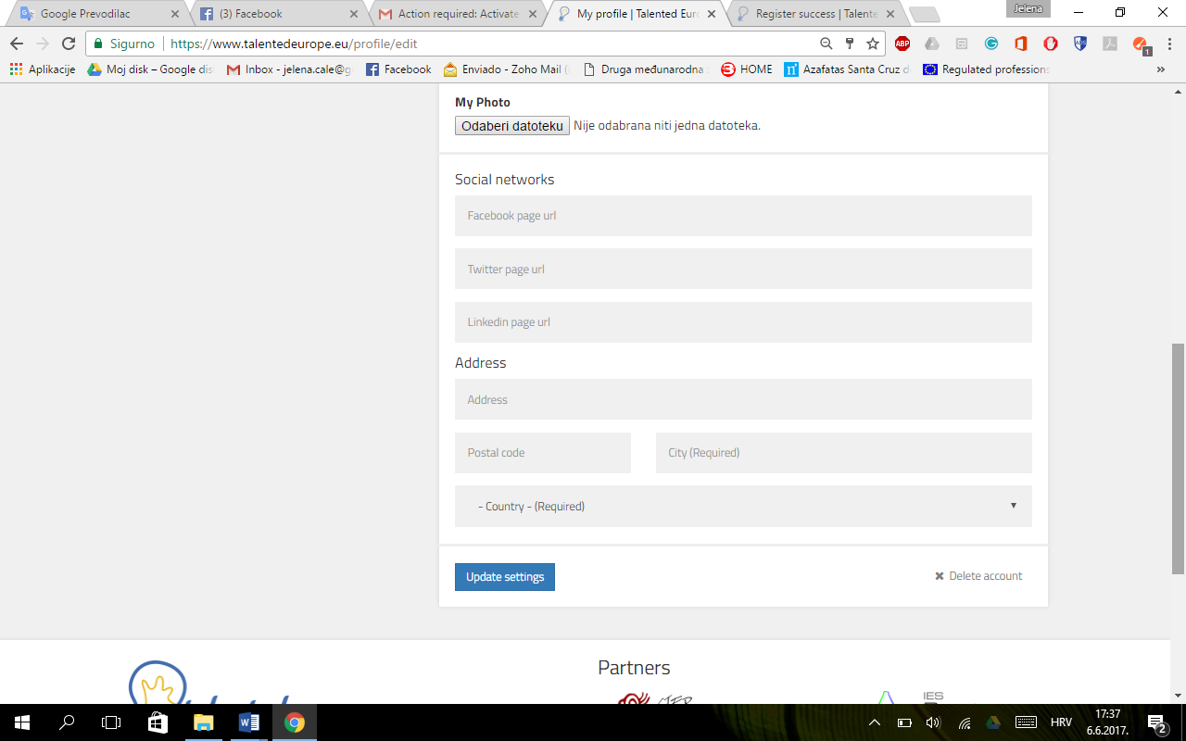

No file has been chosen

Choose File

**Click**

-> Your **photo** should be uploaded in the jpg or png format. Doing this is important because it will allow the companies and educational institutions to recognise you.

-> You are free to add URLs of your social networks to give more details to your potential employers.

-> Fill in your address, postal code and city, and select your country.

Whenever a modification is made to the profile, you have to click on the Update settings button. Otherwise, the changes will not be saved.

You can also delete your account by clicking on Delete account.

If you click on the Career and Skills button, you can edit your academic information by uploading your CV in the Europass format, listing your studies (institution name, course/studies name, level, fields of study), and uploading a certificate.

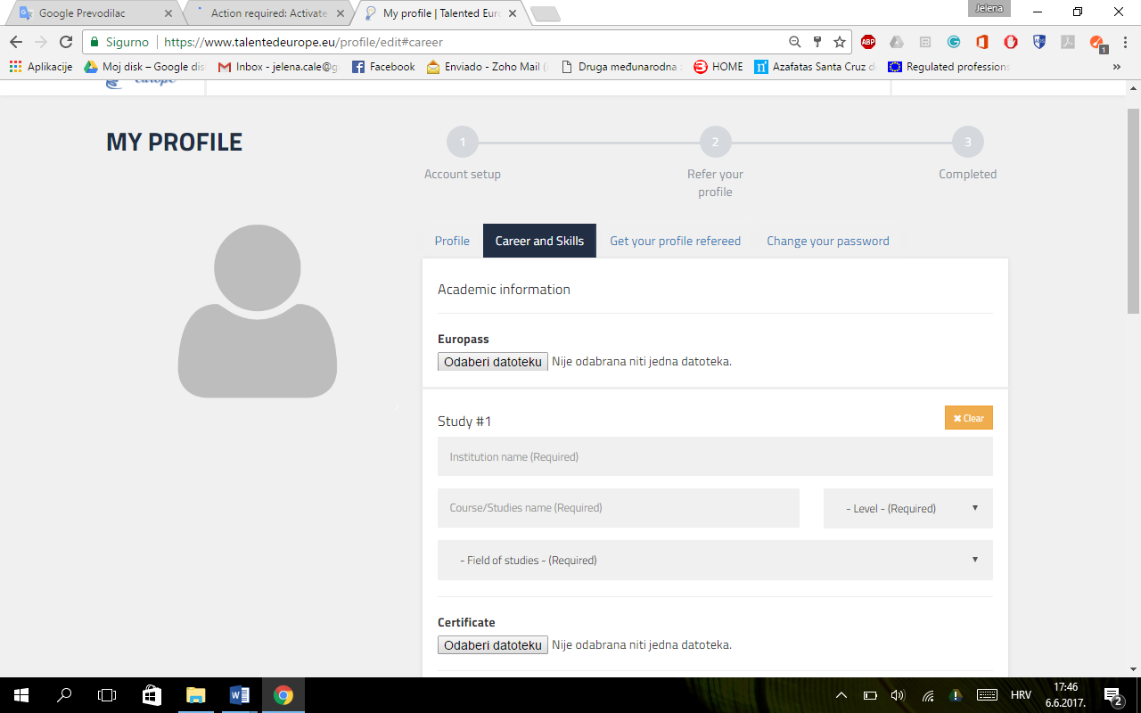

No file has been chosen

Choose File

No file has been chosen

Choose File

Continuing with the completion of the above, the following fields appear:

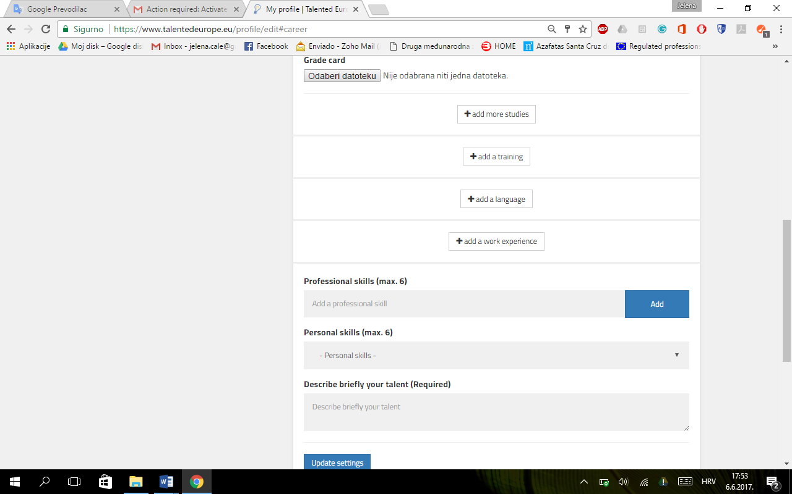

**Click**

No file has been chosen

Choose File

Here you can upload your grade card, add more studies, add training, add language/s, add work experience. Also, you are to list your professional and personal skills, with a maximum of six for each, and briefly describe your talent.

Again, it is important to press the Update settings button. Otherwise, the changes will not be saved.

Next, if you click on the Get your profile refereed button, you are directed to the following:

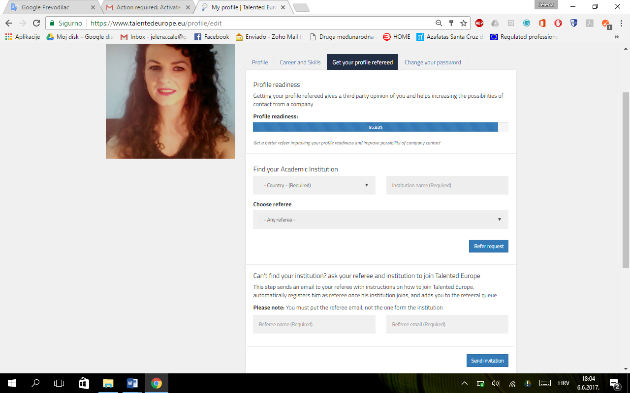

**Click**

**Click**

Here it specifies your profile readiness and you have to select your country, fill in your intitution's name, choose a referee and click on the Refer request button.

However, if you cannot find your educational institution, you can list the name and email of your intented referee, which then sends an email to him/her with instructions on how to join Talented Europe, automatically registers him/her as a referee once his educational institution joins, and adds you to the refeeral queue.

Finally, in the Change your password tab, you can change the password of your account.

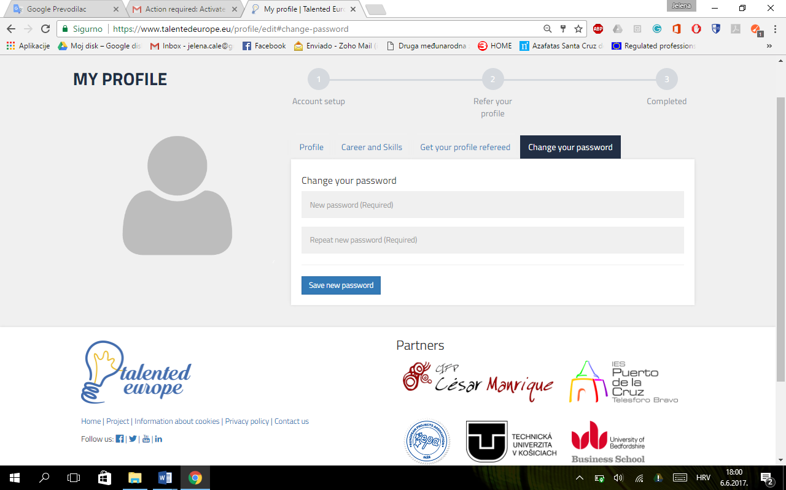

**Click**

It is important to press the Save new password button for the changes to take effect.

At any time you can change your profile by clicking on the upper right area, where it says your name and surname, and select the settings option.

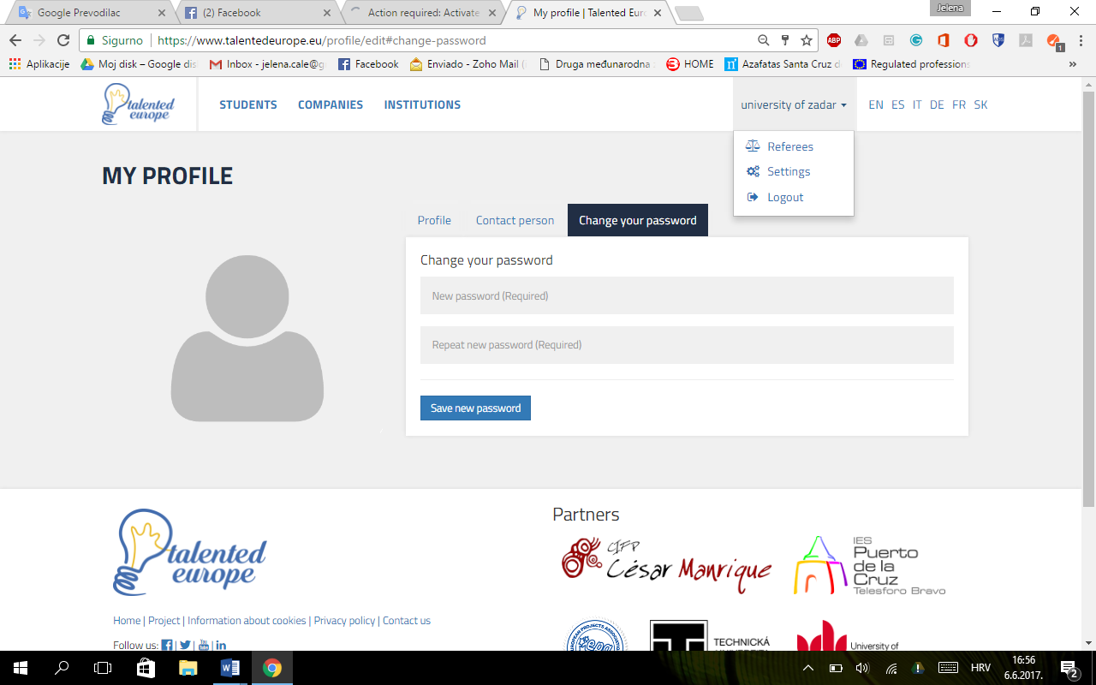

**Click**

*Student's name*

Login

To log in to the Talented Europe platform, access the <https://www.talentedeurope.eu/> and click on Login:

**Click**

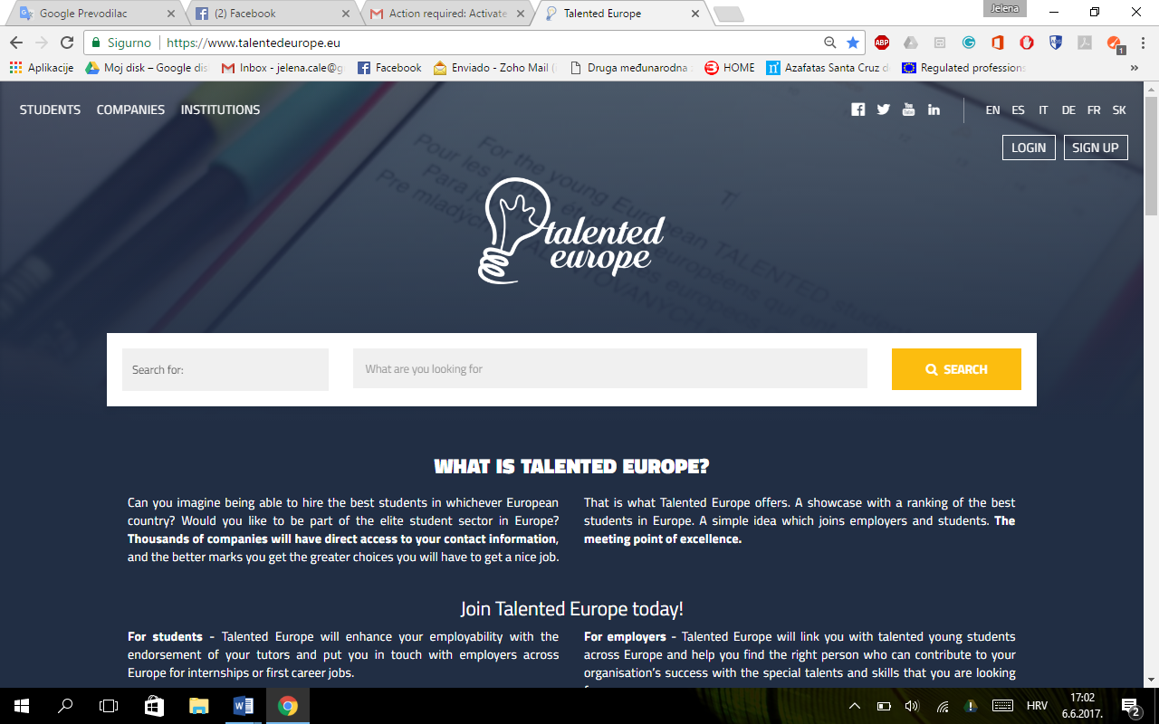

The following form will appear, where you have to enter email and password used upon your (student's) registration.

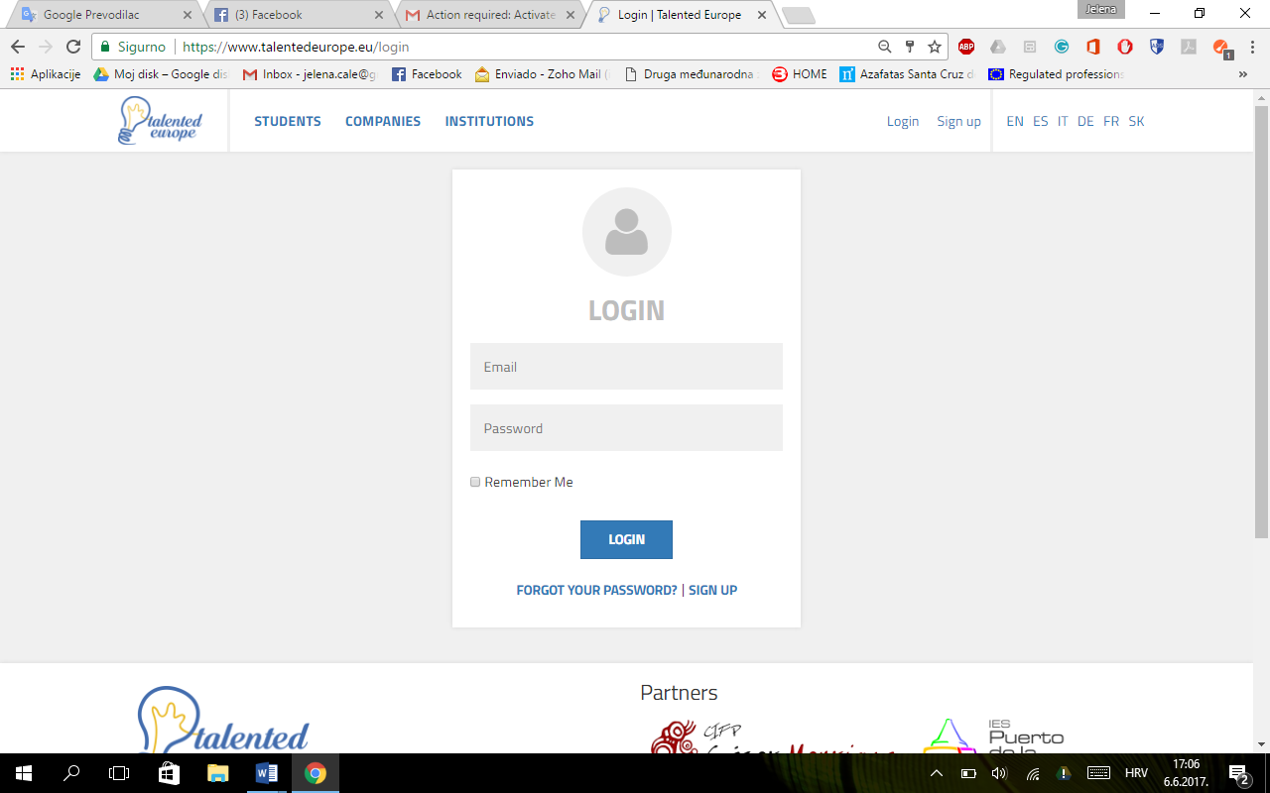

**Click**