Game Design Document

Fill up the Following document

1. Write the title of your project.

The title of my project is Space Shooter.

1. What is the goal of the game?

The goal of the game is to win after shooting all the enemies .

1. Write a brief story of your game?

There are some aliens that are from Mars want to take control over

our planet Earth. One of the members of team Earth went to space

to defeat the aliens.

THIS IS THE STORY OF MY GAME

1. Which are the playing characters of this game?

* Playing characters are the ones which respond to the user based on the input from the user
* Cars, monkeys, dinos, wizards etc, are the playing characters in the game.

|  |  |  |
| --- | --- | --- |
| Number | Character Name | What can this character do? |
| 1 | Player spaceship | This character can shoot the enemies by pressing the space key |

1. Which are the Non Playing Characters of this game?

* Non Playing characters are the ones which don't have an action or a behaviour when the user interacts with the game.
* Hurdles, stones, bananas, coins, etc are non playing characters in the game.

|  |  |  |
| --- | --- | --- |
| Number | Character Name | What can this character do? |
| 1 | Coins | This acts as a bonus points |
| 2 | 3 Enemies spaceship | This can end the game and out the players |

Draw your imagination of this game. What does this game look like?

* Draw the game either on your computer or on paper,
* Add images of scenes of the game to show each of the playing and non-playing characters at least once.

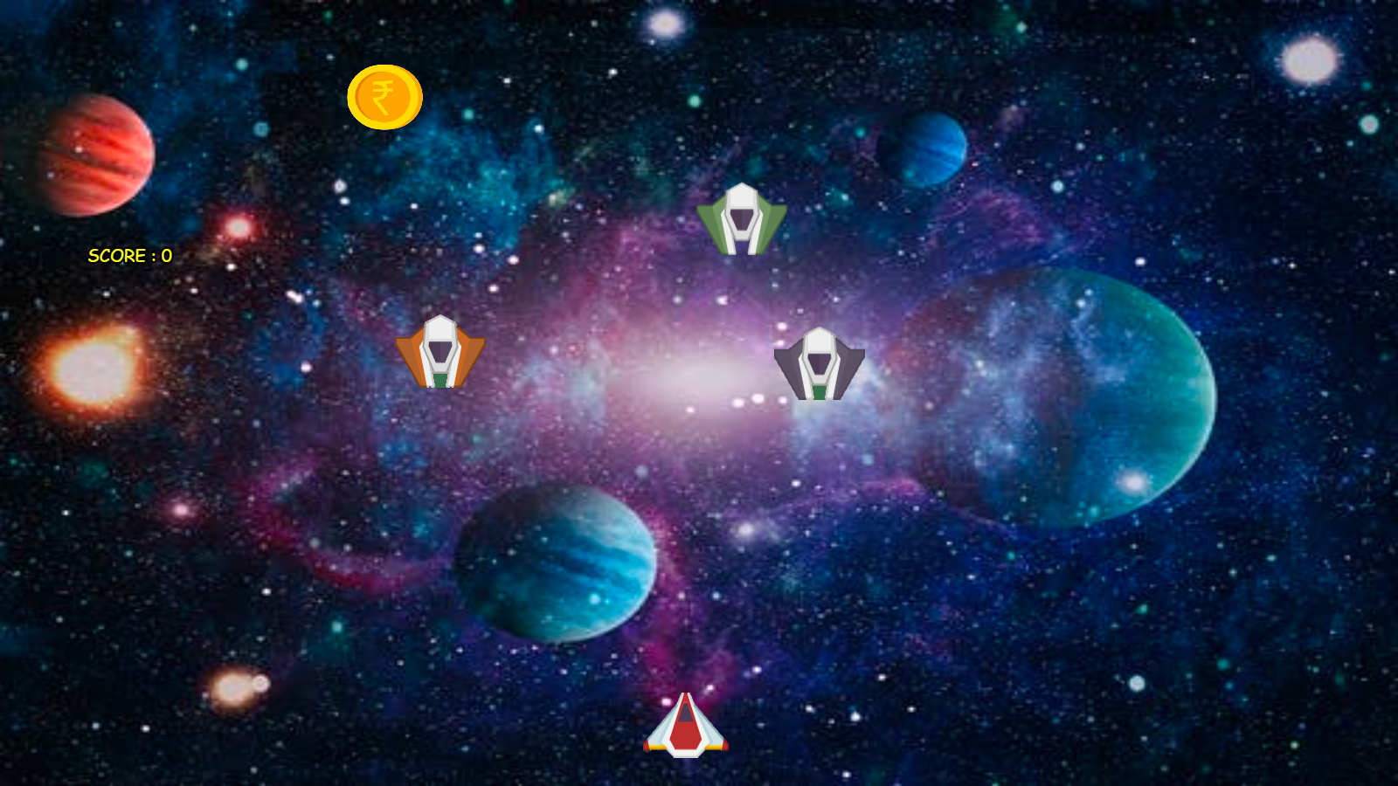

How do you plan to make your game engaging?

I first select beautiful background, player image and non- playing character images.

I make the game more interesting by increasing the levels like if the score or points is 100 than the non- playing characters speed will increase and background image changes this makes the game more interesting.

I also make the game not so difficult and not so easy which makes the game more engaging.